MANAGEMENT DISCUSSION DRAFT

PEFT Model Fine-Tuning and
Continuous-Improvement Process
  - A governed lifecycle for data curation, training, evaluation, deployment, and continuous learning
Prepared for | Manager review and process alignment
Prepared by | Krishna Kumar
Date | August 6, 2026

Executive overview
This document establishes a repeatable and auditable PEFT lifecycle for classification models. It starts with high-quality historical labels, reserves an independent golden evaluation set, uses controlled LoRA/QLoRA training, and makes production promotion conditional on measurable improvement.
Recommended control: Capture a reproducible base-model and RAG baseline before fine-tuning. The new adapter should be promoted only when it improves the agreed business and technical metrics without unacceptable regression.

Process at a glance
Stage | Primary input | Required outcome
1. Prepare | 12K curated examples | Balanced, deduplicated and human-validated data
2. Train | 10K training examples | Versioned LoRA/QLoRA adapter and training lineage
3. Evaluate | 2K holdout examples | Precision, recall, micro/macro F1, errors and latency
4. Operate | Online evidence | Monitored rollout, challenger comparison and human oversight
5. Improve | 90 days / 5K trigger | Human-reviewed incremental dataset and regression-tested release

End-to-End PEFT Lifecycle
The forward path is gated at data quality, offline evaluation and production promotion. Production evidence then feeds the next curation cycle.
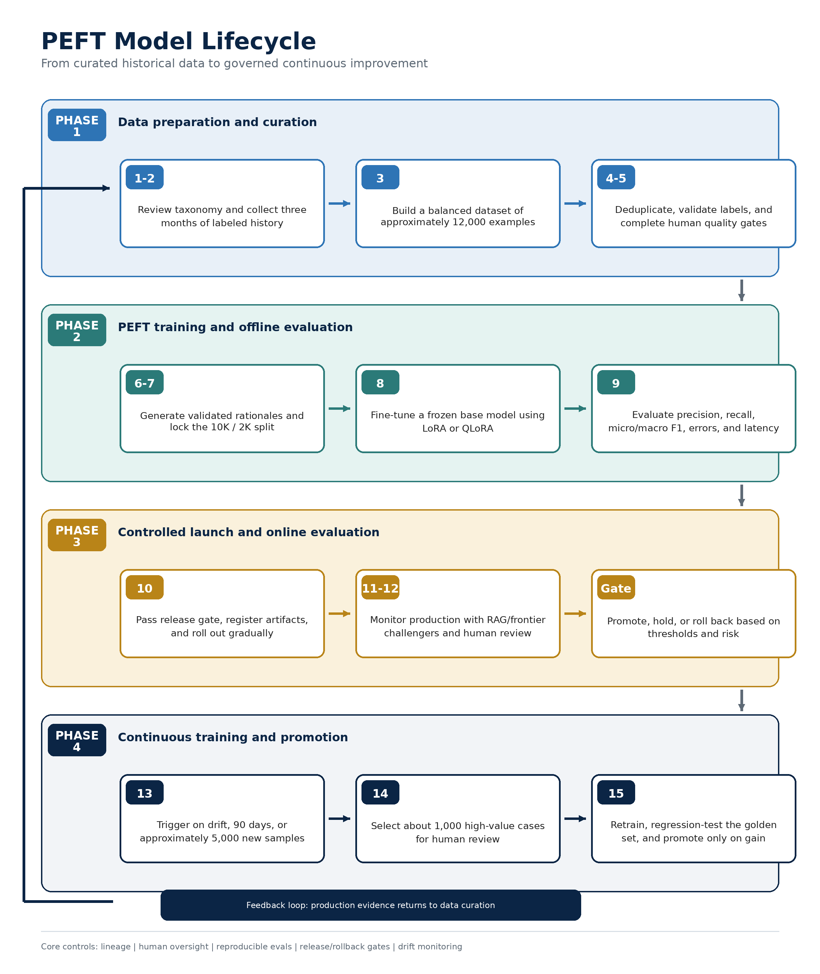
Figure 1. Governed PEFT model lifecycle and continuous-improvement loop.

Phase 1 - Data Preparation and Curation
PHASE 1 | Build trustworthy training and evaluation data  Outcome: balanced, deduplicated, traceable, and human-validated examples

STEP 1 Review the classification taxonomy
Confirm that class definitions are business-relevant, mutually distinguishable, and sufficiently granular. Resolve overlapping or ambiguous classes before data preparation.
STEP 2 Collect historical classifications
Collect approximately three months of data with the actual class at the required granularity. Include accepted classifications as positive examples and human-corrected misclassifications as negative examples.
- Target at least 500 examples per class; use controlled augmentation only where genuine samples are insufficient.
- Retain source, timestamp, original prediction, final classification, reviewer action and applicable rationale.
- Separate label correction from ordinary metadata changes so that positive and negative examples remain reliable.
STEP 3 Create an approximately 12K balanced dataset
Balance class representation and preserve important edge cases. Do not allow high-volume classes to dominate the training objective or the overall accuracy metric.
STEP 4 Deduplicate and perform human quality assurance
Embed examples, identify near-duplicates, and begin with an approximate 90% semantic-similarity threshold. Human reviewers should inspect at least 200 proposed duplicate pairs or clusters before bulk elimination.
STEP 5 Pass the data-quality gate
Use a stratified sample of approximately 2,000 records for human confirmation. Verify label accuracy, class balance, negative-example quality, edge-case coverage, leakage and source lineage.
Risk to control: An imbalanced or incorrectly labeled dataset can teach durable unwanted behavior. Training should not begin until the data-quality gate is signed off.

Phase 2 - PEFT Training and Offline Evaluation
PHASE 2 | Train the smallest effective task-specific delta  Outcome: versioned adapter with reproducible evidence of improvement

STEP 6 Generate and validate rationales
Use an approved teacher model to generate reasoning or rationales where they add learning value. Treat generated rationales as candidate labels: validate them through automated checks, AI-as-judge and targeted human review.

Recommended training-record schema
Field | Purpose
content | Original input to classify
baseline_model_result | Prediction from the frozen base model
actual_classification | Human-approved ground-truth class
rationale | Validated explanation or teacher-model reasoning
validation_status | Human-approved, judge-approved or rejected
lineage | Source, extraction date and dataset/model version
STEP 7 Lock the golden evaluation set
Reserve approximately 2,000 human-annotated examples before training. Prevent leakage and preserve the set as a stable regression benchmark across adapters and training cycles.
STEP 8 Fine-tune on approximately 10K examples
Freeze the pretrained backbone, default to LoRA, and use QLoRA when memory efficiency is required. Version the adapter separately so it can be swapped, compared or rolled back without replacing the base model.
STEP 9 Evaluate against baseline and release criteria
Use actual model outputs for the final report. Mock inference may support smoke and unit tests but must be excluded from production-quality performance metrics.
Evaluation dimension | Required evidence
Predictive quality | Precision, recall, F1, micro-F1, macro-F1 and per-class results
Error quality | Confusion matrix, high-confidence errors and business-critical false positives/negatives
Operational quality | P50/P95 latency, throughput, memory footprint, availability and cost
Regression | Original golden set, general capability checks and catastrophic-forgetting review

Phase 3 - Controlled Launch and Online Evaluation
PHASE 3 | Deploy gradually and validate real-world performance  Outcome: observable production model with safe fallback and rollback paths

STEP 10 Optimize, register and launch
Optimize inference, register the base model, adapter, dataset, hyperparameters and evaluation results, and deploy through a controlled canary or phased rollout.
- Define overall and per-class acceptance thresholds before deployment.
- Document owners for model approval, data approval, production support and rollback authority.
- Preserve the prior production adapter until the new release completes the observation period.
STEP 11 Maintain a RAG-based fallback or challenger
Index the approximately 12,000 curated examples in vector space and retrieve similar historical cases. Use the RAG result as a benchmark, challenger or governed fallback rather than silently treating it as ground truth.
STEP 12 Run monitored online evaluation
Sample or mirror production traffic to an approved frontier model, such as Gemini, and compare results with the production adapter and RAG challenger. Use AI-as-judge to prioritize disagreements, not to replace human accountability.
Observed condition | Recommended action
High confidence + agreement | Process normally; retain monitoring evidence
Low confidence | Route to human review or approved fallback
Model disagreement | Use judge criteria and risk rules to prioritize human review
Policy or high-impact class | Require human approval regardless of confidence
Threshold breach | Hold rollout, reduce traffic or roll back

Online monitoring dashboard
- Class distribution, confidence distribution and human override rate
- RAG/PEFT/frontier disagreement rate and judge escalation rate
- Per-class quality on adjudicated samples and business-impact incidents
- Latency, throughput, errors, cost and rollback readiness

Phase 4 - Continuous Training and Promotion
PHASE 4 | Convert production evidence into controlled improvement  Outcome: incremental release with demonstrated gain and no unacceptable forgetting

STEP 13 Detect drift and trigger the next cycle
Monitor input drift, class-distribution drift, confidence degradation, human overrides, emerging classes and challenger disagreement. Begin a formal review after approximately 90 days or 5,000 new samples, subject to the agreed trigger rule.
STEP 14 Create a human-reviewed incremental dataset
Prioritize uncertain predictions, model disagreements, emerging patterns, high-impact errors and RAG-versus-PEFT mismatches. Select approximately 1,000 high-value cases for human review and adjudication.
STEP 15 Retrain, regression-test and promote
Repeat the applicable curation and PEFT steps. Compare the challenger with the current production adapter and promote only when it demonstrates incremental gain without unacceptable regression on the original golden set.

Continuous-learning controls
Control | Purpose
Replay / retention | Retain representative prior-task examples so new training does not erase earlier capabilities
Regression suite | Evaluate the original golden set and critical-class scenarios after every training round
Versioning | Link every adapter to the exact data, labels, teacher/judge versions, code and hyperparameters
Promotion | Require documented gain, governance sign-off and rollback readiness before traffic increases
Retirement | Archive superseded adapters and retain reproducibility evidence according to policy
Promotion principle: The continuous-training loop is not an automatic retraining job. It is a controlled challenger process with human-reviewed data, offline regression evidence and an explicit production decision.

Governance, Decision Gates and Ownership
Each phase should produce a defined artifact and an accountable approval. The suggested roles below can be mapped to the organization’s formal governance structure.
Gate | Required evidence | Accountable approval | Decision
G0 - Use-case qualification | Baseline report and fine-tuning rationale | Product owner + model lead | Proceed / use prompt-RAG only
G1 - Data readiness | Taxonomy, data card, QA results and split | Data owner + model risk | Train / remediate data
G2 - Offline readiness | Eval report, error analysis and risk checks | Model lead + independent validator | Launch / tune / reject
G3 - Production promotion | Canary results, incidents and rollback test | Business + technology owner | Promote / hold / roll back
G4 - Continuous update | Incremental data and regression comparison | Same approvers as G2/G3 | Replace / retain current adapter

Minimum audit trail
- Dataset version, inclusion/exclusion rules, deduplication threshold and human-review records
- Base model, adapter, tokenizer, prompt/schema, teacher model and AI-as-judge versions
- Training configuration, seeds, code commit, environment and hardware
- Offline results, online comparison evidence, approvals, release date and rollback result
- Post-launch drift, overrides, incidents and retraining-intake decisions

Recommended promotion criteria
Criterion | Gate expectation
Business-critical classes | Meet class-specific precision/recall floors; no unresolved severe error
Overall predictive quality | Meet agreed macro-F1 and micro-F1 improvement over the production baseline
Operational performance | Stay within latency, throughput, cost and availability budgets
Robustness and regression | No unacceptable degradation on the golden set or general capability checks
Governance readiness | Complete lineage, human approvals, monitoring and tested rollback path

Manager Discussion: Decisions to Confirm
Meeting objective: Agree on the operating process and ownership first. Numerical thresholds can then be calibrated through baseline results and the first controlled pilot.

# | Decision area | What to confirm
1 | Dataset scale | Confirm approximately 12K total records with a 10K training / 2K holdout split
2 | Model scope | Confirm whether this process targets a 7B-class base model and whether LoRA is the default
3 | Human review | Confirm reviewers, adjudication rules, expected turnaround and approximately 1K incremental reviews
4 | RAG role | Choose benchmark, challenger, fallback, or a combination with explicit routing rules
5 | AI-as-judge | Approve rubric, judge model, sampling rate and mandatory human-escalation conditions
6 | Retraining trigger | Define whether 90 days or 5K new samples means whichever occurs first or a combined threshold
7 | Release gates | Set precision/recall floors, macro/micro F1 improvement, latency budget and observation period
8 | Ownership | Assign data, model, validation, production-monitoring and rollback accountability

Suggested next-step sequence
- Approve the taxonomy, ground-truth definition and dataset acceptance criteria.
- Build the reproducible base-model and RAG baseline using actual model outputs.
- Run a limited curation pilot to validate class balance, deduplication and reviewer effort.
- Finalize release thresholds and governance sign-offs before full PEFT training.
- Create the detailed Draw.io architecture and operating-process map after process approval.
Expected decision: Approve this lifecycle as the working model-factory process and authorize a pilot to calibrate volumes, thresholds, cost and reviewer capacity.

