ENGINEERING EXECUTION PACK / COPY-READY ASKDEVIN PROMPT

EDGE Settlement Fails
Support Agent
AskDevin Coding Session • Phase 0 Foundation + Phase 1 Read-Only Diagnostic MVP
Implementation brief grounded in the approved architecture proposal and editable architecture diagram.
Version 1.0 | 1 November 2026 | Internal engineering use

MISSION
Implement an out-of-band EDGE Support Agent that detects incidents, collects correlated ADK/Postgres/log/telemetry evidence, evaluates existing workflow invariants, selects versioned diagnostic skills, and returns evidence-grounded remediation recommendations. Phase 1 must be read-only.

IMPLEMENT NOW | DO NOT IMPLEMENT IN THIS SESSION
Phase 0: contracts, discovery, eval diagnostic adapter, incident collector | State-changing recovery or infrastructure repair
Phase 1: six skill playbooks, deterministic routing, report generation, offline replay/tests | Live QMA dispatch, commentary publication, human-review bypass
Graceful fallback and trace/evidence citation validation | Automatic retries of business tools, MCP writes, or production DB mutations

Delivery outcome: code + tests + docs + a sample sanitized diagnosis report + a concise handoff summary. No live business actions.

How to run this AskDevin session
- Open a new AskDevin session with access to the enterprise repository containing the Settlement Fails ADK application and eval harness.
- Attach the existing EDGE Support Agent Architecture.docx and EDGE Support Agent Architecture.drawio if Devin can access attachments. If not, this document is self-contained: the architecture and acceptance criteria below are authoritative for this assignment.
- Copy from the boxed “START OF ASKDEVIN PROMPT” through “END OF ASKDEVIN PROMPT” into the session. Ask Devin to implement Phases 0 and 1; leave Phases 2–3 as proposals only.
- Tell Devin to use the existing enterprise Git repository, approved dependency registry, existing database connection configuration, and current test conventions. Do not introduce new external code repositories.
- Review the discovery checkpoint and final tests; require Devin to list all modified files and any environment-dependent integrations left as adapters.
IMPORTANT BOUNDARY
The repository paths in this prompt are search hints from the supplied documentation, not guarantees. Devin must discover the actual package layout before editing. An internal enterprise environment may not expose every telemetry source; missing sources must be represented explicitly, never fabricated.

Decisions to confirm before production integration
Decision | Recommended starting position
Code location | Within current Settlement Fails repository as an out-of-band package/service; extract later when reusable.
ADK event source | Use existing Postgres session helper and shared trace walker; do not duplicate parsing.
Observability source | Prefer existing AgentFlow/OTel interfaces; build optional adapter and clearly report if absent.
LLM provider | Use enterprise-approved configurable adapter, plus a complete non-LLM fallback.
Authorization | Read-only at code and credential layers; no exposed business action methods.
Deployment | Separate support job/service with explicit RBAC and a different quota/failure domain where feasible.

Reference artifacts: EDGE_Settlement_Fails_Support_Agent_Architecture.docx and EDGE_Support_Agent_Architecture.drawio. Their diagram defines component boundaries; this prompt defines the Phase 0/1 coding contract.

Architecture reference
The following visual is reproduced from the previously created editable architecture. The Support Agent is a separate control-plane service and does not sit in the business workflow request path.
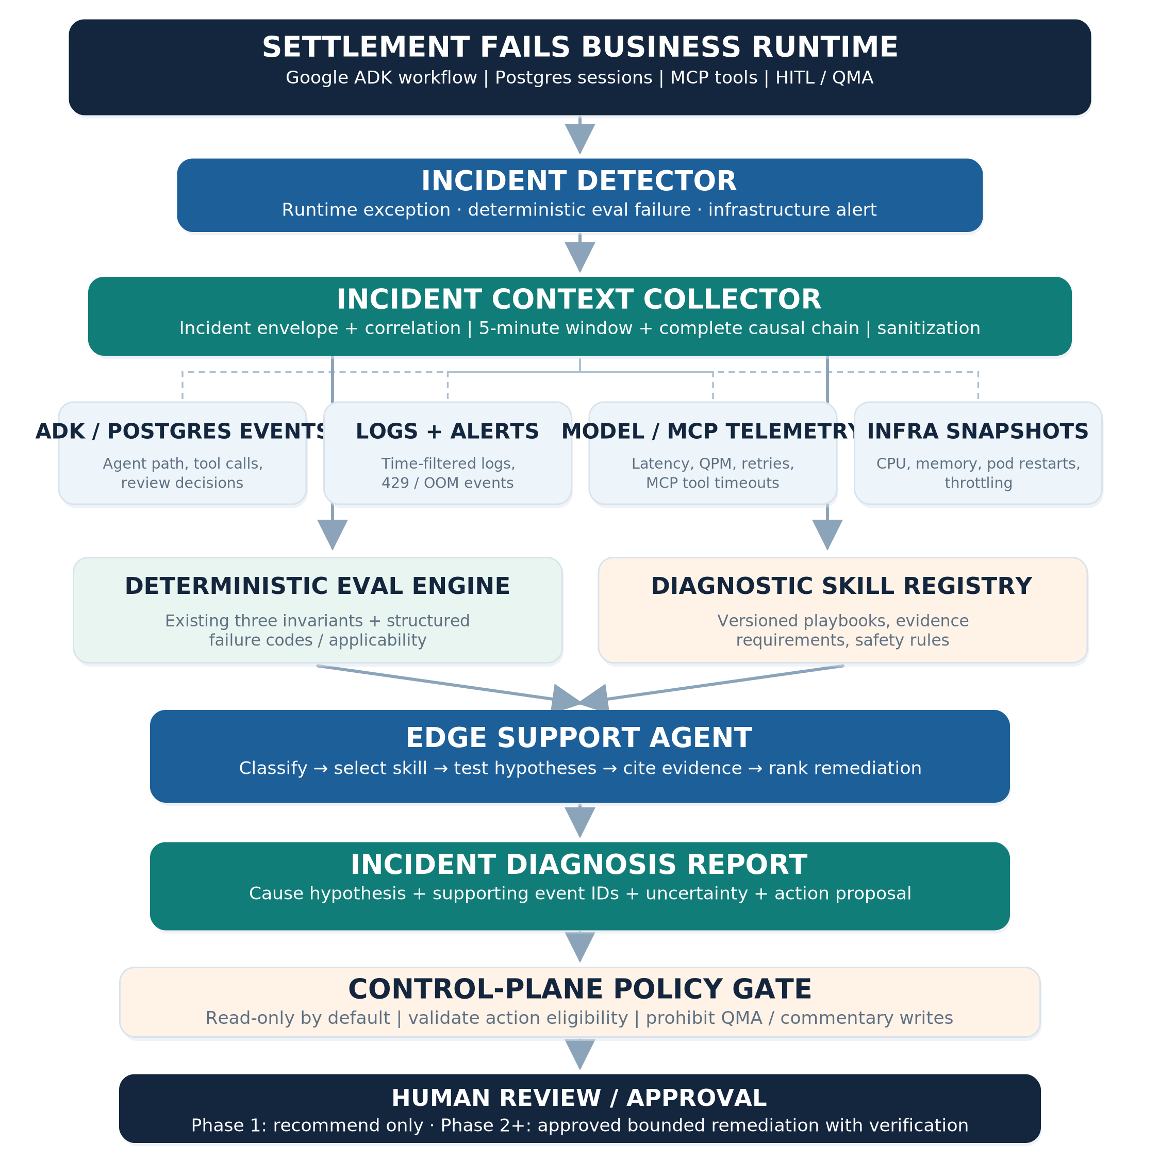
Architecture: runtime → detector → context collector (+ four evidence sources) → deterministic evals and skill registry → Support Agent → report → policy gate / human review.

START OF ASKDEVIN PROMPT
SESSION ROLE
You are implementing an enterprise production-oriented feature in an existing Google ADK Settlement Fails application. Execute the coding work, not only a design review. Start by inspecting the repository and existing tests. Respect all safety controls and stop only for a genuine security, data-access, or architecture blocker.

A. Objective and non-negotiable outcomes
Build an out-of-band EDGE Support Agent MVP for diagnosing failures in the Settlement Fails multi-agent workflow. The design is invariant-first and evidence-grounded: deterministic evaluations decide whether workflow controls were violated; skills describe investigation procedures; the Support Agent synthesizes a recommendation; authorization is decided separately.
- Phase 0: implement incident identity/correlation, strongly typed evidence contracts, diagnostic-eval adapters for the existing three metrics, and a read-only collector.
- Phase 1: implement six versioned diagnostic skills, a deterministic skill router, structured diagnosis/report generation, a CLI or existing project-native entry point, and an offline test/replay harness.
- Preserve existing offline CI eval behavior and 53-fixture / 159-expected-cell baseline shown in the reference design. Validate against repository reality rather than assuming counts remain identical.
- Outputs must cite concrete event IDs, trace/span IDs, log references, alert IDs, or metric sample references. When supporting evidence is insufficient, return INSUFFICIENT_EVIDENCE rather than inventing root cause.
- No autonomous remediation in Phase 1. Analysis tools are read-only; no production workflow execution during tests.

B. Mandatory guardrails
Rule | Required behavior
Isolation | Do not put the Support Agent in the Settlement Fails business path; do not change HITL state machine or business decisions.
No business writes | Never call send_qma_email, publish_commentary, create_qma_inquiry, or any equivalent dispatch/publish endpoint from support code or tests.
Data safety | Do not print secrets, credentials, raw emails, CUSIPs, user IDs, or sensitive raw Postgres rows in logs/reports/commits. Sanitize and bound inputs.
Connectivity | Use enterprise-local approved services only. No public API requests, external Git clone, or runtime pip install unless already approved.
Database | Inspect via existing helpers and authorized read-only role; do not migrate, write, or alter production DB; use mocks/sanitized fixtures in CI.
Model failure | Provide a deterministic diagnostic/report fallback when model access is unavailable; LLM output cannot override a rule result.
Change scope | Prefer additive modules; do not refactor or break three existing eval metrics and current invocation/DB walkers.

C. Repository reconnaissance — first checkpoint
Before editing code, inspect the enterprise repository and produce a short inventory in the session. Locate the actual counterparts of the following search hints:
edge_fails_ai/evals/trajectory_metrics.py
edge_fails_ai/evals/trace/walkers.py
edge_fails_ai/evals/convert_traces.py
edge_fails_ai/evals/score_fixtures.py
edge_fails_ai/evals/datasets/manifest.json
ADK agent definitions and runner/session store initialization
Postgres event_data and session access helpers
Existing test fixtures, pyproject.toml/uv.lock, logging and observability hooks
AgentFlow/OTel/monitoring connectors, if present

Verify the names and signatures of summary_runs_once, correct_commentary_agent_order and no_dispatch_without_accept. Determine how the current scorer represents a non-applicable path (None, 1.0 or another convention), how step paths are normalized, and how decision-turn resumes are represented. Confirm the current fixture counts by running the safe offline scorer/tests, if already configured.
Record an “as-is → proposed” file map, relevant dependency versions, existing DB abstraction, whether AgentFlow/log/metrics adapters already exist, and any integration gaps. Do not block the entire implementation if optional telemetry sources are unavailable; design an adapter interface and use deterministic sanitized fixtures.

D. Phase 0: contracts and deterministic diagnostic adapter
Implement Pydantic or project-native typed models with strict validation and serialization. These are target semantics; adjust filenames and field shapes to existing project conventions.
Contract | Mandatory logical fields
IncidentEnvelope | incident_id, trigger_type, severity, app_name, session_id, invocation_id?, trace_id?, failed_event_id?, failure_timestamp_utc, source, correlation_status
EvidenceRef | evidence_id, source_type, source_ref, event_timestamp_utc, trace/span/pod IDs if known, sanitized summary, retrieval_timestamp, provenance
EvidenceBundle | incident, ADK ordered steps, diagnostic findings, log/alert/model/MCP/infra slices, collection window, unavailable_sources, sanitization status
EvalFinding | metric, metric_version, score, applicability, outcome, failure_code?, first_violation_event_id?, evidence_ids[], explanation
DiagnosisReport | incident_id, diagnosis_status, hypotheses with ranked evidence, missing_evidence[], recommended_actions[], prohibited_actions[], skill_ids[], version map, generated_at

Keep the existing numeric eval contract unchanged for ADK CI compatibility. Add a non-breaking diagnostic interface that can express PASS, FAIL and NOT_EXERCISED (plus ERROR/UNKNOWN for malformed traces if supported) independently from legacy 0.0/1.0 scoring. A vacuous 1.0 must not be reported as positive evidence of an exercised safety gate.
Diagnostic findings must include the first violated agent/tool transition when determinable, relevant event refs, and explicit invocation kind: FRESH_RUN, HITL_RESUME, or UNKNOWN. A legitimate human decision-turn resume must not spuriously fail the commentary ordering check.
Preserve fixture/scenario independence: deterministic first-match scenario labels may route testing but must not be treated as proved root cause. Do not modify expected scores solely to make tests pass.
# Illustrative diagnostic shape; adopt repo-native field names
{
"metric": "correct_commentary_agent_order",
"score": 0.0,
"outcome": "FAIL",
"applicability": "EXERCISED",
"failure_code": "VALIDATION_MISSING",
"invocation_type": "FRESH_RUN",
"evidence_ids": ["event:evt-21", "event:evt-24"],
"metric_version": "v1"
}

E. Phase 0: out-of-band detection and context collection
Implement an IncidentDetector interface with adapters for (a) detected deterministic eval failure, (b) ADK/runtime or tool/model exception, and (c) infrastructure alert. Include deduplication/idempotency key(s) using stable incident identity. Do not require an active Settlement Fails agent invocation to run diagnosis.
Implement an IncidentContextCollector accepting the incident envelope and authorized lookup context. Retrieve ordered ADK session events from existing Postgres helpers or sanitized offline session fixtures. The lookup must use the applicable authorized app_name/user_id/session_id scope (not session_id in isolation). Normalize via current shared event walkers; do not duplicate normalization logic.
- Logs: default [-5 minutes, +5 minutes] around failure, time zone UTC; extend backward to include the complete failing invocation and preceding HITL decision chain. Bound queries and evidence volume.
- Telemetry: model requests/rate limits/retries, MCP tool timeouts/concurrency, CPU/memory/pod restarts/OOM/throttling, alerts. Use interface/adapters, with explicit MISSING_SOURCE or UNAVAILABLE status when not wired.
- Correlation: prefer trace/span/session/event IDs; use pod + time only as a lower-confidence fallback, visibly labeled as such.
- Security: allowlist sanitized fields, redact sensitive values, treat log/error/tool contents as untrusted data, forbid prompt instructions from logs, and audit evidence retrieval.
- Reliability: per-source query timeout, max window expansion, max rows/bytes, deterministic ordering, safe partial bundle, and bounded failures. Never block the business workflow.
Implement immutable evidence IDs and a provenance map so every hypothesis and recommended action can be checked against the collected bundle. Source timestamps should be stored separately from retrieval timestamps.

F. Phase 1: diagnostic skills, deterministic routing, support diagnosis
Create six versioned SKILL.md playbooks (use a repo-native skills mechanism if available; do not require an experimental external dependency). Each must contain trigger codes, required evidence, ordered checks, likely hypotheses, disconfirming tests, safe read-only tools, forbidden actions, escalation, owner/version, and response schema:
Skill | Primary triggers / expected evidence
workflow-invariant-diagnosis | Missing/duplicate summary; misordered commentary; missing validation; fresh-run vs resumed HITL.
hitl-authorization-diagnosis | Dispatch without accept; reject then dispatch; reviewer task state mismatch; authorization lineage.
model-rate-limit-diagnosis | 429/RESOURCE_EXHAUSTED; QPM, concurrency, retry budget, model latency.
mcp-tool-failure | Timeout, connection failure, duplicate invocation, queue pressure, tool failure result.
infrastructure-resource-diagnosis | OOM/restart, CPU throttling, memory growth, saturated worker/resource metrics.
business-data-diagnosis | Missing/stale position or settlement data; inconsistent CUSIP classifications; source gaps.

Select skills using deterministic event/eval/error signature mapping first; use model assistance only to rank ambiguous hypotheses after evidence collection. The selected skill must not grant tools or privileges. Allow multiple skills if correlated failures exist (for example 429 plus downstream MCP timeout), and track which evidence supports each.
Implement a SupportAgent orchestration entry point that: validates incident → collects evidence → runs eval diagnostics → selects skills → executes safe diagnostic rules → optionally uses approved enterprise LLM for explanation → evidence-validates the structured result → emits report. On model failure, fall back to a deterministic incident report including exact failure codes, known facts, missing sources, and analyst next steps.
Use a configurable provider adapter; do not hardcode Gemini endpoint, model ID, keys, or token limits. Avoid introducing another model dependency on the business request path. If no approved model endpoint is available in the repository, implement and test with a fake reasoning adapter and document the integration seam.

G. Output and operator experience
Expose an offline command or repo-native equivalent, including a fixture mode that cannot call live ADK/MCP/business tools:
# Illustrative, not a required exact package path
uv run python -m edge_fails_ai.support.cli diagnose \
--fixture path/to/sanitized_incident.json \
--output-dir reports/support_agent \
--no-live-tools

Write a machine-readable JSON report plus a concise human-readable Markdown or text incident report. Each report must show: incident summary, trigger, failed invariant(s), whether any safety rule was not exercised, ranked probable cause(s), cited evidence, disconfirming facts, missing evidence, recommended diagnostic/recovery actions, approval requirement and escalation owner.
Every recommended action should have action_id, action_class (READ_ONLY, ADVISORY, APPROVAL_REQUIRED, PROHIBITED), expected benefit, risk, prerequisite and evidence_ids. Phase 1 returns advice only; never executes action proposals. Validate every cited evidence_id exists in the actual bundle, and reject/flag unsupported claims.
An explicit INSUFFICIENT_EVIDENCE state is preferable to unsupported “high confidence.” Confidence values must be calibrated later; do not create a fake 0.95 confidence from heuristic prompt wording.

H. Tests and acceptance gate — must run
Build unit, integration-with-fixture and security tests using existing repo test conventions; no production DB, model, MCP, publisher, or QMA access. At minimum include these cases:
Case | Required result
Regression | Current offline eval suite passes and existing expected outcomes remain unchanged (reference baseline: 53 fixtures × 3 metrics = 159).
Valid resume | HITL decision-turn resume without writer/validation leaves is correctly identified, not marked as ordering failure.
Missing validation | Missing commentary validation before reviewer generates failure code + exact event refs.
Summary cardinality | Zero and two summary calls fail; exactly one authorized call passes.
Dispatch safety | Approved dispatch passes, reject or missing accept fails; no dispatch is NOT_EXERCISED, not “positively proved safe.”
Provider stress | Synthetic 429 with retry burst routed to rate-limit skill, with cited model events.
MCP outage | Tool timeout routed to MCP skill; no retry or write executed.
Infra | Synthetic OOM/restart and CPU alert traced to resource skill; missing metrics shown explicitly.
Data quality | Missing/stale position data classified as a data issue, no fabricated underlying business values.
Security | Malicious instructions in log text cannot trigger tool calls, secrets or unsafe recommendations.
Offline fallback | No LLM, no metrics provider, and no database still produce a valid partial deterministic report.
Evidence integrity | Reports with nonexistent evidence_ids or a conclusion unsupported by refs are rejected/flagged.

Add tests for time-window expansion, ordering/time zones, cross-session isolation, redaction, duplicate incident suppression, query bounds and malformed event payloads. Prefer property-based tests for event ordering/sanitization if such tooling is already approved in the project.
Acceptance: 0 unsafe/state-changing tool invocations; complete test traceability for each scenario; no regressions to existing metrics; repeatable fully offline runs; all submitted example reports clearly labeled synthetic and sanitized.

I. Suggested implementation layout — adapt to actual repo
edge_fails_ai/
evals/
trajectory_metrics.py # unchanged scoring contract
trace/ # reuse existing walkers
diagnostic_adapter.py # new, non-breaking
support/
contracts.py # incident/evidence/diagnosis models
detector.py # signal normalization, dedupe
collector.py # bounded read-only evidence retrieval
adapters/ # session, logs, telemetry, alerts
skills/ # six versioned SKILL.md playbooks
skill_router.py # deterministic trigger → skills
orchestrator.py # read-only investigation
evidence_validator.py # cite-what-you-have gate
report.py # JSON + human report
cli.py # offline fixture entry point
tests/support/ # offline, negative, security tests
docs/support_agent/ # runbook, ADR, integration notes

Keep imports, dependency injection and async patterns aligned with the current ADK project. Avoid building an unrelated framework or inventing non-existent production integration modules. Keep new files small, tested and maintainable.

J. Execution sequence, deliverables and handoff
1. Discovery checkpoint: post an inventory of real files/classes and a short implementation plan; then proceed unless blocked by missing authorization or unsafe integration.
2. Implementation checkpoint 1: deliver schemas, diagnostic adapter, regression/tri-state tests, and event IDs in findings.
3. Implementation checkpoint 2: deliver collector + read-only adapters, correlation, sanitization and offline fixture tests.
4. Implementation checkpoint 3: deliver six playbooks, skill router, support orchestration, and structured reports with non-LLM fallback.
5. Implementation checkpoint 4: run full relevant tests/linters; generate one sanitized sample report for a 429 and one for failed validation; update operator README.
6. Final response: list exact files created/modified, commands run and results, decisions/deviations from diagram, integrations implemented vs stubbed, remaining risks, and recommended Phase 2 backlog. If feasible, create logically separated commits but follow enterprise repository policy.
Do not claim production deployment or live incident recovery. Phase 2 authorization, bounded remediation tools and rollback; Phase 3 multi-workflow reuse and controlled self-healing are design backlog only. Do not implement or enable those capabilities in this session.
END OF ASKDEVIN PROMPT

Engineer review: suggested acceptance checklist
Use this checklist when reviewing Devin’s pull request. A “yes” for tests is not sufficient unless the corresponding implementation is demonstrably read-only and evidence-grounded.
☐ Existing three evaluation functions remain authoritative; legacy numerical scores remain backward compatible.
☐ New diagnostic result distinguishes PASS, FAIL, NOT_EXERCISED; includes first failing transition and event references.
☐ Valid HITL resume traces are not falsely classified as fresh-run sequence failures.
☐ Incident correlation uses authorized ADK session scope and handles entire invocation history.
☐ Five-minute default telemetry window is bounded but expandable based on causal evidence.
☐ Six versioned diagnostic skills exist with evidence requirements and prohibited action sections.
☐ The support path cannot invoke email dispatch, commentary publish or other business write tools.
☐ The CLI/test harness works on sanitized fixtures without provider keys, live MCP or a database.
☐ Generated hypotheses and recommendations have resolvable evidence IDs or insufficient-evidence status.
☐ All tests, negative security cases and regression suites have recorded results.
☐ Integration gaps (AgentFlow, logs, CPU metrics, alerts) are declared, not silently assumed.
☐ Phase 2/3 recovery is not enabled; changes are reviewable and isolated from business runtime.

Implementation checkpoints for later Devin sessions
If code complexity or enterprise review requires splitting the work, use these short follow-up instructions after the initial repository discovery. They are optional and do not replace the full master prompt.

Checkpoint A — deterministic foundation
Continue the current branch. Implement only Phase 0 contracts and
non-breaking eval diagnostic adapter. Preserve three legacy metric
scores and existing fixture expectations. Add applicability, failure
codes, first-violation evidence IDs, and HITL resume semantics.
Run regression tests and report exact changes. No live tools.

Checkpoint B — collector and skills
Continue from the merged/approved Phase 0 baseline. Implement the
read-only incident context collector and the six versioned diagnostic
skills. Reuse Postgres/ADK walkers and authorized session lookup.
Support sanitized fixture mode and mark missing telemetry explicitly.
Run offline, correlation, redaction and malicious-log tests.

Checkpoint C — Support Agent and release gate
Continue from the approved collector and skills implementation.
Add deterministic skill routing, diagnosis orchestration, evidence
validation, structured JSON/human incident reports and no-LLM fallback.
Do not expose business write tools. Run the full offline suite,
generate synthetic examples, and document deployment prerequisites.

