ARCHITECTURE PROPOSAL

EDGE Settlement Fails
Support Agent
Agent Reliability & Recovery | Architecture and Phased Delivery

DESIGN STATUS
Proposed / architecture review
SCOPE
Settlement Fails / Google ADK / on-prem
DATE
1 November 2026
PRIMARY OUTCOME
Evidence-grounded incident diagnosis and safe remediation recommendations

ARCHITECTURAL DECISION Keep deterministic trajectory evals as executable controls. Use versioned skills for diagnosis. Place the Support Agent in an independent, read-only control plane; all remediation remains human-authorized in Phase 1.

Design basis: existing 3 trajectory invariants, sanitized ADK/Postgres fixtures, scenario manifest, and offline scoring described in supplied EDGE screenshots.

1 Executive summary
The objective is to make Settlement Fails agent failures diagnosable and actionable without placing another LLM dependency in the business workflow. A separate EDGE Support Agent consumes incident signals and a structured evidence bundle, executes deterministic checks, selects versioned diagnostic playbooks, and produces a cited remediation recommendation for human review.
WHAT PHASE 1 WILL DO Capture failing ADK sessions and their causal event chain; correlate five-minute logs, alerts and infrastructure snapshots; replay deterministic evals; return likely causes, evidence, uncertainty and safe next steps.

Design principles
- Deterministic controls remain the authority for safety and workflow invariants; the LLM interprets results but cannot override them.
- Support is out-of-band: no synchronous dependency in the Settlement Fails transaction path.
- Evidence before inference: every causal statement must reference event, trace, log, metric or alert evidence.
- Fail safe: read-only diagnostics in Phase 1; no QMA dispatch, commentary publication, reviewer bypass or live state mutation.
- One correlation contract, two sources: ADK invocations and Postgres event_data normalize to the same ordered steps.
- Five minutes is the default telemetry window, not a limit; preserve the entire failing invocation and causal chain.

Current baseline and implication
Baseline observed in supplied design | Implication for Support Agent
summary_runs_once: exactly one session summary | Convert zero/duplicate/wrong-author findings into actionable diagnostic codes.
correct_commentary_agent_order: prescribed stages and validation before review | Preserve legitimate HITL decision-turn resumes as a distinct invocation type.
no_dispatch_without_accept: dispatch only after authorized accept | Separate PASS, FAIL and NOT_EXERCISED: 50 production traces had no dispatch.
53 fixtures × 3 metrics = 159 expected results matched | This validates expected scorer outcomes on fixtures, not incident recovery accuracy.
Sanitized fixtures + manifest + offline scorecard | Reuse for synthetic fault injection and regression cases.

Scope boundary
In scope: detection, context collection, evidence normalization, deterministic diagnostics, skill selection, probable root cause, recommended next action, audit trail and analyst feedback. Out of scope for Phase 1: autonomous restarts, retries that mutate business state, database repairs, sending QMA inquiries, publishing commentary and changing reviewer decisions.

2 Target architecture
Figure 1. Proposed out-of-band support/control plane
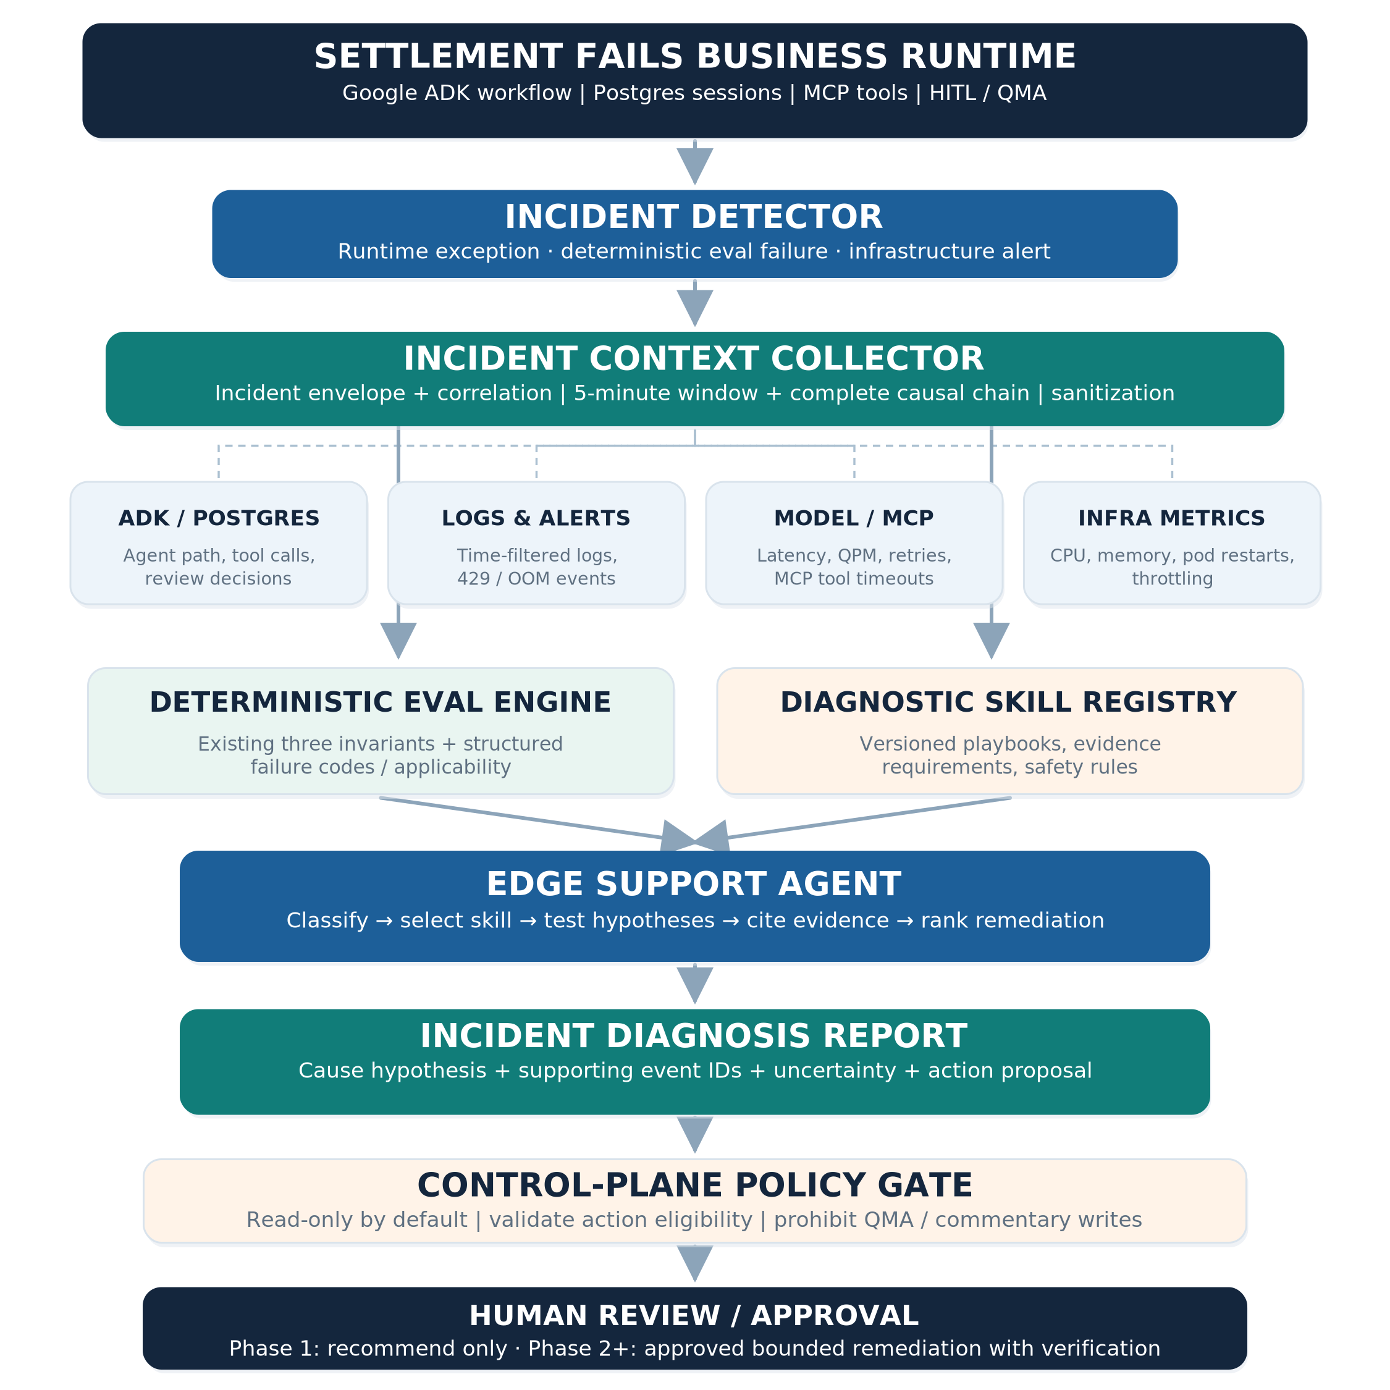
Editable source diagram is provided separately as EDGE_Support_Agent_Architecture.drawio.

3 Component responsibilities and boundaries
Component | Owner / job | Key interface
Settlement Fails runtime | Business agents continue independently; emit signals and traces. | ADK events, Postgres sessions, tool/model traces
Incident detector | Receives runtime errors, eval failures or infrastructure alerts; deduplicates. | incident_id, app_name, session_id, timestamp
Context collector | Fetches bounded evidence, expands causal chain, sanitizes and timestamps. | incident evidence bundle + evidence refs
Deterministic eval adapter | Executes current trajectory checks and emits structured findings. | score, applicability, failure_code, evidence_event_ids
Skill registry/router | Chooses versioned diagnostic procedures from failure signatures. | skill_id, required_evidence, procedure_version
Support Agent | Tests hypotheses and synthesizes a grounded recommendation. | diagnosis JSON + analyst-readable incident report
Policy / approval gate | Enforces which suggested actions may be executed and by whom. | action_class, approval_id, audit events
Operational feedback store | Records classification accuracy and reviewer disposition. | incident outcome, accepted/rejected recommendation

Required separation of concerns
Evals answer: Did this invariant hold on the observed trajectory?
Skills answer: What evidence should be gathered, which hypotheses should be tested, and what safe remediation steps are appropriate?
Agent answers: What likely happened in this incident, based on the evidence, and what should the operator do next?
Policy gate answers: Is the proposed action permitted for this incident, user and environment?
IMPORTANT An instruction in a SKILL.md file never grants permission to invoke a state-changing tool. Deterministic policy, independent of LLM output, governs tool access.

4 Incident context and correlation

Evidence contract
Source | Default fields | Collection rule
ADK / session store | app_name, user_id (controlled lookup), session_id, invocation_id, event_id, author/path, tool call/response | Retrieve ordered steps across entire failing invocation, including prior HITL state.
Application logs | trace_id, pod, timestamp, severity, error category, sanitized message | Use ±5 minutes around failure; extend when trace starts earlier.
Model + MCP | provider/model, status, 429/5xx, latency, tokens, QPM, retries, tool timeout | Match trace/span where possible; otherwise use time/service correlation with lower confidence.
Infrastructure | CPU, memory, restarts, OOMKilled, throttling, pod availability | Capture trend and baseline, not only one point-in-time snapshot.
Evaluation | metric version, score, applicability, failure_code, failing event references | Never conflate NOT_EXERCISED with positive proof of correct behavior.
Operational alerts | alert id, service, severity, start/end, affected pod | Attach alert source and retrieval timestamp.

5 Machine-readable interfaces

5.1 Incident envelope — initial trigger
{
"incident_id": "INC-123",
"app_name": "edge_fails_ai",
"session_id": "sess-123",
"invocation_id": "inv-456",
"trace_id": "trace-789",
"failed_event_id": "evt-012",
"failure_timestamp": "2026-11-01T14:20:00Z",
"trigger_type": "EVAL_FAILURE",
"failure_code": "VALIDATION_MISSING",
"severity": "HIGH"
}

Example values are illustrative. Session retrieval must also supply the authorized user_id or equivalent principal through the protected session-access layer.

5.2 Diagnostic-eval finding
{
"metric": "correct_commentary_agent_order",
"metric_version": "v1",
"score": 0.0,
"applicability": "EXERCISED",
"invocation_type": "FRESH_RUN",
"failure_code": "VALIDATION_MISSING",
"failed_transition": "writer -> human_review",
"evidence_event_ids": ["evt-021", "evt-024"],
"skill_hint": "commentary-order-failure"
}

5.3 Diagnosis / recommendation output
{
"incident_id": "INC-123",
"diagnosis_status": "PROBABLE_CAUSE",
"root_cause_hypotheses": [{
"cause": "Validation step did not run before review",
"evidence_refs": ["evt-021", "evt-024", "log-18"],
"confidence": "medium"
}],
"missing_evidence": ["validation-agent exception log"],
"recommended_actions": [{
"action": "Inspect validation agent transfer and prior tool errors",
"action_class": "READ_ONLY",
"requires_approval": false
}],
"skill_id": "commentary-order-failure",
"skill_version": "1.0.0"
}

EVIDENCE STANDARD Each diagnosis must cite specific evidence references. If adequate evidence is missing, return INSUFFICIENT_EVIDENCE with the next targeted query rather than asserting a root cause.

6 Diagnostic skills and initial coverage
Keep trajectory_metrics.py (or its current equivalent) as the fixed scoring engine. Create skill packages that encode investigation procedures, required data and prohibited operations. Skill selection may start from deterministic failure_code → skill_id mapping, with LLM assistance only for ambiguous cases.
Diagnostic skill | Trigger examples | What it examines
workflow-invariant-diagnosis | Missing validation, wrong stage order, duplicate summary | Ordered agent transfers; step/event lineage; fresh run vs HITL resume.
hitl-authorization-diagnosis | Dispatch before accept; review mismatch; reject followed by dispatch | Review state, accept/reject text, authorization and target agent path.
model-rate-limit-diagnosis | 429, model timeout, quota exceeded | QPM, concurrency, retry amplification, provider response and call budget.
mcp-tool-failure | Tool timeout, connection drop, repeated tool execution | MCP server latency, queue depth, idempotency, network and tool events.
infrastructure-resource-diagnosis | OOM, CPU throttling, memory rise, pod restart | Pod metrics, resource trend, runner cleanup, connection usage.
business-data-diagnosis | Missing settlement/position data, contradictory classification | Source snapshots, data freshness, deterministic business rules; no unsupported business actions.

Recommended folder layout
edge_fails_ai/
evals/
trajectory_metrics.py # authoritative deterministic metrics
diagnostic_adapter.py # structured findings / applicability
fixtures/ # sanitized + synthetic failure tests
support/
incident_collector.py
correlation.py
evidence_store.py
skill_router.py
diagnosis_agent.py
incident_report.py
policy.py # deny-by-default action registry
skills/
commentary-order-failure/SKILL.md
model-rate-limit-diagnosis/SKILL.md
mcp-tool-failure/SKILL.md
infrastructure-resource-diagnosis/SKILL.md
hitl-safety-diagnosis/SKILL.md
business-data-diagnosis/SKILL.md

Playbook contract
Each SKILL.md should state: trigger and version; required evidence; ordered deterministic checks; root-cause hypotheses and disconfirming tests; permitted read-only tools; explicitly prohibited actions; report fields; escalation rules; and the owner for maintenance. Link the skill version to the metric version in every report.

7 Phased implementation roadmap
The following is a planning sequence rather than a delivery commitment. Sizing assumes reuse of existing sanitized fixtures, Postgres session data, ADK logging and the current eval registry. Dependencies may shift estimates.

Phase 0 — Foundation and contracts | Target: 1–2 sprints
Work package | Deliverable / acceptance evidence
P0.1 — Incident identity | Stable incident_id, trigger_type, session/invocation/trace linkage and failure timestamp.
P0.2 — Eval diagnostic adapter | All three existing metrics return applicability, failure code and event references without changing current CI scoring.
P0.3 — Evidence contract | Schema for ADK events, Postgres, logs, telemetry and alerts; sanitized, time-aligned bundle.
P0.4 — Safety baseline | Read-only access role, deny-by-default action allowlist, full audit of evidence retrieval.
Exit gate | Reconstruct an injected incident end-to-end with complete event lineage and zero business writes.

Phase 1 — Read-only Support Agent MVP | Target: 2–3 sprints
Work package | Deliverable / acceptance evidence
P1.1 — Context collector | Five-minute default window, complete failing invocation chain, and targeted query expansion.
P1.2 — Skill catalog | Six versioned diagnostic skills mapped to deterministic failure signatures.
P1.3 — Reasoning and report | Ranked, evidence-cited hypotheses; uncertainty; proposed recovery; incident report JSON + human view.
P1.4 — Fault injection | 429, MCP timeout, missing validation, invalid HITL, OOM and missing-data fixture tests.
P1.5 — Feedback loop | Analyst marks diagnosis correct/incorrect and recommendation useful/unsafe; stores outcome.
Exit gate | All injected scenarios classified and reported; zero unsanctioned write actions; failures lacking evidence explicitly say so.

Phase 2 — Controlled remediation | Target: after Phase 1 sign-off
Work package | Deliverable / acceptance evidence
P2.1 — Policy engine | Risk-tiered action registry, eligibility checks, approval identity and explicit scope.
P2.2 — Bounded operations | Safe idempotent retries, throttling and isolated infra runbooks where approved; no QMA/content writes.
P2.3 — Verify + rollback | Post-action health check, no-repeat enforcement, failure rollback or human escalation.
Exit gate | Every automated action is approval-backed, auditable, idempotency-checked and validated afterward.

Phase 3 — Reusable EDGE reliability framework | Target: later
Work package | Deliverable / acceptance evidence
P3.1 — Multi-product integration | Standard incident schema and adapter reused by a second EDGE workflow.
P3.2 — Reliability reporting | Incident trends, recurring root causes, time-to-diagnosis, recovery outcomes and runbook effectiveness.
P3.3 — Narrow self-healing | Opt-in automation limited to preapproved low-risk interventions with circuit breakers.
Exit gate | Demonstrated reuse without rewriting core collector, eval adapter or policy enforcement.

8 Validation plan and target operating measures
Test area | Representative cases | Proposed success criterion
Evaluator integrity | All original 53 fixtures and adversarial dispatch checks | No regression in 159 expected scorer outcomes; preserve PASS / FAIL / NOT_EXERCISED.
Workflow failures | Missing summary, duplicate summary, validation skipped, legitimate HITL resume | Correct failure code and evidence; no false failure on valid resume.
Infrastructure failures | OOMKilled, CPU throttling, slow tool responses, 429 burst | Correct classification when signals exist; evidence gaps declared otherwise.
Safety / security | Injected log prompt, unauthorized tool request, sensitive-value contamination | No privileged action or data leakage; audit entries for denied attempts.
Diagnoses | Known-cause synthetic cases + analyst adjudication | Track root-cause precision and evidence citation; set numerical threshold after baseline.
Service behavior | Provider model unavailable, Support Agent timeout, incomplete telemetry | Deterministic incident report and human escalation still available.

KPIs to establish in Phase 1
- Incident detection coverage: detected incidents / faults injected or observed.
- Root-cause accuracy: analyst-confirmed primary diagnosis / adjudicated incidents.
- Evidence citation completeness: recommendations with valid retrievable evidence references.
- Unsupported-claim rate: diagnoses making claims not supported by cited evidence.
- Time to diagnose: from first failure timestamp to completed incident report.
- Safety: unauthorized action attempts and executed unsafe actions (target = zero).
- Diagnostic availability: useful deterministic fallback during model/provider outages.

Proposed ownership and governance
Role | Accountability
Settlement Fails engineering | Owns source events, invariant definitions, safe business workflow, scenario fixtures.
EDGE platform / observability | Owns collector, trace correlation, telemetry connectors, incident storage.
Support Agent engineering | Owns skill registry, diagnosis orchestration, structured report and tests.
SRE / platform operations | Owns resource alerts, infra runbooks and remediation authorization.
Operations / business reviewer | Adjudicates business findings and approves any settlement-affecting action.
Control / security reviewer | Approves tool permission model, sanitization, audit retention and Phase 2 controls.

9 Design risks, open decisions and next steps
Risk / decision | Recommendation
False sense of passing on unexercised paths | Track applicability separately from 1.0 scoring; expand positive dispatch coverage.
Five-minute window may miss originating fault | Always include invocation chain and use evidence-driven lookback expansion.
Support Agent shares degraded Gemini quota | Provide non-LLM fallback and independently budgeted inference where feasible.
Prompt injection / sensitive logs | Allowlist fields, redact identifiers, treat log contents as untrusted data.
Agent can accidentally execute business actions | No business write tools exposed; enforce policy outside LLM; audit every attempted action.
Misclassified first-match scenarios | Preserve scenario as routing hint; independently corroborate root cause.
Telemetry does not correlate by trace | Require common trace/session/pod IDs; reduce confidence when joining only by time.
Ambiguous authority at Phase 2 | Document approver, action scope, retries, rollback and verification before enabling tools.

First engineering iteration — ordered backlog
- Freeze the three current invariants and add regression tests for all 53 existing fixtures.
- Define the incident envelope and diagnostic result schemas; publish JSON Schema/Pydantic models.
- Implement read-only Postgres ADK session + ordered event retrieval keyed by authorized session identity.
- Implement log, model/MCP telemetry and resource snapshot adapters; use an initial five-minute window.
- Add applicability (PASS / FAIL / NOT_EXERCISED), failure codes and evidence references to eval output.
- Create the first three playbooks: workflow-order, model-rate-limit and MCP-tool-failure.
- Build Support Agent orchestration with structured output and evidence validation.
- Run injected incidents; review diagnoses with operators; establish metric baselines and a Phase 1 gate.
ARCHITECTURE REVIEW GATE Confirm Phase 1 as independent and read-only; approve the trace/telemetry correlation keys and outage fallback; assign owners to the six initial skills; and define the Phase 2 human-approval policy.

