VOYA

VOYA Activity SaaS
  - Architecture, API and Database Walkthrough
BRD-Aligned Marketplace Core
NestJS | React | PostgreSQL
This walkthrough connects role-specific VOYA experiences to the shared Marketplace Core, the NestJS business rules that make decisions authoritative, and the PostgreSQL records that preserve those decisions for audit and reconciliation.

Verified live environment
Surface | Verified URL
Application | https://demo.dhisoft.in/voya/
Swagger UI | https://demo.dhisoft.in/voya/api/docs
Health endpoint | https://demo.dhisoft.in/voya/api/health
Live API verification was performed against the deployed environment above. The walkthrough uses sanitized response excerpts; passwords, bearer tokens, refresh tokens and database connection details are excluded.

1 Opening
The walkthrough shows how the BRD becomes a connected transactional architecture. A Vendor supplies governed catalogue and operating data; an Agent consumes eligible offers through a controlled marketplace; Admin governs readiness, exceptions and commercial policy. The same Product, Variant, Rate Plan, Schedule, Inventory and Booking concepts are preserved as the request moves through React, NestJS and PostgreSQL.

Walkthrough narrative
Tenant -> Product -> ProductRevision -> Variant -> Rate Plan -> Commercial version -> Schedule / ServiceSession -> InventoryState -> Booking snapshots -> Events / outbox
The live evidence is anchored to the seeded Sunrise Trek to Top Station record and the existing confirmed booking VY-8DC3C3CC7D12. No new booking was created during this verification run; the booking is used as a read-only reconciliation anchor between deployed API evidence and PostgreSQL.

2 BRD Architecture
The BRD defines one shared Marketplace Core with role-specific experiences around it. Vendor, Agent and Admin consoles are views into the same governed domain records, not separate product masters or independent inventory systems.
Experience | Primary responsibility | Shared truth consumed
Vendor | Create and operate supply; manage catalogue, commercial inputs, schedules, inventory and fulfilment readiness. | Product, ProductRevision, ProductVariant, RatePlan, ScheduleTemplate, ServiceSession, InventoryState, Resource
Agent | Discover eligible offers and submit booking requests using permitted customer-facing commercial data. | Eligible RatePlan + session, agent projection, booking lifecycle and voucher projection
Admin | Govern vendor and agent readiness, review catalogue, manage commercial rules, inspect exceptions and financial outcomes. | Tenant, verification, rule/version, audit, event, cancellation, financial and settlement records

BRD source-of-truth principle
The BRD states that there must be one authoritative record for each Product, Variant, Rate Plan, Schedule, Inventory state and Booking. Portal-specific responses may be projections or caches, but they do not become competing masters. The repository follows this principle through shared service modules and Prisma-backed domain models.

3 Technical Architecture
React experience -> NestJS controllers and services -> Prisma -> PostgreSQL
React presents role-aware workflows and customer-safe projections. NestJS owns authorization, tenant scoping, commercial evaluation, eligibility, capacity calculation, final booking validation and event creation. Prisma provides the typed persistence boundary to PostgreSQL, where operational state, historical snapshots and asynchronous work records remain queryable.
Layer | Repository evidence | Architectural responsibility
React | activity-saas-frontend/src/pages and src/api.ts | Role-specific pages, forms, search and projections
NestJS | activity-saas-backend/src controllers and services | Business rules, permissions, transactions and response shaping
Prisma | prisma/schema.prisma and migrations | Typed domain access, relations, constraints and versioned schema
PostgreSQL | Configured demo database | Authoritative records, snapshots, events, outbox and reconciliation evidence

4 BRD to Implementation Alignment
The matrix distinguishes the concept described by the BRD, the repository implementation that carries it, and the live evidence that can be shown from the deployed environment.
BRD concept | What the BRD describes | Current implementation | Live evidence shown
Shared Marketplace Core | One domain model supports Vendor, Agent and Admin experiences. | Catalogue, eligibility, inventory, booking, fulfilment and finance modules share Prisma entities. | Live health, identity, products and inventory; newer marketplace routes are not in current deployed Swagger.
Tenant / RBAC | Tenant isolation and role-specific permissions. | JwtAuthGuard, RolesGuard, PermissionsGuard and tenant predicates. | GET /api/auth/me returns role and tenant context; Agent login also returns TRAVEL_AGENT.
Product | Governed experience master with a published revision. | Product + ProductRevision; currentRevisionId points to current content. | GET /api/products returns LIVE product and revision data.
Variant | Operational version of the experience. | ProductVariant stores duration, private/shared, pickup, meal and inclusions. | Database relationship query returns SUNRISE_SHARED_0515.
Rate Plan | Commercial and booking conditions for a Variant. | RatePlan plus channel, traveller and cancellation relationships. | Database query returns RP-DEMO-001; detail route was not used after unsuccessful live response.
Commercial Engine | Supplier cost, Voya revenue, agent outcome, tax and promotion are separate. | RatePlanCommercialVersion, CommercialRule and CommercialRuleVersion with calculator and rule trace. | Economics snapshot returns NET_RATE, vendor payable 2998, Voya revenue 0, tax NONE and final 2998.
Schedule | Operating model, timezone, slots, exceptions and effective dates. | ScheduleTemplate, ScheduleSlotTemplate, RatePlanSchedule and ServiceSession. | GET /api/variants/{variantId}/schedules returns active Sunrise schedules.
Inventory | Capacity is authoritative and bookability depends on current state. | InventoryState plus InventoryHold and InventoryAllocation. | GET /api/inventory returns 12 total, 0 blocked, 0 held, 2 confirmed and 10 available.
Resources | Vehicles, guides, boats, equipment or venues can constrain fulfilment. | Resource, ScheduleResourceRequirement and SessionResourceAllocation. | GET /api/resources returns active Demo Sunrise SUV resources.
Eligibility | Any failed gate makes an offer non-bookable. | Eligibility service checks tenant, publish state, plan dates, channel, session, inventory, resources and commercial readiness. | Repository implementation verified; marketplace route absent from current deployed Swagger.
Marketplace Search | Search resolves eligible sellable offers, not merely published products. | MarketplaceService groups eligible sessions into product, variant and offer projections. | Repository implementation verified; not claimed as a live result.
Booking Preview | Preview exposes current quote, policy and context to support acknowledgement. | Agent booking preview returns fingerprints, gates, capacity and commercial projection. | Repository implementation verified; route absent from current deployed Swagger.
Booking | Final create revalidates context and persists booking truth. | Booking service writes Booking, travellers, snapshots and allocation/hold in one transaction. | Existing confirmed booking reconciled read-only in PostgreSQL.
Idempotency | Retries must not create a second business booking. | Unique agentTenantId + idempotencyKey and request fingerprint comparison. | Code path verified; live retry not repeated because canonical Agent route is absent.
Booking Snapshot | Historical operational truth survives master-data changes. | BookingSnapshot freezes product, variant, session, capacity, policy and fulfilment context. | SQL returns snapshot for VY-8DC3C3CC7D12.
Booking Economics Snapshot | Historical financial truth is deterministic. | BookingEconomicsSnapshot stores version, supplier basis, vendor payable, Voya revenue, agent amount, tax, promotion and final amount. | SQL returns the verified economics row.
Hold / Allocation | Capacity is held for pending flows and allocated for confirmed flows. | InventoryHold and InventoryAllocation transition inside booking transactions. | SQL returns one CONFIRMED allocation of quantity 2 and no booking hold.
Fulfilment / Events | Voucher and notifications are separated from core transaction state. | BookingFulfilment, VoucherVersion, BookingEvent, AuditLog and OutboxEvent. | SQL returns VOUCHER_GENERATED plus two booking outbox rows.

5 Live Swagger Walkthrough
Open the live application at the verified base URL, then open the Swagger UI at the deployed route below. The deployed Swagger document is the route source of truth for this live walkthrough.
https://demo.dhisoft.in/voya/api/docs
Verified operation | What to point out | BRD concept
GET /api/health | status = ok; service = voya-api; current timestamp. | Service availability
POST /api/auth/login | HTTP 201 confirms configured demo identity can authenticate. Do not expose the returned token. | Tenant and identity
GET /api/auth/me | Role, organizationRole, tenantId and active flag establish context. | Tenant isolation and RBAC
GET /api/vendor/profile | Verification status, operating city, readiness score and masked payout account. | Vendor readiness
GET /api/products | Product code, LIVE status, product name, published revision and variant count. | Product and revision
GET /api/variants/{variantId}/schedules | Active schedules and operating model. | Schedule and session
GET /api/inventory | Session key, capacity components, available capacity and readiness flags. | Canonical inventory
GET /api/resources | Resource code, type, allocation mode, capacity and active state. | Resource readiness
GET /api/bookings | Deployed booking list route exists; do not use it as canonical Agent booking evidence. | Compatibility surface
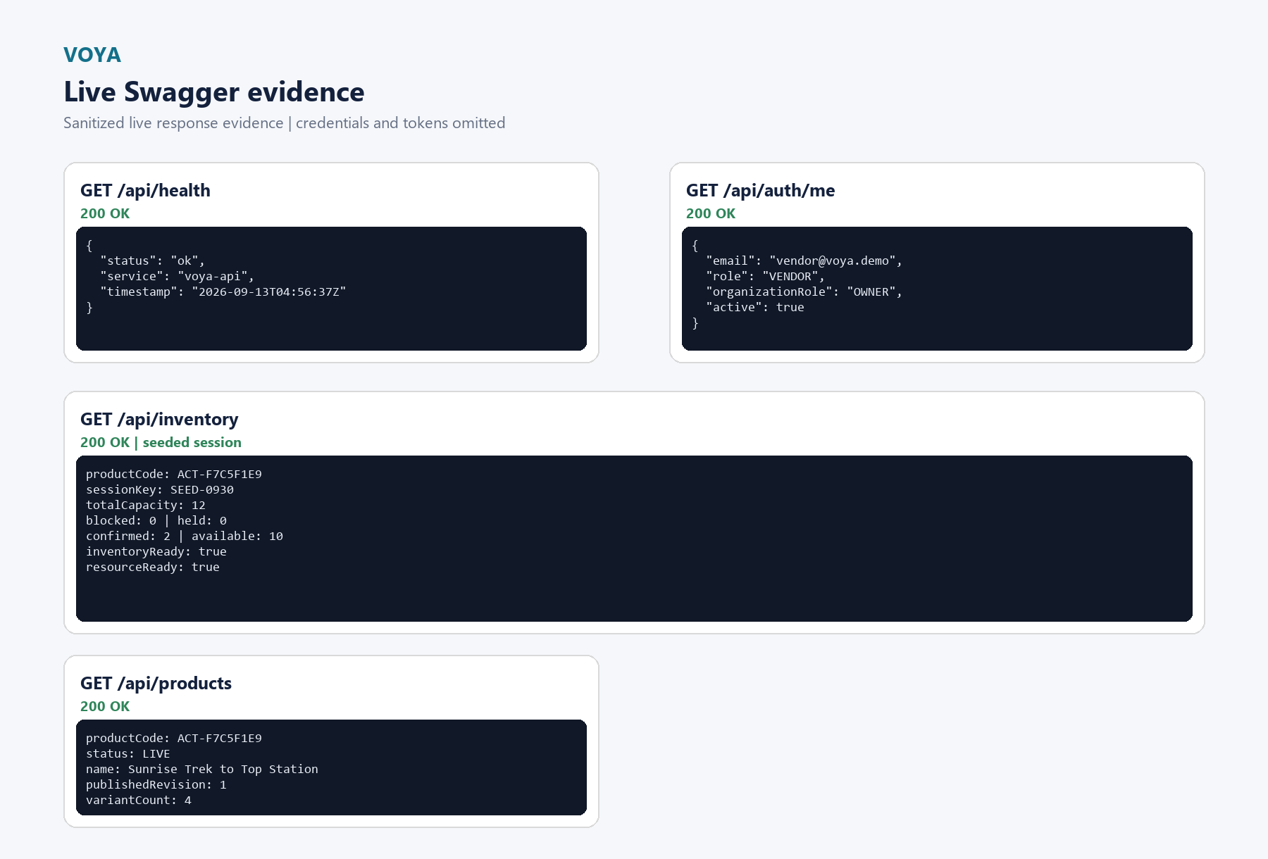
Figure 1. Sanitized excerpts from current live responses. The values shown are verified live response values; bearer tokens are excluded.
The current deployed Swagger document does not expose /api/marketplace/search or /api/agent/bookings. Those operations are implemented in the repository and are covered in the architecture sections below, but they are not presented as live results for this environment.

6 Product, Variant and Rate Plan
Product answers: what is the experience? It carries the governed experience identity and points to the current ProductRevision. Variant answers: which operational version is being sold? It carries differences such as duration, shared/private mode, pickup, meal and inclusion details. Rate Plan answers: under what commercial and booking conditions is it sold? It carries the commercial identity, effective window, channel mappings, traveller and cancellation relationships.
Object | Verified example | Why it matters
Product | ACT-F7C5F1E9 | Sunrise Trek to Top Station | Stable experience identity and published content boundary
ProductRevision | Version 1 | PUBLISHED | Historical content version; later edits can become a new draft
Variant | SUNRISE_SHARED_0515 | Shared Sunrise Trek with Breakfast | Operational version of the experience
Rate Plan | RP-DEMO-001 | Standard B2B | Commercial, channel and booking conditions

7 Commercial Engine
The implemented design keeps commercial inputs and outputs separate. A RatePlanCommercialVersion provides supplier model, pricing unit, supplier base amount, booking mode and effective dating. CommercialRule and CommercialRuleVersion provide rule-driven Voya revenue, agent commercial, tax, promotion, FOC and eligibility inputs. The calculator returns a traceable set of components rather than only one selling price.
GLOBAL -> VENDOR -> PRODUCT -> VARIANT -> RATE_PLAN -> AGENT_GROUP -> AGENT
Commercial rule resolution matches applicable scope, then selects the most specific scope and highest priority effective version for each rule kind. An exclusive tie at the same specificity and priority is ambiguous. Effective dates are checked against the service date, and selected version IDs are carried into the calculation trace and booking economics snapshot.
Stored component | Verified booking value | Purpose
Supplier model | NET_RATE | Defines supplier basis
Supplier gross basis / vendor payable | 2998 / 2998 INR | Supports reconciliation without reconstructing the quote
Voya revenue | MARKUP_FIXED / 0 | Separates platform revenue from supplier payable
Agent commercial | NET_PLUS_MARKUP / 2998 INR facing | Defines permitted agent-facing amount
Tax and promotion | NONE / 0 / 0 | Makes explicit that no tax or promotion was applied
Final amount | 2998 INR | Outcome of stored calculation components

8 Schedule, Inventory and Resources
ScheduleTemplate defines operating model, timezone and effective date window. ServiceSession materializes a date-and-slot instance. InventoryState is one authoritative capacity row for the session; holds and allocations explain reserved or consumed capacity. Resources add a second operational constraint: an offer can be non-bookable when required vehicles, guides, equipment or venues cannot fulfil it.
Available capacity = Total capacity - Blocked capacity - Held capacity - Confirmed capacity
For the verified session SEED-0930 on 15 September 2026, the live API and PostgreSQL agree on 12 total, 0 blocked, 0 held, 2 confirmed and 10 available. The session is OPEN, inventoryReady is true and resourceReady is true.
Entity | Live example | Evidence
ServiceSession | SEED-0930 | 15 Sep 2026 | 09:30-13:30 | Inventory API and SQL join
InventoryState | 12 total | 2 confirmed | 10 available | GET /api/inventory and tested SQL
InventoryAllocation | CONFIRMED | quantity 2 | Booking-linked allocation query
Resource | DEMO-SUV-01 | VEHICLE | EXCLUSIVE | capacity 6 | GET /api/resources

9 Eligibility and Marketplace
The repository implementation treats marketplace search as an eligibility decision, not a generic product listing. The service checks vendor verification, published revision, active variant and rate plan, effective dates, channel mapping, approved agent context, operating session, cutoff, commercial readiness, inventory and resource readiness. Only after those gates pass does it build a product -> variant -> offer projection for the Agent.
The Agent sees permitted commercial output such as currency, pricing unit, booking mode, final amount, tax/promotion projection and quote fingerprint. Supplier cost, Voya margin and internal control data remain behind explicit permissioned projections.
The current deployed Swagger route list was inspected live. Because /api/marketplace/search is not present in that deployed document, this walkthrough does not claim a live marketplace response. The repository code and database relationships remain the implementation evidence for this domain.

10 Booking Preview and Final Booking
The repository booking flow separates preview from final commit. Preview evaluates current eligibility, commercial quote, cancellation policy, traveller questions, capacity consumption and context fingerprints. Final create reloads the context inside a transaction, locks the inventory state, re-evaluates eligibility and commercial values, checks expected fingerprints and only then persists the booking, snapshot records and inventory outcome.
Stage | Implementation behavior | Historical result for verified booking
Preview | Projects current quote, policy, gates, capacity and fingerprints for acknowledgement. | Repository implementation; live route not deployed in current Swagger.
Final create | Revalidates plan, session, agent, channel, eligibility, quote, policy and context. | Existing booking is CONFIRMED / INSTANT with amount 2998 INR.
Persistence | Writes Booking, BookingTraveller, BookingSnapshot, BookingEconomicsSnapshot and allocation/hold. | PostgreSQL contains the booking, both snapshots and a confirmed allocation.
After commit | Emits BookingEvent, AuditLog and OutboxEvent; fulfilment can progress asynchronously. | BOOKING_CREATED, BOOKING_CONFIRMED and VOUCHER_GENERATED are present.
The confirmed booking used for reconciliation is VY-8DC3C3CC7D12. This document treats it as read-only evidence. It does not present a newly created booking or claim that the current deployed Swagger supports the newer Agent booking routes.

11 Idempotency and Concurrency
The repository uses a unique agent tenant plus idempotency key constraint and stores a request fingerprint. A retry with the same key returns the original booking when the request fingerprint matches; reusing the key for a different request is rejected. The create path locks the session inventory state with PostgreSQL SELECT ... FOR UPDATE, reloads booking context and validates current eligibility and commercial fingerprints before committing.
This protects the business outcome at the server and database boundary. The current live verification did not repeat a create request because the deployed Swagger does not expose the canonical Agent booking route; no concurrency test is claimed here.

12 PostgreSQL Database Design
Product -> ProductRevision -> ProductVariant -> RatePlan
Variant -> ScheduleTemplate -> ServiceSession -> InventoryState
Booking -> BookingSnapshot / BookingEconomicsSnapshot -> Hold or Allocation
The relationship model separates master data, operational availability and historical transaction truth. Foreign keys use restrictive deletes where booking history would otherwise be damaged. Version and effective-date columns make changes explicit instead of overwriting the context of a past transaction.
Domain | Primary tables | Key relationship
Catalogue | Product, ProductRevision, ProductVariant, RatePlan | Product has revisions and variants; Variant has rate plans
Commercial | RatePlanCommercialVersion, CommercialRule, CommercialRuleVersion | Rate plan version plus scoped rule versions
Operations | ScheduleTemplate, ServiceSession, InventoryState, Resource | Session owns inventory; resources can gate readiness
Booking truth | Booking, BookingTraveller, BookingSnapshot, BookingEconomicsSnapshot | Booking links to immutable operational and economics snapshots
Async and audit | BookingEvent, AuditLog, OutboxEvent | Committed work is recorded for audit and asynchronous consumers

13 SQL Evidence
The companion SQL file contains the exact read-only queries used for the database walkthrough. The queries were executed successfully against the configured demo database. They use the actual Prisma table and column names and reconcile through bookingCode VY-8DC3C3CC7D12.
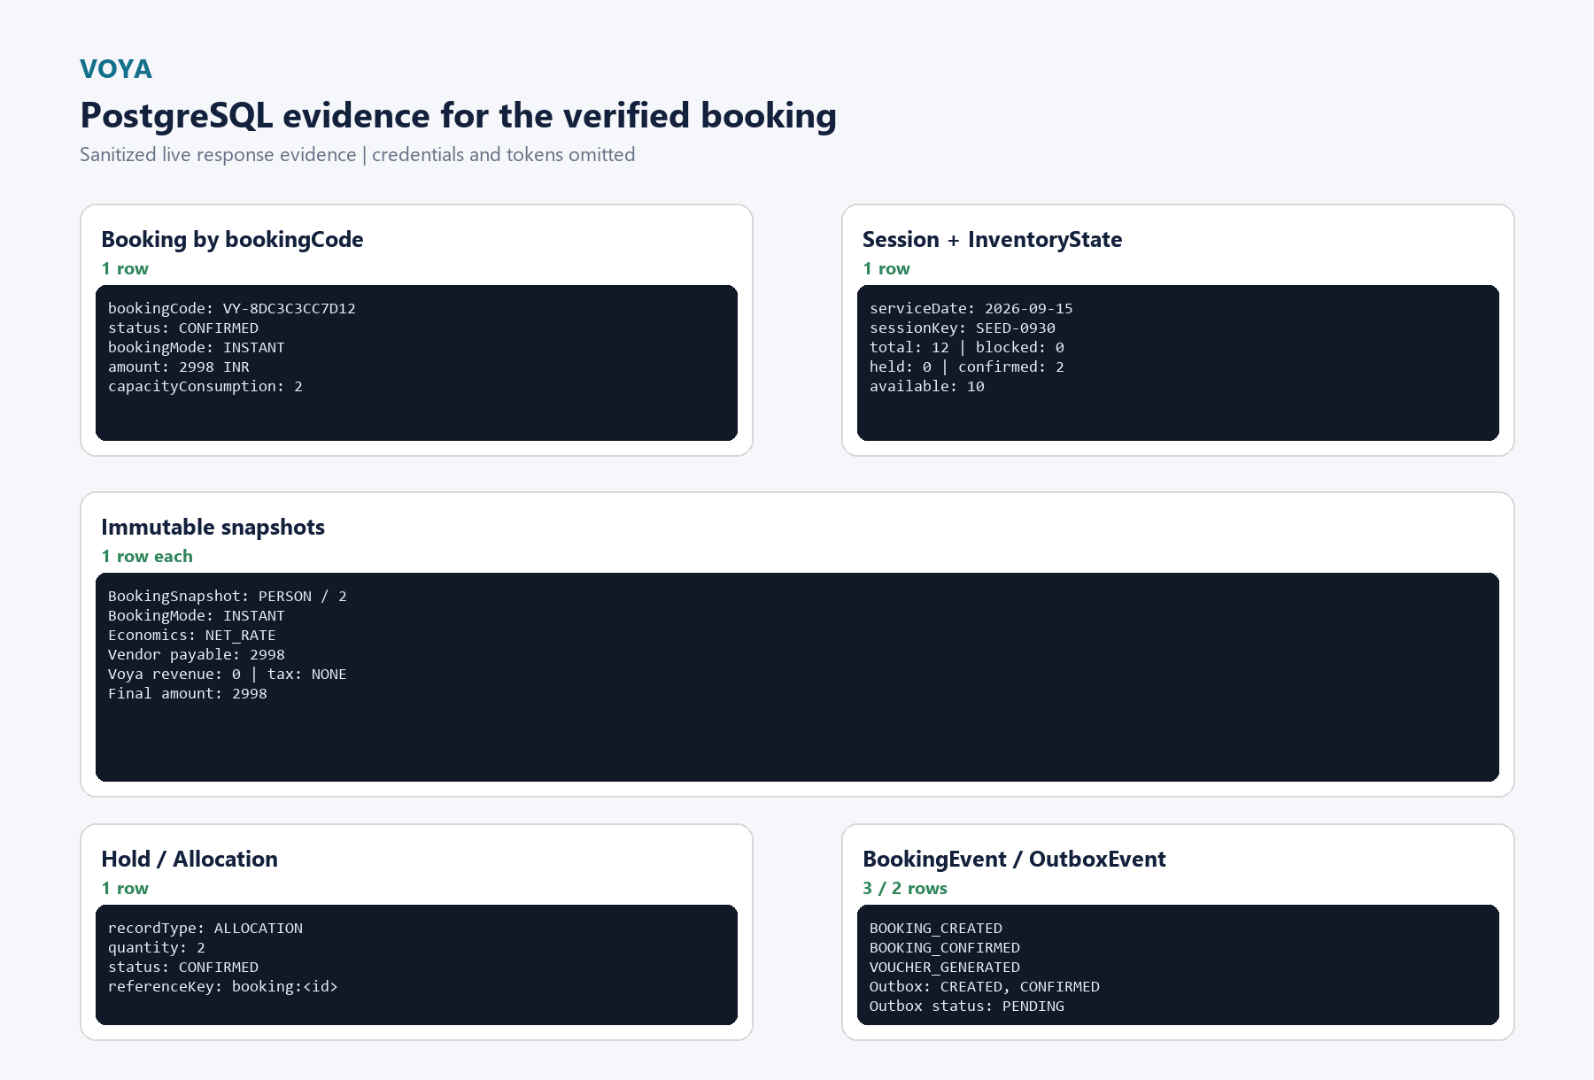
Figure 2. Sanitized PostgreSQL result excerpts for the verified booking. No credentials or connection strings are included.
Query | Purpose | Verified result
1 | Product -> Variant -> Rate Plan | Seeded product hierarchy including RP-DEMO-001 and active commercial version
2 | ServiceSession + InventoryState | 12 total, 0 blocked, 0 held, 2 confirmed, 10 available
3 | Booking by bookingCode | One CANONICAL CONFIRMED INSTANT booking, 2998 INR
4 | BookingSnapshot | PERSON capacity, consumption 2, policy fingerprint
5 | BookingEconomicsSnapshot | NET_RATE, vendor payable 2998, Voya revenue 0, final 2998
6 | InventoryHold / InventoryAllocation | One confirmed allocation of quantity 2
7 | BookingEvent | BOOKING_CREATED, BOOKING_CONFIRMED, VOUCHER_GENERATED
8 | OutboxEvent | BOOKING_CREATED and BOOKING_CONFIRMED, both PENDING
For the live walkthrough, open VOYA_Live_Demo_SQL.sql in a PostgreSQL-aware tool and run the statements in order. Read the booking, inventory and snapshots together as one reconciliation chain.

14 Booking Snapshot
Snapshot duplication is intentional. A booking preserves the product revision, variant and rate plan context selected at purchase time; the session date, timezone and capacity consumption used for the decision; the cancellation policy and acknowledgement; the traveller summary and answers; and the fulfilment policy relevant to redemption. Later master-data changes can improve future bookings without rewriting historical transaction truth.
Snapshot | What it freezes | Verified value
BookingSnapshot | Product, variant, rate plan, session, traveller, capacity, policy, agent and fulfilment context | Product revision ID, session ID, PERSON capacity, consumption 2, INSTANT mode, policy fingerprint
BookingEconomicsSnapshot | Commercial version and calculated financial components | NET_RATE, supplier basis 2998, vendor payable 2998, Voya revenue 0, tax NONE, final 2998

15 Related Architecture

Cancellation and refund separation
Cancellation is modeled as an operational decision with an initiator, reason, policy calculation and inventory release. Refund is a separate financial state transition. The separation allows booking status, cancellation responsibility and refund processing to be reconciled independently.

Fulfilment and voucher architecture
Fulfilment is represented separately from the booking core through BookingFulfilment, evidence, voucher versions and redemption records. Voucher generation is idempotent and can be retried without creating a second booking. The verified database contains a VOUCHER_GENERATED booking event; this walkthrough does not claim an external delivery workflow.

Events, outbox and settlement
BookingEvent and AuditLog preserve lifecycle and actor context. OutboxEvent records asynchronous work after the transaction commits, so notification or downstream processing does not need to be part of the booking transaction. FinancialEvent, Payout and settlement entities are separate from booking status and presentation reports; they provide architecture for additive reconciliation and future settlement operations.

16 Closing
The walkthrough demonstrates the BRD as a connected transactional architecture rather than a collection of screens or isolated APIs. The same domain concepts remain consistent from the role-specific experience, through NestJS business rules, into PostgreSQL, and back out as an auditable booking outcome.

Verified reference set
Reference | Value
Live application | https://demo.dhisoft.in/voya/
Live Swagger | https://demo.dhisoft.in/voya/api/docs
Live health | https://demo.dhisoft.in/voya/api/health
Read-only booking anchor | VY-8DC3C3CC7D12
Product anchor | ACT-F7C5F1E9 | Sunrise Trek to Top Station
Session anchor | 3329fc2e-4219-4e71-b002-75a11930450c | SEED-0930 | 15 September 2026
The current live booking flow was kept read-only for this document. The companion SQL file contains the tested evidence queries used to reconcile the existing booking across Booking, inventory, snapshots, events and outbox records.

