VOYA
Activity Marketplace Vendor Platform
Client-ready solution proposal
A practical operating platform for activity suppliers and marketplace administrators ' covering onboarding, catalogue management, rate plans, availability, bookings, vouchers and governance.
Prepared from the implemented NestJS, React and PostgreSQL application and the running Chrome screens.

1. Executive Summary
Voya is a multi-tenant activity marketplace platform. Vendors manage their own business profile, compliance documents, activity products, media, commercial rate plans, date-based inventory and bookings. Platform administrators manage vendor verification, document review, activity publication and marketplace readiness across all tenants.
The implemented product is designed around a real operating flow rather than a static catalogue: a vendor creates data, the API stores it in PostgreSQL, files are stored under public/uploads with database references, and the administrator reviews the same records through a protected admin workflow.
Business area | What the system provides
Vendor onboarding | Business profile, required documents, bank/payout details and readiness checklist.
Catalogue | Create/edit activities, location, logistics, media gallery, rate plans, traveller rules and cancellation rules.
Inventory | Select a rate plan, choose a date range and slot scope, apply capacity/price updates in bulk, and review read-only results.
Marketplace control | Admin vendor list, vendor detail, document preview, approve/suspend, verify/reject and activity review.
Operations | Booking filters, confirmation/cancellation actions, voucher PDF generation and payout visibility.

2. Roles and Logical Flow
The application has two protected operating roles. Vendor data is tenant-scoped; administrators receive controlled cross-tenant visibility for governance.
Vendor flow:
1. Register or sign in and receive a vendor tenant.
2. Complete business details and payout profile.
3. Upload compliance documents; files are saved and referenced by the API.
4. Create an activity, add media and create one or more rate plans.
5. Configure date/slot inventory and pricing rules.
6. Submit the vendor/listing for review and operate bookings after approval.
Administrator flow:
1. Sign in to the administrator console.
2. View all vendors and their onboarding states.
3. Open a vendor, preview uploaded documents and verify or reject each document.
4. Approve or suspend a vendor.
5. Open Activity Review and publish or reject listings.
6. Monitor the marketplace and trace the resulting operational records.

3. Vendor Onboarding
A fresh vendor starts with a five-step checklist: Business Details, Documents, Bank & Payout, Catalogue Setup and Go Live Review. Completion is represented by persisted vendor state, not only by a visual progress indicator.
- Business details: legal name, city, region, GSTIN and category.
- Documents: GSTIN certificate, PAN, cancelled cheque/bank proof and trade licence/activity permit.
- Bank and payout: masked account plus account holder, bank, branch, IFSC, SWIFT, account type and currency.
- Catalogue setup: at least one activity and rate plan, media and operational policies.
- Go-live review: vendor readiness is available to administrator review.
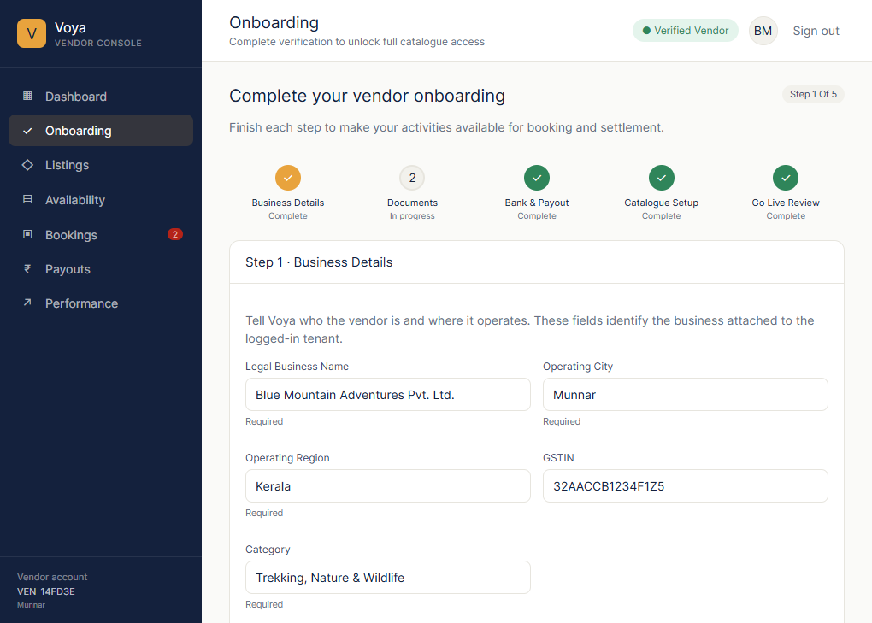
Figure 1. Vendor onboarding screen captured from the running Chrome application.

4. Listings and Activity Catalogue
Listings is the vendor's catalogue workspace. Each row represents a persisted activity and exposes its lifecycle status, location/category context and commercial headline. The vendor can search, filter by All/Live/Under Review/Draft, create a new listing or open Add/Edit Activity.
The editor follows the prototype's seven logical areas: Basic Info; Category & Location; Media; Logistics & Inclusions; Rate Plan & Travellers; Policies & Cancellation; and Availability & Promo. Saving the activity persists the business fields to the API and PostgreSQL.
- Media supports a cover image and multiple gallery images. Uploaded images are previewed in the editor, stored in the backend public/uploads folder and referenced by URL in the database.
- An activity can contain multiple rate plans with validity, currency, unit type, base price, pax limits and traveller pricing.
- Cancellation rules are stored against the selected rate plan and remain separate from slot inventory.
- Availability and promotion management is opened separately so catalogue content and operational inventory are not mixed.
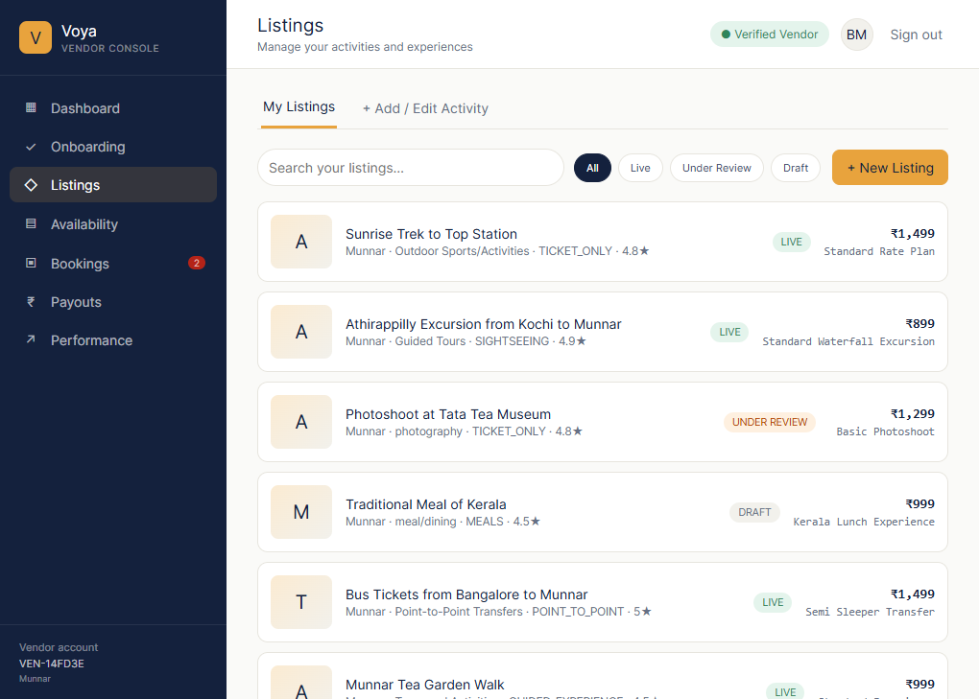
Figure 2. Listings workspace captured from the running Chrome application, showing persisted activities, filters and the Add/Edit entry point.

5. Availability and Pricing
Availability is managed for a selected activity rate plan. The screen presents the plan selector and promotion summary, followed by the Rate Availability editor and a read-only inventory grid.
The update interaction is intentionally simple: select the date range, select All Slots or one slot, enter Free/Available, Total and Price in the compact control row, then click Update. The values are applied to the selected slot scope across the selected range. The API writes the rows to PostgreSQL and the UI reloads the read-only grid from the saved records.
- Date range: From Date and To Date determine the horizontally displayed dates.
- Slot scope: All Slots applies one value set to every configured slot; an individual slot applies only to that time.
- Slot management: Add Slot opens a time picker; after Add, the new time is inserted into the dropdown and selected. Delete removes a configured slot.
- Read-only grid: date/slot cells show available/total and price; colors communicate healthy, low or unavailable inventory without exposing editable cell controls.
- Pricing rules: Standing Pricing Rules are editable database records with Add, Edit, Delete and Active/Inactive actions.
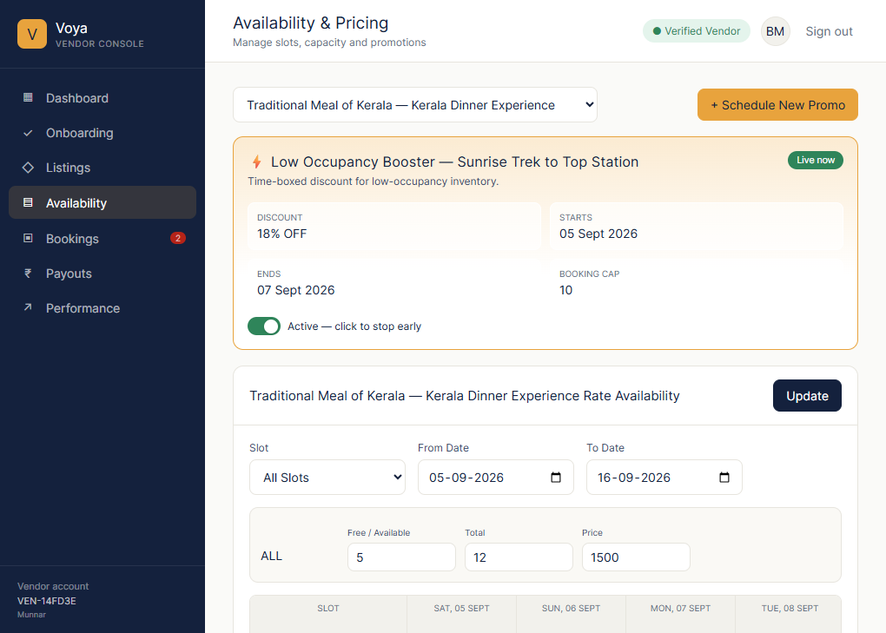
Figure 3. Availability & Pricing screen captured from the running Chrome application, showing rate-plan selection, date-range controls, bulk slot values and the read-only inventory grid.

6. Booking and Voucher Operations
Bookings are isolated to the vendor tenant and can be filtered by All, Needs Action, Confirmed and Cancelled. A vendor confirms or cancels a pending booking. For eligible confirmed bookings, Voucher opens the generated PDF returned by the API.
- Booking records include activity, rate plan, service date, pax, amount, customer and status.
- Voucher PDFs are generated by the backend, saved under public/uploads and opened using the returned URL.
- Availability and booking validation prevent overbooking and protect vendor ownership boundaries.
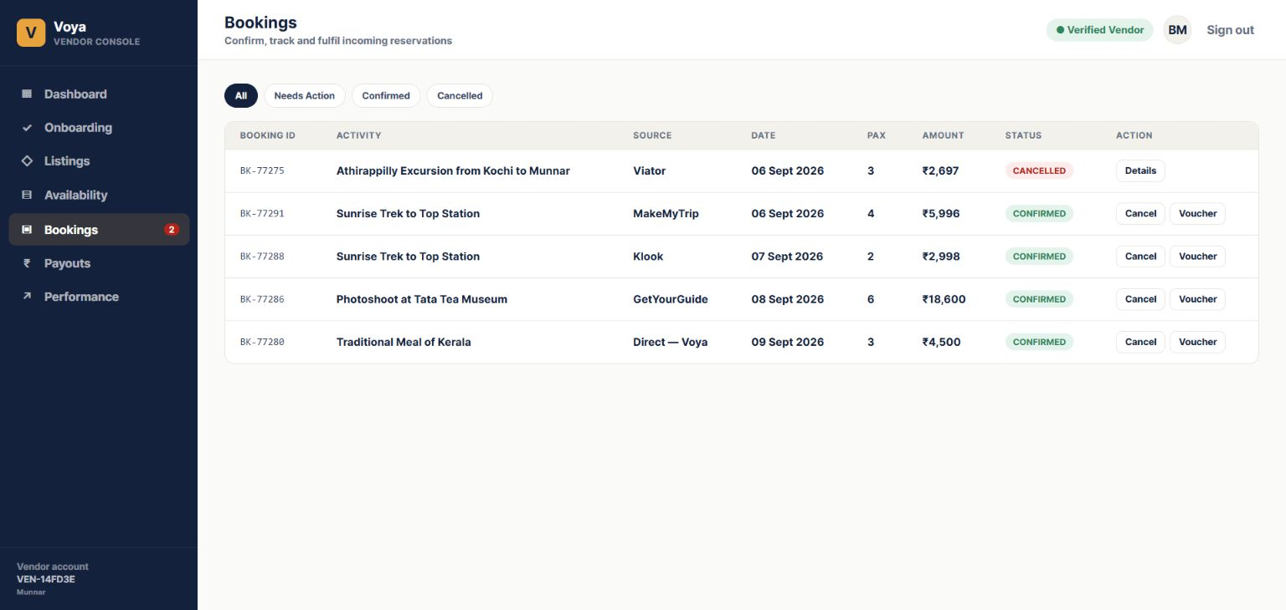
Figure 4. Vendor booking screen captured from the running Chrome application, including confirmation, cancellation and voucher actions.

7. Administrator Governance
The administrator console is a separate role-protected experience. It can see all vendor tenants while vendors can see only their own records.
- Dashboard: vendor counts, pending vendors, activities, bookings and review workload.
- Vendors: searchable tenant list with verification state and vendor detail view.
- Documents: uploaded filename, status, preview for images/PDFs, Verify and Reject actions.
- Vendor actions: approve, suspend and inspect business/profile/listing data.
- Activity Review: publish or reject vendor activities after catalogue review.
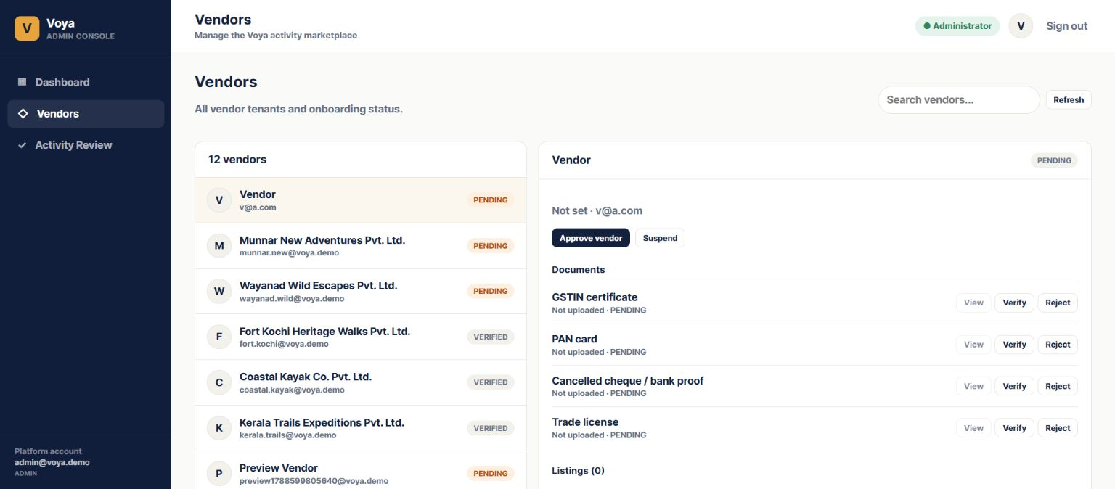
Figure 5. Administrator vendor detail and document review screen captured from the running Chrome application.

8. Technical and Data Flow
React provides the vendor and administrator interfaces. NestJS exposes authenticated, role-aware APIs. Prisma maps the PostgreSQL schema. Files are written to public/uploads and their paths/URLs are stored with the corresponding document or media record.
Layer | Responsibility
React frontend | Screens, forms, validation feedback, previews, filters and read-only inventory rendering.
NestJS API | Authentication, tenant scoping, workflow transitions, uploads, bulk availability updates and pricing-rule CRUD.
PostgreSQL | Vendor tenants, profiles, documents, activities, media, rate plans, traveller rules, cancellation rules, availability, promotions, bookings and pricing rules.
File storage | Uploaded documents, images and voucher PDFs under public/uploads, with references returned by API.
Core relationship: Vendor ' Activities ' Rate Plans ' Availability Slots / Promotions / Traveller Rules / Cancellation Rules. Vendor ' Documents / Payout Profile / Bookings. Administrator actions update the same persisted records with role checks.

9. Current Implementation Position
Capability | Status
Vendor and administrator authentication | Implemented and role-protected.
Vendor onboarding and document upload | Implemented with backend file references and admin review.
Listings, media preview and multi-image gallery | Implemented for the current catalogue workflow.
Rate plans and traveller pricing | Implemented with multiple plans per activity.
Availability date-range bulk update | Implemented; updates are persisted and reloaded from PostgreSQL.
Slot add/delete and slot dropdown selection | Implemented.
Editable standing pricing rules | Implemented with database-backed Add/Edit/Delete/Active actions.
Bookings and voucher PDF | Implemented for the vendor operating flow.
Workbook-complete Activity Product Master coverage | Remaining extension area for every detailed field and production rule.

10. Demonstration Script for the Client
1. Log in as a vendor and open Listings.
2. Open an activity and show its seven editor sections, cover image and gallery previews.
3. Open Availability & Pricing, select a rate plan and date range, leave All Slots selected, enter Free/Available, Total and Price, and click Update.
4. Show that the read-only grid refreshes with the saved values. Select Add Slot, add a new time and show it selected in the dropdown; then demonstrate Delete.
5. Add or edit a Standing Pricing Rule and refresh to show that it is persisted.
6. Switch to Admin, open the vendor, preview an uploaded document, verify/reject it, approve/suspend the vendor and publish/reject the activity.
7. Return to Bookings, confirm a reservation and open its voucher PDF.

11. Recommended Next Phase
- Expose every remaining Activity Product Master field in the editor and map dictionary values to validated controls.
- Add comprehensive audit logs and production-grade file validation, malware scanning, retention and object storage.
- Add automated API/browser regression tests for onboarding, uploads, admin review, slot updates, pricing rules, bookings and vouchers.
- Confirm production marketplace, payment, channel-manager and settlement integrations as separate scope.
Prepared for client demonstration and review.

Screen-by-Screen Field Reference
The following reference explains every visible form field and action used in the implemented pages. It is intended for client demonstration, training and acceptance review.

Vendor Onboarding
Field / action | What it means | Where it goes
Legal Business Name | Registered company name. | Vendor profile; shown to Admin.
Operating City | Main city where the supplier operates. | Vendor profile and listing defaults.
Operating Region | State or operating region. | Vendor profile/reporting.
GSTIN | Tax registration identifier. | Vendor profile and document review.
Category | Supplier?s primary business category. | Vendor classification.
Upload / Replace document | Uploads GSTIN, PAN, bank proof or licence. | File in public/uploads; filename, URL, status and timestamp in DB.
Payout Account | Masked account display; never a raw secret. | Vendor payout profile.
Account Holder / Bank / Branch | Settlement ownership and bank routing information. | Payout profile.
IFSC / SWIFT | Domestic and international bank routing codes. | Payout profile.
Account Type / Currency | Settlement account type and currency. | Payout profile.
Save / Continue | Validates and persists current step. | Onboarding readiness state.

Listings / Activity Editor
Section / field | What it means | System result
Search / status filters | Find records and filter All, Live, Under Review or Draft. | Filters persisted activities.
Product Name | Customer-facing activity title. | Activity master.
Activity Type / Sub-type / Sub-category | Classifies the product. | Catalogue classification.
Star Rating | Internal/display quality rating. | Activity master.
Short / Full Description | Summary and detailed customer copy. | Activity content.
Activity Highlights | Key selling points, one per line. | Normalized highlight values.
City / State / Country | Activity operating location. | Search/location context.
Address / Meeting Point | Customer meeting or pickup point. | Operational instructions.
Latitude / Longitude | Map coordinates. | Location/map context.
Cover Image | Primary listing image. | Upload plus ranked media record.
Gallery / Manage | Multiple supporting images and ordering. | Files plus media references; previews shown.
Media Type / URL / SEO Description | Optional video or hosted media and search copy. | Media metadata.
Things to Carry / Important Information | Customer preparation and safety notes. | Operational content.
Rate plan fields | Name/code, validity, currency, unit, price, pax and traveller rules. | RatePlan and traveller records.
Terms / Cancellation slabs | Commercial cancellation conditions. | Rules linked to rate plan.
Save Draft / Publish | Stores content and lifecycle state. | Admin review/publication queue.

Availability & Pricing
Field / action | What it means | System result
Rate plan selector | Chooses the activity plan whose inventory is edited. | All writes link to selected plan.
Promotion summary | Discount, dates, booking cap and active state. | Promotion record.
Slot selector | All Slots or one time slot. | Controls update scope.
From Date / To Date | Inclusive date range shown horizontally. | Controls range written by Update.
Free / Available | Bookable quantity. | Bulk-applied; cannot exceed Total.
Total | Maximum capacity. | Bulk-applied across selected scope.
Price | Price override. | Bulk-applied and stored per date/slot.
Update | Commits the compact input row. | API bulk upsert to PostgreSQL; grid reloads.
Read-only grid | Displays date, slot, available/total, price and status color. | No direct cell editing.
Add Slot | Time picker to add a new slot. | Saved, added to dropdown and selected.
Delete | Removes a slot. | Deletes and refreshes grid.
Standing Pricing Rules | Editable name, scope, adjustment, validity and active state. | Add/Edit/Delete/Active are persisted.

Bookings and Voucher
Field / action | What it means | System result
Booking ID | Reservation identifier. | Booking/voucher lookup.
Activity / Source | Booked product and sales channel. | Tenant/reporting context.
Date / Pax / Amount | Service date, travellers and money value. | Capacity and financial record.
Status filters | All, Needs Action, Confirmed, Cancelled. | Operational queue.
Confirm / Cancel | Vendor decision on reservation. | Status transition through API.
Voucher | Customer fulfilment document. | PDF saved in public/uploads and opened from returned URL.

Administrator Review
Field / action | What it means | System result
Vendor search/list | Find all tenant accounts and status. | Loads vendor detail.
Business/profile | Review identity, location, payout and catalogue. | Approval evidence.
Approve / Suspend vendor | Enable or pause participation. | Persists vendor state.
Document filename/status | See uploaded state and review state. | Reads DB metadata.
View / Preview | Open actual uploaded image or PDF. | Uses API file URL.
Verify / Reject | Accept or return a document. | Persists review decision/time.
Listings / Activity Review | Inspect and publish or reject activities. | Changes listing lifecycle state.

Persistence Rule for All Screens
Every editable field follows the same path: user input ? authenticated NestJS endpoint ? validation and tenant/role check ? PostgreSQL record or public/uploads file ? API response ? refreshed screen. Read-only grids and status labels are rendered from returned API data, so refresh verifies persistence.

Current Add / Edit Activity Screen
The Add / Edit Activity page is the working form for a vendor?s product catalogue. The left navigation is the form map; selecting a section takes the vendor to the corresponding saved field group.
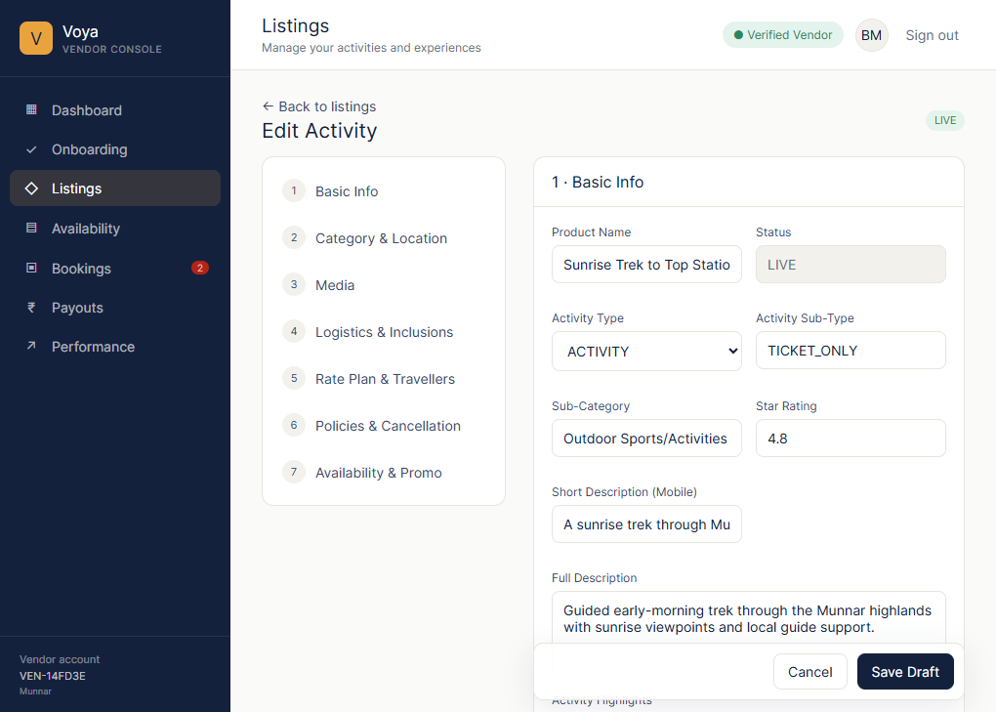
Figure 6. Current Add / Edit Activity screen captured from Chrome, showing the seven-section editor and Basic Info fields.

Add / Edit Activity fields
- Product Name: customer-facing activity title.
- Status: read-only lifecycle state such as LIVE, DRAFT or UNDER REVIEW.
- Activity Type: business classification such as activity, meal, transfer or package add-on.
- Activity Sub-Type and Sub-Category: operational and catalogue classification.
- Star Rating: product quality/display rating.
- Short Description (Mobile): concise copy for compact cards and mobile display.
- Full Description: detailed customer-facing product description.
- Activity Highlights: selling points entered one per line.
- Section navigation: Basic Info, Category & Location, Media, Logistics & Inclusions, Rate Plan & Travellers, Policies & Cancellation and Availability & Promo.
- Save Draft: persists the current activity fields and keeps the activity in the vendor workflow for later editing.

