VOYA

Activity Marketplace Vendor Platform
Updated Solution Proposal
A client-facing operating platform for activity suppliers and marketplace governance
Proposal item | Current proposal
Customer / Product Owner | Voya activity marketplace operations
Proposed product | Voya Vendor Platform
Implemented foundation | React vendor console, NestJS API and PostgreSQL persistence
Operating model | Multi-tenant vendor marketplace with administrator review

Prepared from the current source code, PostgreSQL schema and running Chrome screens.

1. Executive Summary
Voya is being developed as a multi-tenant activity marketplace platform connecting activity vendors with a central administrative operation. The current implementation provides a working vendor console, administrator console, PostgreSQL-backed data model and NestJS APIs for onboarding, product catalogue, rate plans, availability, promotions, bookings, vouchers and payouts.
The intended lifecycle is complete and operational: a new vendor registers, completes onboarding, uploads verification documents, adds payout information, creates activities and rate plans, configures media and inventory, submits listings for review, and receives bookings after approval. Administrators can view all vendor tenants, review documents, approve or suspend vendors, and publish or reject activities.
- Reduce manual coordination between vendors and platform operations.
- Keep vendor data isolated by tenant while allowing administrators controlled cross-tenant visibility.
- Persist business fields, uploaded files, media references, inventory, booking status and workflow state.
- Complete the remaining Activity Product Master fields in the Add/Edit experiences.

1.1 What the client can demonstrate
A client demonstration can follow one continuous story: create or sign in as a vendor, complete the onboarding checklist, add a bookable activity, attach a rate plan and media, open inventory, then switch to the administrator role to review the vendor and publish the activity. The vendor can then manage the resulting booking and open its voucher. This is the core business loop represented by the current application.
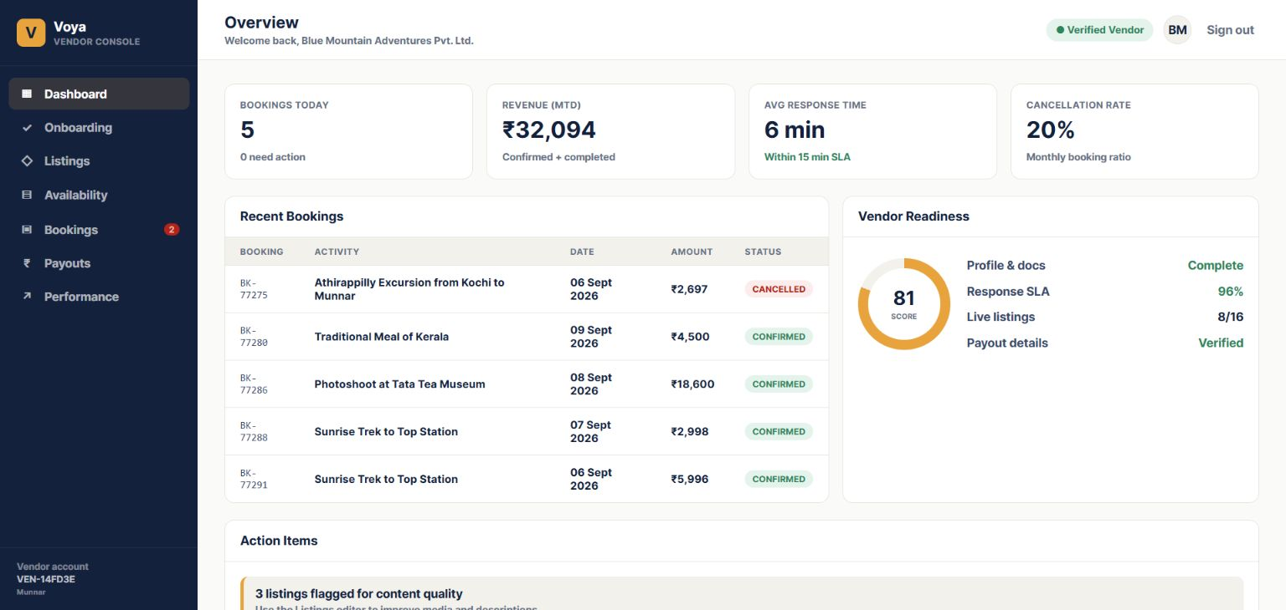
Figure 1. Fresh vendor dashboard captured from the running Chrome application on 06 September 2026.

2. Current Business Need
Activity suppliers need a dependable workspace to maintain business identity, compliance documents, activity products, commercial rate plans, media, inventory and booking operations. Platform administrators need a separate control surface to verify vendor readiness and control which activities become live.

2.1 Vendor-side operational requirements
- Capture business details, documents and payout details in one onboarding flow.
- Maintain product content including logistics, traveller rules, media, cancellation rules and redemption information.
- Maintain availability at slot and date level with capacity, remaining inventory, price overrides and closures.
- Manage booking confirmation, cancellation and voucher generation.

2.2 Platform-side control requirements
- View all vendor tenants and onboarding status.
- Inspect uploaded documents before verification or rejection.
- Persist vendor approval, suspension, document review and activity publication actions.
- Prevent vendor users from accessing another tenant’s data.

3. Proposed Voya Solution
The solution is a modular web application with two role-oriented experiences. Vendors manage their own operating data. Administrators manage marketplace readiness and catalogue governance. Both experiences use the same authenticated API and PostgreSQL data model.
Area | Implemented responsibility
Vendor console | Onboarding, listings, rate plans, media, availability, promotions, bookings, vouchers, payouts and performance.
Admin console | Dashboard, vendor list, vendor detail, document preview, document review, vendor approval/suspension and activity review.
API layer | NestJS modules for authentication, vendor profile, activities, rate plans, availability, bookings, payouts, dashboard and admin operations.
Persistence | PostgreSQL via Prisma with tenant relationships, status fields and uploaded-file references.
File storage | Documents, activity media and voucher PDFs are stored under backend public/uploads and served through API URLs.

4. Vendor Onboarding Workflow
Onboarding is the entry point for a fresh vendor. Registration creates a vendor tenant and user account. The vendor then completes a five-step readiness journey before the account is ready for platform review.
- Register or sign in as a vendor; the account is associated with a vendor tenant and profile.
- Complete Business Details: legal business name, operating city and region, GSTIN and category.
- Upload GSTIN certificate, PAN card, cancelled cheque or bank proof, and trade licence or activity permit.
- Complete Bank and Payout details, including masked account, holder, bank, branch, IFSC, SWIFT, account type and currency.
- Create at least one activity and one rate plan, then configure catalogue readiness.
- Review readiness and submit the vendor’s activity or onboarding state for administrator action.
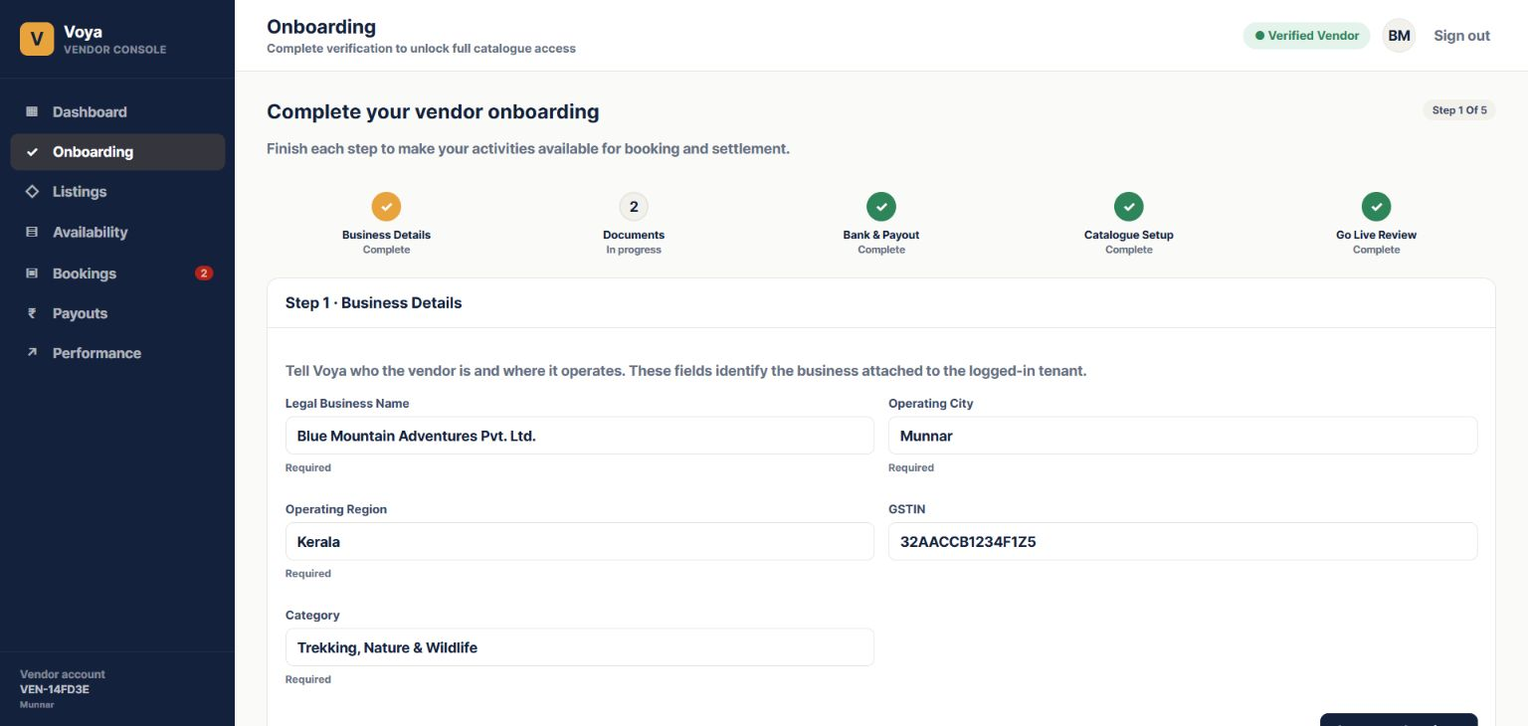
Figure 2. Fresh vendor onboarding screen captured from the running Chrome application on 06 September 2026.

5. Product Catalogue and Activity Management
Activities are the vendor’s bookable products. The Listings workspace is the vendor’s catalogue home: it shows each activity, its lifecycle state, location, category and headline rate, and provides the entry point to Add or Edit Activity. The Activity Editor follows the prototype’s seven-part structure and saves core product content to PostgreSQL. A new activity is first saved as a draft, after which rate plans and media can be attached.
Catalogue section | Current behavior
Basic information | Product name, type, subtype, descriptions, category, rating, highlights, terms and supporting information.
Category and location | City, state, country, address, latitude and longitude.
Media | Cover image, multi-image gallery, image preview, video URL, description and persisted media URL.
Logistics and inclusions | Things to carry and important information; operational logistics are primarily rate-plan specific.
Rate plan and travellers | Price, validity, pax, traveller prices, pickup, vehicle, timing, voucher, confirmation and rules.
Policies and availability | Terms, structured cancellation rules, inventory slots and promotions.

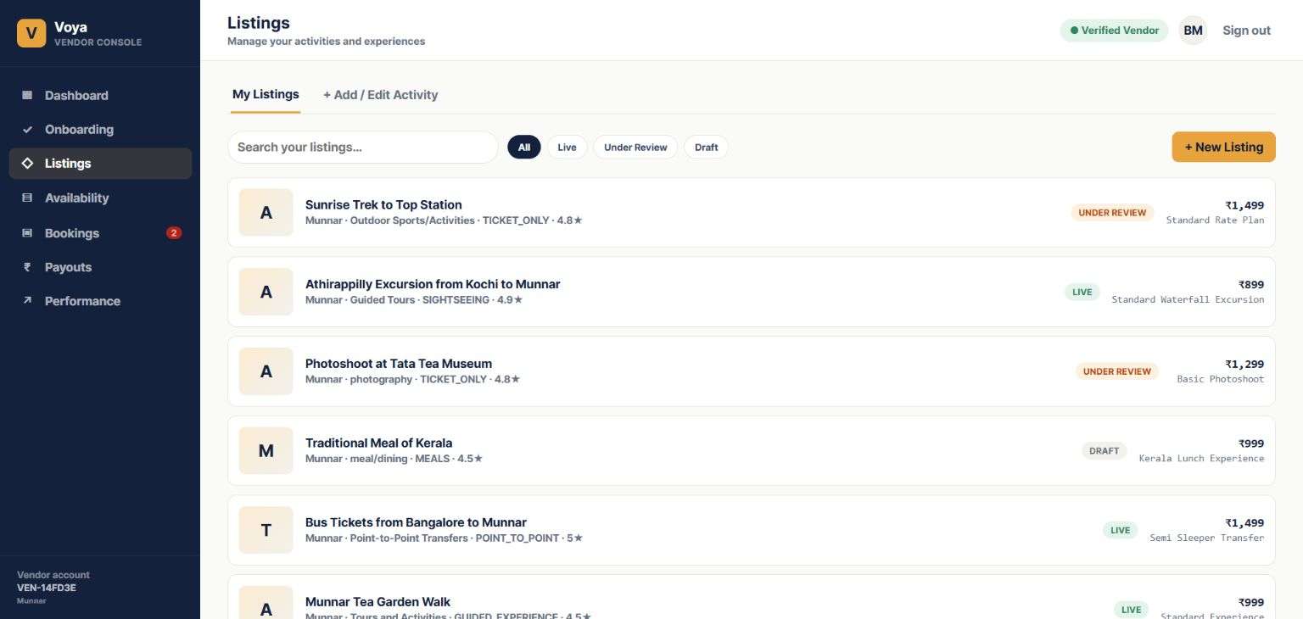
Figure 3. Fresh vendor Listings workspace captured from the running Chrome application on 06 September 2026. The Add or Edit Activity entry point is available in the same screen.

6. Rate Plan and Traveller Rules
A rate plan is the commercial and operational version of an activity. One activity can have multiple rate plans with different prices, validity periods, traveller pricing, pickup rules, cancellation charges and confirmation behavior.
- Rate-plan code, name, status, currency, unit type and base price.
- Validity dates, minimum and maximum pax, valid weekdays and blackout dates.
- Duration, meal, pickup, drop-off, vehicle, ticket, entry-fee, voucher, confirmation and auto-redeem settings.
- Traveller rules with age range, counts, display name, description and price.
- Cancellation rules stored as structured date ranges with percentage or absolute charges.
The current foundation persists the major rate-plan structures. Full completion against the Activity Product Master requires exposing every detailed field in the Add/Edit screens, including Youth, Infant and Group traveller configurations, flexible cancellation slabs, sightseeing and affiliate fields, meeting-point details, vendor codes and other operational metadata.

7. Availability and Promotion Management
Availability is maintained against a selected rate plan. Vendors can work with a date and slot grid, update capacity and available inventory, apply a price override, close a slot and save changes in bulk. The API validates ownership and prevents available inventory from exceeding capacity.
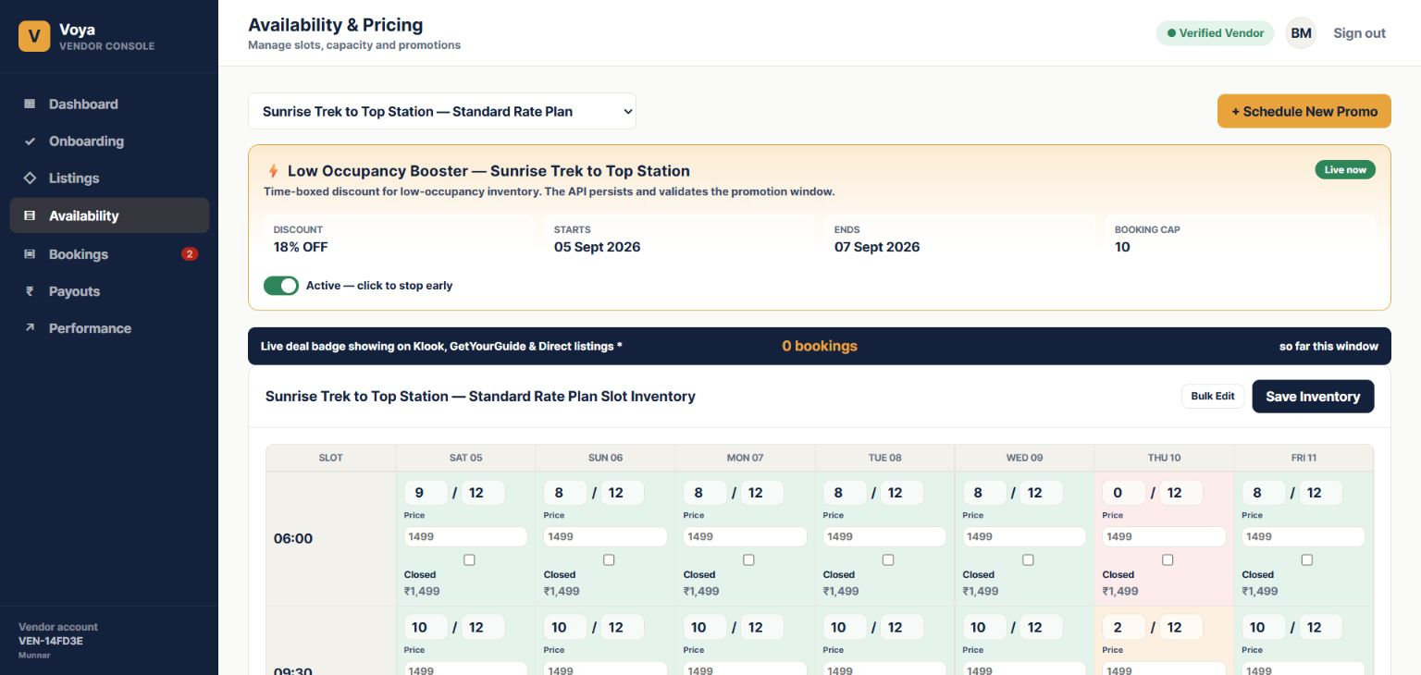
Figure 4. Fresh availability and pricing screen captured from the running Chrome application on 06 September 2026.
- Rate-plan selection determines which inventory is being edited.
- Each slot stores date, start time, capacity, available quantity, optional price override and closed state.
- Version fields protect updates from overwriting a newer change.
- Promotions store name, discount percentage, start/end window, booking cap and active state.

8. Booking and Voucher Workflow
Bookings are tenant-scoped and displayed to the vendor with filters for all, needs action, confirmed and cancelled states. A pending booking can be confirmed or cancelled. Confirmed and completed bookings can generate a voucher PDF.
- A booking is created for an activity and optional rate plan with service date, pax, amount and customer details.
- The vendor reviews the booking and confirms or cancels it through the API.
- For eligible bookings, the vendor selects Voucher.
- The backend generates a PDF, stores it in public/uploads and returns the file URL.
- The frontend opens the returned PDF in an in-app preview frame.
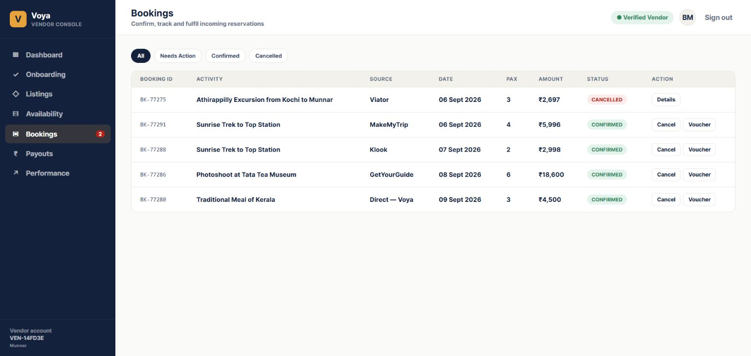
Figure 5. Fresh booking list and voucher action captured from the running Chrome application on 06 September 2026.

9. Administrator Workflow
The administrator console is a separate role-protected experience for marketplace governance. It provides cross-tenant visibility that vendor users do not receive.

9.1 Administrator dashboard
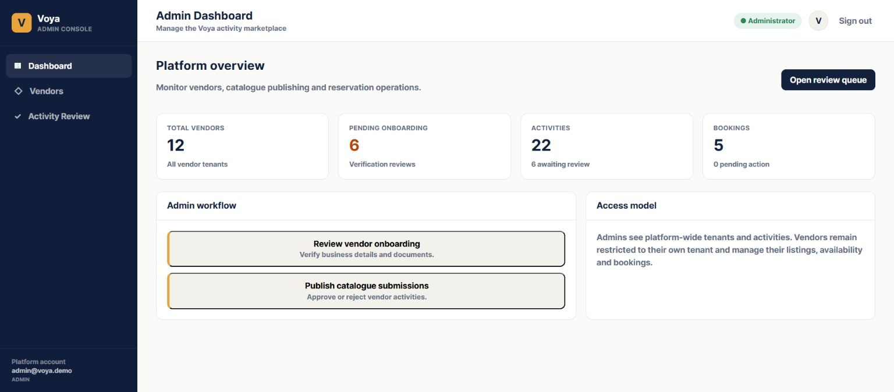
Figure 6. Fresh administrator dashboard captured from the running Chrome application on 06 September 2026.
- Summarises vendors, pending vendors, activities, review activities, bookings and pending bookings.
- Provides the starting point for operational review.

9.2 Vendor review
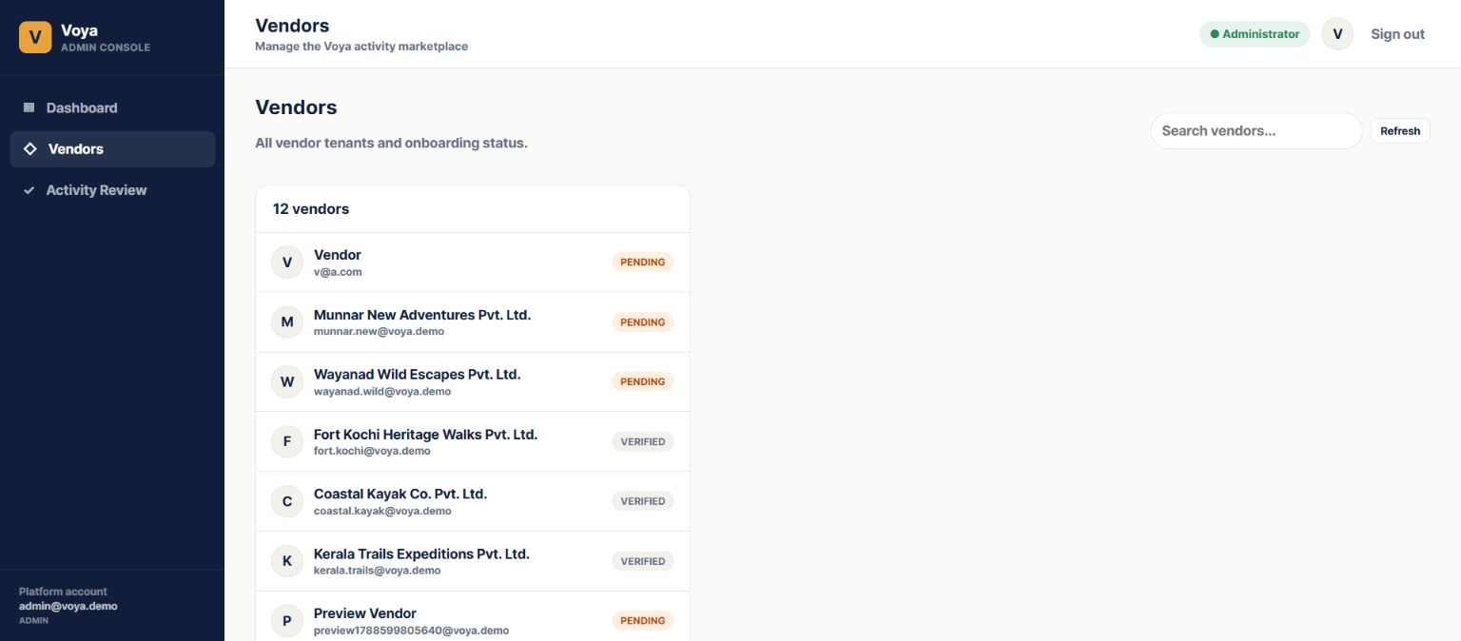
Figure 7. Fresh administrator vendor list captured from the running Chrome application on 06 September 2026.
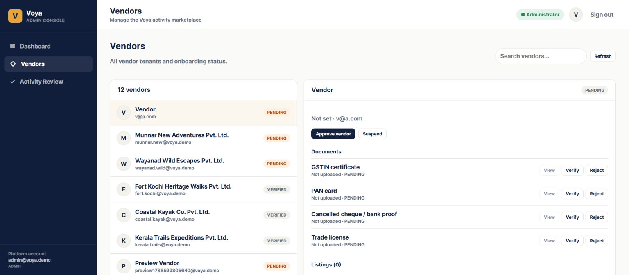
Figure 8. Fresh administrator vendor detail and document review captured from the running Chrome application on 06 September 2026.
- Lists vendor tenants and verification state.
- Opens vendor details with business information, users, listings and rate plans.
- Allows vendor approval or suspension.
- Shows required document filename and status.
- Provides preview for uploaded images and PDFs.
- Allows Verify or Reject actions that update persisted document status and review time.

9.3 Activity review
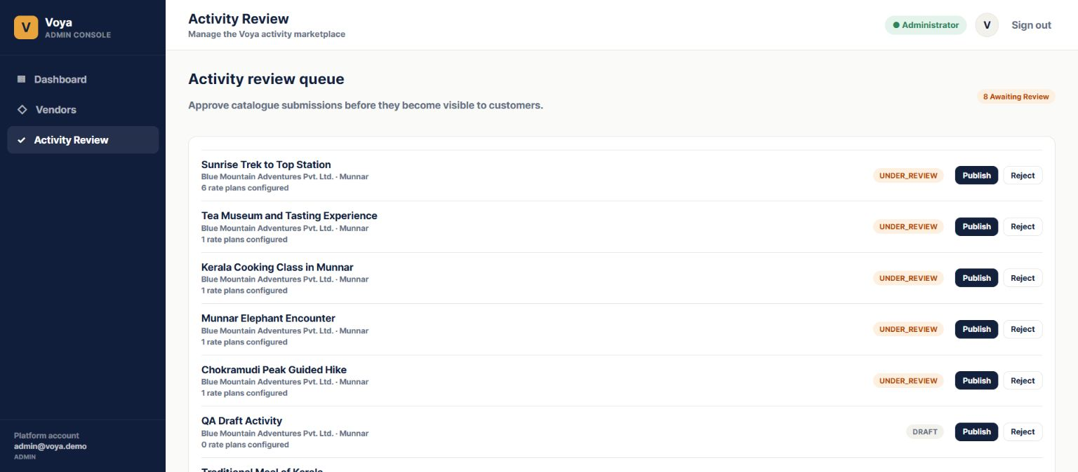
Figure 9. Fresh administrator activity review queue captured from the running Chrome application on 06 September 2026.
- Lists activities in review with owning vendor and rate-plan count.
- Allows publish or reject actions that change activity lifecycle status.

10. Technical Architecture
Layer | Implementation
Frontend | React with TypeScript, Vite and role-aware navigation for vendor and administrator consoles.
Backend | NestJS modules, controllers, services, DTO validation and JWT authentication.
Database | PostgreSQL accessed through Prisma ORM.
Authorization | JWT authentication, role guards and tenant ownership checks.
Files | Backend public/uploads directory with URL references returned by APIs.
Deployment shape | Separate frontend and backend processes with API base URL configuration.

11. Core Data Model
The database models the marketplace around tenants. A tenant owns a vendor profile, activities, bookings and payouts. Activities own media, rate plans and promotions. Rate plans own traveller rules, cancellation rules and availability slots.
Entity | Purpose
Tenant and User | Tenant isolation, account identity, role and active state.
VendorProfile | Business identity, verification, readiness, payout details and document references.
Activity | Product master content, location, status and commercial relationships.
ActivityMedia | Image or video URL, description and rank.
RatePlan | Bookable price and operating rules.
TravellerRule / CancellationRule | Traveller pricing and cancellation windows.
AvailabilitySlot / Promotion | Inventory and time-boxed discount configuration.
Booking / Payout / AuditLog | Booking lifecycle, settlement records and action history structure.

12. Activity Product Master Alignment
The supplied Activity Product Master workbook is treated as the functional requirements baseline for the activity catalogue and rate-plan experience. The current implementation covers the core data model and workflows, but the user-facing forms do not yet expose every detailed workbook field.
Requirement group | Current position | Completion needed
Activity content | Core fields implemented and persisted. | Expose FAQs, affiliates, visibility, amenities, persuasions, labels, redemption, safety, additional information and metaname.
Location | Core location fields implemented. | Add structured meeting-point details and city-code handling.
Media | Upload, preview, gallery and references implemented. | Add explicit rank/reorder and complete metadata editing.
Rate plans | Core price, validity, logistics, traveller and cancellation structures implemented. | Expose all workbook fields and support full edit workflow.
Traveller types | Adult, Child and Senior are currently generated. | Add configurable Youth, Infant and Group rules.
Dictionary values | Some enum validation exists. | Connect controlled values to dropdowns and validate consistently.

13. Proposed Completion Plan

13.1 Workbook-aligned catalogue completion
- Complete every Activity Product Master field in the Activity Editor.
- Complete every rate-plan field and implement Edit, Duplicate and Deactivate actions.
- Add configurable traveller categories and flexible cancellation rules.
- Add structured meeting point, media ranking and gallery ordering.
- Connect Dictionary values to validated dropdown controls.

13.2 Operational hardening
- Add comprehensive audit logging for administrator and vendor actions.
- Add stronger file validation, retention and production object-storage option.
- Add automated API and browser regression tests for every critical workflow.
- Add reporting and operational monitoring as requirements mature.

14. Assumptions and Dependencies
- The Activity Product Master workbook is the requirements reference, not an import file.
- Business owners will confirm definitions for ambiguous fields such as visibility bit, salience, vendor voucher flag and transfer type.
- Production file storage, malware scanning, retention and access policies will be confirmed before deployment.
- Banking credentials remain masked and raw secrets are not stored in the application database.
- Administrator review rules and the exact conditions for vendor verification and activity publication will be confirmed for production.

15. Initial Scope Exclusions
- Customer-facing marketplace booking and payment collection are outside the current vendor-console scope unless separately commissioned.
- Live supplier, hotel, DMC or channel-manager integrations are not part of the current foundation.
- Automated settlement reconciliation and full accounting are not yet implemented.
- Native mobile applications are not included in this web-platform proposal.

16. Conclusion
The Voya Vendor Platform has progressed beyond a static prototype: it has a working vendor and administrator operating model backed by NestJS APIs, PostgreSQL persistence and real file references. The foundation supports the core lifecycle from vendor onboarding through catalogue setup, availability, bookings, vouchers and administrative review.
The next material step is workbook-aligned completion of the Activity Editor and Rate Plan Editor. That work will make every required product-master field visible, editable, validated and persisted, completing the transition from a strong operational foundation to a full activity product-management platform.

17. Latest Implementation Update ? September 2026
This addendum records the behavior now visible in the running Chrome application after the Rev2 proposal was prepared. It focuses on the latest Availability & Pricing and Listings changes, including the database-backed update workflow and editable pricing rules.

17.1 Availability & Pricing ? current behavior
- The vendor first selects an activity rate plan. The Availability screen then shows the selected plan?s promotion summary and inventory editor.
- From Date and To Date define the update range. Dates are rendered horizontally in the read-only inventory grid, with horizontal scrolling for longer ranges.
- The Slot filter contains All Slots and every configured slot. With All Slots selected, one compact Free / Available, Total and Price input row is shown; Update applies those values to every displayed slot for the selected date range. With one slot selected, the same row applies only to that slot.
- The grid below is read-only. It displays slot, date, available/total and price values with color-coded availability states. Update persists the selected range through the API and refreshes the grid from PostgreSQL.
- Adding a slot is an operational action: the vendor chooses Add Slot, enters a time, submits it, and the new time is inserted into the slot dropdown and selected automatically. Delete removes a configured slot after confirmation.
- Standing Pricing Rules are now database-backed and editable. The vendor can add, edit, activate/deactivate and delete a rule; each action is persisted through the pricing-rules API and scoped to the selected activity.

Figure 10. Current Availability & Pricing screen from the running Chrome application. The screen shows rate-plan selection, date-range inventory, shared update controls, read-only slot values and pricing-rule management.

17.2 Listings ? current behavior
- Listings is the vendor?s catalogue workspace. It displays persisted activities with lifecycle status, category/location context and headline price, rather than a static prototype-only list.
- The vendor can search and filter listings by All, Live, Under Review and Draft, then open an existing activity or choose + New Listing.
- The Add/Edit Activity flow follows the prototype sections: Basic Info; Category & Location; Media; Logistics & Inclusions; Rate Plan & Travellers; Policies & Cancellation; and Availability & Promo.
- Listing media is persisted as file references. Cover and gallery images are previewed in the editor, and the gallery supports multiple uploaded images with individual removal.
- Each activity can hold multiple rate plans. Availability is edited separately from the listing editor so catalogue content, commercial rules and date/slot inventory remain distinct responsibilities.

Figure 11. Current Listings workspace from the running Chrome application. The screen provides search, lifecycle filters, persisted listing rows and the entry point to create or edit an activity.

17.3 Latest end-to-end demonstration path
- 1. Sign in as the vendor and open Listings.
- 2. Create or edit an activity and save its catalogue fields, media, rate plans and policies.
- 3. Open Availability & Pricing, choose the rate plan, select a date range and either All Slots or an individual slot.
- 4. Enter Free / Available, Total and Price once, click Update, and confirm the read-only grid refreshes with the saved values.
- 5. Add a new slot and confirm it appears in the dropdown and grid; delete it when no longer required.
- 6. Add or edit a Standing Pricing Rule and confirm its status and values remain after refresh.
- 7. Switch to the administrator workflow to review the vendor/listing state and continue to booking and voucher operations.

17.4 Persistence and API notes
- Availability updates are written using the backend bulk inventory endpoint and read back after save; the UI does not treat the grid as the source of truth.
- Slot creation/deletion and pricing-rule CRUD use authenticated API endpoints with vendor/activity ownership checks.
- The PostgreSQL schema contains the availability rows, rate plans, promotions and pricing rules; uploaded media remains in public/uploads with its URL/reference stored in the database.

17.5 Change summary since Rev2
Area | Latest behavior | Client-visible result
Availability update | Shared compact inputs; All Slots or one slot; date-range bulk update | One Update action refreshes the read-only grid from persisted data.
Slot management | Add Slot inserts and selects the new time; Delete removes a slot | Slot list remains synchronized with the database.
Pricing rules | Add, Edit, Delete and Active toggle are API-backed | Standing rules are operational data, not static display text.
Listings and media | Search/filter catalogue; multi-image media preview and persisted references | Vendor can manage a real catalogue lifecycle.
Revision note: Figures 10 and 11 document the latest Availability and Listings implementation areas requested after Rev2.

