Voya Activity SaaS User Guide
What each screen does, how screens are linked, and what the fields mean
This guide explains the vendor portal in plain language. It follows the real application screens and shows how a vendor moves from onboarding to activities, rate plans, availability, bookings, payouts, and performance.

Quick start
Item | Value
Frontend | http://localhost:3007
Backend API | http://localhost:4007/api
Swagger | http://localhost:4007/api/docs
Demo email | vendor@voya.demo
Demo password | Demo@123

The browser application is the front door. It calls the NestJS API, and the API reads and writes PostgreSQL through Prisma. You normally work in the browser; pgAdmin is useful when you want to inspect the stored rows.

Technical architecture
The demo has three runtime layers. The React and Vite frontend runs on port 3007 and owns screen state, form controls, validation messages, and navigation. The NestJS backend runs on port 4007 under the /api prefix and owns authentication, role checks, validation, business rules, and database access. PostgreSQL stores the tenant, vendor, catalogue, pricing, inventory, booking, payout, and audit data in the activity_saas database.
Layer | Technology | Responsibility | Demo evidence
Browser | React + Vite | Renders screens, collects input, stores the JWT, calls API endpoints | Menu changes screens without a page reload
API | NestJS + class-validator | Authenticates requests, validates DTOs, applies workflow rules | HTTP status and error messages in the UI
Data access | Prisma ORM | Maps typed service calls to PostgreSQL rows and relations | Saved values remain after refresh
Database | PostgreSQL 16 | Persists vendor-owned business data | Rows visible in pgAdmin under activity_saas

End to end technical flow
Use this sequence when demonstrating the system. Each step produces a visible result and a corresponding API or database change.
Step | User action | Frontend request | Backend and database result
1. Authenticate | Enter demo email and password and select Sign in | POST /api/auth/login | NestJS verifies the password and returns a JWT. The browser stores it as voya_token.
2. Restore session | Refresh the browser | GET /api/auth/me | The JWT guard identifies the user. The app then loads GET /api/vendor/profile.
3. Complete vendor setup | Edit business fields and select Save Business Details | PATCH /api/vendor/profile | VendorProfile is updated for the logged-in tenant only.
4. Verify documents | Choose a PDF, JPG, JPEG, or PNG in a document control | POST /api/vendor/documents/{key} | The document filename, status, and upload time are stored in VendorProfile.documentStatus.
5. Create catalogue content | Select Listings, New Listing, enter fields, and save | POST /api/activities or PATCH /api/activities/{id} | An Activity row is created or updated. Highlights, terms, location, rating, and information arrays are normalized.
6. Add commercial rules | Open an activity and add a rate plan | POST /api/activities/{id}/rate-plans | RatePlan is created with TravellerRule and CancellationRule child rows.
7. Publish | Select Publish Listing on a draft activity | POST /api/activities/{id}/publish | The activity status changes to LIVE in the demo workflow.
8. Manage inventory | Choose a rate plan, edit available/capacity/price/closed, and save | POST /api/availability/bulk | AvailabilitySlot rows are updated with version checks to prevent stale overwrites.
9. Manage demand | Schedule a promotion or toggle one off | POST /api/promotions or PATCH /api/promotions/{id} | Promotion stores its time window, percentage, cap, and active flag.
10. Fulfil bookings | Confirm, cancel, or request a voucher | POST /api/bookings/{id}/confirm, /cancel, or GET /voucher | Booking status transitions are validated. Confirmed bookings can return a voucher code.

Logical business flow
The business logic moves from identity to supply, then from supply to demand and settlement. The dependency is intentional: a booking is meaningful only when it points to an activity and, where applicable, a rate plan; an availability slot is meaningful only when it belongs to a rate plan.
Business object | Owns or belongs to | Why it matters
Tenant | Users, VendorProfile, Activities, Bookings, Payouts | Defines the vendor boundary used for isolation
VendorProfile | Business details and documentStatus JSON | Controls readiness, verification, and payout identity
Activity | Media, RatePlans, Promotions, Bookings | Represents the sellable product or experience
RatePlan | TravellerRules, CancellationRules, AvailabilitySlots | Represents a specific price and operating contract
AvailabilitySlot | One rate plan, date, and start time | Controls capacity, remaining inventory, closure, and optional price
Booking | One tenant, activity, optional rate plan | Represents a reservation and its state transition
Payout | One tenant and settlement status | Represents money moving through scheduled, transit, or paid states

State transitions to demonstrate
Object | Starting state | Action | Result
Activity | DRAFT | Submit for Review | UNDER_REVIEW
Activity | DRAFT, INACTIVE, or UNDER_REVIEW | Publish Listing in the vendor demo | LIVE
Activity | LIVE | Edit and save | UNDER_REVIEW, so changes are reviewed
Booking | PENDING | Confirm | CONFIRMED
Booking | PENDING or CONFIRMED | Cancel | CANCELLED
Promotion | active = true | Toggle switch | active = false
AvailabilitySlot | open | Set Closed and save | closed = true; inventory remains auditable

Tenant isolation and security flow
Every protected request carries Authorization: Bearer <JWT>. The JWT identifies the user role and tenantId. NestJS guards reject missing or invalid tokens, the roles guard limits vendor routes to vendor users, and service queries add the current tenantId to their filters. This is why one vendor cannot list or modify another vendor’s activities, bookings, availability, or payouts. ValidationPipe rejects unknown fields and invalid types before the service writes data.

Request lifecycle in detail
A normal save follows the same lifecycle on every screen. First, a React control changes local form state. When the user selects a save or action button, the API client serializes the state as JSON and adds the bearer token. NestJS receives the request under /api, authenticates it, validates the DTO, and calls the feature service. The service adds tenant ownership rules, performs business validation, writes through Prisma, and returns the updated row. React then replaces its local state with the response, which is why the screen immediately reflects the server result.
Stage | Component | What happens | Failure visible to the user
1. Input | React field or toggle | Value is held in component state and displayed immediately | The control remains editable
2. Submit | api.request | JSON body and Authorization header are sent | Network or authentication error
3. Authenticate | JwtAuthGuard | Token is decoded and the user is loaded | 401 Unauthorized
4. Authorize | RolesGuard | Role metadata is checked against the route | 403 Forbidden
5. Validate | ValidationPipe and DTO | Unknown fields, wrong types, invalid dates, and invalid ranges are rejected | 400 Bad Request with a readable message
6. Apply rules | Feature service | Tenant ownership, status transition, and optimistic version rules run | 409 Conflict or 404 Not Found
7. Persist | Prisma and PostgreSQL | Rows and related child records are inserted or updated | 500 only for an unexpected server failure
8. Refresh state | React page | Returned data replaces stale local state | Success message or refreshed table

Detailed screen responsibilities
Screen | Reads from the API | Writes to the API | Logical purpose
Login | None before authentication | POST /auth/login | Creates the authenticated vendor session
Dashboard | GET /dashboard/summary | None | Shows a read-only operational overview
Onboarding | GET /vendor/profile | PATCH /vendor/profile; POST /vendor/documents/{key} | Maintains the vendor identity, readiness, payout display, and document status
Listings | GET /activities | POST /activities; PATCH /activities/{id} | Finds activities and opens the editor
Activity Editor | GET /activities/{id}; GET /activities/{id}/rate-plans | PATCH activity; media endpoints; rate-plan create; submit; publish | Maintains the product master and its commercial offers
Availability | GET /availability; GET /promotions | POST /availability/bulk; promotion create/toggle | Maintains saleable inventory and time-boxed discounts
Bookings | GET /bookings | Confirm, cancel, voucher | Runs the operational reservation queue
Payouts | GET /payouts | None | Displays settlement history
Performance | GET /dashboard/summary | None | Turns operational metrics into quality indicators

Example API messages
The following examples show the logical shape of the messages. The browser sends the request body; the server adds generated IDs, timestamps, tenant ownership, and version fields.

Create an activity
POST /api/activities with a body such as: { productName: "Sunrise Trek", type: "ACTIVITY", subType: "TICKET_ONLY", description: "Guided sunrise trek", shortDescription: "A guided morning experience", starRating: 4.8, cityName: "Munnar", stateName: "Kerala", countryName: "INDIA", address: "Meeting point", lat: 10.0889, lon: 77.0595, highlights: ["Guide included", "Sunrise viewpoint"], terms: ["Carry valid ID"], thingsToCarry: ["Walking shoes"], importantInfo: ["Weather dependent"] }. The response contains the new Activity id and status DRAFT.

Create a rate plan
POST /api/activities/{activityId}/rate-plans creates the commercial contract. The body contains ratePlanCode, name, currency, basePrice, unitType, minPax, maxPax, validFrom, validTo, validDays, blackoutDates, durationMinutes, timeOfDay, pickup and drop-off details, inclusions, exclusions, travellerRules, and cancellationRules. Prisma creates the RatePlan and its nested TravellerRule and CancellationRule rows in one logical operation.

Save inventory
POST /api/availability/bulk sends a list of slots. Each slot contains ratePlanId, slotDate, startTime, capacity, available, closed, priceOverride, and expectedVersion. The expectedVersion prevents an older browser tab from overwriting a newer edit. A successful response is followed by a reload so the displayed values come from PostgreSQL.

Field behavior and validation rules
Area | Field | Expected value | Validation or business rule
Onboarding | Legal Business Name | Registered vendor name | Stored against the current VendorProfile
Onboarding | GSTIN | Tax registration number | Optional text in this demo; document verification is separate
Onboarding | Payout Account | Masked account display | Never used as a raw bank credential
Documents | File | PDF, JPG, JPEG, or PNG | The demo records filename, status, and upload time in documentStatus
Activity | Star Rating | 0 through 5, decimals allowed | Backend limits the value to the supported range
Activity | Latitude / Longitude | Decimal coordinates | Converted to numeric values before persistence
Rate Plan | Base Price and traveller prices | Zero or positive numbers | Stored as PostgreSQL Decimal values
Rate Plan | Min Pax / Max Pax | Positive integers | Max Pax cannot be lower than Min Pax
Rate Plan | Valid From / Valid To | Dates | Valid To must be on or after Valid From
Rate Plan | Blackout Dates | Comma-separated ISO dates | Excluded dates remain visible as rate-plan configuration
Rate Plan | Cancellation slabs | Percentage values | Each charge is stored as a structured rule, not free text
Availability | Available / Capacity | Non-negative integers | Capacity and available are bounded by business inventory logic
Availability | Price Override | Optional non-negative number | If blank, rate-plan base price is used
Availability | Closed | On or off | Closed slots remain stored but are not saleable
Promotion | Discount % | 0.01 through 100 | Start and end define the active time window

What changes in the database during the demo
Demo action | Primary table | Related tables or fields | How to prove it
Save onboarding | VendorProfile | legalBusinessName, GSTIN, category, payoutAccountMasked | Refresh Onboarding and open VendorProfile in pgAdmin
Upload a document | VendorProfile.documentStatus JSON | key, fileName, status, uploadedAt | Open the JSON column and find the document key
Save an activity | Activity | terms, highlights, thingsToCarry, importantInfo, lat, lon, starRating | Refresh the editor and inspect Activity
Add media | ActivityMedia | activityId, kind, url, rank | Open the ActivityMedia rows for the activity
Add rate plan | RatePlan | TravellerRule and CancellationRule | Match ratePlanCode to its child rows
Save inventory | AvailabilitySlot | capacity, available, closed, priceOverride, version | Match ratePlanId, date, and startTime
Schedule promotion | Promotion | activityId, discountPercent, startsAt, endsAt, active | Open Promotion and compare the displayed card
Confirm booking | Booking | status and version | Refresh Bookings and inspect status CONFIRMED

Error and recovery scenarios
Scenario | Expected result | How to recover
Wrong login password | Login remains on screen with an error | Use vendor@voya.demo and Demo@123
Backend unavailable | Screen shows a request error or cannot load | Start the backend on port 4007 and reload
Invalid rate-plan dates | Create action is rejected | Choose a Valid To date on or after Valid From
Max Pax below Min Pax | Client-side error appears before submission | Increase Max Pax or reduce Min Pax
Expired or missing JWT | API returns 401 | Sign in again
Editing stale availability | API returns a conflict | Reload Availability and apply the change again
Voucher requested for pending booking | API refuses the request | Confirm the booking first
Publishing an already live activity | Status transition is rejected or unnecessary | Edit, submit, and publish only when a new review is required

Narrated demonstration explanation
Begin by saying: “This is a tenant-aware vendor console. I will create a business-to-booking flow. I will first authenticate, then update vendor readiness, maintain a sellable activity, attach a commercial rate plan, add inventory, accept a booking, and finally verify the rows in PostgreSQL.”
At Onboarding, explain that the vendor profile is the identity anchor. At Listings, explain that an Activity is the product master and does not itself define every price. At the Activity Editor, explain that one activity can have several rate plans, for example shared, private, child, premium, or vehicle-specific offers. At Availability, explain that the selected rate plan determines which inventory grid is being edited. At Bookings, explain that the booking points back to the activity and selected rate plan and moves through controlled states. Finish in pgAdmin to prove that the UI is connected to real stored data.

Role and ownership matrix
Capability | Vendor | Admin / Sub-admin | Reason
Read own profile and catalogue | Yes | Yes | Vendor operates its own data; platform roles can supervise
Create or edit own activity | Yes | Yes | Changes are tenant-scoped
Submit for review | Yes | No requirement in demo | Vendor requests operational approval
Publish in this demo | Yes | Yes | Enabled for demonstrating the complete lifecycle
Manage own inventory and promotions | Yes | Yes | Inventory belongs to the vendor’s rate plans
Confirm or cancel own bookings | Yes | No requirement in demo | Vendor fulfils reservations
Access another tenant’s rows | No | Platform policy dependent | Service filters enforce tenant ownership

How the screens are linked
The left menu is available after login. Each menu item changes the main screen without changing the vendor account. Several screens are linked by IDs: an Activity owns Rate Plans; a Rate Plan owns Traveller Rules, Cancellation Rules, and Availability Slots; Bookings can refer to an Activity and Rate Plan.
Screen | Main purpose | What it links to
Dashboard | Summary of vendor activity | Bookings, Listings, Onboarding
Onboarding | Business verification and payout readiness | VendorProfile and documents
Listings | Search and open activities | Activity Editor and Rate Plans
Activity Editor | Create/edit product information | Media, Rate Plans, Availability
Availability | Set dates, slots, capacity and promotions | RatePlan and AvailabilitySlot
Bookings | Confirm or cancel reservations | Activity, RatePlan and Booking
Payouts | View settlement history | Payout
Performance | Review service quality | Dashboard and booking metrics

Login and dashboard
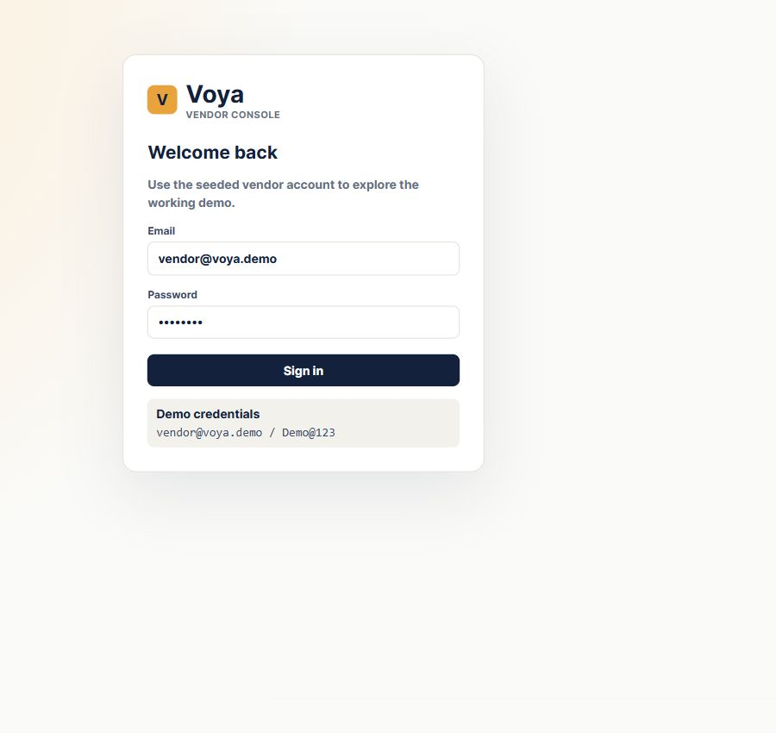
Figure 1. Exact login screen captured from the running Chrome application.
Enter the seeded demo email and password, then select Sign in. Authentication is performed by the NestJS API and the returned JWT is stored by the browser for authenticated requests; the React app does not fake a successful login.
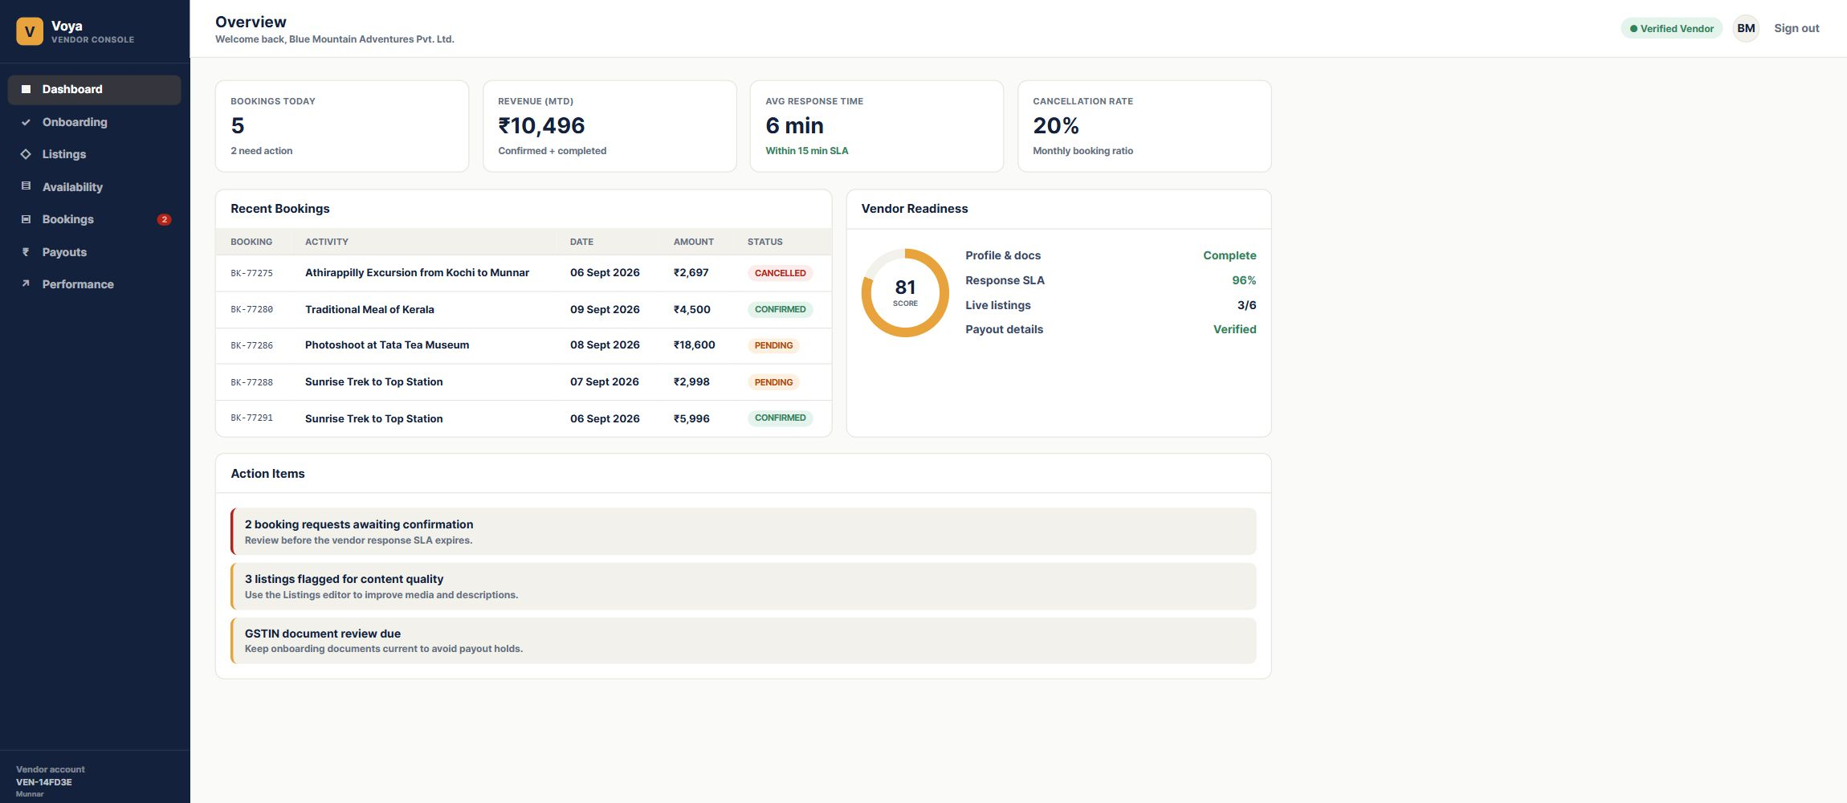
Figure 2. Exact dashboard screen captured from the running Chrome application. The dashboard is the starting point after a successful login.
The dashboard gives a quick operational summary. Bookings Today counts recent booking activity, Revenue MTD shows confirmed and completed revenue for the month, Pending Bookings needs vendor action, and Vendor Readiness shows how complete the account is.

Onboarding
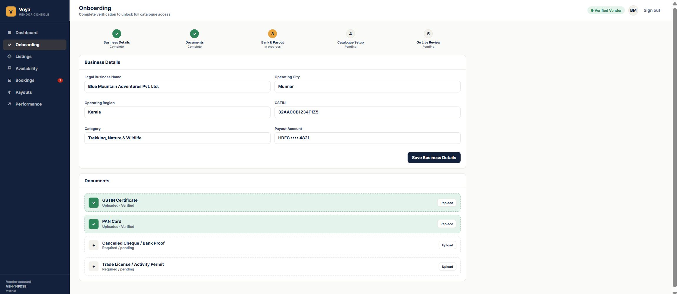
Figure 3. Exact onboarding screen captured from the running Chrome application.
Field | Meaning | Where it is stored
Legal Business Name | Registered business name | VendorProfile.legalBusinessName
Operating City / Region | Location used for vendor identity and operations | VendorProfile.operatingCity / operatingRegion
GSTIN | Tax registration identifier | VendorProfile.gstin
Category | Business category shown to the vendor | VendorProfile.category
Payout Account | Masked settlement account display | VendorProfile.payoutAccountMasked

Listings
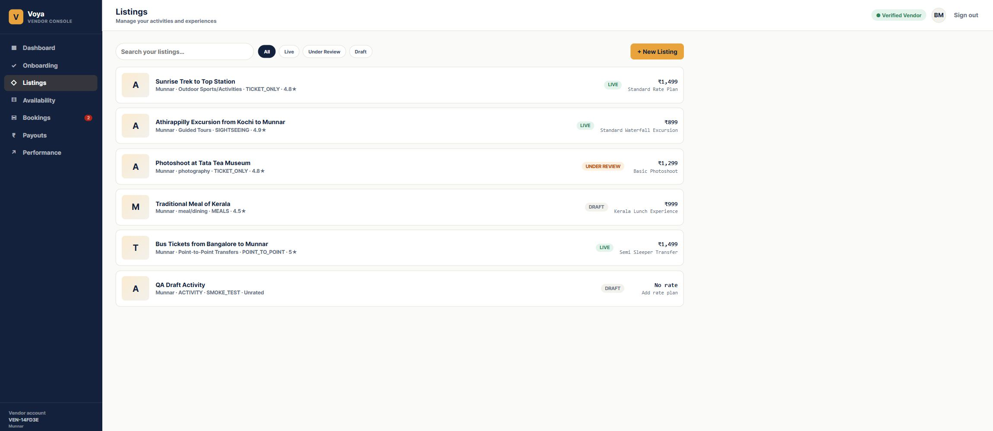
Figure 4. Exact listings screen captured from the running Chrome application.
Listings is the activity catalogue. Use the search box to find an activity, use status filters to narrow the list, and click a listing card to open the Activity Editor. “Live”, “Under Review”, and “Draft” are workflow states. A listing price is taken from its first rate plan when one exists.

Activity editor
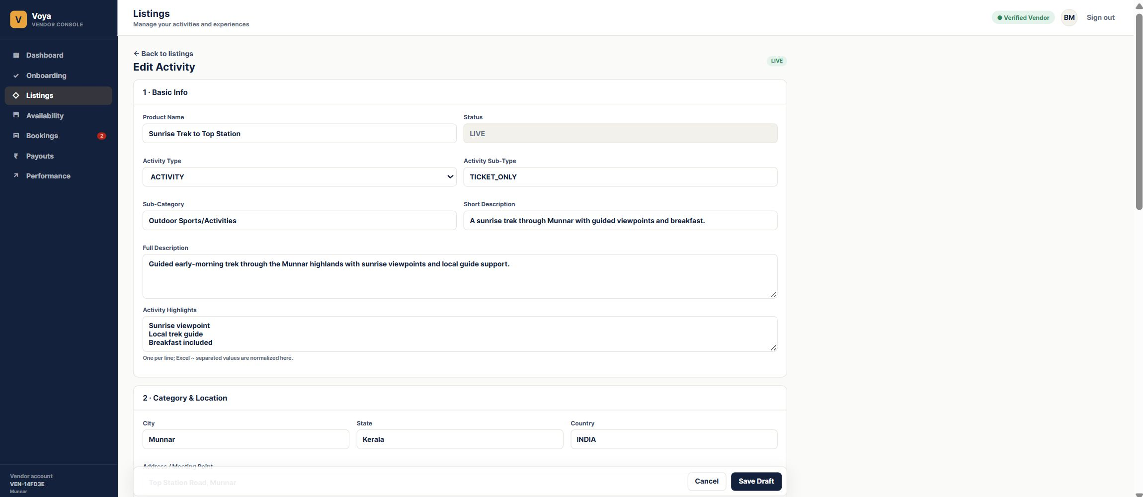
Figure 5. Exact Activity Editor screen captured from the running Chrome application.
Section | Important fields | What to enter
Basic Info | Product Name, Activity Type, Activity Sub-Type, Star Rating, Description | Customer-facing product identity and explanation
Category and Location | Sub-Category, City, State, Country, Address, Latitude, Longitude | Where the activity happens and how it is categorized
Media | Media Type, Media URL | Image or video URL for the product catalogue
Logistics | Things to Carry, Important Information | Operational instructions shown with the product
Rate Plan and Travellers | Rate plan code, currency, price, pax limits, traveller prices | Commercial offer that can be booked
Policies and Cancellation | Terms and cancellation slabs | Customer terms and charges based on days before service

Save Draft writes the activity to the database. Submit for Review changes a draft to Under Review. Publish Listing is available in the working demo and changes the listing to Live. Editing a live activity moves it back to review so production changes are checked.

Rate plans and traveller pricing
A rate plan is a bookable commercial version of an activity. One activity can have many rate plans, such as Standard, Private, Premium, Adult, Child, or different vehicle options. The activity is the product; the rate plan is the price and operating rules for that product.
Field | Meaning
Rateplan ID / Code | Unique code for the plan within its activity
Rateplan Name | Human-readable commercial name
Base Price | Default price stored as a database Decimal
Unit Type | Whether price is per person or per unit
Min Pax / Max Pax | Allowed booking group size
Valid From / Valid To | Date range when the plan can be used
Currency | Three-letter currency code used for the plan
Valid Days / Blackout Dates | Days the plan operates and dates that are excluded
Duration | Expected activity duration in minutes
Time of Day / Pickup Details | Operating time and meeting-point information
Pickup / Drop-off | Operational transport details
Inclusions / Exclusions | What is and is not included in the price
Traveller Rules | Adult, child, senior, and other age/price rules
Auto-Redeem Voucher | Whether the voucher is marked redeemed automatically
Cancellation Rules | Ordered slabs for cancellation charges

Availability and promotions
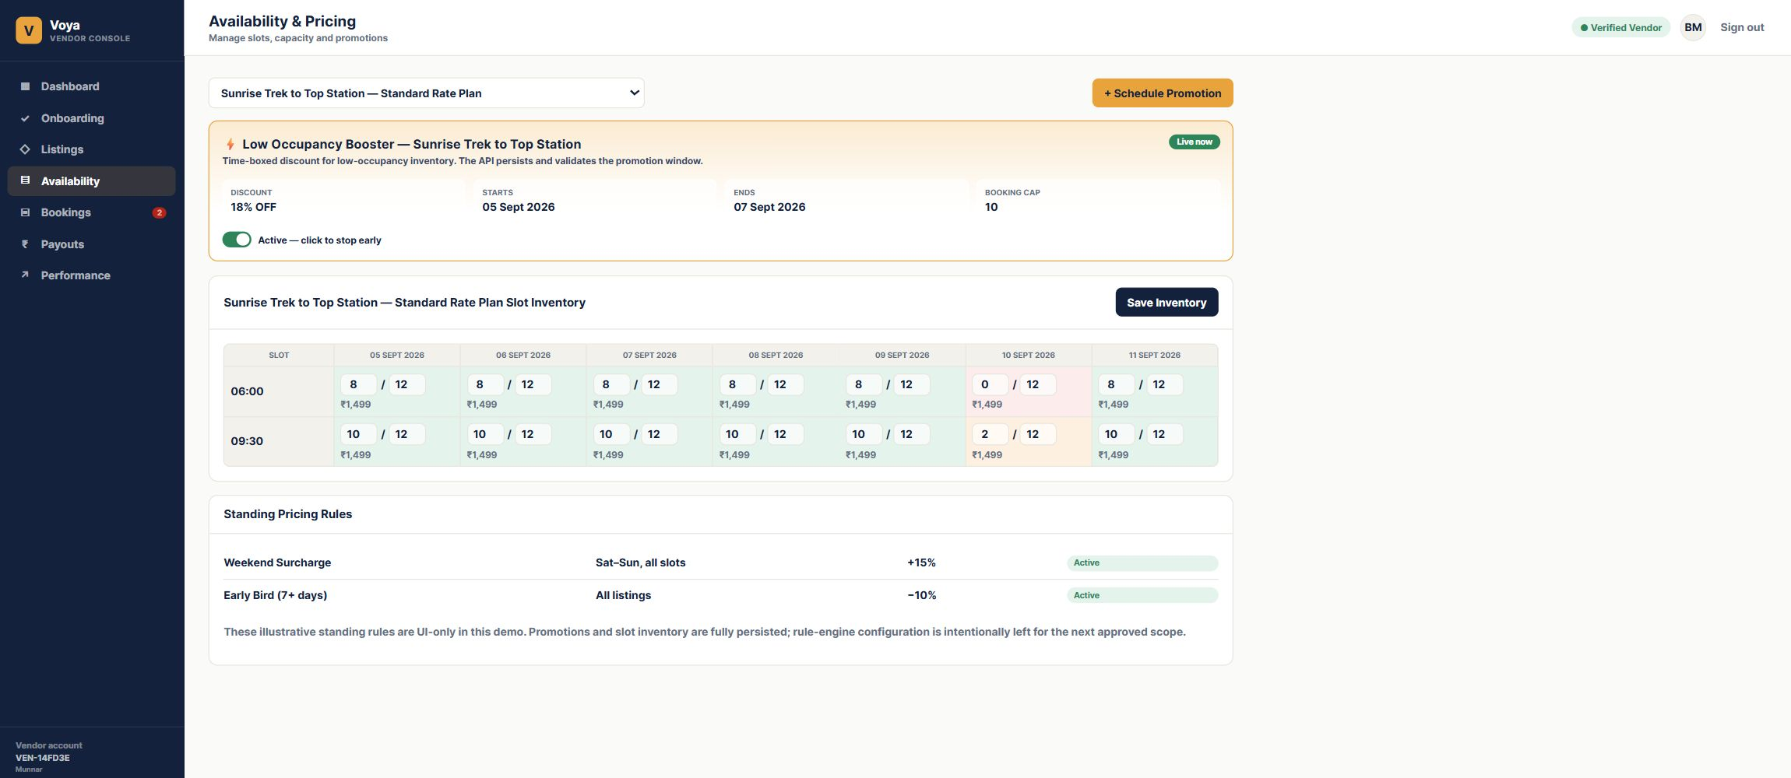
Figure 6. Exact Availability screen captured from the running Chrome application. The live demo contains at least 10 selectable rate plans with inventory.
Field | Meaning | Rule
Rate Plan Selector | Chooses which plan’s slots are being viewed | Only rate plans with seeded inventory appear
Slot Date | Service date | Stored as a date without a time of day
Start Time | Daily operating slot time | Combined with date and plan to identify a slot
Available | Remaining places for that slot | Must not be greater than capacity
Capacity | Maximum places for that slot | Used to protect inventory limits
Price Override | Optional slot-specific price | Otherwise the rate plan base price is used
Closed | Temporarily closes a slot | Closed slots cannot be sold
Promotion | Time-boxed discount for an activity | Has start, end, discount, and booking cap

Save Inventory sends the visible slots to the API. The backend uses optimistic version checks so a stale browser cannot silently overwrite another update.

Bookings
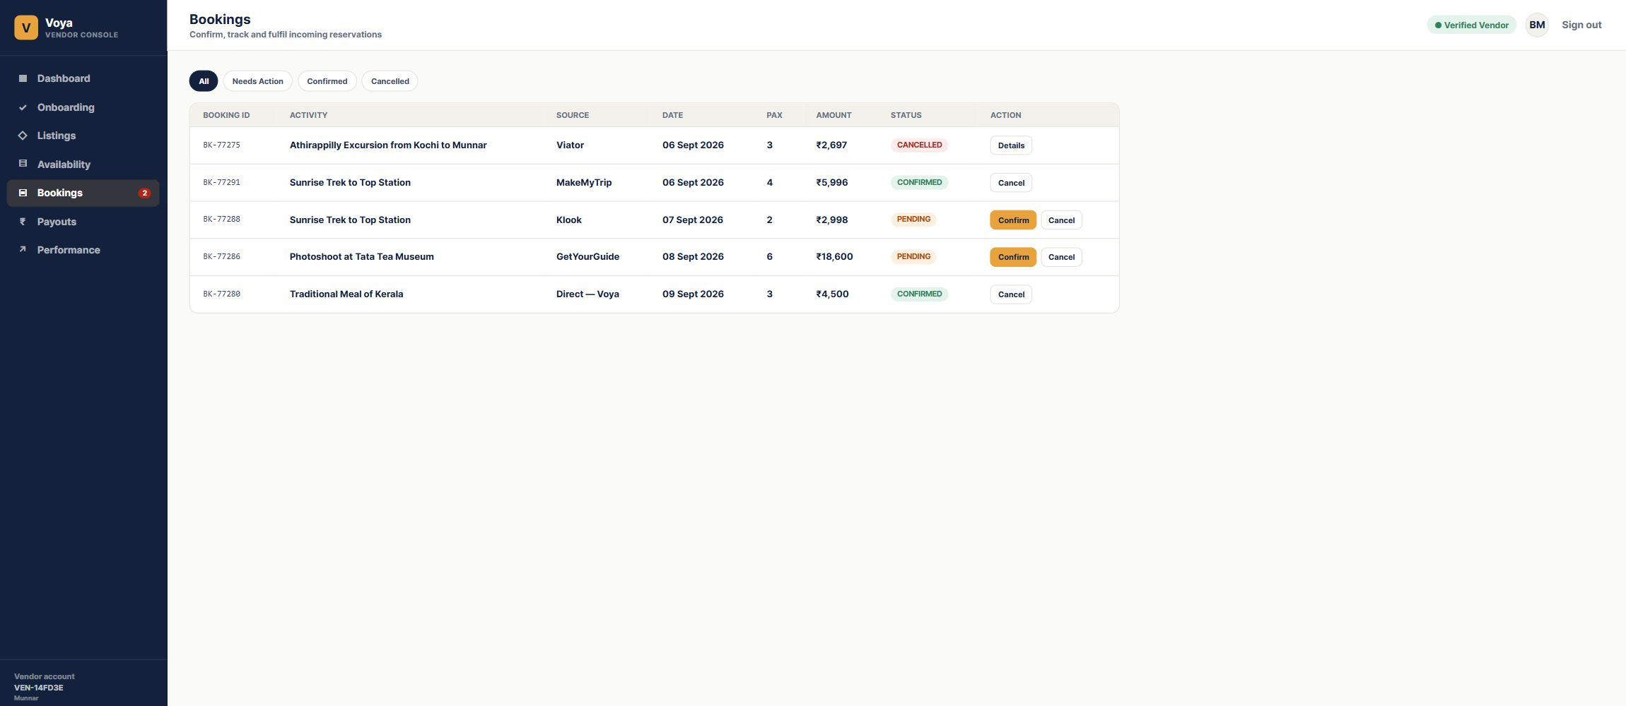
Figure 7. Exact Bookings screen captured from the running Chrome application.
Use All, Needs Action, Confirmed, and Cancelled filters to manage incoming reservations. A pending booking can be confirmed or cancelled. Confirmed and completed bookings expose Voucher. The API protects valid state transitions and keeps booking records isolated to the vendor tenant.

Payouts and performance
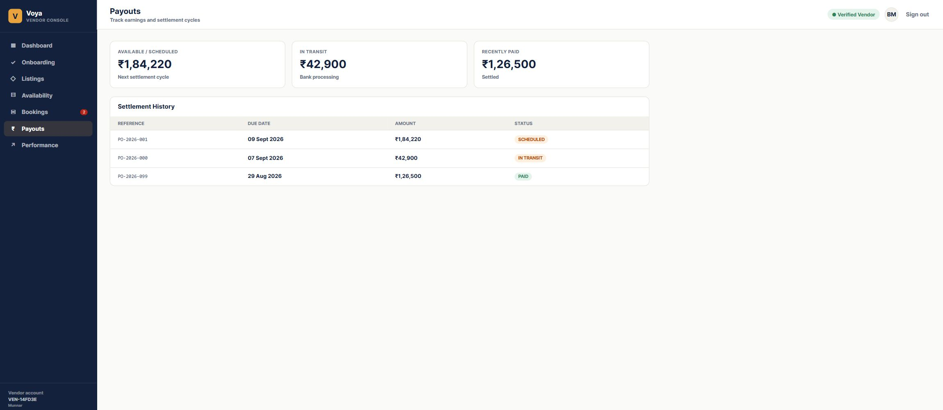
Figure 8. Exact Payouts screen captured from the running Chrome application.
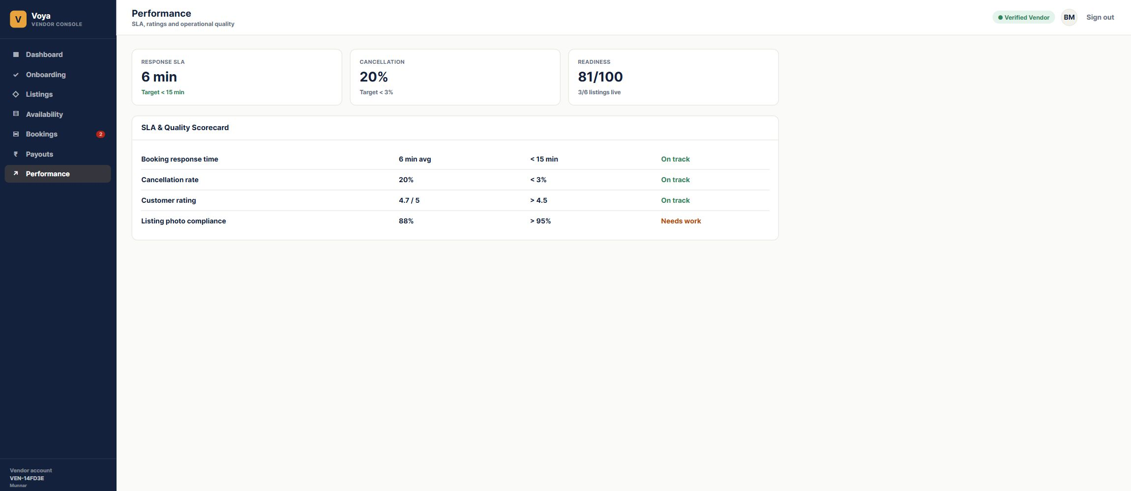
Figure 9. Exact Performance screen captured from the running Chrome application.
Payouts is read-only settlement history in this demo. Performance summarizes response time, cancellation rate, customer rating, readiness, and listing quality so the vendor knows what needs attention.

Recommended live demo script
This is a short logical demonstration for a stakeholder or tester. Keep the browser and pgAdmin open side by side when you want to prove that the UI change reached PostgreSQL.
Order | What to do | What to point out
1 | Open http://localhost:3007 and sign in with vendor@voya.demo / Demo@123 | The login is real and creates an authenticated session.
2 | Open Onboarding and change the category, then save | The success message confirms the PATCH request; refresh to prove persistence.
3 | Choose a pending document and select a file | The card changes to Uploaded and Verified with the filename.
4 | Open Listings, select an activity, and review the editor sections | Basic information, location, media, logistics, rate plans, policies, and availability are linked by the activity ID.
5 | Add or edit a rate plan | Explain currency, traveller prices, pax limits, valid dates, operating days, blackout dates, cancellation rules, and auto-redeem.
6 | Select Publish Listing | The activity becomes LIVE in the demo and returns to the listing list.
7 | Open Availability and choose one of the 10 seeded plans | Edit available seats, capacity, price override, and Closed, then select Save Inventory.
8 | Schedule a promotion and toggle it | The time-boxed promotion is persisted and can be stopped or resumed.
9 | Open Bookings and confirm a pending booking | The status changes to CONFIRMED; select Voucher to show the generated voucher code.
10 | Return to Dashboard, Payouts, and Performance | These screens read summary and settlement data from the API and show the operational result.

How to verify the flow in pgAdmin
Connect to PostgreSQL 16, expand Databases, select activity_saas, then expand Schemas, public, and Tables. Right-click a table and choose View/Edit Data followed by All Rows. Useful tables for the demonstration are VendorProfile for onboarding and documents, Activity for listing fields and status, RatePlan for commercial rules, TravellerRule and CancellationRule for nested pricing rules, AvailabilitySlot for inventory, Promotion for discounts, Booking for confirmations and vouchers, and Payout for settlement history.
The strongest verification is to edit one value in the browser, save it, refresh the screen, and then open the corresponding table row in pgAdmin. The value should be identical because the browser does not use a mock-only form state for these persisted actions.

Database relationship in simple terms
The important chain is: Tenant → Vendor User and Vendor Profile. Tenant → Activities. Activity → Media, Rate Plans, Promotions, and Bookings. Rate Plan → Traveller Rules, Cancellation Rules, and Availability Slots. Booking can point back to the Activity and the selected Rate Plan.
When you use this screen | The main database row being changed
Save Business Details | VendorProfile
Save Draft / Edit Activity | Activity
Add Media | ActivityMedia
Create Rate Plan | RatePlan plus TravellerRule and CancellationRule
Save Inventory | AvailabilitySlot
Schedule Promotion | Promotion
Confirm or Cancel Booking | Booking

Troubleshooting
If the browser is blank, confirm the backend is running on port 4007 and the frontend on port 3007. If lists are empty, confirm the browser is logged in as vendor@voya.demo and that PostgreSQL database activity_saas is running. In pgAdmin, browse rows by expanding activity_saas → Schemas → public → Tables, then right-click a table and choose View/Edit Data → All Rows.

