Voya Activity SaaS User Guide
What each screen does, how screens are linked, and what the fields mean
This guide explains the vendor portal in plain language. It follows the real application screens and shows how a vendor moves from onboarding to activities, rate plans, availability, bookings, payouts, and performance.

Quick start
Item | Value
Frontend | http://localhost:3007
Backend API | http://localhost:4007/api
Swagger | http://localhost:4007/api/docs
Demo email | vendor@voya.demo
Demo password | Demo@123

The browser application is the front door. It calls the NestJS API, and the API reads and writes PostgreSQL through Prisma. You normally work in the browser; pgAdmin is useful when you want to inspect the stored rows.

Technical architecture
The demo has three runtime layers. The React and Vite frontend runs on port 3007 and owns screen state, form controls, validation messages, and navigation. The NestJS backend runs on port 4007 under the /api prefix and owns authentication, role checks, validation, business rules, and database access. PostgreSQL stores the tenant, vendor, catalogue, pricing, inventory, booking, payout, and audit data in the activity_saas database.
Layer | Technology | Responsibility | Demo evidence
Browser | React + Vite | Renders screens, collects input, stores the JWT, calls API endpoints | Menu changes screens without a page reload
API | NestJS + class-validator | Authenticates requests, validates DTOs, applies workflow rules | HTTP status and error messages in the UI
Data access | Prisma ORM | Maps typed service calls to PostgreSQL rows and relations | Saved values remain after refresh
Database | PostgreSQL 16 | Persists vendor-owned business data | Rows visible in pgAdmin under activity_saas

End to end technical flow
Use this sequence when demonstrating the system. Each step produces a visible result and a corresponding API or database change.
Step | User action | Frontend request | Backend and database result
1. Authenticate | Enter demo email and password and select Sign in | POST /api/auth/login | NestJS verifies the password and returns a JWT. The browser stores it as voya_token.
2. Restore session | Refresh the browser | GET /api/auth/me | The JWT guard identifies the user. The app then loads GET /api/vendor/profile.
3. Complete vendor setup | Edit business fields and select Save Business Details | PATCH /api/vendor/profile | VendorProfile is updated for the logged-in tenant only.
4. Verify documents | Choose a PDF, JPG, JPEG, or PNG in a document control | POST /api/vendor/documents/{key} | The document filename, status, and upload time are stored in VendorProfile.documentStatus.
5. Create catalogue content | Select Listings, New Listing, enter fields, and save | POST /api/activities or PATCH /api/activities/{id} | An Activity row is created or updated. Highlights, terms, location, rating, and information arrays are normalized.
6. Add commercial rules | Open an activity and add a rate plan | POST /api/activities/{id}/rate-plans | RatePlan is created with TravellerRule and CancellationRule child rows.
7. Publish | Select Publish Listing on a draft activity | POST /api/activities/{id}/publish | The activity status changes to LIVE in the demo workflow.
8. Manage inventory | Choose a rate plan, edit available/capacity/price/closed, and save | POST /api/availability/bulk | AvailabilitySlot rows are updated with version checks to prevent stale overwrites.
9. Manage demand | Schedule a promotion or toggle one off | POST /api/promotions or PATCH /api/promotions/{id} | Promotion stores its time window, percentage, cap, and active flag.
10. Fulfil bookings | Confirm, cancel, or request a voucher | POST /api/bookings/{id}/confirm, /cancel, or GET /voucher | Booking status transitions are validated. Confirmed bookings can return a voucher code.

Logical business flow
The business logic moves from identity to supply, then from supply to demand and settlement. The dependency is intentional: a booking is meaningful only when it points to an activity and, where applicable, a rate plan; an availability slot is meaningful only when it belongs to a rate plan.
Business object | Owns or belongs to | Why it matters
Tenant | Users, VendorProfile, Activities, Bookings, Payouts | Defines the vendor boundary used for isolation
VendorProfile | Business details and documentStatus JSON | Controls readiness, verification, and payout identity
Activity | Media, RatePlans, Promotions, Bookings | Represents the sellable product or experience
RatePlan | TravellerRules, CancellationRules, AvailabilitySlots | Represents a specific price and operating contract
AvailabilitySlot | One rate plan, date, and start time | Controls capacity, remaining inventory, closure, and optional price
Booking | One tenant, activity, optional rate plan | Represents a reservation and its state transition
Payout | One tenant and settlement status | Represents money moving through scheduled, transit, or paid states

State transitions to demonstrate
Object | Starting state | Action | Result
Activity | DRAFT | Submit for Review | UNDER_REVIEW
Activity | DRAFT, INACTIVE, or UNDER_REVIEW | Publish Listing in the vendor demo | LIVE
Activity | LIVE | Edit and save | UNDER_REVIEW, so changes are reviewed
Booking | PENDING | Confirm | CONFIRMED
Booking | PENDING or CONFIRMED | Cancel | CANCELLED
Promotion | active = true | Toggle switch | active = false
AvailabilitySlot | open | Set Closed and save | closed = true; inventory remains auditable

Tenant isolation and security flow
Every protected request carries Authorization: Bearer <JWT>. The JWT identifies the user role and tenantId. NestJS guards reject missing or invalid tokens, the roles guard limits vendor routes to vendor users, and service queries add the current tenantId to their filters. This is why one vendor cannot list or modify another vendor’s activities, bookings, availability, or payouts. ValidationPipe rejects unknown fields and invalid types before the service writes data.

How the screens are linked
The left menu is available after login. Each menu item changes the main screen without changing the vendor account. Several screens are linked by IDs: an Activity owns Rate Plans; a Rate Plan owns Traveller Rules, Cancellation Rules, and Availability Slots; Bookings can refer to an Activity and Rate Plan.
Screen | Main purpose | What it links to
Dashboard | Summary of vendor activity | Bookings, Listings, Onboarding
Onboarding | Business verification and payout readiness | VendorProfile and documents
Listings | Search and open activities | Activity Editor and Rate Plans
Activity Editor | Create/edit product information | Media, Rate Plans, Availability
Availability | Set dates, slots, capacity and promotions | RatePlan and AvailabilitySlot
Bookings | Confirm or cancel reservations | Activity, RatePlan and Booking
Payouts | View settlement history | Payout
Performance | Review service quality | Dashboard and booking metrics

Login and dashboard
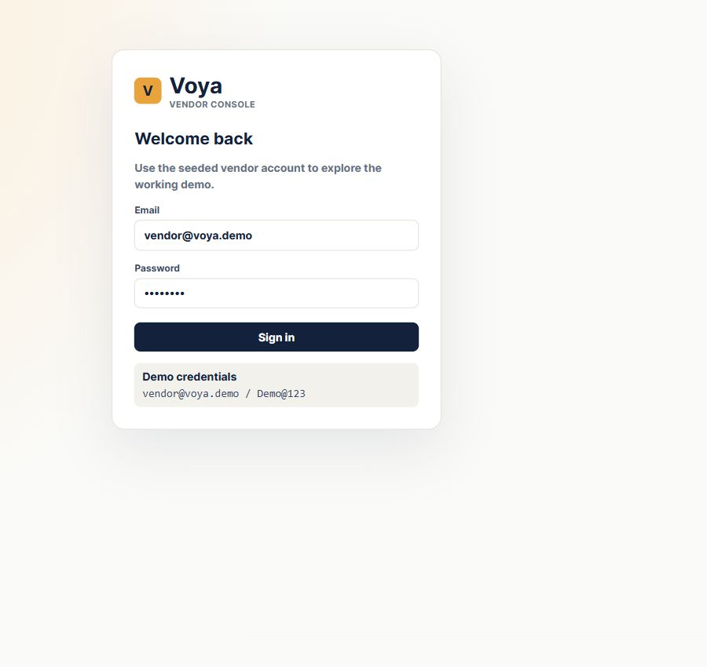
Figure 1. Exact login screen captured from the running Chrome application.
Enter the seeded demo email and password, then select Sign in. Authentication is performed by the NestJS API and the returned JWT is stored by the browser for authenticated requests; the React app does not fake a successful login.
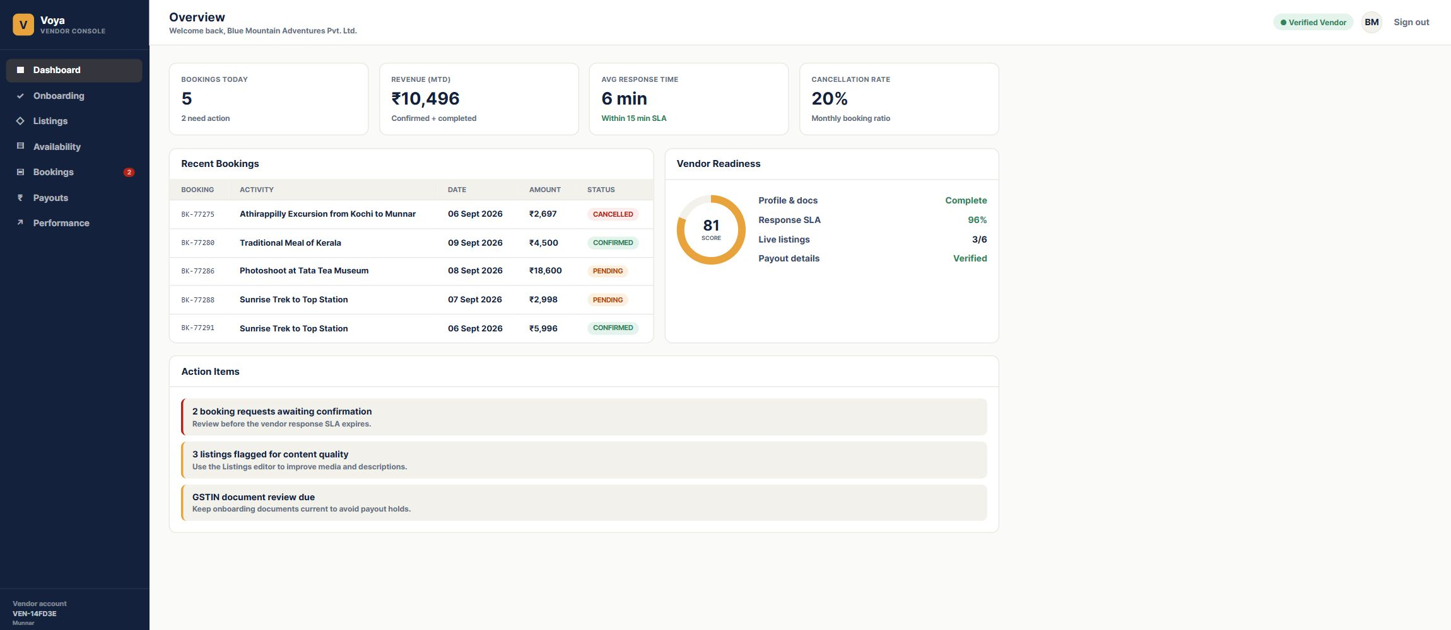
Figure 2. Exact dashboard screen captured from the running Chrome application. The dashboard is the starting point after a successful login.
The dashboard gives a quick operational summary. Bookings Today counts recent booking activity, Revenue MTD shows confirmed and completed revenue for the month, Pending Bookings needs vendor action, and Vendor Readiness shows how complete the account is.

Onboarding
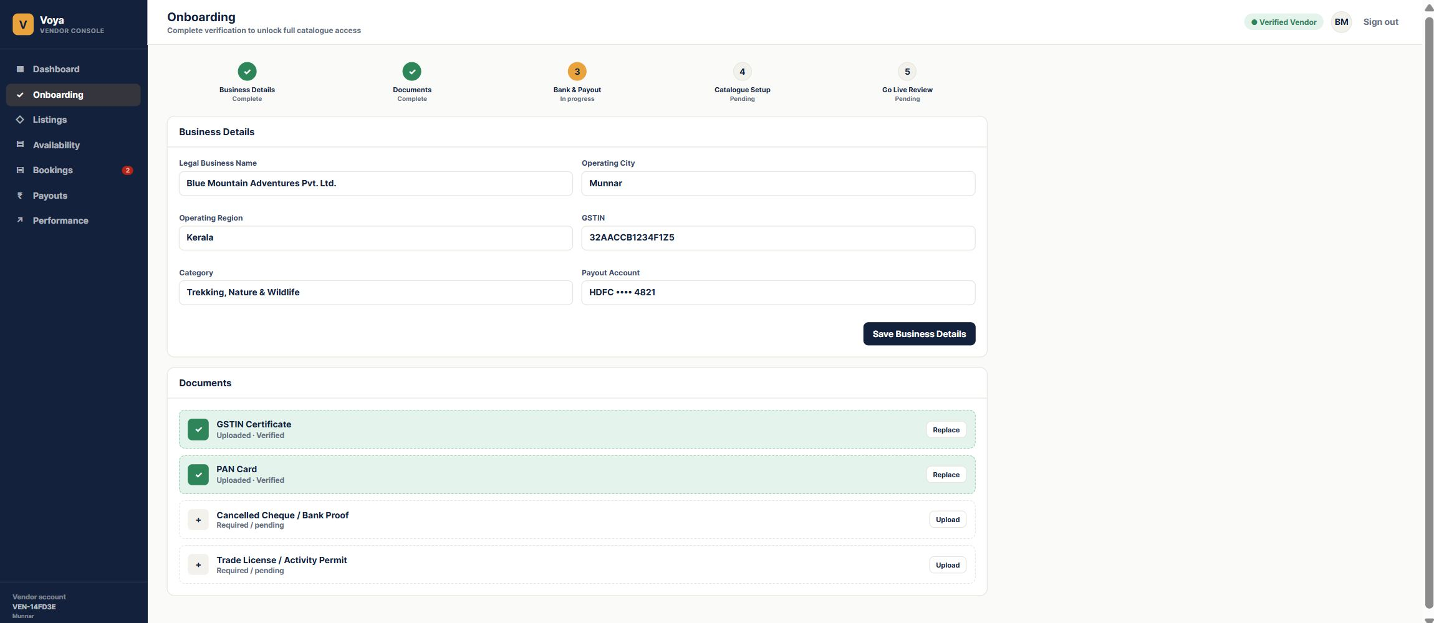
Figure 3. Exact onboarding screen captured from the running Chrome application.
Field | Meaning | Where it is stored
Legal Business Name | Registered business name | VendorProfile.legalBusinessName
Operating City / Region | Location used for vendor identity and operations | VendorProfile.operatingCity / operatingRegion
GSTIN | Tax registration identifier | VendorProfile.gstin
Category | Business category shown to the vendor | VendorProfile.category
Payout Account | Masked settlement account display | VendorProfile.payoutAccountMasked

Listings
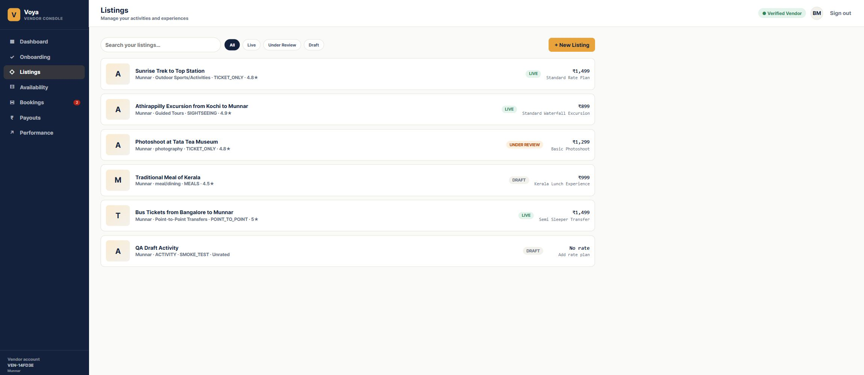
Figure 4. Exact listings screen captured from the running Chrome application.
Listings is the activity catalogue. Use the search box to find an activity, use status filters to narrow the list, and click a listing card to open the Activity Editor. “Live”, “Under Review”, and “Draft” are workflow states. A listing price is taken from its first rate plan when one exists.

Activity editor
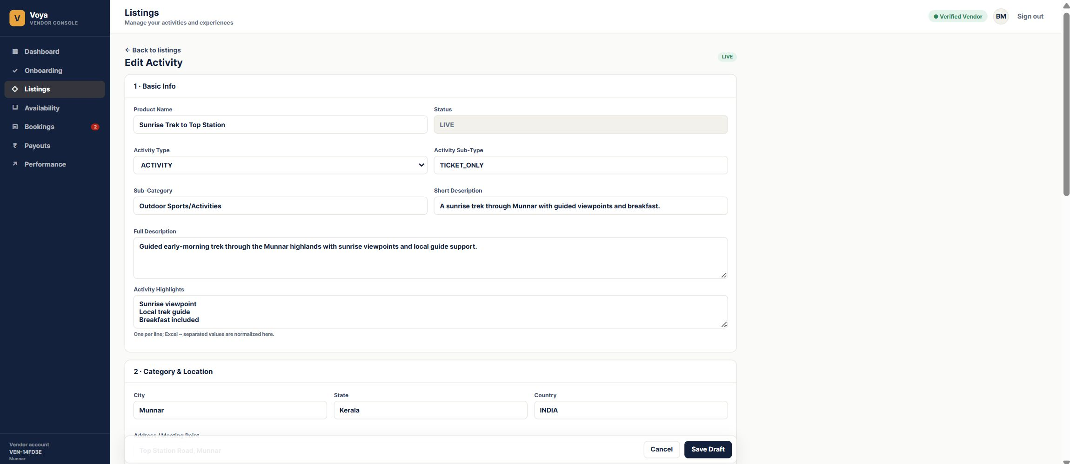
Figure 5. Exact Activity Editor screen captured from the running Chrome application.
Section | Important fields | What to enter
Basic Info | Product Name, Activity Type, Activity Sub-Type, Star Rating, Description | Customer-facing product identity and explanation
Category and Location | Sub-Category, City, State, Country, Address, Latitude, Longitude | Where the activity happens and how it is categorized
Media | Media Type, Media URL | Image or video URL for the product catalogue
Logistics | Things to Carry, Important Information | Operational instructions shown with the product
Rate Plan and Travellers | Rate plan code, currency, price, pax limits, traveller prices | Commercial offer that can be booked
Policies and Cancellation | Terms and cancellation slabs | Customer terms and charges based on days before service

Save Draft writes the activity to the database. Submit for Review changes a draft to Under Review. Publish Listing is available in the working demo and changes the listing to Live. Editing a live activity moves it back to review so production changes are checked.

Rate plans and traveller pricing
A rate plan is a bookable commercial version of an activity. One activity can have many rate plans, such as Standard, Private, Premium, Adult, Child, or different vehicle options. The activity is the product; the rate plan is the price and operating rules for that product.
Field | Meaning
Rateplan ID / Code | Unique code for the plan within its activity
Rateplan Name | Human-readable commercial name
Base Price | Default price stored as a database Decimal
Unit Type | Whether price is per person or per unit
Min Pax / Max Pax | Allowed booking group size
Valid From / Valid To | Date range when the plan can be used
Currency | Three-letter currency code used for the plan
Valid Days / Blackout Dates | Days the plan operates and dates that are excluded
Duration | Expected activity duration in minutes
Time of Day / Pickup Details | Operating time and meeting-point information
Pickup / Drop-off | Operational transport details
Inclusions / Exclusions | What is and is not included in the price
Traveller Rules | Adult, child, senior, and other age/price rules
Auto-Redeem Voucher | Whether the voucher is marked redeemed automatically
Cancellation Rules | Ordered slabs for cancellation charges

Availability and promotions
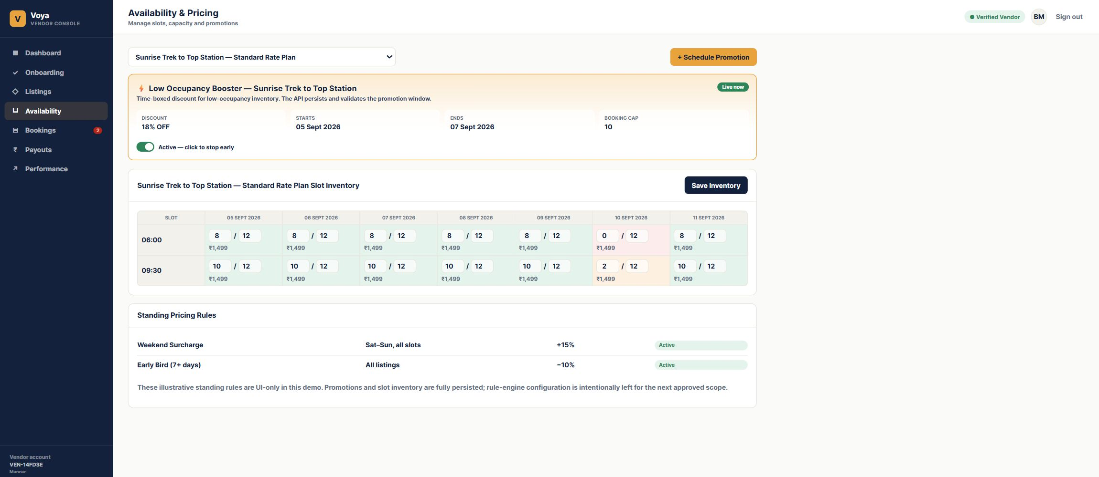
Figure 6. Exact Availability screen captured from the running Chrome application. The live demo contains at least 10 selectable rate plans with inventory.
Field | Meaning | Rule
Rate Plan Selector | Chooses which plan’s slots are being viewed | Only rate plans with seeded inventory appear
Slot Date | Service date | Stored as a date without a time of day
Start Time | Daily operating slot time | Combined with date and plan to identify a slot
Available | Remaining places for that slot | Must not be greater than capacity
Capacity | Maximum places for that slot | Used to protect inventory limits
Price Override | Optional slot-specific price | Otherwise the rate plan base price is used
Closed | Temporarily closes a slot | Closed slots cannot be sold
Promotion | Time-boxed discount for an activity | Has start, end, discount, and booking cap

Save Inventory sends the visible slots to the API. The backend uses optimistic version checks so a stale browser cannot silently overwrite another update.

Bookings
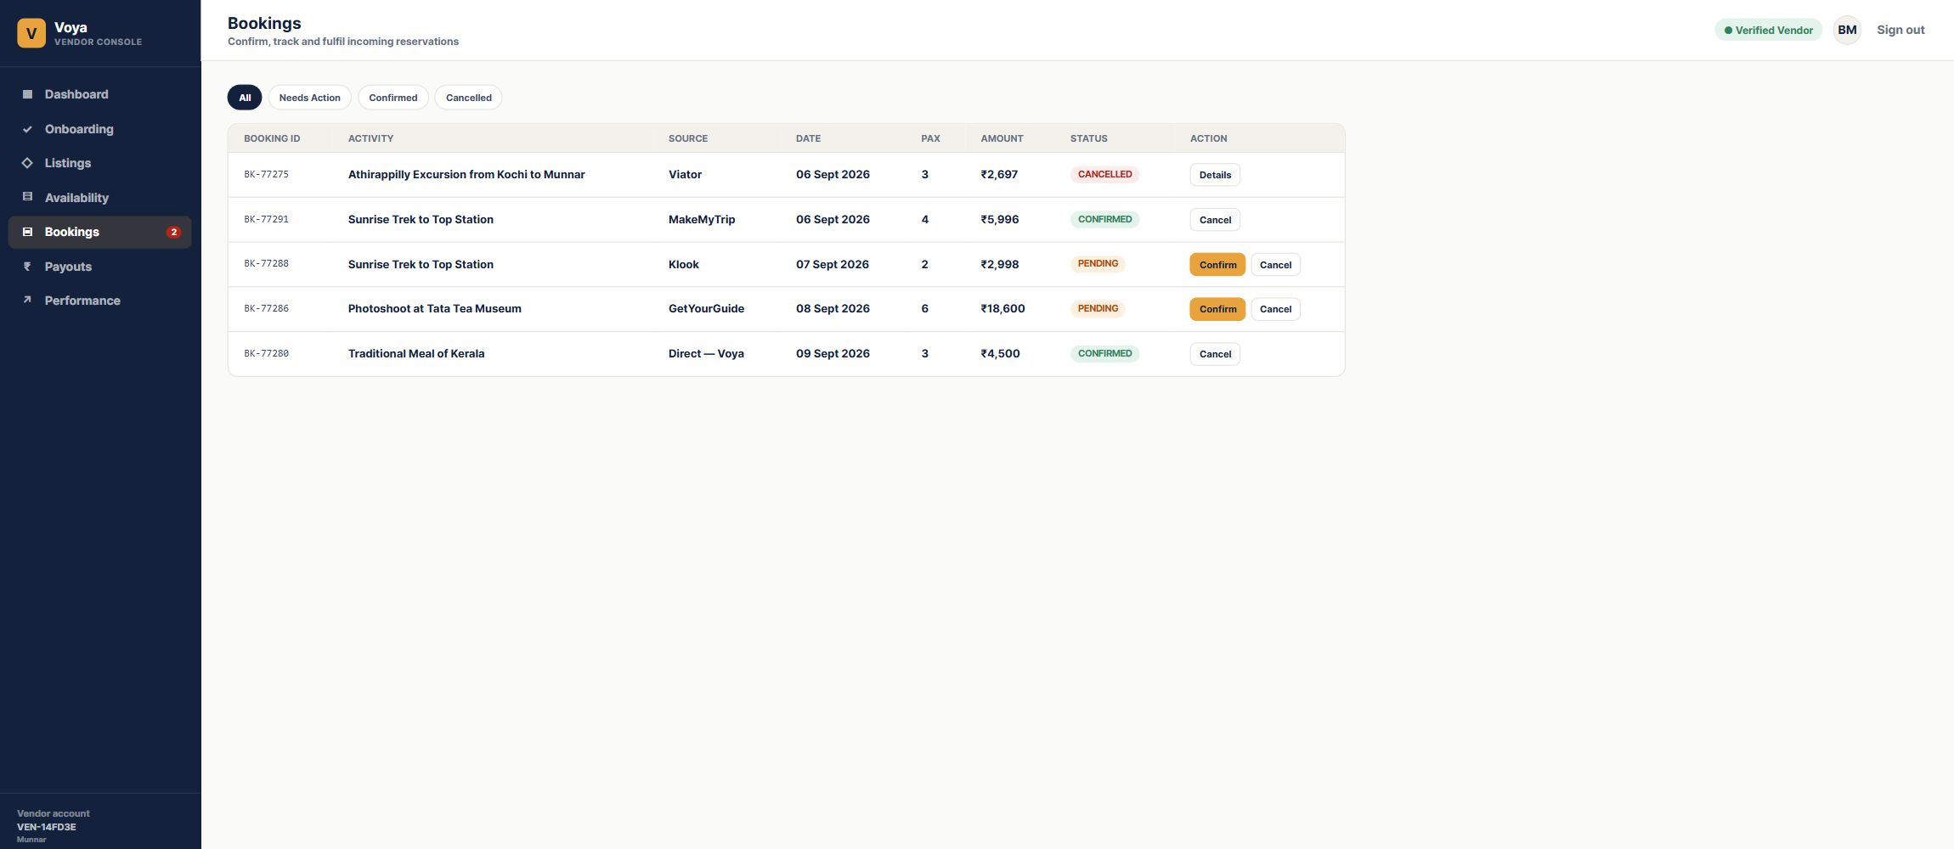
Figure 7. Exact Bookings screen captured from the running Chrome application.
Use All, Needs Action, Confirmed, and Cancelled filters to manage incoming reservations. A pending booking can be confirmed or cancelled. Confirmed and completed bookings expose Voucher. The API protects valid state transitions and keeps booking records isolated to the vendor tenant.

Payouts and performance
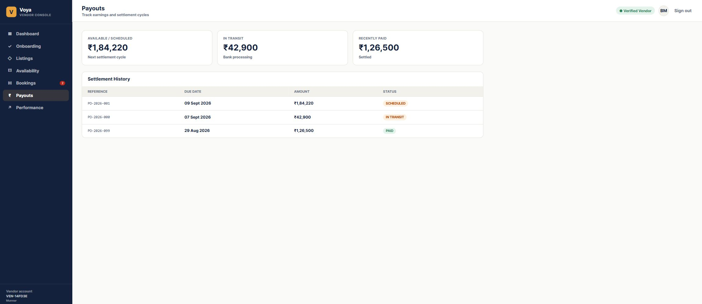
Figure 8. Exact Payouts screen captured from the running Chrome application.
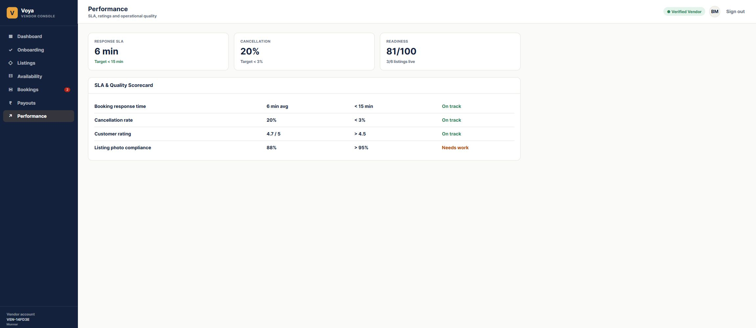
Figure 9. Exact Performance screen captured from the running Chrome application.
Payouts is read-only settlement history in this demo. Performance summarizes response time, cancellation rate, customer rating, readiness, and listing quality so the vendor knows what needs attention.

Recommended live demo script
This is a short logical demonstration for a stakeholder or tester. Keep the browser and pgAdmin open side by side when you want to prove that the UI change reached PostgreSQL.
Order | What to do | What to point out
1 | Open http://localhost:3007 and sign in with vendor@voya.demo / Demo@123 | The login is real and creates an authenticated session.
2 | Open Onboarding and change the category, then save | The success message confirms the PATCH request; refresh to prove persistence.
3 | Choose a pending document and select a file | The card changes to Uploaded and Verified with the filename.
4 | Open Listings, select an activity, and review the editor sections | Basic information, location, media, logistics, rate plans, policies, and availability are linked by the activity ID.
5 | Add or edit a rate plan | Explain currency, traveller prices, pax limits, valid dates, operating days, blackout dates, cancellation rules, and auto-redeem.
6 | Select Publish Listing | The activity becomes LIVE in the demo and returns to the listing list.
7 | Open Availability and choose one of the 10 seeded plans | Edit available seats, capacity, price override, and Closed, then select Save Inventory.
8 | Schedule a promotion and toggle it | The time-boxed promotion is persisted and can be stopped or resumed.
9 | Open Bookings and confirm a pending booking | The status changes to CONFIRMED; select Voucher to show the generated voucher code.
10 | Return to Dashboard, Payouts, and Performance | These screens read summary and settlement data from the API and show the operational result.

How to verify the flow in pgAdmin
Connect to PostgreSQL 16, expand Databases, select activity_saas, then expand Schemas, public, and Tables. Right-click a table and choose View/Edit Data followed by All Rows. Useful tables for the demonstration are VendorProfile for onboarding and documents, Activity for listing fields and status, RatePlan for commercial rules, TravellerRule and CancellationRule for nested pricing rules, AvailabilitySlot for inventory, Promotion for discounts, Booking for confirmations and vouchers, and Payout for settlement history.
The strongest verification is to edit one value in the browser, save it, refresh the screen, and then open the corresponding table row in pgAdmin. The value should be identical because the browser does not use a mock-only form state for these persisted actions.

Database relationship in simple terms
The important chain is: Tenant → Vendor User and Vendor Profile. Tenant → Activities. Activity → Media, Rate Plans, Promotions, and Bookings. Rate Plan → Traveller Rules, Cancellation Rules, and Availability Slots. Booking can point back to the Activity and the selected Rate Plan.
When you use this screen | The main database row being changed
Save Business Details | VendorProfile
Save Draft / Edit Activity | Activity
Add Media | ActivityMedia
Create Rate Plan | RatePlan plus TravellerRule and CancellationRule
Save Inventory | AvailabilitySlot
Schedule Promotion | Promotion
Confirm or Cancel Booking | Booking

Troubleshooting
If the browser is blank, confirm the backend is running on port 4007 and the frontend on port 3007. If lists are empty, confirm the browser is logged in as vendor@voya.demo and that PostgreSQL database activity_saas is running. In pgAdmin, browse rows by expanding activity_saas → Schemas → public → Tables, then right-click a table and choose View/Edit Data → All Rows.

