Mortgage UWA V0.2 Page Guide
Chrome screenshots, navigation, forms, fields, and workflow explanations
Prepared 2026-09-13 | Local demo environment

This guide explains the pages currently available in the single Angular application. Screenshots were captured from the running local application using synthetic demo accounts. Values and credentials are for portfolio testing only and must not be used for real lending decisions.

Application map
Workspace | Login | Main purpose
Consumer | /consumer/login | Borrower progress, application details, documents, and requests
Operations | /operations/login | Mortgage pipeline, processor queue, policy rules, and underwriting
Admin | /admin/login | Tenant configuration, users, memberships, branches, products, and policies

Demo credentials
Workspace | Email | Password
Consumer | consumer@mortgage-uwa.local | Mortgage@123
Operations | underwriter@mortgage-uwa.local | Mortgage@123
Admin | admin@mortgage-uwa.local | Mortgage@123
Tenant admin | tenant.admin@mortgage-uwa.local | Mortgage@123

Each workspace has a separate route shell and backend authorization context. The landing page workspace buttons also prefill the corresponding synthetic credentials.

1 Consumer login
Route: /consumer/login Audience: Consumer

What this page does
Provides the borrower entry point and identifies the selected workspace before authentication.

Links and actions
- Borrower / Consumer selects the consumer demo identity.
- Lending Operations selects the underwriter demo identity.
- Tenant Administration selects the platform-admin demo identity.
- Sign in submits email, password, and the selected portal to the backend.

Forms and fields
Field or control | How it is used
Workspace selector | Prefills the demo email and password and marks the selected portal.
Email | Login email sent to the local authentication API.
Password | Synthetic demo password used for local authentication.
Sign in | Authenticates and redirects to the selected workspace.

Implementation notes
- The same login component is reused by all three login routes.
- Consumer, operations, and admin portal mismatches are rejected by the backend.
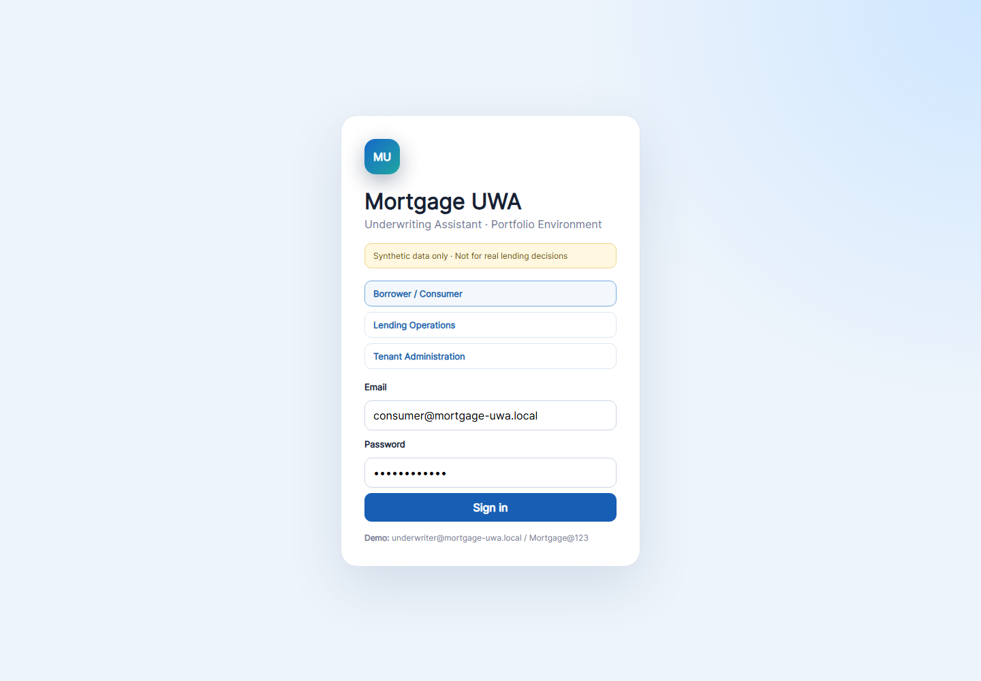
Chrome screenshot: /consumer/login

2 Operations login
Route: /operations/login Audience: Loan officer, processor, underwriter, manager, or auditor

What this page does
Authenticates an internal lending user and routes the user to the operations workspace.

Links and actions
- Workspace selector changes the prefilled identity.
- Sign in redirects to the operations dashboard.

Forms and fields
Field or control | How it is used
Email | Internal synthetic user email.
Password | Synthetic demo password.
Sign in | Creates a tenant-scoped operations session.

Implementation notes
- The underwriter account is used for the operations screenshots in this guide.
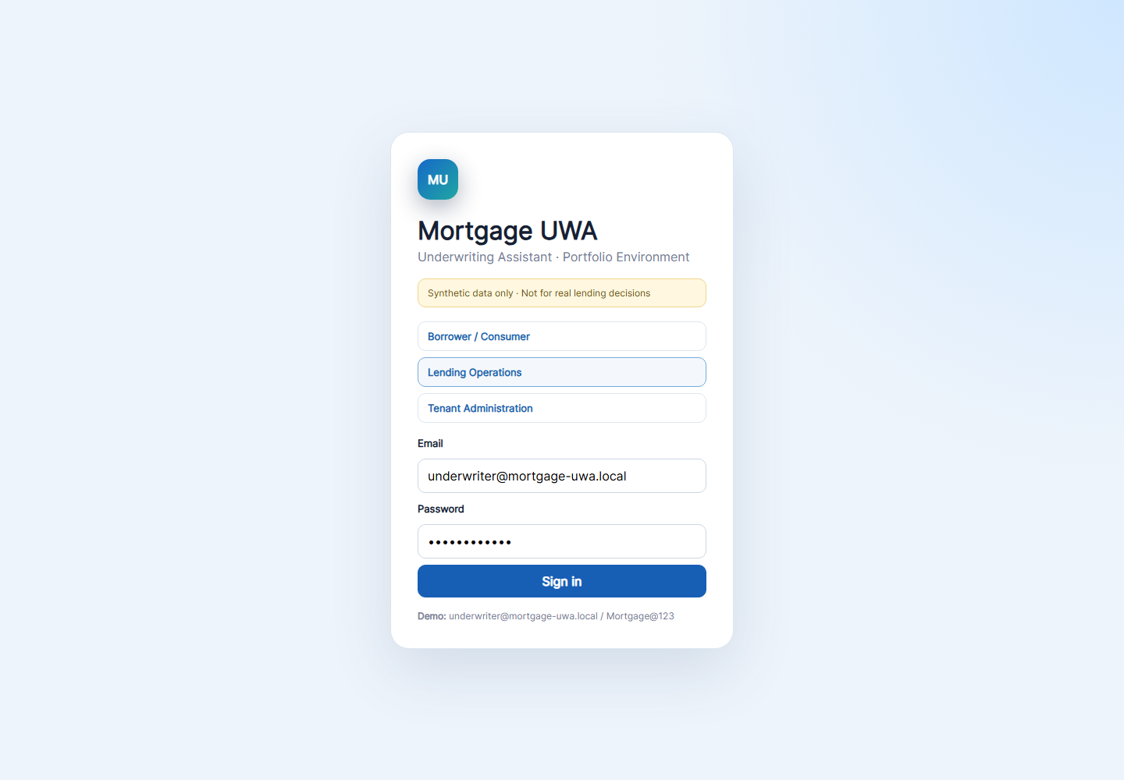
Chrome screenshot: /operations/login

3 Admin login
Route: /admin/login Audience: Platform administrator or tenant administrator

What this page does
Authenticates an administrator and routes to tenant configuration pages.

Links and actions
- Tenant Administration selects the platform-admin credentials.
- Sign in opens the admin overview.

Forms and fields
Field or control | How it is used
Email | Admin identity email.
Password | Synthetic demo password.
Sign in | Creates a platform or tenant-admin session.

Implementation notes
- An underwriter cannot enter the admin portal; the backend returns a clear authorization error.
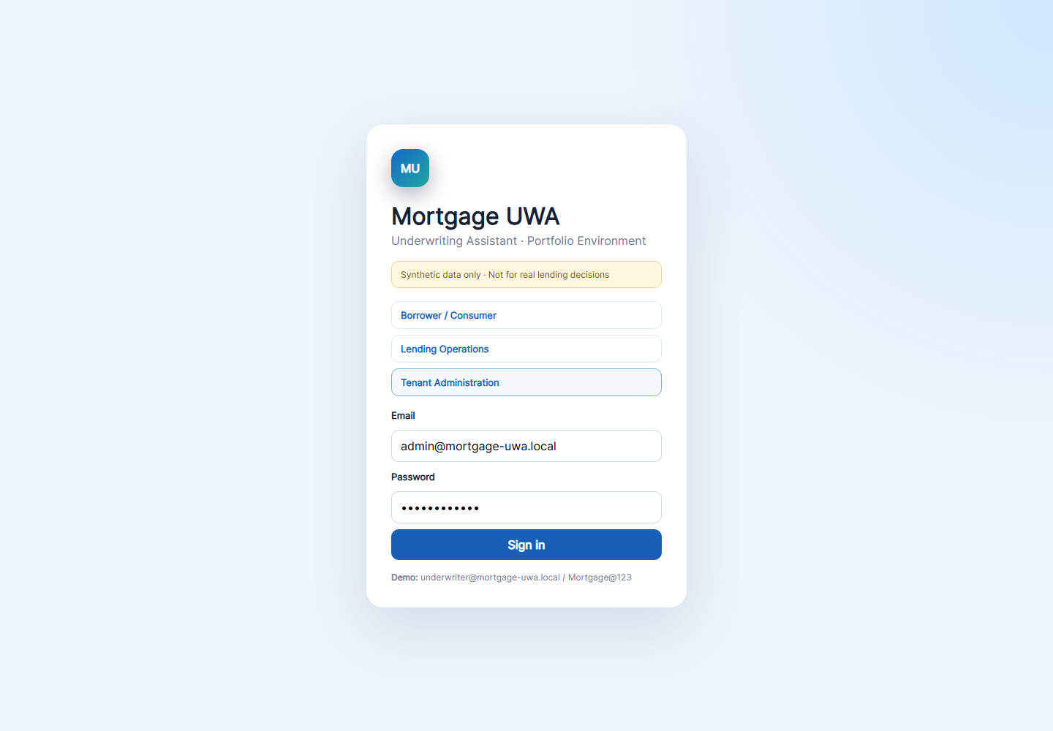
Chrome screenshot: /admin/login

4 Consumer dashboard
Route: /consumer/dashboard Audience: Consumer

What this page does
Shows the borrower-owned application, current status, progress indicators, and next action.

Links and actions
- Overview opens the dashboard.
- My application opens editable borrower details and documents.
- Documents opens the current document experience.
- Tasks & requests opens the current consumer progress experience.
- Open application and Continue open My application.
- Sign out clears the local session.

Forms and fields
Field or control | How it is used
Application card | Displays the consumer-owned application number, borrower name, and status.
Progress cards | Shows application, document, credit authorization, and closing progress.
Next action | Explains what the borrower should do next.

Implementation notes
- The consumer view is tenant and consumer-identity scoped; it does not expose internal rules or other borrowers.
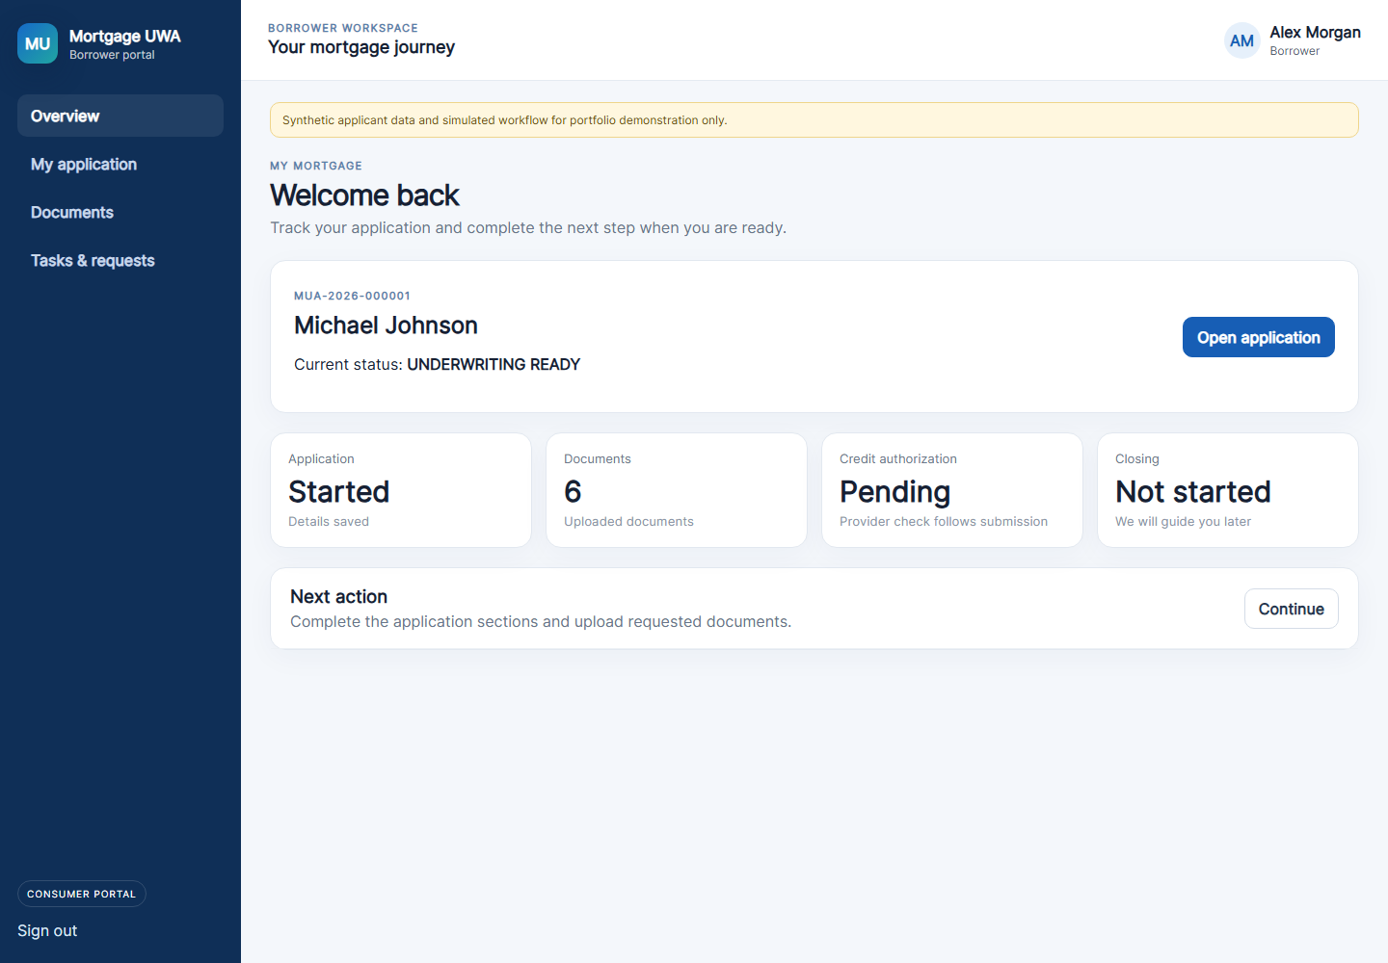
Chrome screenshot: /consumer/dashboard

5 Consumer application
Route: /consumer/application Audience: Consumer

What this page does
Displays the borrower-owned application details and allows document submission or download.

Links and actions
- Overview, My application, Documents, and Tasks & requests are the consumer navigation links.
- Save details shows a local synthetic save confirmation.
- Download retrieves a protected document copy.

Forms and fields
Field or control | How it is used
First name | Borrower first name displayed in the application form.
Last name | Borrower last name displayed in the application form.
Email | Borrower email displayed in the application form.
Save details | Shows a synthetic local confirmation; full borrower-field persistence is not yet implemented.
Document type | Selects PAYSLIP, BANK_STATEMENT, CREDIT_REPORT, IDENTITY, or TAX_RETURN.
File | Accepts PDF, JPG, or PNG documents.
Upload document | Stores the private file and queues local processing.
Download | Downloads an existing protected application document.

Implementation notes
- Credit is not entered by the consumer; it comes from the mock credit provider or document extraction.
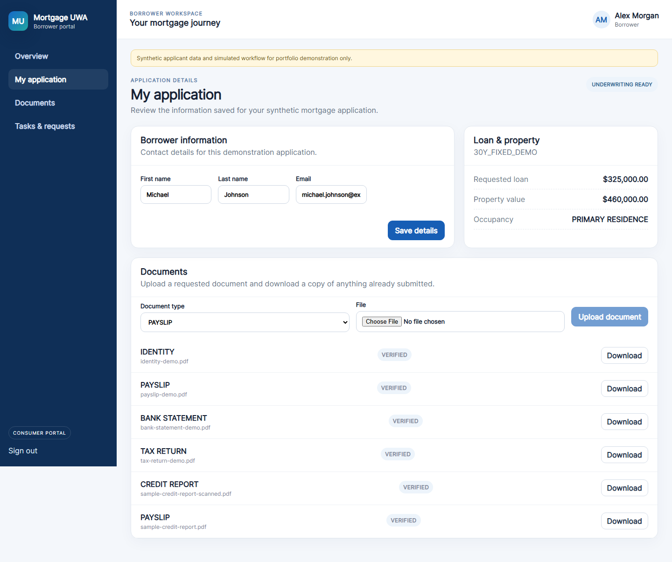
Chrome screenshot: /consumer/application

6 Consumer documents
Route: /consumer/documents Audience: Consumer

What this page does
Provides the documents navigation entry for the borrower.

Links and actions
- The same consumer shell links remain available.
- Document type, file, upload, and download controls are available in the current shared application component.

Forms and fields
Field or control | How it is used
Document type | Chooses the document category.
File | Chooses a PDF, JPG, or PNG.
Upload document | Queues the selected document for processing.
Download | Downloads a submitted document.

Implementation notes
- This route currently reuses the ConsumerApplicationComponent, so it displays the same functional document area as My application.
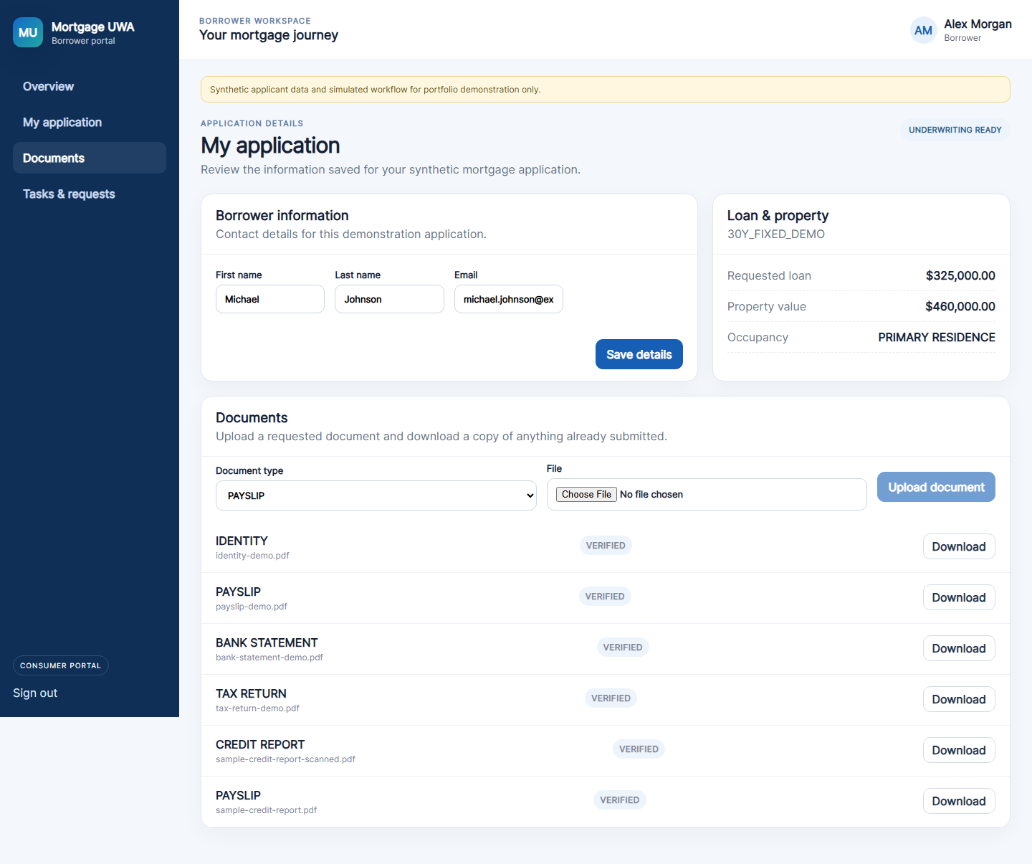
Chrome screenshot: /consumer/documents

7 Consumer tasks
Route: /consumer/tasks Audience: Consumer

What this page does
Provides the borrower tasks and requests navigation entry.

Links and actions
- Overview, My application, Documents, and Tasks & requests remain available.
- Continue opens the application details workflow.

Forms and fields
Field or control | How it is used
Next action | Displays the current borrower action message.
Continue | Opens the consumer application page.

Implementation notes
- This route currently reuses the ConsumerDashboardComponent; the full consumer task inbox is a future enhancement.
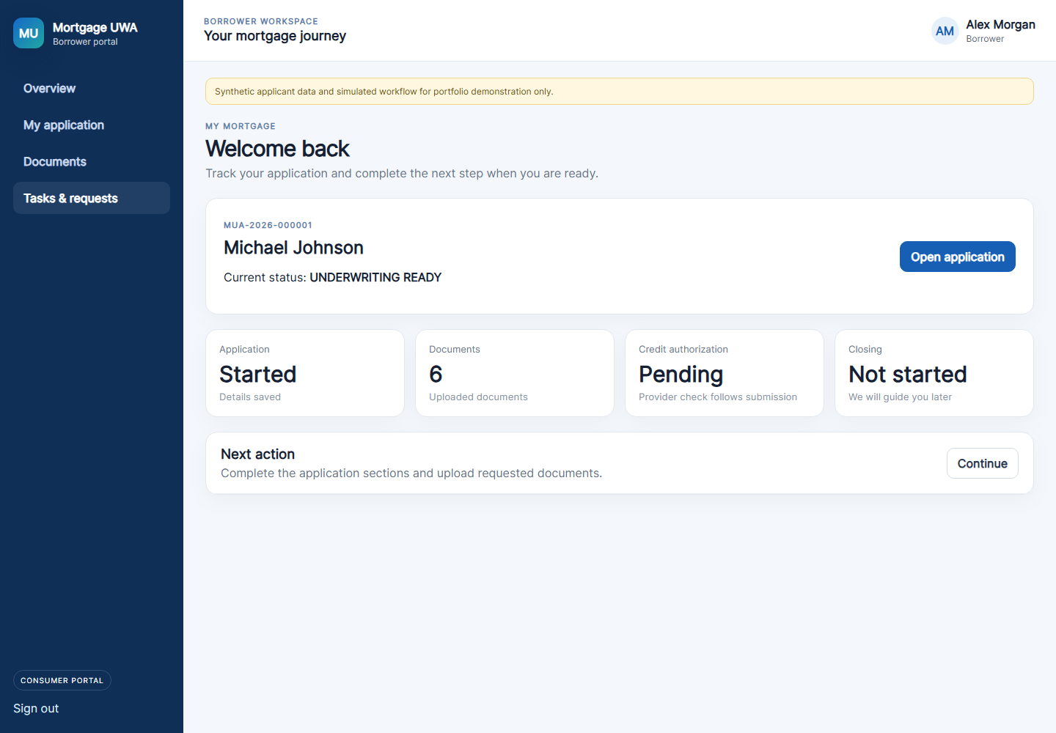
Chrome screenshot: /consumer/tasks

8 Operations dashboard
Route: /operations/dashboard Audience: Internal lending operations

What this page does
Summarizes the tenant-scoped mortgage portfolio and recent applications.

Links and actions
- Overview opens this dashboard.
- Processor queue opens processing work.
- Applications opens the pipeline.
- Policy rules opens tenant rules.
- Open applications opens the application list.
- Review opens an application workbench.

Forms and fields
Field or control | How it is used
Portfolio metrics | Total, ready, manual-review, approved, and declined counts.
Recent applications table | Shows application, applicant, loan, underwriter, status, and Review link.

Implementation notes
- The dashboard uses the authenticated tenant context for internal users.
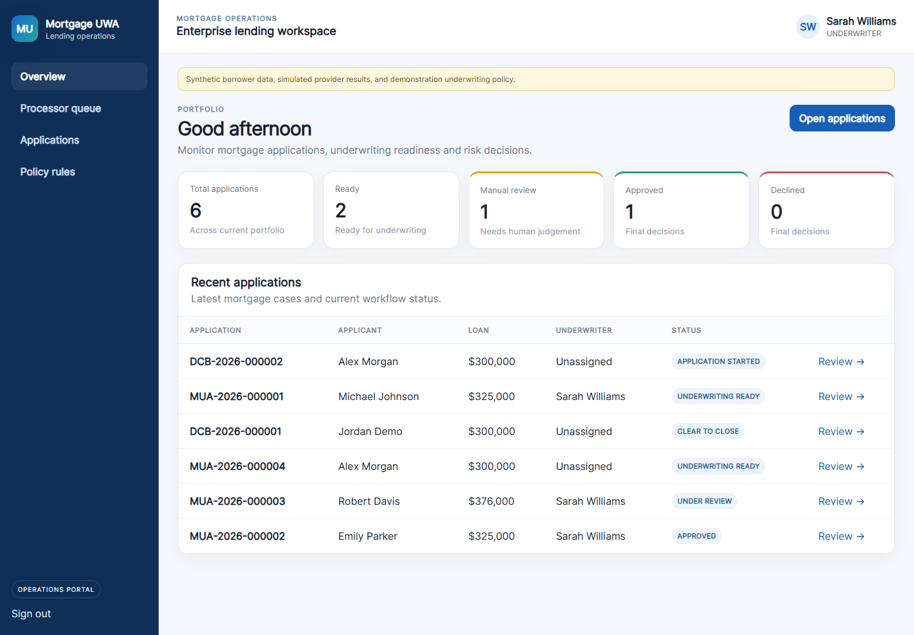
Chrome screenshot: /operations/dashboard

9 Processor queue
Route: /operations/processor Audience: Loan processor or internal operations user

What this page does
Lists assigned applications and document readiness for processing follow-up.

Links and actions
- Overview, Processor queue, Applications, and Policy rules are the main operations links.
- Open opens the application workbench.

Forms and fields
Field or control | How it is used
Application | Application number and SLA indicator.
Borrower | Applicant name.
Loan product | Current product label.
Documents | Number of uploaded documents.
Status | Current application lifecycle status.
Open | Opens the application workbench.

Implementation notes
- Task creation and completion are available through the backend operations task API.
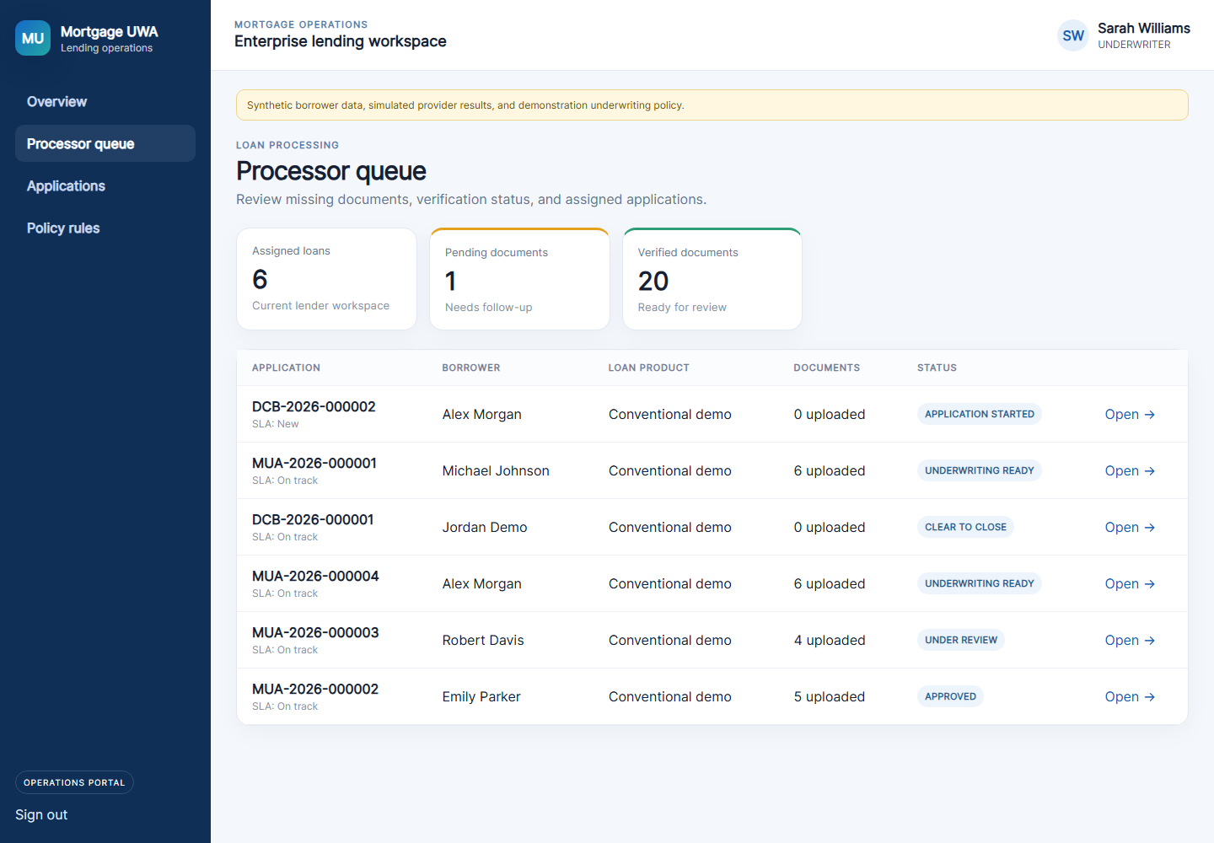
Chrome screenshot: /operations/processor

10 Operations applications
Route: /operations/applications Audience: Loan officer or internal operations user

What this page does
Displays the mortgage pipeline and exposes the new-application form.

Links and actions
- New application toggles the intake form.
- Cancel closes the form.
- Start application creates a persisted APPLICATION_STARTED application.
- Open navigates to the application workbench.

Forms and fields
Field or control | How it is used
First name | Applicant first name.
Last name | Applicant last name.
Email | Applicant email.
Requested loan | Requested loan amount; must be positive.
Property value | Estimated property value; must be positive.
Gross monthly income | Declared gross monthly income; must be positive.
Monthly debt | Declared monthly debt; zero or greater.
Start application | Creates the application; credit score is not accepted from this form.

Implementation notes
- The current form is a compact operations intake. A full multi-section consumer wizard is not yet implemented.
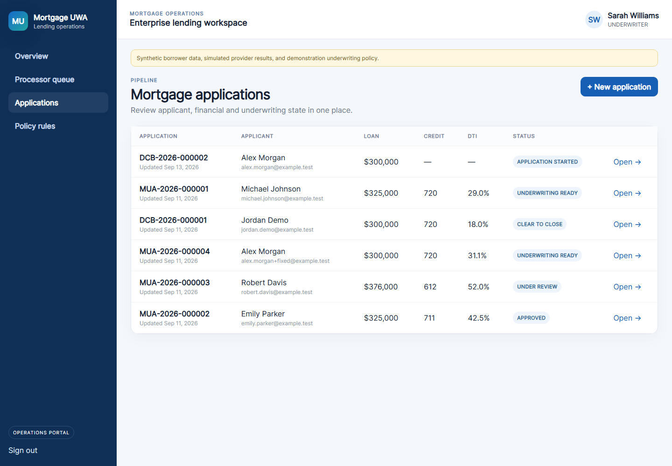
Chrome screenshot: /operations/applications

11 Policy rules
Route: /operations/rules Audience: Underwriter or authorized internal user

What this page does
Displays tenant-scoped demonstration underwriting thresholds and versions.

Links and actions
- Operations navigation links remain available.
- Policy cards are informational; no policy-edit form is currently exposed.

Forms and fields
Field or control | How it is used
Version | Policy version, such as 2026.1.
Rule name and code | Human-readable and system rule identifiers.
Approve threshold | Synthetic approve boundary.
Review threshold | Synthetic manual-review boundary.
Status | Shows whether the rule is active.

Implementation notes
- These are demonstration policies only and are not real lender policies.
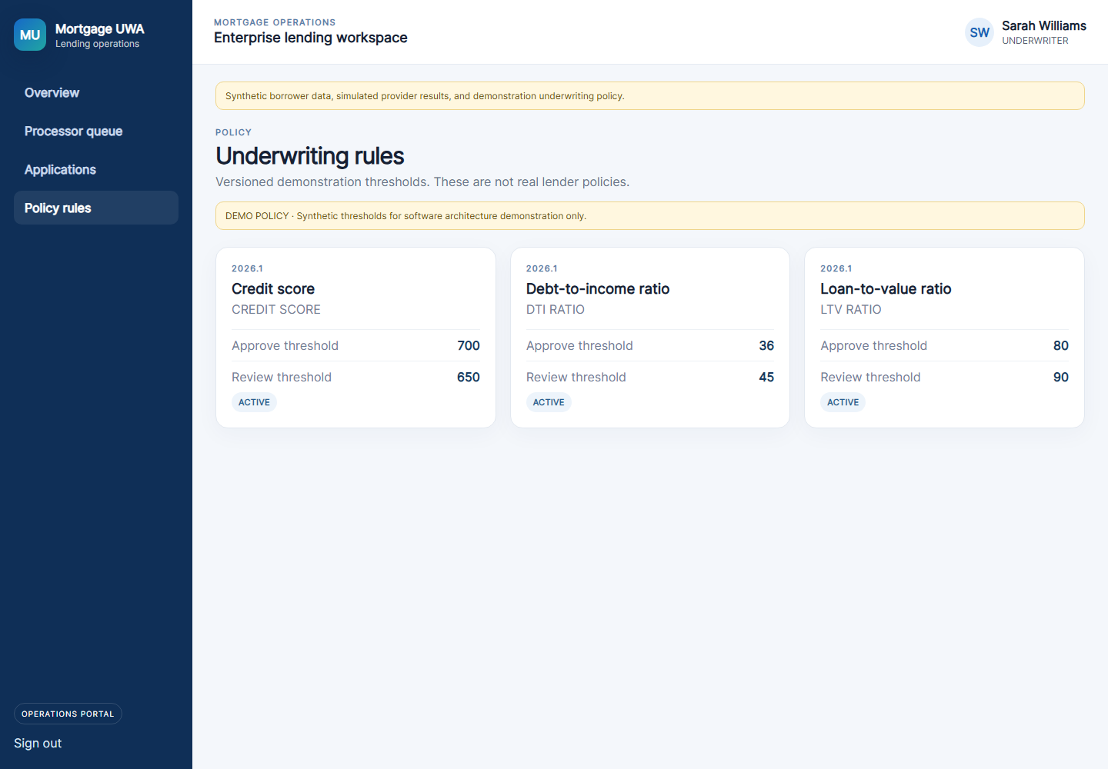
Chrome screenshot: /operations/rules

12 Underwriter workbench
Route: /applications/:id Audience: Underwriter or authorized operations user

What this page does
Combines provider actions, underwriting findings, documents, conditions, financial values, decisions, and audit history.

Links and actions
- Run mock credit creates a synthetic report and tradelines.
- Run Demo AUS creates an AUS submission and recommendation.
- Run underwriting evaluates tenant rules.
- Document type, File, Upload document, and Download manage evidence.
- Add source-of-funds condition creates a required condition.
- Approve, Request documents, and Decline record human decisions.

Forms and fields
Field or control | How it is used
Provider buttons | Run credit, AUS, and underwriting services for the application.
Document type | Selects the evidence category.
File | Selects a PDF, JPG, or PNG.
Upload document | Queues tenant-aware document processing.
Condition control | Creates or advances a condition through its workflow.
Reason | Human decision explanation.
Approve / Request documents / Decline | Records the authorized human decision.
Audit trail | Shows append-only application events.

Implementation notes
- Required conditions block Clear to Close until satisfied or waived.
- Provider results are synthetic and persisted for the tenant.
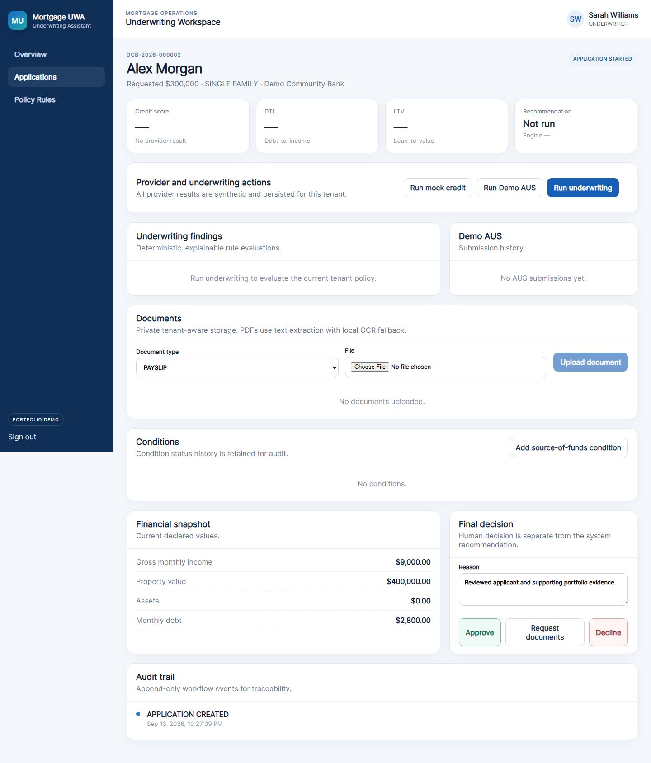
Chrome screenshot: /applications/:id

13 Admin overview
Route: /admin/overview Audience: Platform administrator or tenant administrator

What this page does
Summarizes tenant configuration, users, memberships, branches, products, policies, and application counts.

Links and actions
- Tenant overview opens this page.
- Users & memberships opens the dedicated users page.
- Branches opens the dedicated branches page.
- Policies & products currently opens this overview page.
- Sign out clears the session.

Forms and fields
Field or control | How it is used
Tenant cards | Show tenant code, name, application count, membership count, branches, and status.
Policy versions | Show tenant, rule code, thresholds, and version.
Summary metrics | Show tenants, branches, users, and applications.

Implementation notes
- Platform admins see both seeded tenants; tenant admins see only their own tenant.
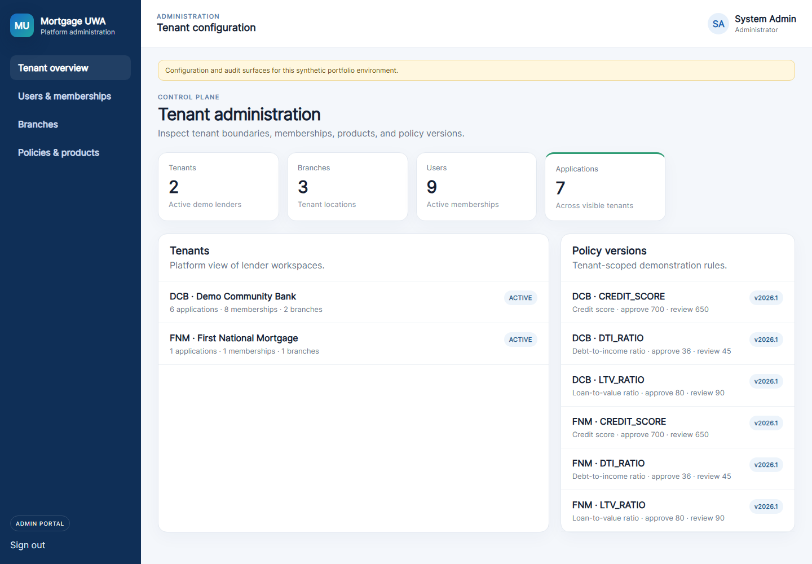
Chrome screenshot: /admin/overview

14 Admin users and memberships
Route: /admin/users Audience: Platform administrator or tenant administrator

What this page does
Lists active users and the tenant memberships that grant roles and branch context.

Links and actions
- Tenant overview returns to the overview.
- Users & memberships is the active navigation item.
- Branches opens the branch directory.
- Policies & products returns to the overview-based policy screen.

Forms and fields
Field or control | How it is used
User | Display name and email for the identity.
Account type | INTERNAL, CONSUMER, or PLATFORM_ADMIN.
Tenant | Tenant code and name for the membership.
Role | Membership role such as UNDERWRITER or TENANT_ADMIN.
Branch | Assigned branch or All branches.
Status | Active or inactive identity/membership.

Implementation notes
- This is currently a read-only directory; add/edit membership forms are not yet implemented.
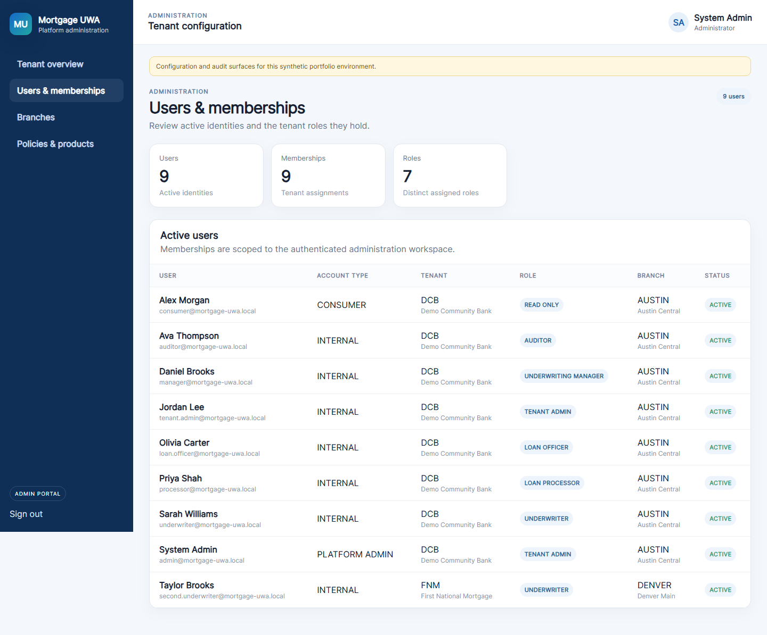
Chrome screenshot: /admin/users

15 Admin branches
Route: /admin/branches Audience: Platform administrator or tenant administrator

What this page does
Lists lender branches available in the authenticated administration scope.

Links and actions
- Tenant overview returns to the overview.
- Users & memberships opens the user directory.
- Branches is the active navigation item.
- Policies & products returns to the overview-based policy screen.

Forms and fields
Field or control | How it is used
Tenant | Tenant code and lender name.
Branch code | Tenant-unique branch code.
Branch name | Display name of the branch.
Location | City and state.
Status | ACTIVE or INACTIVE.

Implementation notes
- Platform admin sees all three seeded branches; tenant admin sees only its tenant branches.
- This is currently a read-only directory; branch create/edit forms are not yet implemented.
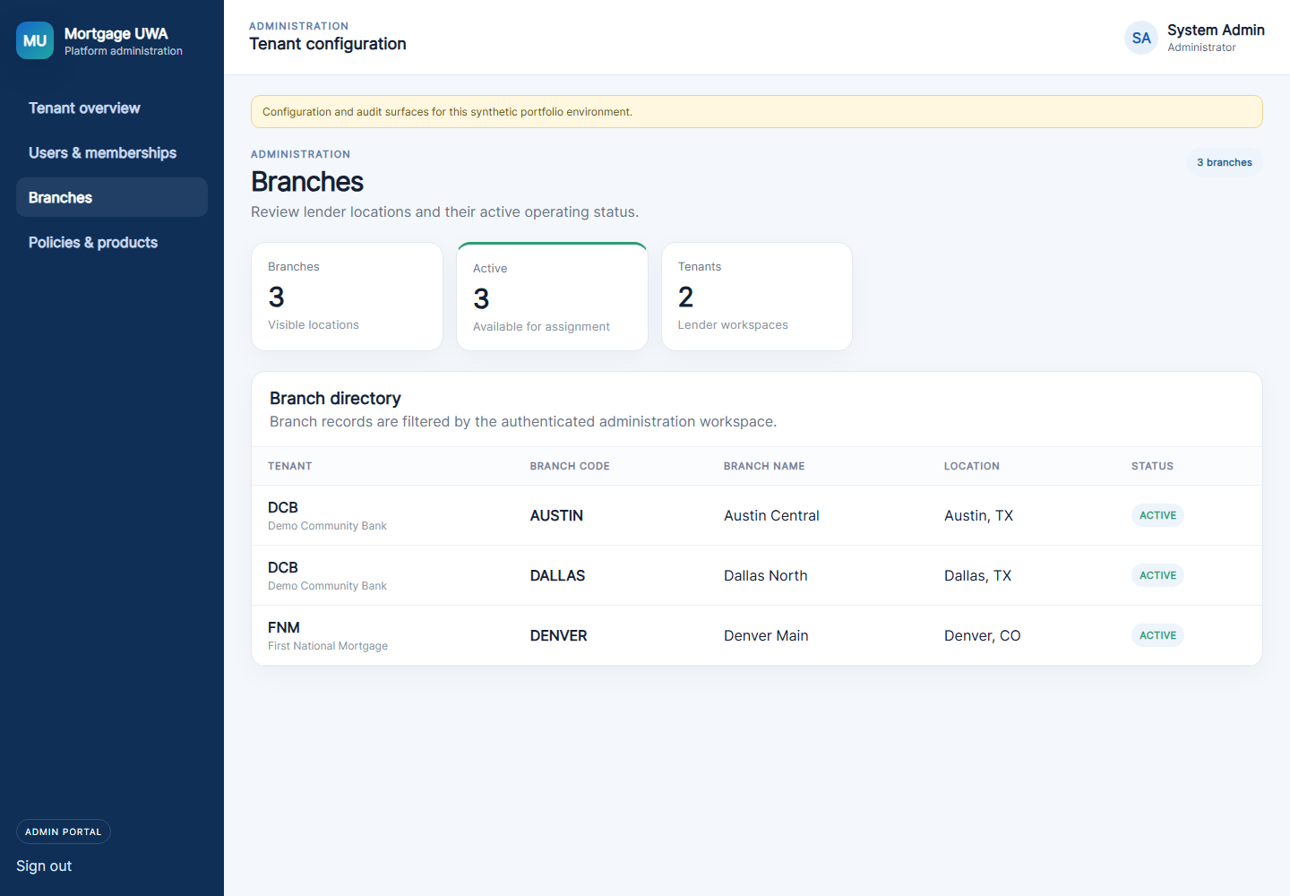
Chrome screenshot: /admin/branches

16 Admin policies and products
Route: /admin/policies Audience: Platform administrator or tenant administrator

What this page does
Provides the policy and product administration navigation entry.

Links and actions
- Tenant overview, Users & memberships, Branches, and Policies & products are available in the admin shell.

Forms and fields
Field or control | How it is used
Policy version | Displays the current tenant-scoped policy version.
Rule code | Displays the underwriting rule identifier.
Thresholds | Displays synthetic approve and review thresholds.
Product summary | Products are returned by the admin overview API but are not yet shown in a dedicated table.

Implementation notes
- This route currently reuses the AdminOverviewComponent. A dedicated policy/product management screen is a remaining enhancement.
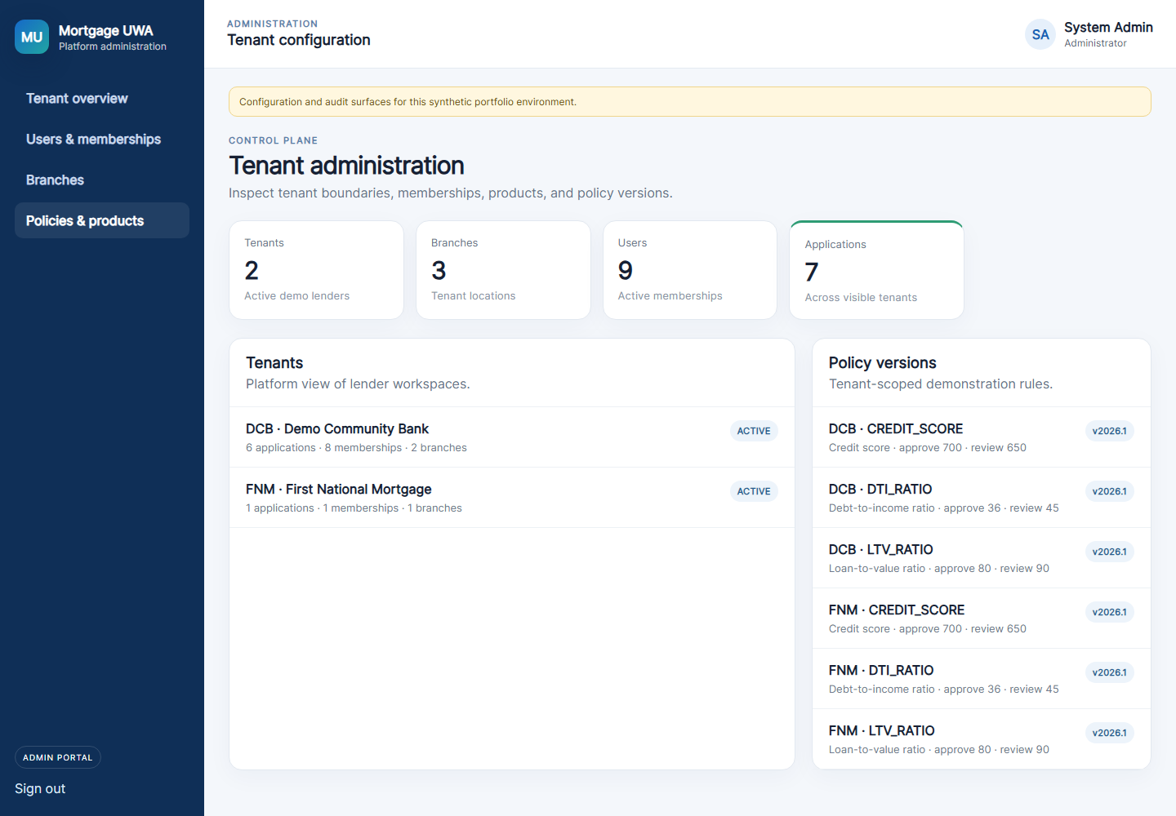
Chrome screenshot: /admin/policies

Workflow reference
A typical local demonstration flow is:
- Sign in through the appropriate workspace.
- Create or open a synthetic mortgage application.
- Upload documents and wait for S3/SQS worker processing.
- Run mock credit and Demo AUS.
- Run underwriting using tenant-scoped policies.
- Create and satisfy conditions.
- Record a human decision and issue Clear to Close only after required conditions are satisfied.

Local addresses
Service | Address
Frontend | http://localhost:6002
Backend | http://localhost:7002
Swagger | http://localhost:7002/api/docs
Floci | http://localhost:4566

All information in this guide is synthetic and intended for local portfolio demonstration only.

