RAINWOOD HOTELS

Manage Hotels
Client user guide
A practical walkthrough for creating and maintaining a hotel from Basic Info through Preview.

Audience | Hotel administrators and operations users
Workflow | Basic Info → Rooms → Amenities → Price Book → Review → Preview
Guide date | 13 August 2026
Purpose Use this guide while entering a new hotel or editing an existing one. Required fields are marked with an asterisk (*) in the application.

Before you start
- Collect the approved hotel name, code, contact details, location, status, and gallery images.
- Prepare room names, capacity, check-in/check-out times, tax settings, amenities, and room images.
- Confirm the rate plans, date ranges, occupancy prices, taxes, and inventory that should be sellable.
- Use Save, Update, or Update & Continue as shown. Draft rows are displayed at the top so they are easy to complete.

How the six-step wizard works
- Basic Info — identify the hotel and provide its public and operational details.
- Rooms — create room categories and define capacity, tax, timings, food inclusions, and images.
- Amenities — record what the hotel offers, including quantities and time-limited availability.
- Price Book — assign rate plans, apply date ranges, set daily prices, and publish inventory.
- Review & Feedback — add and manage guest reviews; search, copy, and export the review list.
- Preview — check the saved hotel summary before handing the property to the next operational process.
Navigation tip Use the stepper at the top to revisit a step. Use Back to return one step, and Update & Continue to move forward after saving the current work.

Step 1 — Basic Info
Enter the hotel master record first. These values identify the property across the admin area and the public hotel pages.
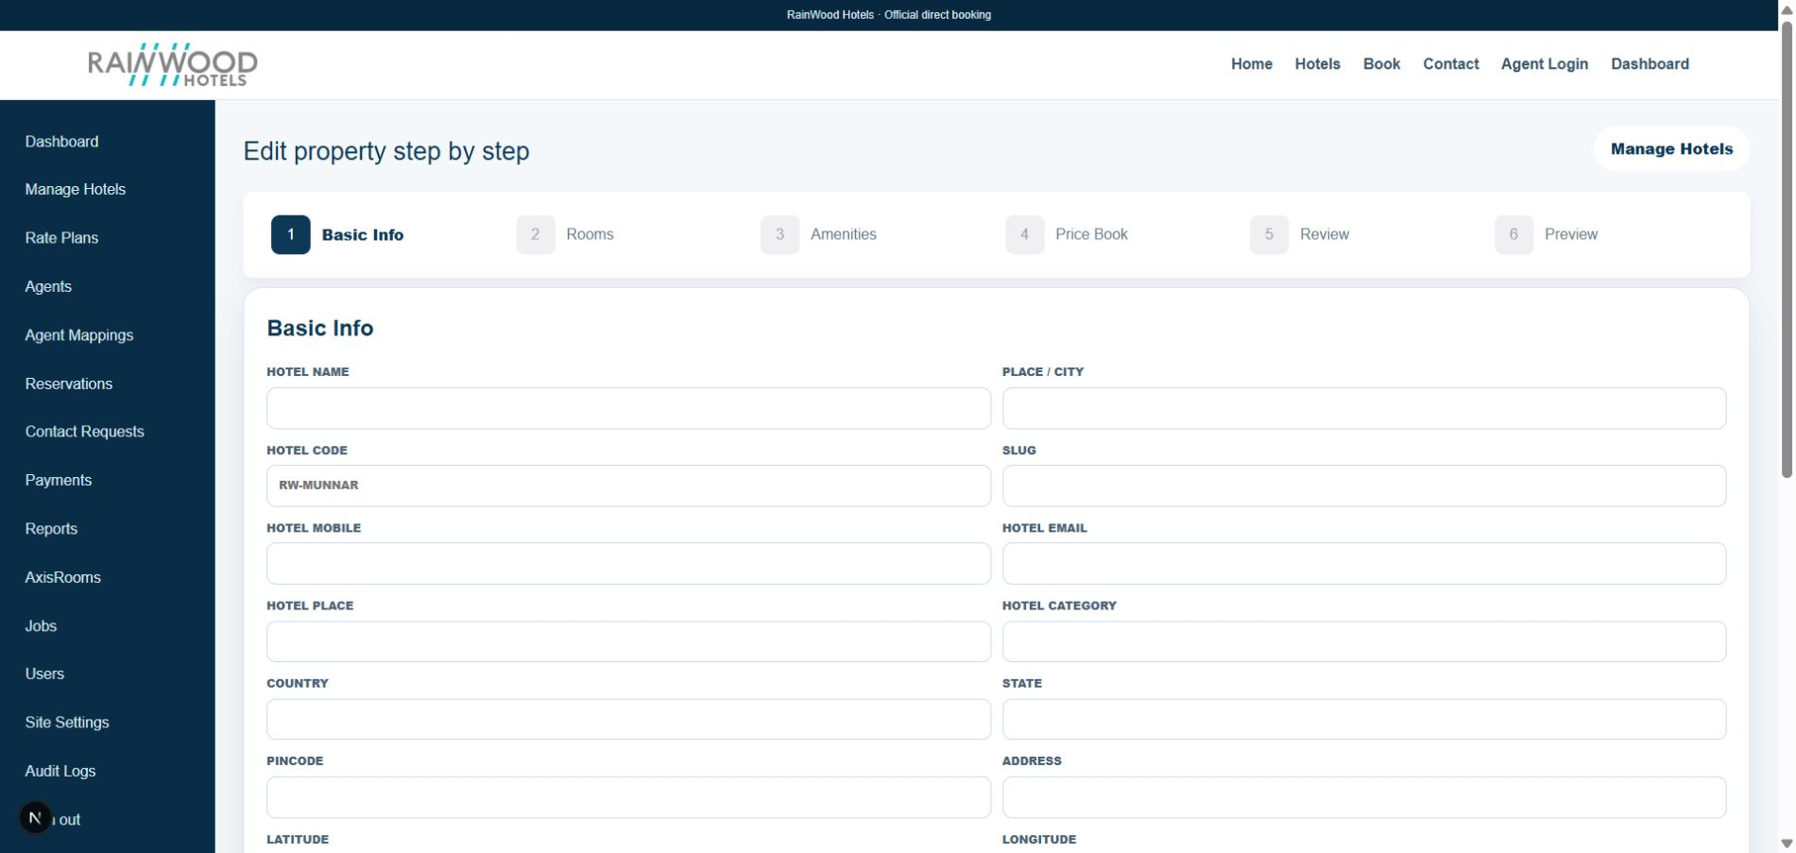
Figure 1. Local Manage Hotels preview showing the saved Basic Info fields.

Field-by-field guide
Field / control | What to enter | Why it is used
Hotel Name | Official property name. | Primary name shown in hotel listings, bookings, and preview.
Hotel Code | Short unique code, for example RW-KODAI. | Used by operations and integrations to identify the hotel.
Hotel Mobile / Email | Reservation or front-office contact details. | Used for operational communication and guest enquiries.
Hotel Place / City | Local area and city where the property is located. | Supports search, location display, and reporting.
Hotel Category | Approved category, such as 4 Star. | Communicates the property category to users and channels.
Country / State | Select the correct country and state. | Provides geographic context and supports address consistency.
Pincode | Postal code for the property address. | Used in the complete address and location records.
Latitude / Longitude | Decimal map coordinates. | Supports maps, location accuracy, and future channel integrations.
Address | Full street address, including area and postal code. | Used for guest directions, confirmations, and public details.
Hotel Status | Active when the hotel should be available. | Inactive properties can be kept for reference without being offered for sale.
Hotel Margin % | Approved margin percentage, if configured. | Used by pricing or commercial calculations.
Power Backup | Yes or No. | Communicates an important operational facility.
Description / SEO Title | Approved description and search title. | Controls public presentation and search-friendly copy.
Hotel Gallery / Hero URL | JPEG/PNG gallery images or an approved legacy hero URL. | Provides visual content for hotel cards and detail pages.

How to complete this step
- Complete all required fields before continuing. Keep the code stable once it is used by integrations.
- Use clear, approved wording in the description and SEO title; do not paste internal notes into public text.
- Select multiple gallery files only when they are final. The application shows uploaded image thumbnails for review.
- Save & Continue to move to Rooms. You can return to this step later from the stepper.
Next step After saving Basic Info, continue to Rooms and add each sellable room category.

Step 2 — Rooms
Create one room row for every room category that can be sold. Persisted rooms remain editable; a new draft row is placed at the top after Add Rooms.
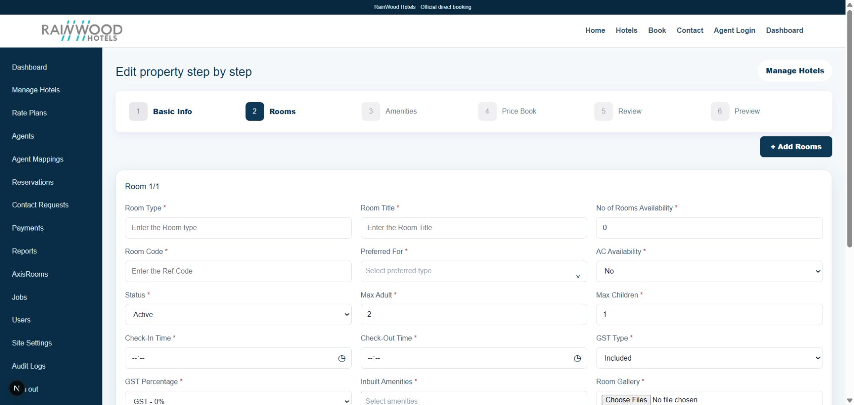
Figure 2. Local RainWood Rooms screen showing the multi-field room form and room gallery area.

Field-by-field guide
Field / control | What to enter | Why it is used
Room Type | Internal room type or category. | Groups rooms for inventory and rate management.
Room Title | Guest-facing room name. | Shown to guests and in room selections.
No. of Rooms Availability | Number of rooms available for this category. | Provides the starting capacity for availability.
Room Code | Unique reference code. | Used to identify the room in rate plans and integrations; saved codes are read-only.
Preferred For | Select one or more audiences: Couple, Family, Business, or Group. | Helps staff and guests understand the intended use.
AC Availability | Yes or No. | Communicates an important room facility.
Status | Active or Inactive. | Controls whether the room category can be offered.
Max Adult / Max Children | Maximum supported adults and children. | Supports occupancy validation and booking decisions.
Check-In / Check-Out Time | Choose the time using the time picker. | Sets the expected arrival and departure windows.
GST Type / Percentage | Included or Excluded and the approved GST band. | Controls how tax is represented in pricing and guest totals.
Inbuilt Amenities | Select room facilities such as Wi-Fi, Room Service, or Parking. | Describes facilities included with this room category.
Room Gallery | Select one or more JPEG/PNG images. | Shows room visuals; selected and uploaded thumbnails appear below the file picker.
Food Included | Optional Breakfast, Lunch, and Dinner checkboxes. | Records meal inclusions for the room offer.
Save / Update / Delete | Save a draft, update a persisted room, or remove a row. | Controls the lifecycle of each room record.

How to complete this step
- Click Add Rooms to add a blank draft. Complete the top row before starting another room.
- For a persisted room, edit the fields and click Update. Use the time picker for both time fields.
- After selecting images, confirm the thumbnails before saving. Do not upload confidential documents.
- Use Update & Continue after all room rows are saved. The next step is Amenities.
Next step Once the room categories and their images are saved, continue to Amenities.

Step 3 — Amenities
Record hotel-level amenities and the conditions under which each amenity is available. New draft amenities appear at the top of the list.
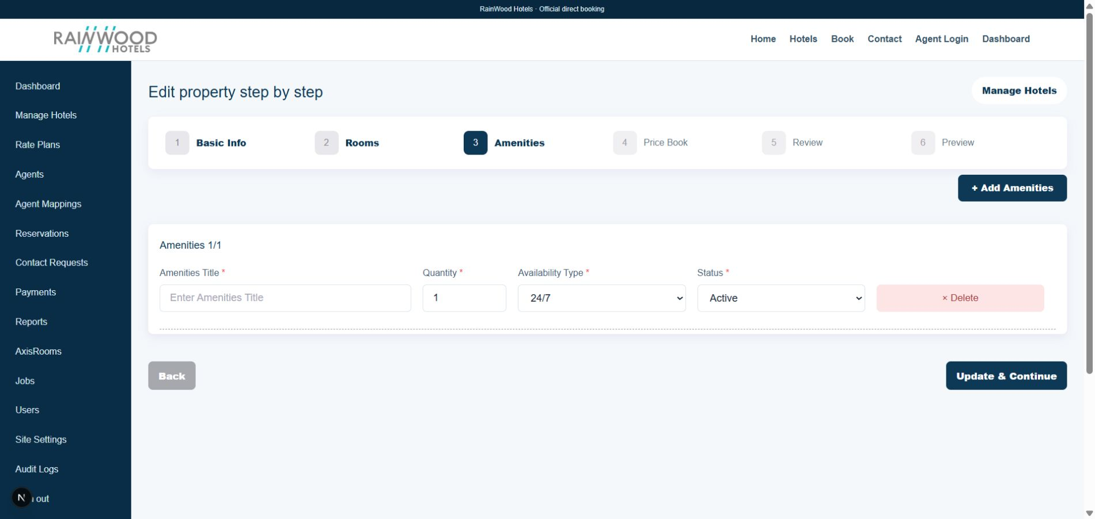
Figure 3. Local Amenities screen with Add Amenities, availability type, status, and delete controls.

Field-by-field guide
Field / control | What to enter | Why it is used
Amenities Title | Name such as Breakfast available or On-site parking. | The guest-facing label for the facility.
Quantity | Number of units or quantity available. | Helps operations describe limited or countable facilities.
Availability Type | 24/7 or Duration. | Determines whether the amenity is always available or has a time window.
Available Start / End time | Displayed when Duration is selected; choose both with the time picker. | Defines the daily availability window.
Status | Active or Inactive. | Controls whether the amenity is currently offered.
Amenities Code | Generated code shown for persisted amenities. | Provides a stable internal reference for the amenity.
Add Amenities | Adds a new blank draft row. | Keeps the new item at the top for quick entry.
Save / Update / Delete | Save a draft, update a persisted item, or remove it. | Draft deletion is immediate; persisted deletion asks for confirmation.

How to complete this step
- Choose 24/7 for an always-available facility. Choose Duration to reveal start and end time fields.
- Click outside an open custom selector to close it. Keep status Active only when the amenity is currently available.
- Delete a draft directly. For a persisted amenity, review the confirmation message before deleting because the action cannot be undone.
- Use Update & Continue after saving the amenity rows. The next step is Price Book.
Next step After amenities are accurate, continue to Price Book to configure sellable rates and inventory.

Step 4 — Price Book
Apply a rate plan to one or all rooms, add date ranges, enter occupancy pricing and tax, and publish the number of rooms available for each date.
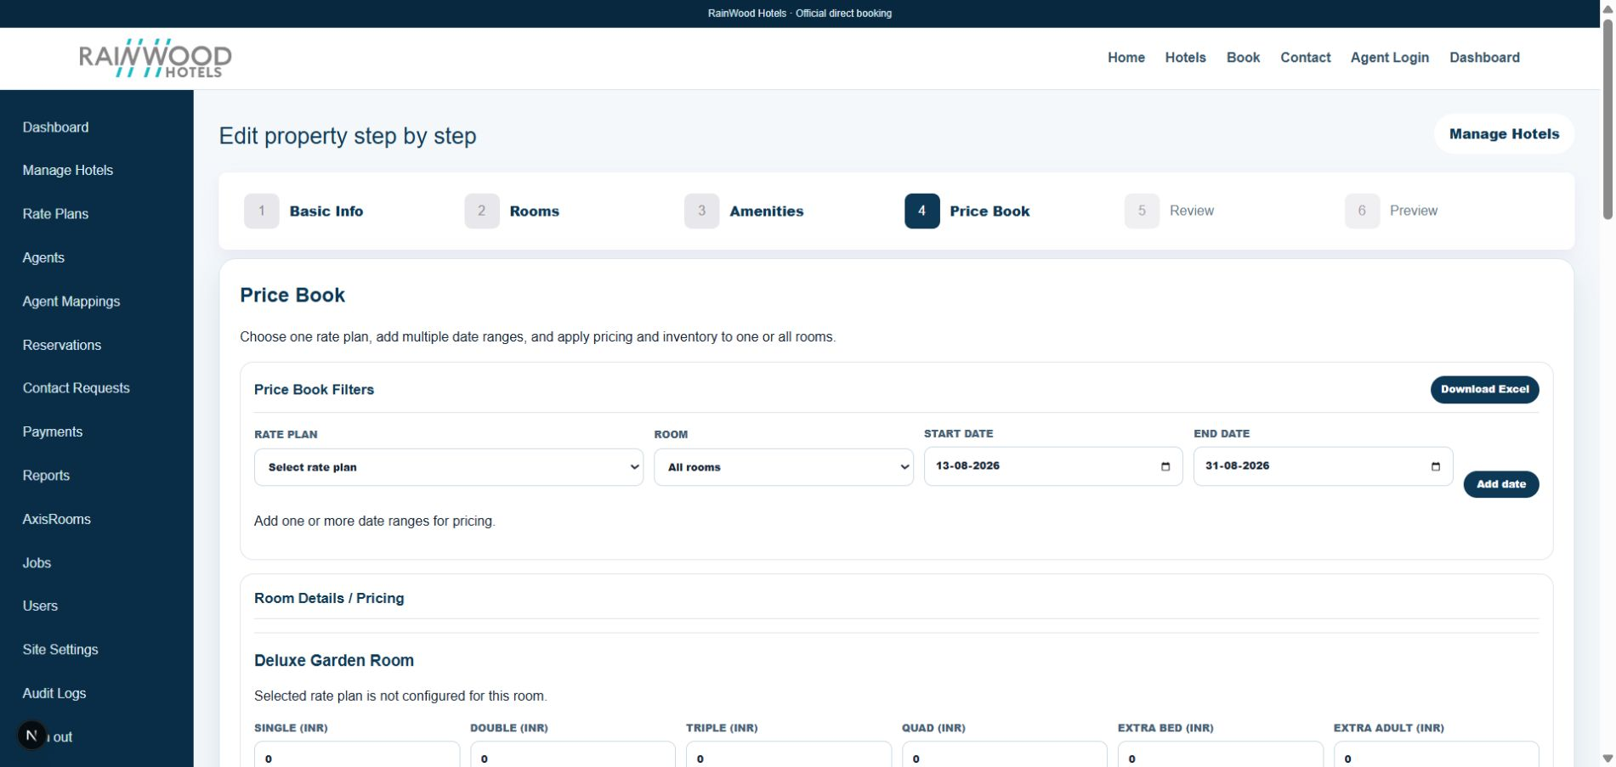
Figure 4. Local Price Book screen showing filters, date range controls, and room pricing.

Field-by-field guide
Field / control | What to enter | Why it is used
Rate Plan | Select the configured plan and meal plan. | Determines which commercial offer receives the rates.
Room | Choose one room or All rooms. | Controls which room categories receive the selected rates.
Start Date / End Date | Select the rate period. | Defines the dates on which the rate applies.
Add Date | Adds the selected range to the date-range list. | Allows multiple seasons or promotional periods on one screen.
Download Excel | Download the hotel price book workbook. | Provides an offline copy for review, sharing, or audit.
Single / Double / Triple / Quad | Enter the approved INR price for each occupancy. | Supports correct pricing for different guest counts.
Extra Bed / Extra Adult / Extra Child | Enter applicable supplements. | Adds occupancy supplements to the correct booking calculation.
Base Amount / Tax Amount | Enter the base rate and tax for the date range. | Creates the daily rate records used in availability and booking quotes.
Save Pricing | Save rates for the selected rooms and dates. | Writes or updates daily rates across the selected range.
Inventory Start / End Date | Choose the inventory period independently from pricing. | Lets availability be managed even when pricing periods differ.
Available Rooms / Stop Sell | Enter sellable rooms; check Stop sell when sales must be closed. | Controls whether rooms can be booked for each inventory date.
Save Inventory | Save inventory for selected rooms. | Creates or updates the daily room availability records.

How to complete this step
- Select a rate plan and room first, then add one or more valid date ranges.
- Enter all occupancy values that the commercial team has approved. Use 0 only when a supplement truly does not apply.
- Save pricing and inventory separately. A rate without inventory, or inventory without a rate, may not be sellable.
- Use Download Excel after saving to review the configured price book outside the application.
- Use Update & Continue to move to Review & Feedback.
Next step Once rates and inventory are saved for the intended dates, continue to Review & Feedback.

Step 5 — Review & Feedback
Add genuine guest feedback and maintain the review list. Reviews are optional, but they improve the quality of the hotel presentation and provide a useful demo dataset.
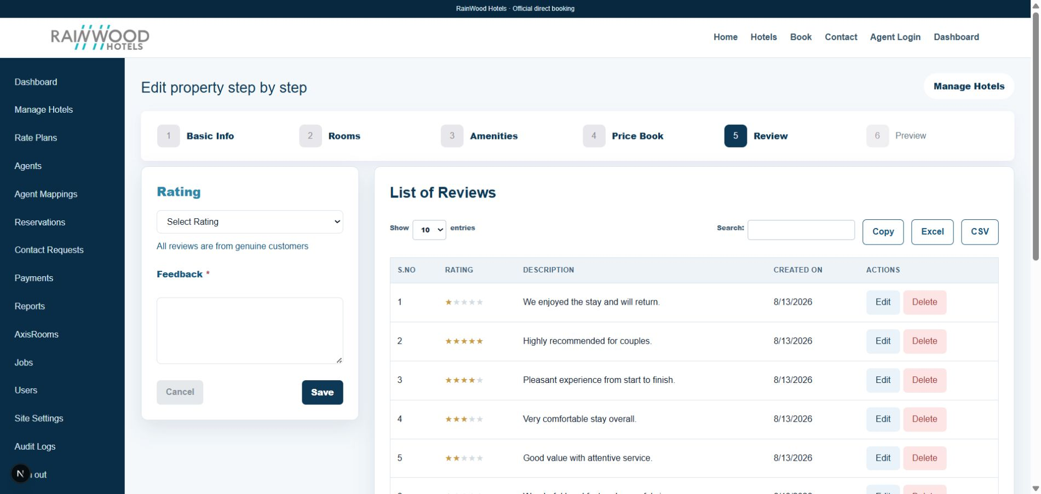
Figure 5. Local Review screen showing the entry form, search, export controls, and paginated review list.

Field-by-field guide
Field / control | What to enter | Why it is used
Rating | Choose the guest rating. | Displays the review score using stars.
Feedback | Enter the guest’s approved feedback text. | Provides the written customer experience shown in the review list.
Save | Save a new review or changes to an existing review. | Adds or updates the persisted review record.
Show entries | Choose the number of rows visible, such as 10, 25, or 50. | Controls the current page size.
Search | Search review text or visible review values. | Quickly filters the list without scrolling through every row.
Copy / Excel / CSV | Use the export button required by the client. | Copies the table or downloads it for reporting and sharing.
Edit / Delete | Edit a review or request deletion. | Maintains data quality; persisted deletion should be confirmed.
Previous / Next | Move between pages of results. | Supports review lists larger than one page.

How to complete this step
- Choose a rating, enter concise approved feedback, and click Save. Do not include private guest information.
- Use Search to verify the new review. Test Copy, Excel, and CSV when preparing a client demo.
- Use the page-size selector and Previous/Next to confirm pagination works when more than one page exists.
- After the review list is ready, use Update & Continue to open Preview.
Next step After reviewing the list and exports, continue to Preview for the final saved-property check.

Step 6 — Preview
Preview is the final read-only checkpoint for the saved hotel summary. It is intended for a quick client or operations review before the property is handed over.
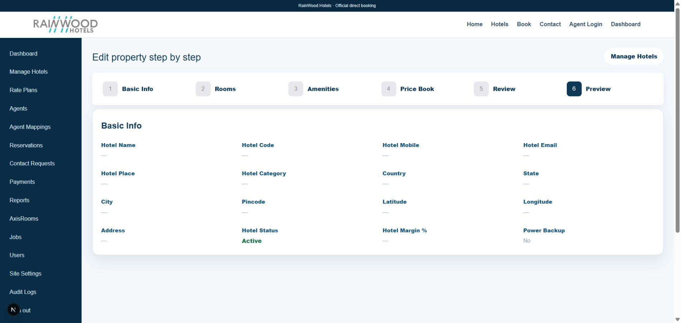
Figure 6. Local RainWood Preview screen showing the saved hotel summary and final wizard position.

Field-by-field guide
Field / control | What to enter | Why it is used
Stepper | Use steps 1–6 to revisit a section. | Lets the operator correct details without leaving the hotel workflow.
Basic Info summary | Review the displayed hotel identity, contact, location, status, margin, and power backup. | Confirms that the saved master record is correct.
Hotel Status | Confirm Active when the property should be live. | Prevents an accidental inactive hotel from being treated as sellable.
Rooms / Amenities / Price Book / Review | Return to the relevant step to inspect or edit these records. | Keeps the final check connected to the editable source data.
Manage Hotels | Return to the hotel list. | Lets the operator open another property or confirm the hotel record in the list.

How to complete this step
- Check spelling, code, contact details, location, status, margin, and power backup.
- If a value is missing or incorrect, return to its step, update it, and come back to Preview.
- Before handover, confirm at least one active room, the intended amenities, a valid rate period, and inventory where applicable.
Next step Preview completes the wizard review. Use Manage Hotels to return to the property list or revisit any step from the stepper.

Client handover checklist
- Basic Info is complete, approved, and Active where required.
- At least one room category is saved with capacity, tax, timings, and correct images.
- Amenities have the right availability type; Duration amenities have both times.
- Rate plans, date ranges, occupancy prices, taxes, and inventory are saved and reviewed.
- Review entries and exports have been checked if reviews are part of the launch content.
- Preview has been reviewed by the client or property owner.
Important The application validates required fields, but the client remains responsible for approved commercial values, tax values, public copy, images, and availability before publishing.

Quick troubleshooting
- A new room or amenity appears at the top: this is intentional; draft rows are prepended so they are easy to complete.
- Duration does not show times: choose Duration in Availability Type; the start and end time fields then appear.
- A time field is empty: open the time picker and select a valid time, then save the row.
- A gallery thumbnail is missing: confirm the file is JPEG or PNG, wait for the thumbnail, then save the room or hotel.
- A saved delete asks for confirmation: persisted records require confirmation; draft rows can be removed immediately.
- The review list looks incomplete: use Search, change Show entries, and use Previous/Next pagination.

