Property Management System
Video-derived product and implementation specification
  - Target stack: NestJS backend + React frontend
Source: 2026-08-15 10-14-38.mp4 | 35:31.97 | 1280 x 720 | 30 FPS
Prepared for an implementation agent. Screens and workflows are transcribed from the recording; labels too small to read are marked as inferred and should be confirmed against the source UI.

1. Executive implementation brief
The recording shows a browser-based hotel PMS centered on a room-board dashboard, master-data configuration, reports, reservations, guest/booking records, billing, and operational front-desk workflows. The UI uses a blue application shell, horizontal module navigation, data tables, card grids, modals, and printable PDF previews.
Area | Observed capability | Priority
Dashboard / room board | Room occupancy/status grid, counts, date context, room actions | P0
Reservations | Create/search reservation, guest/room selection, charges, payment, print | P0
Front desk | Check-in/out style operational panels and room availability | P0
Guests / bookings | Searchable tables, detail modals, status actions, document print | P0
Master data | Categories, room types, rooms, beds and configuration lists | P1
Reports | Report cards, filters, PDF/print preview | P1
Users / access | Sign-in screen and user/staff records shown or implied | P1

1.1 Evidence and confidence
- Evidence: approximately one screenshot every two seconds plus targeted keyframes around visible page/modal transitions.
- High confidence: room board, master data, room/bed/category setup, report cards/previews, reservation/guest/booking tables, billing forms and print states.
- Medium confidence: exact field labels and API names where 1280 x 720 makes text unreadable. Preserve behavior and relationships, then validate labels in the original UI.
- The recording includes repeated navigation, scrolling, hover states and modal open/close actions; repeated frames are consolidated into one screen specification per distinct state.

2. Information architecture
Navigation group | Screens / sub-screens inferred | Suggested React route
Operations | Room board; front desk; availability/day view | /dashboard, /front-desk, /availability
Reservations | Search; new reservation; detail; payment/checkout | /reservations, /reservations/new, /reservations/:id
Guests | Guest list; detail modal; guest invoice/document | /guests, /guests/:id
Bookings | Booking list; detail; booking document | /bookings, /bookings/:id
Setup | Categories; room types; rooms; beds; configuration | /settings/*
Reports | Report catalog; filters; printable output | /reports, /reports/:key
Identity | Sign in; users/staff and permissions | /auth/login, /users

2.1 Recommended NestJS module boundaries
- AuthModule: login, refresh, sessions, roles and permission guards.
- PropertyModule: property, floor, room, room type, bed, amenity and room status.
- GuestModule: guest profile, contacts, documents, preferences and search.
- ReservationModule: stay dates, occupancy, allocation, status history and commands.
- FrontDeskModule: check-in/out, room status and housekeeping/maintenance flags.
- BillingModule: folio, line items, taxes/discounts, payments, refunds and receipts.
- BookingModule: internal/external booking records and status synchronization.
- ReportModule: report definitions, filters, exports and print templates.
- AuditModule: immutable activity log for every operational mutation.

3. Screen inventory from the recording
ID | Time | Distinct screen/form state | Implementation note
S01 | 00:02 | Room-board dashboard | Counts, date context, room tiles and tile actions.
S02 | 00:08 | Reservation/search form | Date/guest/room criteria and result area.
S03 | 02:10 | Master-data list | Search/filter, add, edit/delete row actions.
S04 | 02:36 | Empty-state configuration list | No-data state with add action.
S05 | 04:20 | Configuration table | Rows with edit actions.
S06 | 04:30 | Room inventory grid | Green room cards and room status.
S07 | 04:36 | Room detail modal | Room fields and save.
S08 | 05:18 | Add category modal | Name/description-like fields and save.
S09 | 05:40 | Room/asset modal | Image placeholder, fields and save.
S10 | 08:06 | Room category editor | Colored category/status rows.
S11 | 09:20 | Room settings form | Key/value setup fields.
S12 | 09:34 | Property/settings details | Long settings form.
S13 | 09:48 | Permission/group matrix | Multiple list columns and actions.
S14 | 10:18 | Room configuration table | Room rows, status colors and edit/delete.
S15 | 10:22 | Room editor | Metadata and two image placeholders.
S16 | 10:38 | Add room type modal | Modal form opened from table.
S17 | 11:04 | Room type cards | Cards with actions and status controls.
S18 | 11:16 | Room type detail modal | Editable metadata and upload area.
S19 | 11:38 | Bed/room selection modal | Selection dialog over card view.
S20 | 12:16 | Report preview/PDF viewer | Printable output in browser viewer.
S21 | 14:10 | Report catalog | Report cards grouped by category.
S22 | 15:16 | Front desk/search dashboard | Search panel and summary.
S23 | 15:22 | Add guest modal | Guest fields and save.
S24 | 15:34 | Add reservation modal | Reservation fields and save.
S25 | 15:44 | Guest/booking table | Searchable rows and actions.
S26 | 17:28 | New reservation form | Guest, stay, room and financial sections.
S27 | 19:14 | Reservation list | Status tabs/filters and row actions.
S28 | 20:16 | Day/calendar view | Room/date matrix with date picker.
S29 | 21:06 | Reservation billing form | Folio table, totals and payment controls.
S30 | 21:48 | List detail card | Row action opens detail.
S31 | 22:16 | Payment/transaction modal | Transaction fields and confirmation.
S32 | 23:20 | Reservation list variants | Status filters and expanded columns.
S33 | 24:36 | Reservation edit/checkout form | Guest, stay, folio and totals.
S34 | 24:56 | Reservation summary modal | Edit/payment/print/status actions.
S35 | 25:48 | Printable receipt/document | PDF preview with PMS branding.
S36 | 27:36 | Front-desk booking panel | Guest/room allocation and amount summary.
S37 | 27:56 | Compact guest/room modal | Small operational form.
S38 | 28:48 | Compact booking form | Stacked guest and amount fields.

4. Detailed screen specifications
Each distinct page/form state in the inventory is represented by at least one screenshot below; repeated states are consolidated.

4.1 Dashboard and reservation search
S01: render status-count chips, date/context controls, room tiles, status color, occupancy/booking markers and quick actions. Clicking a tile opens room/reservation context.
S02: support guest/booking/reservation, check-in/out dates, room/category and status criteria; use server-side filtering and preserve query state in the URL.
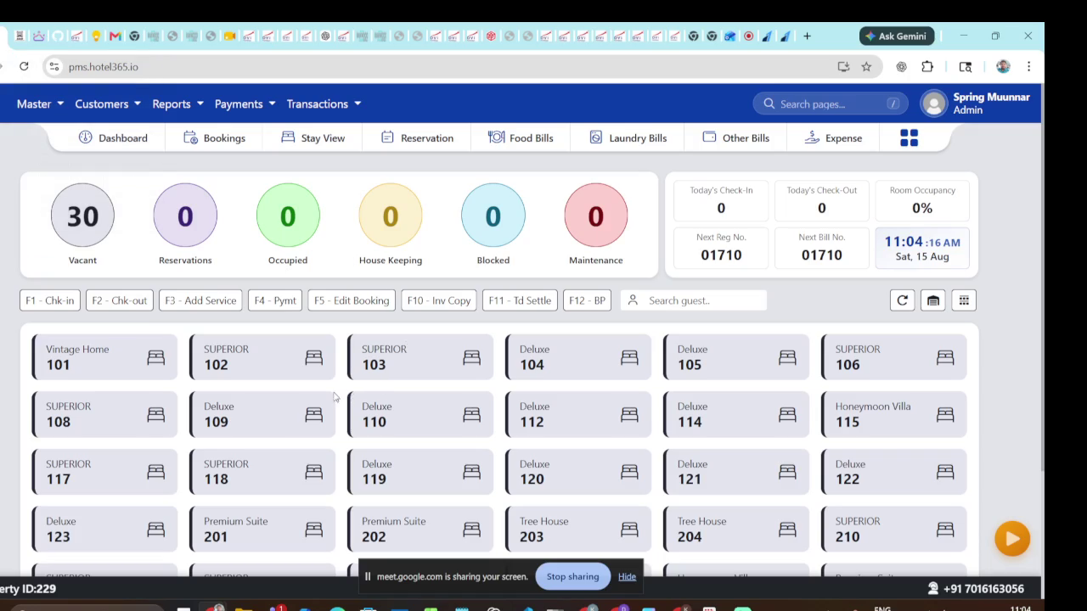
Video evidence: 0002 seconds - representative state
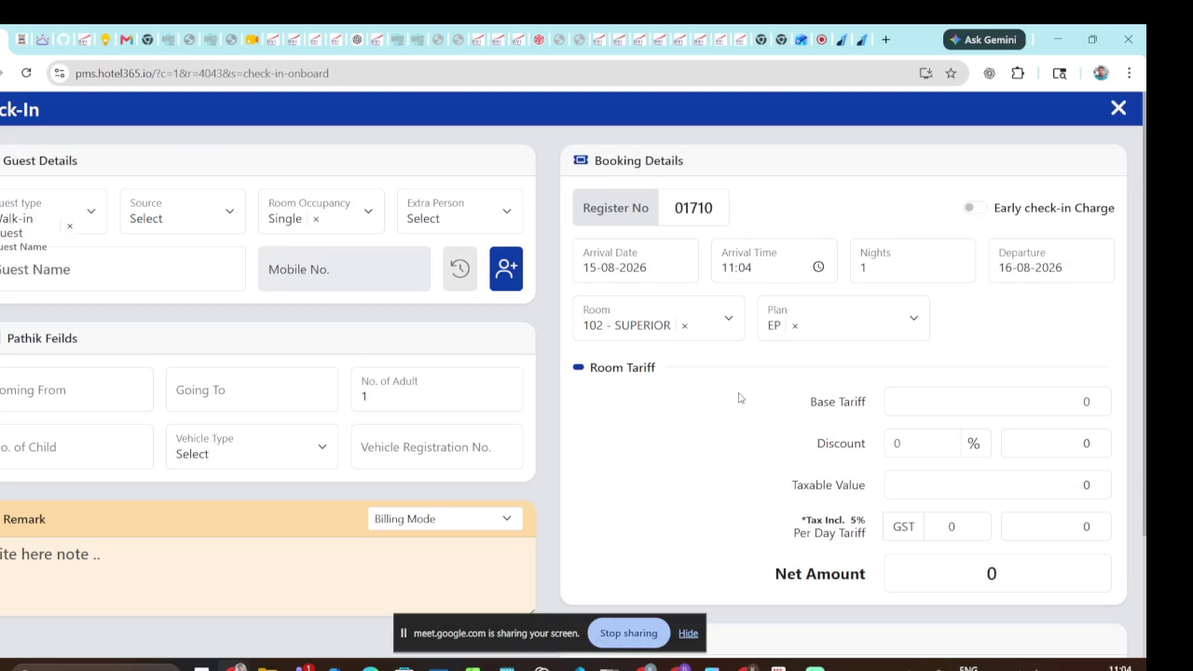
Video evidence: 0008 seconds - representative state

4.2 Master data and room configuration
S03-S10: searchable/paginated tables and grids for rooms, room types/categories, beds and image placeholders. Model RoomType, RoomCategory, Room, Bed, Amenity and RoomStatus. Validate required names/codes and return to list after save.
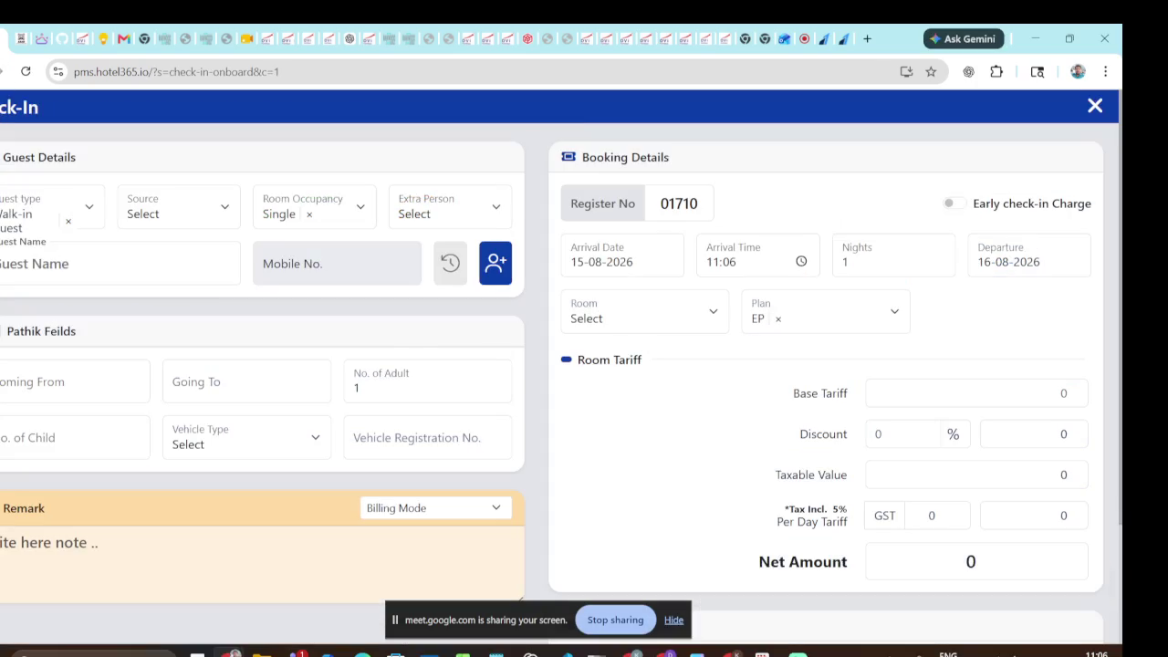
Video evidence: 0130 seconds - representative state
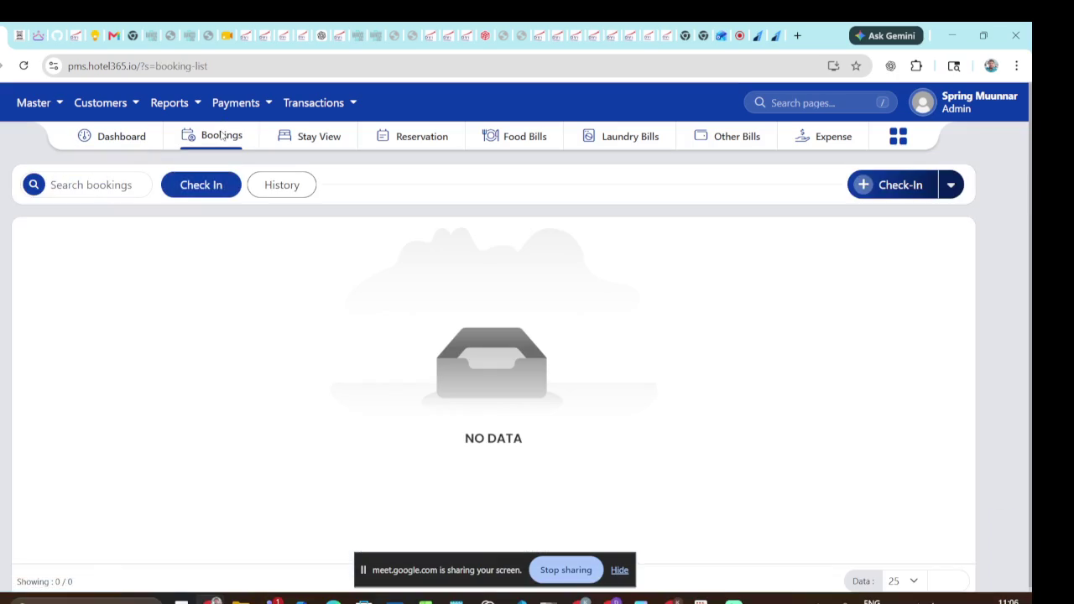
Video evidence: 0155 seconds - representative state
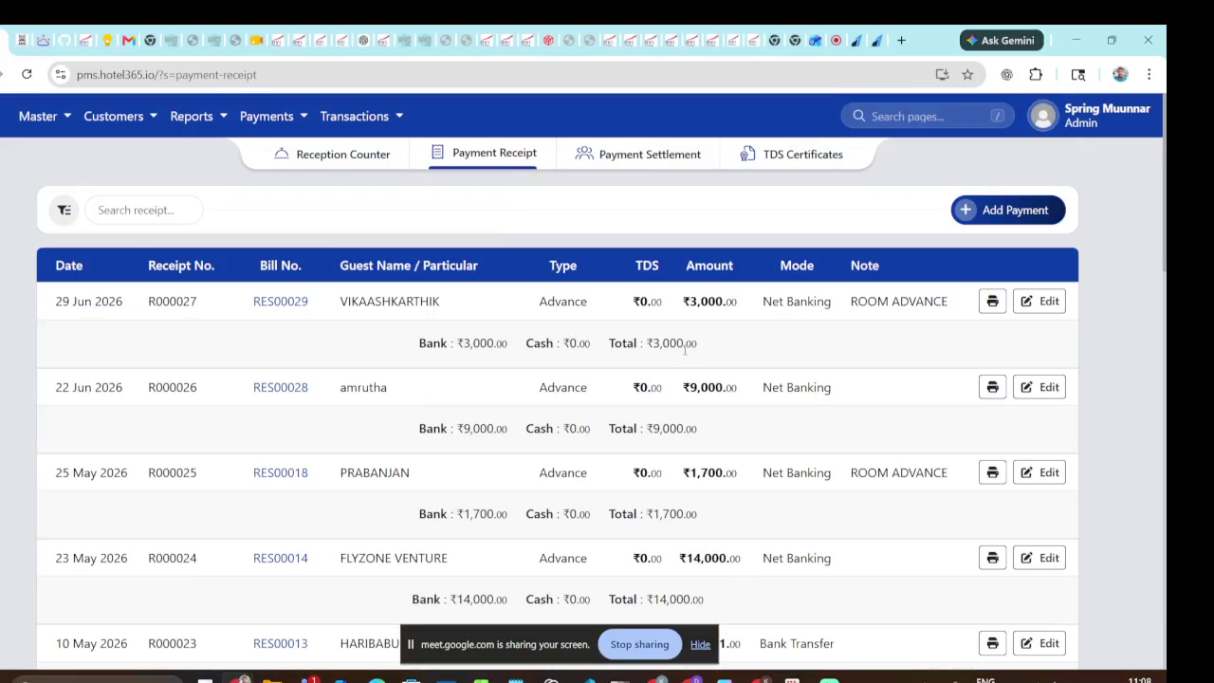
Video evidence: 0250 seconds - representative state
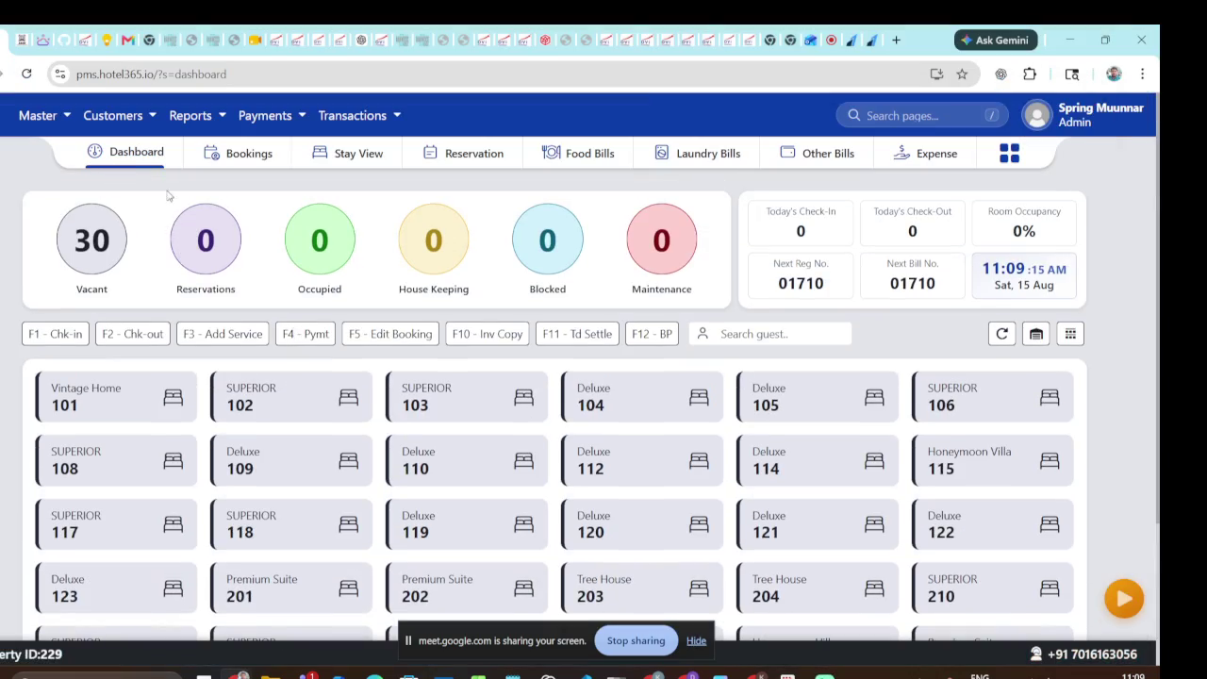
Video evidence: 0300 seconds - representative state
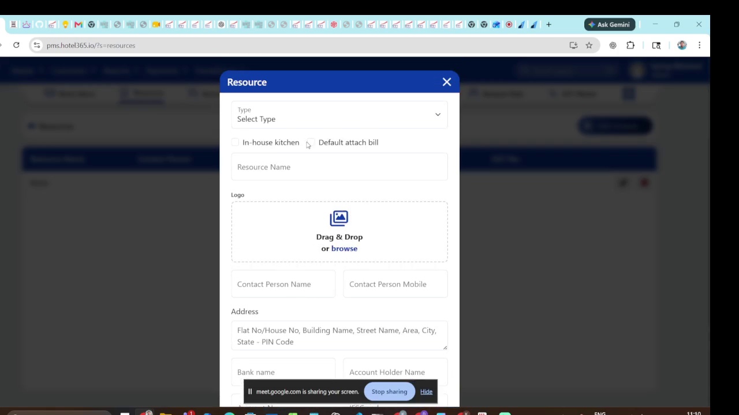
Video evidence: 0350 seconds - representative state
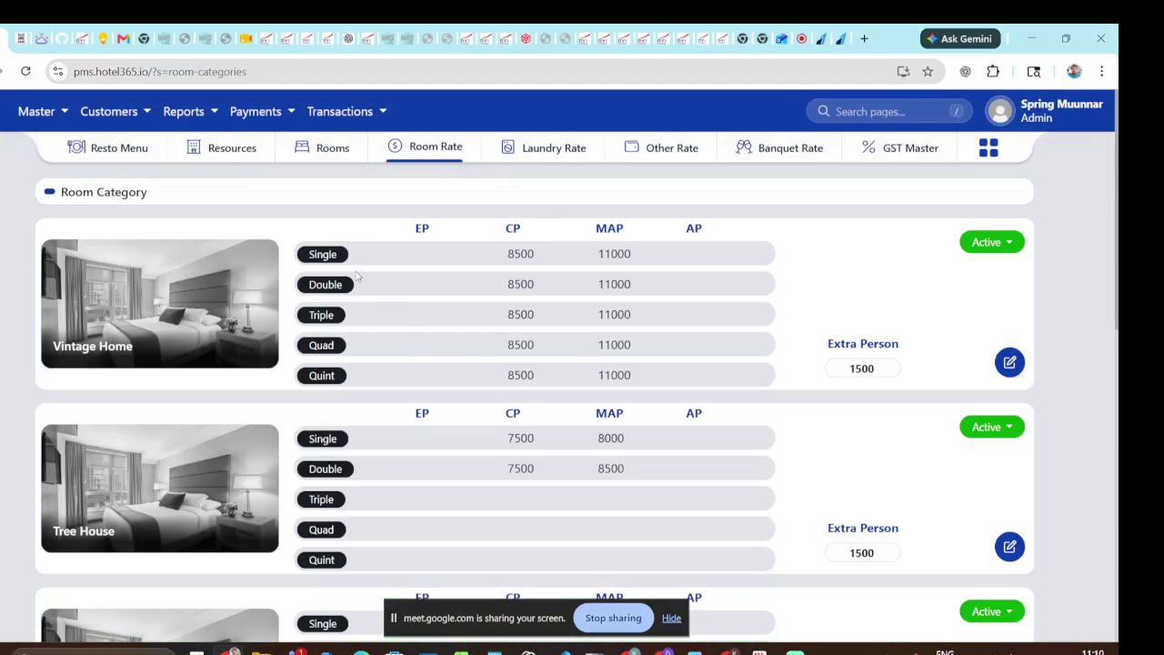
Video evidence: 0400 seconds - representative state

4.3 Settings, permissions and reports
S11-S21: property settings, permission/group matrix, report catalog, filters and PDF/print viewer. Use whitelisted report keys and printable HTML/PDF templates.
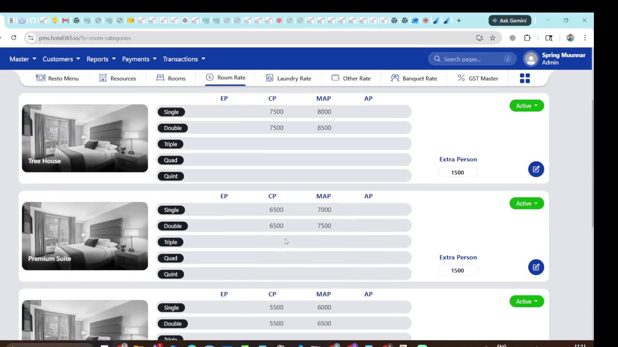
Video evidence: 0430 seconds - representative state
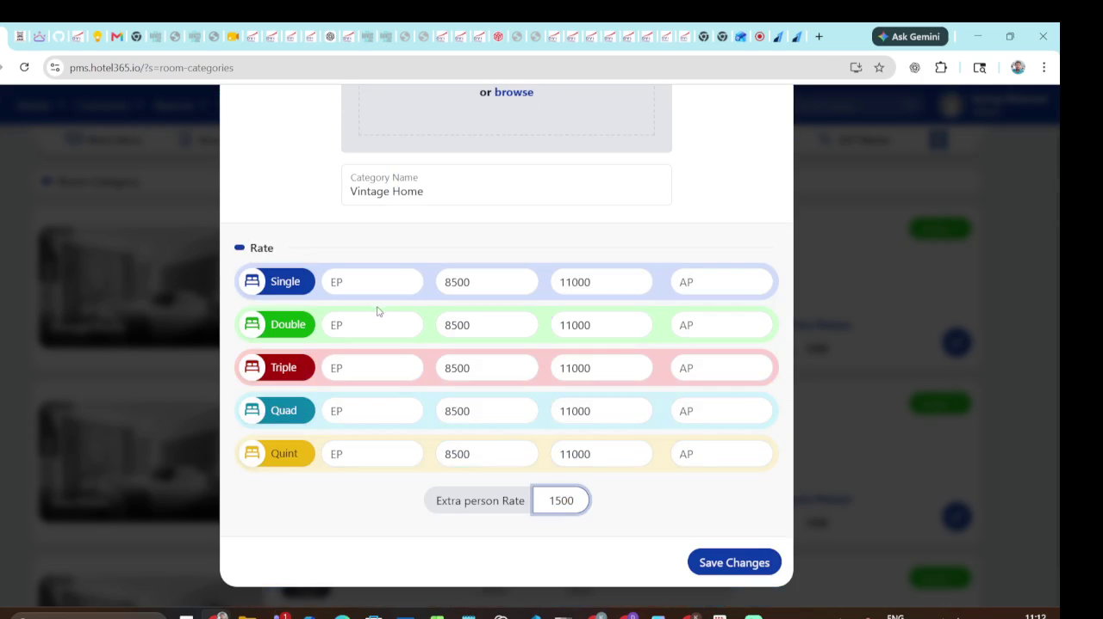
Video evidence: 0500 seconds - representative state
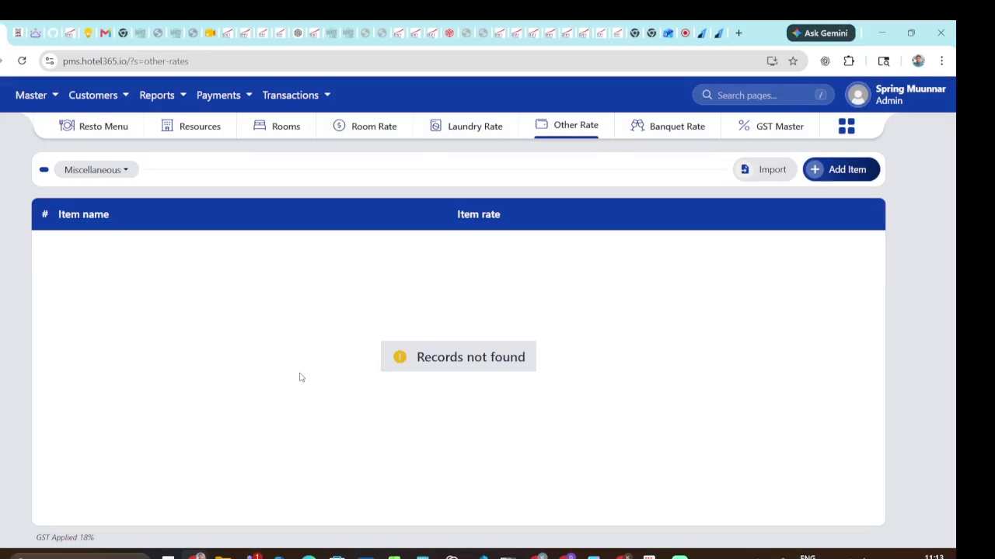
Video evidence: 0540 seconds - representative state
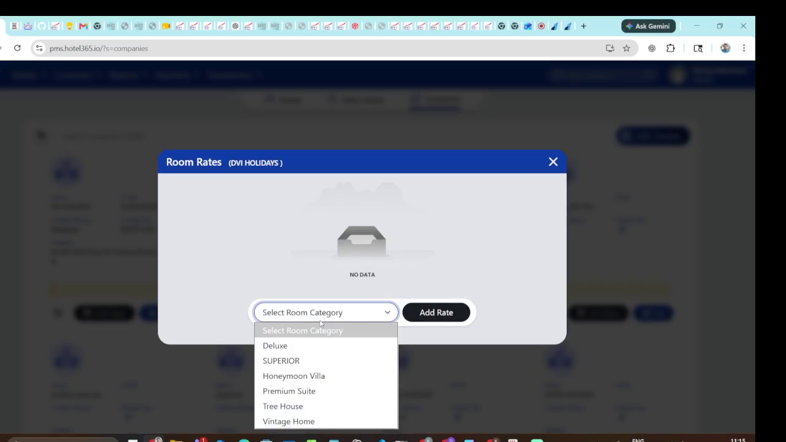
Video evidence: 0700 seconds - representative state

4.4 Guests and reservations
S22-S30: guest create/search, reservation draft, stay dates, occupancy, room allocation, notes, status tabs, row actions and detail card. Nested guest creation must not lose the reservation draft.
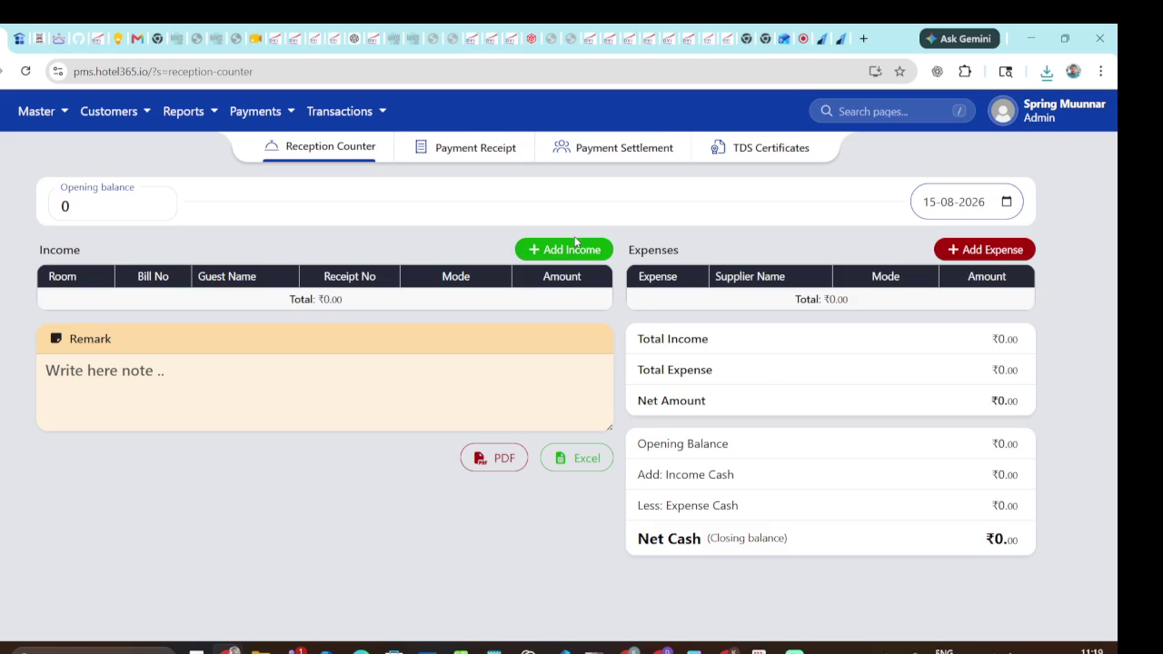
Video evidence: 0920 seconds - representative state
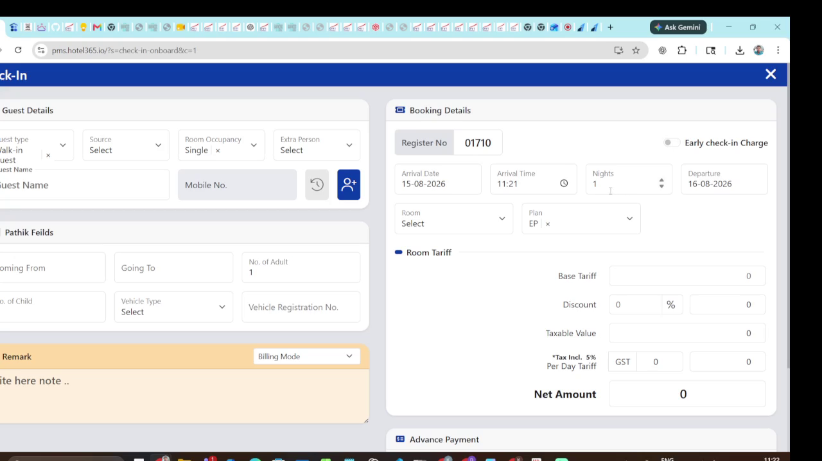
Video evidence: 1080 seconds - representative state
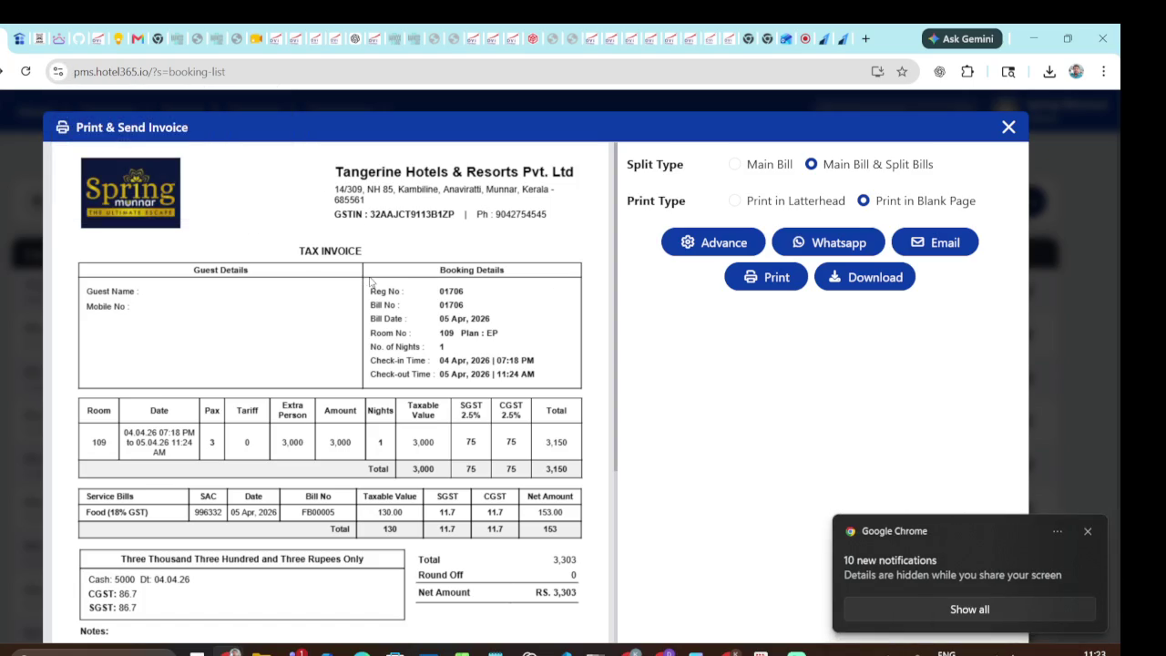
Video evidence: 1180 seconds - representative state
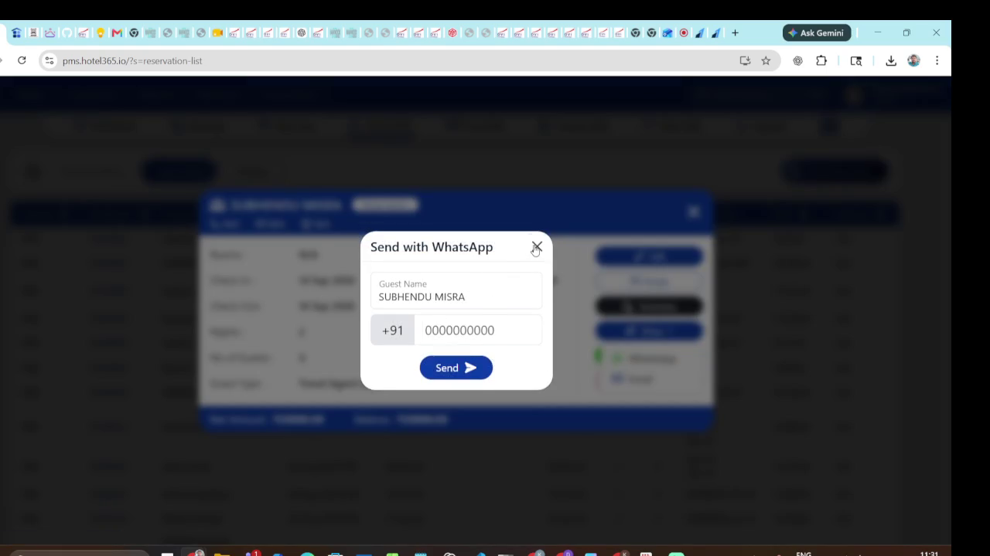
Video evidence: 1640 seconds - representative state

4.5 Calendar, billing, payments and print
S28-S35: date picker and room/date matrix; folio line items; tax/discount; paid/due/total; payment method/reference; confirmation; receipt/invoice print. Calculate money on the server in minor units or a decimal-safe type.
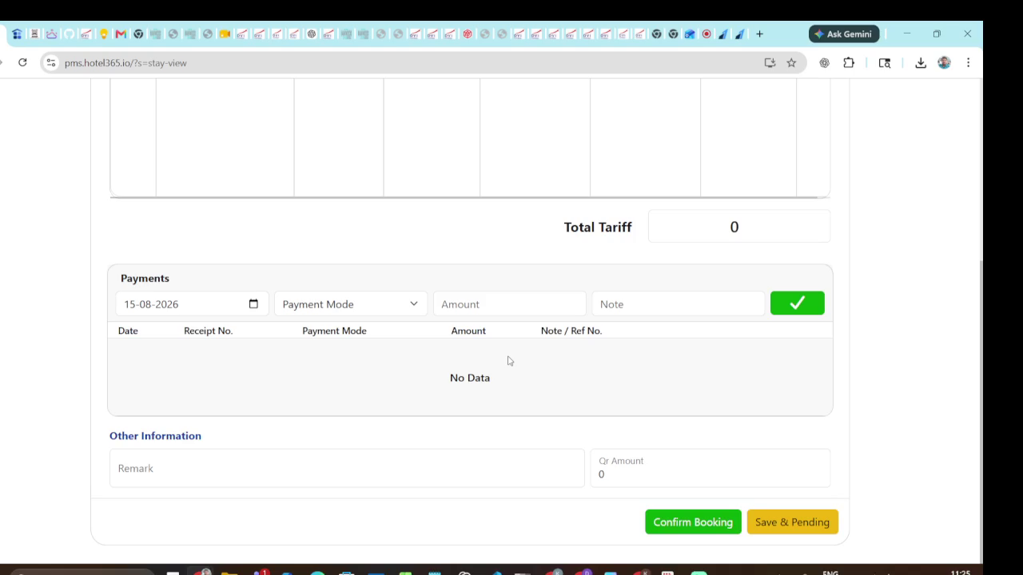
Video evidence: 1300 seconds - representative state
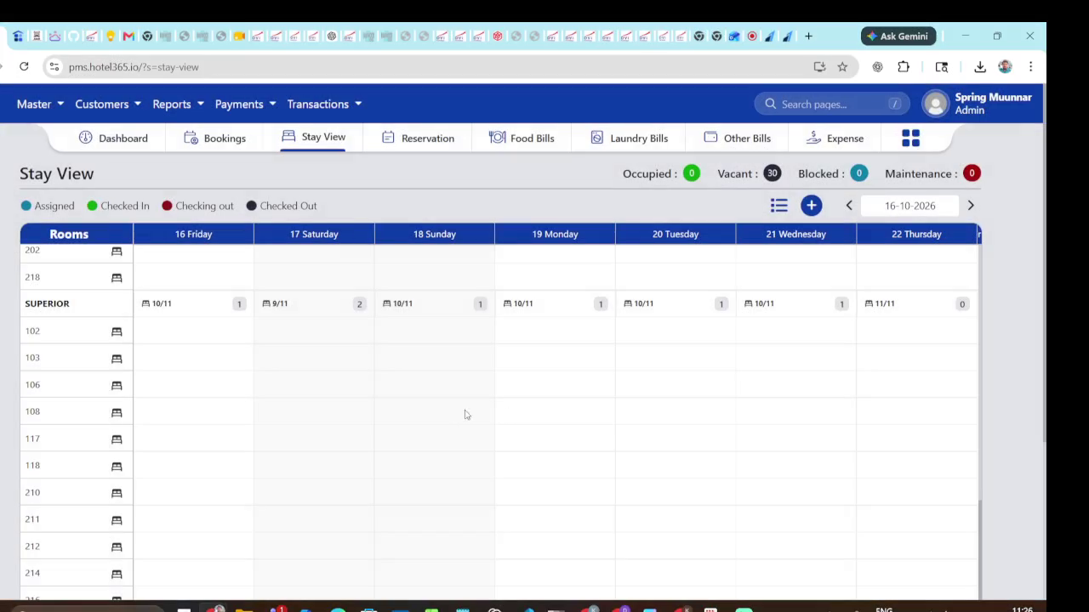
Video evidence: 1340 seconds - representative state
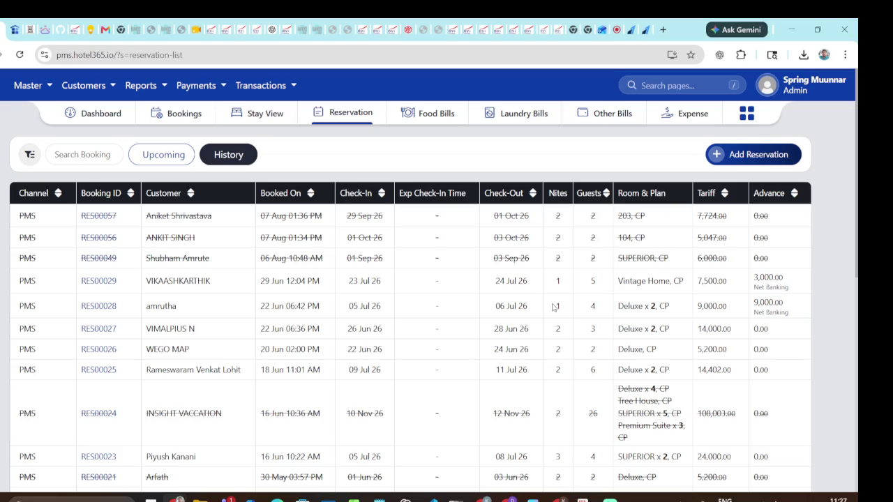
Video evidence: 1410 seconds - representative state
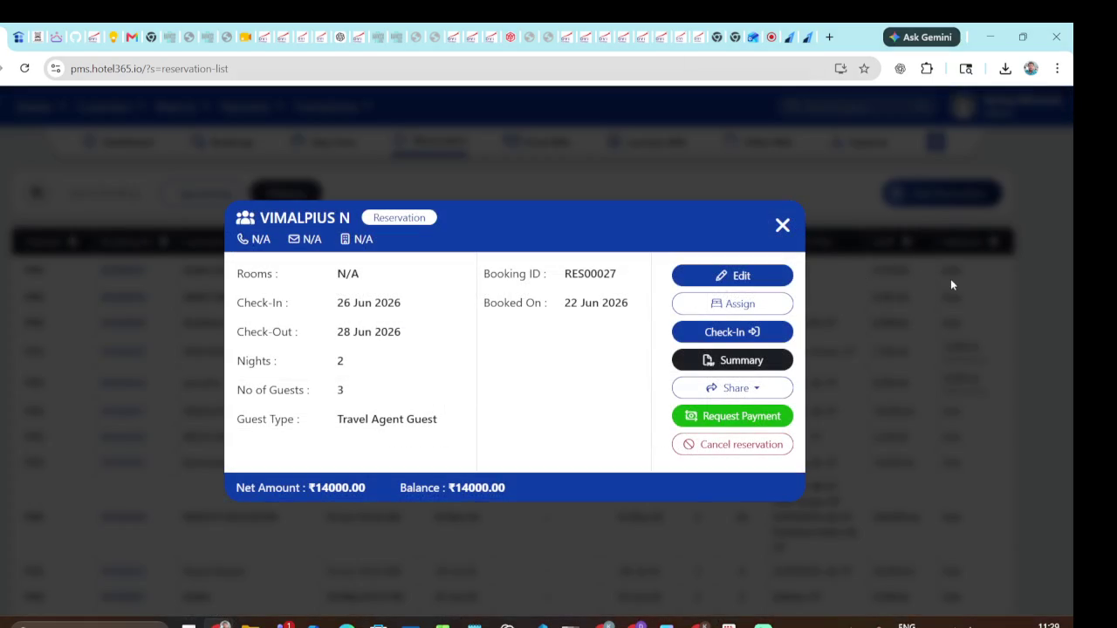
Video evidence: 1500 seconds - representative state
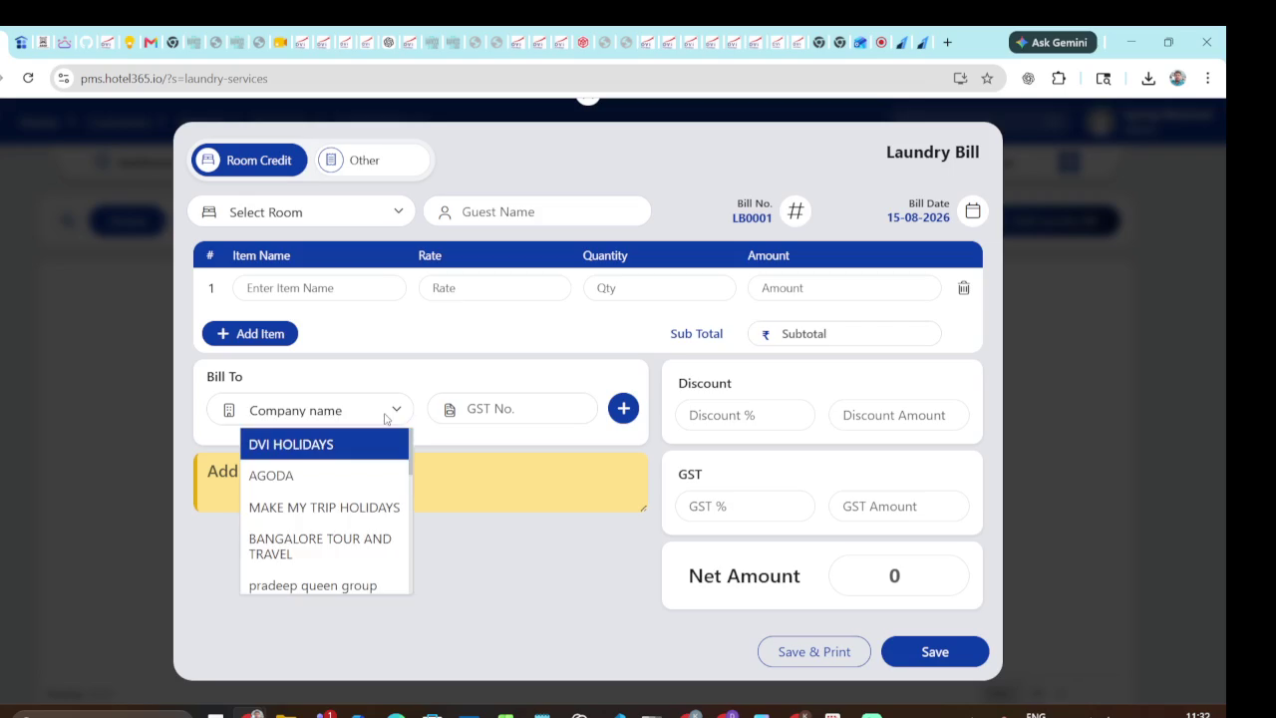
Video evidence: 1700 seconds - representative state
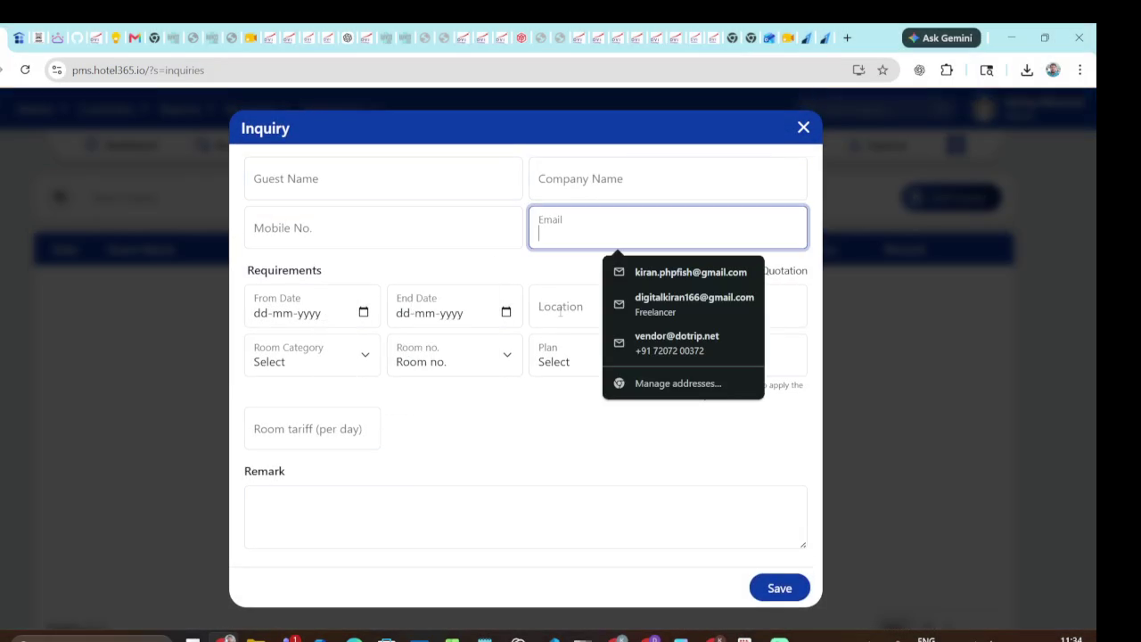
Video evidence: 1800 seconds - representative state

4.6 Booking and front desk operations
S25/S27/S32/S36-S38: search by guest/booking/source/status/date, assign room, show amount summary, accept payment and finalize status. Desktop and compact layouts should share APIs and commands.
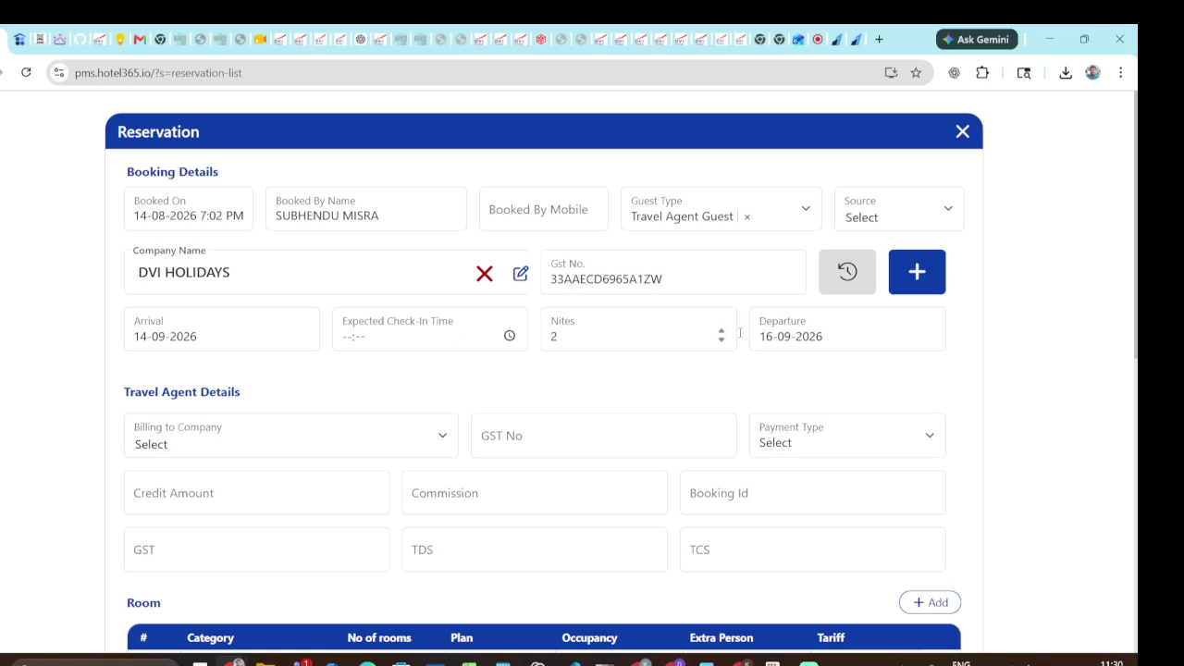
Video evidence: 1580 seconds - representative state
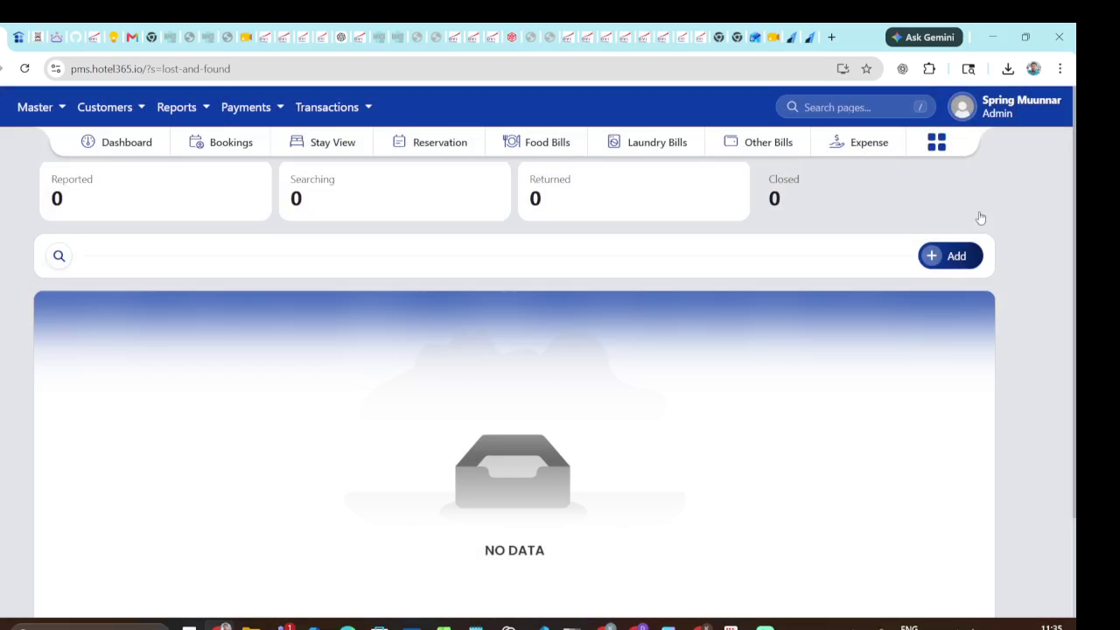
Video evidence: 1860 seconds - representative state
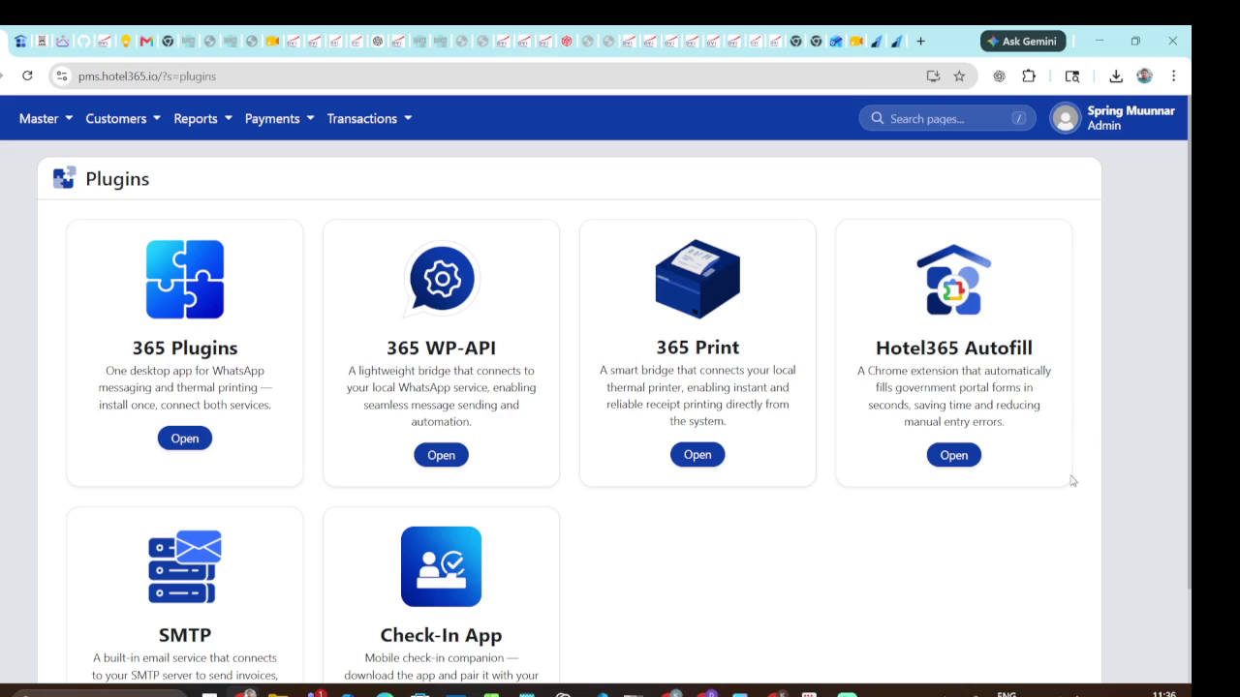
Video evidence: 1920 seconds - representative state
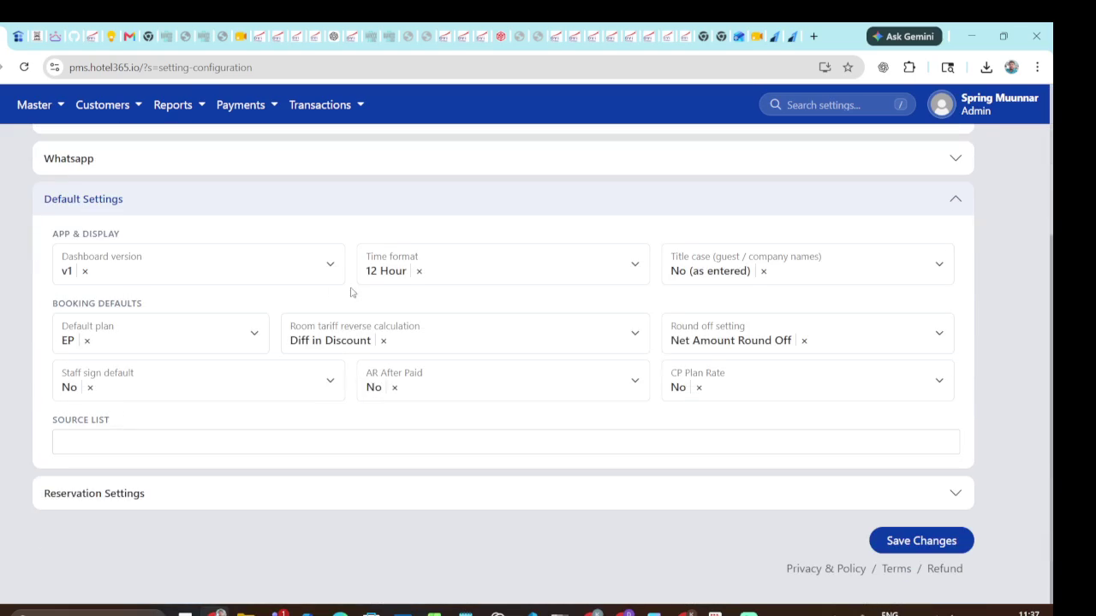
Video evidence: 1980 seconds - representative state

5. Domain model and state machine
Use normalized transactional entities plus read-optimized queries for dashboards and reports. The minimum model below covers the observed flows.
Entity | Core fields | Relationships / rules
Property | id, name, timezone, currency, address, logo | Owns rooms, settings, users and reports.
RoomType | id, code, name, capacity, baseRate, images, active | Has rooms; may have beds/amenities.
Room | id, number, floor, roomTypeId, status, housekeepingStatus | No overlapping active allocations.
Guest | id, name, phone, email, address, documents, notes | Has reservations, folios, payments and documents.
Reservation | id, code, guestId, roomId, stay dates, occupancy, status, source | State history, allocation and folio.
Folio/LineItem | folioId, description, qty, unitRate, tax, discount, total | Server-calculated; posted items immutable.
Payment | id, folioId, method, amount, reference, status, receivedAt | Reconciliation and refund support.
ReportRun | reportKey, filters, requestedBy, outputType, createdAt | Auditable and reproducible.
AuditEvent | actor, action, entity, entityId, before, after, timestamp | Append-only.

5.1 Reservation lifecycle
- DRAFT -> CONFIRMED -> CHECKED_IN -> CHECKED_OUT.
- Alternative terminal states: CANCELLED, NO_SHOW, EXPIRED; configure allowed transitions.
- Room status is separate: AVAILABLE, RESERVED, OCCUPIED, DIRTY/TO_CLEAN, CLEAN, OUT_OF_ORDER, MAINTENANCE.
- Payment status is separate: UNPAID, PARTIALLY_PAID, PAID, REFUNDED/PARTIAL_REFUND.

6. NestJS backend contract
Module | Representative endpoints | Notes
Auth | POST /auth/login; POST /auth/refresh; GET /me | JWT/session, role guards and reset.
Rooms | GET/POST /rooms; PATCH /rooms/:id; GET /rooms/board | Board returns counts, tiles, status and current reservation.
Setup | CRUD /room-types, /categories, /beds, /amenities | Validate codes and uniqueness within property.
Guests | GET /guests?query=; POST /guests; GET/PATCH /guests/:id | Fast partial matching and autocomplete.
Reservations | GET/POST /reservations; PATCH /reservations/:id; POST /:id/status | Command endpoints for check-in/out/cancel.
Availability | GET /availability?from=&to=&roomTypeId= | Transactional overlap validation.
Billing | GET /folios/:id; POST /folios/:id/items; POST /payments | Server totals and idempotency keys.
Reports | GET /reports; POST /reports/:key/run; GET /report-runs/:id/print | Whitelist report keys and filter schemas.
Audit | GET /audit?entity=&entityId= | Admin-only immutable events.

6.1 Cross-cutting requirements
- DTO validation with class-validator and consistent errors {code, message, fields}.
- Transactions around reservation allocation, status transitions and payment posting.
- Pagination with {items,total,page,pageSize}; URL-synchronized filters.
- Idempotency for create reservation and payment commands.
- Role/permission guards on every mutation and export/print endpoint.
- UTC timestamps plus property-local business dates.
- Storage abstraction for logos, guest documents, room images and generated PDFs.

7. React frontend architecture
- AppShell: top navigation, property context, user menu, responsive layout, toast and error boundary.
- Feature folders: dashboard, rooms, setup, guests, reservations, billing, bookings, reports and users.
- TanStack Query for server state; URL-synchronized filters; cautious optimistic updates.
- Reusable components: DataTable, StatusChip, RoomTile, EntityModal, DateRangePicker, MoneySummary, ConfirmDialog and PrintPreview.
- React Hook Form + Zod; preserve draft state when nested guest modals open.
- Accessibility: keyboard modal control, labels, non-color status cues, table headers and focus states.
- Compact workflows reuse the same domain components and APIs at narrower breakpoints.

8. Build order for the implementation agent
- Scaffold auth, property context, design tokens and AppShell.
- Create schema, seed one property, room types, rooms, guests and sample reservations.
- Implement room board and availability query.
- Implement guest search/create and reservation draft/create.
- Implement reservation lifecycle and front-desk check-in/out.
- Implement folio, payments, receipts and print templates.
- Implement master-data setup pages and permissions.
- Implement reports and PDF/print previews.
- Add audit events, tests, accessibility checks and end-to-end workflows mirroring the video.

9. Verification checklist and open questions
- Confirm exact labels, menu names, field order, statuses and report names against the source system.
- Confirm single-property versus multi-property scope; the video appears property-scoped.
- Confirm payment providers, tax rules, receipt numbering and refund policy.
- Confirm whether booking channels are external integrations or internal records only.
- Confirm role-specific modal actions and whether deletion is soft-delete.
- Capture production labels/screens at kickoff; this recording is sufficient for structure and behavior but not every small text label.
End of specification. Screenshots are representative evidence from the supplied recording; timestamps refer to the original 35:31.97 video.

