RAINWOOD HOTELS

RainWood System Module Index
Code-based map of the functional application modules
Scope This index identifies the major modules observed in the Next.js frontend, NestJS backend, and Prisma schema. Each linked module guide explains its purpose, UI surface, code locations, endpoints, data model, workflow, permissions, risks, and verification scenarios.

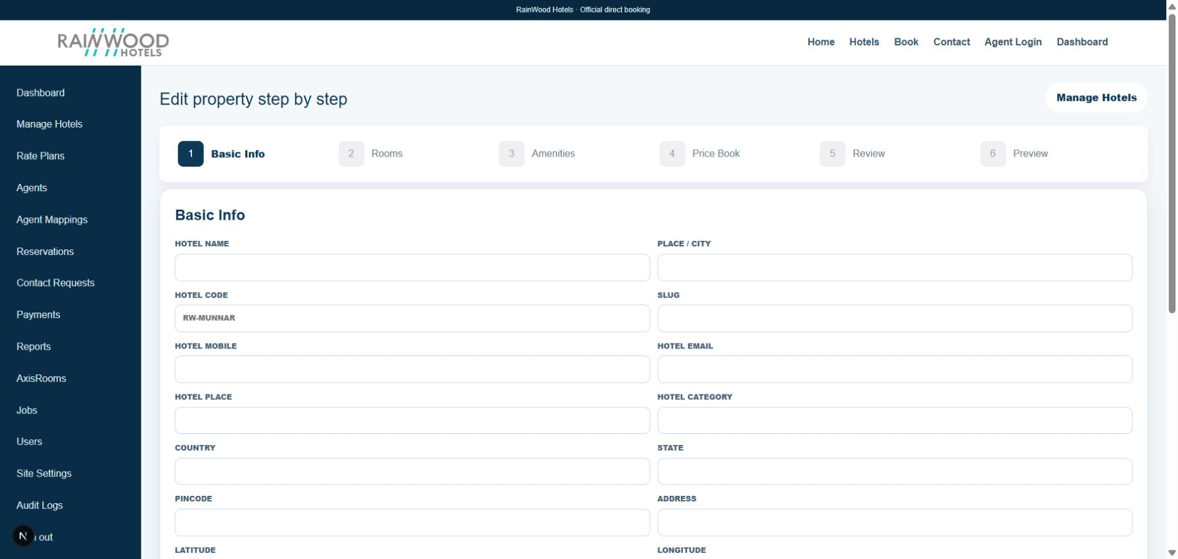
Representative local RainWood admin screenshot used as the visual index reference.
How a client should use these guides Start with the module that matches the task. Read the plain-language purpose, use the field table to understand what to enter or review, follow the numbered workflow, and use the verification scenarios before moving to the next module.

Architecture at a glance
- Frontend: Next.js App Router, React, and TypeScript under frontend/src.
- Backend: NestJS REST API under backend/src, with authentication, role guards, services, and controllers.
- Persistence: Prisma schema and migrations under backend/prisma, backed by PostgreSQL.
- Operational boundary: payments, SMTP, storage, AxisRooms, and monitoring are configured per environment.

Module inventory
Module | Primary responsibility | Document
Hotel Management and Catalogue | Hotel identity, rooms, amenities, images, and catalogue records | module-guides/hotel-management-and-catalogue.docx
Rate Plans and Price Book | Commercial offers, dates, occupancy prices, taxes, and inventory | module-guides/rate-plans-and-price-book.docx
Public Discovery and Booking | Public hotel discovery, search, availability, holds, and booking initiation | module-guides/public-discovery-and-booking.docx
Reservations | Reservation lifecycle, guest details, amendments, and cancellation | module-guides/reservations.docx
Payments | Payment orders, manual receipts, verification, and webhooks | module-guides/payments.docx
Authentication, Users, Agents, and Wallets | Staff access, role control, agent onboarding, mappings, and balances | module-guides/authentication-users-agents-and-wallets.docx
Contact Requests | Public enquiries and staff follow-up queue | module-guides/contact-requests.docx
Reports | Operational, reservation, payment, arrival, departure, and cancellation reporting | module-guides/reports.docx
Files and Media | Hotel images, room images, payment proof, and public file access | module-guides/files-and-media.docx
AxisRooms Integration | Inbound inventory/rate sync and booking synchronization boundary | module-guides/axisrooms-integration.docx
Jobs and Reconciliation | Background processing, retries, dead letters, and operational recovery | module-guides/jobs-and-reconciliation.docx
Vouchers | Reservation voucher generation, email, and download | module-guides/vouchers.docx
Site Settings | Public configuration and admin-managed branding | module-guides/site-settings.docx
Audit Logs | Actor-linked history of administrative and operational changes | module-guides/audit-logs.docx
Health and Metrics | Liveness, readiness, and Prometheus-style operational metrics | module-guides/health-and-metrics.docx

Cross-module lifecycle
- Identity and role access gate staff and agent operations.
- Hotel Management creates the hotel, rooms, amenities, and media catalogue.
- Rate Plans and Price Book attach commercial offers, daily rates, and inventory.
- Public Discovery calculates availability and creates a temporary hold.
- Reservations converts the hold into a booking contract.
- Payments records money and updates the reservation balance.
- Jobs, Reconciliation, AxisRooms, Reports, Vouchers, and Audit Logs support operations and traceability.
Reading guidance The module guides intentionally separate observed code behavior from business-policy decisions. Before changing a module, check its data relationships, role guards, idempotency behavior, and the production runbook.

