RAINWOOD HOTELS

Audit Logs
Actor-linked history of administrative and operational changes
Audience | Engineering, product, and operations
Source basis | Static analysis of frontend routes, backend controllers/services, and Prisma schema
Status | Observed implementation; confirm business policy before production changes
Module purpose Provides traceability for protected actions by recording what entity was changed, who acted, and when, with the ability to filter recent history.

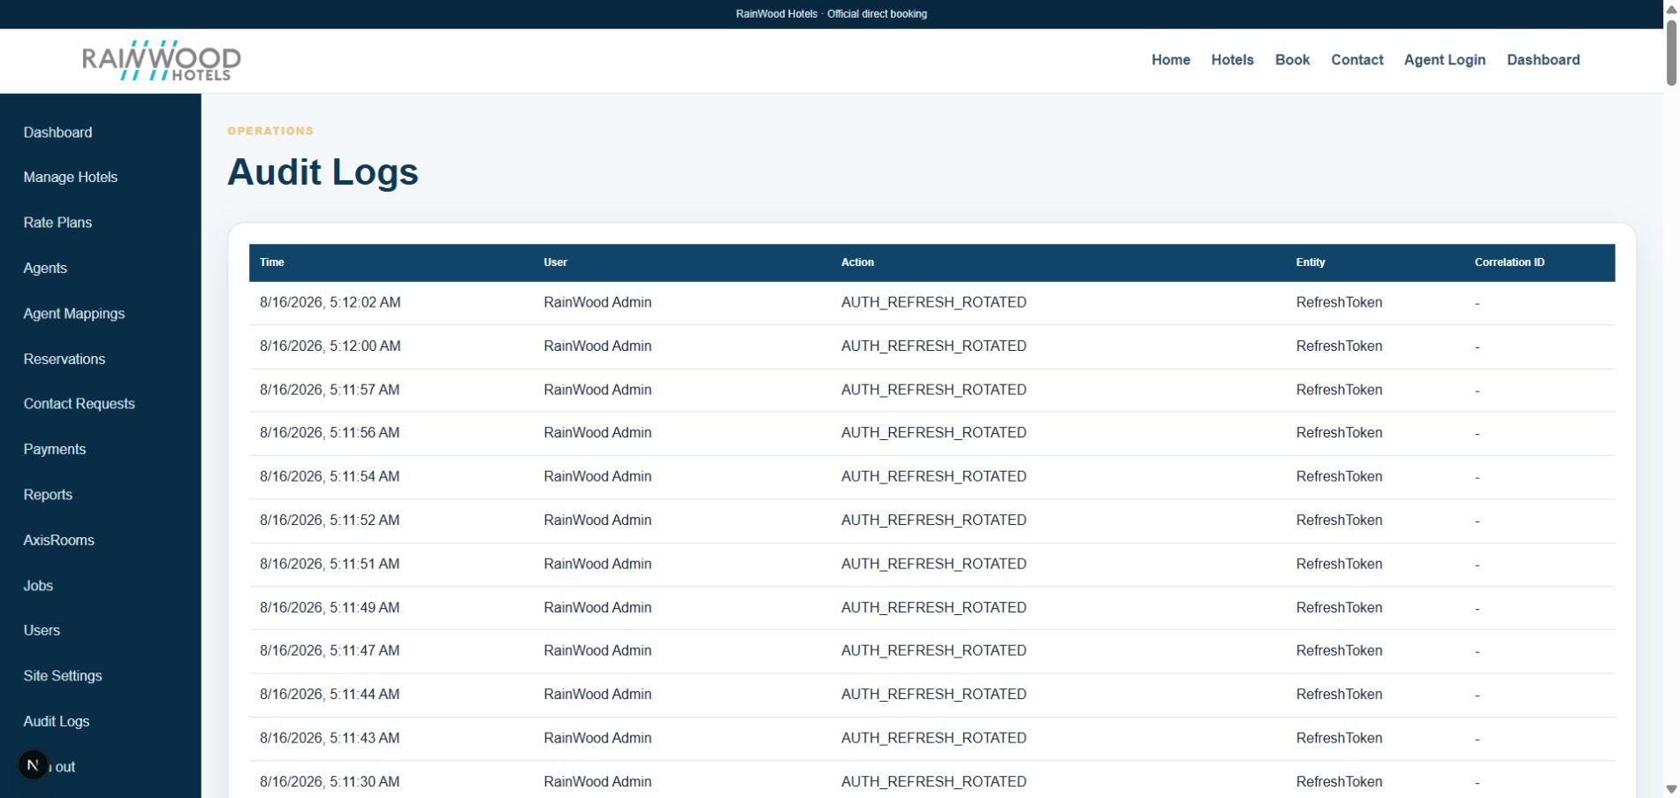
Local RainWood UI screenshot: Audit Logs.

Client guide: what this screen is for
In plain language Use audit logs to see who changed important records and when.

Field or control | What you see | Why it is used
Actor | User or system process | Identify who performed the action.
Action and entity | Created, updated, deleted, or changed status | Understand what record was affected.
Timestamp | Date and time of the event | Reconstruct the order of operational changes.
Metadata | Request or record context | Support investigation and compliance review.

Next step Complete the required fields, save the record, then use the workflow and verification steps below to confirm that the information is available to the next module.

Functional surface
Surface | Observed responsibility
Admin audit log | Review recent audit records and filter by entity type.
Service events | Business services emit audit events as part of mutations.
Investigation | Use actor and timestamps to trace an operational change.

Code map
Layer | Files / symbols | What the code does
Frontend | frontend/src/app/admin/audit-logs/page.tsx | Audit table and filtering UI.
Backend | backend/src/modules/audit/audit.controller.ts; audit.service.ts | Protected audit listing and event persistence.
Schema | AuditLog | Actor, entity, action, metadata, and timestamp.
Cross-cutting | service mutation paths | Emit events when records change.

API contract
Method | Path | Role in the module
GET | /audit-logs | List up to the recent audit records, optionally filtered by entityType.
Internal | Audit service calls | Write audit events during protected mutations.

Data model
Entity | Fields / relationships observed | Reason it exists
AuditLog | actorId, entityType, entityId, action, metadata, createdAt | Immutable-style operational trace.
Actor | User name and email | Identify the person or service account.
Entity | Business object reference | Connect event to the changed record.

Primary workflow
- A protected mutation performs its business action.
- Service writes a corresponding audit event with actor and entity information.
- Admin opens the audit view and filters by entity type.
- Operations correlate timestamps with jobs, reservations, or sync logs.

Access and permissions
- Audit listing is protected and restricted to privileged roles.
- Audit metadata must avoid raw secrets and excessive personal data.
- Deletion or alteration of audit logs should be prohibited or tightly controlled.

Risks, boundaries, and implementation notes
- Not every mutation is automatically auditable; event coverage should be reviewed.
- Metadata can accidentally contain tokens or payment data if unfiltered.
- Retention and export policy is not a substitute for monitoring/alerting.

Recommended verification scenarios
- Perform a hotel, user, reservation, and payment mutation and verify audit records.
- Filter by entityType and confirm the result set.
- Verify a non-privileged role cannot list audit logs.
- Inspect metadata for secrets before production use.
Analyst conclusion This document describes the behavior visible in the current repository. Any change to business rules, external credentials, tax policy, or production data should be reviewed against the API contract and deployment runbook.

