RAINWOOD HOTELS

Authentication, Users, Agents, and Wallets
Staff access, role control, agent onboarding, mappings, and balances
Audience | Engineering, product, and operations
Source basis | Static analysis of frontend routes, backend controllers/services, and Prisma schema
Status | Observed implementation; confirm business policy before production changes
Module purpose Provides identity, session, role-based access, agent account management, rate-plan assignment, and agent wallet operations across the application.

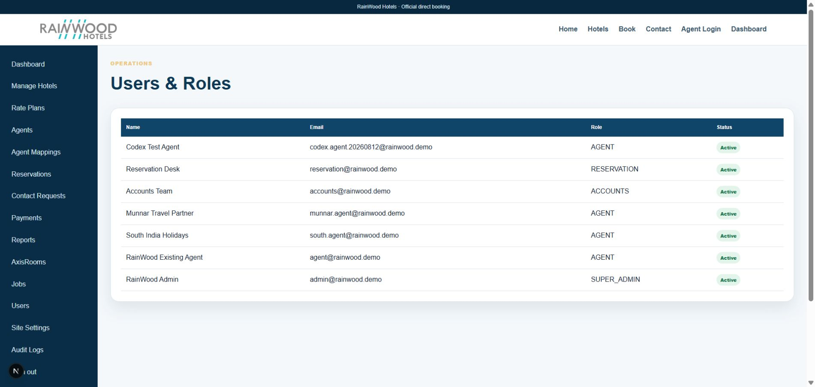
Local RainWood UI screenshot: Authentication, Users, Agents, and Wallets.

Client guide: what this screen is for
In plain language Use these screens to control who can access the system and what partner accounts can do.

Field or control | What you see | Why it is used
User details | Name, email, role, active status | Create the right login and limit access.
Role | Administrator, staff, agent, or other role | Apply the correct permission set.
Agent profile | Agency, contact, address, approval status | Maintain the partner identity used for bookings.
Wallet | Credit, debit, balance, transaction reference | Track agent funds and booking-related adjustments.

Next step Complete the required fields, save the record, then use the workflow and verification steps below to confirm that the information is available to the next module.

Functional surface
Surface | Observed responsibility
Staff login | Sign in, refresh a session, and sign out.
Users and Agents | Create, edit, activate, deactivate, and revoke sessions.
Agent mappings | Assign active rate plans to an agent.
Agent portal | Book, view assigned rate plans, and manage wallet activity.

Code map
Layer | Files / symbols | What the code does
Frontend | frontend/src/app/login/page.tsx; agent/login/page.tsx | Staff and agent login paths.
Frontend | frontend/src/app/admin/users/page.tsx; agents/page.tsx; agent-mappings/page.tsx | Admin identity and access management.
Backend | auth/auth.controller.ts; users/users.controller.ts; wallet/wallet.controller.ts | Authentication, role, mapping, and wallet APIs.
Schema | User, RefreshToken, AgentRatePlan, AgentWallet, WalletTransaction | Identity, session, access, and financial balance records.

API contract
Method | Path | Role in the module
POST | /auth/login; /auth/refresh; /auth/logout | Session lifecycle.
GET/POST/PATCH | /users and /users/:id | Staff user administration.
GET/POST/PATCH | /users/agents and /users/agents/:id | Agent administration.
PUT | /users/agents/:id/rate-plans | Assign rate plans.
GET/POST | /wallet and /wallet/recharge | Agent balance and recharge operations.

Data model
Entity | Fields / relationships observed | Reason it exists
User | email, role, active, tokenVersion, passwordHash | Authenticated identity and access role.
RefreshToken | hashed token, expiry, revocation | Rotating session continuity.
AgentRatePlan | agent/user and ratePlan link | Least-privilege commercial access.
AgentWallet | balance and wallet transactions | Agent credit and recharge history.

Primary workflow
- User submits credentials and receives a short-lived access token plus refresh session.
- Frontend stores the access token and sends it to protected APIs.
- Admins manage users and agent status; session revocation increments tokenVersion.
- Admin maps specific rate plans to an agent.
- Agent uses assigned plans for booking and wallet operations.

Access and permissions
- JWT authentication is combined with role guards in protected controllers.
- Agent accounts must not expose other agents' bookings or unassigned plans.
- Wallet recharge and balance operations should be treated as financial actions.

Risks, boundaries, and implementation notes
- The local demo password must be changed before shared or production use.
- Token refresh and revocation behavior must be tested across multiple browser tabs.
- Role naming and UI visibility should remain aligned with backend guards.

Recommended verification scenarios
- Sign in, refresh after expiry, and sign out.
- Deactivate a user and verify access is denied.
- Assign one plan to an agent and verify only that plan appears in the agent portal.
- Recharge a wallet and reconcile the transaction with the balance.
Analyst conclusion This document describes the behavior visible in the current repository. Any change to business rules, external credentials, tax policy, or production data should be reviewed against the API contract and deployment runbook.

