RAINWOOD HOTELS

AxisRooms Integration
Inbound inventory/rate sync and booking synchronization boundary
Audience | Engineering, product, and operations
Source basis | Static analysis of frontend routes, backend controllers/services, and Prisma schema
Status | Observed implementation; confirm business policy before production changes
Module purpose Defines the integration boundary for AxisRooms-style inventory, rate, and booking synchronization while allowing mock mode for local development.

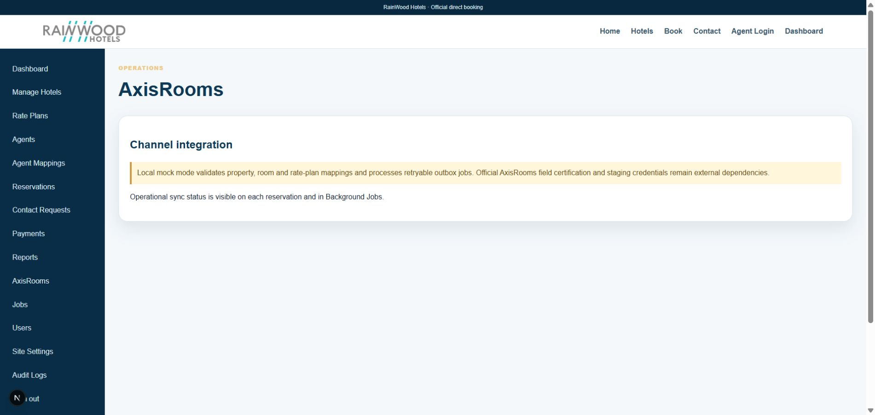
Local RainWood UI screenshot: AxisRooms Integration.

Client guide: what this screen is for
In plain language Use this area to understand or monitor synchronisation with the external channel manager.

Field or control | What you see | Why it is used
Connection | Provider and connection mode | Identify where inventory and rates are exchanged.
Inbound update | Room, rate, inventory, or reservation message | Understand data received from the channel manager.
Outbound update | Availability, price, or booking notification | Understand data sent to the partner.
Result | Accepted, failed, retrying, or mock mode | Confirm whether synchronisation completed.

Next step Complete the required fields, save the record, then use the workflow and verification steps below to confirm that the information is available to the next module.

Functional surface
Surface | Observed responsibility
Admin AxisRooms | View sync state, errors, and integration activity.
Inbound inventory/rates | Accept channel updates into the platform.
Reservation sync | Queue confirmed reservation changes for channel push.
Configuration | Use AXISROOMS_MODE and provider credentials per environment.

Code map
Layer | Files / symbols | What the code does
Frontend | frontend/src/app/admin/axisrooms/page.tsx | Sync and operational view.
Backend | backend/src/modules/axisrooms/axisrooms.controller.ts; axisrooms.service.ts | Inbound sync handlers and adapter boundary.
Schema | AxisSyncLog, Reservation.syncStatus | Track channel synchronization state.
Config | AXISROOMS_MODE, base URL, username, password, API key, webhook secret | Environment-specific integration settings.

API contract
Method | Path | Role in the module
POST | /axisrooms/inbound/inventory | Receive inventory update payload.
POST | /axisrooms/inbound/rates | Receive rate update payload.
Internal | AXIS_BOOKING_PUSH outbox job | Queue reservation synchronization.
Admin | AxisRooms page APIs | Inspect logs and retry state where implemented.

Data model
Entity | Fields / relationships observed | Reason it exists
AxisSyncLog | direction, entity, status, request/response metadata | Trace synchronization attempts.
Reservation | syncStatus and version | Track whether confirmed bookings reached the channel.
OutboxJob | type, payload, retry, idempotency | Reliable asynchronous push boundary.
Room/rate/inventory | mapped IDs and date values | Translate internal catalog to channel concepts.

Primary workflow
- Channel sends an inbound inventory or rate payload.
- Adapter validates and maps external identifiers to RainWood records.
- Service applies the update and writes sync/audit details.
- Confirmed reservations create outbox work for channel push.
- Failures retry or move to dead-letter/reconciliation for staff action.

Access and permissions
- Inbound endpoints must authenticate/sign requests according to the provider contract.
- Admin sync views should be protected and should not expose secrets.
- Only mapped active room/rate records should be synchronized.

Risks, boundaries, and implementation notes
- The repository states that official AxisRooms certification/specification remains external.
- Mock mode is a complete local path but not production certification.
- Identifier mapping, retry semantics, and webhook verification require provider-specific tests.

Recommended verification scenarios
- Send a valid mock inventory payload and verify InventoryDay updates.
- Send an unknown room/rate identifier and verify a clear failure log.
- Create a confirmed reservation and verify an outbox job is queued.
- Retry a failed sync and verify idempotency prevents duplicate application.
Analyst conclusion This document describes the behavior visible in the current repository. Any change to business rules, external credentials, tax policy, or production data should be reviewed against the API contract and deployment runbook.

