RAINWOOD HOTELS

Contact Requests
Public enquiries and staff follow-up queue
Audience | Engineering, product, and operations
Source basis | Static analysis of frontend routes, backend controllers/services, and Prisma schema
Status | Observed implementation; confirm business policy before production changes
Module purpose Captures public contact requests and exposes them to staff for follow-up without mixing them into reservations.

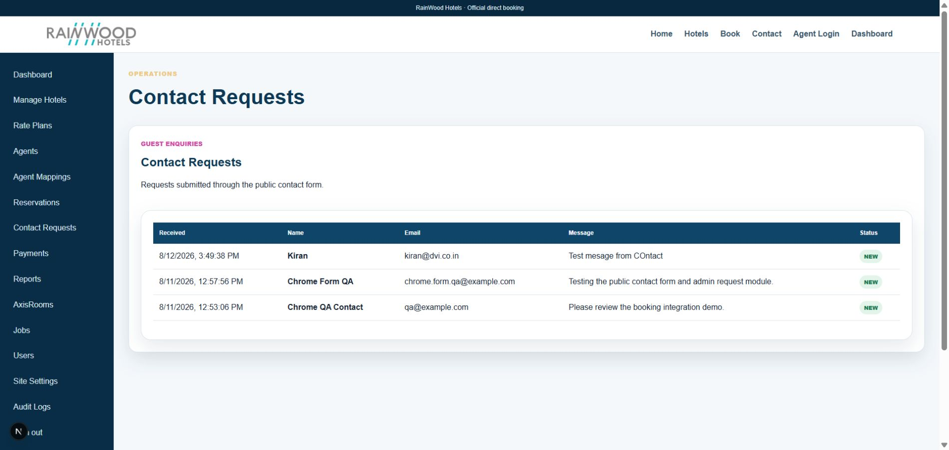
Local RainWood UI screenshot: Contact Requests.

Client guide: what this screen is for
In plain language Use this area to follow up on enquiries submitted by guests, agencies, or prospective customers.

Field or control | What you see | Why it is used
Requester | Name, email, mobile | Know who needs a response.
Message | The enquiry or requested assistance | Understand what action is needed.
Status | New, in progress, resolved | Prevent requests from being missed.
Notes | Internal follow-up notes | Record the response or next action for staff.

Next step Complete the required fields, save the record, then use the workflow and verification steps below to confirm that the information is available to the next module.

Functional surface
Surface | Observed responsibility
Public Contact page | Collect contact name, email, phone, and request message.
Admin Contact Requests | List and review incoming enquiries.
Email/logging | Use configured SMTP or log mode for outbound handling where enabled.

Code map
Layer | Files / symbols | What the code does
Frontend | frontend/src/app/contact/page.tsx; frontend/src/app/admin/contact-requests/page.tsx | Public form and staff queue.
Backend | backend/src/modules/contact/contact.controller.ts; contact.service.ts | Create and list contact requests.
Schema | ContactRequest | Stores enquiry details and status metadata.

API contract
Method | Path | Role in the module
POST | /contact-requests | Create a public enquiry.
GET | /contact-requests | List requests for staff follow-up.

Data model
Entity | Fields / relationships observed | Reason it exists
ContactRequest | name, email, phone, message, status, timestamps | Separable enquiry record.
Site settings | SMTP mode and sender configuration | Controls delivery behavior where configured.

Primary workflow
- Visitor submits a contact form.
- API validates and stores the request.
- Staff opens the admin queue and follows up outside or through the configured messaging path.
- Update status/handling according to the operational process.

Access and permissions
- Create is public; list is staff-protected.
- Contact data should be visible only to staff with a business need.
- Do not expose internal notes or request lists in public endpoints.

Risks, boundaries, and implementation notes
- Email delivery is dependent on SMTP configuration; local log mode is not delivery.
- Anti-spam, rate limiting, and retention policy should be confirmed for production.
- Contact requests may contain personal data and need retention controls.

Recommended verification scenarios
- Submit a valid enquiry and verify one stored request.
- Submit invalid email or empty message and verify validation.
- Open the staff queue as an unauthenticated user and verify access is denied.
- Verify SMTP/log behavior in the target environment.
Analyst conclusion This document describes the behavior visible in the current repository. Any change to business rules, external credentials, tax policy, or production data should be reviewed against the API contract and deployment runbook.

