RAINWOOD HOTELS

Files and Media
Hotel images, room images, payment proof, and public file access
Audience | Engineering, product, and operations
Source basis | Static analysis of frontend routes, backend controllers/services, and Prisma schema
Status | Observed implementation; confirm business policy before production changes
Module purpose Provides controlled upload and retrieval paths for hotel/room gallery images and payment evidence, abstracting local or future object storage behind one API.

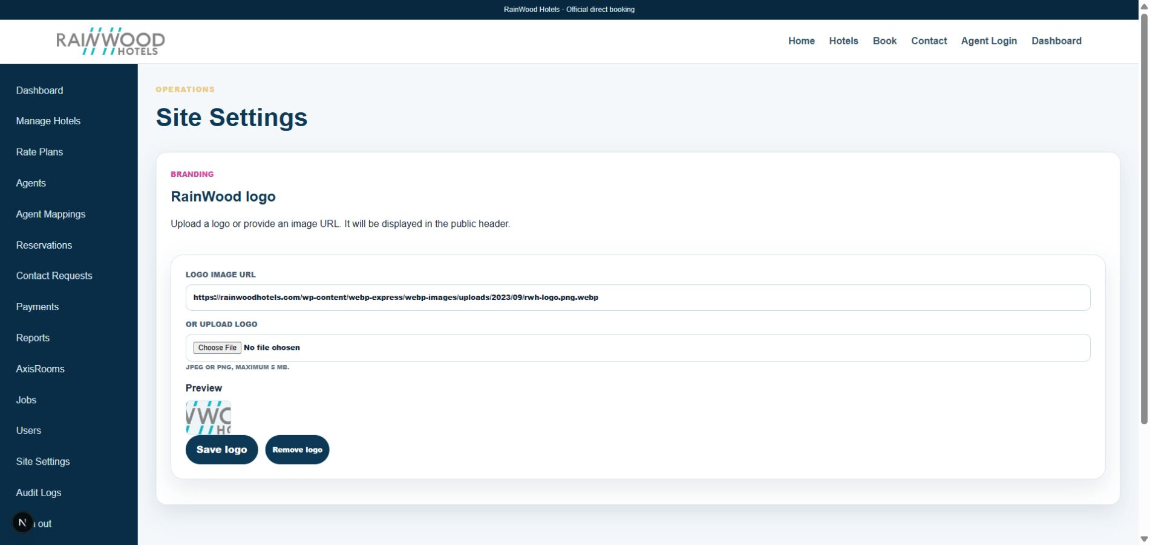
Related local UI evidence: the Site Settings image-upload surface uses the shared file storage flow.

Client guide: what this screen is for
In plain language This service stores and serves uploaded hotel, room, logo, and voucher files used by the application.

Field or control | What you see | Why it is used
File | JPEG, PNG, or generated PDF | Upload or generate the asset needed by another module.
Purpose | Hotel image, room gallery, logo, voucher | Keep the asset associated with the correct business use.
Public URL | Safe file-serving URL | Allow approved images or documents to be displayed or downloaded.

Next step Complete the required fields, save the record, then use the workflow and verification steps below to confirm that the information is available to the next module.

Functional surface
Surface | Observed responsibility
Hotel gallery upload | Upload multiple JPEG/PNG images and show thumbnails.
Room gallery upload | Upload room-specific images and show selected or persisted previews.
Payment proof | Attach evidence to a manual payment flow.
Public file route | Serve approved public media without exposing private files.

Code map
Layer | Files / symbols | What the code does
Frontend | hotel wizard file inputs and image preview components | Build File objects, preview thumbnails, and submit uploads.
Backend | backend/src/modules/files/files.controller.ts; files.service.ts | Validate, store, and retrieve files.
Schema | StoredFile, HotelImage, RoomImage | Persist file metadata and ownership.
Config | STORAGE_DRIVER, STORAGE_PATH, MAX_UPLOAD_BYTES | Select storage behavior and limits.

API contract
Method | Path | Role in the module
POST | /files/payment-proof | Upload payment evidence.
POST | /files/hotel-image | Upload hotel media.
GET | /files/public/:id | Retrieve approved public file.
GET | /files/:id | Retrieve protected file by ID.
POST/DELETE | /hotels/:hotelId/images...; /hotels/rooms/:roomId/images... | Associate or remove gallery media.

Data model
Entity | Fields / relationships observed | Reason it exists
StoredFile | mime, size, storage key, ownership, public flag | File metadata and access control.
HotelImage | hotel, file, altText/order | Hotel gallery presentation.
RoomImage | room, file, altText/order | Room gallery presentation.
Payment proof | payment association and file reference | Evidence for payment review.

Primary workflow
- User selects files in the browser and sees local previews.
- Frontend sends multipart data to the appropriate file endpoint.
- Backend validates type/size and stores the binary plus metadata.
- Domain record is linked to the hotel, room, or payment.
- Public or protected retrieval returns the correct access path.

Access and permissions
- Upload and delete operations are staff-protected.
- Public file access should be limited to explicitly public media.
- Payment proof must remain protected from public access.

Risks, boundaries, and implementation notes
- Local storage is not a durable production object store by itself.
- MIME/type and size checks must be enforced server-side, not only by input accept attributes.
- Image alt text and deletion behavior affect both accessibility and content quality.

Recommended verification scenarios
- Upload one and multiple valid images; verify thumbnails and persisted retrieval.
- Upload an invalid type or oversize file and verify rejection.
- Delete an image and confirm the domain link is removed.
- Attempt to retrieve private payment proof through the public route and verify denial.
Analyst conclusion This document describes the behavior visible in the current repository. Any change to business rules, external credentials, tax policy, or production data should be reviewed against the API contract and deployment runbook.

