RAINWOOD HOTELS

Health and Metrics
Liveness, readiness, and Prometheus-style operational metrics
Audience | Engineering, product, and operations
Source basis | Static analysis of frontend routes, backend controllers/services, and Prisma schema
Status | Observed implementation; confirm business policy before production changes
Module purpose Exposes lightweight operational signals so deployment and monitoring systems can distinguish a running process from a ready application.

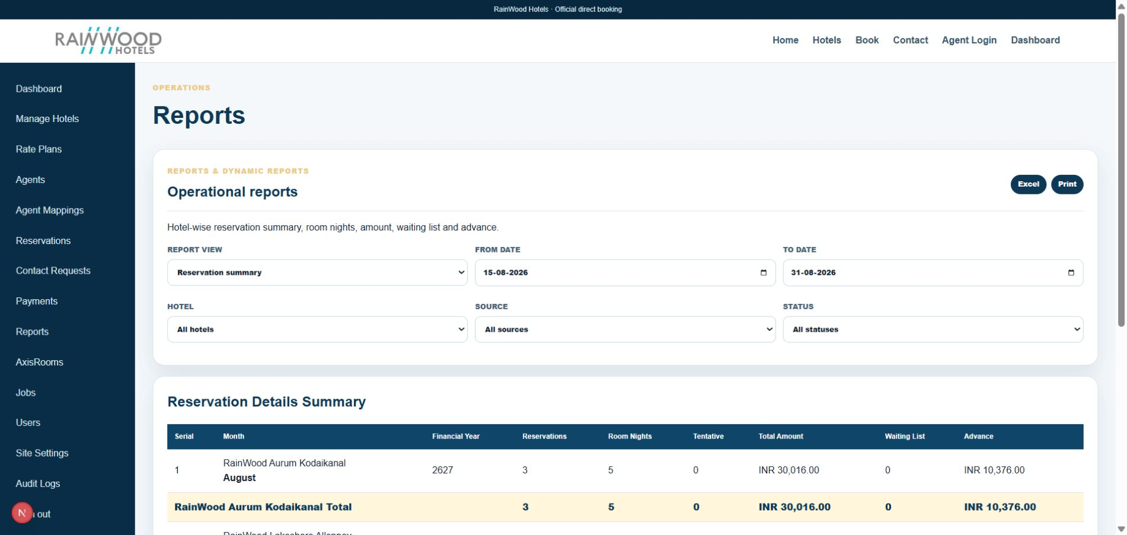
Related local UI evidence: the Reports surface consumes the same operational aggregates used by monitoring and metrics.

Client guide: what this screen is for
In plain language Use these technical endpoints and metrics to confirm that the application and its dependencies are healthy.

Field or control | What you see | Why it is used
Health status | Overall application readiness | Confirm the service can accept work.
Database check | Database connectivity and response | Detect persistence problems.
Metrics | Request, job, and operational counters | Spot errors, slowdowns, or growing queues.

Next step Complete the required fields, save the record, then use the workflow and verification steps below to confirm that the information is available to the next module.

Functional surface
Surface | Observed responsibility
Live check | Process liveness endpoint.
Ready check | Dependency/readiness endpoint.
Metrics | Prometheus-compatible metrics endpoint.
Runbook | Operational checks for deployment and incident response.

Code map
Layer | Files / symbols | What the code does
Backend | backend/src/modules/health/health.controller.ts; health.service.ts | Liveness, readiness, and metrics endpoints.
Operations | docs/CODEX_RUNBOOK.md; PRODUCTION_READINESS_CHECKLIST.md | Deployment and verification guidance.
Cross-cutting | prom-client and database checks | Collect runtime and service signals.
Frontend | loading/error states | React surfaces show service failure to users.

API contract
Method | Path | Role in the module
GET | /health/live | Process is alive.
GET | /health/ready | Application dependencies are ready.
GET | /metrics | Metrics scrape endpoint.

Data model
Entity | Fields / relationships observed | Reason it exists
Health result | status and dependency checks | Machine-readable operational decision.
Metrics | request/process/application counters | Monitoring and alerting inputs.
Environment | database and service configuration | Determines readiness behavior.

Primary workflow
- Load balancer or operator calls live check.
- Deployment system calls ready check before routing traffic.
- Monitoring scrapes metrics on an interval.
- On failure, operator follows the runbook and checks logs/dependencies.

Access and permissions
- Health endpoints may be public to infrastructure but should not reveal secrets.
- Metrics should avoid high-cardinality personal or reservation labels.
- Admin users should not be required for liveness checks.

Risks, boundaries, and implementation notes
- A live process can still be unable to serve traffic; readiness must include important dependencies.
- Metrics exposure should be restricted at the network layer where required.
- Health checks need environment-specific timeout and alert thresholds.

Recommended verification scenarios
- Stop the backend and verify live/readiness failure behavior.
- Break the database dependency and verify readiness changes.
- Scrape metrics and verify valid response format.
- Confirm health output contains no secrets or personal data.
Analyst conclusion This document describes the behavior visible in the current repository. Any change to business rules, external credentials, tax policy, or production data should be reviewed against the API contract and deployment runbook.

