RAINWOOD HOTELS

Hotel Management and Catalogue
Hotel identity, rooms, amenities, images, and catalogue records
Audience | Engineering, product, and operations
Source basis | Static analysis of frontend routes, backend controllers/services, and Prisma schema
Status | Observed implementation; confirm business policy before production changes
Module purpose Owns the hotel master record and the room-level catalogue that the rest of the platform uses for availability, pricing, public pages, and reservations.

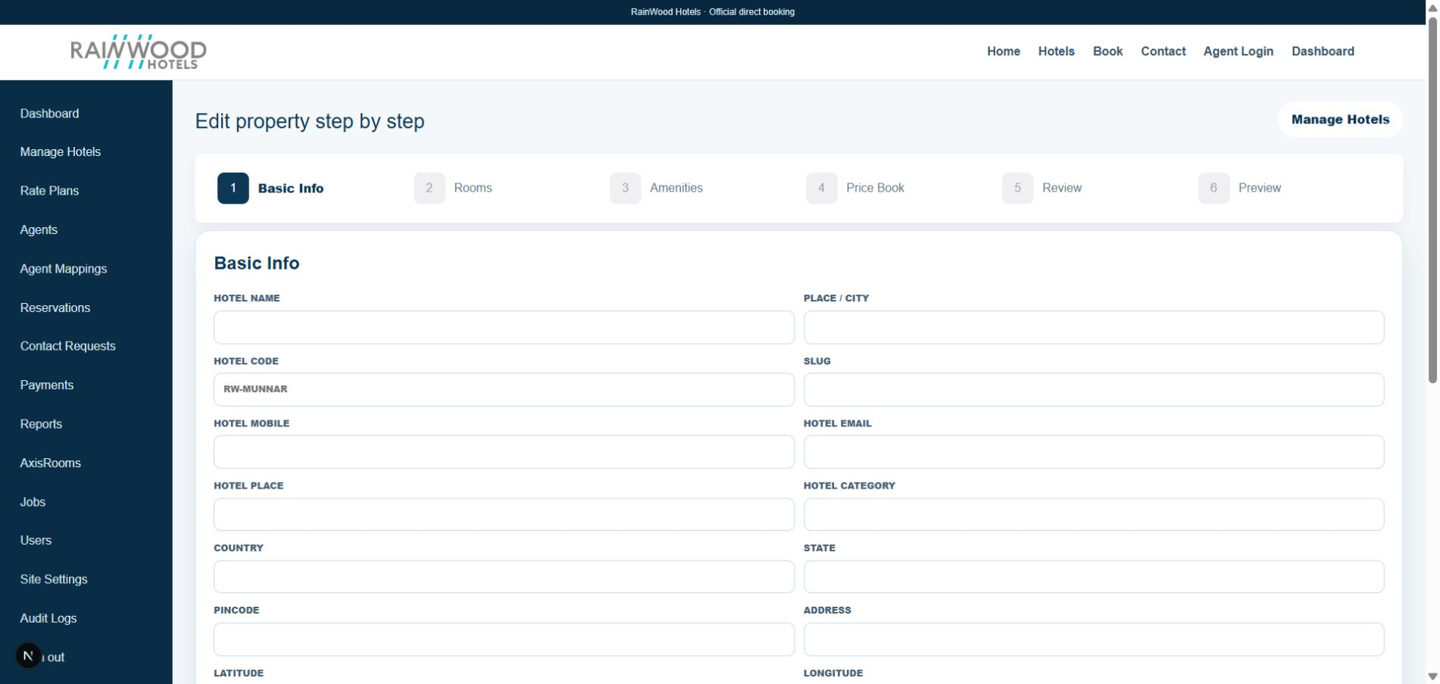
Local RainWood UI screenshot: Hotel Management and Catalogue.

Client guide: what this screen is for
In plain language Use this area to create and maintain the hotel information that guests, booking staff, pricing, and availability use.

Field or control | What you see | Why it is used
Basic Info | Hotel name, code, address, contacts, category, coordinates, status | Identify the property and control whether it is active and publishable.
Rooms | Room type, title, availability, occupancy, timings, tax, gallery | Define what guests can book, how many can be sold, and how the room is displayed.
Amenities | Amenity title, quantity, availability type, duration times, status, code | Tell guests what facilities exist and when they are available.
Price Book | Rate plans, dates, prices, inventory, restrictions | Set the sell price and availability rules for each room and date.
Reviews and Preview | Customer feedback, summary, public preview | Review content before it is used on the public hotel page.

Next step Complete the required fields, save the record, then use the workflow and verification steps below to confirm that the information is available to the next module.

Functional surface
Surface | Observed responsibility
Admin hotel list | Search hotels, view status, edit a hotel, or open its rooms and rates catalogue.
Manage Hotels wizard | Edit Basic Info, Rooms, Amenities, Price Book, Reviews, and Preview.
Catalogue | Inspect rooms, inventory rows, rate plans, and rates for one hotel.
Public hotel detail | Expose approved hotel and room content through the public website.

Code map
Layer | Files / symbols | What the code does
Frontend | frontend/src/app/admin/hotels/page.tsx; frontend/src/app/admin/hotels/new/page.tsx | Hotel list and six-step edit wizard.
Frontend | frontend/src/app/admin/hotels/[id]/catalog/page.tsx | Room, rate plan, daily rate, and inventory catalogue view.
Backend | backend/src/modules/hotels/hotels.controller.ts; hotels.service.ts | Hotel, room, amenity, image, review, rate, and inventory endpoints.
Schema | Hotel, HotelImage, RoomType, RoomImage, Amenity, HotelAmenity | Relational catalogue entities and hotel-owned media.

API contract
Method | Path | Role in the module
GET | /hotels | List hotels for admin and selection.
POST/PATCH | /hotels and /hotels/:id | Create and update hotel master data.
GET | /hotels/:hotelId/catalog | Load rooms, rate plans, rates, and inventory.
POST/PATCH | /hotels/:hotelId/rooms and /hotels/rooms/:id | Create or update room categories.
POST/DELETE | /hotels/:hotelId/amenities...; .../images | Manage hotel amenities and image records.

Data model
Entity | Fields / relationships observed | Reason it exists
Hotel | name, code, slug, contacts, address, coordinates, category, active | Canonical property identity.
RoomType | code, name, occupancy, room count, tax, timings, food flags | Sellable room category and occupancy rules.
Amenity | name, quantity, availability, status, code | Hotel-level facility available to guests.
Images | hotel and room image records with public file references | Visual presentation for public pages and cards.

Primary workflow
- Create or select a hotel from the admin list.
- Complete Basic Info and save the master record.
- Add room categories, room images, capacities, tax, timings, and food inclusions.
- Add hotel-level amenities and review generated codes or duration fields.
- Continue to rates, reviews, and preview; use the catalogue page to audit persisted records.

Access and permissions
- Admin hotel routes are protected by the shared JWT and role guard in the backend.
- Public hotel pages consume only public-safe fields and media.
- Room and amenity deletion should be treated as destructive; persisted records may have dependencies.

Risks, boundaries, and implementation notes
- Room, rate, and inventory dependencies mean deletion and deactivation are not equivalent.
- Image upload depends on the configured storage driver and file-size policy.
- Business rules for hotel margin, status, tax, and publication should be confirmed before release.

Recommended verification scenarios
- Create a hotel, refresh it, and verify all Basic Info fields persist.
- Add a room with multiple images and verify thumbnails and public image URLs.
- Change an amenity to Duration and verify start/end times are required.
- Deactivate a room or hotel and verify it is excluded from sellable availability.
Analyst conclusion This document describes the behavior visible in the current repository. Any change to business rules, external credentials, tax policy, or production data should be reviewed against the API contract and deployment runbook.

