RAINWOOD HOTELS

Jobs and Reconciliation
Background processing, retries, dead letters, and operational recovery
Audience | Engineering, product, and operations
Source basis | Static analysis of frontend routes, backend controllers/services, and Prisma schema
Status | Observed implementation; confirm business policy before production changes
Module purpose Runs asynchronous work and gives operations a way to identify and re-enqueue failed booking/channel/payment synchronization work.

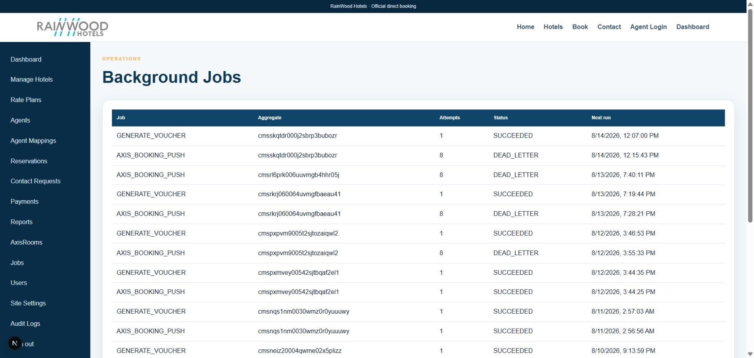
Local RainWood UI screenshot: Jobs and Reconciliation.

Client guide: what this screen is for
In plain language Use this area to inspect background work such as email, voucher creation, payment reconciliation, and sync retries.

Field or control | What you see | Why it is used
Job type | The background task being run | Identify the business operation behind the job.
Status | Queued, running, succeeded, failed, dead-letter | Know whether the task needs attention.
Attempts and error | Retry count and failure message | Help support staff decide whether to retry or investigate.

Next step Complete the required fields, save the record, then use the workflow and verification steps below to confirm that the information is available to the next module.

Functional surface
Surface | Observed responsibility
Jobs admin | List queued, running, failed, and dead-letter jobs.
Retry | Retry a selected failed job.
Reconciliation | Summarize failures and enqueue recoverable reservation sync work.
Worker | Process outbox jobs on a configured interval.

Code map
Layer | Files / symbols | What the code does
Frontend | frontend/src/app/admin/jobs/page.tsx | Job list and retry controls.
Backend | backend/src/modules/jobs/jobs.controller.ts; jobs.service.ts | Job listing and retry operation.
Backend | backend/src/modules/reconciliation/reconciliation.controller.ts | Failure summary and enqueue operation.
Config | WORKER_ENABLED, JOB_WORKER_INTERVAL_MS, JOB_MAX_ATTEMPTS | Worker and retry policy.

API contract
Method | Path | Role in the module
GET | /jobs | List jobs and statuses.
POST | /jobs/:id/retry | Retry a failed job.
GET | /reconciliation/summary | Count failed jobs, failed sync, and pending payments.
POST | /reconciliation/enqueue | Queue confirmed reservations needing Axis sync.

Data model
Entity | Fields / relationships observed | Reason it exists
OutboxJob | type, aggregate, payload, status, attempts, availableAt | Durable asynchronous work item.
Reservation.syncStatus | PENDING, FAILED, DEAD_LETTER or equivalent | Tracks channel synchronization state.
PaymentAttempt | PENDING and provider statuses | Source for pending payment reconciliation.
AxisSyncLog | Attempt and result records | Evidence for recovery decisions.

Primary workflow
- Business action creates an outbox job or a failed state.
- Worker picks available jobs and applies the operation.
- Failures increment attempts and eventually become dead-letter.
- Staff reviews the Jobs or Reconciliation view.
- Retry or enqueue a safe recovery operation and verify final state.

Access and permissions
- Job and reconciliation controls are privileged operational actions.
- Retry should be idempotent and should not be exposed to public users.
- Failure payloads can contain sensitive identifiers and should be access-controlled.

Risks, boundaries, and implementation notes
- Retrying a non-idempotent operation can duplicate external effects.
- Dead-letter queues need an owner and response-time policy.
- Worker settings differ between local and production; verify deployment environment variables.

Recommended verification scenarios
- Create a known failed job and retry it once.
- Verify retry does not duplicate a reservation push.
- Check reconciliation summary against database counts.
- Verify dead-letter jobs remain visible until resolved.
Analyst conclusion This document describes the behavior visible in the current repository. Any change to business rules, external credentials, tax policy, or production data should be reviewed against the API contract and deployment runbook.

