RAINWOOD HOTELS

Payments
Payment orders, manual receipts, verification, and webhooks
Audience | Engineering, product, and operations
Source basis | Static analysis of frontend routes, backend controllers/services, and Prisma schema
Status | Observed implementation; confirm business policy before production changes
Module purpose Tracks payment attempts and payment state separately from the reservation, supporting online order creation, manual payment capture, verification, mock completion, and provider webhooks.

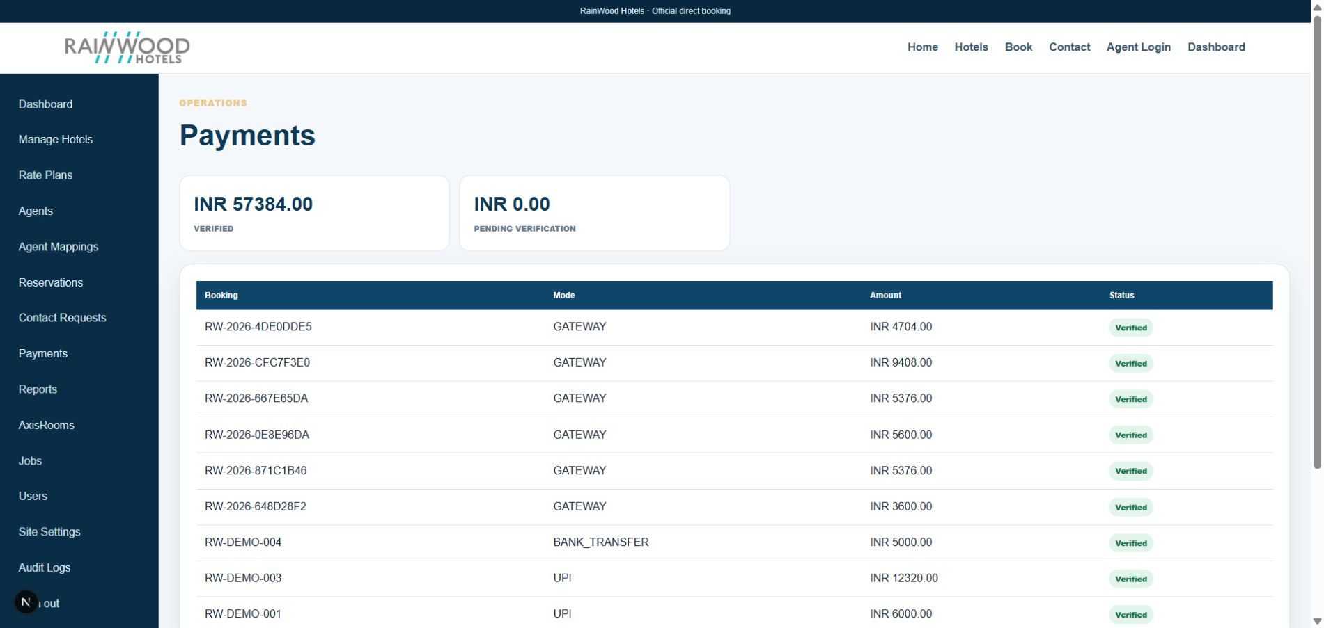
Local RainWood UI screenshot: Payments.

Client guide: what this screen is for
In plain language Use this area to reconcile money received against reservations and identify outstanding or failed payments.

Field or control | What you see | Why it is used
Reservation | Booking reference and guest | Connect the payment to the correct stay.
Amount and currency | Paid value and currency | Record the financial value received.
Method | Card, bank transfer, cash, or gateway | Explain how the money was collected.
Status | Pending, verified, failed, refunded | Show whether the payment can be treated as received.

Next step Complete the required fields, save the record, then use the workflow and verification steps below to confirm that the information is available to the next module.

Functional surface
Surface | Observed responsibility
Admin payments | Review payment attempts and verify manual payments.
Guest checkout | Start an online payment order for a reservation.
Manual payment | Record cash, bank, or other staff-entered payment evidence.
Provider webhook | Accept signed/idempotent payment status callbacks.

Code map
Layer | Files / symbols | What the code does
Frontend | frontend/src/app/admin/payments/page.tsx; components/BookingFlow.tsx | Payment operations and guest payment initiation.
Backend | backend/src/modules/payments/payments.controller.ts; payments.service.ts | Order, manual, verify, mock, and webhook behavior.
Schema | Payment, PaymentAttempt | Payment state, provider references, amounts, and attempts.
Files | backend/src/modules/files/files.controller.ts | Payment-proof upload path for manual payment evidence.

API contract
Method | Path | Role in the module
POST | /payments/:reference/order | Create a provider payment order.
POST | /payments/:reference/manual | Record a manual payment.
POST | /payments/:reference/manual/:paymentId/verify | Verify a manual payment.
POST | /payments/:reference/mock-complete | Complete the local mock payment path.
POST | /payments/webhooks/:provider | Receive provider callback.

Data model
Entity | Fields / relationships observed | Reason it exists
Payment | reservation, provider, amount, status, reference | Business payment record.
PaymentAttempt | attempt status, provider order/payment IDs, timestamps | Retryable provider interaction and reconciliation state.
Reservation | paymentStatus, total, advance, balance | Reservation-level financial summary.
StoredFile | proof metadata and storage reference | Evidence for manual payments where configured.

Primary workflow
- Create or load a reservation with an outstanding balance.
- Create an online order or record a manual payment.
- Complete provider callback or staff verification.
- Update payment and reservation balances idempotently.
- Use reports and reconciliation for exceptions or pending attempts.

Access and permissions
- Payment operations are role-protected; verification is a privileged action.
- Provider webhooks must use signature and idempotency checks.
- Payment proof and financial details require restricted access and careful logging.

Risks, boundaries, and implementation notes
- Local mock mode is not production merchant certification.
- Duplicate webhooks or retries must not double-apply money.
- Provider credentials, refund rules, and settlement behavior are external dependencies.

Recommended verification scenarios
- Create a mock order and complete it once; replay the completion and verify no duplicate payment.
- Record a manual payment, verify it, and confirm balance changes.
- Upload proof and confirm it is linked to the intended payment.
- Send an invalid webhook signature and verify rejection.
Analyst conclusion This document describes the behavior visible in the current repository. Any change to business rules, external credentials, tax policy, or production data should be reviewed against the API contract and deployment runbook.

