RAINWOOD HOTELS

Public Discovery and Booking
Public hotel discovery, search, availability, holds, and booking initiation
Audience | Engineering, product, and operations
Source basis | Static analysis of frontend routes, backend controllers/services, and Prisma schema
Status | Observed implementation; confirm business policy before production changes
Module purpose Connects public hotel content to server-side availability and pricing so a guest can search, choose a room and meal plan, place a temporary hold, and start a booking.

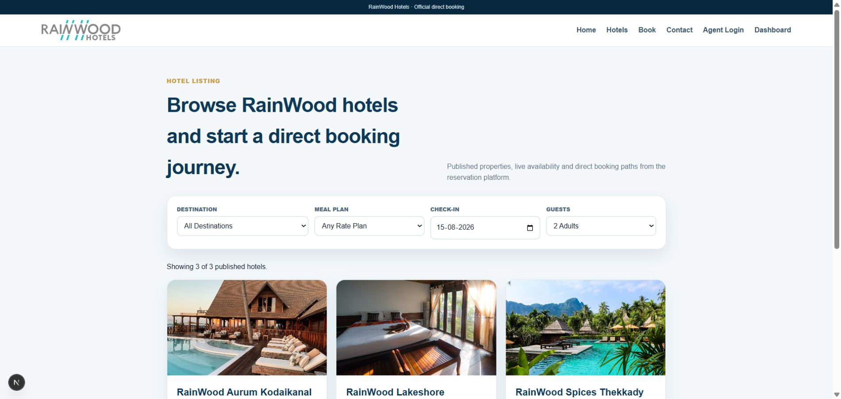
Local RainWood UI screenshot: Public Discovery and Booking.

Client guide: what this screen is for
In plain language This is the guest journey: finding a hotel, viewing rooms, and submitting a booking.

Field or control | What you see | Why it is used
Search | Destination, check-in, check-out, guests | Find hotels that can serve the requested stay.
Hotel card | Name, location, image, starting price, status | Choose a property to inspect.
Room and rate | Room category, occupancy, inclusions, price | Select the product the guest wants to book.
Guest details | Name, email, mobile, special request | Collect the information needed to confirm the reservation.

Next step Complete the required fields, save the record, then use the workflow and verification steps below to confirm that the information is available to the next module.

Functional surface
Surface | Observed responsibility
Public home and hotels | Present hotels, search, and property detail pages.
Hotel detail | Show rooms, rate plans, restrictions, and prices.
Booking flow | Collect stay dates, occupancy, hotel/room/rate selections, and guest details.
Hold | Temporarily reserve selected inventory before payment or reservation conversion.

Code map
Layer | Files / symbols | What the code does
Frontend | frontend/src/app/page.tsx; hotels/page.tsx; hotels/[slug]/page.tsx | Public discovery and hotel detail pages.
Frontend | frontend/src/app/booking/page.tsx; components/BookingFlow.tsx | Multi-step search and selection flow.
Backend | availability/availability.controller.ts; availability.service.ts | Night-by-night availability and server-side pricing.
Backend | holds/holds.controller.ts; holds.service.ts | Temporary inventory holds and quote snapshots.

API contract
Method | Path | Role in the module
GET | /availability/search | Search available room/rate options for stay dates and occupancy.
POST | /holds | Create a time-limited hold from a selected quote.
GET | /holds/:token | Read a hold while it is valid.
GET | /hotels/:slug | Load public hotel detail content.

Data model
Entity | Fields / relationships observed | Reason it exists
InventoryDay | available, held, sold, stopSell | Controls night-level availability.
RateDay | amount, tax, occupancy prices, CTA/CTD/LOS | Controls night-level price and restrictions.
InventoryHold | token, expiry, status, quoted totals | Prevents race conditions during checkout.
InventoryHoldLine/Night | room, rate plan, dates, rooms | Snapshots selected inventory across each night.

Primary workflow
- Guest enters dates, rooms, adults, children, and optional meal plan.
- API calculates availability and price for every occupied night.
- Guest selects a room and rate plan; client submits the server quote for a hold.
- System creates an expiring hold and returns a booking token.
- Booking conversion hands the hold to Reservations and Payment workflows.

Access and permissions
- Public search and public hotel detail are intended for unauthenticated users.
- Hold and booking endpoints must validate the server-side quote and expiry.
- Agent booking uses the same domain model but filters accessible rate plans by assignment.

Risks, boundaries, and implementation notes
- Availability must be rechecked at hold and reservation conversion time.
- Date/time zone handling can change night boundaries if date-only values are parsed incorrectly.
- Payment or reservation conversion should never trust client-submitted totals without revalidation.

Recommended verification scenarios
- Search a two-night stay and verify two nightly breakdown rows.
- Search a stop-sell date and confirm the room is unavailable.
- Create a hold, wait past expiry, and verify conversion is rejected.
- Change occupancy and confirm server-side prices change appropriately.
Analyst conclusion This document describes the behavior visible in the current repository. Any change to business rules, external credentials, tax policy, or production data should be reviewed against the API contract and deployment runbook.

