RAINWOOD HOTELS

Rate Plans and Price Book
Commercial offers, dates, occupancy prices, taxes, and inventory
Audience | Engineering, product, and operations
Source basis | Static analysis of frontend routes, backend controllers/services, and Prisma schema
Status | Observed implementation; confirm business policy before production changes
Module purpose Defines what can be sold, at what price, for which room, meal plan, date range, occupancy, and inventory level.

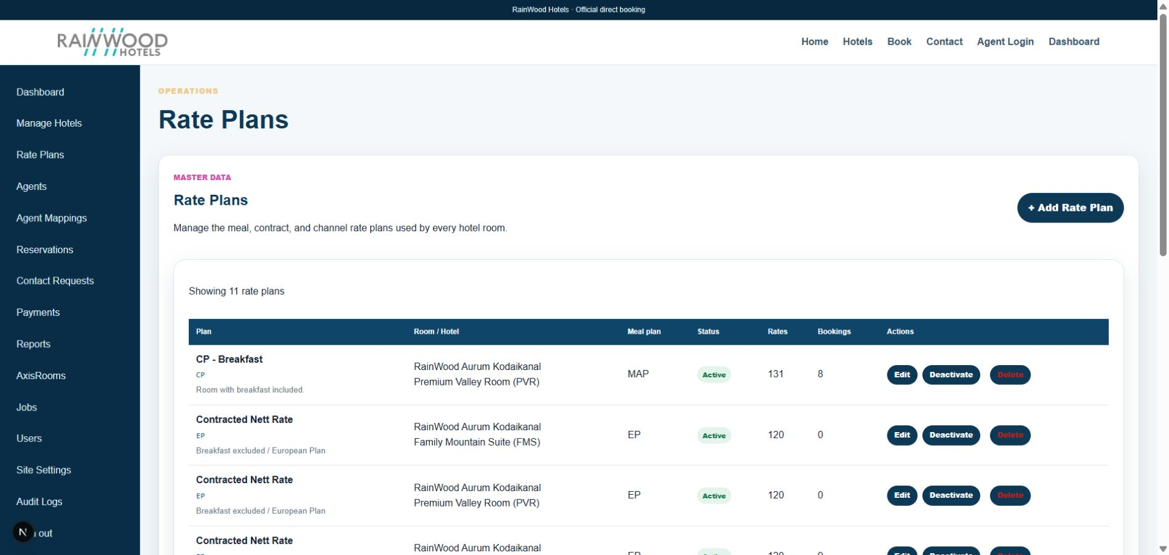
Local RainWood UI screenshot: Rate Plans and Price Book.

Client guide: what this screen is for
In plain language Use this area to decide which prices and booking rules apply to each room.

Field or control | What you see | Why it is used
Rate plan name | A guest-facing plan such as Room Only or Breakfast Included | Explain what the price includes.
Room type | The room category to which the plan belongs | Connect the plan to a sellable room.
Dates and amount | Stay date range and nightly price | Control the price for a specific period.
Restrictions | Minimum stay, stop-sell, or availability rules | Prevent bookings that do not meet the hotel policy.

Next step Complete the required fields, save the record, then use the workflow and verification steps below to confirm that the information is available to the next module.

Functional surface
Surface | Observed responsibility
Rate Plans admin | Create, edit, activate, deactivate, and delete rate plans.
Price Book step | Apply one rate plan to one or all rooms across date ranges.
Catalogue | Review daily rates and inventory by room and plan.
Excel export | Download a complete hotel price book for review or sharing.

Code map
Layer | Files / symbols | What the code does
Frontend | frontend/src/app/admin/rate-plans/page.tsx | Master rate plan management.
Frontend | frontend/src/app/admin/hotels/new/page.tsx | Range-based pricing and inventory editor.
Backend | backend/src/modules/hotels/hotels.controller.ts; hotels.service.ts | Rate plan, rate day, inventory, and export operations.
Schema | RatePlan, RateDay, InventoryDay | Commercial offer and date-level sellability records.

API contract
Method | Path | Role in the module
GET | /hotels/rate-plans | List active and configured rate plans.
POST | /hotels/rooms/:roomId/rate-plans | Create a room-specific rate plan.
PATCH/DELETE | /hotels/rate-plans/:id | Update, deactivate, or remove a plan.
POST | /hotels/rate-plans/:ratePlanId/rates | Create or update a daily rate.
GET | /hotels/:hotelId/pricebook.xlsx | Export the hotel price book.

Data model
Entity | Fields / relationships observed | Reason it exists
RatePlan | code, name, mealPlan, active, roomTypeId | Defines the offer sold for a room.
RateDay | date, amount, taxAmount, occupancyPrices, restrictions | Stores a rate for one date.
InventoryDay | date, available, stopSell, held, sold | Stores sellable inventory and stop-sell state.
Pricing inputs | single/double/triple/quad, extra bed/adult/child | Supports occupancy-aware pricing.

Primary workflow
- Create or select a rate plan for a room.
- Select a room scope and add one or more valid start/end date ranges.
- Enter base, tax, occupancy prices, and supplements.
- Save pricing, then create inventory date ranges and set available rooms or Stop sell.
- Export the price book and validate the resulting catalogue before enabling sales.

Access and permissions
- Rate plan and price book operations are admin/staff operations behind JWT and role guards.
- Agents see only rate plans assigned through the mapping module.
- Public availability should use server-side price and inventory calculations, not client-entered totals.

Risks, boundaries, and implementation notes
- A rate without inventory, or inventory without a rate, may not produce a sellable result.
- Date-range updates can overwrite existing date-level values; review the selected scope before saving.
- Tax, CTA, CTD, minimum/maximum LOS, and occupancy policies require business sign-off.

Recommended verification scenarios
- Create a plan, add a date range, save rates, and verify a RateDay row.
- Save inventory with Stop sell and confirm public search excludes the date.
- Export Excel and reconcile several rows against the catalogue.
- Verify agents cannot see unassigned rate plans.
Analyst conclusion This document describes the behavior visible in the current repository. Any change to business rules, external credentials, tax policy, or production data should be reviewed against the API contract and deployment runbook.

