RAINWOOD HOTELS

Reports
Operational, reservation, payment, arrival, departure, and cancellation reporting
Audience | Engineering, product, and operations
Source basis | Static analysis of frontend routes, backend controllers/services, and Prisma schema
Status | Observed implementation; confirm business policy before production changes
Module purpose Provides management and operations with filtered report views and CSV export over reservations and financial activity.

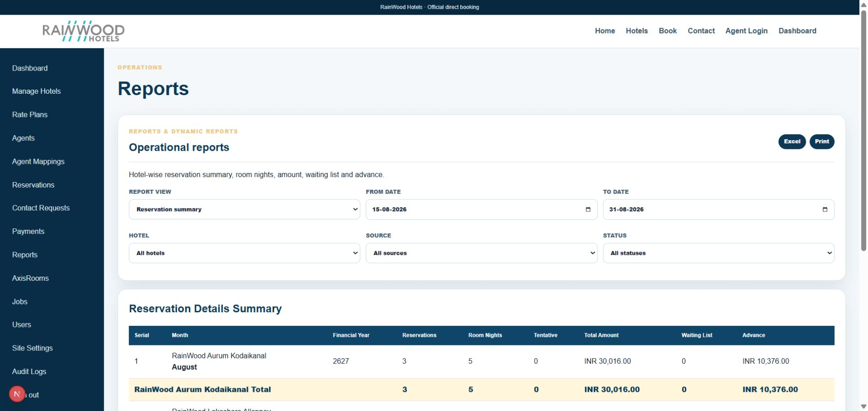
Local RainWood UI screenshot: Reports.

Client guide: what this screen is for
In plain language Use reports to understand bookings, revenue, occupancy, payments, and operational performance for a selected period.

Field or control | What you see | Why it is used
Date range | Start and end dates | Choose the period being analysed.
Hotel or source | Property, website, agent, phone, or direct | Narrow the report to the relevant business segment.
Summary metrics | Reservations, revenue, balance, occupancy | Read the high-level performance for the period.
Export | CSV, Excel, or report download | Share or further analyse the filtered results.

Next step Complete the required fields, save the record, then use the workflow and verification steps below to confirm that the information is available to the next module.

Functional surface
Surface | Observed responsibility
Admin dashboard | High-level operational metrics.
Reports page | Filter date range and report type.
CSV export | Download reservation report data for analysis.
Expected arrivals/departures | Support front-office planning.

Code map
Layer | Files / symbols | What the code does
Frontend | frontend/src/app/admin/dashboard/page.tsx; reports/page.tsx | Dashboard and report controls.
Backend | backend/src/modules/reports/reports.controller.ts; reports.service.ts | Aggregated report queries and CSV serialization.
Schema | Reservation, Payment, ReservationLine, ReservationRoomNight | Source records for reports.
Runbook | docs/CODEX_RUNBOOK.md | Operational context and deployment checks.

API contract
Method | Path | Role in the module
GET | /reports/dashboard | Dashboard metrics.
GET | /reports/reservations | Reservation report.
GET | /reports/summary | Summary aggregation.
GET | /reports/expected-arrivals; /arrivals; /departures | Front-office date reports.
GET | /reports/payments; /cancellations; /reservations.csv | Financial, cancellation, and export reports.

Data model
Entity | Fields / relationships observed | Reason it exists
Reservation | status, source, dates, totals, balance | Primary operational report record.
Payment | status, amount, verified timestamps | Payment report source.
Room nights | date, rooms, amount, tax, total | Arrival/departure and revenue detail.
Query filters | date range and report-specific options | Controls report scope.

Primary workflow
- Staff selects report type and date filters.
- Frontend requests a protected report endpoint.
- Service aggregates reservations, payment attempts, or room-night data.
- User reviews the result and optionally downloads CSV.
- Use the exported file for reconciliation or management reporting.

Access and permissions
- Reports are staff/admin surfaces and may contain personal and financial data.
- CSV export should carry the same authorization as the on-screen report.
- Avoid adding sensitive fields to exports without explicit approval.

Risks, boundaries, and implementation notes
- Large date ranges may increase query cost and response time.
- Report definitions must be documented when business totals change.
- Time zone and date-only semantics need consistent treatment.

Recommended verification scenarios
- Run every report with a narrow date range and compare to source records.
- Export CSV and validate headers, encoding, and row counts.
- Verify unauthorized roles cannot access protected reports.
- Test empty result ranges and boundary dates.
Analyst conclusion This document describes the behavior visible in the current repository. Any change to business rules, external credentials, tax policy, or production data should be reviewed against the API contract and deployment runbook.

