RAINWOOD HOTELS

Reservations
Reservation lifecycle, guest details, amendments, and cancellation
Audience | Engineering, product, and operations
Source basis | Static analysis of frontend routes, backend controllers/services, and Prisma schema
Status | Observed implementation; confirm business policy before production changes
Module purpose Owns the operational reservation record after a hold is converted, including guest data, stay dates, room/rate lines, payment balance, status, and controlled changes.

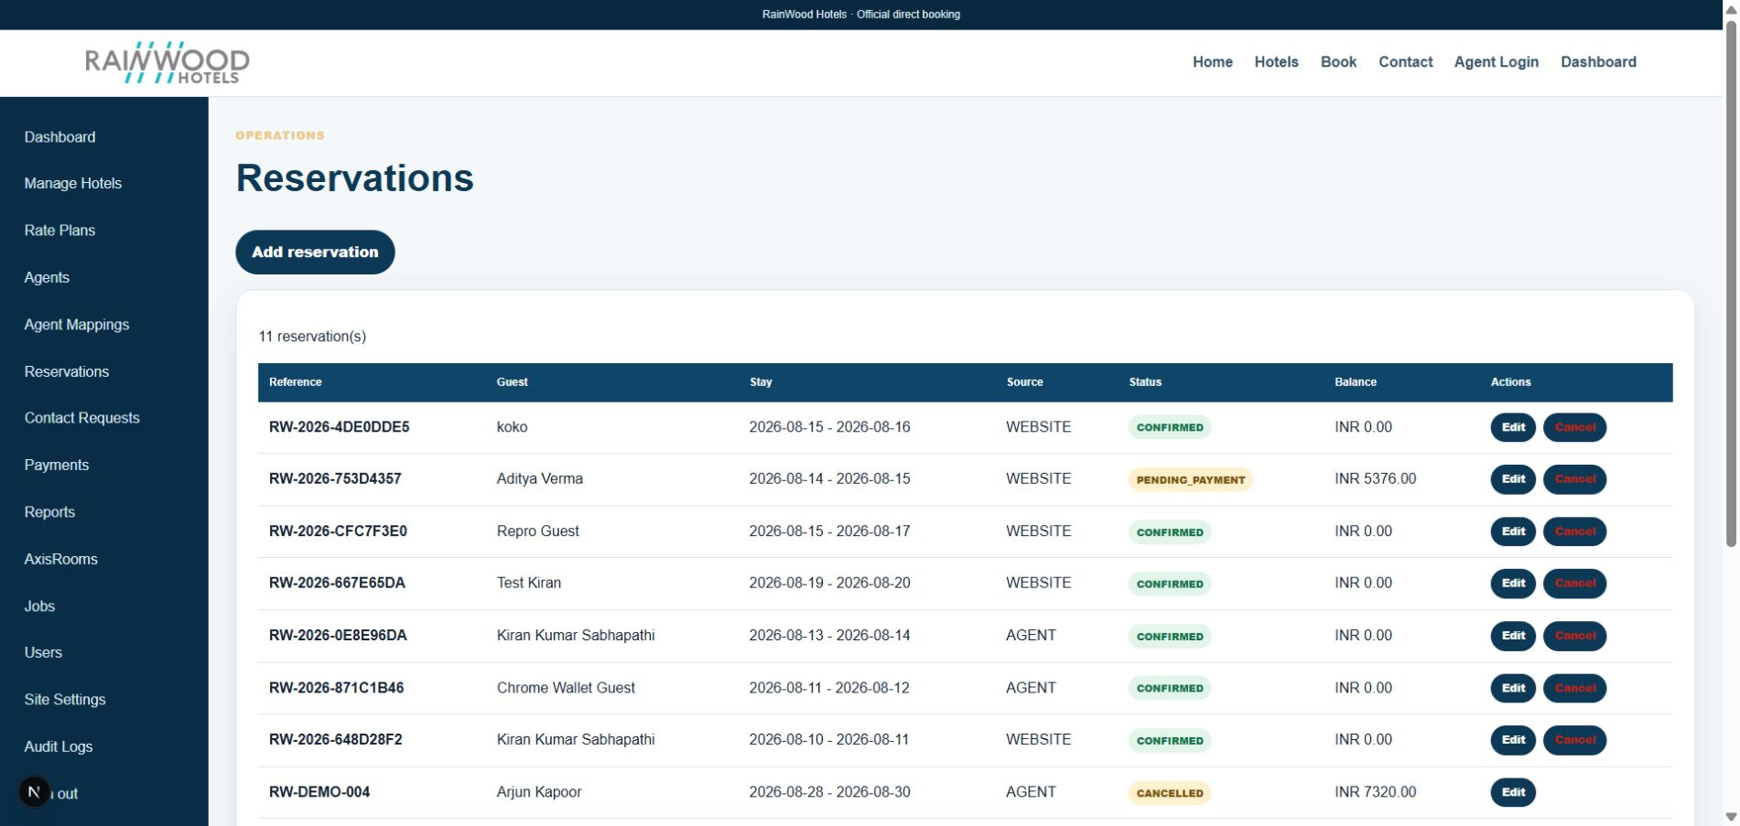
Local RainWood UI screenshot: Reservations.

Client guide: what this screen is for
In plain language Use this area to monitor and manage guest bookings from creation through completion or cancellation.

Field or control | What you see | Why it is used
Reference | Unique booking number | Use it when discussing a reservation with a guest or partner.
Guest and stay | Guest name, dates, room, occupancy | Confirm who is staying and what was booked.
Status | Pending, confirmed, cancelled, completed | Show the current booking lifecycle state.
Balance and actions | Paid amount, balance, edit/cancel actions | Track money still due and allowed operational actions.

Next step Complete the required fields, save the record, then use the workflow and verification steps below to confirm that the information is available to the next module.

Functional surface
Surface | Observed responsibility
Admin reservations | List, search, create manual reservations, edit guest/instruction data, and cancel.
Agent bookings | Show bookings created by an agent and their operational status.
Reservation detail | Expose room, rate, stay, payment, cancellation, and modification information.
Public booking completion | Convert an approved hold into a reservation.

Code map
Layer | Files / symbols | What the code does
Frontend | frontend/src/app/admin/reservations/page.tsx | Admin reservation list and form.
Frontend | frontend/src/app/agent/bookings/page.tsx; components/AdminData.tsx | Agent and shared operational data surfaces.
Backend | backend/src/modules/reservations/reservations.controller.ts; reservations.service.ts | Create, list, view, update, cancel, and convert reservations.
Schema | Reservation, ReservationLine, ReservationRoomNight, ReservationModification | Reservation contract and versioned operational history.

API contract
Method | Path | Role in the module
POST | /reservations/from-hold/:token | Convert a valid hold into a reservation.
POST | /reservations/manual | Create a manual staff reservation.
GET | /reservations | List reservations with filters and pagination.
GET/PATCH | /reservations/:reference | Read or update permitted reservation details.
POST | /reservations/:reference/cancel | Cancel and restore inventory through the cancellation workflow.

Data model
Entity | Fields / relationships observed | Reason it exists
Reservation | reference, status, paymentStatus, guest, dates, totals, version | Master booking contract.
ReservationLine | room, rate plan, occupancy, nightly rate, tax | Room/rate breakdown for the reservation.
ReservationRoomNight | date, rooms, amount, tax, total | Night-by-night inventory and price snapshot.
ReservationModification | before/after changes, version, type, status | Audit-friendly controlled amendments.

Primary workflow
- Create from a hold or enter a manual reservation.
- Persist guest, stay, room/rate, pricing snapshot, and payment state.
- Use payment workflows to record and verify money received.
- Allow only supported non-inventory modifications through the versioned PATCH workflow.
- Cancel through the cancellation endpoint so inventory restoration and audit behavior run together.

Access and permissions
- Admin roles can view operational reservations; role guards are enforced in the backend.
- Agents are limited to their own booking surface and assigned rate plans.
- Stay dates, tariff, and payment facts should be treated as snapshots rather than freely editable fields.

Risks, boundaries, and implementation notes
- Concurrent changes require version/idempotency handling to avoid lost updates.
- Cancellation must restore inventory exactly once.
- Guest contact details and internal remarks are sensitive operational data.

Recommended verification scenarios
- Convert a valid hold and verify reservation lines and nights.
- Create a manual reservation and verify required guest/stay validation.
- Patch a permitted guest field and confirm a modification record.
- Cancel a reservation and verify inventory restoration and status transition.
Analyst conclusion This document describes the behavior visible in the current repository. Any change to business rules, external credentials, tax policy, or production data should be reviewed against the API contract and deployment runbook.

