RAINWOOD HOTELS

Site Settings
Public configuration and admin-managed branding
Audience | Engineering, product, and operations
Source basis | Static analysis of frontend routes, backend controllers/services, and Prisma schema
Status | Observed implementation; confirm business policy before production changes
Module purpose Stores configurable site-level settings such as branding and logo data that are consumed by the public site and admin shell.

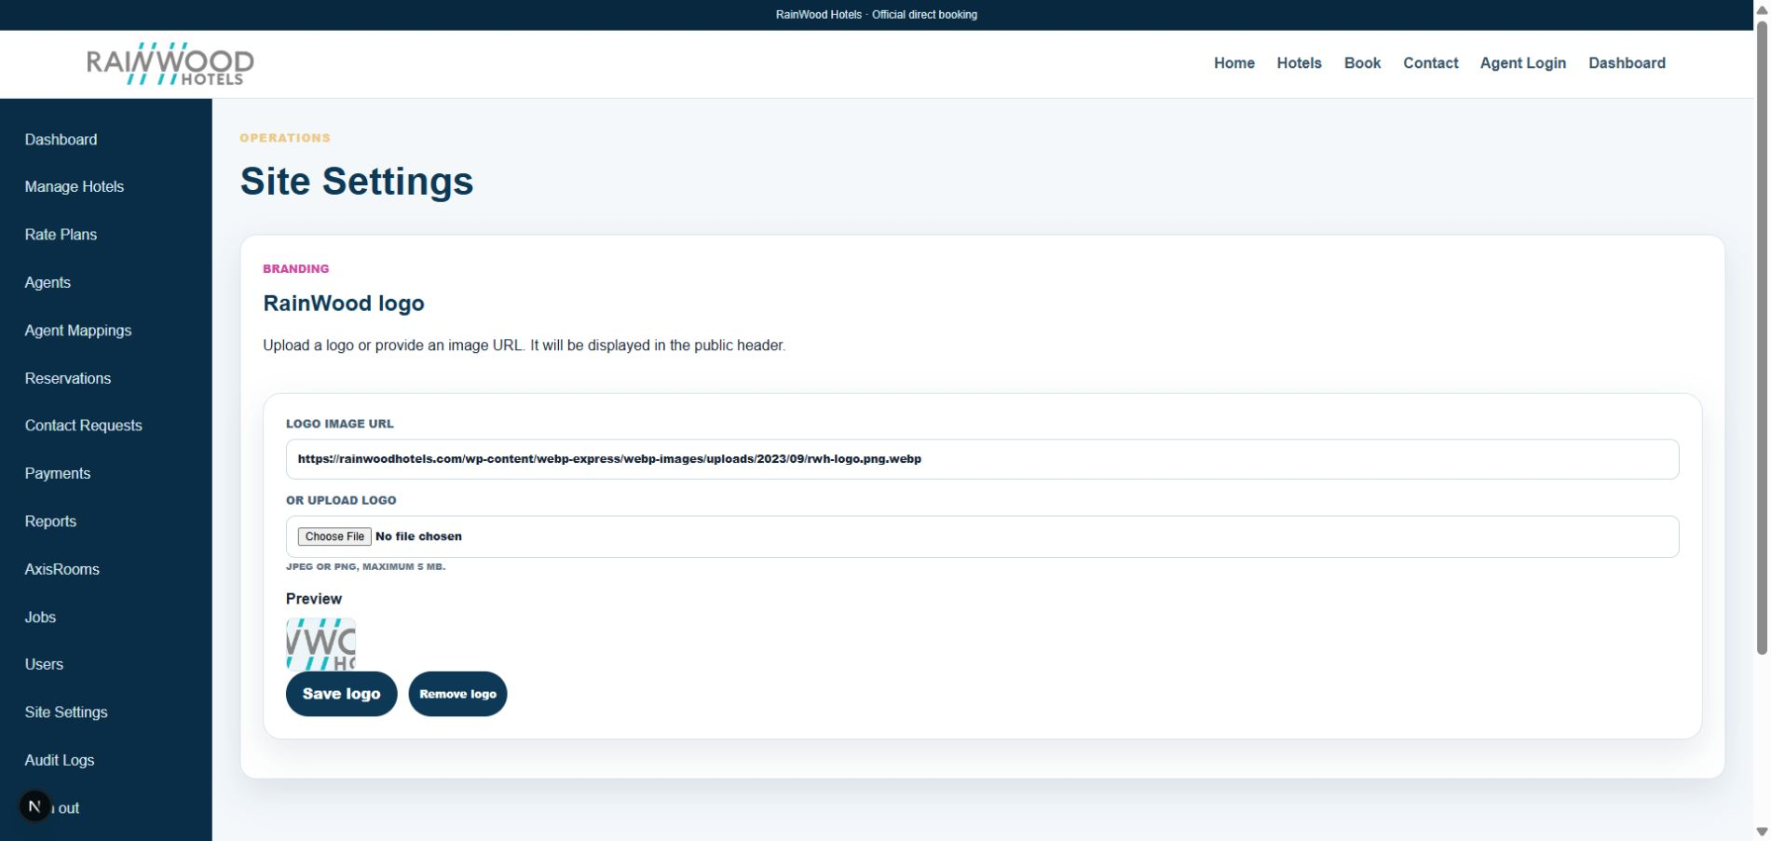
Local RainWood UI screenshot: Site Settings.

Client guide: what this screen is for
In plain language Use these settings to maintain the public brand presentation and shared site configuration.

Field or control | What you see | Why it is used
Logo URL or upload | A hosted image URL or JPEG/PNG file | Choose the logo shown in the public header.
Preview | Rendered logo preview | Check the selected asset before saving.
Save or remove | Persist or clear the current setting | Apply the branding change to the site.

Next step Complete the required fields, save the record, then use the workflow and verification steps below to confirm that the information is available to the next module.

Functional surface
Surface | Observed responsibility
Admin settings | View or update site settings and logo.
Public shell | Apply public branding and contact/site configuration.
Logo upload | Replace the configured logo through a controlled endpoint.

Code map
Layer | Files / symbols | What the code does
Frontend | frontend/src/app/admin/settings/page.tsx; app/layout.tsx | Admin setting editor and public layout consumption.
Backend | backend/src/modules/site-settings/site-settings.controller.ts; service.ts | Public read, admin read, and logo update.
Schema | SiteSetting | Key/value configuration store.
Supporting | Files module | Stores uploaded logo media where applicable.

API contract
Method | Path | Role in the module
GET | /site-settings/public | Public-safe settings.
GET | /site-settings/admin | Protected admin settings.
PUT | /site-settings/logo | Update site logo or logo metadata.

Data model
Entity | Fields / relationships observed | Reason it exists
SiteSetting | key, value, public visibility, updatedAt | Central configuration record.
Logo file | file ID/url and alt text | Brand asset used by the shell.
Environment config | site URL, SMTP, storage | Deployment-level configuration outside DB.

Primary workflow
- Admin opens settings and loads protected values.
- Admin updates approved branding or configuration.
- Backend persists the change or associated file.
- Public layout reads only public-safe settings.
- Verify cache/reload behavior after a branding change.

Access and permissions
- Public settings are deliberately limited; admin settings require staff authorization.
- Logo changes should be restricted to administrators.
- Secrets must remain in environment configuration, not public settings.

Risks, boundaries, and implementation notes
- A public/private flag mistake can expose operational configuration.
- Logo file storage and caching can make updates appear delayed.
- Configuration changes need environment-specific review.

Recommended verification scenarios
- Update a logo and confirm public shell rendering.
- Verify public endpoint excludes admin-only settings.
- Attempt logo update without the required role.
- Test missing/default settings behavior on a clean environment.
Analyst conclusion This document describes the behavior visible in the current repository. Any change to business rules, external credentials, tax policy, or production data should be reviewed against the API contract and deployment runbook.

