RAINWOOD HOTELS

Vouchers
Reservation voucher generation, email, and download
Audience | Engineering, product, and operations
Source basis | Static analysis of frontend routes, backend controllers/services, and Prisma schema
Status | Observed implementation; confirm business policy before production changes
Module purpose Creates a guest-facing voucher from a reservation and supports emailing or downloading the generated document.

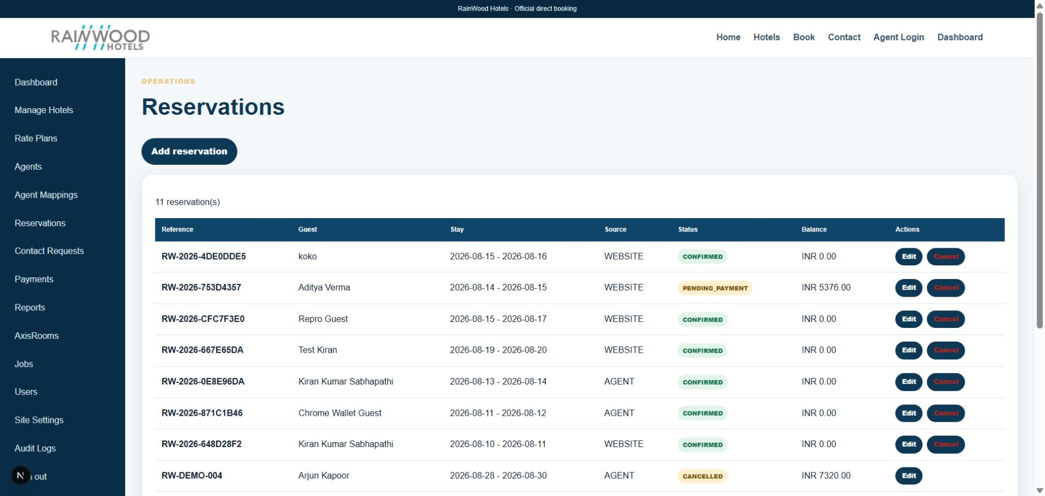
Related local UI evidence: voucher generation is initiated from persisted reservation records.

Client guide: what this screen is for
In plain language Vouchers are the customer-facing confirmation documents generated from reservations.

Field or control | What you see | Why it is used
Reservation | Booking reference and stay details | Select the booking for which the voucher is issued.
Version | Current voucher revision | Keep a history when a voucher is regenerated.
Email status | Whether the voucher was sent | Confirm delivery action taken by the system.
Download | PDF voucher file | Give the guest or staff a printable confirmation.

Next step Complete the required fields, save the record, then use the workflow and verification steps below to confirm that the information is available to the next module.

Functional surface
Surface | Observed responsibility
Reservation action | Generate a voucher for a confirmed or applicable reservation.
Email voucher | Send voucher to the reservation guest contact.
Download voucher | Retrieve a printable/downloadable voucher file.
Document content | Show hotel, guest, stay, room, rate, payment, and policy snapshot details.

Code map
Layer | Files / symbols | What the code does
Frontend | reservation detail/actions and voucher download links | Expose voucher actions to staff or guest flow.
Backend | backend/src/modules/vouchers/vouchers.controller.ts; vouchers.service.ts | Create, email, and download operations.
Schema | Voucher and reservation snapshot relationships | Persist the issued document reference and lifecycle.
Supporting | pdfkit and SMTP configuration | Generate PDF and deliver email where enabled.

API contract
Method | Path | Role in the module
POST | /vouchers/reservation/:id | Create a voucher for a reservation.
POST | /vouchers/:id/email | Email an existing voucher.
GET | /vouchers/:id/download | Download the voucher file.

Data model
Entity | Fields / relationships observed | Reason it exists
Voucher | reservation, document reference, status, timestamps | Issued guest document record.
Reservation snapshot | guest, dates, room/rate, totals, policy | Keeps the voucher tied to the booking contract.
StoredFile | generated file metadata | File storage and retrieval.

Primary workflow
- Staff or booking workflow requests a voucher for a reservation.
- Service composes a document from the reservation snapshot.
- Voucher record and file are stored.
- User downloads or emails the voucher.
- Keep the issued document consistent even if later catalogue data changes.

Access and permissions
- Voucher creation and email should be reservation-authorized actions.
- Downloads must not expose another guest's voucher by guessing an ID.
- Email delivery should not leak voucher content to an unverified address.

Risks, boundaries, and implementation notes
- SMTP is external and may run in log mode locally.
- PDF content is a booking contract presentation and needs product/legal review.
- Storage cleanup and document retention policy should be defined.

Recommended verification scenarios
- Generate a voucher and verify the PDF opens.
- Download the voucher as an authorized user.
- Email in local log mode and verify the message payload.
- Attempt another reservation's voucher URL and verify authorization.
Analyst conclusion This document describes the behavior visible in the current repository. Any change to business rules, external credentials, tax policy, or production data should be reviewed against the API contract and deployment runbook.

