**CS 5560 Knowledge Discovery and Management**

**Lab Assignment 2**

1. Create a simple “Animals” ontology.

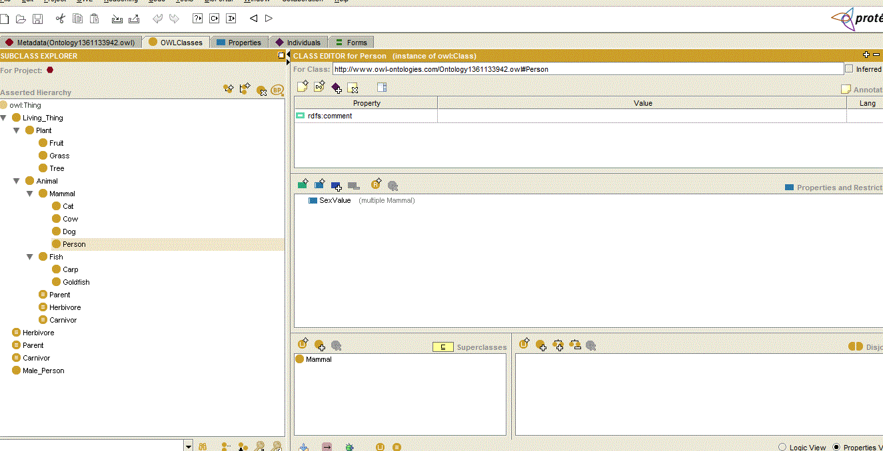

1. (a) Set domain and range constraints for properties like:

Animal eats Living_thing

* eats domain: Animal;   
   range: Living_thing

Person owns Living_thing except person

* owns domain: Person   
   range: Living_thing & not Person

Living_thing parent_of Living_thing

* parent_of: domain: Animal  
   range: Animal

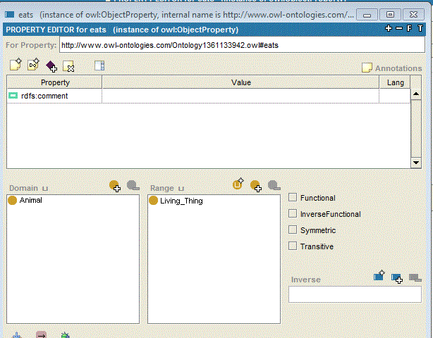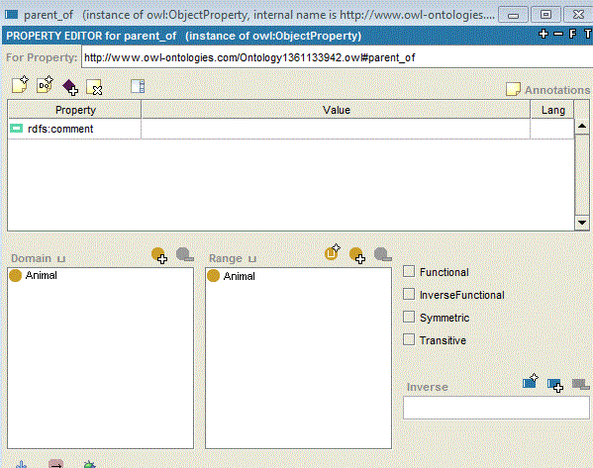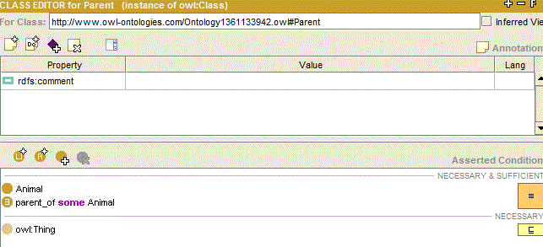

……….

(b) Define the things that are definable from the primitives and relations, such as

* Parent = Animal and parent_of some Animal
* Herbivore = Animal and eats only Plant
* Carnivore = Animal and eats only Animal



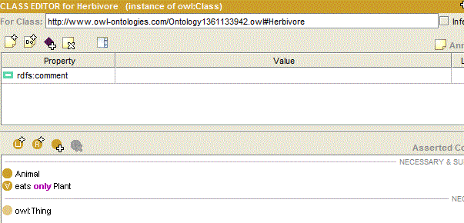(c)

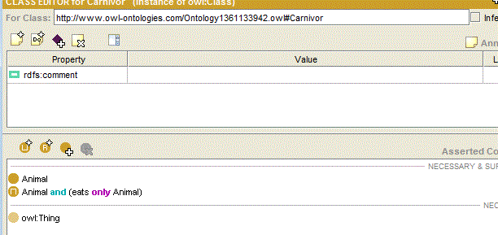Set restrictions like:

* eats
  + All cows eat some plants
  + All cats eat some animals
  + All dogs eat some animals &  
     eat some plants
  + ………

1. Show examples of functional, inverse, transitive, symmetric relations.

Functional Relation:

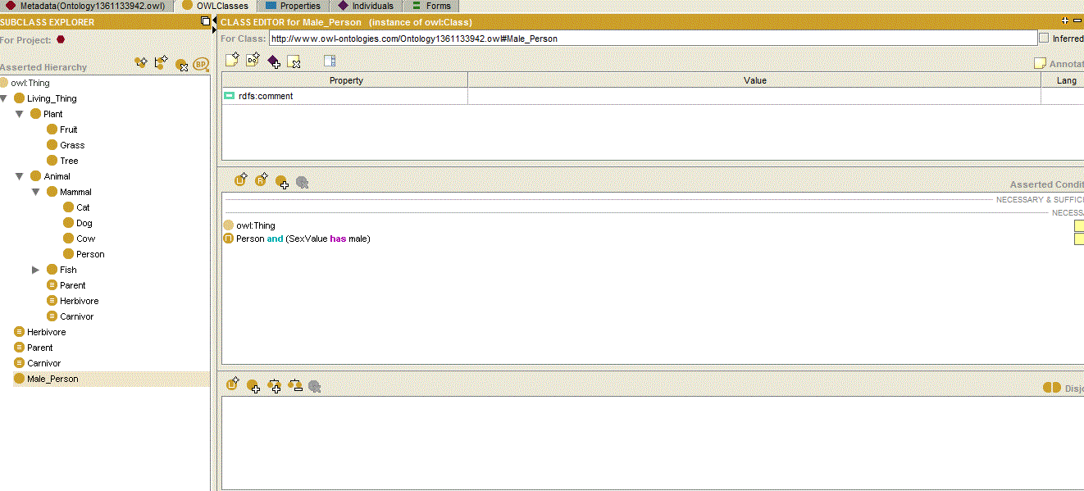

male is person with sex_value male

inverse Functional Relation:

Dog is Subcategory Mammal

Cat is Subcategory Mammal

Dog and Cat are Mammals

Transitive Relation

Cat is type of animal

animal is type of livingthing

cat is living thing

Symmetric Relation

livingthing is type of Mammal.

mammal is type of livingthing

Screenshots:



