尚硅谷大模型技术之掌柜问数
（作者：尚硅谷研究院）

版本：V1.0

- 项目概述
掌柜问数是一个基于自然语言处理与数据分析技术的智能数据服务系统，面向数据仓库应用场景，旨在帮助用户通过对话方式高效获取数据仓库中的数据洞察。用户无需掌握复杂的查询语法，即可用自然语言提出问题，系统自动完成对数据仓库数据的理解、计算分析与结果可视化，大幅提升数据使用效率，降低数据分析门槛，助力业务决策智能化。
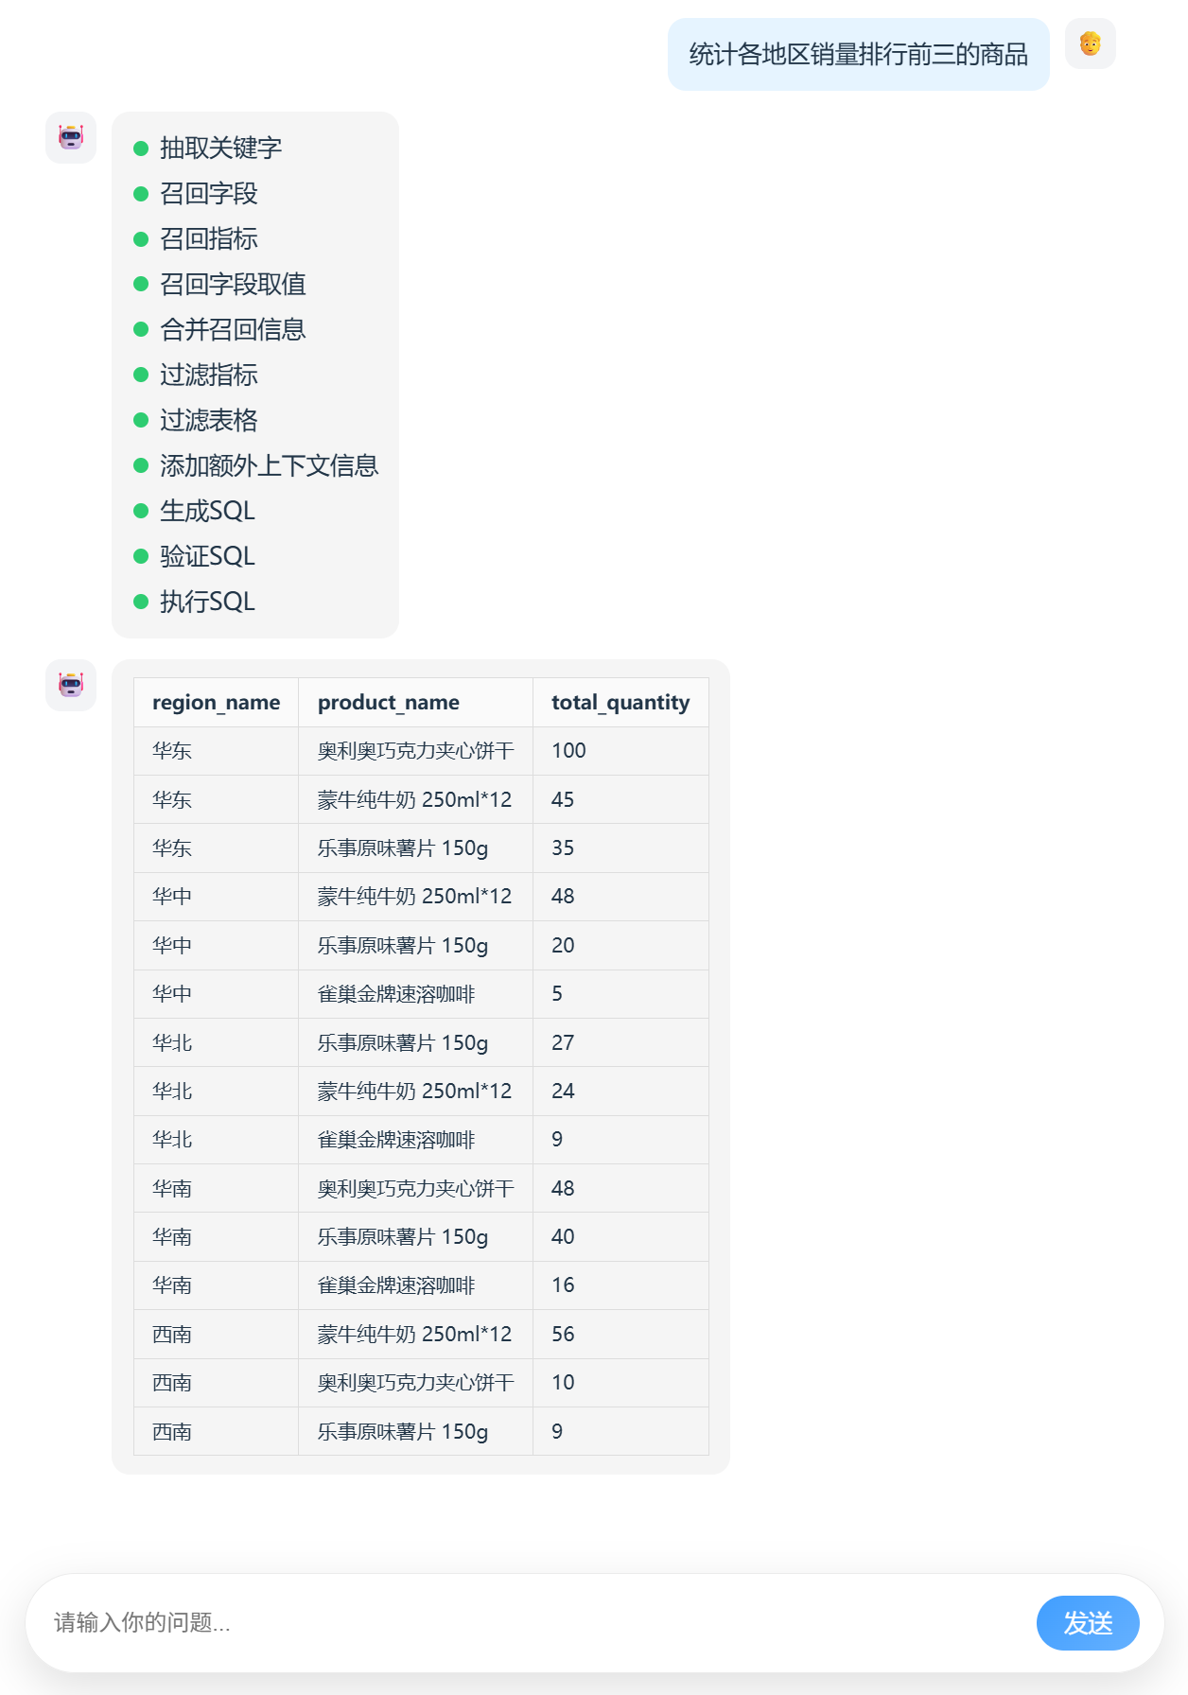
- 项目架构
  - 概述
本项目以数据仓库的元数据为核心，使用 MySQL 存储结构化元数据信息，结合 Qdrant 构建语义向量索引、Elasticsearch 构建全文索引，形成统一的元数据知识库。查询过程中，系统首先根据用户自然语言问题进行多路召回，筛选相关表、字段及指标定义，再将元数据信息与用户问题共同输入大模型生成 SQL，最终完成自动查询与结果返回，确保生成结果的准确性与可控性。
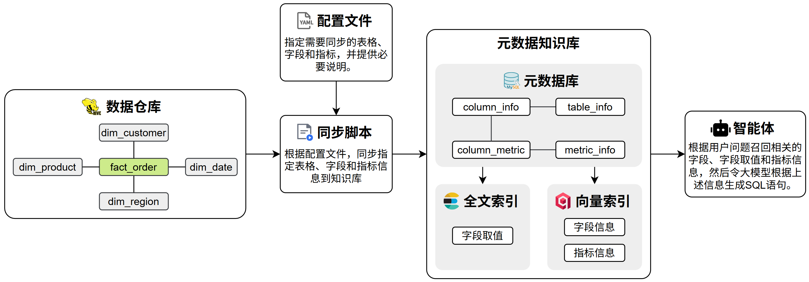
  - 元数据知识库
元数据知识库作为数据仓库的语义基础设施，用于集中管理和高效检索表结构、字段定义、字段取值示例及复杂指标说明等元数据信息，支撑后续的SQL 生成。
完整的元数据统一存储于 MySQL 数据库中，并对其中部分关键信息构建向量索引和全文索引，以提升语义召回与关键词召回的效果。
    - 元数据库
元数据库共有如下四张表，用于存储完整的元数据信息，包括数据仓库的表格信息、字段信息和指标信息。
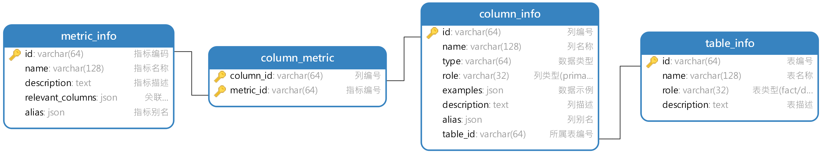
各表具体内容示例如下：
    - 向量索引
向量索引主要用于对column_info（字段信息）和metric_info（指标信息）进行语义召回。
- column_info
column_info中，需要建立向量索引的字段如下图所示：
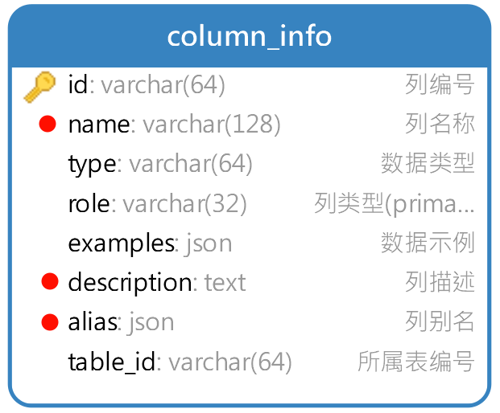
具体示例如下图所示：
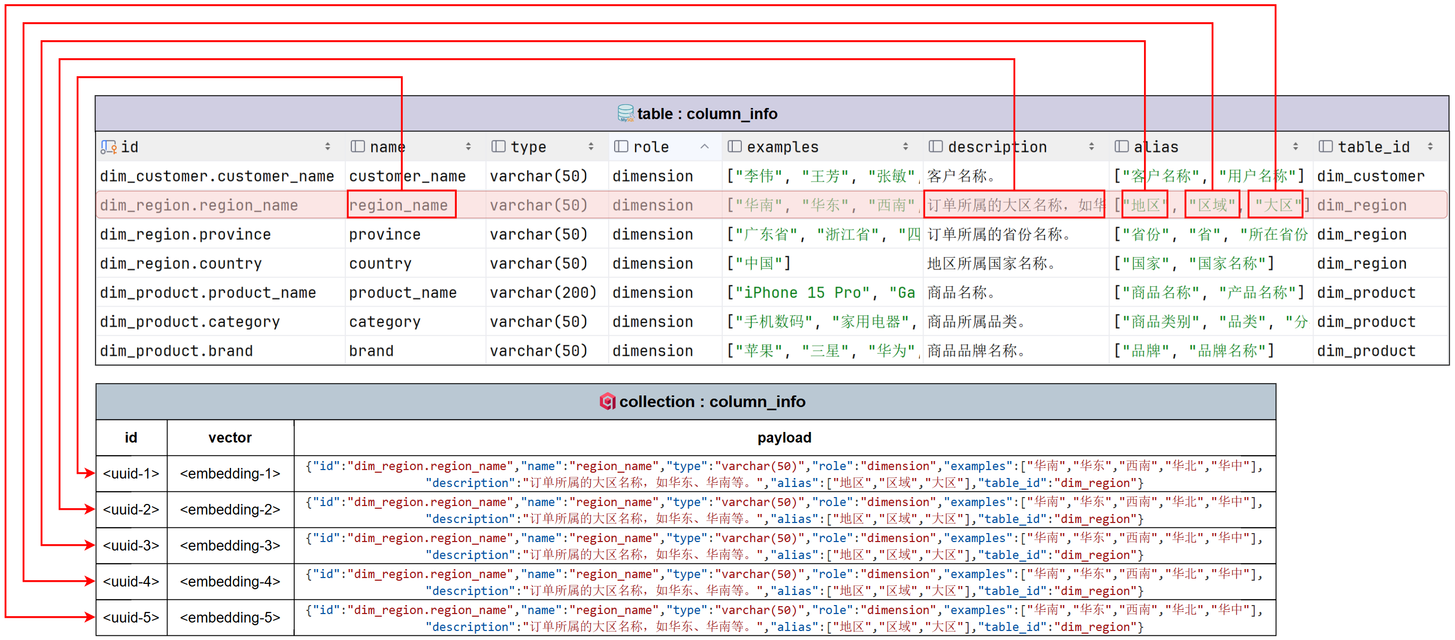
- metric_info
metric_info中，需要建立向量索引的字段如下图所示：
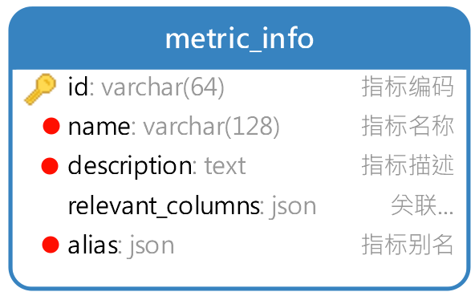
具体示例如下图所示：
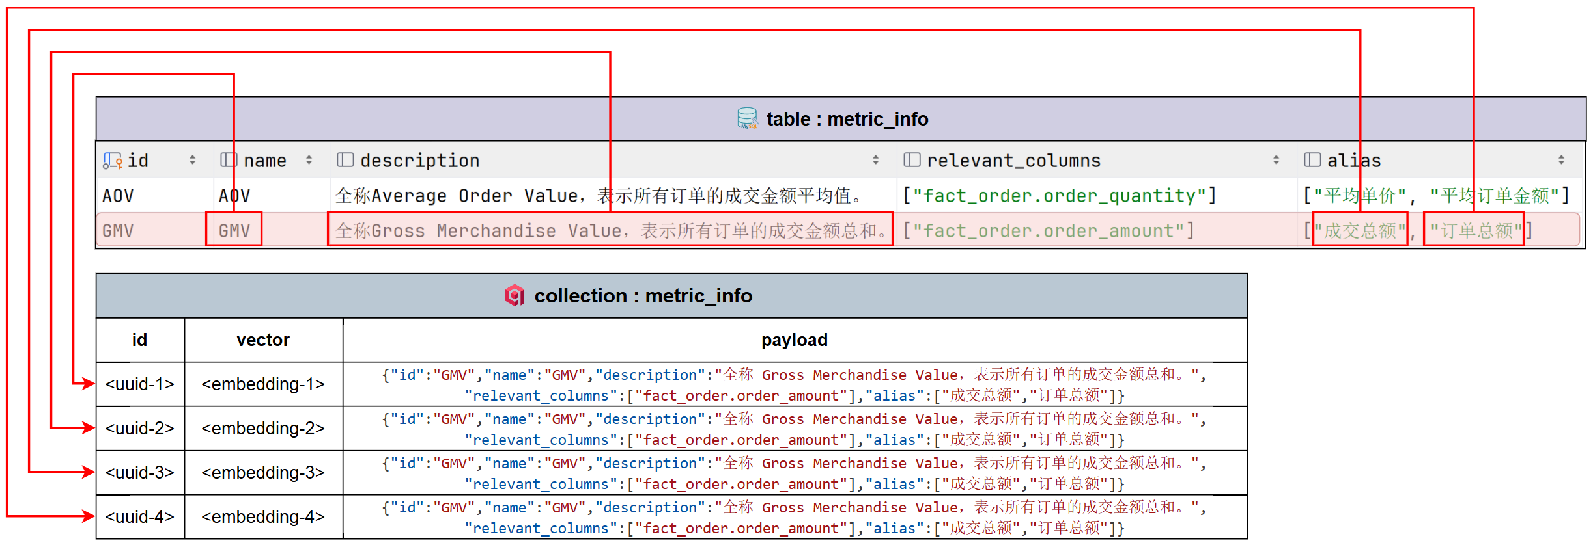
    - 全文索引
全文索引主要用于对字段取值进行检索与匹配，建立全文索引的主要是数据仓库中的各种维度表中的维度字段，具体字段如下图所示：
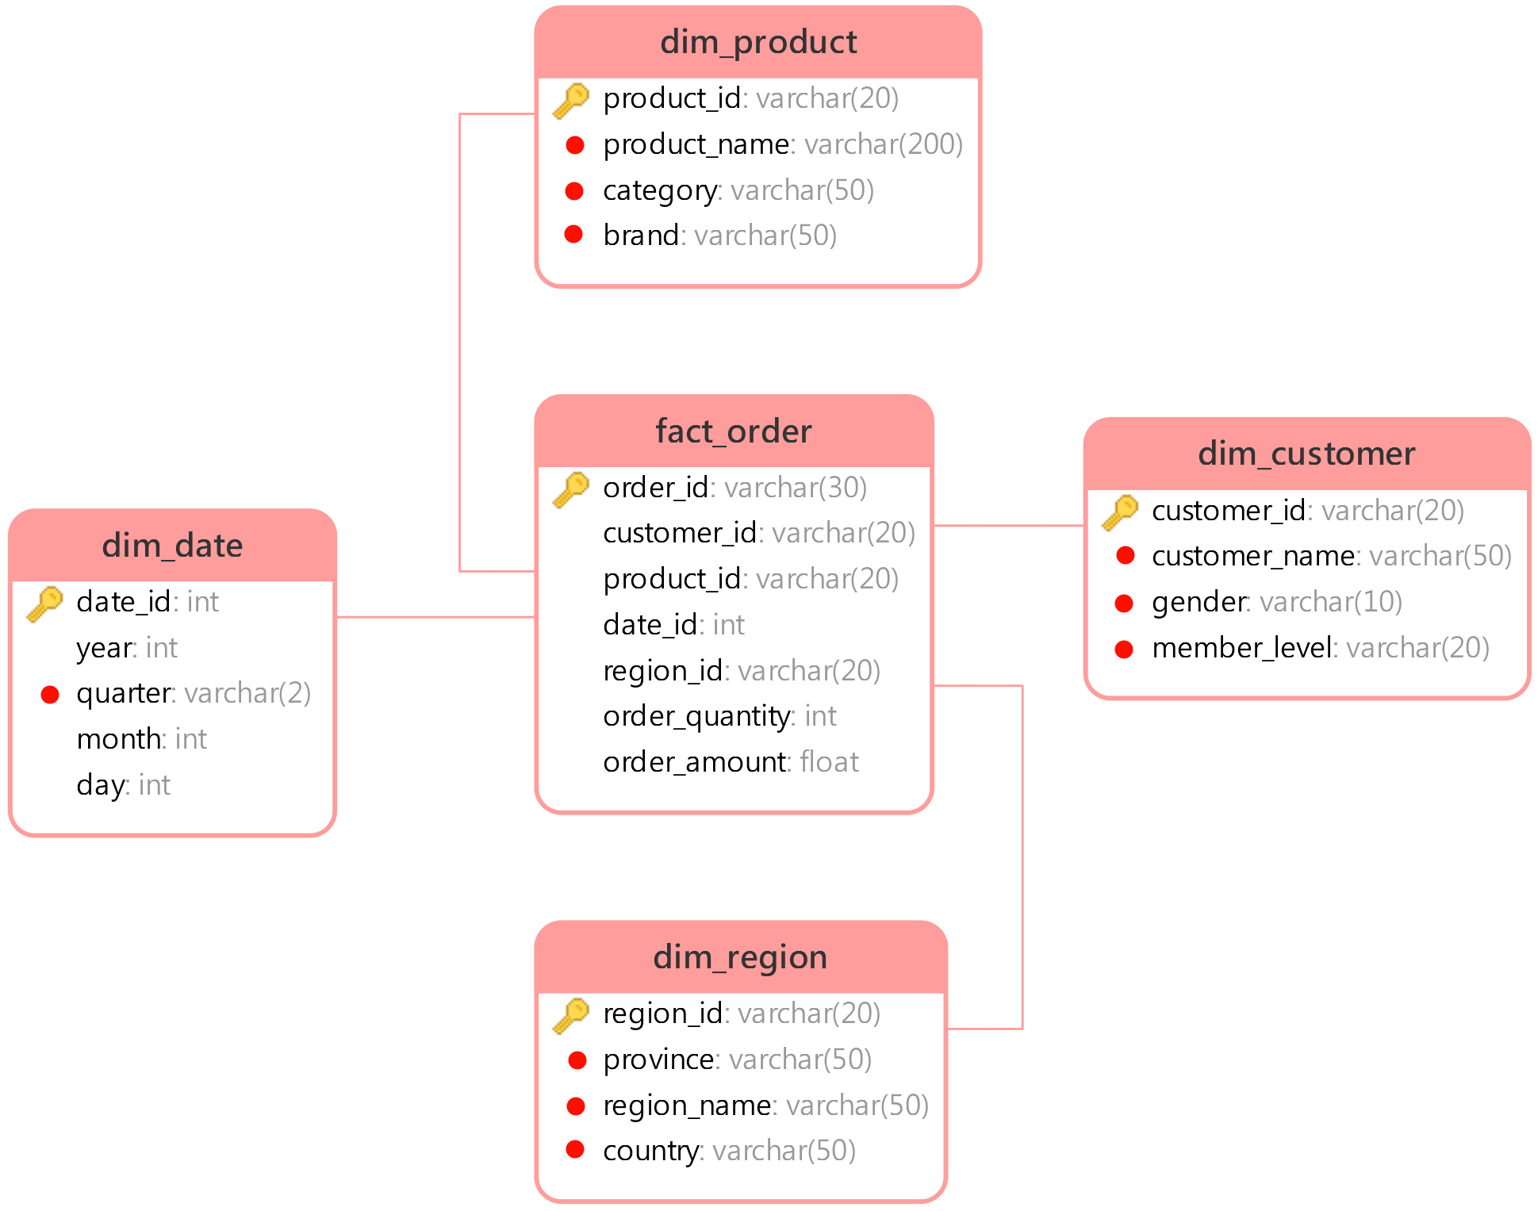
具体示例如下图所示：
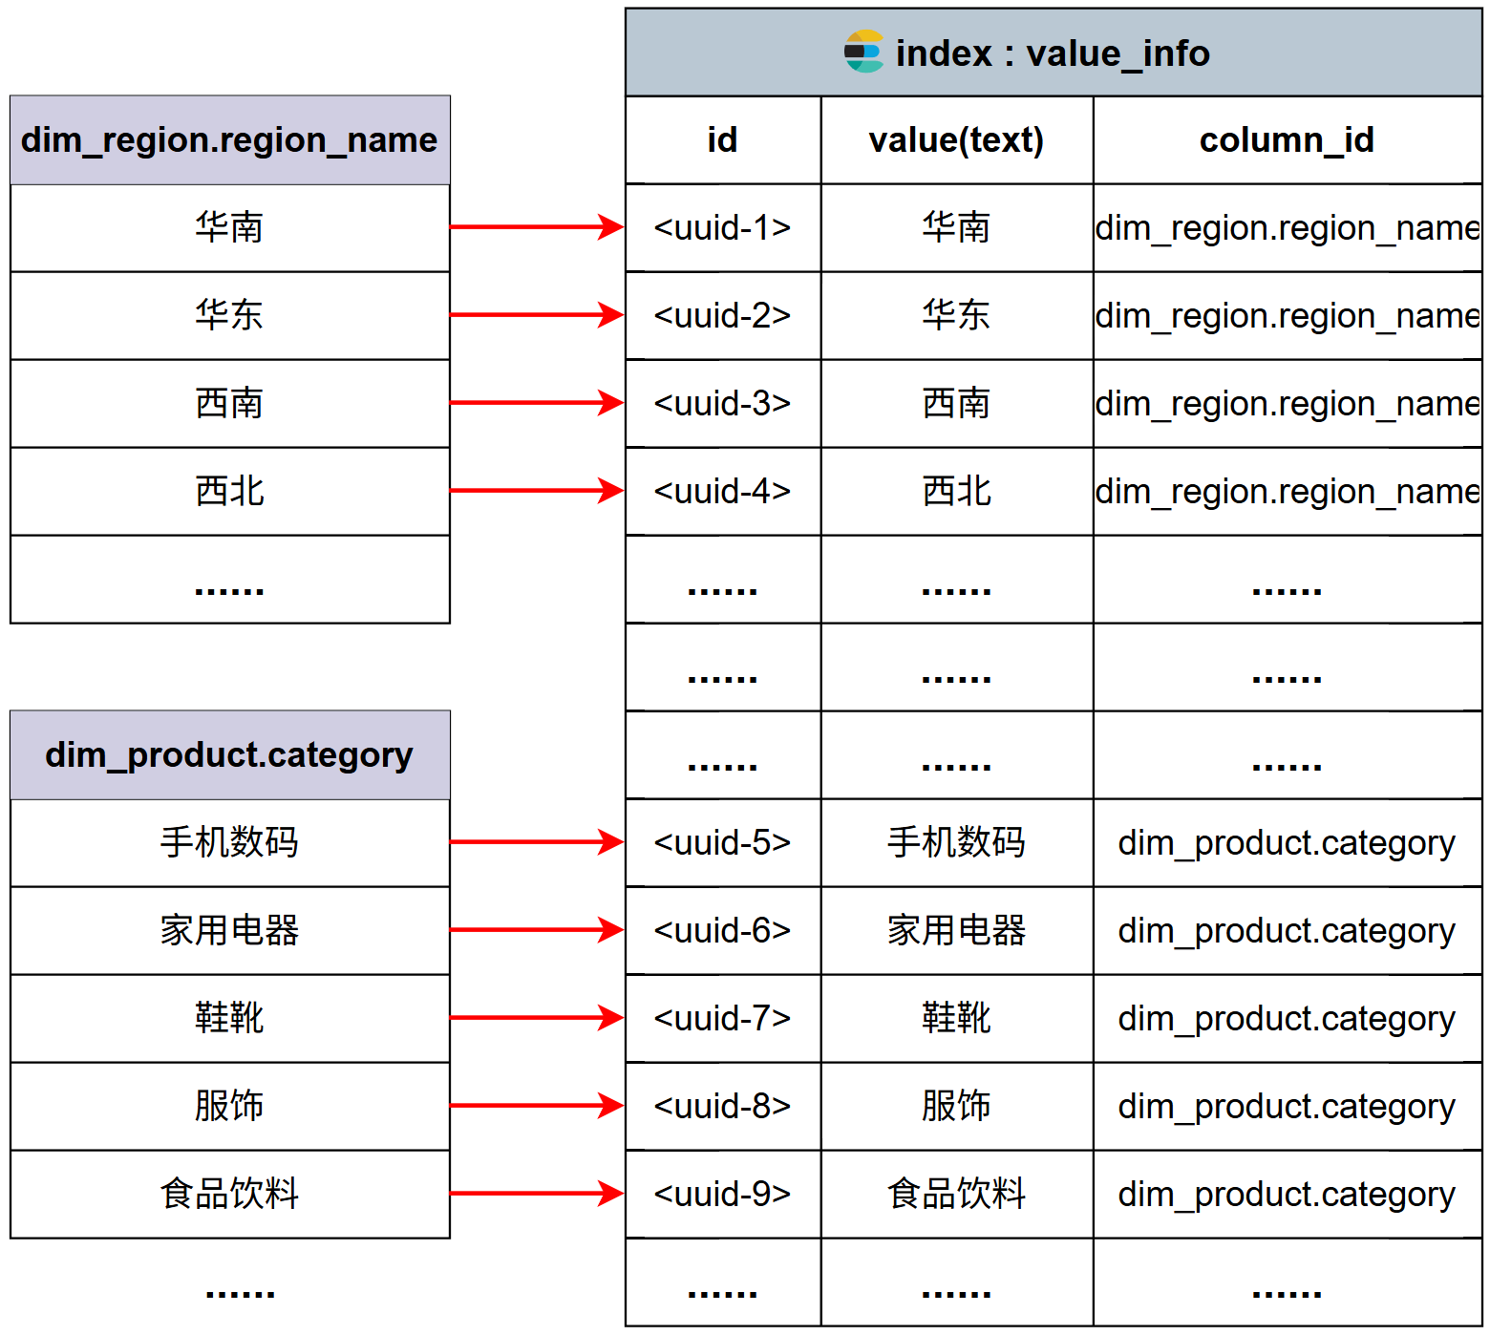
  - 问数智能体
问数智能体主要基于Langgraph进行开发，具体结构如下图所示：
- 项目开发环境
  - 创建项目
本项目使用 uv进行依赖管理与虚拟环境管理，如下图所示
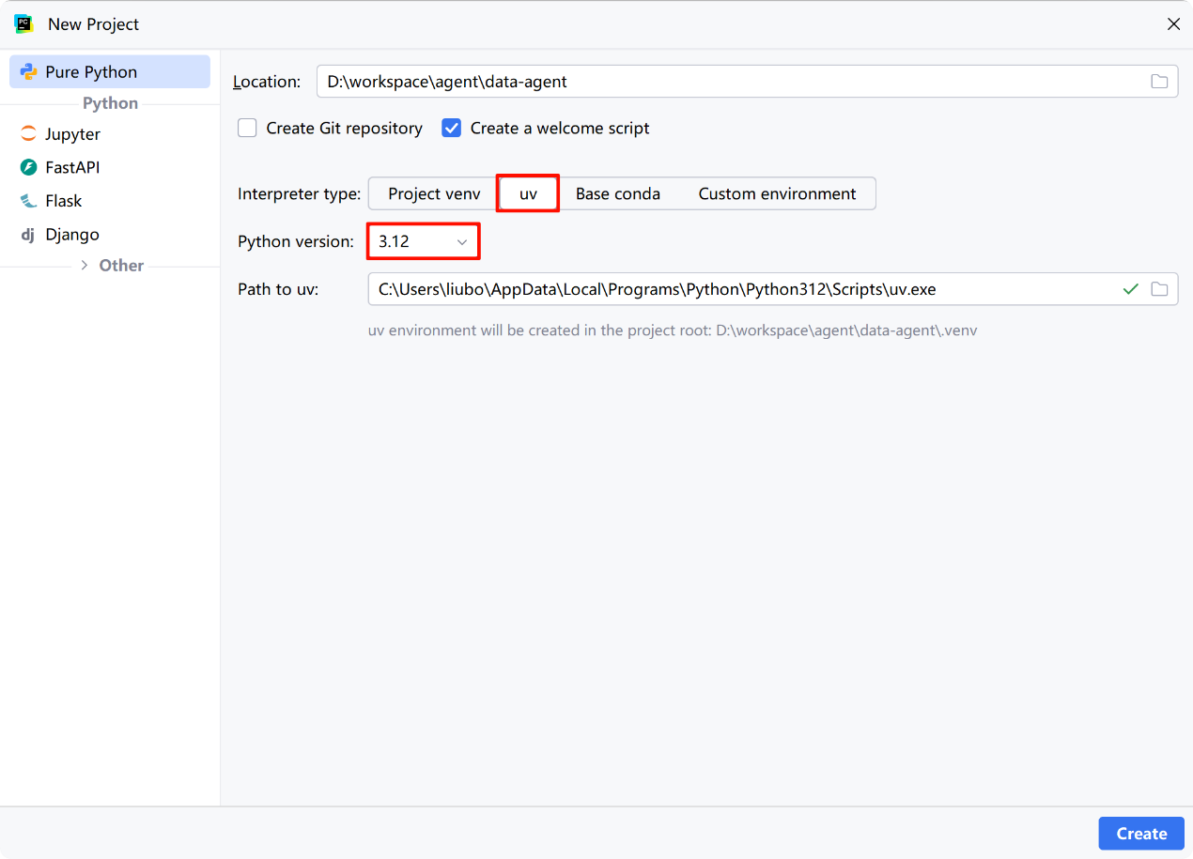
  - 安装依赖
执行以下命令安装项目所需的全部依赖：
uv add fastapi[standard] sqlalchemy asyncmy qdrant-client "elasticsearch[async]>=8,<9" langchain langchain-huggingface langgraph jieba omegaconf pyyaml loguru cryptography
各依赖说明如下：
- fastapi[standard]
高性能异步 Web 框架，作为整个服务的 API 入口。
- sqlalchemy
Python 最主流 ORM，用统一模型管理数据库读写与事务。
- asyncmy
MySQL 的高性能 asyncio 驱动，配合 SQLAlchemy 实现全异步数据库访问。
- qdrant-client
向量数据库客户端，用于 Embedding 向量存储与相似度检索。
- elasticsearch[async]
异步 Elasticsearch 客户端，用于全文检索。
- langchain
LLM 应用编排框架，用于构建 RAG、Tool 调用、Prompt 链路。
- langchain-huggingface
LangChain 与 HuggingFace 模型的桥接层（Embedding / LLM 加载）。
- langgraph
用图结构构建可控 Agent 流程。
- jieba
中文分词库。
- omegaconf
强大的分层配置系统，适合多环境、多模型、多参数管理。
- pyyaml
YAML导入导出。
- loguru
更优雅的日志库，替代 logging，适合工程化项目。
- cryptography
加密与证书基础库，很多网络/数据库/安全库的底层依赖。
  - 安装所需服务
    - 概述
本项目所需的全部服务如下：
- MySQL
MySQL 用于存储数据仓库的元数据信息，包括表格信息、字段信息和指标信息，同时也充当业务数据仓库使用（模拟 Hive 场景）。
- Qdrant
Qdrant 作为向量数据库，用于存储字段信息、指标信息的向量表示，在用户提问时通过语义相似度检索出最相关的元数据，为生成SQL提供高相关性的上下文信息。
- Elasticsearch
Elasticsearch 对各维度字段的实际取值建立倒排索引。当用户问题中包含自然语言形式的维度描述时（例如“华北地区”、“数码品类”），可通过全文检索匹配到数据库中真实存在的字段取值，为生成 SQL 时的 WHERE 条件或者GROUP BY分组提供准确依据。
- Kibana
Kibana 是 Elasticsearch 的可视化管理与调试界面，用于索引管理、查询语句调试以及检索效果验证，方便开发过程中观察和优化检索行为。
- Text Embedding Inference
Text Embedding Inference 用于部署 Embedding 模型推理服务，将元数据文本及用户问题转换为向量表示，为 Qdrant 提供向量数据来源，是语义检索能力的基础。
    - 安装
本项目所需的全部基础服务通过 Docker Compose 统一部署。相关脚本与依赖文件已包含在项目资料中。进入 docker-compose.yaml 所在目录，执行以下命令即可完成所有服务的安装与启动：
docker compose up -d
- 基础设施搭建
  - 项目目录结构
项目目录结构如下：
data-agent/
├── app/ # 代码目录
│ ├── agent/ # 智能体相关逻辑
│ ├── api/ # 对外接口（HTTP / RPC）
│ ├── clients/ # 数据库 / 外部服务客户端
│ ├── conf/ # 配置类
│ ├── core/ # 基础设施、通用能力
│ ├── models/ # 数据库实体类（ORM Model）
│ ├── entities/ # 业务实体类（Domain Entity）
│ ├── prompt/ # 提示词工具（Prompt Builder / Loader）
│ ├── repositories/ # Repo 层（数据库底层查询）
│ ├── scripts/ # 脚本（初始化 / 迁移 / 工具）
│ └── services/ # Service 层（业务逻辑）
│
├── conf/ # 配置文件（YAML / ENV 等）
│
├── docker/ # 开发环境
│ ├── elasticsearch/
│ ├── embedding/
│ └── mysql/
│
├── logs/ # 日志目录
└── prompts/ # 提示词目录（静态 Prompt）
  - 配置参数管理
    - 配置文件
本项目采用 YAML 文件管理配置参数，配置文件的路径为data-agent/app/conf/app_config.yaml ，以下是本项目所需的全部参数。
logging:
file:
enable: true
level: INFO
path: logs
rotation: "10 MB"
retention: "7 days"
console:
enable: true
level: INFO

db_meta:
host: localhost
port: 3306
user: atguigu
password: Atguigu.123
database: meta

db_dw:
host: localhost
port: 3306
user: atguigu
password: Atguigu.123
database: dw

qdrant:
host: localhost
port: 6333
embedding_size: 1024

embedding:
host: localhost
port: 8081
model: BAAI/bge-large-zh-v1.5

es:
host: localhost
port: 9200
index_name: data_agent

llm:
model_name: gpt-5.2-codex
api_key: <api_key>
base_url: https://api.openai-proxy.org/v1
    - 加载工具
本项目使用的yaml配置文件加载工具为OmegaConf，具体用法可参考其官网。
用于读取配置文件的代码放置在data-agent/app/conf/app_config.py文件中，具体内容如下：
# 日志配置
from dataclasses import dataclass
from pathlib import Path

from omegaconf import OmegaConf

@dataclass
class File:
enable: bool
level: str
path: str
rotation: str
retention: str

@dataclass
class Console:
enable: bool
level: str

@dataclass
class LoggingConfig:
file: File
console: Console

# 数据库配置
@dataclass
class DBConfig:
host: str
port: int
user: str
password: str
database: str

@dataclass
class QdrantConfig:
host: str
port: int
embedding_size: int

@dataclass
class EmbeddingConfig:
host: str
port: int
model: str

@dataclass
class ESConfig:
host: str
port: int
index_name: str

@dataclass
class LLMConfig:
model_name: str
api_key: str
base_url: str

@dataclass
class AppConfig:
logging: LoggingConfig
db_meta: DBConfig
db_dw: DBConfig
qdrant: QdrantConfig
embedding: EmbeddingConfig
es: ESConfig
llm: LLMConfig

config_file = Path(__file__).parents[2] / 'conf' / 'app_config.yaml'
context = OmegaConf.load(config_file)
schema = OmegaConf.structured(AppConfig)
app_config: AppConfig = OmegaConf.to_object(OmegaConf.merge(schema, context))
  - MySQL客户端管理
本项目中的MySQL客户端使用SQLAlchemy，具体用法参考官方文档。
在data-agent/app/clients/mysql_client_manager.py中编写如下代码，用来管理MySQL客户端。
import asyncio
from typing import Optional

from sqlalchemy import text
from sqlalchemy.ext.asyncio import create_async_engine, AsyncEngine, async_sessionmaker

from app.conf.app_config import DBConfig, app_config

class MysqlClientManager:
def __init__(self, db_config: DBConfig):
self.db_config = db_config
self.engine: Optional[AsyncEngine] = None
self.session_factory = None

def _get_url(self):
return f"mysql+asyncmy://{self.db_config.user}:{self.db_config.password}@{self.db_config.host}:{self.db_config.port}/{self.db_config.database}?charset=utf8mb4"

def init(self):
self.engine = create_async_engine(url=self._get_url(),
pool_size=10,
pool_pre_ping=True)
self.session_factory = async_sessionmaker(self.engine,
autoflush=True,
expire_on_commit=False,
autobegin=True)

async def close(self):
await self.engine.dispose()

dw_mysql_client_manager = MysqlClientManager(app_config.db_dw)
meta_mysql_client_manager = MysqlClientManager(app_config.db_meta)

if __name__ == '__main__':
meta_mysql_client_manager.init()

async def test():
async with meta_mysql_client_manager.session_factory() as session:
result = await session.execute(text("select * from table_info limit 10"))
rows = result.fetchall()
print(rows)

asyncio.run(test())

另外，在data-agent/app/models/包下创建meta数据库中各表的ORM实体类，如下：
- data-agent/app/models/base.py
from sqlalchemy.orm import DeclarativeBase

class Base(DeclarativeBase):
pass

- data-agent/app/models/table_info.py
from sqlalchemy import String, Text
from sqlalchemy.orm import Mapped, mapped_column

from app.models.base import Base

class TableInfoMySQL(Base):
__tablename__ = "table_info"

id: Mapped[str] = mapped_column(
String(64),
primary_key=True,
comment="表编号"
)
name: Mapped[str | None] = mapped_column(
String(128),
comment="表名称"
)
role: Mapped[str | None] = mapped_column(
String(32),
comment="表类型(fact/dim)"
)
description: Mapped[str | None] = mapped_column(
Text,
comment="表描述"
)

- data-agent/app/models/column_info.py
from sqlalchemy import String, Text
from sqlalchemy.types import JSON
from sqlalchemy.orm import Mapped, mapped_column

from app.models.base import Base

class ColumnInfoMySQL(Base):
__tablename__ = "column_info"

id: Mapped[str] = mapped_column(
String(64),
primary_key=True,
comment="列编号"
)
name: Mapped[str | None] = mapped_column(
String(128),
comment="列名称"
)
type: Mapped[str | None] = mapped_column(
String(64),
comment="数据类型"
)
role: Mapped[str | None] = mapped_column(
String(32),
comment="列类型(primary_key,foreign_key,measure,dimension)"
)
examples: Mapped[dict | list | None] = mapped_column(
JSON,
comment="数据示例"
)
description: Mapped[str | None] = mapped_column(
Text,
comment="列描述"
)
alias: Mapped[dict | list | None] = mapped_column(
JSON,
comment="列别名"
)
table_id: Mapped[str | None] = mapped_column(
String(64),
comment="所属表编号"
)

- data-agent/app/models/metric_info.py
from sqlalchemy import String, Text
from sqlalchemy.types import JSON
from sqlalchemy.orm import Mapped, mapped_column

from app.models.base import Base

class MetricInfoMySQL(Base):
__tablename__ = "metric_info"

id: Mapped[str] = mapped_column(
String(64),
primary_key=True,
comment="指标编码"
)
name: Mapped[str | None] = mapped_column(
String(128),
comment="指标名称"
)
description: Mapped[str | None] = mapped_column(
Text,
comment="指标描述"
)
relevant_columns: Mapped[dict | list | None] = mapped_column(
JSON,
comment="关联字段"
)
alias: Mapped[dict | list | None] = mapped_column(
JSON,
comment="指标别名"
)

- data-agent/app/models/column_metric.py
from sqlalchemy import String
from sqlalchemy.orm import Mapped, mapped_column

from app.models.base import Base

class ColumnMetricMySQL(Base):
__tablename__ = "column_metric"

column_id: Mapped[str] = mapped_column(
String(64),
primary_key=True,
comment="列编号"
)
metric_id: Mapped[str] = mapped_column(
String(64),
primary_key=True,
comment="指标编号"
)

  - Qdrant客户端管理
本项目中的Qdrant客户端使用qdrant-client，具体用法参考官方文档。
在data-agent/app/clients/qdrant_client_manager.py中编写如下代码，用来管理Qdrant客户端。
import asyncio
import random
from typing import Optional

from qdrant_client import AsyncQdrantClient, models

from app.conf.app_config import QdrantConfig, app_config

class QdrantClientManager:
def __init__(self, qdrant_config: QdrantConfig):
self.qdrant_config = qdrant_config
self.client: Optional[AsyncQdrantClient] = None

def _get_url(self):
return f"http://{self.qdrant_config.host}:{self.qdrant_config.port}"

def init(self):
self.client = AsyncQdrantClient(url=self._get_url())

async def close(self):
await self.client.close()

qdrant_client_manager = QdrantClientManager(app_config.qdrant)

if __name__ == '__main__':
qdrant_client_manager.init()

async def test():
client = qdrant_client_manager.client
if not await client.collection_exists("my_collection"):
await client.create_collection(
collection_name="my_collection",
vectors_config=models.VectorParams(size=10, distance=models.Distance.COSINE),
)

await client.upsert(
collection_name="my_collection",
points=[
models.PointStruct(
id=i,
vector=[random.random() for _ in range(10)],
)
for i in range(100)
],
)

res = await client.query_points(
collection_name="my_collection",
query=[random.random() for _ in range(10)], # type: ignore
limit=10,
score_threshold=0.8
)

print(res)

asyncio.run(test())

  - ES客户端管理
本项目中的ES客户端使用elasticsearch，具体用法参考官方文档。
在data-agent/app/clients/es_client_manager.py中编写如下代码，用来管理ES客户端。
import asyncio
from typing import Optional

from elasticsearch import AsyncElasticsearch

from app.conf.app_config import ESConfig, app_config

class ESClientManager:
def __init__(self, es_config: ESConfig):
self.es_config = es_config
self.client: Optional[AsyncElasticsearch] = None

def _get_url(self):
return f"http://{self.es_config.host}:{self.es_config.port}"

def init(self):
self.client = AsyncElasticsearch(hosts=[self._get_url()])

async def close(self):
await self.client.close()

es_client_manager = ESClientManager(app_config.es)

if __name__ == '__main__':
es_client_manager.init()

async def test():
client = es_client_manager.client

# 创建索引
await client.indices.create(
index="my-books",
mappings={
"dynamic": False,
"properties": {
"name": {
"type": "text"
},
"author": {
"type": "text"
},
"release_date": {
"type": "date",
"format": "yyyy-MM-dd"
},
"page_count": {
"type": "integer"
}
}
},
)

# 插入数据
await client.bulk(
operations=[
{
"index": {
"_index": "my-books"
}
},
{
"name": "Revelation Space",
"author": "Alastair Reynolds",
"release_date": "2000-03-15",
"page_count": 585
},
{
"index": {
"_index": "my-books"
}
},
{
"name": "1984",
"author": "George Orwell",
"release_date": "1985-06-01",
"page_count": 328
},
{
"index": {
"_index": "my-books"
}
},
{
"name": "Fahrenheit 451",
"author": "Ray Bradbury",
"release_date": "1953-10-15",
"page_count": 227
},
{
"index": {
"_index": "my-books"
}
},
{
"name": "Brave New World",
"author": "Aldous Huxley",
"release_date": "1932-06-01",
"page_count": 268
},
{
"index": {
"_index": "my-books"
}
},
{
"name": "The Handmaids Tale",
"author": "Margaret Atwood",
"release_date": "1985-06-01",
"page_count": 311
}
],
)

# 搜索
resp = await client.search(
index="my-books",
query={
"match": {
"name": "brave"
}
},
)
print(resp)
await es_client_manager.close()

asyncio.run(test())

  - Embedding客户端管理
本项目中的Text Embedding Inference客户端使用HuggingFaceEndpointEmbeddings，具体用法参考官方文档。
在data-agent/app/clients/embedding_client_manager.py中编写如下代码，用来管理Text Embedding Inference客户端。
from typing import Optional

from langchain_huggingface import HuggingFaceEndpointEmbeddings

from app.conf.app_config import EmbeddingConfig, app_config

class EmbeddingClientManager:
def __init__(self, config: EmbeddingConfig):
self.client: Optional[HuggingFaceEndpointEmbeddings] = None
self.config = config

def _get_url(self):
return f"http://{self.config.host}:{self.config.port}"

def init(self):
self.client = HuggingFaceEndpointEmbeddings(model=self._get_url())

embedding_client_manager = EmbeddingClientManager(app_config.embedding)

  - 日志管理
本项目使用loguru管理日志，具体用法参考官网。
在data-agent/app/core/log.py中编写如下代码，统一管理日志。
import sys
from pathlib import Path

from loguru import logger

from app.conf.app_config import app_config

log_format = (
"<green>{time:YYYY-MM-DD HH:mm:ss.SSS}</green> | "
"<level>{level: <8}</level> | "
"<cyan>{name}</cyan>:<cyan>{function}</cyan>:<cyan>{line}</cyan> - "
"<level>{message}</level>"
)

logger.remove()
if app_config.logging.console.enable:
logger.add(sink=sys.stdout, level=app_config.logging.console.level, format=log_format)
if app_config.logging.file.enable:
path = Path(app_config.logging.file.path)
path.mkdir(parents=True, exist_ok=True)
logger.add(
sink=path / "app.log",
level=app_config.logging.file.level,
format=log_format,
rotation=app_config.logging.file.rotation,
retention=app_config.logging.file.retention,
encoding="utf-8"
)

- 元数据知识库
  - 需求说明
本章旨在开发一个用于构建元数据知识库的脚本。该脚本以一个 YAML 配置文件作为输入参数，配置文件中定义了需要同步至元数据知识库的表格信息与指标信息。脚本功能包括：
- 根据配置内容，将指定的表格及指标信息同步至 Meta 数据库；
- 为字段信息和指标信息构建向量索引；
- 为字段取值建立全文索引。
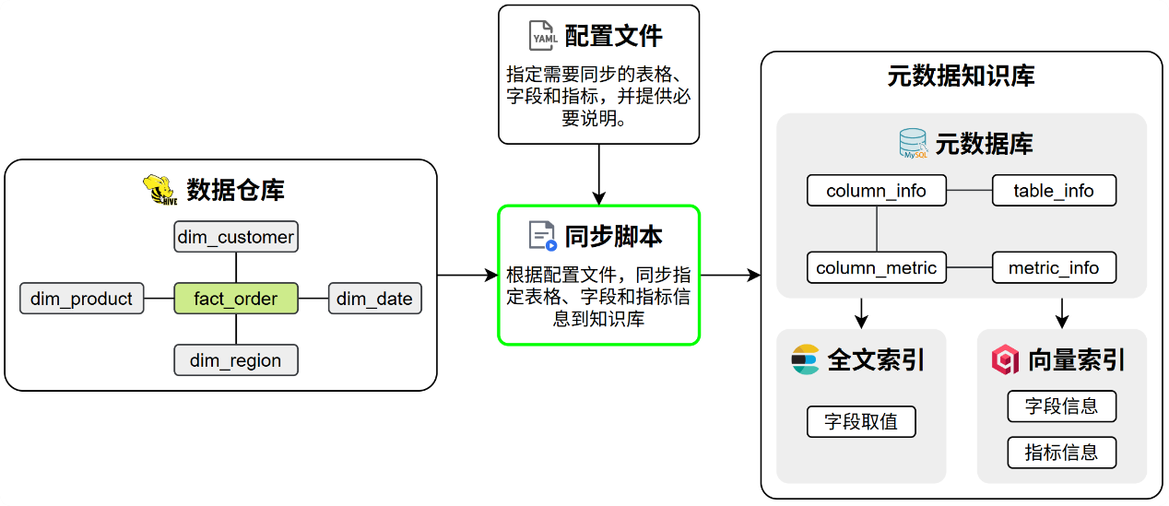
  - 代码组织规划
构建元数据知识库模块的核心代码采用分层设计，具体组织结构如下：
data-agent/
├── conf/
│ └── meta_config.yaml # 配置文件，用于指定待同步的表格和指标
└── app/
├── conf/
│ └── meta_config.py # 用于定义meta_config.yaml的参数结构
├── scripts/
│ └── build_meta_knowledge.py # 构建元数据知识库的入口脚本，负责解析命令行参数
├── services/
│ └── meta_knowledge_service.py # 负责实现构建元数据知识库的核心逻辑
├── entities/
│ ├── table_info.py # 用于定义表格信息的业务实体类
│ ├── column_info.py # 用于定义字段信息的业务实体类
│ ├── metric_info.py # 用于定义指标信息的业务实体类
│ ├── column_metric.py # 用于定义字段指标关系的业务实体类
│ └── value_info.py # 用于定义字段取值的业务实体类
└── repositories/
├── mysql/
│ ├── meta/
│ │ ├── meta_mysql_repository.py # 负责实现meta数据库的读写操作
│ │ └── mappers/
│ │ ├── table_info_mapper.py # table_info orm实体和业务实体的类型转换
│ │ ├── column_info_mapper.py # column_info orm实体和业务实体的类型转换
│ │ ├── metric_info_mapper.py # metric_info orm实体和业务实体的类型转换
│ │ └── column_metric_mapper.py # column_metric orm实体和业务实体的类型转换
│ ├── dw/
│ │ └── dw_mysql_repository.py # 负责实现dw数据库的读写操作
├── qdrant/
│ ├── column_qdrant_repository.py # 负责实现qdrant中column相关集合的读写操作
│ └── metric_qdrant_repository.py # 负责实现qdrant中metric相关集合的读写操作
└── es/
└── value_qdrant_repository.py # 用于定义es中value索引的实体类

  - 具体实现
    - 配置文件
      - 结构说明
配置文件采用yaml格式，用于指定待同步的表格和指标信息，其结构要求如下
tables: # 表格信息
- name: <table_name> # 真实表名
role: dim | fact # 表角色
description: <table_description> # 表的业务含义说明
columns:
- name: <column_name> # 真实字段名
role: primary_key | foreign_key | dimension | measure # 字段角色
description: <column_description> # 字段的业务含义
alias: [<alias1>, <alias2>] # 字段同义词
sync: true | false # 该字段取值是否需要同步到ES建立全文索引

metrics: # 指标信息
- name: <metric_name> # 指标名称，如 GMV、AOV
description: <metric_description> # 指标的业务含义与计算口径说明
relevant_columns: [<table_name.column_name>] # 指标相关字段
alias: [<alias1>, <alias2>] # 指标同义词
      - 具体配置
当前的数据仓库模拟环境（dw库）中共有 5 张表和 2 个指标需要同步到元数据知识库，具体配置如下。
tables:
- name: dim_region
role: dim
description: 地区维度表，用于描述订单发生的地理区域信息。
columns:
- name: region_id
role: primary_key
description: 地区唯一标识。
alias: [地区ID, 区域ID]
sync: false

- name: province
role: dimension
description: 订单所属的省份名称。
alias: [省份, 省, 所在省份]
sync: true

- name: region_name
role: dimension
description: 订单所属的大区名称，如华东、华南等。
alias: [地区, 区域, 大区]
sync: true

- name: country
role: dimension
description: 地区所属国家名称。
alias: [国家, 国家名称]
sync: true

- name: dim_customer
role: dim
description: 客户维度表，描述下单客户的基本属性。
columns:
- name: customer_id
role: primary_key
description: 客户唯一标识。
alias: [客户ID, 用户ID]
sync: false

- name: customer_name
role: dimension
description: 客户名称。
alias: [客户名称, 用户名称]
sync: true

- name: gender
role: dimension
description: 客户性别。
alias: [性别]
sync: true

- name: member_level
role: dimension
description: 客户会员等级。
alias: [会员等级, 用户等级]
sync: true

- name: dim_product
role: dim
description: 商品维度表，描述商品的基本属性信息。
columns:
- name: product_id
role: primary_key
description: 商品唯一标识。
alias: [商品ID, 产品ID]
sync: false

- name: product_name
role: dimension
description: 商品名称。
alias: [商品名称, 产品名称]
sync: true

- name: category
role: dimension
description: 商品所属品类。
alias: [商品类别, 品类, 分类]
sync: true

- name: brand
role: dimension
description: 商品品牌名称。
alias: [品牌, 品牌名称]
sync: true

- name: dim_date
role: dim
description: 时间维度表，用于多时间粒度分析。
columns:
- name: date_id
role: primary_key
description: 日期唯一标识，格式 yyyyMMdd。
alias: [日期ID, 日期]
sync: false

- name: year
role: dimension
description: 年份。
alias: [年, 年份]
sync: false

- name: quarter
role: dimension
description: 季度。
alias: [季度]
sync: true

- name: month
role: dimension
description: 月份。
alias: [月, 月份]
sync: false

- name: day
role: dimension
description: 日。
alias: [日, 天]
sync: false

- name: fact_order
role: fact
description: 订单事实表，记录订单数量和金额等核心指标。
columns:
- name: order_id
role: primary_key
description: 订单唯一标识。
alias: [订单ID]
sync: false

- name: customer_id
role: foreign_key
description: 关联客户维度的外键。
alias: [客户ID, 用户ID]
sync: false

- name: product_id
role: foreign_key
description: 关联商品维度的外键。
alias: [商品ID, 产品ID]
sync: false

- name: date_id
role: foreign_key
description: 关联时间维度的外键。
alias: [日期, 下单日期]
sync: false

- name: region_id
role: foreign_key
description: 关联地区维度的外键。
alias: [地区ID, 区域ID]
sync: false

- name: order_quantity
role: measure
description: 订单中商品的购买数量。
alias: [销量, 购买数量, 件数]
sync: false

- name: order_amount
role: measure
description: 订单金额。
alias: [销售额, 订单金额, 收入]
sync: false

metrics:
- name: GMV
description: 全称Gross Merchandise Value，表示所有订单的成交金额总和。
relevant_columns:
- fact_order.order_amount
alias: [成交总额, 订单总额]
- name: AOV
description: 全称Average Order Value，表示所有订单的成交金额平均值。
relevant_columns:
- fact_order.order_quantity
alias: [平均单价, 平均订单金额]

说明：该配置文件应由脚本调用方提供，所以该文件在项目中的路径不做要求，现暂将其置于data-agent/conf/meta_config.yaml中。
      - 结构定义
在data-agent/app/conf/meta_config.py中编写如下内容，用于定义上述配置参数的结构。
from dataclasses import dataclass
from typing import Optional

@dataclass
class ColumnConfig:
name: str
role: str
description: str
alias: list[str]
sync: bool

@dataclass
class TableConfig:
name: str
role: str
description: str
columns: list[ColumnConfig]

@dataclass
class MetricConfig:
name: str
description: str
relevant_columns: list[str]
alias: list[str]

@dataclass
class MetaConfig:
tables: Optional[list[TableConfig]] = None
metrics: Optional[list[MetricConfig]] = None

    - 入口脚本
入口脚本（data-agent/app/scripts/build_meta_knowledge.py）主要负责解析调用者传入的配置文件路径。具体内容如下：
import asyncio
from argparse import ArgumentParser
from pathlib import Path

from app.clients.embedding_client_manager import embedding_client_manager
from app.clients.es_client_manager import es_client_manager
from app.clients.mysql_client_manager import (
meta_mysql_client_manager,
dw_mysql_client_manager,
)
from app.clients.qdrant_client_manager import qdrant_client_manager
from app.repositories.qdrant.column_qdrant_repository import ColumnQdrantRepository
from app.repositories.mysql.dw.dw_mysql_repository import DWMySQLRepository
from app.repositories.mysql.meta.meta_mysql_repository import MetaMySQLRepository
from app.repositories.es.value_es_repository import ValueESRepository
from app.repositories.qdrant.metric_qdrant_repository import MetricQdrantRepository
from app.services.meta_knowledge_service import MetaKnowledgeService

async def build(config_path: Path):
meta_mysql_client_manager.init() # 初始化元数据MySQL客户端
dw_mysql_client_manager.init() # 初始化数据仓库MySQL客户端
qdrant_client_manager.init() # 初始化Qdrant客户端
embedding_client_manager.init() # 初始化Embedding客户端
es_client_manager.init() # 初始化Elasticsearch客户端

async with (
meta_mysql_client_manager.session_factory() as meta_session,
dw_mysql_client_manager.session_factory() as dw_session,
):
meta_mysql_repository = MetaMySQLRepository(
meta_session
) # 创建元数据MySQLRepo实例
dw_mysql_repository = DWMySQLRepository(dw_session) # 创建数据仓库MySQLRepo实例
column_qdrant_repository = ColumnQdrantRepository(
qdrant_client_manager.client
) # 创建列QdrantRepo实例
embedding_client = embedding_client_manager.client # 获取Embedding客户端实例
value_es_repository = ValueESRepository(
es_client_manager.client
) # 创建值ElasticsearchRepo实例
metric_qdrant_repository = MetricQdrantRepository(
qdrant_client_manager.client
) # 创建指标QdrantRepo实例

mete_knowledge_service = MetaKnowledgeService(
meta_mysql_repository=meta_mysql_repository,
dw_mysql_repository=dw_mysql_repository,
column_qdrant_repository=column_qdrant_repository,
embedding_client=embedding_client,
value_es_repository=value_es_repository,
metric_qdrant_repository=metric_qdrant_repository,
) # 创建MetaKnowledgeService实例
await mete_knowledge_service.build(config_path) # 构建元知识库

await meta_mysql_client_manager.close() # 关闭元数据MySQL客户端
await dw_mysql_client_manager.close() # 关闭数据仓库MySQL客户端
await qdrant_client_manager.close() # 关闭Qdrant客户端
await es_client_manager.close() # 关闭Elasticsearch客户端

if __name__ == "__main__":
parser = ArgumentParser()

parser.add_argument("-c", "--conf") # option that takes a value

args = parser.parse_args()

config_path = Path(args.conf)

asyncio.run(build(config_path))

    - 核心业务逻辑
核心业务逻辑位于data-agent/app/services/meta_knowledge_service.py中，具体内容如下：
import uuid
from pathlib import Path

from langchain_huggingface import HuggingFaceEndpointEmbeddings
from omegaconf import OmegaConf

from app.conf.meta_config import MetaConfig
from app.core.log import logger
from app.entities.column_info import ColumnInfo
from app.entities.column_metric import ColumnMetric
from app.entities.metric_info import MetricInfo
from app.entities.table_info import TableInfo
from app.entities.value_info import ValueInfo
from app.repositories.es.value_es_repository import ValueESRepository
from app.repositories.mysql.dw.dw_mysql_repository import DWMySQLRepository
from app.repositories.mysql.meta.meta_mysql_repository import MetaMySQLRepository
from app.repositories.qdrant.column_qdrant_repository import ColumnQdrantRepository
from app.repositories.qdrant.metric_qdrant_repository import MetricQdrantRepository

class MetaKnowledgeService:
def __init__(
self,
meta_mysql_repository: MetaMySQLRepository,
dw_mysql_repository: DWMySQLRepository,
column_qdrant_repository: ColumnQdrantRepository,
embedding_client: HuggingFaceEndpointEmbeddings,
value_es_repository: ValueESRepository,
metric_qdrant_repository: MetricQdrantRepository,
):
self.meta_mysql_repository = meta_mysql_repository
self.dw_mysql_repository = dw_mysql_repository
self.column_qdrant_repository = column_qdrant_repository
self.embedding_client = embedding_client
self.value_es_repository = value_es_repository
self.metric_qdrant_repository = metric_qdrant_repository

async def _save_tables_to_meta_db(self, meta_config: MetaConfig)-> list[ColumnInfo]:
table_infos: list[TableInfo] = []
column_infos: list[ColumnInfo] = []

for table in meta_config.tables:
# 构造TableInfo实例
table_info = TableInfo(
id=table.name,
name=table.name,
role=table.role,
description=table.description,
)
table_infos.append(table_info)

# 查询该表的所有字段类型
column_types: dict[str, str] = await self.dw_mysql_repository.get_column_types(table.name)
for column in table.columns:
# 查询该字段的部分取值作为示例
column_values: list = await self.dw_mysql_repository.get_column_values(table.name, column.name, 10)
# 构造ColumnInfo实例
column_info = ColumnInfo(
id=f"{table.name}.{column.name}",
name=column.name,
type=column_types[column.name],
role=column.role,
examples=column_values,
description=column.description,
alias=column.alias,
table_id=table.name,
)
column_infos.append(column_info)

# 保存表信息和字段信息到元数据数据库
async with self.meta_mysql_repository.session.begin():
await self.meta_mysql_repository.save_table_infos(table_infos)
await self.meta_mysql_repository.save_column_infos(column_infos)

return column_infos

async def _save_column_info_to_qdrant(self, column_infos: list[ColumnInfo]):
# 确保column_info的collection存在
await self.column_qdrant_repository.ensure_collection()
# 构造待保存的数据
points: list[dict] = []
for column_info in column_infos:
points.append(
{
"id": uuid.uuid4(),
"embedding_text": column_info.name,
"payload": column_info,
}
)
points.append(
{
"id": uuid.uuid4(),
"embedding_text": column_info.description,
"payload": column_info,
}
)
for alia in column_info.alias:
points.append(
{"id": uuid.uuid4(), "embedding_text": alia, "payload": column_info}
)
# 向量列表
embedding_texts = [point["embedding_text"] for point in points]
embedding_batch_size = 10
embeddings = []
for i in range(0, len(embedding_texts), embedding_batch_size):
batch_embedding_texts = embedding_texts[i : i + embedding_batch_size]
batch_embeddings = await self.embedding_client.aembed_documents(
batch_embedding_texts
)
embeddings.extend(batch_embeddings)

# id列表
ids = [point["id"] for point in points]

# payload列表
payloads = [point["payload"] for point in points]

# 保存数据到qdrant
await self.column_qdrant_repository.upsert(ids, embeddings, payloads)

async def _save_value_info_to_es(
self, meta_config: MetaConfig, column_infos: list[ColumnInfo]
):
# 取保index存在
await self.value_es_repository.ensure_index()

# 获取需要同步取值的列
column2sync: dict[str, bool] = {}
for table in meta_config.tables:
for column in table.columns:
column2sync[f"{table.name}.{column.name}"] = column.sync

# 构造ValueInfo列表
value_infos: list[ValueInfo] = []
for column_info in column_infos:
sync = column2sync[column_info.id]
if sync:
# 查询这个列的所有取值
table_name = column_info.table_id
column_name = column_info.name
values = await self.dw_mysql_repository.get_column_values(
table_name, column_name, 100000
)
current_value_infos = [
ValueInfo(
id=f"{column_info.id}.{value}",
value=value,
column_id=column_info.id,
)
for value in values
]
value_infos.extend(current_value_infos)
# 批量保存到Elasticsearch
await self.value_es_repository.index(value_infos)

async def _save_metrics_to_meta_db(self, meta_config):
metric_infos: list[MetricInfo] = []
column_metrics: list[ColumnMetric] = []
for metric in meta_config.metrics:
# 构造MetricInfo数据
metric_info = MetricInfo(
id=metric.name,
name=metric.name,
description=metric.description,
relevant_columns=metric.relevant_columns,
alias=metric.alias,
)
metric_infos.append(metric_info)

for relevant_column in metric.relevant_columns:
# 构造ColumnMetric数据
column_metric = ColumnMetric(
column_id=relevant_column, metric_id=metric.name
)
column_metrics.append(column_metric)
# 保存到元数据数据库
async with self.meta_mysql_repository.session.begin():
await self.meta_mysql_repository.save_metric_infos(metric_infos)
await self.meta_mysql_repository.save_column_metrics(column_metrics)

return metric_infos

async def _save_metric_info_to_qdrant(self, metric_infos: list[MetricInfo]):
# 确保collection存在
await self.metric_qdrant_repository.ensure_collection()

# 构造待保存的数据
points: list[dict] = []
for metric_info in metric_infos:
points.append(
{
"id": uuid.uuid4(),
"embedding_text": metric_info.name,
"payload": metric_info,
}
)
points.append(
{
"id": uuid.uuid4(),
"embedding_text": metric_info.description,
"payload": metric_info,
}
)
for alia in metric_info.alias:
points.append(
{"id": uuid.uuid4(), "embedding_text": alia, "payload": metric_info}
)

ids = [point["id"] for point in points]
embeddings = []
embedding_texts = [point["embedding_text"] for point in points]
embedding_batch_size = 10
for i in range(0, len(embedding_texts), embedding_batch_size):
batch_embedding_texts = embedding_texts[i : i + embedding_batch_size]
batch_embeddings = await self.embedding_client.aembed_documents(
batch_embedding_texts
)
embeddings.extend(batch_embeddings)
payloads = [point["payload"] for point in points]

# 保存数据到qdrant
await self.metric_qdrant_repository.upsert(ids, embeddings, payloads)

async def build(self, config_path: Path):
# 1.加载配置文件
context = OmegaConf.load(config_path)
schema = OmegaConf.structured(MetaConfig)
meta_config: MetaConfig = OmegaConf.to_object(OmegaConf.merge(schema, context))
logger.info("加载配置文件")
# 2.处理表信息
if meta_config.tables:
# 2.1 保存表信息到meta数据库
column_infos = await self._save_tables_to_meta_db(meta_config)
logger.info("保存表信息到meta数据库")

# 2.2 为字段信息建立向量索引
await self._save_column_info_to_qdrant(column_infos)
logger.info("为字段信息建立向量索引")

# 2.3 为字段取值建立全文索引
await self._save_value_info_to_es(meta_config, column_infos)
logger.info("为字段取值建立全文索引")

# 3.处理指标信息
if meta_config.metrics:
# 3.1 保存指标信息到meta数据库
metric_infos = await self._save_metrics_to_meta_db(meta_config)
logger.info("保存指标信息到meta数据库")

# 3.2 为指标信息建立向量索引
await self._save_metric_info_to_qdrant(metric_infos)
logger.info("为指标信息建立向量索引")

logger.info("元数据知识库构建完成")

    - 数据读写操作
      - 业务实体类
业务实体类用于统一封装不同存储系统中的数据结构（如 Meta 数据库、Elasticsearch、Qdrant），作为应用上层组件进行读写操作时的标准参数类型和返回值类型。本项目定义的业务实体有：TableInfo、ColumnInfo、MetricInfo、ColumnMetric、ValueInfo，具体代码如下：
- TableInfo（data-agent/app/entities/table_info.py）
from dataclasses import dataclass

@dataclass
class TableInfo:
id: str
name: str
role: str
description: str

- ColumnInfo（data-agent/app/entities/column_info.py）
from dataclasses import dataclass
from typing import Any

@dataclass
class ColumnInfo:
id: str
name: str
type: str
role: str
examples: list[Any]
description: str
alias: list[str]
table_id: str

- MetricInfo（data-agent/app/entities/metric_info.py）
from dataclasses import dataclass

@dataclass
class MetricInfo:
id: str
name: str
description: str
relevant_columns: list[str]
alias: list[str]

- ColumnMetric（data-agent/app/entities/column_metric.py）
from dataclasses import dataclass

@dataclass
class ColumnMetric:
column_id: str
metric_id: str

- ValueInfo（data-agent/app/entities/value_info.py）
from dataclasses import dataclass

@dataclass
class ValueInfo:
id: str
value: str
column_id: str

      - meta_mysql_repository
meta_mysql_repository用于实现meta数据库的读写操作，具体代码如下：
        - 类型映射
在data-agent/app/repositories/mysql/meta/mappers包下定义如下Mapper类，用于SQLAlchemy实体类与对应的业务实体类之间的类型转换。
- TableInfoMapper
（data-agent/app/repositories/mysql/meta/mappers/table_info_mapper.py）
from dataclasses import asdict

from app.entities.table_info import TableInfo
from app.models.table_info_mysql import TableInfoMySQL

class TableInfoMapper:
@staticmethod
def to_entity(table_info_mysql: TableInfoMySQL) -> TableInfo:
return TableInfo(
id=table_info_mysql.id,
name=table_info_mysql.name,
role=table_info_mysql.role,
description=table_info_mysql.description
)

@staticmethod
def to_model(table_info: TableInfo) -> TableInfoMySQL:
return TableInfoMySQL(**asdict(table_info))
- ColumnInfoMapper
（data-agent/app/repositories/mysql/meta/mappers/column_info_mapper.py）
from dataclasses import asdict

from app.entities.column_info import ColumnInfo
from app.models.column_info_mysql import ColumnInfoMySQL

class ColumnInfoMapper:
@staticmethod
def to_entity(column_info_mysql: ColumnInfoMySQL) -> ColumnInfo:
return ColumnInfo(
id=column_info_mysql.id,
name=column_info_mysql.name,
type=column_info_mysql.type,
role=column_info_mysql.role,
examples=column_info_mysql.examples,
description=column_info_mysql.description,
alias=column_info_mysql.alias,
table_id=column_info_mysql.table_id,
)

@staticmethod
def to_model(column_info: ColumnInfo) -> ColumnInfoMySQL:
return ColumnInfoMySQL(**asdict(column_info))

- MetricInfoMapper
（data-agent/app/repositories/mysql/meta/mappers/metric_info_mapper.py）
from dataclasses import asdict

from app.entities.metric_info import MetricInfo
from app.models.metric_info_mysql import MetricInfoMySQL

class MetricInfoMapper:
@staticmethod
def to_entity(model: MetricInfoMySQL) -> MetricInfo:
return MetricInfo(
id=model.id,
name=model.name,
description=model.description,
relevant_columns=model.relevant_columns,
alias=model.alias
)

@staticmethod
def to_model(entity: MetricInfo):
return MetricInfoMySQL(**asdict(entity))
- ColumnMetricMapper
（data-agent/app/repositories/mysql/meta/mappers/column_metric_mapper.py）
from dataclasses import asdict

from app.entities.column_metric import ColumnMetric
from app.models.column_metric_mysql import ColumnMetricMySQL

class ColumnMetricMapper:
@staticmethod
def to_entity(column_metric_mysql: ColumnMetricMySQL):
return ColumnMetric(
column_id=column_metric_mysql.column_id,
metric_id=column_metric_mysql.metric_id
)

@staticmethod
def to_model(column_metric: ColumnMetric):
return ColumnMetricMySQL(**asdict(column_metric))
        - 读写操作
在data-agent/app/repositories/mysql/meta/meta_mysql_repository.py中编写如下代码：
from sqlalchemy.ext.asyncio import AsyncSession

from app.entities.column_info import ColumnInfo
from app.entities.column_metric import ColumnMetric
from app.entities.metric_info import MetricInfo
from app.entities.table_info import TableInfo
from app.repositories.mysql.meta.mappers.column_info_mapper import ColumnInfoMapper
from app.repositories.mysql.meta.mappers.column_metric_mapper import ColumnMetricMapper
from app.repositories.mysql.meta.mappers.metric_info_mapper import MetricInfoMapper
from app.repositories.mysql.meta.mappers.table_info_mapper import TableInfoMapper

class MetaMySQLRepository:
def __init__(self, session: AsyncSession):
self.session = session

async def save_table_infos(self, table_infos: list[TableInfo]):
models = [TableInfoMapper.to_model(table_info) for table_info in table_infos]
self.session.add_all(models)

async def save_column_infos(self, columns_info: list[ColumnInfo]):
models = [ColumnInfoMapper.to_model(column_info) for column_info in columns_info]
self.session.add_all(models)

async def save_metric_infos(self, metric_infos: list[MetricInfo]):
self.session.add_all([MetricInfoMapper.to_model(metric_info) for metric_info in metric_infos])

async def save_column_metrics(self, column_metrics: list[ColumnMetric]):
self.session.add_all([ColumnMetricMapper.to_model(column_metric) for column_metric in column_metrics])
      - dw_mysql_repository
dw_mysql_repository用于实现模拟数据仓库（dw库）的读写操作。
在data-agent/app/repositories/mysql/dw/dw_mysql_repository.py中编写如下代码：
from sqlalchemy import text
from sqlalchemy.ext.asyncio import AsyncSession

class DWMySQLRepository:
def __init__(self, session: AsyncSession):
self.session = session

async def get_column_types(self, table_name: str) -> dict[str, str]:
sql = f"show columns from {table_name}"
result = await self.session.execute(text(sql))
return {row.Field: row.Type for row in result.fetchall()}

async def get_column_values(self, table_name: str, column_name: str, limit: int):
sql = f"select distinct {column_name} from {table_name} limit {limit}"
result = await self.session.execute(text(sql))
return result.scalars().fetchall()
      - column_qdrant_repository
column_qdrant_repository用于实现qdrant中的column_info集合的读写操作。
在data-agent/app/repositories/qdrant/column_qdrant_repository.py中编写如下代码：
from dataclasses import asdict

from qdrant_client import AsyncQdrantClient
from qdrant_client.models import VectorParams, Distance, PointStruct

from app.conf.app_config import app_config
from app.entities.column_info import ColumnInfo

class ColumnQdrantRepository:
collection_name: str = 'data-agent-column'

def __init__(self, client: AsyncQdrantClient):
self.client = client

async def ensure_collection(self):
if not await self.client.collection_exists(self.collection_name):
await self.client.create_collection(self.collection_name,
vectors_config=VectorParams(size=app_config.qdrant.embedding_size,
distance=Distance.COSINE))

async def upsert(self, ids: list[str], embeddings: list[list[float]], payloads: list[ColumnInfo],
batch_size: int = 20):
zipped = list(zip(ids, embeddings, payloads))
for i in range(0, len(zipped), batch_size):
batch = zipped[i:i + batch_size]
batch_points = [PointStruct(id=id, vector=embedding, payload=asdict(payload)) for id, embedding, payload in
batch]
await self.client.upsert(collection_name=self.collection_name, points=batch_points)
      - metric_qdrant_repository
metric_qdrant_repository用于实现qdrant中的metric_info集合的读写操作。
在data-agent/app/repositories/qdrant/metric_qdrant_repository.py中编写如下代码：
from dataclasses import asdict

from qdrant_client import AsyncQdrantClient
from qdrant_client.models import VectorParams, Distance, PointStruct

from app.conf.app_config import app_config
from app.entities.column_info import ColumnInfo

class ColumnQdrantRepository:
collection_name: str = 'data-agent-column'

def __init__(self, client: AsyncQdrantClient):
self.client = client

async def ensure_collection(self):
if not await self.client.collection_exists(self.collection_name):
await self.client.create_collection(self.collection_name,
vectors_config=VectorParams(size=app_config.qdrant.embedding_size,
distance=Distance.COSINE))

async def upsert(self, ids: list[str], embeddings: list[list[float]], payloads: list[ColumnInfo],
batch_size: int = 20):
zipped = list(zip(ids, embeddings, payloads))
for i in range(0, len(zipped), batch_size):
batch = zipped[i:i + batch_size]
batch_points = [PointStruct(id=id, vector=embedding, payload=asdict(payload)) for id, embedding, payload in
batch]
await self.client.upsert(collection_name=self.collection_name, points=batch_points)
      - value_es_repository
value_es_repository用于实现es中的value_info index的读写操作。
在data-agent/app/repositories/es/value_es_repository.py中编写如下代码：
from dataclasses import asdict

from elasticsearch import AsyncElasticsearch

from app.entities.value_info import ValueInfo

class ValueESRepository:
index_name = 'data-agent-value'
index_mappings = {
"dynamic": False,
"properties": {
"id": {"type": "keyword"},
"value": {"type": "text", "analyzer": "ik_max_word", "search_analyzer": "ik_max_word"},
"column_id": {"type": "keyword"}
}
}

def __init__(self, client: AsyncElasticsearch):
self.client = client

async def ensure_index(self):
if not await self.client.indices.exists(index=self.index_name):
await self.client.indices.create(index=self.index_name, mappings=self.index_mappings)

async def index(self, value_infos: list[ValueInfo], batch_size=20):
for i in range(0, len(value_infos), batch_size):
batch = value_infos[i:i + batch_size]
operations = []
for value_info in batch:
operations.append({"index": {"_index": self.index_name, "_id": value_info.id}})
operations.append(asdict(value_info))
await self.client.bulk(operations=operations)

  - 测试
在终端执行如下命令执行build脚本
(data-agent) PS D:\workspace\data-agent> python -m app.scripts.build_meta_knowledge -c .\conf\meta_config.yaml
执行完毕后，可查看meta数据库、es和qdrant中是否有数据写入。
- 问数智能体
  - 需求说明
本章旨在实现问数智能体的工作流，工作流的编排以及各节点的职责可参考前文2.3节。另外，为保证将来前端有一个较好的用户体验，工作流需要实时的输出执行进度和查询结果。
工作流的流式输出可参考langgraph官网，本项目与前端约定的具体格式如下：
执行进度：
- 节点开始执行
{
"type": "progress",
"step": "召回字段",
"status": "running"
}
- 节点执行成功
{
"type": "progress",
"step": "召回字段",
"status": "success"
}
- 节点执行失败
{
"type": "progress",
"step": "召回字段",
"status": "error"
}
查询结果：
{
"type": "result",
"data": [
{
"region_name": "华北",
"order_amount": 1000
},
{
"region_name": "华东",
"order_amount": 2000
},
{
"region_name": "华南",
"order_amount": 3000
}
]
}
错误信息：
{
"type": "error",
"message": "数据查询失败，数据库连接超时"
}
  - 代码组织规划
问数智能体的核心代码主要位于 data-agent/app/agent 目录下。
在智能体执行过程中，部分节点需要访问元数据或向量/检索系统以获取辅助信息，相关的查询与访问逻辑统一封装在 data-agent/app/repositories 目录中，供各个 Agent 节点按需调用。
除代码逻辑外，智能体运行还高度依赖提示词（Prompt）。所有提示词均集中管理在data-agent/prompts目录下。
具体组织规划如下：
data-agent/
├─ app/
│ ├─ agent/
│ │ ├─ graph.py # 负责定义langgraph图
│ │ ├─ state.py # 负责定义langgraph状态
│ │ ├─ context.py # 负责定义langgraph运行上下文
│ │ ├─ llm.py # 负责定义llm
│ │ └─ nodes/
│ │ ├─ extract_keywords.py # 负责定义关键词抽取的节点
│ │ ├─ recall_column.py # 负责定义召回字段信息的节点
│ │ ├─ recall_metric.py # 负责定义召回指标信息的节点
│ │ ├─ recall_value.py # 负责定义召回字段取值的节点
│ │ ├─ merge_retrieved_info.py # 负责定义合并召回信息的节点
│ │ ├─ filter_metric.py # 负责定义过滤指标信息的节点
│ │ ├─ filter_table.py # 负责定义过滤表格信息的节点
│ │ ├─ add_extra_context.py # 负责定义添加额外上下文信息的节点
│ │ ├─ generate_sql.py # 负责定义生成SQL的节点
│ │ ├─ validate_sql.py # 负责定义校验SQL的节点
│ │ ├─ correct_sql.py # 负责定义校正SQL的节点
│ │ └─ execute_sql.py # 负责定义执行SQL的节点
│ │
│ └─ repositories/
│ ├─ mysql/
│ │ ├─ meta/
│ │ │ ├─ meta_mysql_repository.py
│ │ │ └─ mappers/
│ │ │ ├─ table_info_mapper.py
│ │ │ ├─ column_info_mapper.py
│ │ │ ├─ metric_info_mapper.py
│ │ │ └─ column_metric_mapper.py
│ │ └─ dw/
│ │ └─ dw_mysql_repository.py
│ │
│ ├─ qdrant/
│ │ ├─ column_qdrant_repository.py
│ │ └─ metric_qdrant_repository.py
│ │
│ └─ es/
│ └─ value_qdrant_repository.py
│
├─ prompts/
│ ├─ extend_keywords_for_column_recall.prompt # 为召回字段信息扩展关键词 的提示词
│ ├─ extend_keywords_for_metric_recall.prompt # 为召回指标信息扩展关键词 的提示词
│ ├─ extend_keywords_for_value_recall.prompt # 为召回字段取值扩展关键词 的提示词
│ ├─ filter_metric_info.prompt # 过滤指标信息 的提示词
│ ├─ filter_table_info.prompt # 过滤表格信息 的提示词
│ ├─ generate_sql.prompt # 生成SQL 的提示词
│ └─ correct_sql.prompt # 校正SQL 的提示词
│
└─ prompt/
└─ prompt_loader.py
  - 具体实现
    - prompts
      - 提示词
提示词可从课程资料获取，此处不再展示。
      - 提示词加载
在data-agent/app/prompt/prompt_loader中编写如下代码，用于加载提示词：
from pathlib import Path

def load_prompt(name: str) -> str:
prompt_path = Path(__file__).parents[2] / 'prompts' / f'{name}.prompt'
return prompt_path.read_text(encoding='utf-8')

    - llm
在data-agent/app/agent/llm.py中编写如下代码，用于定义llm：
from langchain.chat_models import init_chat_model

from app.conf.app_config import app_config

llm = init_chat_model(model=app_config.llm.model_name,
model_provider="openai",
api_key=app_config.llm.api_key,
base_url=app_config.llm.base_url,
temperature=0)
    - state
在data-agent/app/agent/state.py中编写如下代码，用于定义智能体状态：
from typing import TypedDict

from app.entities.column_info import ColumnInfo
from app.entities.metric_info import MetricInfo
from app.entities.value_info import ValueInfo

class ColumnInfoState(TypedDict):
name: str
type: str
role: str
examples: list
description: str
alias: list[str]

class TableInfoState(TypedDict):
name: str
role: str
description: str
columns: list[ColumnInfoState]

class MetricInfoState(TypedDict):
name: str
description: str
relevant_columns: list[str]
alias: list[str]

class DateInfoState(TypedDict):
date: str
weekday: str
quarter: str

class DBInfoState(TypedDict):
dialect: str
version: str

class DataAgentState(TypedDict):
query: str # 用户查询
keywords: list[str] # 用户查询的关键字

retrieved_columns: list[ColumnInfo] # 召回的字段信息
retrieved_values: list[ValueInfo] # 召回的值信息
retrieved_metrics: list[MetricInfo] # 召回的指标信息

table_infos: list[TableInfoState] # 表信息
metric_infos: list[MetricInfoState] # 指标信息

date_info: DateInfoState # 日期信息
db_info: DBInfoState # 数据库信息

sql: str # 生成的SQL

error: str # 验证SQL时的错误信息

    - context
在data-agent/app/agent/context.py中编写如下代码，用于定义智能体运行时所需的上下文依赖：
from typing import TypedDict

from langchain_huggingface import HuggingFaceEndpointEmbeddings

from app.repositories.es.value_es_repository import ValueESRepository
from app.repositories.mysql.dw.dw_mysql_repository import DWMySQLRepository
from app.repositories.mysql.meta.meta_mysql_repository import MetaMySQLRepository
from app.repositories.qdrant.column_qdrant_repository import ColumnQdrantRepository
from app.repositories.qdrant.metric_qdrant_repository import MetricQdrantRepository

class DataAgentContext(TypedDict):
embedding_client: HuggingFaceEndpointEmbeddings
column_qdrant_repository: ColumnQdrantRepository
value_es_repository: ValueESRepository
metric_qdrant_repository: MetricQdrantRepository
meta_mysql_repository: MetaMySQLRepository
dw_mysql_repository: DWMySQLRepository

    - nodes
      - extract_keywords
在data-agent/app/agent/nodes/extract_keywords.py中编写如下代码：
import jieba.analyse
from langgraph.runtime import Runtime

from app.agent.context import DataAgentContext
from app.agent.state import DataAgentState
from app.core.log import logger

async def extract_keywords(state: DataAgentState, runtime: Runtime[DataAgentContext]):
writer = runtime.stream_writer
writer({"type": "progress", "step": "抽取关键字", "status": "running"})

query = state["query"]

# 对查询进行分词，只提取指定词性的词
allow_pos = (
"n", # 名词: 数据、服务器、表格
"nr", # 人名: 张三、李四
"ns", # 地名: 北京、上海
"nt", # 机构团体名: 政府、学校、某公司
"nz", # 其他专有名词: Unicode、哈希算法、诺贝尔奖
"v", # 动词: 运行、开发
"vn", # 名动词: 工作、研究
"a", # 形容词: 美丽、快速
"an", # 名形词: 难度、合法性、复杂度
"eng", # 英文
"i", # 成语
"l", # 常用固定短语
)

keywords = jieba.analyse.extract_tags(query, allowPOS=allow_pos)

keywords = list(set(keywords + [query]))

writer({"type": "progress", "step": "抽取关键字", "status": "success"})
logger.info(f"抽取关键字: {keywords}")
return {"keywords": keywords}

      - recall_column
        - 在data-agent/app/agent/nodes/recall_column.py中编写如下代码：
from langchain_core.output_parsers import JsonOutputParser
from langchain_core.prompts import PromptTemplate
from langgraph.runtime import Runtime

from app.agent.context import DataAgentContext
from app.agent.llm import llm
from app.agent.state import DataAgentState
from app.core.log import logger
from app.entities.column_info import ColumnInfo
from app.prompt.prompt_loader import load_prompt

async def recall_column(state: DataAgentState, runtime: Runtime[DataAgentContext]):
writer = runtime.stream_writer
writer({"type": "progress", "step": "召回字段", "status": "running"})

query = state["query"]
keywords = state["keywords"]

embedding_client = runtime.context["embedding_client"]
column_qdrant_repository = runtime.context["column_qdrant_repository"]

try:
# 使用LLM扩展关键词
prompt = PromptTemplate(
template=load_prompt("extend_keywords_for_column_recall"),
input_variables=["query"],
)
output_parser = JsonOutputParser()

chain = prompt | llm | output_parser

result = await chain.ainvoke({"query": query})

# 使用扩展后的关键词召回字段信息
retrieved_columns_map: dict[str, ColumnInfo] = {}

keywords = list(set(keywords + result))
logger.info(f"召回字段信息扩展关键词：{keywords}")
for keyword in keywords:
embedding = await embedding_client.aembed_query(keyword)
payloads: list[ColumnInfo] = await column_qdrant_repository.search(
embedding
)
for payload in payloads:
column_id = payload.id
if column_id not in retrieved_columns_map:
retrieved_columns_map[column_id] = payload

retrieved_columns = list(retrieved_columns_map.values())

writer({"type": "progress", "step": "召回字段", "status": "success"})
logger.info(f"召回字段信息：{list(retrieved_columns_map.keys())}")
return {"retrieved_columns": retrieved_columns}
except Exception as e:
writer({"type": "progress", "step": "召回字段", "status": "error"})
logger.error(f"召回字段信息失败: {str(e)}")
raise

        - 在data-agent/app/repositories/qdrant/column_qdrant_repository.py中添加如下方法：
async def search(self, embedding: list[float], score_threshold: float = 0.6, limit: int = 5) -> list[ColumnInfo]:
result = await self.client.query_points(collection_name=self.collection_name,
query=embedding,
score_threshold=score_threshold,
limit=limit)
return [ColumnInfo(**point.payload) for point in result.points]

      - recall_metric
        - 在data-agent/app/agent/nodes/recall_metric.py中编写如下代码：
from langchain_core.output_parsers import JsonOutputParser
from langchain_core.prompts import PromptTemplate
from langgraph.runtime import Runtime

from app.agent.context import DataAgentContext
from app.agent.llm import llm
from app.agent.state import DataAgentState
from app.core.log import logger
from app.entities.metric_info import MetricInfo
from app.prompt.prompt_loader import load_prompt

async def recall_metric(state: DataAgentState, runtime: Runtime[DataAgentContext]):
writer = runtime.stream_writer
writer({"type": "progress", "step": "召回指标", "status": "running"})

query = state["query"]
keywords = state["keywords"]

embedding_client = runtime.context['embedding_client']
metric_qdrant_repository = runtime.context['metric_qdrant_repository']

try:
# 使用LLM扩展关键词
prompt = PromptTemplate(template=load_prompt("extend_keywords_for_metric_recall"), input_variables=["query"])
output_parser = JsonOutputParser()

chain = prompt | llm | output_parser

result = await chain.ainvoke({"query": query})

# 使用扩展后的关键词召回指标信息
retrieved_metrics_map: dict[str, MetricInfo] = {}

keywords = list(set(keywords + result))
logger.info(f"召回指标信息扩展关键词：{keywords}")
for keyword in keywords:
embedding = await embedding_client.aembed_query(keyword)
payloads: list[MetricInfo] = await metric_qdrant_repository.search(embedding)
for payload in payloads:
metric_id = payload.id
if metric_id not in retrieved_metrics_map:
retrieved_metrics_map[metric_id] = payload

retrieved_metrics = list(retrieved_metrics_map.values())

writer({"type": "progress", "step": "召回指标", "status": "success"})
logger.info(f"召回指标信息：{list(retrieved_metrics_map.keys())}")
return {"retrieved_metrics": retrieved_metrics}
except Exception as e:
writer({"type": "progress", "step": "召回指标", "status": "error"})
logger.error(f"召回指标信息失败: {str(e)}")
raise

        - 在data-agent/app/repositories/qdrant/metric_qdrant_repository.py中添加如下方法：
async def search(self, embedding: list[float], score_threshold: float = 0.6, limit: int = 5) -> list[MetricInfo]:
result = await self.client.query_points(collection_name=self.collection_name,
query=embedding,
score_threshold=score_threshold,
limit=limit)
return [MetricInfo(**point.payload) for point in result.points]

      - recall_value
        - 在data-agent/app/agent/nodes/recall_value.py中编写如下代码：
from langchain_core.output_parsers import JsonOutputParser
from langchain_core.prompts import PromptTemplate
from langgraph.runtime import Runtime

from app.agent.context import DataAgentContext
from app.agent.llm import llm
from app.agent.state import DataAgentState
from app.core.log import logger
from app.entities.value_info import ValueInfo
from app.prompt.prompt_loader import load_prompt

async def recall_value(state: DataAgentState, runtime: Runtime[DataAgentContext]):
writer = runtime.stream_writer
writer({"type": "progress", "step": "召回字段取值", "status": "running"})

query = state["query"]
keywords = state["keywords"]

value_es_repository = runtime.context["value_es_repository"]

try:
# 使用LLM扩展关键词
prompt = PromptTemplate(template=load_prompt("extend_keywords_for_value_recall"), input_variables=["query"])
output_parser = JsonOutputParser()

chain = prompt | llm | output_parser

result = await chain.ainvoke({"query": query})

# 使用扩展后的关键词召回字段取值
values_map: dict[str, ValueInfo] = {}
keywords = list(set(keywords + result))
logger.info(f"召回字段取值扩展关键词：{keywords}")
for keyword in keywords:
values: list[ValueInfo] = await value_es_repository.search(keyword)
for value in values:
value_id = value.id
if value_id not in values_map:
values_map[value_id] = value

retrieved_values = list(values_map.values())

writer({"type": "progress", "step": "召回字段取值", "status": "success"})
logger.info(f"召回字段取值：{list(values_map.keys())}")

return {'retrieved_values': retrieved_values}
except Exception as e:
writer({"type": "progress", "step": "召回字段取值", "status": "error"})
logger.error(f"召回字段取值失败: {str(e)}")
raise
        - 在data-agent/app/repositories/es/value_es_repository.py中添加如下代码：
async def search(self, keyword: str, score_threshold: float = 0.6, limit: int = 5) -> list[ValueInfo]:
result = await self.client.search(index=self.index_name,
query={
"match": {
"value": keyword
}
},
min_score=score_threshold,
size=limit)
return [ValueInfo(**hit['_source']) for hit in result['hits']['hits']]
      - merge_retrieved_info
        - 在data-agent/app/agent/nodes/merge_retrieved_info.py中编写如下代码：
from langgraph.runtime import Runtime

from app.agent.context import DataAgentContext
from app.agent.state import DataAgentState, TableInfoState, MetricInfoState, ColumnInfoState
from app.core.log import logger
from app.entities.column_info import ColumnInfo
from app.entities.table_info import TableInfo

async def merge_retrieved_info(state: DataAgentState, runtime: Runtime[DataAgentContext]):
writer = runtime.stream_writer
writer({"type": "progress", "step": "合并召回信息", "status": "running"})

# 已召回信息
retrieved_columns = state["retrieved_columns"]
retrieved_values = state["retrieved_values"]
retrieved_metrics = state["retrieved_metrics"]

# 获取所需依赖
meta_mysql_repository = runtime.context["meta_mysql_repository"]

retrieved_columns_map: dict[str, ColumnInfo] = {retrieved_column.id: retrieved_column for retrieved_column
in retrieved_columns}

# 合并表格信息
table_infos: list[TableInfoState] = []

try:
# 将指标信息的相关字段加入字段信息列表
for retrieved_metric in retrieved_metrics:
relevant_columns = retrieved_metric.relevant_columns
for relevant_column in relevant_columns:
if relevant_column not in retrieved_columns_map:
column_info = await meta_mysql_repository.get_column_info_by_id(relevant_column)
retrieved_columns_map[relevant_column] = column_info

# 将字段取值合并到字段信息列表
for retrieved_value in retrieved_values:
column_id = retrieved_value.column_id
column_value = retrieved_value.value
#
if column_id not in retrieved_columns_map:
column_info = await meta_mysql_repository.get_column_info_by_id(column_id)
retrieved_columns_map[column_id] = column_info
if column_value not in retrieved_columns_map[column_id].examples:
retrieved_columns_map[column_id].examples.append(column_value)

# 按照字段所属的表id进行分组，得到table_id->columns映射
table_to_columns_map: dict[str, list[ColumnInfo]] = {}
for column in retrieved_columns_map.values():
table_id = column.table_id
if table_id not in table_to_columns_map:
table_to_columns_map[table_id] = []
table_to_columns_map[table_id].append(column)

# 显式的添加每个表的主外键
for table_id in table_to_columns_map.keys():
# 查询主外键字段
key_columns: list[ColumnInfo] = await meta_mysql_repository.get_key_columns_by_table_id(table_id)

# 当前表已有的所有列的ID
column_ids = [column.id for column in table_to_columns_map[table_id]]

for key_column in key_columns:
if key_column.id not in column_ids:
table_to_columns_map[table_id].append(key_column)

# 将table_id->columns映射 转换为 list[TableInfoState]
for table_id, columns in table_to_columns_map.items():
table: TableInfo = await meta_mysql_repository.get_table_info_by_id(table_id)
columns = [
ColumnInfoState(name=column.name, type=column.type, role=column.role, examples=column.examples,
description=column.description, alias=column.alias)
for column in columns]
table_info_state = TableInfoState(name=table.name,
role=table.role,
description=table.description,
columns=columns)
table_infos.append(table_info_state)

# 处理指标信息
metric_infos: list[MetricInfoState] = [
MetricInfoState(name=metric_info.name, description=metric_info.description,
relevant_columns=metric_info.relevant_columns, alias=metric_info.alias)
for metric_info in retrieved_metrics]

writer({"type": "progress", "step": "合并召回信息", "status": "success"})
logger.info(
f"合并召回信息: 表信息-{[table_info['name'] for table_info in table_infos]},指标信息-{[metric_info['name'] for metric_info in metric_infos]}")

return {"table_infos": table_infos, "metric_infos": metric_infos}
except Exception as e:
writer({"type": "progress", "step": "合并召回信息", "status": "error"})
logger.error(f"合并召回信息失败: {str(e)}")
raise

        - 在data-agent/app/repositories/mysql/meta/meta_mysql_repository.py中添加如下代码：
async def get_column_info_by_id(self, column_id: str) -> ColumnInfo | None:
result: ColumnInfoMySQL | None = await self.session.get(ColumnInfoMySQL, column_id)
if result:
return ColumnInfoMapper.to_entity(result)
return None

async def get_table_info_by_id(self, table_id: str) -> TableInfo | None:
result: TableInfoMySQL | None = await self.session.get(TableInfoMySQL, table_id)
if result:
return TableInfoMapper.to_entity(result)
return None

async def get_key_columns_by_table_id(self, table_id: str) -> list[ColumnInfo]:
sql = """
select *
from column_info
where table_id = :table_id
and role in ('primary_key', 'foreign_key')
"""
result = await self.session.execute(text(sql), {"table_id": table_id})
return [ColumnInfo(**row) for row in result.mappings().fetchall()]

      - filter_table
在data-agent/app/agent/nodes/filter_table.py中编写如下代码：
import yaml
from langchain_core.output_parsers import JsonOutputParser
from langchain_core.prompts import PromptTemplate
from langgraph.runtime import Runtime

from app.agent.context import DataAgentContext
from app.agent.llm import llm
from app.agent.state import DataAgentState
from app.core.log import logger
from app.prompt.prompt_loader import load_prompt

async def filter_table(state: DataAgentState, runtime: Runtime[DataAgentContext]):
writer = runtime.stream_writer
writer({"type": "progress", "step": "过滤表格", "status": "running"})

query = state["query"]
table_infos = state["table_infos"]

try:
# 用LLM过滤表信息
prompt = PromptTemplate(template=load_prompt("filter_table_info"), input_variables=["query", "table_infos"])
output_parser = JsonOutputParser()

chain = prompt | llm | output_parser

result = await chain.ainvoke(
{"query": query, "table_infos": yaml.dump(table_infos, allow_unicode=True, sort_keys=False)})

# 利用模型输出过滤table_infos
# {
# 'fact_order':['order_amount', 'region_id'],
# 'dim_region':['region_id', 'region_name']
# }
for table_info in table_infos[:]:
if table_info["name"] not in result:
table_infos.remove(table_info)
else:
selected_columns = result[table_info["name"]]
for column_info in table_info["columns"][:]:
if column_info["name"] not in selected_columns:
table_info["columns"].remove(column_info)

writer({"type": "progress", "step": "过滤表格", "status": "success"})
logger.info(f"过滤后的表信息: {[table_info['name'] for table_info in table_infos]}")
return {"table_infos": table_infos}
except Exception as e:
writer({"type": "progress", "step": "过滤表格", "status": "error"})
logger.error(f"过滤表失败:{str(e)}")
raise

      - filter_metric
在data-agent/app/agent/nodes/filter_metric.py中编写如下代码：
import yaml
from langchain_core.output_parsers import JsonOutputParser
from langchain_core.prompts import PromptTemplate
from langgraph.runtime import Runtime

from app.agent.context import DataAgentContext
from app.agent.llm import llm
from app.agent.state import DataAgentState
from app.core.log import logger
from app.prompt.prompt_loader import load_prompt

async def filter_metric(state: DataAgentState, runtime: Runtime[DataAgentContext]):
writer = runtime.stream_writer
writer({"type": "progress", "step": "过滤指标", "status": "running"})

query = state["query"]
metric_infos = state["metric_infos"]
try:
# 用LLM过滤表信息
prompt = PromptTemplate(template=load_prompt("filter_metric_info"), input_variables=["query", "metric_infos"])
output_parser = JsonOutputParser()

chain = prompt | llm | output_parser

result = await chain.ainvoke(
{"query": query, "metric_infos": yaml.dump(metric_infos, allow_unicode=True, sort_keys=False)})

# 利用模型输出过滤metric_infos
for metric_info in metric_infos[:]:
if metric_info["name"] not in result:
metric_infos.remove(metric_info)

writer({"type": "progress", "step": "过滤指标", "status": "success"})
logger.info(f"过滤后的指标: {[metric_info['name'] for metric_info in metric_infos]}")
return {"metric_infos": metric_infos}
except Exception as e:
writer({"type": "progress", "step": "过滤指标", "status": "error"})
logger.error(f"过滤指标失败:{str(e)}")
raise

      - add_extra_context
        - 在data-agent/app/agent/nodes/add_extra_context.py中编写如下代码：
from datetime import datetime

from langgraph.runtime import Runtime

from app.agent.context import DataAgentContext
from app.agent.state import DataAgentState, DateInfoState
from app.core.log import logger

async def add_extra_context(state: DataAgentState, runtime: Runtime[DataAgentContext]):
writer = runtime.stream_writer
writer({"type": "progress", "step": "添加额外上下文信息", "status": "running"})

dw_mysql_repository = runtime.context["dw_mysql_repository"]

try:
# 当前的时间信息
today = datetime.today()
# 日期
date = today.strftime("%Y-%m-%d")
# 星期
weekday = today.strftime("%A")
# 季度
quarter = f"Q{(today.month - 1) // 3 + 1}"

date_info = DateInfoState(date=date, weekday=weekday, quarter=quarter)

# 数据仓库环境信息
db_info = await dw_mysql_repository.get_db_info()

writer({"type": "progress", "step": "添加额外上下文信息", "status": "success"})
logger.info(f"额外上下文信息：数据库信息-{db_info} 日期信息-{date_info}")
return {
"date_info": date_info,
"db_info": db_info,
}
except Exception as e:
writer({"type": "progress", "step": "添加额外上下文信息", "status": "error"})
logger.error(f"添加上下文失败:{str(e)}")
raise

        - 在data-agent/app/repositories/mysql/dw/dw_mysql_repository.py中添加如下代码：
async def get_db_info(self):
result = await self.session.execute(text("select version()"))
version = result.scalar()

dialect = self.session.get_bind().dialect.name

return {'version': version, 'dialect': dialect}

async def validate_sql(self, sql):
await self.session.execute(text(f"explain {sql}"))

      - generate_sql
在data-agent/app/agent/nodes/generate_sql.py中编写如下代码：
import yaml
from langchain_core.output_parsers import StrOutputParser
from langchain_core.prompts import PromptTemplate
from langgraph.runtime import Runtime

from app.agent.context import DataAgentContext
from app.agent.llm import llm
from app.agent.state import DataAgentState
from app.core.log import logger
from app.prompt.prompt_loader import load_prompt

async def generate_sql(state: DataAgentState, runtime: Runtime[DataAgentContext]):
writer = runtime.stream_writer
writer({"type": "progress", "step": "生成SQL", "status": "running"})

query = state["query"]
table_infos = state["table_infos"]
metric_infos = state["metric_infos"]
date_info = state["date_info"]
db_info = state["db_info"]

try:
prompt = PromptTemplate(template=load_prompt("generate_sql"),
input_variables=["query", "table_infos", "metric_infos", "date_info", "db_info"])
output_parser = StrOutputParser()

chain = prompt | llm | output_parser

result = await chain.ainvoke(
{"query": query,
"table_infos": yaml.dump(table_infos, allow_unicode=True, sort_keys=False),
"metric_infos": yaml.dump(metric_infos, allow_unicode=True, sort_keys=False),
"date_info": yaml.dump(date_info, allow_unicode=True, sort_keys=False),
"db_info": yaml.dump(db_info, allow_unicode=True, sort_keys=False)
})

writer({"type": "progress", "step": "生成SQL", "status": "success"})
logger.info(f"生成的SQL: {result}")
return {"sql": result}
except Exception as e:
writer({"type": "progress", "step": "生成SQL", "status": "error"})
logger.error(f"生成SQL失败: {str(e)}")
raise

      - validate_sql
在data-agent/app/agent/nodes/validate_sql.py中编写如下代码：
from langgraph.runtime import Runtime

from app.agent.context import DataAgentContext
from app.agent.state import DataAgentState
from app.core.log import logger

async def validate_sql(state: DataAgentState, runtime: Runtime[DataAgentContext]):
writer = runtime.stream_writer
writer({"type": "progress", "step": "验证SQL", "status": "running"})

dw_mysql_repository = runtime.context["dw_mysql_repository"]

sql = state["sql"]

try:
await dw_mysql_repository.validate_sql(sql)
writer({"type": "progress", "step": "验证SQL", "status": "success"})
logger.info(f"SQL验证成功: {sql}")
return {"error": None}
except Exception as e:
writer({"type": "progress", "step": "验证SQL", "status": "error"})
logger.error(f"SQL验证失败: {sql}")
return {"error": str(e)}

      - correct_sql
在data-agent/app/agent/nodes/correct_sql.py中编写如下代码：
import yaml
from langchain_core.output_parsers import StrOutputParser
from langchain_core.prompts import PromptTemplate
from langgraph.runtime import Runtime

from app.agent.context import DataAgentContext
from app.agent.llm import llm
from app.agent.state import DataAgentState
from app.core.log import logger
from app.prompt.prompt_loader import load_prompt

async def correct_sql(state: DataAgentState, runtime: Runtime[DataAgentContext]):
writer = runtime.stream_writer
writer({"type": "progress", "step": "校正SQL", "status": "running"})

sql = state["sql"]
error = state["error"]

query = state["query"]
table_infos = state["table_infos"]
metric_infos = state["metric_infos"]
date_info = state["date_info"]
db_info = state["db_info"]

try:
prompt = PromptTemplate(template=load_prompt("correct_sql"), input_variables=["query", "metric_infos"])
output_parser = StrOutputParser()

chain = prompt | llm | output_parser

result = await chain.ainvoke(
{"query": query,
"table_infos": yaml.dump(table_infos, allow_unicode=True, sort_keys=False),
"metric_infos": yaml.dump(metric_infos, allow_unicode=True, sort_keys=False),
"date_info": yaml.dump(date_info, allow_unicode=True, sort_keys=False),
"db_info": yaml.dump(db_info, allow_unicode=True, sort_keys=False),
"sql": sql,
"error": error
})
writer({"type": "progress", "step": "校正SQL", "status": "success"})
logger.info(f"校正后的SQL: {result}")
return {"sql": result}
except Exception as e:
writer({"type": "progress", "step": "校正SQL", "status": "error"})
logger.error(f"校正SQL失败:{str(e)}")
raise

      - execute_sql
        - 在data-agent/app/agent/nodes/execute_sql.py中编写如下代码：
from langgraph.runtime import Runtime

from app.agent.context import DataAgentContext
from app.agent.state import DataAgentState
from app.core.log import logger

async def execute_sql(state: DataAgentState, runtime: Runtime[DataAgentContext]):
writer = runtime.stream_writer
writer({"type": "progress", "step": "执行SQL", "status": "running"})

sql = state["sql"]

dw_mysql_repository = runtime.context["dw_mysql_repository"]

try:
result = await dw_mysql_repository.execute_sql(sql)

writer({"type": "progress", "step": "执行SQL", "status": "success"})
writer({"type": "result", "data": result})
logger.info(f"执行SQL结果: {result}")

except Exception as e:
writer({"type": "progress", "step": "执行SQL", "status": "error"})
logger.error(f"执行SQL失败:{str(e)}")
raise

        - 在data-agent/app/repositories/mysql/dw/dw_mysql_repository.py中添加如下代码：
async def execute_sql(self, sql):
result = await self.session.execute(text(sql))
return [dict(row) for row in result.mappings().fetchall()]

    - graph
在data-agent/app/agent/graph.py中编写如下代码，用于定义智能体工作流：
import asyncio

from langgraph.constants import START, END
from langgraph.graph import StateGraph

from app.agent.context import DataAgentContext
from app.agent.nodes.add_extra_context import add_extra_context
from app.agent.nodes.correct_sql import correct_sql
from app.agent.nodes.execute_sql import execute_sql
from app.agent.nodes.extract_keywords import extract_keywords
from app.agent.nodes.filter_metric import filter_metric
from app.agent.nodes.filter_table import filter_table
from app.agent.nodes.generate_sql import generate_sql
from app.agent.nodes.merge_retrieved_info import merge_retrieved_info
from app.agent.nodes.recall_column import recall_column
from app.agent.nodes.recall_metric import recall_metric
from app.agent.nodes.recall_value import recall_value
from app.agent.nodes.validate_sql import validate_sql
from app.agent.state import DataAgentState
from app.clients.embedding_client_manager import embedding_client_manager
from app.clients.es_client_manager import es_client_manager
from app.clients.mysql_client_manager import meta_mysql_client_manager, dw_mysql_client_manager
from app.clients.qdrant_client_manager import qdrant_client_manager
from app.repositories.es.value_es_repository import ValueESRepository
from app.repositories.mysql.dw.dw_mysql_repository import DWMySQLRepository
from app.repositories.mysql.meta.meta_mysql_repository import MetaMySQLRepository
from app.repositories.qdrant.column_qdrant_repository import ColumnQdrantRepository
from app.repositories.qdrant.metric_qdrant_repository import MetricQdrantRepository

graph_builder = StateGraph(state_schema=DataAgentState, context_schema=DataAgentContext)

# 添加节点
graph_builder.add_node("extract_keywords", extract_keywords)
graph_builder.add_node("recall_column", recall_column)
graph_builder.add_node("recall_value", recall_value)
graph_builder.add_node("recall_metric", recall_metric)
graph_builder.add_node("merge_retrieved_info", merge_retrieved_info)
graph_builder.add_node("filter_metric", filter_metric)
graph_builder.add_node("filter_table", filter_table)
graph_builder.add_node("add_extra_context", add_extra_context)
graph_builder.add_node("generate_sql", generate_sql)
graph_builder.add_node("validate_sql", validate_sql)
graph_builder.add_node("correct_sql", correct_sql)
graph_builder.add_node("execute_sql", execute_sql)

# 添加关系
graph_builder.add_edge(START, "extract_keywords")
graph_builder.add_edge("extract_keywords", "recall_column")
graph_builder.add_edge("extract_keywords", "recall_value")
graph_builder.add_edge("extract_keywords", "recall_metric")
graph_builder.add_edge("recall_column", "merge_retrieved_info")
graph_builder.add_edge("recall_value", "merge_retrieved_info")
graph_builder.add_edge("recall_metric", "merge_retrieved_info")
graph_builder.add_edge("merge_retrieved_info", "filter_table")
graph_builder.add_edge("merge_retrieved_info", "filter_metric")
graph_builder.add_edge("filter_table", "add_extra_context")
graph_builder.add_edge("filter_metric", "add_extra_context")
graph_builder.add_edge("add_extra_context", "generate_sql")
graph_builder.add_edge("generate_sql", "validate_sql")

graph_builder.add_conditional_edges("validate_sql",
lambda state: "execute_sql" if state["error"] is None else "correct_sql",
{"execute_sql": "execute_sql", "correct_sql": "correct_sql"})

graph_builder.add_edge("correct_sql", "execute_sql")
graph_builder.add_edge("execute_sql", END)

graph = graph_builder.compile()

  - 测试
在data-agent/app/agent/graph.py中添加如下代码，并运行该脚本观察输出
if __name__ == '__main__':
async def test():
embedding_client_manager.init()
qdrant_client_manager.init()
es_client_manager.init()
meta_mysql_client_manager.init()
dw_mysql_client_manager.init()

async with meta_mysql_client_manager.session_factory() as meta_session, dw_mysql_client_manager.session_factory() as dw_session:
meta_mysql_repository = MetaMySQLRepository(meta_session)
dw_mysql_repository = DWMySQLRepository(dw_session)
column_qdrant_repository = ColumnQdrantRepository(qdrant_client_manager.client)
value_es_repository = ValueESRepository(es_client_manager.client)
metric_qdrant_repository = MetricQdrantRepository(qdrant_client_manager.client)

context = DataAgentContext(
embedding_client=embedding_client_manager.client,
column_qdrant_repository=column_qdrant_repository,
value_es_repository=value_es_repository,
metric_qdrant_repository=metric_qdrant_repository,
meta_mysql_repository=meta_mysql_repository,
dw_mysql_repository=dw_mysql_repository
)
state = DataAgentState(query="统计去年各地区的销售总额")
async for chunk in graph.astream(input=state, context=context, stream_mode="custom"):
print(chunk)

await qdrant_client_manager.close()
await es_client_manager.close()
await meta_mysql_client_manager.close()
await dw_mysql_client_manager.close()

asyncio.run(test())
- API接口
  - 需求说明
本章旨在实现一个查询接口，用于接收用户查询，并实时响应工作流执行进度和查询结果。接口使用FastAPI框架编写，涉及到的相关知识点如下：
流式相应：https://fastapi.org.cn/advanced/custom-response/#streamingresponse
SSE协议：https://www.ruanyifeng.com/blog/2017/05/server-sent_events.html
生命周期事件：https://fastapi.org.cn/advanced/events/
中间件：https://fastapi.org.cn/tutorial/middleware/
依赖注入：https://fastapi.org.cn/tutorial/dependencies/
  - 代码组织规划
data-agent/
├─ main.py # FastAPI入口脚本
└─ app/
├─ api/
│ ├─ routers/
│ │ └─ query_router.py # 负责定义查询接口
│ ├─ schemas/
│ │ └─ query_schema.py # 负责定义查询接口请求体结构
│ └─ dependencies.py # 负责定义查询接口依赖项
│
├─ services/
│ └─ query_service.py # 负责定义查询接口核心业务逻辑
│
└─ core/
├─ lifespan.py # 负责定义FastAPI声明周期事件
├─ context.py # 负责定义异步任务上下文变量
└─ log.py # 重新定义日志的输出格式
  - 具体实现
    - 入口脚本
在data-agent/main.py中编写如下内容：
from fastapi import FastAPI

app = FastAPI()
后续可在终端的main.py所在的目录直接执行fastapi dev命令来启动测试服务器。
    - 查询接口
      - 接口定义
查询接口用于接收来自客户端的查询请求并流式响应工作流的执行进度和查询结果。
在data-agent/app/api/routers/query_router.py中编写如下代码，定义查询接口：
from fastapi import APIRouter
from fastapi.params import Depends
from starlette.responses import StreamingResponse

from app.api.dependencies import get_query_service
from app.api.schemas.query_schema import QuerySchema
from app.services.query_service import QueryService

query_router = APIRouter()

@query_router.post("/api/query")
async def query(
query: QuerySchema, query_service: QueryService = Depends(get_query_service)
):
return StreamingResponse(
query_service.query(query.query), media_type="text/event-stream"
)
除此之外，还需要将query_router注册到FastAPI实例中，在data-agent/main.py中添加如下代码：
# 注册路由
app.include_router(query_router)
      - 接口实现
查询接口的具体实现如下
        - QuerySchema
在data-agent/app/api/schemas/query_schema.py中编写如下代码：
from pydantic import BaseModel

class QuerySchema(BaseModel):
query: str
        - QueryService
在data-agent/app/services/query_service.py中编写如下代码：
import json

from langchain_huggingface import HuggingFaceEndpointEmbeddings

from app.agent.context import DataAgentContext
from app.agent.graph import graph
from app.agent.state import DataAgentState
from app.repositories.es.value_es_repository import ValueESRepository
from app.repositories.mysql.dw.dw_mysql_repository import DWMySQLRepository
from app.repositories.mysql.meta.meta_mysql_repository import MetaMySQLRepository
from app.repositories.qdrant.column_qdrant_repository import ColumnQdrantRepository
from app.repositories.qdrant.metric_qdrant_repository import MetricQdrantRepository

class QueryService:
def __init__(self,
embedding_client: HuggingFaceEndpointEmbeddings,
column_qdrant_repository: ColumnQdrantRepository,
value_es_repository: ValueESRepository,
metric_qdrant_repository: MetricQdrantRepository,
meta_mysql_repository: MetaMySQLRepository,
dw_mysql_repository: DWMySQLRepository):
self.embedding_client = embedding_client
self.column_qdrant_repository = column_qdrant_repository
self.value_es_repository = value_es_repository
self.metric_qdrant_repository = metric_qdrant_repository
self.meta_mysql_repository = meta_mysql_repository
self.dw_mysql_repository = dw_mysql_repository

async def query(self, query: str):
context = DataAgentContext(
embedding_client=self.embedding_client,
column_qdrant_repository=self.column_qdrant_repository,
value_es_repository=self.value_es_repository,
metric_qdrant_repository=self.metric_qdrant_repository,
meta_mysql_repository=self.meta_mysql_repository,
dw_mysql_repository=self.dw_mysql_repository
)
state = DataAgentState(query=query)
try:
async for chunk in graph.astream(input=state, context=context, stream_mode="custom"):
yield f"data: {json.dumps(chunk, ensure_ascii=False, default=str)}\n\n" # SSE格式发送数据
except Exception as e:
yield f"data: {json.dumps({'type': 'error', 'message': str(e)}, ensure_ascii=False, default=str)}\n\n"
        - 依赖注入
在data-agent/app/api/dependencies.py中编写如下内容：
from fastapi import Depends
from langchain_huggingface import HuggingFaceEndpointEmbeddings
from sqlalchemy.ext.asyncio import AsyncSession

from app.clients.embedding_client_manager import embedding_client_manager
from app.clients.es_client_manager import es_client_manager
from app.clients.mysql_client_manager import meta_mysql_client_manager, dw_mysql_client_manager
from app.clients.qdrant_client_manager import qdrant_client_manager
from app.repositories.es.value_es_repository import ValueESRepository
from app.repositories.mysql.dw.dw_mysql_repository import DWMySQLRepository
from app.repositories.mysql.meta.meta_mysql_repository import MetaMySQLRepository
from app.repositories.qdrant.column_qdrant_repository import ColumnQdrantRepository
from app.repositories.qdrant.metric_qdrant_repository import MetricQdrantRepository
from app.services.query_service import QueryService

async def get_meta_session():
async with meta_mysql_client_manager.session_factory() as session:
yield session

async def get_dw_session():
async with dw_mysql_client_manager.session_factory() as session:
yield session

async def get_embedding_client():
return embedding_client_manager.client

async def get_column_qdrant_repository():
return ColumnQdrantRepository(qdrant_client_manager.client)

async def get_value_es_repository():
return ValueESRepository(es_client_manager.client)

async def get_metric_qdrant_repository():
return MetricQdrantRepository(qdrant_client_manager.client)

async def get_meta_mysql_repository(session: AsyncSession = Depends(get_meta_session)):
return MetaMySQLRepository(session)

async def get_dw_mysql_repository(session: AsyncSession = Depends(get_dw_session)):
return DWMySQLRepository(session)

async def get_query_service(
embedding_client: HuggingFaceEndpointEmbeddings = Depends(get_embedding_client),
column_qdrant_repository: ColumnQdrantRepository = Depends(get_column_qdrant_repository),
value_es_repository: ValueESRepository = Depends(get_value_es_repository),
metric_qdrant_repository: MetricQdrantRepository = Depends(get_metric_qdrant_repository),
meta_mysql_repository: MetaMySQLRepository = Depends(get_meta_mysql_repository),
dw_mysql_repository: DWMySQLRepository = Depends(get_dw_mysql_repository)
) -> QueryService:
return QueryService(
embedding_client=embedding_client,
column_qdrant_repository=column_qdrant_repository,
value_es_repository=value_es_repository,
metric_qdrant_repository=metric_qdrant_repository,
meta_mysql_repository=meta_mysql_repository,
dw_mysql_repository=dw_mysql_repository
)
    - 生命周期事件
本项目使用生命周期事件实现各外部存储系统客户端的初始化和关闭。具体实现如下：
在data-agent/app/core/lifespan.py中编写如下代码：
from contextlib import asynccontextmanager

from fastapi import FastAPI

from app.clients.embedding_client_manager import embedding_client_manager
from app.clients.es_client_manager import es_client_manager
from app.clients.mysql_client_manager import meta_mysql_client_manager, dw_mysql_client_manager
from app.clients.qdrant_client_manager import qdrant_client_manager

@asynccontextmanager
async def lifespan(app: FastAPI):
# FastAPI 应用启动前执行
embedding_client_manager.init()
qdrant_client_manager.init()
es_client_manager.init()
meta_mysql_client_manager.init()
dw_mysql_client_manager.init()
yield
# FastAPI 应用结束前执行

await qdrant_client_manager.close()
await es_client_manager.close()
await meta_mysql_client_manager.close()
await dw_mysql_client_manager.close()
除此之外，还需向FastAPI注册该函数，修改data-agent/main.py中的如下代码：
app = FastAPI(lifespan=lifespan)
    - 中间件
本项目通过中间件为每个请求生成唯一的 request_id，并存储于 contextvar 中；日志系统在输出时自动附带该 request_id，从而在并发场景下实现精准的日志追踪与请求定位。具体实现如下：
在data-agent/app/core/context.py中添加如下代码，定义上下文变量：
from contextvars import ContextVar

request_id_ctx_var = ContextVar("request_id", default="1")
在data-agent/main.py中添加如下代码，通过中间件为每个请求创建一个唯一id
# 添加中间件，在每个请求中生成唯一的request_id
@app.middleware("http")
async def add_process_time_header(request: Request, call_next):
# 调用路径函数之前
request_id_ctx_var.set(uuid.uuid4())
# 调用路径函数
response = await call_next(request)
# 调用路径函数之后
return response
修改data/agent/core/log.py中日志的格式，修改之后的完整代码如下：
import asyncio
import sys
from pathlib import Path

from loguru import logger

from app.conf.app_config import app_config
from app.core.context import request_id_ctx_var

# 配置日志格式
log_format = (
"<green>{time:YYYY-MM-DD HH:mm:ss.SSS}</green> | "
"<level>{level: <8}</level> | "
"<magenta>request_id - {extra[request_id]}</magenta> | "
"<cyan>{name}</cyan>:<cyan>{function}</cyan>:<cyan>{line}</cyan> - "
"<level>{message}</level>"
)

# 注入request_id到日志记录中
def inject_request_id(record):
request_id = request_id_ctx_var.get()
record["extra"]["request_id"] = request_id

logger.remove()

# 给日志打补丁，使其支持注入request_id
logger = logger.patch(inject_request_id)
if app_config.logging.console.enable:
logger.add(sink=sys.stdout, level=app_config.logging.console.level, format=log_format)
if app_config.logging.file.enable:
path = Path(app_config.logging.file.path)
path.mkdir(parents=True, exist_ok=True)
logger.add(
sink=path / "app.log",
level=app_config.logging.file.level,
format=log_format,
rotation=app_config.logging.file.rotation,
retention=app_config.logging.file.retention,
encoding="utf-8"
)

if __name__ == '__main__':
async def graph(request: str):
# 打印日志
logger.info(request)

async def test1():
# 接收到请求
request_id_ctx_var.set("request-1")

# 模拟处理
await asyncio.sleep(1)
await graph("request-1")

async def test2():
# 接收到请求
request_id_ctx_var.set("request-2")

# 模拟处理
await asyncio.sleep(1)
await graph("request-2")

async def main():
await asyncio.gather(test1(), test2())

asyncio.run(main())

  - 测试
可通过Apifox等接口测试工具进行测试，具体具体效果如下：
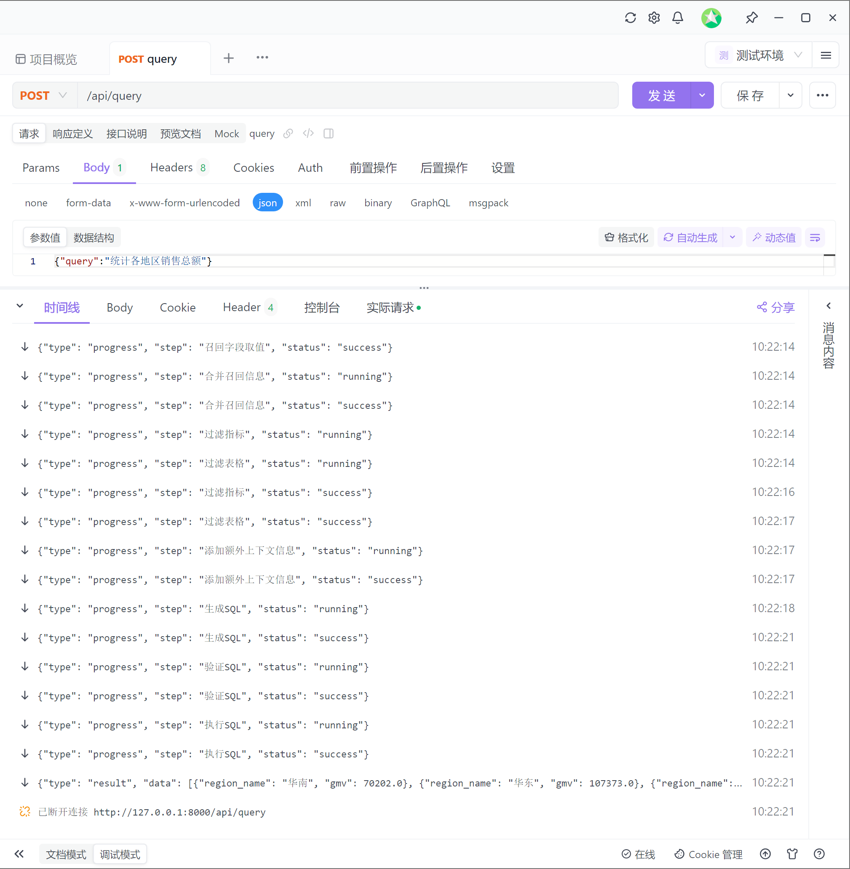
- 前后端对接
  - 启动前端项目
前端代码可从课程资料获取，另外启动项目需要node运行环境，node的安装包也可从课程资料获取。
在准备好node环境后，可在前端项目的根目录执行如下命令启动项目：
安装项目所需依赖
npm install
启动项目
npm run dev
  - 访问前端页面
根据命令行输出反问指定页面即可，具体效果如下：


