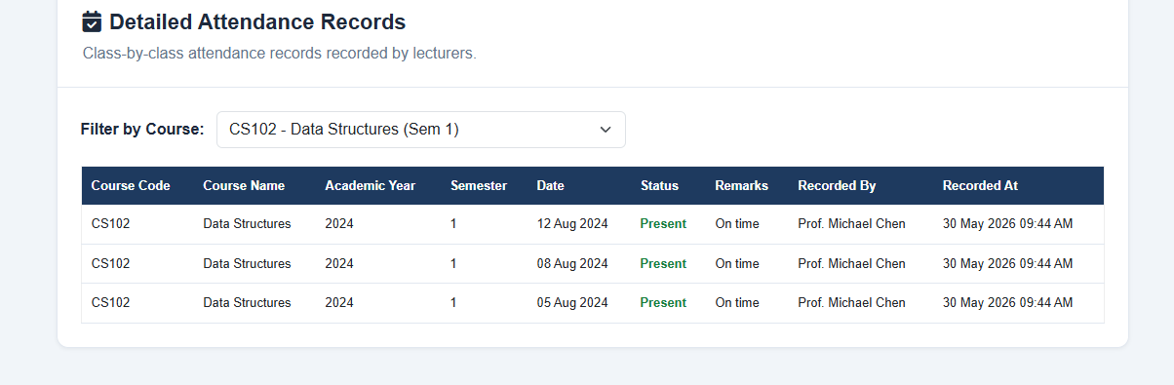
Remove remarks from attendance
Notuification pop up
Pull from admission table for (My profile)

