FINAL USABILITY REVIEW

Rating: 5/5
As a small business owner looking for an easy way to turn customer testimonials into social media content, ReviewsToPost feels very practical and beginner-friendly.

First impression
The homepage clearly communicates the value: turning customer reviews into social posts in one click. The example visuals on the right immediately helped me understand what the product does. Navigation is simple, fast, and intuitive with clear options like Examples, Pricing, FAQ, and Sign Up.

Workflow experience
The process is very straightforward:
- Paste a review
- Generate preview
- Customize style and vibe
- Copy hashtags
- Prepare content for download
The preview generation took around 8–10 seconds and felt quick enough. Each customization change updated visually and was easy to understand even without technical skills.

Usability & design
The layout is clean, scrolling is smooth, and sections are well organized. The examples section is helpful for visual understanding. Customization options like vibe, format, and business type are clear and beginner-friendly.
The hashtag generator is a strong feature and saves time for small business owners who struggle with social media marketing.

Features that stand out
- Preview before paying builds trust
- Simple customization (vibes, formats)
- Hashtags included automatically
- Ready-to-post visuals
- No design skills required
- Fast navigation and responsive interface

Pricing feedback (small business perspective)
The pricing is simple and transparent, and the credit explanation is easy to understand. The ability to cancel anytime is reassuring.
However, some small businesses or beginners may hesitate at $29/month before building trust. A starter plan, pay-per-download option, or credit top-up model could help attract first-time users.

Improvement opportunities
- Add onboarding/tutorial for first-time users
- Show real business case studies or success examples
- Provide beginner posting tips for social media
- Add starter pricing or flexible plans
- Keep “technology” pages inside the main experience instead of external redirects

Small business perspective
For small businesses without a marketing team, this tool saves time and simplifies content creation. It reduces the effort of designing social posts and helps turn customer feedback into marketing assets quickly.

Final verdict
ReviewsToPost is a simple, focused, and useful web app for businesses wanting to share customer testimonials on social media. It removes complexity and provides a fast, beginner-friendly workflow. With a few improvements in onboarding and pricing flexibility, it could become even more appealing to first-time users and small businesses.

Screenshots from usability testing
1. Homepage first impression

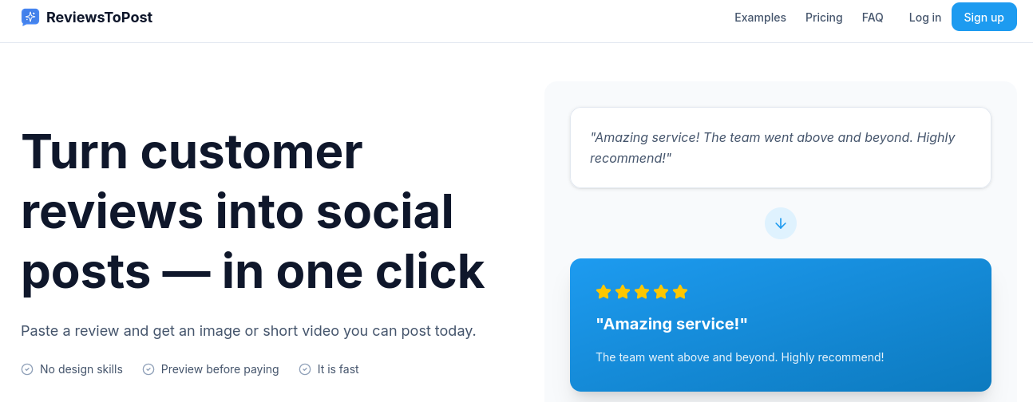
“Navigation is clear and fast.”
2. Review input & preview generation

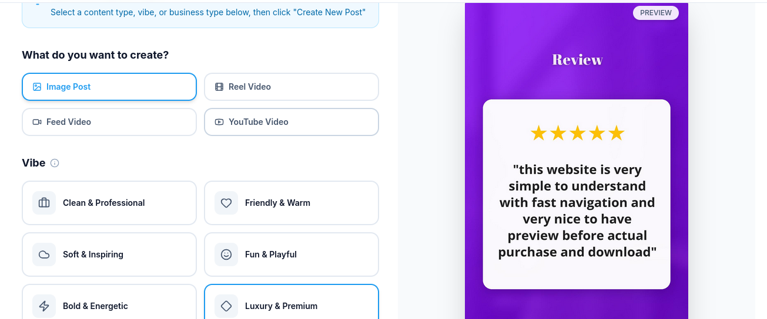
“Preview generated within ~10 seconds.”

3. Customization options

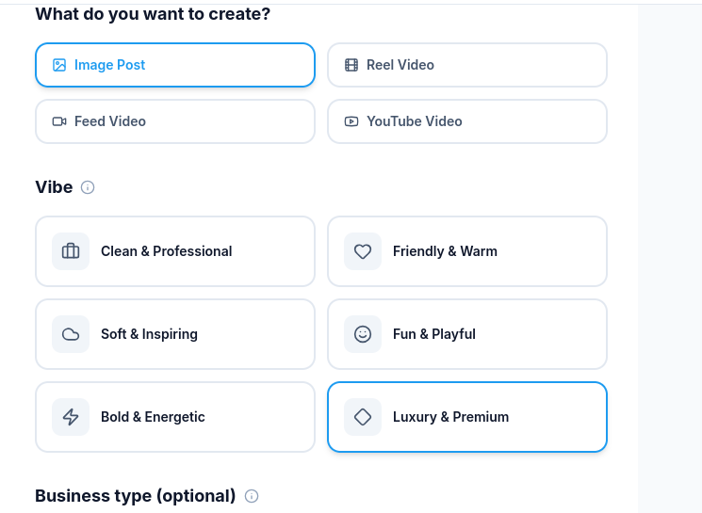
“Customization options are beginner-friendly.”

4. Pricing page clarity


“Pricing is simple but could benefit from tier plans.”

5. Review submission confirmation

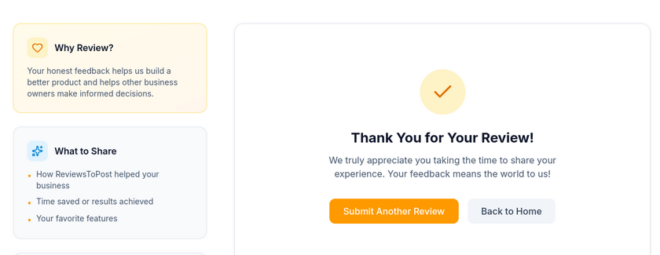
“Review submission flow works smoothly.”

