New Audi A8L 60 TFSI & 60 TFSIe
Storyline v5 – March 22, 2021

NEW STORYLINE

Graphic insert: The all-new Audi A8 L.
新奥迪A8L

画外音：“和谐的。耀眼。家。艺术。香气。声音。四季。自然。与生俱来的力量…”
Voice-over: “Harmonious. Dazzling. Home. Art. Aroma. Sound. Four seasons. Nature。Innate power... ”
(remark: we have recorded the VO more slowly)

(remark: We suggest there is a pause between the first 2 voice-over)

画外音：“感知，是我们了解世界的独特方式。”
Voice-over: “A unique perception of the world.”

画外音：“看见 时间的流动。”
Voice-over: “What you see can be flow of time.”

Exterieur design+OLED lights

Graphic insert: Pure design sophistication.
未来豪华美学
(remark: We suggest this texts appear after the narration “what you see..”)

Graphic insert: HD Matrix-design LED headlights.
高清矩阵式LED大灯

Graphic insert: OLED taillight.
OLED尾灯

画外音：“听见 有温度、可以触碰的情感。”
Voice-over: “What you hear can be warm emotion.”

(remark: We change the order of the narration.. and put B&O to this part.
It seems more logical)

Interieur design+B&O+ambient light+fragrance system

Graphic insert: Feels just like home.
舒享如家

Graphic insert: Four seats .
豪华四座布局
(remark:new highlights)

Graphic insert: With Multicolored LED ambient light.
多色内饰氛围灯

Graphic insert: Negative ion air purifier with fragrance system.
带香氛系统的负离子空气净化器

Graphic insert: B&O with acoustic prism.
带声学棱镜的B&O高级音响

画外音：“多维的感观，启发我们的灵感。“
Voice-over: “It may inspire your senses from all dimensions.”
MIB 3 / Displays

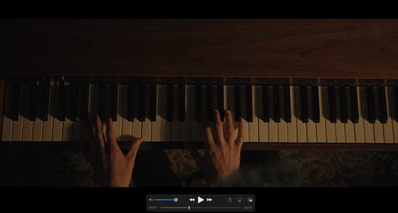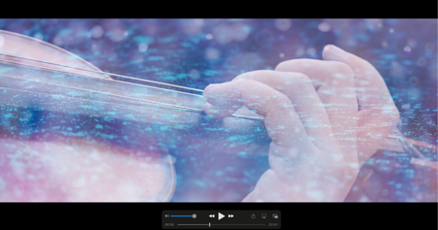
(remark: take out the footage of piano and violin, More sensual footage)

Graphic insert: Inteligent interactive space.
自由交互空间

Graphic insert: Full touch concept display.
全触控概念显示屏

(remark: new highlights. All the screens including Virtual cockpit/2 touch screens/Rear touch screen)
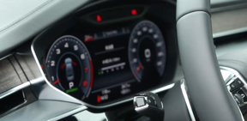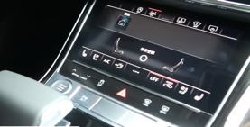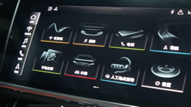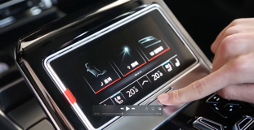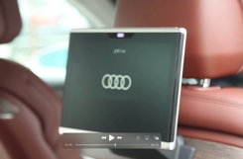

Graphic insert: MIB3 Infotainment system.
MIB3信息娱乐系统
(remark: use the app interface as below)
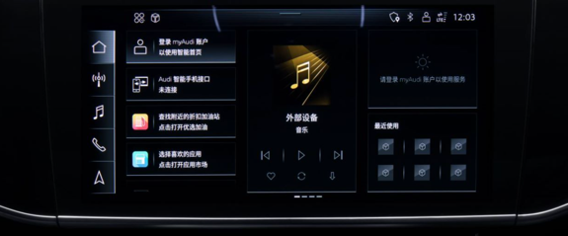

画外音：“将内心的直觉与创想，变为更加简约、值得信赖的个人科技。”
Voice-over: “Turn your inner intuition and creativity into a more simple and trustworthy personal technology. “

Intelligent driving / Intelligent light technology/ Audi pre sense, turning assist, night vision
(remark: combine the intelligent driving and driving assistants)

Graphic insert: Intelligent driving.
智能驾控

Graphic insert: Equipped with eABC.
eABC-智能主动车身控制系统
(remark: eABC graphic inserts first, it is a general name including the below 3 features)

Graphic insert: Red carpet welcome function.
主动迎宾功能

Graphic insert: Magic carpet function.
魔毯功能

Graphic insert: Active side impact protection
侧面防碰撞预提升功能

Graphic insert: Intelligent driving assistants.
智能驾驶辅助
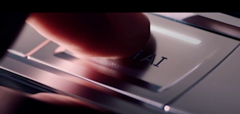
(remark: take out the AI shot, in China it’s park button as below )
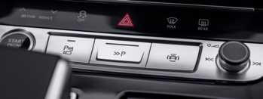

Graphic insert: Avoids potential collisions.
主动避免潜在威胁
(remark: the footage can used for eABC? )

Graphic insert: Night vision function
夜视功能
(remark: new highlights )

画外音：“感受激情的天性，赋予不断向前的生命力。”
Voice-over: “Feel the passionate nature that endows continuous forward vitality.”
(V8/power/driving..)

Performance – V8 engine - driving footage

Graphic insert: Equipped with a 4.0-litre-twin-turbocharged V8 engine.
全新V8 TFSI 双涡轮增压引擎

Graphic insert: Comprehensive power: 338KW
综合功率338kW

Graphic insert: Maximum output torque: 660N·m
最大输出扭矩660N·m

Graphic insert: Acceleration time: 4.5s”
加速时间4.5s

画外音：“聆听未来的声音，让其成为今日的回响。”
Voice-over: “Listen to the sound of the future and make it the echo of today.”

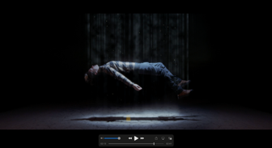
(remark: take out this shot )

Efficiency – electric charging – driving footage

Graphic insert: Plug-in to the future.
驭电未来

Graphic insert: Intelligent hybrid drivetrain system.
智能混合动力系统

画外音：“感知世界，先见未来。“
Voice-over: “Feel eternal vitality.See the future.”

Graphic insert:
驾驭明天的智慧
新奥迪A8L 60 TFSI & 新奥迪A8L 60 TFSIe
联袂重磅上市

