## 示例代码运行,获得日志文件

JVM参数使用: -XX:+UnlockDiagnosticVMOptions -XX:+TraceClassLoading -XX:+LogCompilation -XX:LogFile=bar_hsdis_out.log -XX:+PrintAssembly -XX:+TraceClassLoading

|  |
| --- |
| /**  * 进行jit生成代码反汇编的简单java代码  *  * <p>由于是window环境，需要将hsdis-amd64.dll复制到\jdk1.8.0_241\jre\bin\server目录下  *  * <p>使用JVM参数  *  * -XX:+UnlockDiagnosticVMOptions -XX:+PrintAssembly -Xcomp -XX:CompileCommand=dotinline,*Bar.sum -XX:CompileCommand=compileonly,*Bar,sum  *  *  * 如果使用jitwatch工具查看使用JVM参数  *  * -XX:+UnlockDiagnosticVMOptions -XX:+TraceClassLoading -XX:+LogCompilation -XX:LogFile=bar_hsdis_out.log -XX:+PrintAssembly -XX:+TraceClassLoading  *  * @author liujun  * @version 0.0.1  */  public class Bar {  int a = 1;  static int b = 2;  public int sum(int c) {  return a + b + c;  }  public static void main(String[] args) {  new Bar().sum(3);  }  } |

结果

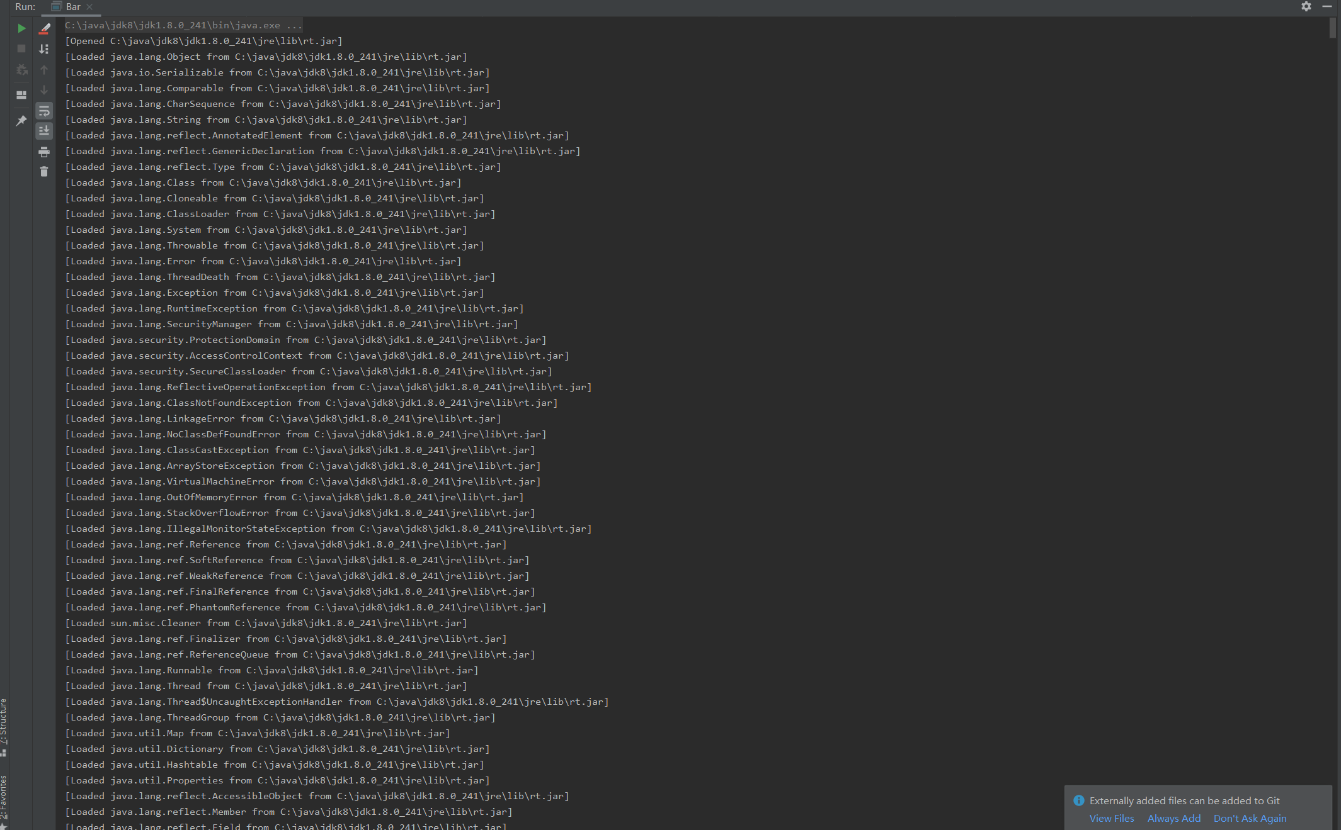

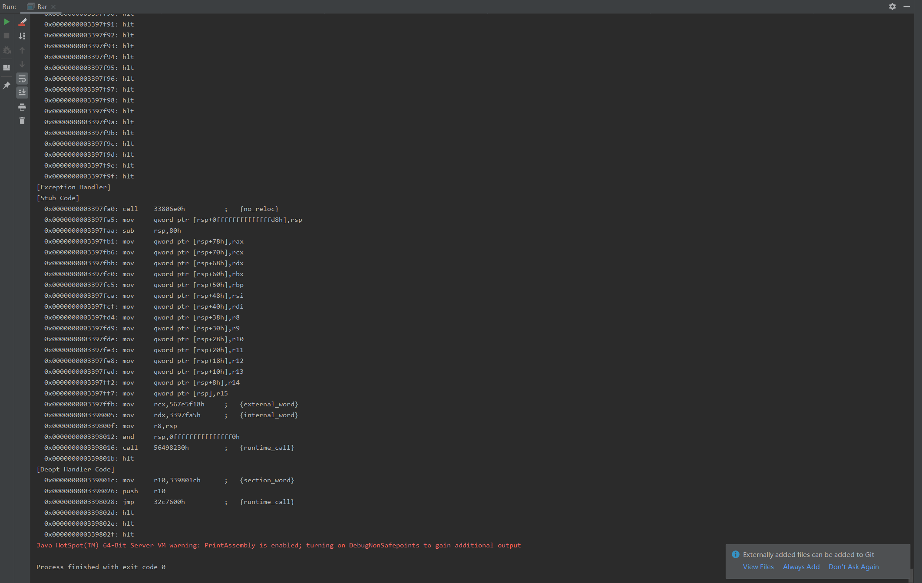

## jitwatch使用

1,下载jitwatch的相关代码，这里使用的版本为: jitwatch-1.3.0

<https://codeload.github.com/AdoptOpenJDK/jitwatch/zip/1.3.0>

2，编译jitwatch

使用mvn clean package -DskipTests

|  |
| --- |
| D:\java\soft\jdk\jitwatch-1.3.0>mvn clean package -DskipTests  [INFO] Scanning for projects...  [INFO] ------------------------------------------------------------------------  [INFO] Reactor Build Order:  [INFO]  [INFO] JITWatch Parent  [INFO] JITWatch Core  [INFO] JITWatch UI  [INFO]  [INFO] ------------------------------------------------------------------------  [INFO] Building JITWatch Parent 1.3.0  [INFO] ------------------------------------------------------------------------  Downloading: https://maven.aliyun.com/repository/central/org/codehaus/mojo/exec-maven-plugin/1.6.0/exec-maven-plugin-1.6.0.pom  Downloaded: https://maven.aliyun.com/repository/central/org/codehaus/mojo/exec-maven-plugin/1.6.0/exec-maven-plugin-1.6.0.pom (13 KB at 13.4 KB/sec)  Downloading: https://maven.aliyun.com/repository/central/org/codehaus/mojo/exec-maven-plugin/1.6.0/exec-maven-plugin-1.6.0.jar  Downloaded: https://maven.aliyun.com/repository/central/org/codehaus/mojo/exec-maven-plugin/1.6.0/exec-maven-plugin-1.6.0.jar (57 KB at 170.4 KB/sec)  [INFO]  [INFO] --- maven-clean-plugin:3.0.0:clean (default-clean) @ jitwatch-parent ---  [INFO]  [INFO] --- maven-source-plugin:3.0.1:jar-no-fork (attach-sources) @ jitwatch-parent ---  [INFO]  [INFO] ------------------------------------------------------------------------  [INFO] Building JITWatch Core 1.3.0  [INFO] ------------------------------------------------------------------------  Downloading: https://maven.aliyun.com/repository/central/org/apache/maven/plugins/maven-compiler-plugin/3.6.1/maven-compiler-plugin-3.6.1.pom  Downloaded: https://maven.aliyun.com/repository/central/org/apache/maven/plugins/maven-compiler-plugin/3.6.1/maven-compiler-plugin-3.6.1.pom (0 B at 0.0 KB/sec)  Downloading: https://maven.aliyun.com/repository/central/org/apache/maven/plugins/maven-compiler-plugin/3.6.1/maven-compiler-plugin-3.6.1.jar  Downloaded: https://maven.aliyun.com/repository/central/org/apache/maven/plugins/maven-compiler-plugin/3.6.1/maven-compiler-plugin-3.6.1.jar (0 B at 0.0 KB/sec)  [INFO]  [INFO] --- maven-clean-plugin:3.0.0:clean (default-clean) @ jitwatch-core ---  [INFO]  [INFO] --- maven-resources-plugin:3.0.2:resources (default-resources) @ jitwatch-core ---  [INFO] Using 'UTF-8' encoding to copy filtered resources.  [INFO] Copying 38 resources  [INFO]  [INFO] --- maven-compiler-plugin:3.6.1:compile (default-compile) @ jitwatch-core ---  Downloading: https://maven.aliyun.com/repository/central/com/thoughtworks/qdox/qdox/2.0-M5/qdox-2.0-M5.pom  Downloaded: https://maven.aliyun.com/repository/central/com/thoughtworks/qdox/qdox/2.0-M5/qdox-2.0-M5.pom (16 KB at 58.3 KB/sec)  Downloading: https://maven.aliyun.com/repository/central/com/thoughtworks/qdox/qdox/2.0-M5/qdox-2.0-M5.jar  Downloaded: https://maven.aliyun.com/repository/central/com/thoughtworks/qdox/qdox/2.0-M5/qdox-2.0-M5.jar (307 KB at 716.8 KB/sec)  [INFO] Changes detected - recompiling the module!  [INFO] Compiling 175 source files to D:\java\soft\jdk\jitwatch-1.3.0\core\target\classes  [INFO]  [INFO] --- maven-resources-plugin:3.0.2:testResources (default-testResources) @ jitwatch-core ---  [INFO] Using 'UTF-8' encoding to copy filtered resources.  [INFO] skip non existing resourceDirectory D:\java\soft\jdk\jitwatch-1.3.0\core\src\test\resources  [INFO]  [INFO] --- maven-compiler-plugin:3.6.1:testCompile (default-testCompile) @ jitwatch-core ---  [INFO] Changes detected - recompiling the module!  [INFO] Compiling 36 source files to D:\java\soft\jdk\jitwatch-1.3.0\core\target\test-classes  [INFO]  [INFO] --- maven-surefire-plugin:2.20:test (default-test) @ jitwatch-core ---  [INFO] Tests are skipped.  [INFO]  [INFO] --- maven-jar-plugin:3.0.2:jar (default-jar) @ jitwatch-core ---  [INFO] Building jar: D:\java\soft\jdk\jitwatch-1.3.0\core\target\jitwatch-core-1.3.0.jar  [INFO]  [INFO] --- maven-source-plugin:3.0.1:jar-no-fork (attach-sources) @ jitwatch-core ---  [INFO] Building jar: D:\java\soft\jdk\jitwatch-1.3.0\core\target\jitwatch-core-1.3.0-sources.jar  [INFO]  [INFO] ------------------------------------------------------------------------  [INFO] Building JITWatch UI 1.3.0  [INFO] ------------------------------------------------------------------------  [INFO]  [INFO] --- maven-clean-plugin:3.0.0:clean (default-clean) @ jitwatch-ui ---  [INFO]  [INFO] --- maven-resources-plugin:3.0.2:resources (default-resources) @ jitwatch-ui ---  [INFO] Using 'UTF-8' encoding to copy filtered resources.  [INFO] Copying 3 resources  [INFO]  [INFO] --- maven-compiler-plugin:3.6.1:compile (default-compile) @ jitwatch-ui ---  [INFO] Changes detected - recompiling the module!  [INFO] Compiling 79 source files to D:\java\soft\jdk\jitwatch-1.3.0\ui\target\classes  [INFO]  [INFO] --- maven-resources-plugin:3.0.2:testResources (default-testResources) @ jitwatch-ui ---  [INFO] Using 'UTF-8' encoding to copy filtered resources.  [INFO] skip non existing resourceDirectory D:\java\soft\jdk\jitwatch-1.3.0\ui\src\test\resources  [INFO]  [INFO] --- maven-compiler-plugin:3.6.1:testCompile (default-testCompile) @ jitwatch-ui ---  [INFO] No sources to compile  [INFO]  [INFO] --- maven-surefire-plugin:2.20:test (default-test) @ jitwatch-ui ---  [INFO] Tests are skipped.  [INFO]  [INFO] --- maven-jar-plugin:3.0.2:jar (default-jar) @ jitwatch-ui ---  [INFO] Building jar: D:\java\soft\jdk\jitwatch-1.3.0\ui\target\jitwatch-ui-1.3.0.jar  [INFO]  [INFO] --- maven-source-plugin:3.0.1:jar-no-fork (attach-sources) @ jitwatch-ui ---  [INFO] Building jar: D:\java\soft\jdk\jitwatch-1.3.0\ui\target\jitwatch-ui-1.3.0-sources.jar  [INFO] ------------------------------------------------------------------------  [INFO] Reactor Summary:  [INFO]  [INFO] JITWatch Parent .................................... SUCCESS [ 4.750 s]  [INFO] JITWatch Core ...................................... SUCCESS [ 8.737 s]  [INFO] JITWatch UI ........................................ SUCCESS [ 2.417 s]  [INFO] ------------------------------------------------------------------------  [INFO] BUILD SUCCESS  [INFO] ------------------------------------------------------------------------  [INFO] Total time: 16.023 s  [INFO] Finished at: 2020-07-13T09:19:59+08:00  [INFO] Final Memory: 24M/330M  [INFO] ------------------------------------------------------------------------  D:\java\soft\jdk\jitwatch-1.3.0> |

## 启动jitwatch

根据不同的平台选择不同的启动脚本

launchUI.bat

launchUI.sh

## 加载日志文件

选择bar_hsdis_out.log文件

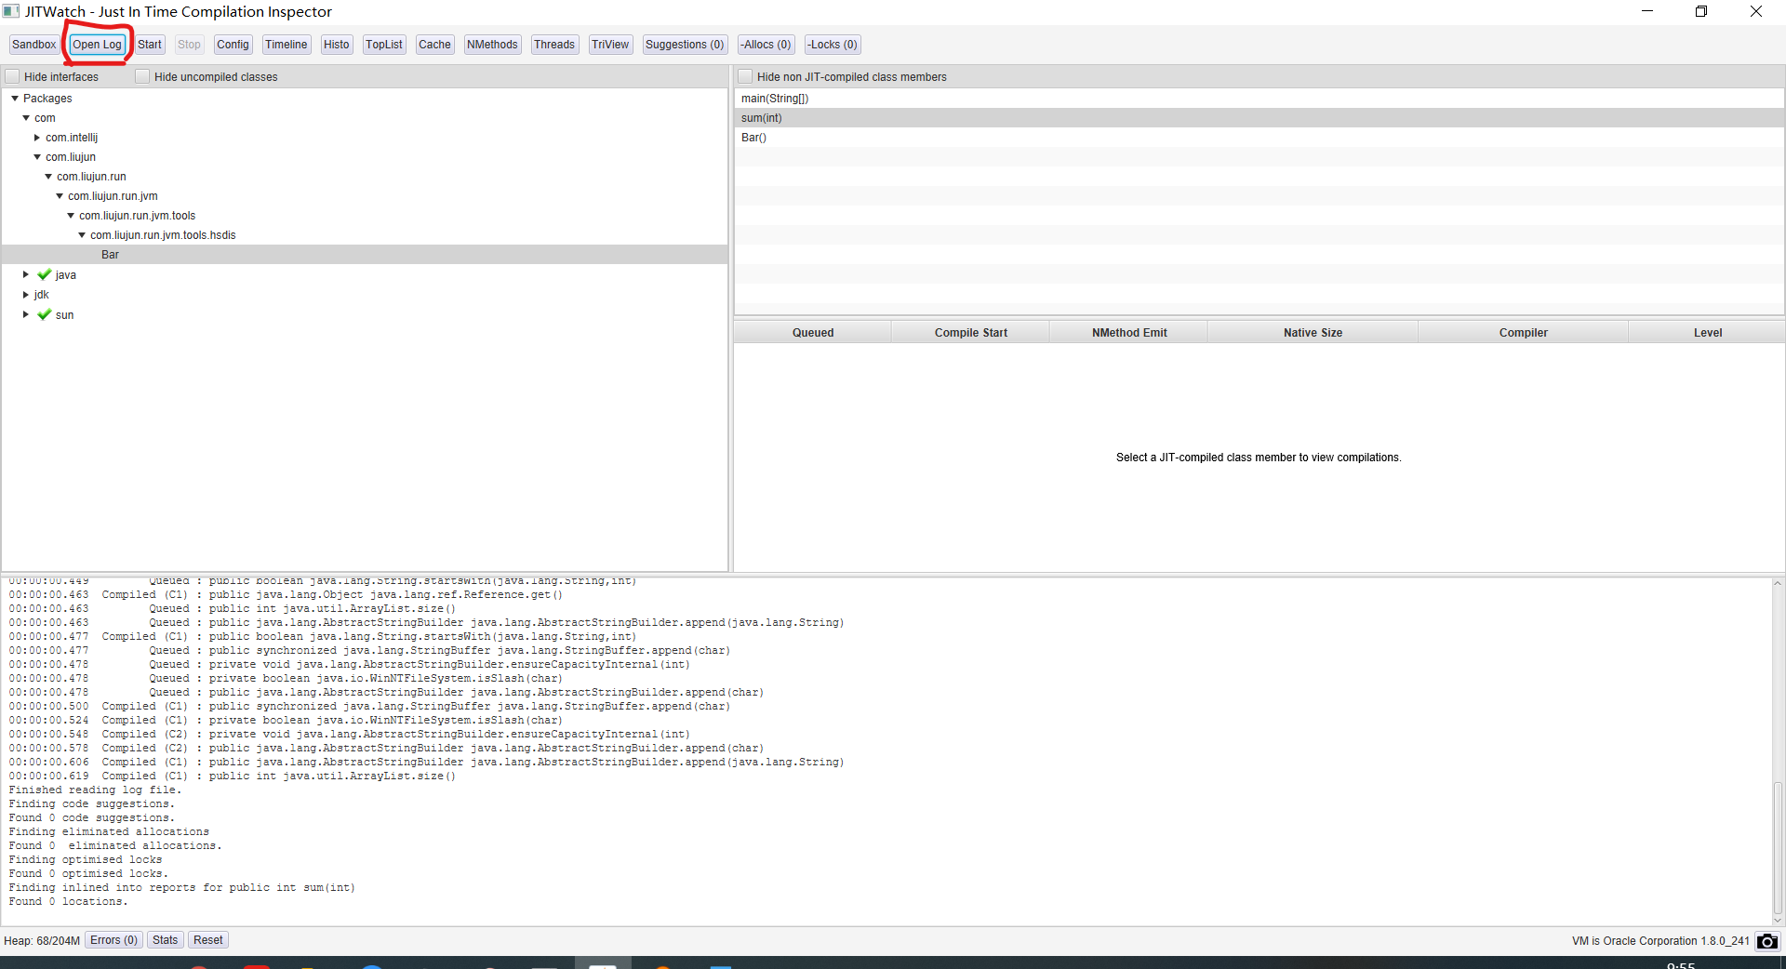

## 配制源代码及class字节码文件目录

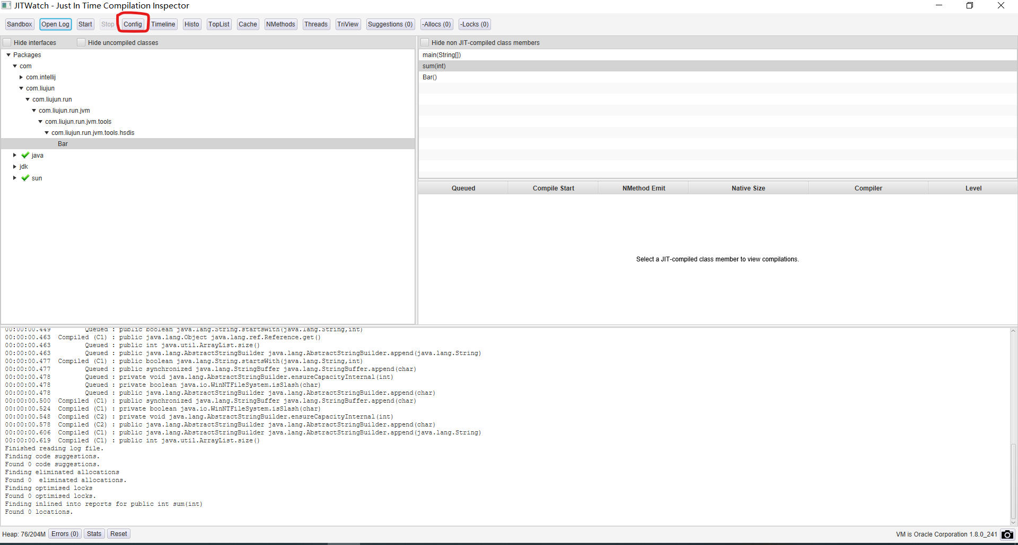

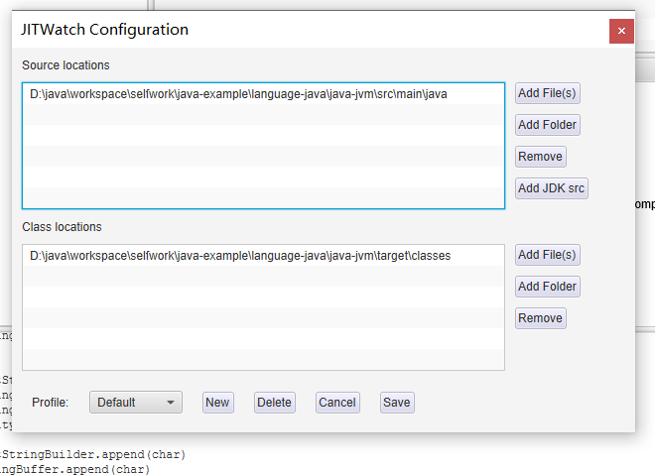

## 查看反汇编代码

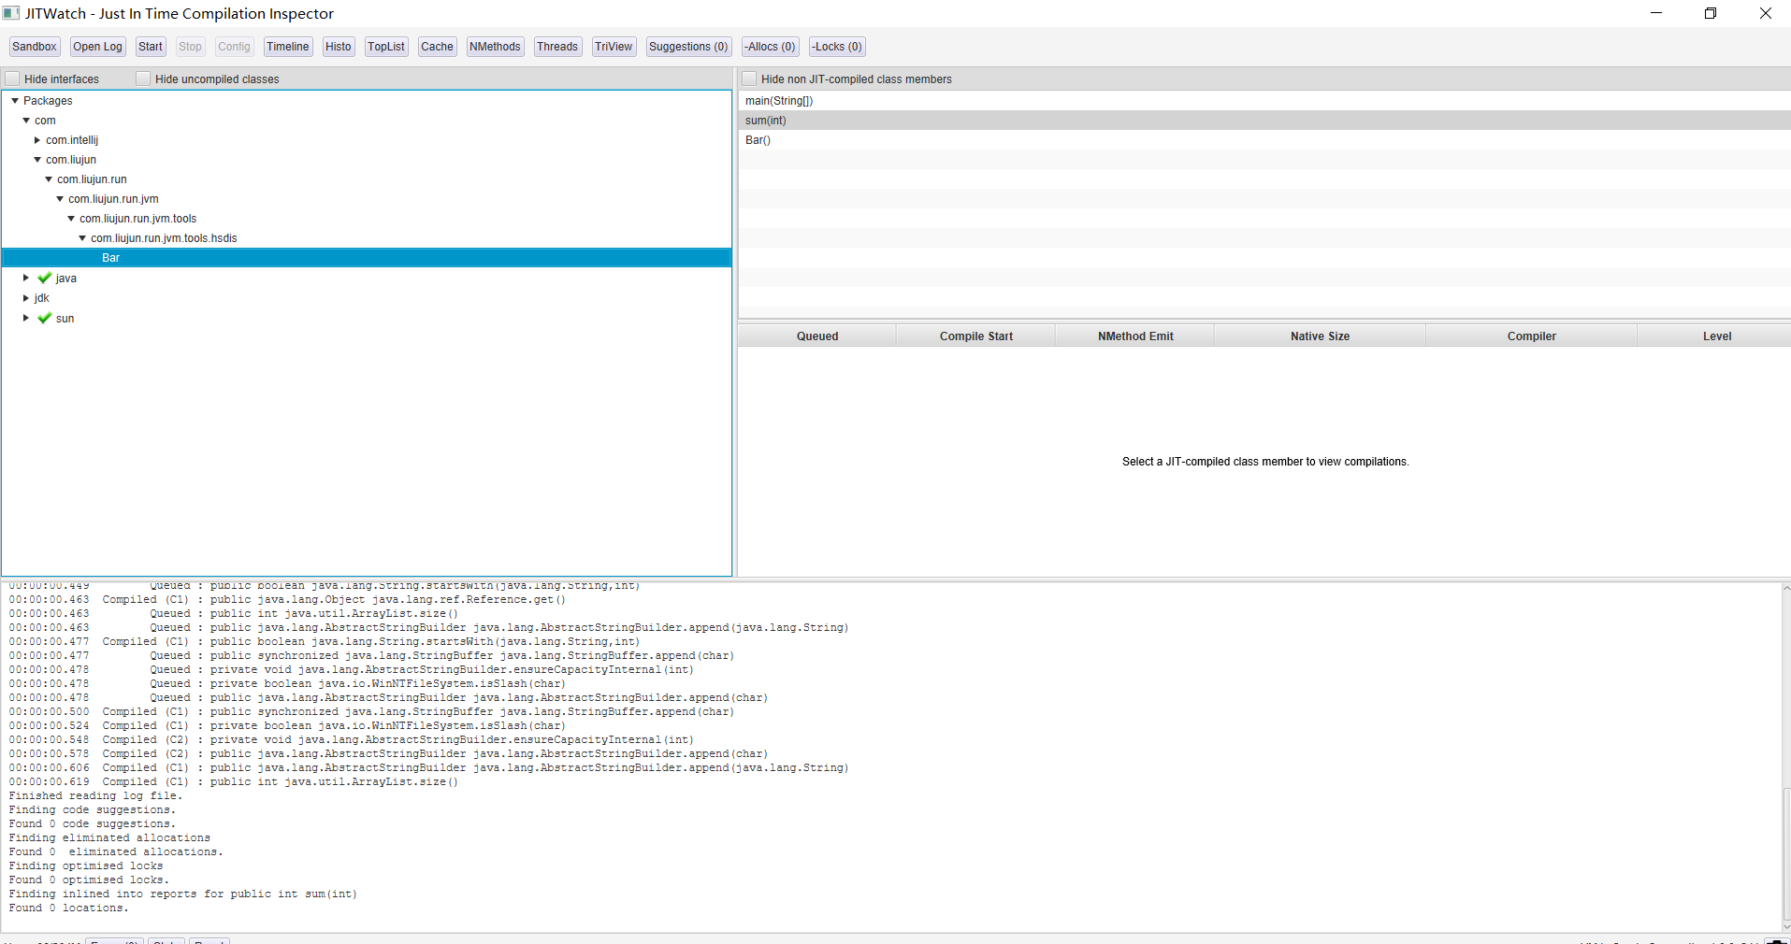

点击方法就可查看相应的代码与汇编代码的对应

