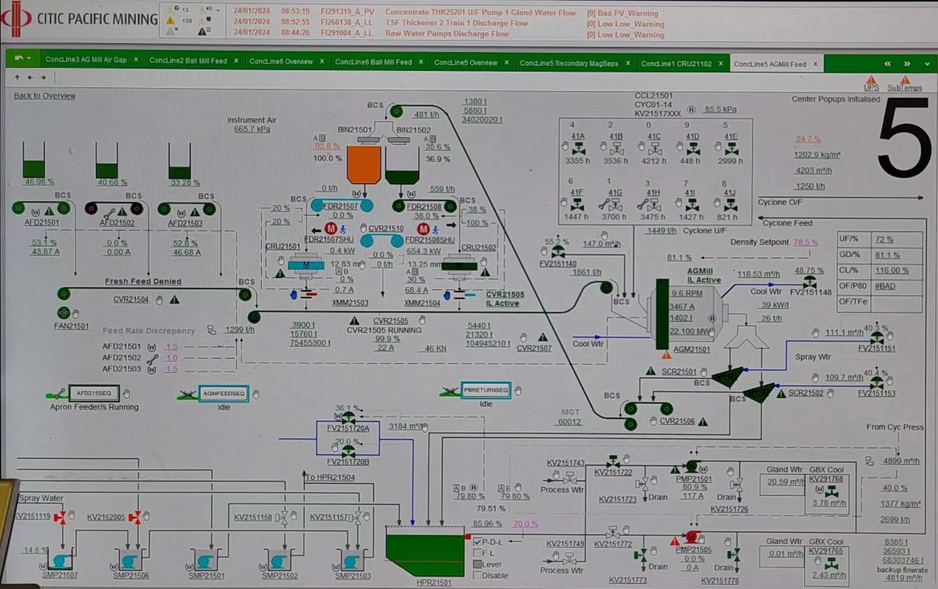

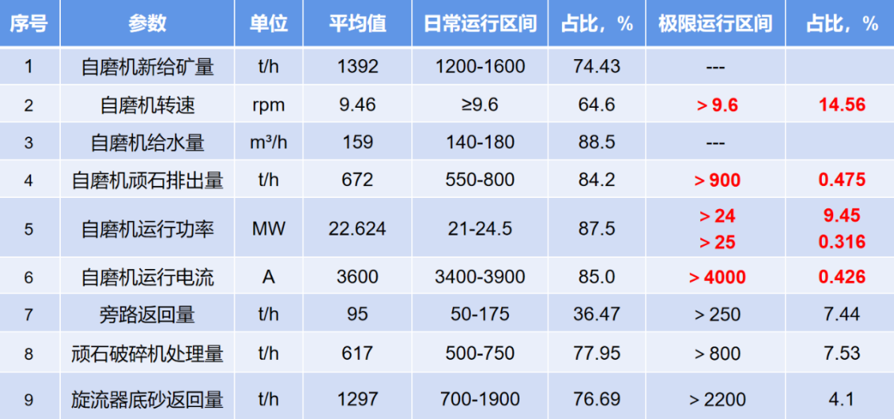 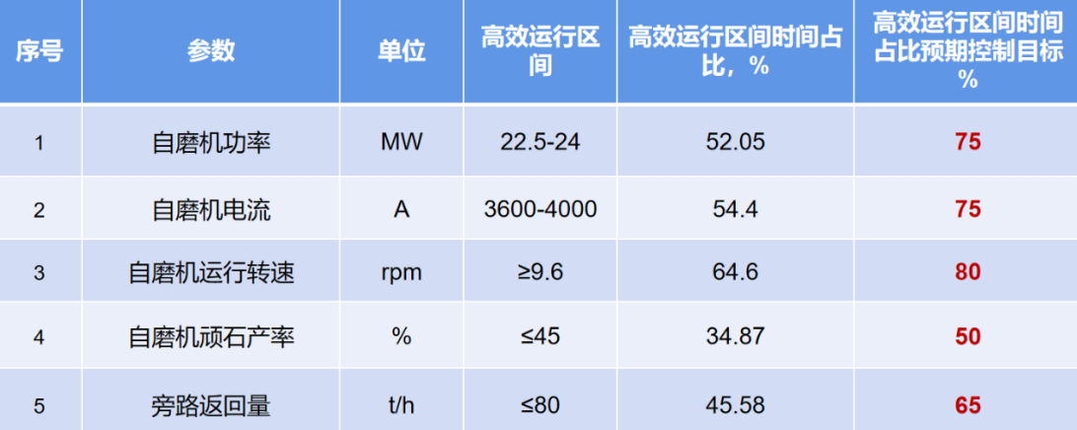

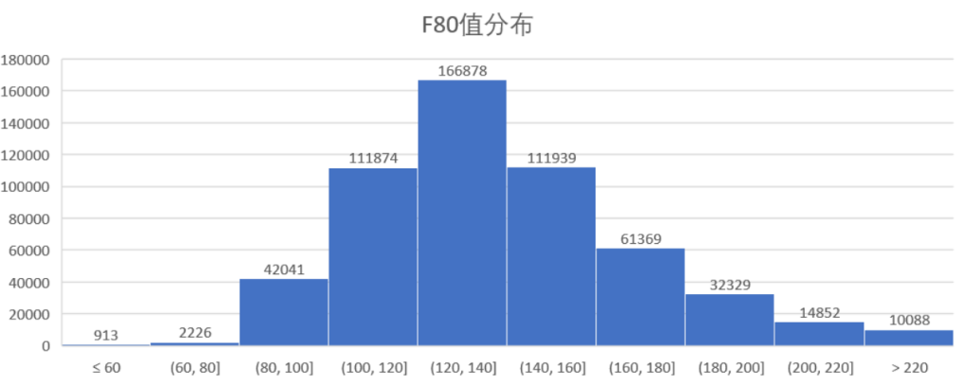

|  |  |  |  |  |  |  |
| --- | --- | --- | --- | --- | --- | --- |
|  | FreshFeedWeight  (MV)  Range >1250t/h  Ini=1299 | CRU1Weight  (DV/MV)  Range 500-600t/h  Ini=559 | BypassWeight  (MV)  0-1500t/h  Ini=0 | AGMSpeed  (MV)  8-9.6rpm  Ini=9.5 | CYCWeight  (DV)  1300-1700t/h  Ini=1449t/h | F80  (DV)  80-220  Ini=140 |
| AGMPower  (CV)  Range <25MW  Ini=22.1 |  |  |  |  |  |  |
| AGMCurrent  (CV)  Range < 4000A  Ini = 3467 |  |  |  |  |  |  |
| AGMWeight  (CalcCV)  Range <1500t  Ini=1402t |  |  |  | ? |  |  |

|  |  |  |  |  |
| --- | --- | --- | --- | --- |
|  | FreshFeed2Pebble  (CalcDV) | BypassWeight*0.7  (CalcDV) | AGMSpeed  (MV) | Other |
| PebbleReturn  (CalcDV)  Range 550-800t/h  Ini=650 |  |  |  |  |

FreshFeed2Pebble = FreshFeedWeight*Fx(F80)

|  |  |  |  |  |  |
| --- | --- | --- | --- | --- | --- |
| F80 | 80 | 220 |  |  |  |
| Fx(F80) | 0.1 | 0.7 |  |  |  |

|  |  |  |  |  |  |
| --- | --- | --- | --- | --- | --- |
|  | PebbleReturn  (DV) | BypassWeight  (MV) | CRU1Weight  (DV/MV) |  |  |
| Bin1Level  (CV)  Range < 160  Ini = 50 |  |  |  |  |  |