SCR模型说明

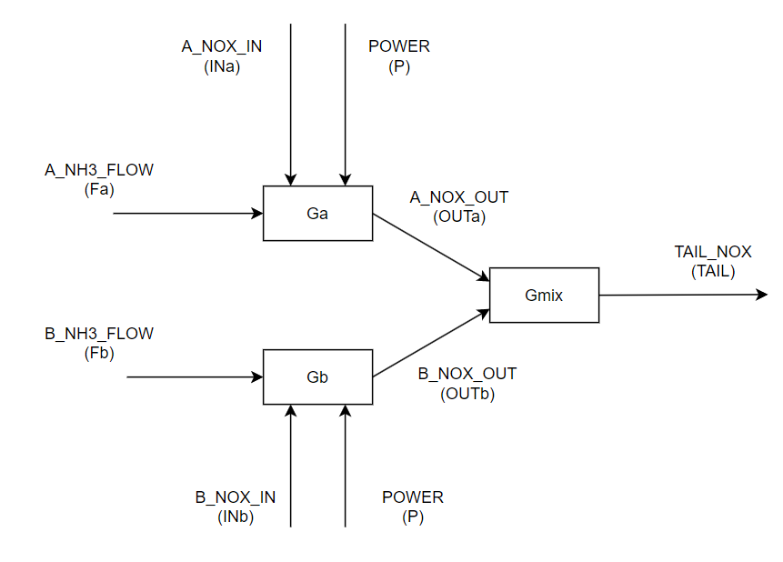







|  |  |  |
| --- | --- | --- |
| MVs | DVs | CVs |
| A_NH3_FLOW | A_NOX_IN | TAIL_NOX |
| B_NH3_FLOW | B_NOX_IN | A_NOX_OUT |
|  | POWER | B_NOX_OUT |