CSE 564 Project 1 POX over HTTP Assignment

Xiaoyu Zhang

1207639026

# ReadMe

1. Download and unzip the package POX-FoodMenu-xzhan320-Netbeans
2. Run NetBeans IDE and click File -> Open Project. On folder selection page, open both POXsrv-FoodMenu-xzhan320-Netbeans and POXcli-FoodMenu-xzhan320-Netbeans.

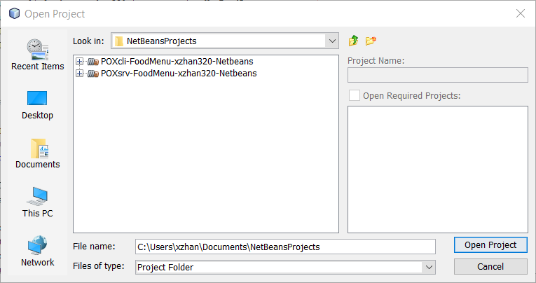

1. Direct to the server folder (POXsrv-FoodMenu-xzhan320-Netbeans) and open **RESTfulResource.java** file under POXsrv-FoodMenu-xzhan320-Netbeans – Source Packages – com.myasu.poxsrv.foodmenu.xzhan320.netbeans – RESTfulResource.java

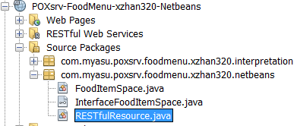

1. Run the server program by clicking the green arrow button on the top right of the control panel.

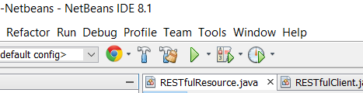

1. When prompt, choose **GlassFish Server 4.1.1** for deployment.



1. The output panel will show following message.

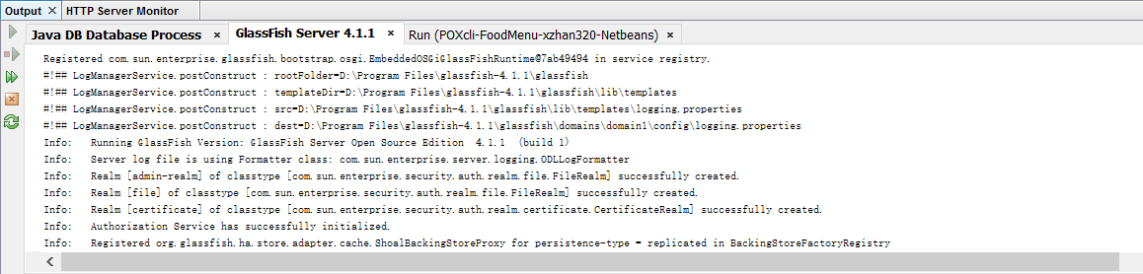

And a sample web page will pop up.

1. Now direct to the client folder (POXcli-FoodMenu-xzhan320-Netbeans) and open **App.java** file under POXcli-FoodMenu-xzhan320-Netbeans – Source Packages – com.myasu.poxcli.foodmenu.xzhan320.netbeans – App.java

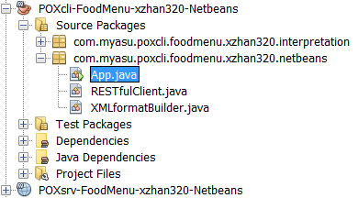

1. Once again, run the client program by clicking the green arrow button on the top right of the control panel.

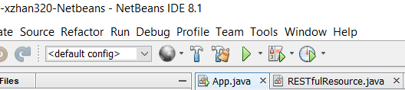

Choose com.myasu.poxcli.foodmenu.xzhan320.netbeans.App as Main()

1. In the output panel, you will see “Build Success” followed by Response message from the interaction with server:

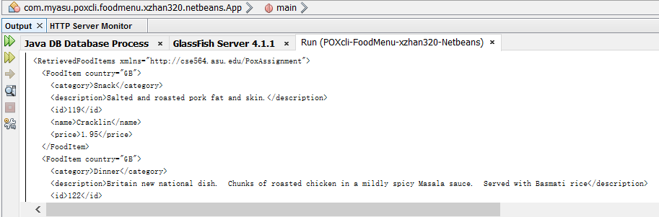

1. All test cases are enclosed in App.java file. Please reference them for further details.