FINTECHATHON 2026 COMPETITION

SOFTWARE REQUIREMENTS SPECIFICATION
Lilact AI Agent
A working capital and liquidity management assistant for small and medium-sized enterprises
Information | Content
Document code | SRS-SLC-FOB-UC00-UC04
Version | 2.10
Release date | 20/10/2026
Status | Version 2.9 adds usability requirements, privacy by design, rules for the tools of the language model, a single audit trail for every channel and a usability review of the interface (sections 3.1, 3.2, 3.6 and 3.7; Appendices G and J). Version 2.10 aligns the security and privacy requirements with SRS v1.10 (two-role separation of duties, vendor support access, legal basis, calibration data, retention) and adds Part 4 on Phase 2 calibration.
Scope | UC00 and the four tasks UC01–UC04; six-cell matrix; three scenarios; Miller–Orr model.
Users | Business Owner and Accountant

Table of Contents

1 Introduction 10
1.1 Purpose 10
1.2 Scope 12
1.3 Terms and conventions 13
1.4 Basis and version management 14
1.5 How to use this document 15
2 Functional requirements 15
2.1 Two user roles 15
2.2 Functions and the principle of reducing user operations 15
2.3 Overview use case diagram 16
2.4 Decomposed use case diagrams 17
2.5 Business process 19
2.5.1 Overall process 19
2.5.2 Diagnosis and threshold building 21
2.5.3 Forecast and routing 23
2.6 Data intake and source confirmation 25
2.6.1 Input sources and the standardisation flow 25
2.6.2 Minimum data and the FOB model 25
2.6.3 Data intake and update 26
2.6.4 Validation, synchronisation and reconciliation 28
2.6.5 Confirmation of master data and policy 29
2.7 UC01 Working capital diagnosis 29
2.7.1 View the diagnosis Dashboard 29
2.7.2 Diagnosis Q&A through the Chat 31
2.7.3 View subject details and evidence 33
2.7.4 View and confirm the diagnosis policy 34
2.7.5 Formulas, period and balance basis 36
2.7.6 Analysis by item 37
2.7.7 Counterparty profiles and inventory 37
2.7.8 FOB thresholds and the three W levels 38
2.7.9 Combined causes and evidence 41
2.7.10 Result structure and interpretation 41
2.7.11 Bottleneck scenarios and how the system responds 42
2.8 UC02 Cash forecast and warning 56
2.8.1 View the forecast and Q&A 56
2.8.2 Forecast Q&A through the Chat 58
2.8.3 Confirm Cash0 and the cash thresholds 59
2.8.4 Compare the three scenarios and view causes 61
2.8.5 View shortfall episodes and contributing factors 62
2.8.6 Upload or supplement data from the forecast screen 64
2.8.7 Open Solutions 65
2.8.8 Three scenarios and assumptions with a basis 67
2.8.9 Miller–Orr cash thresholds 67
2.8.10 Cash schedule formulas and the shortfall 70
2.8.11 Yellow, orange and red warnings 70
2.8.12 Two state branches and the six-cell matrix 71
2.8.13 Causes of a shortfall episode and sources of surplus cash 72
2.8.14 Outputs and interpretation control 72
2.8.15 Forecast feedback and business rules 73
2.8.16 Cash state scenarios and how the system responds 74
2.8.17 Post-operation feedback loop: comparing the forecast with actuals 82
2.9 UC03 Solution recommendation 87
2.9.1 Objective and scope 87
2.9.2 Inputs and outputs 87
2.9.3 Overall processing flow 87
2.9.4 View solution recommendations 88
2.9.5 Recommendation Q&A through the Chat 89
2.9.6 View excluded sources and the reasons 91
2.9.7 Exclude a source or update a selection with a reason 92
2.9.8 Configure products and solution policy 93
2.9.9 Transfer internal options to a test 95
2.9.10 Six-cell priority policy 96
2.9.11 Source groups and their interpretation 97
2.9.12 Checking conditions before ranking 98
2.9.13 Ranking and building a package over time 98
2.9.14 Cost and the unmet portion 99
2.9.15 Surplus cash, reserve and short-term investment 99
2.9.16 Results and interpretation templates 100
2.10 UC04 What-if testing on cash flow 101
2.10.1 Objective and scope 101
2.10.2 Inputs and outputs 101
2.10.3 Overall processing flow 102
2.10.4 Set up and run a test 102
2.10.5 View the result and adjust the test 104
2.10.6 Simulation result Q&A through the Chat 105
2.10.7 Compare tests and Q&A 107
2.10.8 Simulate the option portion received from UC03 108
2.10.9 Draft actions and approval 109
2.10.10 The three levers and the transformation formulas 131
2.10.11 Preventing double counting and items outside the period 132
2.10.12 Comparison and conclusion 132
2.10.13 Outputs, controls and limits 133
3 Non-functional requirements 135
3.1 User interface 135
3.2 Security design 137
3.2.1 Authentication, sessions and enterprise isolation 137
3.2.2 File, source and storage safety 138
3.2.3 LLM limits and output control 139
3.2.4 Change recording, duplicate prevention and incident handling 139
3.2.5 Approval, action drafts and the action log 140
3.2.6 Security Design Document and requirement mapping 140
3.2.7 Privacy by design 140
3.3 Implementation constraints and architecture 141
3.4 Reliability and result status 142
3.5 Performance 143
3.6 Logging and operational support 144
3.7 Tools, APIs and data contracts 145
3.7.1 Standardised data dictionary 149
3.7.2 Record lifecycle and handling of missing information 152
3.7.3 Inter-task handover rules 153
3.7.4 Retention of data 154
3.8 Legal, copyright and usage limits 154
Appendix A UC01 formula dictionary 156
Appendix B UC02 UC03 UC04 formulas 158
Appendix C Parameters and release conditions 160
Appendix D UC01 data and security test cases 162
Appendix E UC02 UC03 UC04 and user experience test cases 165
Appendix F Threshold calibration and FOB data preparation 170
Appendix G Deployment limits and change control 172
Appendix H Action draft templates and sample scripts 175
Appendix I Security requirement codes and mapping 180
Appendix J Usability review of the interface 182

LIST OF FIGURES
Figure 2-1: Overview use case diagram with two roles and five function groups 17
Figure 2-2: Decomposition of UC01 17
Figure 2-3: Decomposition of UC02 18
Figure 2-4: Decomposition of UC03 18
Figure 2-5: Decomposition of UC04 19
Figure 2-6: Overall process and the boundary of user operations 20
Figure 2-7: Simplified diagnostic flow and internal checks 21
Figure 2-8: Separation of the item thresholds and the Miller–Orr cash thresholds 22
Figure 2-9: Three-scenario forecast flow 23
Figure 2-10: Six-case matrix combining diagnosis and forecast 24
Figure 2-11: UC03 flow that opens directly and automatically prepares background results 87
Figure 2-12: What-if testing flow with short operations and three scenarios 102
Figure 2-13: Life cycle of a draft action in the Approval queue 112
Figure 3-1: Architecture supporting two roles, six cells and three scenarios 142

LIST OF TABLES
Table 1-1: Document audience 12
Table 1-2: Functional scope 12
Table 1-3: Common terms 13
Table 1-4: Cross-cutting decisions 15
Table 2-1: Roles and permission limits 15
Table 2-2: Experience simplification requirements 16
Table 2-3: Interpretation of solution priority order for the six cases 24
Table 2-4: Supported data sources 25
Table 2-5: Shared standard data 26
Table 2-6: Specification of use case UC00.1 27
Table 2-7: Input data of UC00.1 28
Table 2-8: Output data of UC00.1 28
Table 2-9: General data rules 29
Table 2-10: Specification of use case UC01.1 30
Table 2-11: Input data of UC01.1 31
Table 2-12: Output data of UC01.1 31
Table 2-13: Specification of use case UC01.2 32
Table 2-14: Input data of UC01.2 32
Table 2-15: Output data of UC01.2 33
Table 2-16: Specification of use case UC01.3 33
Table 2-17: Input data of UC01.3 34
Table 2-18: Output data of UC01.3 34
Table 2-19: Specification of use case UC01.4 35
Table 2-20: Input data of UC01.4 35
Table 2-21: Output data of UC01.4 35
Table 2-22: UC01 core formulas 36
Table 2-23: Depth of diagnosis 37
Table 2-24: Shared business profiles 38
Table 2-25: Current FOB thresholds – configuration fob.threshold.v3 39
Table 2-26: Catalogue of signals and their basis 40
Table 2-27: Capital conversion and prevention of double counting 40
Table 2-28: UC01 classification rules 40
Table 2-29: UC01 outputs 41
Table 2-30: UC01 business rules 42
Table 2-31: Cause status c_i of an item 43
Table 2-32: Capital above the threshold, money_at_risk and bottleneck ranking 44
Table 2-33: The eight bottleneck scenarios BN0 – BN7 44
Table 2-34: Specification of scenario BN0 – No bottleneck 46
Table 2-35: Specification of scenario BN1 – Cause from receivables 47
Table 2-36: Specification of scenario BN2 – Cause from inventory 49
Table 2-37: Specification of scenario BN3 – Cause from payables 49
Table 2-38: Specification of scenario BN4 – Receivables combined with inventory 50
Table 2-39: Specification of scenario BN5 – Receivables combined with payables 51
Table 2-40: Specification of scenario BN6 – Inventory combined with payables 51
Table 2-41: Specification of scenario BN7 – All three items 52
Table 2-42: Link types between a UC01 bottleneck and a UC02 shortfall episode 53
Table 2-43: Handling-source direction for UC03 by bottleneck scenario and cash state 53
Table 2-44: Edge cases of the bottleneck pattern 54
Table 2-45: Test cases for the bottleneck scenarios 55
Table 2-46: Specification of use case UC02.1 57
Table 2-47: Input data of UC02.1 57
Table 2-48: Output data of UC02.1 58
Table 2-49: Specification of use case UC02.2 59
Table 2-50: Input data of UC02.2 59
Table 2-51: Output data of UC02.2 59
Table 2-52: Specification of use case UC02.3 60
Table 2-53: Input data of UC02.3 60
Table 2-54: Output data of UC02.3 61
Table 2-55: Specification of use case UC02.4 62
Table 2-56: Input data of UC02.4 62
Table 2-57: Output data of UC02.4 62
Table 2-58: Specification of use case UC02.5 63
Table 2-59: Input data of UC02.5 63
Table 2-60: Output data of UC02.5 64
Table 2-61: Specification of use case UC02.6 65
Table 2-62: Input data of UC02.6 65
Table 2-63: Output data of UC02.6 65
Table 2-64: Specification of use case UC02.7 66
Table 2-65: Input data of UC02.7 66
Table 2-66: Output data of UC02.7 66
Table 2-67: Definition of the three scenarios 67
Table 2-68: Miller–Orr parameters and formulas 68
Table 2-69: Miller–Orr parameter values and the F01 example 69
Table 2-70: Common forecast formulas 70
Table 2-71: Order of assigning forecast colours 71
Table 2-72: The two UC02 branches 71
Table 2-73: Six-case matrix, version matrix.v2 72
Table 2-74: UC02 output structure 73
Table 2-75: UC02 business rules 74
Table 2-76: Daily cash state and period aggregation 75
Table 2-77: Six cash scenarios CS1 – CS6 75
Table 2-78: Specification of scenario CS1 – Temporary shortfall 76
Table 2-79: Specification of scenario CS2 – Prolonged shortfall 77
Table 2-80: Specification of scenario CS3 – Shortfall with negative cash 77
Table 2-81: Specification of scenario CS4 – Shortfall followed by surplus in the same period 78
Table 2-82: Specification of scenario CS5 – Cash surplus 79
Table 2-83: Specification of scenario CS6 – Within the monitoring zone 80
Table 2-84: Consolidated answers by the six cells 81
Table 2-85: Sensitivity and edge cases when answering 81
Table 2-86: Test cases for the cash scenarios 82
Table 2-87: Error indicators of the feedback loop 84
Table 2-88: model_health states and alert thresholds 84
Table 2-89: Calibration rules from reconciliation results 85
Table 2-90: Specification of the forecast-versus-actual reconciliation flow 86
Table 2-91: Exceptions of the reconciliation flow 86
Table 2-92: Specification of use case UC03.1 89
Table 2-93: Input data of UC03.1 89
Table 2-94: Output data of UC03.1 89
Table 2-95: Specification of use case UC03.2 90
Table 2-96: Input data of UC03.2 90
Table 2-97: Output data of UC03.2 91
Table 2-98: Specification of use case UC03.3 91
Table 2-99: Input data of UC03.3 92
Table 2-100: Output data of UC03.3 92
Table 2-101: Specification of use case UC03.4 93
Table 2-102: Input data of UC03.4 93
Table 2-103: Output data of UC03.4 93
Table 2-104: Specification of use case UC03.5 94
Table 2-105: Input data of UC03.5 94
Table 2-106: Output data of UC03.5 95
Table 2-107: Specification of use case UC03.6 95
Table 2-108: Input data of UC03.6 96
Table 2-109: Output data of UC03.6 96
Table 2-110: Solution priority order by six cells 97
Table 2-111: Catalogue of source groups and options 97
Table 2-112: UC03 hard conditions 98
Table 2-113: Solution package formulas and indicators 99
Table 2-114: UC03 outputs 100
Table 2-115: UC03 business rules 101
Table 2-116: Specification of use case UC04.1 103
Table 2-117: Input data of UC04.1 104
Table 2-118: Output data of UC04.1 104
Table 2-119: Specification of use case UC04.2 105
Table 2-120: Input data of UC04.2 105
Table 2-121: Output data of UC04.2 105
Table 2-122: Specification of use case UC04.3 106
Table 2-123: Input data of UC04.3 106
Table 2-124: Output data of UC04.3 107
Table 2-125: Specification of use case UC04.4 107
Table 2-126: Input data of UC04.4 108
Table 2-127: Output data of UC04.4 108
Table 2-128: Specification of use case UC04.5 109
Table 2-129: Input data of UC04.5 109
Table 2-130: Output data of UC04.5 109
Table 2-131: Action tiers 110
Table 2-132: Action types and their source levers 111
Table 2-133: Draft status model 113
Table 2-134: Status transitions 114
Table 2-135: Permissions for draft actions 115
Table 2-136: Specification of use case UC04.6 117
Table 2-137: Input data of UC04.6 118
Table 2-138: Output data of UC04.6 118
Table 2-139: Specification of use case UC04.7 120
Table 2-140: Input data of UC04.7 121
Table 2-141: Output data of UC04.7 121
Table 2-142: Specification of use case UC04.8 124
Table 2-143: Input data of UC04.8 124
Table 2-144: Output data of UC04.8 125
Table 2-145: Draft checks 126
Table 2-146: Locked and editable parts of a draft 127
Table 2-147: Contract of submit_action in simulation mode 128
Table 2-148: Approval queue screen 129
Table 2-149: Business rules for draft actions 131
Table 2-150: UC04 cash flow transformations 132
Table 2-151: Before-and-after indicators 133
Table 2-152: UC04 outputs 133
Table 2-153: UC04 business rules 134
Table 3-1: Simplified interface layout 135
Table 3-2: User experience requirements 137
Table 3-3: Two-role permission matrix 138
Table 3-4: Processing statuses separated from the business classes 143
Table 3-5: Mandatory reconciliations 143
Table 3-6: Performance targets to be measured 144
Table 3-7: List of controlled tools 145
Table 3-8: Target APIs of version 2.2 147
Table 3-9: Error codes and handling 148
Table 3-10: Output contract constraints 149
Table 3-11: Profile, period and dataset fields 150
Table 3-12: Counterparty, invoice and payment fields 151
Table 3-13: Inventory, cash and event fields 152
Table 3-14: Data and result lifecycle 153
Table 3-15: Shared handover contracts 154
Table 3-16: Data kept, where it is kept and default retention 154
Table A-1: Diagnostic formula dictionary 157
Table B-1: Cross-task formulas 159
Table C-1: Catalogue of parameters to be managed 161
Table D-1: Diagnostic data and security test cases 164
Table E-1: Cross-task and user experience test cases 169
Table F-1: Threshold computation process after the SRS is agreed 170
Table F-2: Covering the six cells with variants of one enterprise 171
Table G-1: Deployment boundaries 173
Table G-2: Change requirement traceability 174
Table H-1: Template catalogue 176
Table H-2: Variables of the templates 177
Table H-3: Sample draft scripts 179
Table H-4: Rules for rendering the samples 180
Table I-1: Prefixes of security requirement codes 181
Table I-2: Mapping of security requirements to this specification 182
Table J-1: Results of the usability review by criterion 184

1 Introduction

1.1 Purpose
Origin and motivation. The idea for Lilact arose from a structural gap in how Vietnamese small and medium-sized enterprises (SMEs) manage their finances. Most of these enterprises do not operate an integrated enterprise resource planning (ERP) system. Sales and purchase transactions are recorded in Excel workbooks or in standalone accounting software installed on the enterprise’s own premises. These records are designed for bookkeeping and for tracking receipts and payments. They are not designed to show the enterprise’s overall working capital position or its short-term cash flow. As a result, the business owner can see what has been invoiced, paid or received, but cannot readily see how much capital is tied up in receivables and inventory, how long it remains tied up, or when the next cash shortfall is likely to occur.
Several related factors reinforce this gap and motivated the development of the agent:
- Fragmented data. Receivables, payables, inventory, payroll and tax obligations are kept in separate files or modules, often with inconsistent formats, units and cut-off dates. Consolidating them manually for each decision is slow and prone to error.
- Absence of a treasury function. Few SMEs employ a dedicated treasury or financial planning specialist. Liquidity decisions are made by the business owner and the accountant, usually on the basis of experience and the current bank balance rather than a forward-looking forecast.
- Reactive cash management. Without a forecast, a shortfall is typically discovered only when a payment falls due. The enterprise then has little time to collect early, negotiate payment terms or arrange financing, and may accept unfavourable terms as a result.
- Limited visibility of the cash conversion cycle. Indicators such as days sales outstanding (DSO), days inventory outstanding (DIO), days payables outstanding (DPO) and the cash conversion cycle (CCC) are rarely computed on a regular basis. Slow-paying customers, ageing inventory and concentrated exposures therefore remain unnoticed until they become material.
- Sensitivity to timing in export manufacturing. Enterprises producing garments under the FOB model purchase raw materials in advance, carry work in progress and finished goods, and collect from buyers after delivery. Their cash flow is therefore exposed to the timing of both supplier payments and customer receipts, and a small delay on either side can create a significant gap.
- Barriers to enterprise-grade tools. Existing ERP and treasury platforms generally require substantial investment, implementation effort and trained staff, which places them beyond the reach of most SMEs. Generic spreadsheet templates, on the other hand, do not combine diagnosis, forecasting, solution selection and impact testing in one workflow.
- Need for explainable decisions. Business owners need to understand why a recommendation is made before acting on it. A general-purpose language model alone cannot guarantee that figures are correct or traceable to source records.
Lilact was therefore designed to work with the data that SMEs already hold. It reads Excel files, accounting software exports or authorised API connections and standardises the data automatically. It then converts these operational records into a consolidated view of working capital and short-term cash flow, supported by figures that are traceable to their sources.
Purpose. The Lilact AI Agent helps business owners and accountants of SMEs identify where their capital is tied up, forecast when cash may fall short or remain in surplus, select an appropriate course of action, and test the impact of each option before deciding. The pilot subject is an SME producing garments under the FOB model, whose customer and supplier relationships are analysed down to the level of individual invoices, inventory lots and cash events.
The system must suit enterprises that track revenue, customers and receivables in Excel or in accounting software installed on their own premises. Depending on the available source, the system accepts files, exports from accounting software or authorised API connections, and then extracts, validates and standardises the data automatically.
Product description. Lilact is a web-based AI Agent for working capital and liquidity management. It combines four analytical tasks within one workflow: diagnosing working capital (UC01), forecasting cash flow under three scenarios (UC02), recommending liquidity solutions (UC03) and testing what-if options (UC04). All four tasks are fed by a common data intake function (UC00). The product serves two user roles. The Business Owner makes decisions and confirms policy, and the Accountant prepares data and supports analysis. Users interact through screens and a controlled Chat interface that draws on the same calculation engines. Every figure, date and conclusion is traceable to its source data, formula and policy version, and the language model is used only to explain verified results, never to calculate them.
In the diagnosis task, Lilact computes the receivable, inventory and payable indicators and the cash conversion cycle. It identifies the customers, suppliers and inventory lots that tie up capital the longest, and classifies the working capital level as safe, at risk or severe bottleneck. In the forecasting task, it builds a daily cash path for up to 13 weeks under the Base, Conservative and Positive scenarios. It compares this path with a lower limit, a target level and an upper limit derived from the Miller–Orr model, and reports the first shortfall day, the shortfall amount and the main contributing factors. The diagnosis and the forecast are then combined into one of six cases, which determines the order in which solution sources are considered. In the solution task, Lilact proposes internal sources first, such as tightening customer credit and collecting receivables earlier, stretching payment terms with suppliers and releasing available stock. It considers borrowing or short-term investment only where the case requires it, and it states the conditions, cost, timing and the portion of need that remains unmet. In the testing task, it simulates the effect of an option on the same cash path before the owner decides.
Objectives of the product. Lilact is intended to give SMEs, which typically lack a dedicated treasury function, the capability to manage liquidity in a disciplined and explainable manner. Specifically, the product is intended to:
- turn scattered operational records into a consistent view of where working capital is tied up and why;
- give early warning of cash shortfall or idle surplus, so that the enterprise can act before a payment becomes due rather than after;
- replace ad hoc, experience-based decisions with a transparent order of priority across the available liquidity sources;
- allow the business owner to compare the effect and cost of each option under all three scenarios before committing to it; and
- keep decision authority with the people responsible. Lilact provides analysis and simulation only. It does not send payment instructions, edit accounting records or sign agreements, and the decision to implement any option belongs to the Business Owner outside the application. Lilact may prepare drafts of the next actions for the Business Owner to approve in the Approval queue; an approval records a simulated action and nothing is sent.
Document audience | Purpose of use
Enterprise | To agree on needs, scope, access rights, how results are read and the acceptance criteria.
Independent evaluator | To assess design consistency, explainability, security and the verification evidence.
Table 1-1: Document audience

1.2 Scope
In scope | Outside the current implementation scope
UC00: upload files or connect supported sources; automatically extract, validate and standardise data; provide consolidated guidance for missing data. | Built-in integration with every accounting package; automatic reading of unstructured reports without verification.
UC01: calculate the working capital ratios DSO, DIO, DPO and CCC; decompose capital and obligations; identify where cash flow is blocked and state the reason; assess the three levels W0/W1/W2, shown with colour labels. | Credit decisions, bankruptcy conclusions or any commitment that an enterprise is absolutely safe.
UC02: forecast up to 13 weeks on a daily calendar; three scenarios; Miller–Orr cash thresholds; two branches TH01/TH02. | Treating aggregated financial statements as sufficient for a detailed forecast; assuming cash will be collected merely because an invoice exists.
UC03: recommendations by six cells; prioritisation by source group, conditions, timing, cost and remaining gap; a conditional branch for holding cash or short-term investment. | Submitting loan applications, purchasing investment products, signing agreements, or treating an illustrative product as an actual financing offer.
UC04: test three internal levers across the three forecast scenarios; before-and-after comparison; drafts of payment reminders, financing applications and term-extension requests in the Approval queue, approved by the Business Owner and recorded as simulated actions (UC04.6–UC04.8). | Simulating the disbursement and repayment of a loan or term investment in the current version; sending any draft outside the application or executing external actions.
Table 1-2: Functional scope

In this document, the FOB model refers to an enterprise that arranges its own purchase of raw materials and trims and produces finished goods to order. This is an operating model used to analyse capital; the FOB delivery-term name alone must not be used to infer ownership, revenue recognition timing or the date of cash receipt. Those matters must be taken from the contract and from validated data.

1.3 Terms and conventions
Term | Meaning in the system
AR / INV / AP | Trade accounts receivable / owned inventory / trade accounts payable. AP is an obligation, not cash belonging to the enterprise that is held by another party.
DSO / DIO / DPO / CCC | Days sales outstanding / days inventory outstanding / days payables outstanding on the published calculation basis; CCC = DSO + DIO − DPO.
W0 / W1 / W2 | Safe within the diagnostic scope / At risk / Severe bottleneck. W2 describes the severity of the working capital position and does not by itself conclude that cash is short.
TH01 / TH02 | Cash shortfall (at least one day with cash below L) / Cash surplus (no shortfall and at least one day with cash above H) under the Base scenario. These are the only two routing branches; cash that stays within [L; H] is a monitoring state and is not assigned a cell.
M1–M6 | The six combinations of W0–W2 and TH01–TH02; the matrix colours must not replace the cash warning colours.
Cash0 | Available cash at the start of the forecast, after excluding restricted amounts; undrawn credit lines are not added.
L / Z / H | Lower cash limit / target return level / upper limit under the confirmed Miller–Orr policy.
Snapshot | A validated dataset at a cut-off date, with an identifier, scope and version. The system displays it as data at the cut-off date.
Base / Conservative / Positive | Base / conservative / positive scenarios; the API codes are base, conservative and positive respectively.
Shortfall below the floor | MAX(0, L − forecast cash). This is the basis for determining a shortfall and differs from the gap to the target Z.
SafeCash | The cash limit that can be allocated after checking the complete schedule of obligations and reserves; it does not equal all cash on hand.
Provisional | A result based on declared assumptions. Missing mandatory data is an issue to be completed, not a fourth classification level.
Security requirement codes | Prefixes such as IAM, AUT, DAT, PRV, LOG, AI, ACT identify the requirements of the Security Design Document; each prefix is expanded in Table I-1 (Appendix I).
Table 1-3: Common terms

1.4 Basis and version management
The business basis is SRS version 2.3, the FOB formula specification for UC01–UC04 version 11 (historical period 01/01–30/06/2026, 181 days) and the Threeshold_SMEs_FOB_2023_2025 threshold set (configuration fob.threshold.v3: 20 FOB garment enterprises, FiinTrade 2023–2025). This version replaces the corresponding classification logic, scenarios, solution priorities and user experience. Earlier numerical results are not carried over as new FOB test results. Security and privacy requirements are specified in section 3.2 together with the Security Design Document v1.2, a normative companion to this specification (section 3.2.6, Appendix I).
Basis for the cash threshold method: Miller, M. H., & Orr, D. (1966). A Model of the Demand for Money by Firms. The Quarterly Journal of Economics, 80(3), 413–435. https://doi.org/10.2307/1880728. The model sets cash control limits according to the transaction cost, cash-flow volatility and opportunity cost; the policy for L is confirmed by the enterprise. The forecasting method and the warning colour levels are applied rules specified separately in this SRS.
The document structure retains the SRS framework of the original: Introduction; Functional requirements; Non-functional requirements; Appendices A–J. This is a layout choice and not a statement of certified compliance with any standard.
Item | Provisions of version 2.9
Enterprise scope | FOB; thresholds or data of CMT (cut-make-trim) enterprises are not used as defaults.
Classification | Three UC01 levels × two UC02 branches (shortfall: cash below L; surplus: cash above H); six codes M1–M6. Cash that stays within [L; H] is a monitoring state and is not assigned a cell. No additional group is created when data is missing.
Forecast and test | Exactly three scenarios. Adverse conditions in a test are expressed through the Conservative scenario or explicit parameters; no additional system scenario is added.
Data and policy | Only the parts with sufficient data and a confirmed policy are released; threshold values are never filled in merely to close a gap.
Calculation and interpretation | The deterministic calculation engine produces the figures; the LLM provides the interpretation. The same data basis and version must reproduce the same result.
Action drafts and approval | Drafts of next actions are prepared only inside UC04 (UC04.6–UC04.8) and kept in the Approval queue. Only the Business Owner approves; an approval records a simulated action and nothing is sent outside the application.
Security requirements | The requirements of Annex A of the Security Design Document v1.2 are part of section 3.2: second factor for every user, step-up re-authentication for sensitive actions, classification of sensitive data, activity report and alerts. They are mapped in Appendix I.
Usability, privacy and audit trail | Requirements UX-09 to UX-17 come from the usability review in Appendix J. Privacy by design is specified in 3.2.7 and the retention periods in Table 3-16; the audit trail is one component for every channel (3.6).
Calibration (Phase 2) | Part 4 specifies how thresholds and model parameters are calibrated for FOB garment SMEs after the demonstration: three-layer thresholds, an SME survey, a Delphi panel, three self-calibration loops and an ML challenger. Only the collection delay of each customer updates automatically; every other change is approved and versioned.
Table 1-4: Cross-cutting decisions

1.5 How to use this document
Part 2 defines the functions and the operating flows; Part 3 specifies how results are protected, verified and presented. The appendices provide the formulas, parameters and acceptance cases needed to develop the calculation engine. Every requirement that uses the word “must” is mandatory. Items awaiting calibration describe the state of the configuration; they do not permit figures to be filled in or conclusions to be released without a basis. Part 4 specifies the Phase 2 calibration of thresholds and model parameters; it does not change Parts 2 and 3.

2 Functional requirements

2.1 Two user roles
Role | Business rights | Limits
Business Owner | View all results within the enterprise scope; ask questions; confirm Cash0, the level L, policies and the strategic/essential flags; view solutions, test options and make decisions outside the system; approve, reject or return the action drafts in the Approval queue (UC04.8). | No operation automatically transfers money, edits ledgers or signs loans. Confirming an assumption does not mean that a counterparty agrees. Approving a draft records a simulated action only; nothing is sent.
Accountant | Upload or refresh assigned sources; check the extracted tables, correct mappings, add supporting documents, reconcile, view results and create tests; prepare, edit and review action drafts (UC04.6–UC04.7). | Cannot approve policies or confirm on behalf of the Business Owner; proposed changes must await the Business Owner’s confirmation; cannot approve or reject an action draft.
Table 2-1: Roles and permission limits

No separate role is created for a policy approver, chief financial officer or business administrator. The Business Owner exercises the right to confirm policies. The LLM, the data API and the accounting software are integrated components or sources, not application users. The independent evaluator receives the documents or exports that are permitted and is not assumed to hold an account.

2.2 Functions and the principle of reducing user operations
Code | Mandatory requirement
FR-G-01 | The system must provide five easily recognised sections: Data, Diagnosis, Forecast, Solutions and What-if Test. The Chat shares the same facts with all screens.
FR-G-02 | The Business Owner can open Solutions directly. The system automatically retrieves the appropriate UC01–UC02 results or runs the missing part, without requiring the user to carry out a separate preparation step.
FR-G-03 | Additional input is requested only when a mandatory field is missing or when a decision by an authorised person is needed. Issues that can be consolidated must be placed in a single list, with the location and the way to correct each one.
FR-G-04 | The user must not be required to choose a tool or enter a snapshot code, formula code, matrix code or technical configuration in order to view ordinary results.
FR-G-05 | Detailed information is placed in an expandable area available on demand. The overview screen first answers with the conclusion, the amount, the timing, the main subject and the next choice.
FR-G-06 | Target number of operations on ready data: open the result; open the solution; select a test. This is a user-experience design target and not a commitment that a feasible solution will be found after a fixed number of questions.
FR-G-07 | After a test, the next action is prepared as a draft in the Approval queue within UC04 (UC04.6–UC04.8). Nothing is carried out until the Business Owner approves; an approval records a simulated action and nothing is sent outside the application.
Table 2-2: Experience simplification requirements

2.3 Overview use case diagram
The diagram shows only the two user actors and the directly accessible function groups. Permission checks, standardisation and calculation are internal activities and are not required of the user as separate screens.
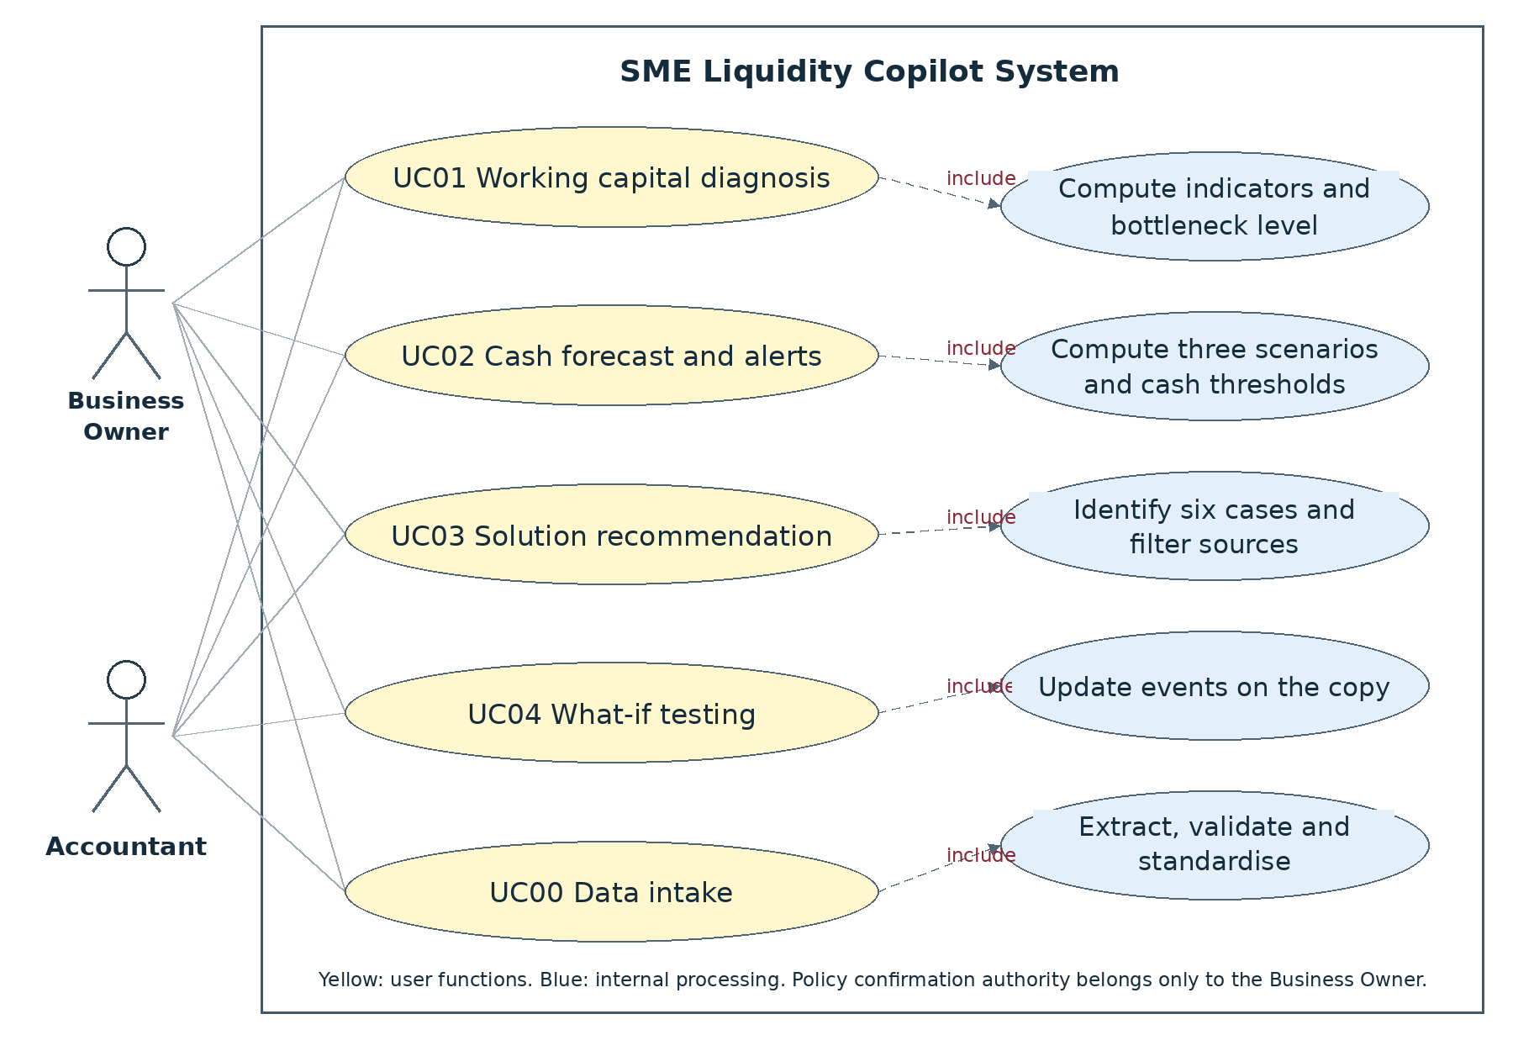
Figure 2-1: Overview use case diagram with two roles and five function groups

2.4 Decomposed use case diagrams
UC01 focuses on the location, value and duration of capital tied up, together with the obligations to be paid. Only the Business Owner may confirm the policy.
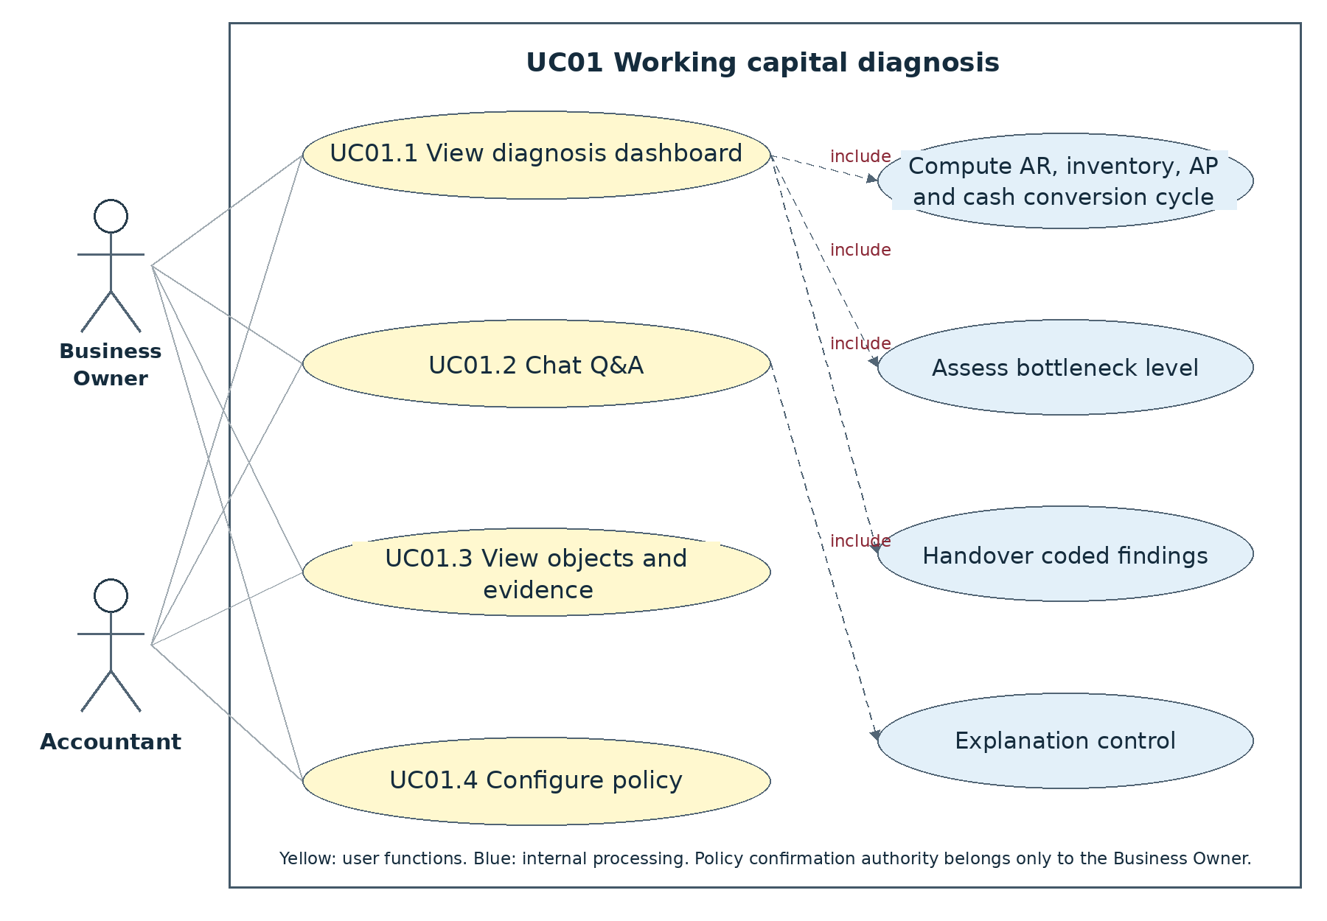
Figure 2-2: Decomposition of UC01
UC02 displays three scenarios on the same data source; threshold confirmation arises only during setup or when a change occurs.

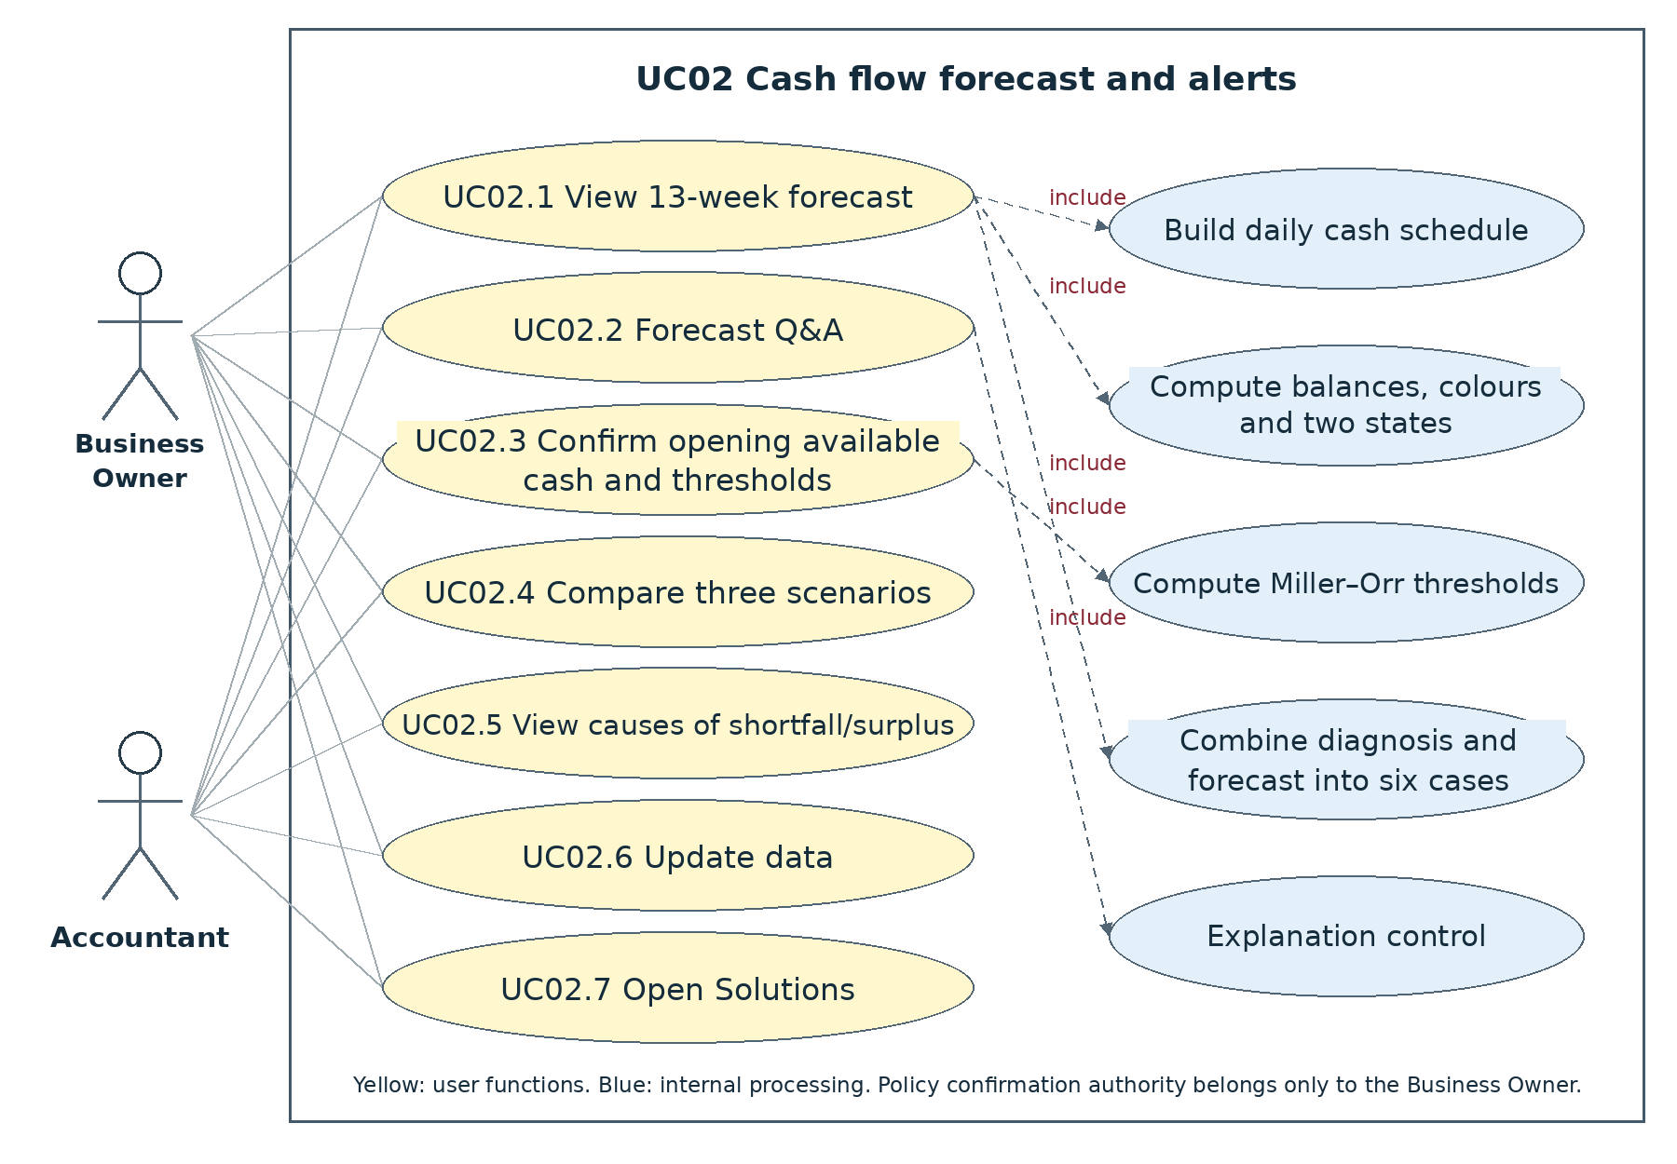
Figure 2-3: Decomposition of UC02
UC03 opens the result that matches the matrix directly, without requiring the user to select a source type before viewing the recommendation.
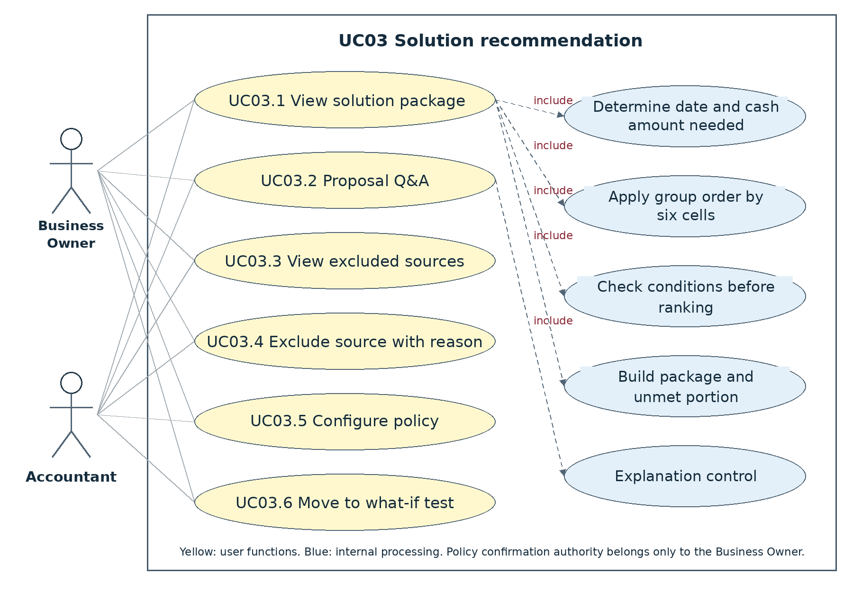
Figure 2-4: Decomposition of UC03
UC04 receives the subject directly from the previous result; the user adjusts only the assumption to be tested.
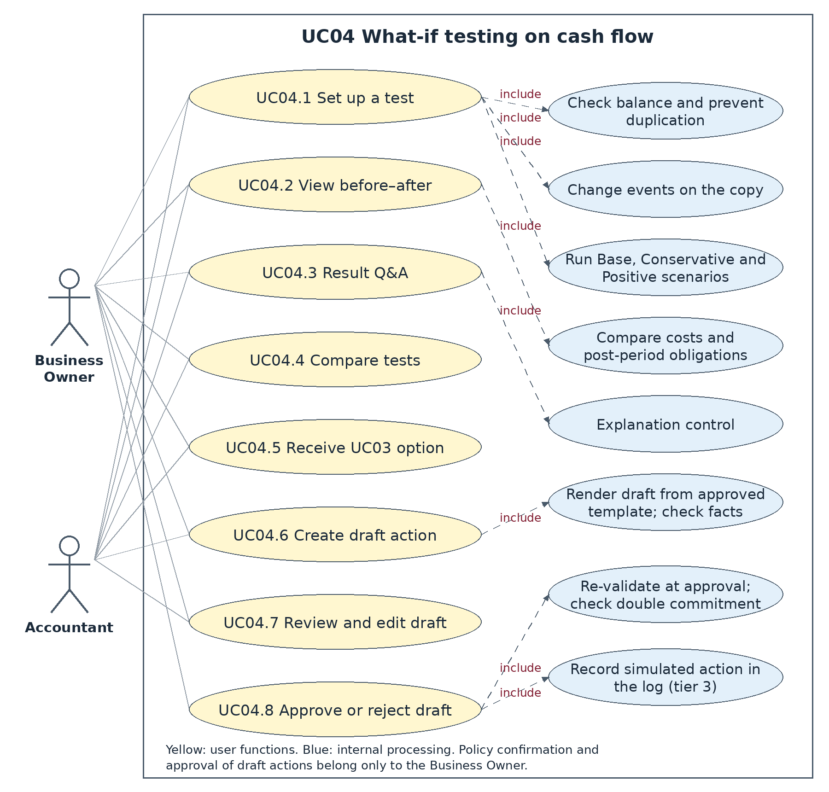
Figure 2-5: Decomposition of UC04

2.5 Business process

2.5.1 Overall process
The Accountant prepares or connects the data once. After that, the Business Owner can open Diagnosis, Forecast or Solutions as needed. Internal coordination ensures that the tasks use the same enterprise, cut-off date and policy version. The business diagrams show the main flow on the assumption that the enterprise data is complete and that the calculation tasks run successfully. Authentication, authorisation, data protection, output control and logging are still performed automatically. The rules for handling technical and security errors are specified separately and do not create additional business classification branches.
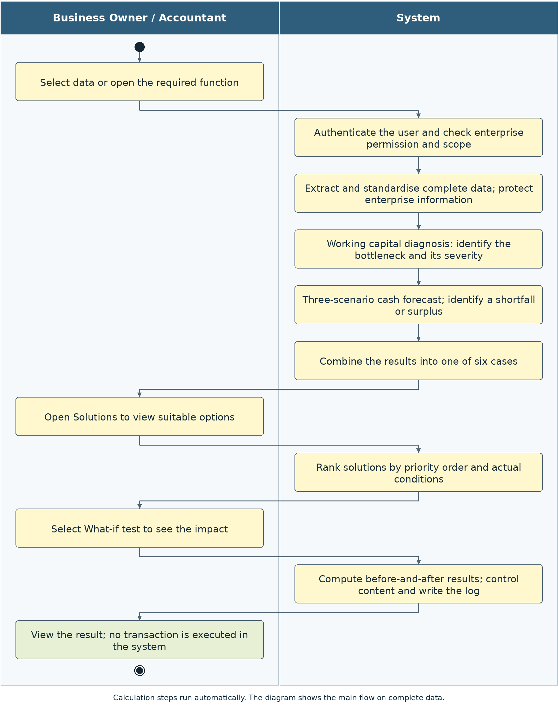
Figure 2-6: Overall process and the boundary of user operations

2.5.2 Diagnosis and threshold building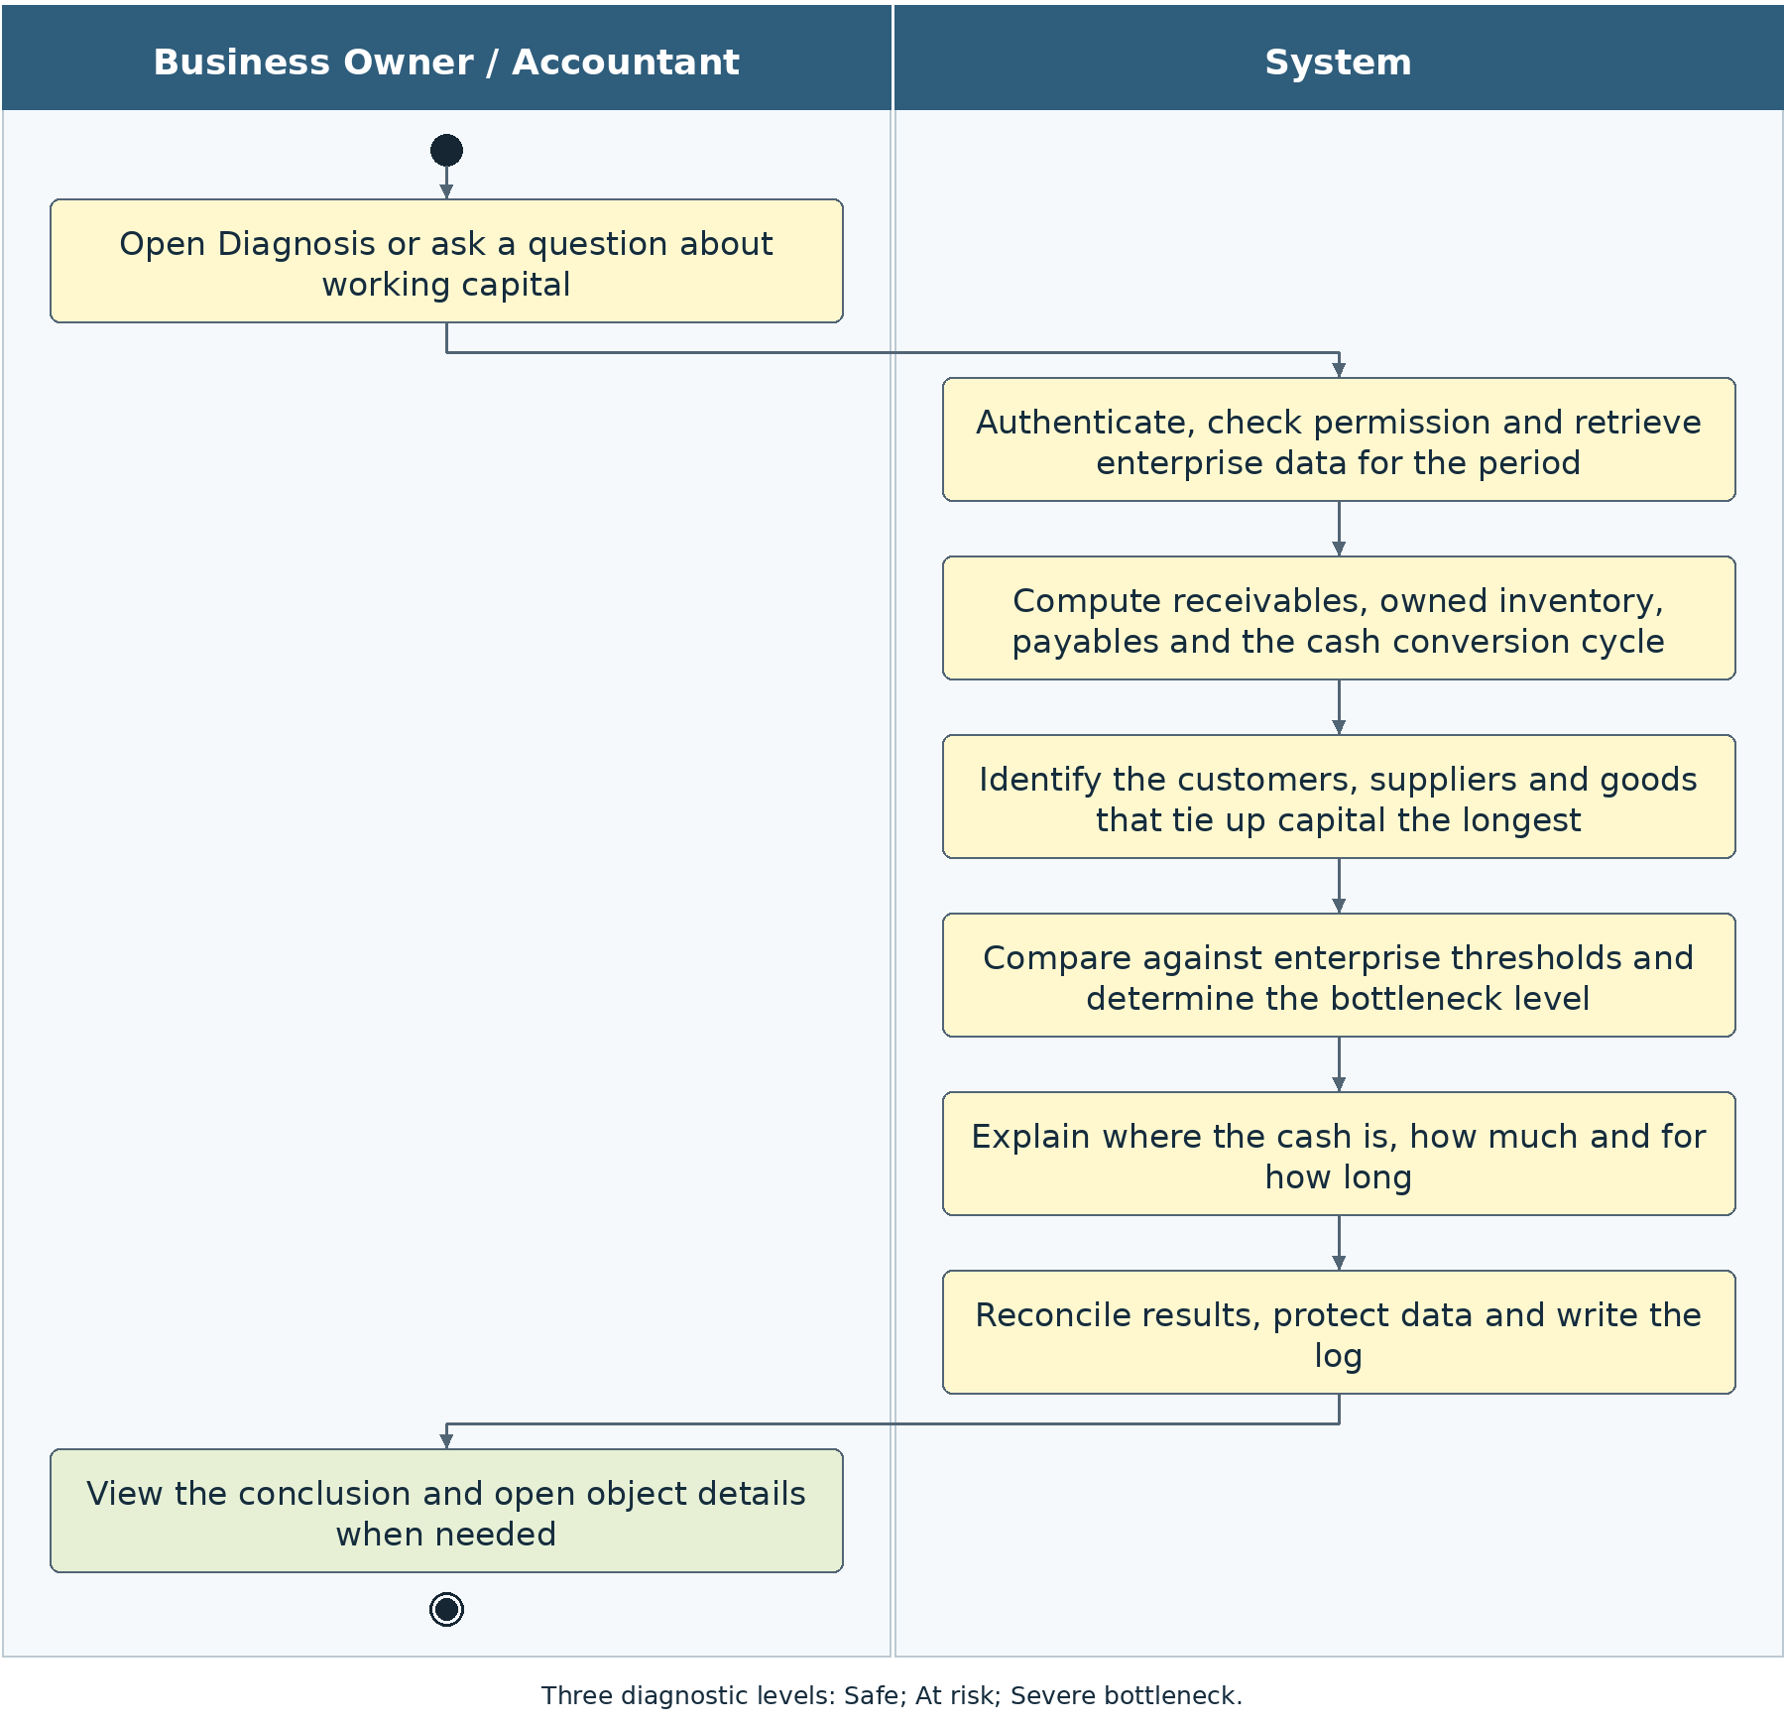
Figure 2-7: Simplified diagnostic flow and internal checks
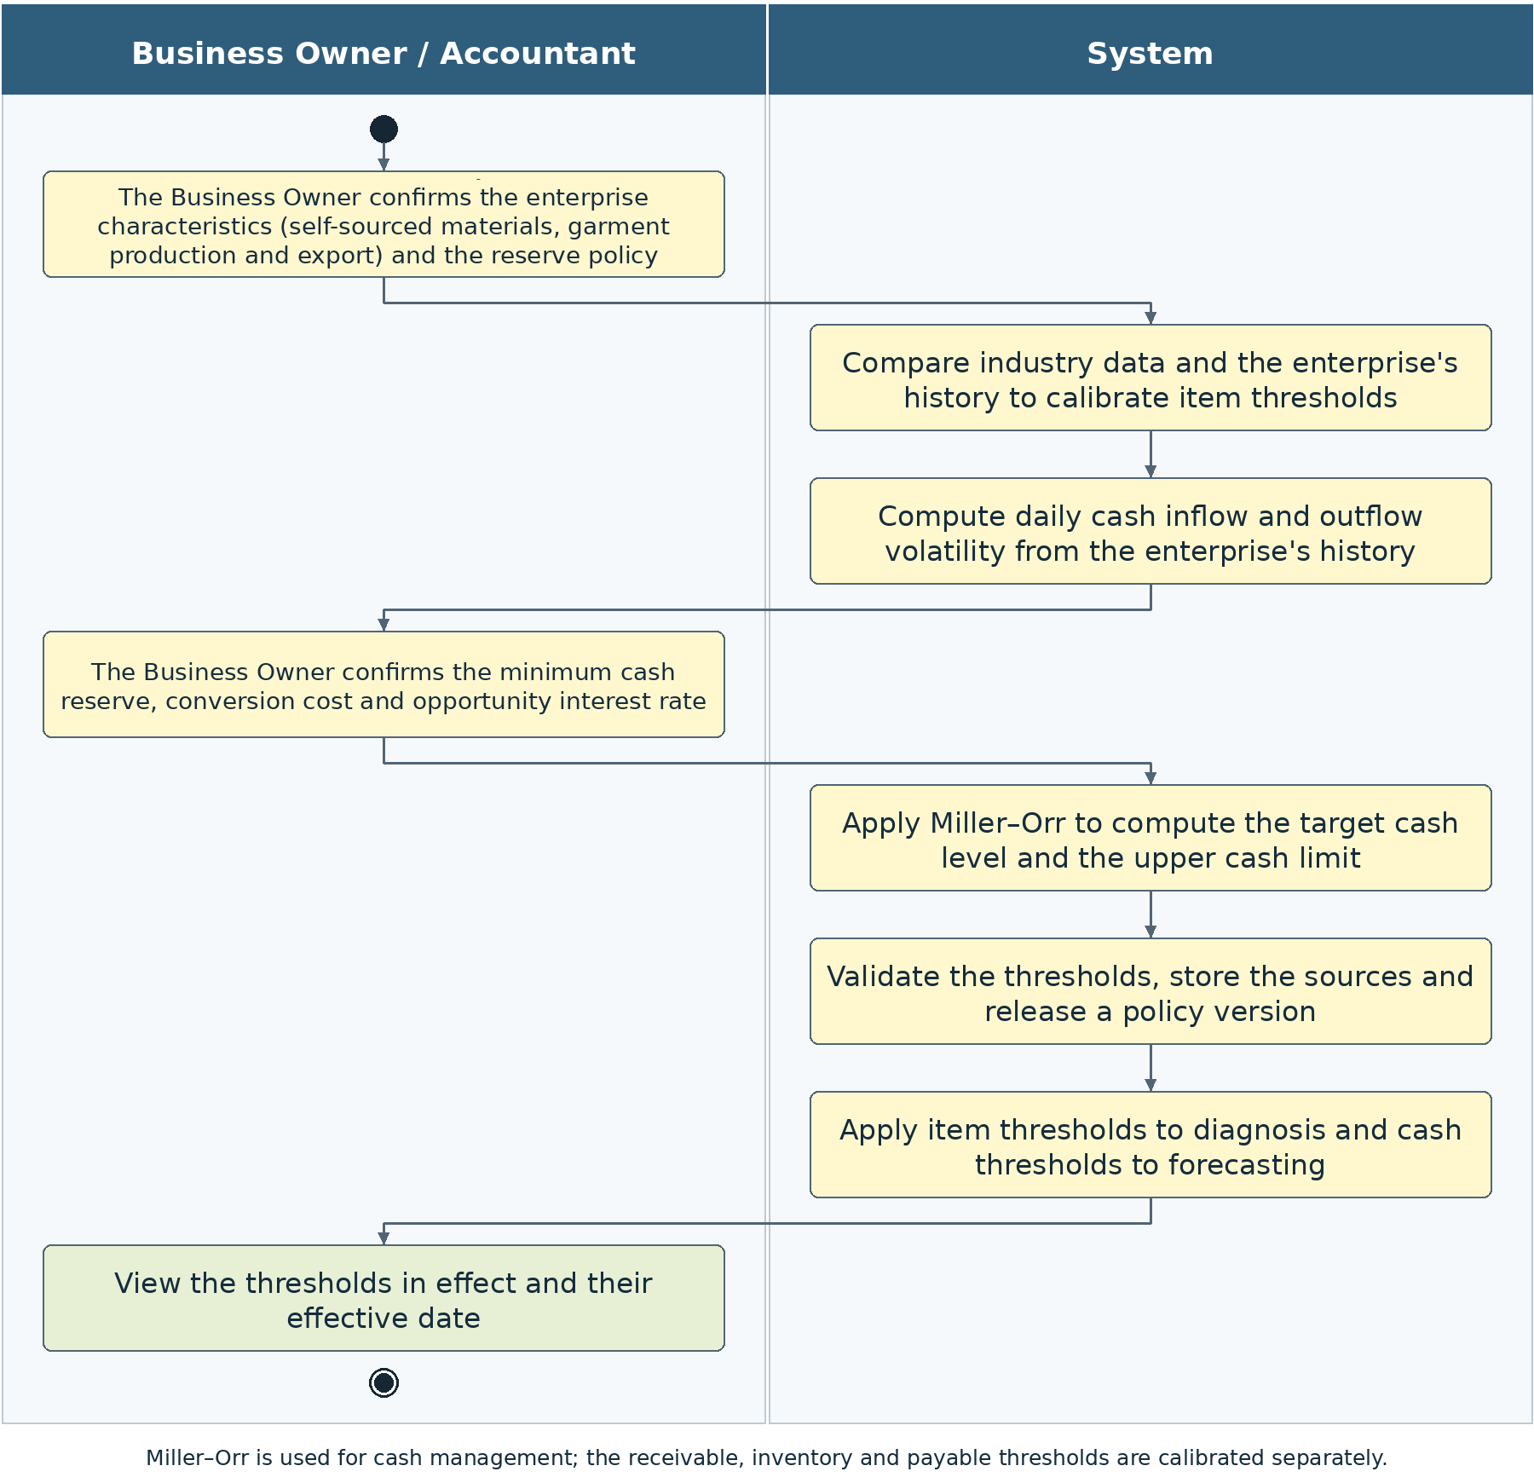
Figure 2-8: Separation of the item thresholds and the Miller–Orr cash thresholds

2.5.3 Forecast and routing
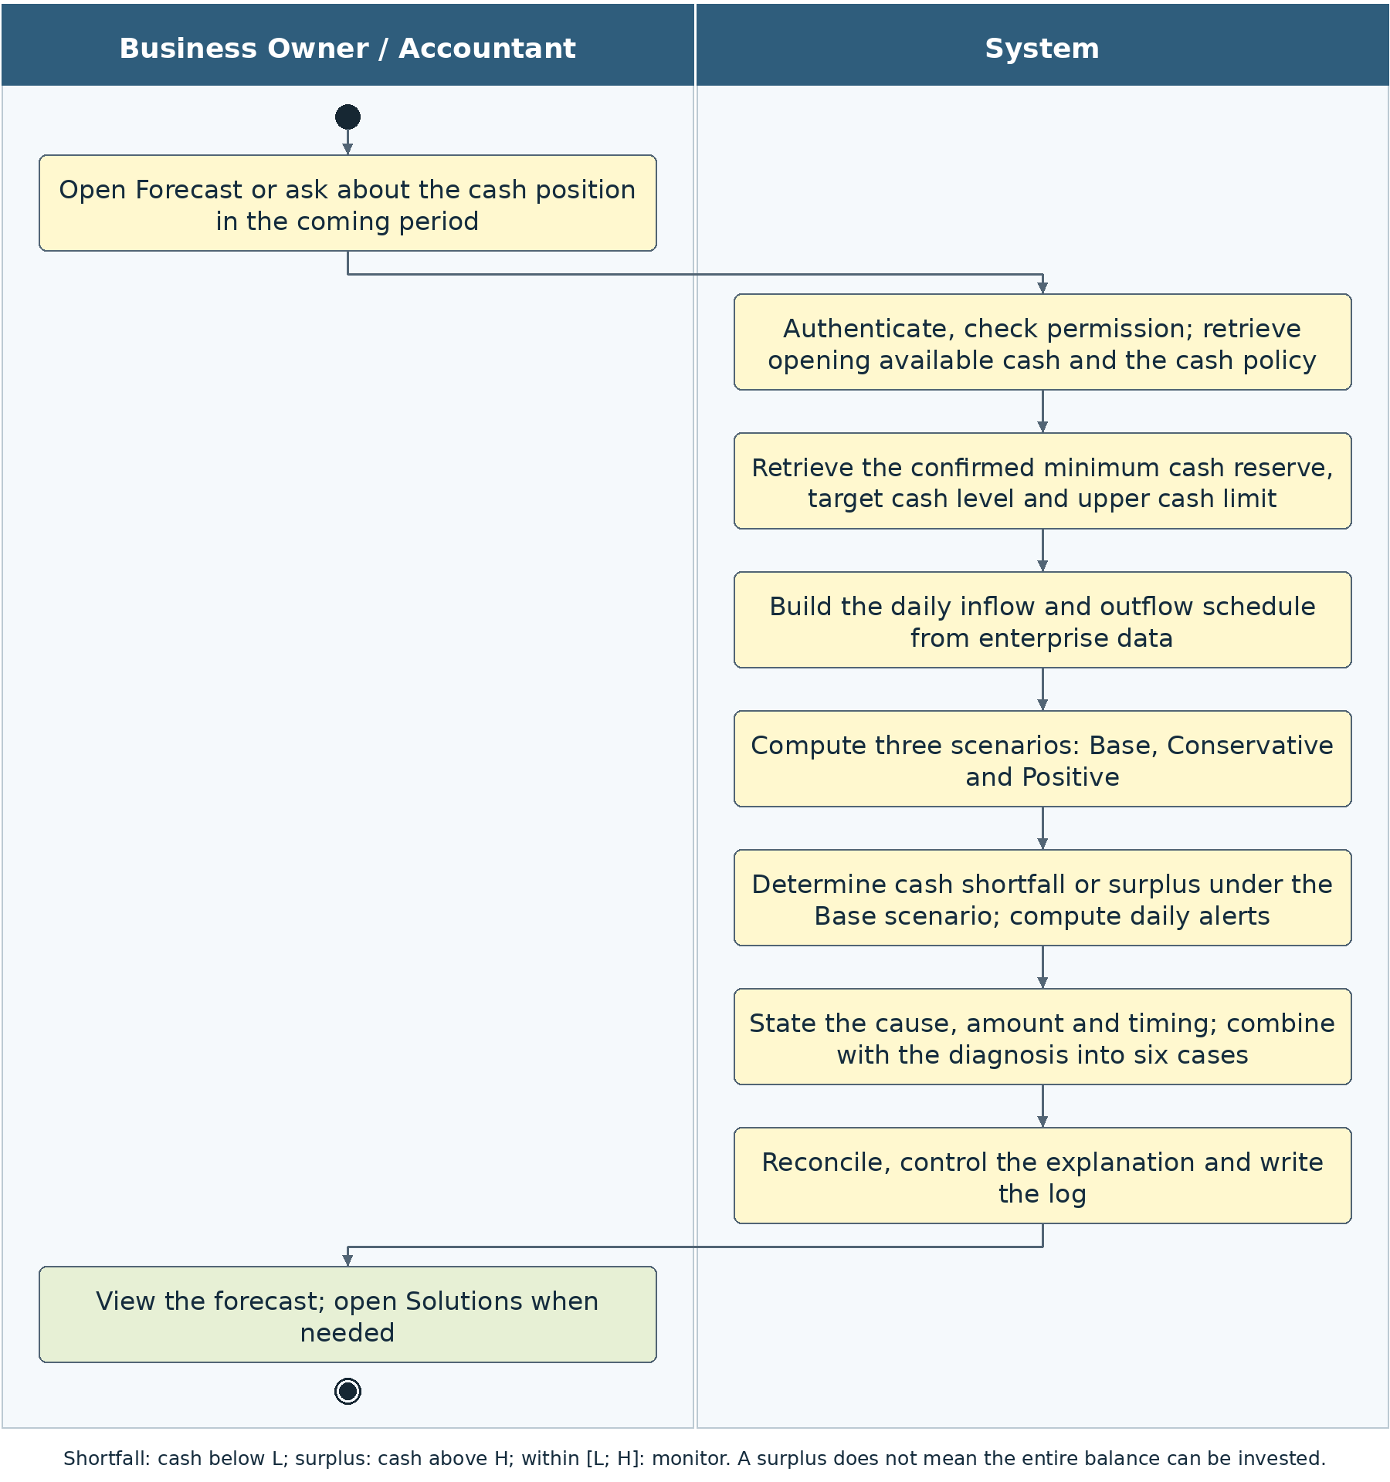
Figure 2-9: Three-scenario forecast flow
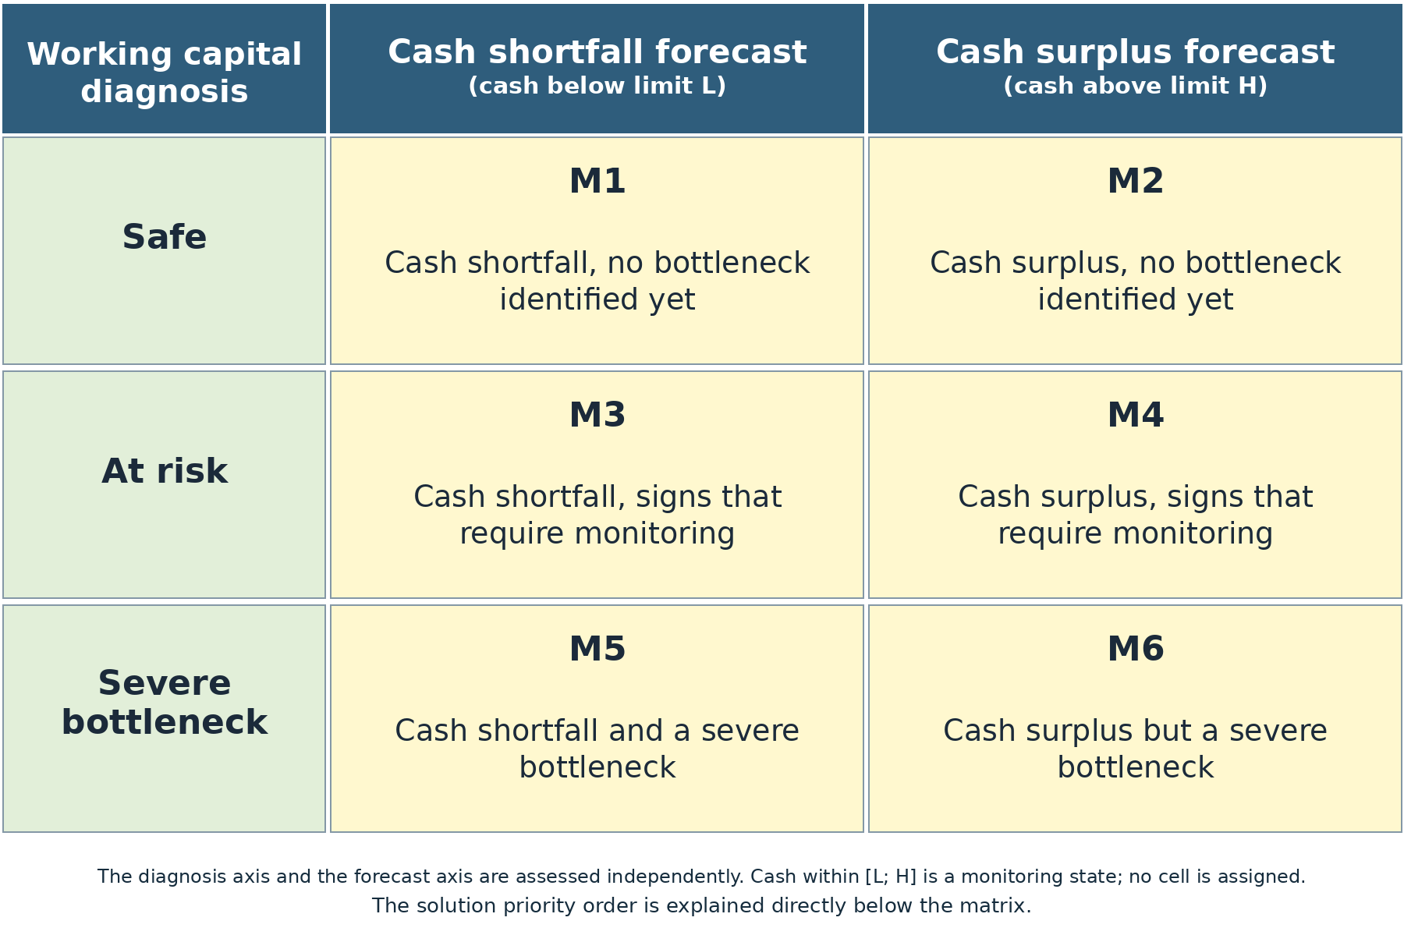
Figure 2-10: Six-case matrix combining diagnosis and forecast
The matrix is read by the diagnosis row and the forecast column of the Base scenario. The three scenarios are used to compare risk, but each run has only one primary routing cell. The order below is the order in which solution groups are considered; only sources that meet the conditions and provide cash at the right time are counted in the plan.
Case | Combined result | Solution priority order
M1 | Safe and cash shortfall | Prioritise short-term financing; check the cost, the conditions and the timing of receipt of funds.
M2 | Safe and cash surplus | Consider short-term investment only for the portion of cash that can genuinely be used after the reserve is maintained and obligations are met, including under the Conservative scenario. Where cash exceeds the upper limit, maintaining the reserve in accordance with policy takes priority before any allocation.
M3 | At risk and cash shortfall | Prioritise early collection of receivables, then consider extending supplier payment terms under agreement.
M4 | At risk and cash surplus | Prioritise maintaining the reserve; do not use the balance for investment by default.
M5 | Severe bottleneck and cash shortfall | Prioritise receivables, then inventory, then supplier payables; consider borrowing only to cover the remaining gap when the three sources above are insufficient.
M6 | Severe bottleneck and cash surplus | Prioritise maintaining the reserve, because the cash on hand has not yet removed the bottleneck in receivables or inventory.
Table 2-3: Interpretation of solution priority order for the six cases

In routing, cash surplus means that the forecast does not fall below the lower limit L and has days above the upper limit H; the excess is not yet a conclusion that idle cash exists. Cash that stays within [L; H] is a monitoring state and is not assigned a cell. Warning colours are still calculated separately by day and are not identical to the three working capital diagnosis levels.
The forecast warning colour is independent of the three W levels. A W0 enterprise may still forecast a cash shortfall because of a timing mismatch between receipts and payments. A W2 enterprise may not yet face a cash shortfall thanks to opening cash or other sources of receipts. Neither axis is to be adjusted to force agreement with the other.

2.6 Data intake and source confirmation

2.6.1 Input sources and the standardisation flow
Source | Intake method | Mandatory behaviour
Excel or CSV | Drag and drop or select files; accept one multi-sheet workbook or several files following the template. | Identify tables, headers, units and periods; propose a mapping; display a preview. Never run macros or formulas from untrusted files.
Local accounting software | Accept ledger export files from the software in use. Connect directly only where a supported interface exists. | Do not claim automatic connection if the software has no API or permitted exchange mechanism.
Authorised data connection | Read the endpoints that the enterprise permits, with documented fields and authentication. | Limit the scope and control errors and duplicates; do not equate an open API with public access to financial data.
Table 2-4: Supported data sources

The system flow comprises source intake, field extraction, mapping, validation, reconciliation, handling of missing parts and locking of the dataset. For data with a stable mapping, later updates reuse the configuration instead of asking again. The screen shows only “Data”, with the status Ready or Needs additions and the time of the last update.

2.6.2 Minimum data and the FOB model
Data group | Minimum fields | Purpose
Enterprise profile | Internal firm_id; confirmed FOB model; currency unit, cut-off date and analysis period; persons permitted to use it. | Appropriate scope and policy.
Period financials | Start and end dates of the period; revenue; cost of goods sold; current assets where used for materiality; tax and balance basis. | Denominator of the indicators and the measure of scale. A period figure must not be replaced by an annual figure without disclosure.
Sales invoices and payments | invoice_id, customer_id, issue and due dates, amount, amount collected, collection date, refunds and deductions, order. | AR balance, ageing, historical delay and the collection schedule.
Purchase invoices and payments | invoice_id, supplier_id, issue and due dates, amount, amount paid, payment date, extension terms and fees if any. | AP balance, due-date pressure and the subjects that can be extended.
Inventory and production | lot_id, type (raw material and trims / work in progress / finished goods / merchandise), quantity, value, receipt date or process start date, order, owner, pledge. | DIO and aged lots; conditions for sale or financing.
Cash and obligations | Reconciled available cash, restricted cash, payroll, tax, electricity, transport, purchases, debt repayment and daily plans. | Cash0 and a cash schedule of sufficient scope, preventing omitted payments.
Daily cash history | Date, actual receipts, actual payments, event type and account; internal transfer information. | Estimation of Miller–Orr volatility, not inferred from annual revenue.
Policy and products | FOB thresholds, level L, conversion cost, opportunity interest rate, loan/investment conditions, effective date and source. | Classification, warnings and conditional recommendations.
Table 2-5: Shared standard data

An FOB enterprise typically has capital in raw materials and trims, work in progress and finished goods, but the system must determine ownership from the data. Goods owned by customers remain excluded from INV even when located at the factory. Semi-finished goods are not assumed to be saleable or usable as collateral. The dates of shipment, acceptance, invoicing and cash collection are different milestones and are not automatically treated as the same.

2.6.3 Data intake and update
Use case code | UC00.1 | Use case name | Data intake and update
Actors | The Accountant prepares; the Business Owner views and confirms the information within their authority.
Description | Obtain usable data with few operations, without requiring the user to standardise everything.
Trigger event | The Accountant uploads a file or refreshes a connected source.
Preconditions | Signed in with enterprise permission. The enterprise code and permission are checked on the server side; no technical code needs to be entered.
Main event flow  (Success)
  Step | Component | Activity and handover result
  1 | Accountant | Select a file or an available source; the system retrieves the stored period and unit.
  2 | System | Check file safety or connection permission; extract into a staging area.
  3 | System | Map fields; check type, date, amount, counterparty code and duplicates; reconcile the tables.
  4 | System | If issues exist, display one consolidated list with the field, row, impact and how to supplement.
  5 | Accountant | Correct or confirm only the necessary fields; do not re-enter valid data.
  6 | System | Create the validated dataset; store the source and version; return to the screen the user had open.
Alternative event flows
  Code | Condition | Handling and result
  A1 | No API for local software | Guide the export of a supported ledger file; continue on the same file upload flow.
  A2 | Duplicate or conflicting records | Flag specifically; do not add two records of the same obligation.
  A3 | Missing daily cash history | Allow the valid part of the data to be used for diagnosis; require the history before calculating Miller–Orr; do not construct volatility from annual figures.
  A4 | Source fails during update | Retain the previously confirmed dataset, labelled as outdated; do not combine part-new and part-old data.
Postconditions | The dataset has an identifier, period, quality, source coverage and an audit trail; no conclusion is released for parts that are incomplete. On failure, state the reason and the part to be supplemented; do not release dependent conclusions and do not create an additional classification layer.
Related rules | The BR-00 rules in the corresponding business section; data, permission and interpretation controls in Section 3. Limit: do not edit accounting data or carry out transactions.

Table 2-6: Specification of use case UC00.1
No. | Data field | Description | Mandatory? | Validity condition | Example / display
1 | Data source | File / connection configuration | Yes | Supported Excel, CSV or API; valid read permission | Accounting ledger export file
2 | Period and unit | Auto-detected; confirm only what is necessary | Yes | Period is consistent; VND or a justified conversion | 01/01–30/06/2026
3 | Missing mapping | Column and data type | If missing | Request only the fields not yet identified | Due date
4 | Master data confirmation | Enterprise owner role | By field | Correct permission and a source | Ownership of goods
Table 2-7: Input data of UC00.1

No. | Component | Description | Mandatory? | Format / value domain | Example / display
1 | Data status | Ready / needs additions | Yes | Not an enterprise class | Validated
2 | List of issues | Row, field, impact, how to correct | If an error occurs | Do not expose the data of other enterprises | Missing invoice due date
3 | Dataset | Internal code and version | When passed | Has source, hash, period and coverage | System details
Table 2-8: Output data of UC00.1

2.6.4 Validation, synchronisation and reconciliation
Code | Mandatory requirement
BR-00-01 | The enterprise code is determined by the login session; every table is filtered to the correct enterprise before aggregation.
BR-00-02 | The cut-off date must lie within the scope of the source. Invoices or payments arising after the cut-off date do not change historical balances.
BR-00-03 | A receipt or payment of zero is accepted where meaningful; negative amounts are valid only under a separate adjustment/refund type. It is not required that every line be positive.
BR-00-04 | A missing due date is recorded in the group without a schedule; it is not treated as not yet overdue and is not assigned a due date equal to the issue date.
BR-00-05 | The invoice value, tax, receipt and payment amounts, and the basis of calculation must be declared; amounts inclusive of VAT must not be mixed with amounts exclusive of VAT without a reconciling bridge.
BR-00-06 | All sources use source_record_id and a duplicate-prevention key. A plan must not be added if it has already been replaced by an invoice for the same obligation.
BR-00-07 | Data is stored by version; an update creates a new version. A result that has been released keeps its original source and is not rewritten.
BR-00-08 | A day without transactions may be recorded with receipts and payments of zero only when the source is confirmed to cover that day. A day with missing data must not be filled with zero automatically.
BR-00-09 | For an API, display the last successful read and the data date. The synchronisation cycle is an operating parameter; the data must not be described as near real-time like instantaneous bank balances.
BR-00-10 | The user is not required to reconfirm all the data on every run. Only changes with an impact, or parts not yet mapped, are confirmed.
Table 2-9: General data rules

2.6.5 Confirmation of master data and policy
The Accountant may propose mappings, classifications and business flags; the Business Owner confirms strategic customers, essential or exclusive suppliers, the ownership or pledge status needed for solutions, Cash0 and the level L. A flag that has not been confirmed is left blank with a stated reason and is not treated as “no”. This is the status of a data field and is not a matrix result group.
Every change stores the person who made it, the person who confirmed it, the before and after values, the basis and the effective date. Where a flag is needed only for UC03, a missing flag does not block all UC01 indicators; it only prevents the system from asserting that the source is eligible. The system must show the impact by field to avoid unnecessary requests for additional input.

2.7 UC01 Working capital diagnosis
UC01 answers how much capital is tied up in receivables and inventory, how much the enterprise owes suppliers, which counterparties hold capital for a long time or create pressure from obligations, and whether the level is a concern under the confirmed policy. UC01 stops at diagnosis and general direction; it does not prepare a collection plan, a supplier payment schedule or designate a loan.

2.7.1 View the diagnosis Dashboard
Use case code | UC01.1 | Use case name | View the diagnosis Dashboard
Actors | Business Owner and Accountant
Description | Understand all three items, the bottleneck and the duration of outstanding balances.
Trigger event | Open Diagnosis.
Preconditions | Has permission, a dataset for the correct period and the required FOB thresholds. The enterprise code and permission are checked on the server side; no technical code needs to be entered.
Main event flow  (Success)
  Step | Component | Activity and handover result
  1 | Users | Open the screen; there is no need to choose a tool or enter technical parameters.
  2 | System | Retrieve the stored cut-off date and period; check the data and policy.
  3 | System | Calculate AR, INV, AP, DSO, DIO, DPO and CCC; decompose by customer, supplier and lot.
  4 | System | Evaluate the signals, materiality, W and evidence; forecast results are not used to raise W.
  5 | System | Reconcile balances, ageing and the explanation; record the history.
  6 | System | Display the overview; allow opening a subject or moving to Forecast/Solutions.
Alternative event flows
  Code | Condition | Handling and result
  A1 | Valid revenue or cost of goods sold is missing | Display the balances with sufficient basis; dependent indicators are left blank with a reason; W is not yet released.
  A2 | No open invoices but the source is complete | An AR or AP of zero is valid; DSO/DPO equal zero when the denominator is valid.
  A3 | Approved FOB policy is missing | Display the observed values; notify that threshold confirmation is needed for the assessment; do not call the result safe.
Postconditions | Indicators, W0/W1/W2 when eligible, the list of bottlenecks and the evidence are available; a log exists. On failure, state the reason and the part to be supplemented; do not release dependent conclusions and do not create an additional classification layer.
Related rules | The BR-01 rules in the corresponding business section; data, permission and interpretation controls in Section 3. Limit: do not edit accounting data or carry out transactions.

Table 2-10: Specification of use case UC01.1
No. | Data field | Description | Mandatory? | Validity condition | Example / display
1 | Enterprise | Taken from the session | Yes | Belongs to the authorised list | The FOB enterprise currently selected
2 | Cut-off date | Select a date that has data | Yes | Balances of different dates are not mixed | 30/06/2026
3 | Analysis period | Start and end dates | Yes | N>0; the period lines match the denominator | 01/01–30/06/2026
4 | FOB policy | The server selects the effective version | Yes, for classification | Confirmed; correct calculation basis | View the source in the details
Table 2-11: Input data of UC01.1

No. | Component | Description | Mandatory? | Format / value domain | Example / display
1 | Four indicators | DSO, DIO, DPO, CCC | When valid | One decimal place, correct period | Value from the calculation engine
2 | Three items | AR, owned INV, AP | Yes, if complete | VND; AP is an obligation | Amount and share
3 | Level W | Diagnosis level | When complete | W0/W1/W2; no additional group | At risk
4 | Main subjects | Customer, lot, supplier | When available | Amount, date, threshold and evidence | View details
5 | Limits | Quality, source, balance basis | Yes | Do not call a provisional result certain | Data at the cut-off date
Table 2-12: Output data of UC01.1

2.7.2 Diagnosis Q&A through the Chat
Use case code | UC01.2 | Use case name | Diagnosis Q&A through the Chat
Actors | Business Owner and Accountant
Description | Explain the correct subject, amount and time without requiring the user to understand technical terms.
Trigger event | Ask through the Chat or select a customer, supplier or lot.
Preconditions | A source result that is still valid and permission to read the evidence are available. The enterprise code and permission are checked on the server side; no technical code needs to be entered.
Main event flow  (Success)
  Step | Component | Activity and handover result
  1 | Users | Ask why capital is tied up or open a finding.
  2 | System | Determine whether the question reuses an existing result or requires a new run; check the version.
  3 | System | If the period or data changes, calculate anew; supply the facts by subject.
  4 | System | Explain the amount, date, threshold and limits; do not generate figures independently.
  5 | System | Reconcile every figure, subject name and date against the facts before displaying.
Alternative event flows
  Code | Condition | Handling and result
  A1 | The question requests a specific action | Explain the scope of UC01 and allow opening Solutions; do not send collection reminders automatically.
  A2 | Due date is missing | State the balance and the part for which there is insufficient basis to determine overdue status; do not assign zero days of delay.
  A3 | The LLM is unavailable or interprets incorrectly | Use a controlled sentence template; the result of the calculation engine is not lost.
Postconditions | An explanation and evidence are provided; the figures match the overview screen. On failure, state the reason and the part to be supplemented; do not release dependent conclusions and do not create an additional classification layer.
Related rules | The BR-01 rules in the corresponding business section; data, permission and interpretation controls in Section 3. Limit: do not edit accounting data or carry out transactions.

Table 2-13: Specification of use case UC01.2
No. | Data field | Description | Mandatory? | Validity condition | Example / display
1 | Question | Chat box | Yes | Not empty; length limit is configurable | Where is the cash tied up?
2 | Context | Period and source result | Automatic | firm_id is not taken from the question | Period currently open
Table 2-14: Input data of UC01.2

No. | Component | Description | Mandatory? | Format / value domain | Example / display
1 | Answer | Conclusion, amount, date and subject | Yes, if passed | All facts are in the fact_registry | Explanation by item
2 | Tools and evidence | Fact source | Yes | Correct turn and permission | Open an invoice/lot
3 | Request for supplementary input | What is missing and the impact | If needed | No additional layer is released | Add the cost of goods sold for the period
Table 2-15: Output data of UC01.2

2.7.3 View subject details and evidence
Use case code | UC01.3 | Use case name | View subject details and evidence
Actors | Business Owner and Accountant
Description | Identify the specific capital or obligation, the duration outstanding and the supporting documents that explain it.
Trigger event | Select a customer, supplier, lot or finding on the Dashboard.
Preconditions | A UC01 result and permission to read the subject are available. The enterprise code and permission are checked on the server side; no technical code needs to be entered.
Main event flow  (Success)
  Step | Component | Activity and handover result
  1 | Users | Select the subject directly in the result, without re-entering a code or period.
  2 | System | Check that the subject belongs to the run and to the enterprise; retrieve the filter currently applied.
  3 | System | Aggregate the balance, ageing of receivables or inventory, terms, missing data and the related thresholds.
  4 | System | Display a paginated list of invoices/lots with a total reconciled to the source result.
  5 | Users | Open the document or return to the overview; the subject can later be used as the target of a test.
Alternative event flows
  Code | Condition | Handling and result
  A1 | No permission for the document | Return no content or a limited total; display a permission notice.
  A2 | Due date or lot age is not available | State the amount concerned and the data to be supplemented; do not assign a duration of zero.
  A3 | The subject has changed since the run | Keep the historical detail according to the old source; to view the current position, the result must be refreshed.
Postconditions | Reconcilable details are available; the balance or the historical conclusion is not changed. On failure, state the reason and the part to be supplemented; do not release dependent conclusions and do not create an additional classification layer.
Related rules | The BR-01 rules in the corresponding business section; data, permission and interpretation controls in Section 3. Limit: do not edit accounting data or carry out transactions.

Table 2-16: Specification of use case UC01.3
No. | Data field | Description | Mandatory? | Validity condition | Example / display
1 | Subject | Select from the result | Yes | The code belongs to the result and to the correct enterprise | Customer or lot
2 | Filter | Ageing, goods type, period | No | Valid value domain | Overdue 31–60 days
Table 2-17: Input data of UC01.3

No. | Component | Description | Mandatory? | Format / value domain | Example / display
1 | Balance and time | Amount, ageing bucket, number of days | Yes, if complete | The part missing a date is reported separately | In stock / overdue
2 | Terms and source | Due date, ownership, business flags | According to the data | Not inferred from the counterparty’s name | Contractual term
3 | Documents | Paginated list | Yes | Total matches the indicator | Open the source record
Table 2-18: Output data of UC01.3

2.7.4 View and confirm the diagnosis policy
Use case code | UC01.4 | Use case name | View and confirm the diagnosis policy
Actors | The Accountant proposes; the Business Owner confirms.
Description | Ensure that thresholds have a basis, suit FOB enterprises and are version-controlled.
Trigger event | Open Policy in the details area or from a notification requiring confirmation.
Preconditions | A policy record and appropriate permission are available. The enterprise code and permission are checked on the server side; no technical code needs to be entered.
Main event flow  (Success)
  Step | Component | Activity and handover result
  1 | Accountant | View the source, the sample period, the calculation method and any proposed change with its basis.
  2 | System | Check the units, the order of the thresholds and the mandatory fields; present a comparison version.
  3 | Business Owner | Confirm or return the proposal; there is no need to calculate formulas manually.
  4 | System | Save a new version with an effective date; rerun on request and retain the history.
Alternative event flows
  Code | Condition | Handling and result
  A1 | The Accountant attempts to apply a policy | The confirmation right is refused; the proposal is retained.
  A2 | A set of figures not yet calibrated for FOB | Keep it in draft status; do not use it as an official threshold.
Postconditions | The policy has a source and a confirmer; earlier results are not renumbered. On failure, state the reason and the part to be supplemented; do not release dependent conclusions and do not create an additional classification layer.
Related rules | The BR-01 rules in the corresponding business section; data, permission and interpretation controls in Section 3. Limit: do not edit accounting data or carry out transactions.

Table 2-19: Specification of use case UC01.4
No. | Data field | Description | Mandatory? | Validity condition | Example / display
1 | Policy proposal | Threshold, source, effective date | Yes | Valid units and order | FOB threshold
2 | Reason and version | Content of the change | Yes | Do not overwrite another concurrent version | Expected version
3 | Confirmation | Business Owner | Yes, to apply | Confirmation is not taken from the LLM | Confirmation action
Table 2-20: Input data of UC01.4

No. | Component | Description | Mandatory? | Format / value domain | Example / display
1 | Policy | Draft / effective / returned | Yes | Has a person, time and source | Effective date
2 | Comparison of changes | Old and new values | Yes | Historical results are not edited | Rerun when needed
Table 2-21: Output data of UC01.4

2.7.5 Formulas, period and balance basis
Symbol / formula | Definition and interpretation
N = end date of the period − start date of the period + 1 | The selected historical period; the period 01/01/2026–30/06/2026 has 181 days. A default of 365 days is not used.
Rev = financials.revenue_vnd | Revenue for exactly the period N, on the same tax basis used for the indicators.
COGS = financials.cogs_vnd | Cost of goods sold for exactly the period N. Ratios from another period are not taken automatically when actual data can be supplemented.
AR = Σ residual_sales_invoice_vnd | Accounts receivable balance at the cut-off date, after allocated payments and deductions.
INV = Σ owned_book_value_vnd | Total owned goods; qty × unit_cost is used only when that is a valid value basis. WIP has a confirmed book value.
AP = Σ residual_purchase_invoice_vnd | Trade accounts payable at the cut-off date; loans, taxes and payroll are separated.
DSO = AR / Rev × N | Receivable days on the period-end balance; this is not the actual collection time of every invoice.
DIO = INV / COGS × N | Inventory days on the period-end balance; the age of each lot is measured separately.
DPO = AP / COGS × N | Payable days measured against cost of goods sold; it is not automatically interpreted as the number of days of credit granted by suppliers.
CCC = DSO + DIO − DPO | The cash conversion cycle on the published basis.
TWC = AR + INV − AP | Net trade working capital; it is not an amount that can certainly be released.
Value of one DSO day = Rev / N | Equivalent capital conversion; DIO and DPO use COGS / N. It is not treated as immediate cash collection.
Table 2-22: UC01 core formulas

All calculations use unrounded figures. Days are displayed to one decimal place; amounts carry a clear unit and can be traced to the original value. A period-end balance over 181 days compared with an industry threshold based on an annual average is only a comparison with a methodological difference; it must be labelled and tested for sensitivity, and the two bases must not be assumed equivalent.

2.7.6 Analysis by item
Item | Mandatory information in the output
Receivables | Total uncollected; not yet due; overdue 1–30, 31–60, 61–90 and over 90 days; the part with a missing due date; the largest and the weighted-average overdue days; share by customer; contribution to DSO.
Inventory | Total owned goods; raw materials and trims, work in progress, finished goods and merchandise; the oldest lot and the slow lot with the largest value; how long it has been stored and by how long it exceeds the threshold; order; ownership; pledge; cancelled orders.
Payables | Total remaining payable; overdue by ageing; obligations due in 7/30 days; the supplier with the largest balance and the one with the longest overdue; terms, criticality and disputes.
Table 2-23: Depth of diagnosis

Overdue status is calculated from the contractual due date: overdue_days = MAX(0, cut-off date − due date). An invoice due exactly on the cut-off date is not yet overdue but belongs to the due group. For receivables that remain open, the remaining balance is used as the weight to calculate the ageing; for collected history, the allocated payment value is used. These two samples are not mixed into a single delay time.
The signed historical delay is the weighted average of the collection date minus the due date, keeping early payments as negative; the positive delay uses MAX(0, collection date − due date). The observation period and the number of transactions used are disclosed. The minimum-invoice parameter is a versioned policy shared by behaviour classification and the collection-schedule model; two conflicting thresholds are not used.
The system must distinguish the customer with the largest balance from the customer that pays latest; the lot that has been in the warehouse longest and the lot that holds the most capital may also differ. The system must not merely list names: the summary must state the main subject, the amount, the duration and the overdue or excess-duration portion where relevant.

2.7.7 Counterparty profiles and inventory
Group | Attribute / label | Usage rule
Customers | New, regular, occasional; transaction scale; strategy; payment delay history; overdue balance; disputes. | The relationship is calculated from history; the strategy is confirmed by the Business Owner. A large customer is not automatically a strategic customer. A lack of history must not be interpreted as late payment.
Suppliers | Criticality/exclusivity; regular/occasional purchasing; share of purchases; payment term; agreement to extend; fees/penalties. | Agreement to extend is not inferred from the goods category. Pay particular attention to suppliers of main fabric, raw materials and trims, and services that cannot be stopped.
Inventory | Process stage type, ownership, order, receipt/process start date, cancelled order, pledge, demand and saleability. | An aged-stock label does not by itself prove the goods can be sold. If ownership or encumbrance has not been confirmed, eligibility for mobilisation is not confirmed.
Enterprise size | Annual revenue, capital, employees and the confirming source. | Use an appropriate confirmed FOB reference group; revenue over 181 days annualised is for reference only and does not by itself confirm legal SME status.
Table 2-24: Shared business profiles

The share of revenue, the number of invoices and the number of months with transactions support relationship classification. The specific milestones are set in the cl.* configuration and calibrated against FOB history; the milestones of the old sample are not retained automatically. The exposure list is ordered by amount; the order of subjects to consider in UC03 also takes into account overdue status, collectability, strategic relationship and timing, and does not automatically apply strong measures to a new customer.

2.7.8 FOB thresholds and the three W levels
Miller–Orr does not replace the item thresholds. The UC01 thresholds are built from an appropriate group of FOB garment enterprises, combined with scale and seasonality when there is a basis. General formula: applied threshold = FOB reference percentile × appropriate size factor × appropriate seasonal factor. Where an FOB sample has already been used, a further FOB factor must not be applied a second time to adjust for the same characteristic.
The watch and severe thresholds of DSO/DIO, the low DPO threshold with its supporting condition, the materiality level and the age of stored goods by type have been recalculated from 20 listed FOB garment enterprises, 60 enterprise-years for 2023–2025 (FiinTrade), configuration fob.threshold.v3, as shown in Table 2-25. CMT figures are not transferred to FOB, and old validation figures are not retained as confirmed evidence for the new sample. When a mandatory parameter is missing, report that the policy needs to be completed and do not yet release W.
Configuration key | Value | How determined | Used for
wc.dso.reference.fob | 43.2 days | P50 DSO FOB | Reference level; display the distance
wc.dso.watch.fob | 58.2 days | P75 DSO FOB | R-AR-1 → At risk
wc.dso.severe.fob | 66.3 days | P90 DSO FOB | R-AR-2 → Severe bottleneck
wc.dio.reference.fob | 69.8 days | P50 DIO FOB | Reference level
wc.dio.watch.fob | 86.1 days | P75 DIO FOB | R-INV-1 → At risk
wc.dio.severe.fob | 138.0 days | P90 DIO FOB | R-INV-2 → Severe bottleneck
wc.dpo.low.fob | 14.9 days | P10 DPO FOB | R-AP-1 when combined with a thin cash buffer
liq.cash_buffer.thin.fob | 8.3% of revenue | P25 (Cash + short-term investments) / Revenue FOB | Accompanying condition for R-AP-1
wc.dpo.high_info.fob | 68.3 days | P75 DPO FOB | R-AP-INFO, information only, does not raise W
wc.materiality_share | 5% of current assets | owner_policy, confirmed by the Business Owner | R-MAT → Severe bottleneck
wc.severe_forces_w2 | 1 | owner_policy | Exceeding P90 places the enterprise at W2 even if materiality is not reached
wc.factor.size / wc.factor.season | 1 / 1 | Mann–Whitney test on size: p = 0.17 (DSO), 0.29 (DIO), 0.59 (DPO), 0.45 (cash buffer); seasonality not yet calibrated | No threshold adjustment
inv.lot.slow_days | 60 days (raw materials, merchandise); 30 days (work in progress, finished goods) | demo_assumption | Lot-level signal, displayed in the details
ar.invoice.overdue_rho | 0.5 (watch); 1.0 (severe) | demo_assumption: overdue days / contractual term | Invoice-level signal, displayed in the details
Table 2-25: Current FOB thresholds – configuration fob.threshold.v3

Example F01 at 30/06/2026: DSO 64.77 days > 58.21 → R-AR-1; DIO 79.46 days ≤ 86.12; DPO 26.61 days ≥ 14.89, so there is no R-AP-1; E_AR = VND 2,524.3 million = 4.25% of current assets < 5% → W1 – At risk (details in Section 2.7.11).
Signal | Configuration condition | Interpretation
Aggregate receivables | DSO > dso_watch or > dso_severe | Capital tied up in receivables exceeds the reference; not every invoice is assumed to be overdue.
Aggregate inventory | DIO > dio_watch or > dio_severe | Inventory exceeds the reference; it needs to be decomposed by type and order.
Payables | Low DPO with an approved pressure condition; or invoices overdue under the contract. | A high DPO is only information if overdue status has not been checked; overdue obligations are not added to releasable capital.
Invoices and lots | Number of overdue days, the excess over the term, or the age by type; confirmed cancelled-order status. | An operating threshold at subject level; it does not by itself make the whole enterprise severe if the value is small.
Materiality | MAX(E_AR, E_INV, E_AP) / current assets ≥ materiality_share | A parameter approved by the enterprise; the ratio is not by default a result of FOB validation.
Table 2-26: Catalogue of signals and their basis

Formula | Control
E_AR_aggregate = MAX(0, AR − dso_watch × Rev / N) | Calculated only when a valid threshold exists on the same published basis.
E_INV_aggregate = MAX(0, INV − dio_watch × COGS / N) | The expected selling price is not used in place of the owned value.
E_AR = E_AR_aggregate (used for materiality and W) | Invoice-level overdue receivables are reported separately; they are not added and do not change W (formula specification v11, T1-90).
E_INV = E_INV_aggregate (used for materiality and W) | Aged-stock lots and cancelled orders are reported separately; lots carrying several labels are counted only once.
E_AP = overdue AP with a signal | An obligation, reported separately.
money_at_risk = E_AR + E_INV | Only capital tied up with a signal; E_AP is not added and it is not equated with recoverable cash.
Table 2-27: Capital conversion and prevention of double counting

Order | Condition when data and policy are valid | Result
1 | An aggregate severe signal that the policy permits to raise to W2; or a signal that reaches materiality. | W2 — Severe bottleneck
2 | A signal exists but does not meet the W2 conditions. | W1 — At risk
3 | No signal within a data scope sufficient for assessment. | W0 — Safe within the diagnostic scope
Table 2-28: UC01 classification rules

The three levels above are the complete set of UC01 business classes. W0 must carry the limitation “no significant bottleneck seen on the available data”; W2 must not be displayed as a severe cash shortage if no UC02 result exists. A state that needs supplementary input is held in data_quality and in the run status; it must not be converted into a classification value.

2.7.9 Combined causes and evidence
The system records cause_items as the list of items with a signal: receivables, inventory, payables or empty. The list may contain several entries; this is an explanatory structure and not an additional matrix or forecast scenario. The primary bottleneck is ranked by signal level, then by the related value, then by a stable subject code, so that the same data produces the same order.
When allocating E_AR/E_INV to subjects, the overdue amount must not be added again to the portion exceeding the threshold. A bridge must be produced between the aggregate figure, the amount assigned to each subject and the unassigned portion; the bridge total reconciles within the permitted tolerance. Overdue payables always sit in the separate obligations table.

2.7.10 Result structure and interpretation
Part | Mandatory content
meta | Enterprise, cut-off date, period N, balance basis, source/formula/policy versions, status and run time.
metrics | AR, INV, AP, DSO, DIO, DPO, CCC, TWC; raw_value, display_value, unit, formula_id, evidence_ids.
findings and profiles | Subject, balance, share, overdue amount/age, threshold, deviation, relationship type, signal, evidence and limitations.
classification | wc_class accepts only W0/W1/W2 when conditions are met; cause_items and main_bottleneck have a basis. If conditions are not met, the classification object is not released.
quality and narrative | What is missing and which indicators are affected; conclusions by item; no action plan is generated automatically.
Table 2-29: UC01 outputs

The overview answer follows this order: the conclusion on the W level; the three items and the number of days; the notable customer/lot/supplier with the amount and duration; the portion above the threshold; limitations. Use “in stock”, “supplier payables” and “data at the cut-off date”; limit internal terminology on the overview screen.
The template content must take its figures from the calculation engine: “Receivables are [AR], of which [overdue] is overdue. [customer] accounts for [share] and has [overdue_amount] overdue by [days or age bucket]. Owned inventory is [INV]; [lot] has been stored for [age] days, exceeding the threshold by [excess_days] days. Payables are [AP], of which [overdue_AP] is overdue; [supplier] is the largest item. This is a diagnosis at the cut-off date and does not conclude when a cash shortfall will occur.”
Code | Mandatory requirement
BR-01-01 | Calculate from balances and period flows of the correct scope; round last; never place converted figures produced by the LLM into the result.
BR-01-02 | Classification is released only when inputs and policy are complete. Missing data is a request for supplementary input and does not create an additional class.
BR-01-03 | Do not use forecast cash, a warning colour or CCC alone to infer W.
BR-01-04 | Do not call an invoice that is not yet due overdue; do not call the book value of inventory an amount that is certain to be collected.
BR-01-05 | The specific duration and subject must be stated for all three items, and not only a list of aggregate figures.
BR-01-06 | Do not infer that a supplier has stopped delivering goods from a single overdue amount alone.
BR-01-07 | Do not edit contracts or prepare a collection plan in UC01; forward the request for solutions to UC03.
BR-01-08 | Reconcile the totals by customer, by supplier, by lot, the debt ageing and CCC before release.
Table 2-30: UC01 business rules

2.7.11 Bottleneck scenarios and how the system responds

2.7.11.1 Purpose and principles
This section specifies how UC01 identifies which of the three items — accounts receivable (AR), inventory (INV) and accounts payable (AP) — the bottleneck comes from; how the system responds to the user in each case, on the screen and through the Chat; and how the result is linked to the cash shortfall episodes of UC02. The combination of items with a signal is called the bottleneck pattern (bn_pattern), comprising eight scenarios BN0 – BN7: no bottleneck; one of the three items; two of the three; all three items.
The bottleneck pattern uses exactly the FOB threshold set in Table 2-25 and the signal catalogue in Table 2-26, and adds no new assessment thresholds. Four principles apply:
• Descriptive, not causal. “Cause” in this section means an item showing signs of exceeding the threshold (a candidate cause). An answer must not state that “item X causes the cash shortfall”.
• Independent of the cash balance. The bottleneck pattern uses only the UC01 snapshot data; it does not read L, Z, H, forecast balances or the warning colours of UC02.
• No change to the W ranking. The W axis still follows Table 2-28; the matrix M1 – M6 still combines W only with the cash state TH (Table 2-73). The bottleneck pattern is supplementary information used to explain W, to select the template answer and to link to the shortfall episode.
• Deterministic. The same snapshot and the same threshold version (fob.threshold.v3) yield the same bottleneck pattern, the same ranking order and the same template answer.

2.7.11.2 Cause status of each item
For each item i ∈ {AR, INV, AP}, the system assigns the status c_i according to the table below. An item with c_i ≥ 1 belongs to the set cause_items. Under the formula specification v11 (T1-90), c_i and W use only the aggregate signal and the materiality level; invoice-level and lot-level signals are recorded as the signal shape, displayed on the detail card and in the answer, but do not raise c_i by themselves.
c_i | Name | Condition (thresholds fob.threshold.v3)
0 | No sign | AR: DSO ≤ 58.2 days. INV: DIO ≤ 86.1 days. AP: no R-AP-1. DPO > 68.3 days (R-AP-INFO) is information only and does not create a sign.
1 | Sign present | AR: 58.2 < DSO ≤ 66.3 (R-AR-1). INV: 86.1 < DIO ≤ 138.0 (R-INV-1). AP: DPO < 14.9 days together with a cash buffer (Cash + short-term investments) / revenue < 8.3% (R-AP-1). And the materiality ratio of the item is < 5% of current assets.
2 | Material sign | AR: DSO > 66.3 (R-AR-2) or m_AR = E_AR / current assets ≥ 5%. INV: DIO > 138.0 (R-INV-2) or m_INV ≥ 5%. AP does not rise to level 2 because R-AP-1 carries no amount above the threshold.
Table 2-31: Cause status c_i of an item

Relationship with the W axis: W2 when at least one c_i = 2; W1 when cause_items is not empty and no c_i = 2; W0 when cause_items is empty. This relationship coincides with Table 2-28, so the bottleneck pattern and the W axis cannot contradict each other.
Signal shape. For each item, the system also records a shape so that it is clear where to look: H – only an aggregate signal (DSO or DIO above the threshold, or R-AP-1); L – only a detail-level signal (a sales invoice overdue with ρ ≥ 0.5; a lot older than 60 days for raw materials or merchandise, or older than 30 days for work in progress or finished goods; a cancelled order; an overdue purchase invoice); HL – both. An item with only shape L still has c_i = 0, is flagged detail_only, and is still mentioned in the answer with the sentence “the aggregate figure is within the threshold but there is…”.
If core data is missing (revenue, cost of goods sold, current assets, AR, INV or AP), bn_pattern = unknown and no matrix cell is assigned. The status of the items with sufficient data is still displayed so that the user knows which part to supplement.

2.7.11.3 Capital above the threshold, prevention of double counting and bottleneck ranking
Quantity | Formula / rule | Note
E_AR | MAX(0; DSO − 58.2) × Revenue / N | Used for materiality and money_at_risk. Invoice-level overdue receivables are reported separately as overdue_ar; they are not added to E_AR.
E_INV | MAX(0; DIO − 86.1) × COGS / N | Only goods owned by the enterprise. Aged stock or cancelled orders are reported separately as slow_inv; they are not added to E_INV.
E_AP | Σ balance of overdue purchase invoices | An obligation to be paid, reported separately as obligation_overdue; it does not change W.
money_at_risk | E_AR + E_INV | Includes tied-up assets only. E_AP is not added; it is not added to the receipts or to the shortfall of UC02.
Materiality ratio | m_i = E_i / current assets; m = MAX(m_AR; m_INV) | Compared with 5% (wc.materiality_share) to determine c_i = 2 and R-MAT.
main_bottleneck | Rank cause_items by (c_i descending; E_i descending; fixed order AR, INV, AP) and take the first item | AP has only R-AP-1, so E_AP is used for comparison when c_i is equal. If fully tied, AR precedes INV and INV precedes AP. BN0: null.
Table 2-32: Capital above the threshold, money_at_risk and bottleneck ranking

The E_i figures are meaningful only within each item. They cannot be added together into a “total cause” and are not the amount that causes the shortfall episode.

2.7.11.4 Summary of the eight scenarios
Code | cause_items | W | main_bottleneck | money_at_risk | obligation_overdue
BN0 | empty | W0 | null | 0 | E_AP (if any, information only)
BN1 | AR | W1 / W2 | AR | E_AR | E_AP (if any)
BN2 | INV | W1 / W2 | INV | E_INV | E_AP (if any)
BN3 | AP | W1 | AP | 0 | E_AP
BN4 | AR, INV | W1 / W2 | By ranking | E_AR + E_INV | E_AP (if any)
BN5 | AR, AP | W1 / W2 | By ranking | E_AR | E_AP
BN6 | INV, AP | W1 / W2 | By ranking | E_INV | E_AP
BN7 | AR, INV, AP | W1 / W2 | By ranking | E_AR + E_INV | E_AP
Table 2-33: The eight bottleneck scenarios BN0 – BN7

In BN3, W can only be W1: R-AP-1 indicates payment pressure when cash is thin, but there is no capital above the threshold sufficient to reach materiality. Overdue payables are obligations that must be paid and therefore increase outflows; UC02 reads obligation_overdue to prepare the payment schedule.

2.7.11.5 General answer framework of UC01
Every UC01 answer, on the Dashboard or through the Chat, follows four fixed parts. Each figure must be tied to a fact_id of the same run; the language model only rephrases and does not calculate or round differently from the calculation engine.
• Part 1 – Conclusion: the W level (Safe / At risk / Severe bottleneck) and the phrase “at the cut-off date {as_of}, based on confirmed data”.
• Part 2 – Primary bottleneck: the item, the indicator against the threshold (for example “DSO 64.8 days, watch threshold 58.2 days”), the amount above the threshold E_i, and the notable subjects (customers, lots, suppliers) with the amount, share and duration.
• Part 3 – Secondary bottlenecks and local signs: the second and third items by ranking; the detail_only items; overdue obligations E_AP stated separately as obligations.
• Part 4 – Limitations and next step: the provisional label if applicable; the sentence “this is a diagnosis at the cut-off date and does not conclude when a cash shortfall will occur”; a View forecast or View solutions button when the user asks “what should be done”.
Phrases prohibited in UC01 answers: “causes a cash shortfall”, “the enterprise has no cash problem”, “certain to be collected”, “the supplier will stop delivering”, “should borrow”. When one is detected, the interpretation control removes the sentence and uses the deterministic template of the scenario.

2.7.11.6 BN0 – No bottleneck
Item | Content
Identification condition | Core data is complete; c_AR = c_INV = c_AP = 0.
W classification | W0 – Safe (row 3 of Table 2-28).
Handover result | bn_pattern = BN0; cause_items = empty; main_bottleneck = null; money_at_risk = 0; findings[] contains only local signs if any. The system still hands over item_states[] for all three items so that UC02 and the Dashboard do not receive an empty result.
Display | A card “No item exceeds the threshold”; three item cards with the number of days, the threshold marks (43.2 / 58.2 / 66.3 for DSO; 69.8 / 86.1 / 138.0 for DIO) and the distance to the watch threshold headroom_i = threshold − indicator (days). The customer, lot and supplier holding the most cash are still listed but are not coloured as warnings.
Internal variants | a) Far from the threshold: every indicator is < 90% of the watch threshold.  b) Close to the threshold: an indicator ≥ 90% of the watch threshold (bn.near_threshold_ratio = 0.9; DSO ≥ 52.4 or DIO ≥ 77.5 days) – flagged near_threshold, W remains W0.  c) Local: there are overdue invoices or aged-stock lots but the aggregate figure is within the threshold – flag detail_only.  d) Provisional: one data group is provisional – the label “provisional” is kept on the conclusion.
Sample interpretation | “At the cut-off date {as_of}, no item exceeds the watch threshold of the FOB garment enterprise group: DSO {x} days (threshold 58.2), DIO {y} days (threshold 86.1), DPO {z} days.” When close to the threshold, add: “Receivables are at {p}% of the watch threshold.” When local signs exist, add: “The aggregate figure is within the threshold but there are {n} overdue invoices, the largest being {customer} {amount}.”
Answer when asked through the Chat | Asked “Is there a problem with my working capital?” → use the sample interpretation. Asked “Then why am I still short of cash?” → “The working capital diagnosis has not found a bottleneck; a cash shortfall (if any) comes from the receipts and payments schedule, see Forecast”, and open UC02. It must not state “the enterprise has no cash problem”, because the sufficiency of cash belongs to UC02.
Link to the cash shortfall episode | Type L3 – timing_only. If UC02 routes to TH01, the cell is M1: the shortfall is caused by the receipts and payments schedule and is not tied to a UC01 finding. If TH02, the cell is M2.
Direction for UC03 | No finding to be handled. M1 prioritises short-term borrowing; M2 considers short-term investment of the portion Cash − Z (Table 2-110).
Test cases | BN-T01, BN-T02, BN-T03, D15.
Table 2-34: Specification of scenario BN0 – No bottleneck

2.7.11.7 Cause from one item: BN1, BN2, BN3
The three scenarios have exactly one item in cause_items. Each scenario distinguishes the shapes H and HL because they point to different checks.
Item | Content
Identification condition | c_AR ≥ 1; c_INV = 0; c_AP = 0.
W classification | W2 if DSO > 66.3 days or m_AR ≥ 5%; otherwise W1.
Handover result | main_bottleneck = AR; money_at_risk = E_AR; findings[] contains the aggregate DSO finding and a finding for each customer with overdue amounts; obligation_overdue = E_AP if any.
Internal variants | H: DSO exceeds the threshold but there are no seriously overdue invoices – collection is slow across the board and the credit terms should be reviewed.  HL: DSO exceeds the threshold and there are overdue invoices – E_AR still takes the aggregate figure; the overdue amount is displayed separately and not added.
Supplementary check | The customer holding the most receivables and the overdue portion of each customer. A customer accounting for 50% or more of receivables (bn.concentration_share = 0.5) is flagged concentrated; otherwise dispersed.
Sample interpretation | “The bottleneck lies in receivables: DSO {x} days against the watch threshold of 58.2 days; about {E_AR} is being held above the normal level of an FOB enterprise. Customer {K1} holds {p}% of receivables, of which {overdue} is overdue by up to {d} days.”
Answer when asked through the Chat | Asked “Where is my cash stuck?” → sample interpretation. Asked “Which customer pays latest?” → ranked by the largest number of overdue days, which differs from the list by balance. Asked “Should I chase customer K1 for payment?” → “UC01 only diagnoses; the recovery option is proposed in Solutions”, and open UC03.
Link to the cash shortfall episode | L1 – direct when the slow receipt from a customer with a finding lies among the contributing factors of the shortfall episode. Maximum evidence level: candidate; supported when the delay is taken from the sample of that customer itself.
Direction for UC03 | When there is a shortfall: M3 recovers receivables first, then extends supplier payment terms; M5 puts receivables at the head of the chain AR → INV → AP → borrowing. When there is a surplus: M4 and M6 maintain the reserve and monitor collection (Table 2-110).
Test cases | BN-T04, BN-T05, BN-T14 (F01).
Table 2-35: Specification of scenario BN1 – Cause from receivables

Example BN1 – illustrative enterprise F01, cut-off date 30/06/2026, period N = 181 days (formula specification v11)
Period revenue VND 69,627.5 million; cost of goods sold VND 57,094.6 million; current assets VND 59,381.9 million. Receivables VND 24,915.6 million; owned inventory VND 25,064.4 million; payables VND 8,393.0 million.
DSO = 64.77 days > 58.21 (watch threshold) and ≤ 66.26 → R-AR-1; E_AR = (64.77 − 58.21) × 69,627.5 / 181 = VND 2,524.3 million; m_AR = 4.25% < 5% → c_AR = 1, shape HL (overdue receivables of VND 9,778.2 million reported separately).
DIO = 79.46 days ≤ 86.12 → c_INV = 0; VND 5,441.3 million of aged stock or goods under cancelled orders → flag detail_only, the oldest lot stored for 238 days.
DPO = 26.61 days ≥ 14.89 → no R-AP-1, c_AP = 0; overdue payables of VND 979.4 million are obligation_overdue (supplier NCC7, VND 979.4 million, overdue 85 days).
Result: BN1, W1 – At risk; main_bottleneck = receivables; money_at_risk = VND 2,524.3 million. Customer K1 (BYR-F01-002) holds 56% of receivables, with VND 4,187.8 million overdue by up to 21 days; customer K5 has VND 1,323.9 million overdue by up to 77 days → flag concentrated.
Answer: “The bottleneck lies in receivables: DSO 64.8 days, above the watch threshold of 58.2 days for FOB garment enterprises; about VND 2,524.3 million is being held above the normal level. Customer K1 holds 56% of receivables, of which VND 4,187.8 million is overdue by up to 21 days. Aggregate inventory is within the threshold, but there is VND 5,441.3 million of aged stock or goods under cancelled orders. Payables include VND 979.4 million overdue – this is an obligation that must be paid. This is a diagnosis at the cut-off date and does not conclude when a cash shortfall will occur.”

Item | Content
Identification condition | c_INV ≥ 1; c_AR = 0; c_AP = 0.
W classification | W2 if DIO > 138.0 days or m_INV ≥ 5%; otherwise W1.
Handover result | main_bottleneck = INV; money_at_risk = E_INV; findings[] contains the aggregate DIO finding and a finding for each lot.
Internal variants | H: DIO exceeds the threshold – the quantity of goods is large relative to the cost of goods sold.  HL: DIO exceeds the threshold and there are over-age lots or cancelled orders – E_INV takes the aggregate figure; the value of slow lots is displayed separately.
Supplementary check | Break down by goods type (raw materials, semi-finished goods, finished goods, merchandise); state the lot holding the most capital and the lot stored the longest. Only owned goods are counted; customer goods and pledged lots are clearly marked.
Sample interpretation | “The bottleneck lies in inventory: DIO {x} days against the watch threshold of 86.1 days; about {E_INV} lies in goods above the normal level; lot {L1} has been stored for {d} days, lot {L2} holds the most capital ({v}).”
Answer when asked through the Chat | Asked “How much cash would I get if I sell down inventory?” → “Book value is not an amount that is certain to be collected; test a lot-sale option in What-if Test (UC04)”.
Link to the cash shortfall episode | L2 – indirect. Inventory does not create cash inflows in UC02; “cash already spent on goods that have not turned over” is mentioned only when the shortfall episode contains a purchasing payment. Maximum evidence level: candidate.
Direction for UC03 | M3: the group AR → AP does not include inventory, so the system presents inventory as a point to monitor; M5: inventory ranks second after receivables; M4 and M6: maintain the reserve.
Test cases | BN-T06, BN-T07.
Table 2-36: Specification of scenario BN2 – Cause from inventory

Item | Content
Identification condition | c_AP ≥ 1 (R-AP-1 present); c_AR = 0; c_INV = 0.
W classification | W1. A high DPO alone (R-AP-INFO) does not create BN3.
Handover result | main_bottleneck = AP; money_at_risk = 0; obligation_overdue = E_AP; findings[] contains the R-AP-1 finding and the overdue suppliers.
Internal variants | H: DPO < 14.9 days and cash buffer < 8.3% of revenue – the enterprise is paying quickly while its cash reserve is thin.  HL: plus overdue purchase invoices (ρ ≥ 0.5) – supplier relationship risk.
Supplementary check | The supplier with the largest overdue amount; the number of overdue days; whether the supplier is essential.
Sample interpretation | “The pressure lies in payables: DPO {x} days, below the 14.9-day level of the FOB group, while cash and short-term investments are only {b}% of revenue (threshold 8.3%). There are {n} overdue purchase invoices, totalling {E_AP} – this is an unpaid obligation, not tied-up capital.”
Answer when asked through the Chat | Asked “Will suppliers stop delivering?” → “The system does not infer a stop in deliveries from an overdue amount; confirm with supplier {S}.”
Link to the cash shortfall episode | L1 – direct when the overdue payment schedule of a supplier with a finding falls within the shortfall episode: “overdue payments concentrated in the shortfall episode”. Maximum evidence level: candidate.
Direction for UC03 | M3: extend payment terms to non-essential suppliers after recovering receivables; M5: AP ranks after AR and inventory; E_AP is not counted as cash to be released.
Test cases | BN-T08, BN-T09.
Table 2-37: Specification of scenario BN3 – Cause from payables

2.7.11.8 Combined cause from two items: BN4, BN5, BN6
When two items are present, the system ranks them by the main_bottleneck rule to select the primary bottleneck and presents the other item as the second bottleneck. Each item keeps its own c_i, E_i and shape; they are not merged into a single indicator.
Item | Content
Identification condition | c_AR ≥ 1 and c_INV ≥ 1; c_AP = 0.
W classification | W2 if at least one of the two has c_i = 2; W1 if both c_i = 1.
Handover result | main_bottleneck by ranking; money_at_risk = E_AR + E_INV (two different assets, so they can be added); obligation_overdue = E_AP if any.
Combined meaning | Capital is tied up at both the collection end and the goods end: the cash conversion cycle is prolonged at two points. Also display the total number of days above the thresholds = MAX(0; DSO − 58.2) + MAX(0; DIO − 86.1).
Sample interpretation | “Capital is being held in two places: {main} ({E1}) and {second} ({E2}); the primary bottleneck is {main} because {ranking reason}.” The ranking reason is one of: a higher materiality level, larger capital above the threshold, or the fixed order.
Answer when asked through the Chat | Asked “Which should I handle first?” → state the UC01 ranking order and move to Solutions; UC01 does not select the option.
Link to the cash shortfall episode | Receivables: L1. Inventory: L2. The two links are recorded separately and not merged.
Direction for UC03 | M3: AR → AP; M5: AR → INV → AP → borrow the remaining gap; M4 and M6: maintain the reserve.
Test cases | BN-T10.
Table 2-38: Specification of scenario BN4 – Receivables combined with inventory

Item | Content
Identification condition | c_AR ≥ 1 and c_AP ≥ 1; c_INV = 0.
W classification | W2 if c_AR = 2; otherwise W1.
Handover result | main_bottleneck by ranking; money_at_risk = E_AR; obligation_overdue = E_AP.
Combined meaning | Pressure from both sides: slow collection while supplier payments are made quickly and cash is thin. Display a reference indicator of overdue receivables / overdue payables; this indicator is not the amount that will be collected.
Sample interpretation | “The enterprise both collects slowly ({E_AR} above the threshold) and faces supplier payment pressure while cash is thin ({b}% of revenue).” Do not state that one amount “is enough to offset” the other.
Answer when asked through the Chat | Asked “Can I use the cash collected from customers to pay suppliers?” → “Only the forecast of the new receipts and payments schedule shows the timing; see Forecast”, and open UC02.
Link to the cash shortfall episode | Both sides are L1 when the slow receipt and the overdue payment fall in the same shortfall episode: UC02 records the label “squeezed from both sides”. If only one side falls in the shortfall episode, only that side is tagged L1.
Direction for UC03 | Follows the order of M3: AR before AP; M5: AR → INV → AP → borrowing.
Test cases | BN-T11.
Table 2-39: Specification of scenario BN5 – Receivables combined with payables

Item | Content
Identification condition | c_INV ≥ 1 and c_AP ≥ 1; c_AR = 0.
W classification | W2 if c_INV = 2; otherwise W1.
Handover result | main_bottleneck by ranking; money_at_risk = E_INV; obligation_overdue = E_AP.
Combined meaning | Goods sit slowly in the warehouse while payables are paid quickly and cash is thin. If a lot has a supplier code, check shared_counterparty: a supplier that has both an overdue invoice and a slow-moving lot; if the code is missing, record “insufficient data”.
Sample interpretation | “Inventory is slow-moving ({E_INV}) while supplier payment pressure is high; supplier {S1} has both a slow-moving lot and an overdue invoice.”
Answer when asked through the Chat | Asked “Should I return goods to the supplier?” → “Outside the scope of diagnosis; see Solutions or What-if Test.”
Link to the cash shortfall episode | Inventory: L2. Payables: L1 when the overdue payment falls within the shortfall episode; state clearly that this payment has no corresponding cash inflow from inventory within the forecast period.
Direction for UC03 | M3: AR → AP (inventory is presented as a point to monitor); M5: INV → AP → borrowing after AR.
Test cases | BN-T12.
Table 2-40: Specification of scenario BN6 – Inventory combined with payables

2.7.11.9 Cause from all three items: BN7
Item | Content
Identification condition | c_AR ≥ 1, c_INV ≥ 1 and c_AP ≥ 1.
W classification | W2 if at least one c_i = 2; otherwise W1.
Handover result | main_bottleneck and the subsequent bottlenecks by ranking; money_at_risk = E_AR + E_INV; obligation_overdue = E_AP. The three E_i figures are not added.
Presentation | The concluding sentence states the three items by rank, with one short clause for each item; the details are placed on the item cards. The reason for the ranking is stated through c_i and E_i, without using the words “primary cause”.
Sample interpretation | “There are signs in all three items. The primary bottleneck is {main} (materiality level {m}%, capital above the threshold {E_main}); next are {second} ({E2}) and payables ({E_AP}, which is an obligation).”
Answer when asked through the Chat | Asked “Is the situation serious?” → state W and the materiality level against 5%; do not use words such as “critical” or “bankruptcy”.
Link to the cash shortfall episode | Each item is tagged separately: receivables L1, inventory L2, payables L1. When several items contribute to a shortfall episode, UC02 lists all of them and does not select a single item as the only cause.
Direction for UC03 | Follows the priority order of the matrix cell; M5: AR → INV → AP → borrow the remaining gap.
Test cases | BN-T13.
Table 2-41: Specification of scenario BN7 – All three items

2.7.11.10 Link to the cash shortfall episode and direction for UC03
The cash shortfall episode is determined by UC02 according to the Miller–Orr thresholds (days when cash is below L). UC02.5 lists the receipts and payments that contribute to the shortfall episode. The two sides are linked through the three link types below; each link carries an evidence level.
Type | Condition | How displayed | Maximum evidence level
L1 – direct | A receipt or payment contributing to the shortfall episode belongs to a subject that has a UC01 finding (an AR customer, an AP supplier). | Attach the finding code to the receipt or payment; state “this item both contributes to the shortfall episode and exceeds the threshold in the diagnosis”. | candidate; supported if the delay is taken from the history of the subject itself
L2 – indirect | The item with a signal is INV: there is no cash event to attach. | State “cash already spent on goods that have not turned over” when the shortfall episode contains a purchasing payment; do not attach it to a receipt. | candidate
L3 – timing_only | cause_items is empty (BN0), or no subject with a finding contributes to the shortfall episode. | State that the shortfall episode is due to the receipts and payments schedule; do not attach any UC01 item. | Not applicable
Table 2-42: Link types between a UC01 bottleneck and a UC02 shortfall episode

• candidate – the item has a finding and the subject is present among the contributing factors of the shortfall episode.
• supported – candidate, and the collection delay or the payment date of the subject is taken from the history of that subject itself.
• confirmed – granted only when a UC04 test shows that removing that factor reduces the shortfall below L by more than 80%. This version does not grant the level confirmed.
The amount attached to each link is a reference figure; it cannot be added across links and is not the shortfall caused by that item. UC02 does not add money_at_risk or obligation_overdue to the cash shortfall.
Scenario | Item | When cash is short (TH01) | When cash is in surplus (TH02)
BN0 | None | M1: appropriate short-term borrowing. | M2: short-term investment of the allocable portion of Cash − Z.
BN1 | Receivables | W1 → M3: recover receivables, then extend supplier payment terms. W2 → M5: AR → INV → AP → borrowing. | M4 / M6: maintain the reserve; monitor collection from customers with a finding.
BN2 | Inventory | W1 → M3: AR → AP, presenting inventory as a point to monitor. W2 → M5: AR → INV → AP → borrowing. | M4 / M6: maintain the reserve; monitor slow lots.
BN3 | Payables | M3: AR → AP; E_AP is not counted as cash to be released. | M4: maintain the reserve; arrange the payment schedule for overdue suppliers.
BN4 – BN7 | By ranking | The order of source groups follows the cell (M3 or M5); the primary item is stated first in the answer. | M4 / M6: maintain the reserve.
Table 2-43: Handling-source direction for UC03 by bottleneck scenario and cash state

The table above only gives UC03 a direction; the official priority order follows Table 2-110. UC01 does not propose, select or rank solutions.

2.7.11.11 Missing data, edge cases and test cases
Situation | Handling
Core data of an item is missing | bn_pattern = unknown; no matrix cell is assigned; item_states[] still displays the items with sufficient data and records the names of the missing fields.
A data group has the status provisional | bn_pattern is still calculated; the label “provisional” is attached to the affected item and to the conclusion.
An indicator exactly equals the threshold (for example DSO = 58.2) | No signal (the condition is “greater than”); c_i = 0.
Two items are equal in c_i and E_i | Fixed order AR, INV, AP.
An invoice or lot is missing a due date or receipt date | Not called overdue or aged stock; no detail-level signal is created.
Data period of 181 days, industry thresholds on an annual average | Comparison labelled “different balance basis”; thresholds are not scaled by the ratio 181/365.
Two runs on the same snapshot yield different bn_pattern values | Must not occur; if it does, the result is not released and an operational error is reported.
The Business Owner changes the threshold policy (UC01.4) | bn_pattern is recalculated with the new configuration version; the earlier result is labelled “outdated”.
Table 2-44: Edge cases of the bottleneck pattern

Code | Setup | Expected result
BN-T01 | DSO 40, DIO 60, DPO 30, cash buffer 12% | BN0, W0; the answer “no item exceeds the threshold”, without the words “no problem with cash”.
BN-T02 | DSO 55 (≥ 90% of 58.2) | BN0, W0, flag near_threshold; the sentence “Receivables are at 94.5% of the watch threshold”.
BN-T03 | BN0 and UC02 TH01 | Cell M1; link L3 timing_only; no finding attached.
BN-T04 | DSO 62, E_AR 3% of current assets | BN1, W1, shape H.
BN-T05 | DSO 70 (> 66.3) | BN1, W2 because of R-AR-2 even though m_AR < 5%.
BN-T06 | DIO 95, m_INV 6% | BN2, W2 because of materiality (R-MAT).
BN-T07 | DIO 80 but a lot of 150 days | BN0 with the flag detail_only for inventory; W0; the answer contains the clause “the aggregate figure is within the threshold but there is…”.
BN-T08 | DPO 12, cash buffer 6% | BN3, W1; money_at_risk = 0.
BN-T09 | DPO 75, cash buffer 20% | No BN3 (R-AP-INFO is information only); the payables card states “check overdue status”.
BN-T10 | DSO 62 (m 2%) and DIO 140 | BN4, W2; main_bottleneck = INV because c_INV = 2.
BN-T11 | DSO 60 and R-AP-1 | BN5, W1; the label “squeezed from both sides” if both fall in the shortfall episode.
BN-T12 | DIO 90 and R-AP-1, same supplier | BN6, W1; shared_counterparty is stated.
BN-T13 | All three items show signs | BN7; three items by rank; money_at_risk = E_AR + E_INV.
BN-T14 | F01 data at 30/06/2026 | BN1, W1; E_AR = VND 2,524.3 million; m_AR = 4.25%; inventory detail_only; overdue payables of VND 979.4 million are an obligation.
Table 2-45: Test cases for the bottleneck scenarios

2.8 UC02 Cash forecast and warning
UC02 prepares a daily receipts-and-payments schedule for up to 13 weeks, displays weekly aggregates and determines the two branches shortfall/surplus under the Base scenario. The result must indicate the timing, the amount, the event and the related subject, and also show the change under the Conservative and Positive scenarios. The Miller–Orr model provides cash control thresholds; it does not itself create receipts, payments or forecast probabilities.

2.8.1 View the forecast and Q&A
Use case code | UC02.1 | Use case name | View the forecast and Q&A
Actors | Business Owner and Accountant
Description | Know whether cash is short during the period, when, and because of which receipts and payments.
Trigger event | Open Forecast or ask about liquidity.
Preconditions | Cash0, the schedule of obligations, sources of receipts and the cash policy are available with sufficient basis. The enterprise code and permission are checked on the server side; no technical code needs to be entered.
Main event flow  (Success)
  Step | Component | Activity and handover result
  1 | Users | Open Forecast; the default is the Base scenario and the saved 13-week period.
  2 | System | Check permission, dataset, Cash0 and policy; take customer/lot/supplier information from UC01 where available.
  3 | System | Prepare the daily receipts-and-payments schedule and run exactly three scenarios on the same source.
  4 | System | Calculate the balance, the shortfall below L, the gap to Z, warnings, shortfall episodes and the six cells if W is available.
  5 | System | Reconcile the totals and trace events; interpret the timing and the contributing factors.
  6 | System | Display the overview; allow switching scenarios or opening Solutions directly.
Alternative event flows
  Code | Condition | Handling and result
  A1 | Cash0 or a mandatory payment source is missing | Return a list of items to supplement; do not release a cash path that appears complete.
  A2 | UC01 has no W yet | The forecast may be displayed independently if the UC02 data is sufficient; the matrix cell or the solution order that depends on W is not yet released.
  A3 | A scenario has an unconfirmed assumption | Display the provisional label and the assumption; do not treat it as a committed forecast.
  A4 | Only aggregated financial statements are available | Explain that a receivables/payables schedule, cash and obligations are needed; do not construct a fictitious daily schedule.
Postconditions | Three cash paths, the day of touching or falling below the floor, the amount, the cause and the evidence are available; no third cash state class is created. On failure, state the reason and the part to be supplemented; do not release dependent conclusions and do not create an additional classification layer.
Related rules | The BR-02 rules in the corresponding business section; data, permission and interpretation controls in Section 3. Limit: do not edit accounting data or carry out transactions.

Table 2-46: Specification of use case UC02.1
No. | Data field | Description | Mandatory? | Validity condition | Example / display
1 | Date and horizon | Automatically take the period in use | Yes | 1–13 weeks; first day = as_of + 1 | 13 weeks
2 | Cash0 and L/Z/H | The server retrieves the confirmed version | Yes | Correct source and policy | Not entered through the Chat
3 | Operating scope | Known plans / new orders with sufficient receipts and payments | Yes | Mandatory obligations are not omitted | Display scope
Table 2-47: Input data of UC02.1

No. | Component | Description | Mandatory? | Format / value domain | Example / display
1 | Cash path | By day, aggregated by week | Yes | Exactly three scenarios | Base by default
2 | Shortfall / surplus | Base status | When complete | TH01/TH02; distinguish touching L | First shortfall day
3 | Warning | Colour, amount and timing | According to policy | Red/Orange/Yellow; not colour alone | Touching the floor
4 | Cause | Receipts-and-payments bridge with events | Yes | No causal link is assigned without evidence | Date and subject
Table 2-48: Output data of UC02.1

2.8.2 Forecast Q&A through the Chat
Use case code | UC02.2 | Use case name | Forecast Q&A through the Chat
Actors | Business Owner and Accountant
Description | Explain the timing of a shortfall or surplus with a clear answer that gives the amount and the cause.
Trigger event | The user asks in the Chat.
Preconditions | Has data permission; the system automatically retrieves or runs the background result when the data is sufficient. The enterprise code and permission are checked on the server side; no technical code needs to be entered.
Main event flow  (Success)
  Step | Component | Activity and handover result
  1 | Users | Ask a question, for example “Over the next three months, when will cash fall below the minimum level?”.
  2 | System | Take the enterprise from the session and the scenario from the context; default to Base if the user does not specify one.
  3 | System | Recalculate if the date, data or assumptions change; otherwise use a compatible result.
  4 | System | State the status, the date, the shortfall below L and the target Z separately; explain through events.
  5 | System | Reconcile every figure, date, subject name and scenario; store the log and then release.
Alternative event flows
  Code | Condition | Handling and result
  A1 | Data needed to answer is missing | Ask for consolidated supplementary input; state only the parts with sufficient basis.
  A2 | The question seeks to change a threshold | Open the policy screen according to permission; thresholds are not changed by an LLM command.
  A3 | The LLM fails or adds figures on its own | Block, rewrite at most once; use the deterministic template if it still fails.
Postconditions | The answer uses the correct source and scenario; allow opening the evidence and Solutions. On failure, state the reason and the part to be supplemented; do not release dependent conclusions and do not create an additional classification layer.
Related rules | The BR-02 rules in the corresponding business section; data, permission and interpretation controls in Section 3. Limit: do not edit accounting data or carry out transactions.

Table 2-49: Specification of use case UC02.2
No. | Data field | Description | Mandatory? | Validity condition | Example / display
1 | Question | Chat text | Yes | Within the permitted data scope | When will cash run short?
2 | Scenario | Taken from the context if not stated | No | base/conservative/positive | Base
Table 2-50: Input data of UC02.2

No. | Component | Description | Mandatory? | Format / value domain | Example / display
1 | Interpretation | Conclusion and limitations | Yes, if passed | Correct date and amount of the scenario | Base and Conservative are not mixed
2 | Evidence | Related events | Yes | Same run and permission | Receipts/payments on the selected date
Table 2-51: Output data of UC02.2

2.8.3 Confirm Cash0 and the cash thresholds
Use case code | UC02.3 | Use case name | Confirm Cash0 and the cash thresholds
Actors | The Accountant prepares; the Business Owner confirms.
Description | Have cash limits that fit the enterprise and its actual volatility.
Trigger event | First-time setup or a change of policy.
Preconditions | Daily receipts-and-payments data, the basis for the cost and the interest rate, or an identified supplementary request is available. The enterprise code and permission are checked on the server side; no technical code needs to be entered.
Main event flow  (Success)
  Step | Component | Activity and handover result
  1 | Accountant | Reconcile available cash, restricted cash and the daily history; propose the basis for L.
  2 | System | Calculate the volatility and present the source, the method and the period together with any quality issues.
  3 | Business Owner | Confirm Cash0, the level L, the cost, the interest rate and the policy to be applied.
  4 | System | Calculate Z and H; check the order, units and assumptions; save the policy version.
  5 | System | Display the three levels with a simple explanation; they are used automatically next time until an update is needed.
Alternative event flows
  Code | Condition | Handling and result
  A1 | No daily receipts and payments, or only annual industry data | Miller–Orr cannot yet be calibrated for the enterprise; request suitable data and do not infer the daily variance.
  A2 | The interest rate or cost is not positive, or volatility equals zero | Notify that the model does not produce a valid band; keep the draft, and do not divide by zero or set the spread arbitrarily.
  A3 | The Accountant proposes a change | Await the Business Owner’s confirmation before use; history is not changed.
Postconditions | Cash0 and the L/Z/H set have a version, source, effective date and confirmation. On failure, state the reason and the part to be supplemented; do not release dependent conclusions and do not create an additional classification layer.
Related rules | The BR-02 rules in the corresponding business section; data, permission and interpretation controls in Section 3. Limit: do not edit accounting data or carry out transactions.

Table 2-52: Specification of use case UC02.3
No. | Data field | Description | Mandatory? | Validity condition | Example / display
1 | L and Cash0 | Minimum cash, available cash | Yes | L≥0; Cash0 is reconciled | Value awaiting confirmation
2 | b, i, daily history | Fees, interest and the cash series | Yes | Correct unit and sufficient coverage | Actual data source
3 | Confirmer | Business Owner | Yes | Confirm through a permitted interface | Not taken from the LLM
Table 2-53: Input data of UC02.3

No. | Component | Description | Mandatory? | Format / value domain | Example / display
1 | L/Z/H | Three cash control levels | When complete | L<Z<H; a method exists | Miller–Orr
2 | Estimation quality | n, duration, coverage | Yes | Annual figures do not replace daily figures | History used for the calculation
3 | Version | Policy and effective date | Yes | History is not edited | Confirmed version
Table 2-54: Output data of UC02.3

2.8.4 Compare the three scenarios and view causes
Use case code | UC02.4 | Use case name | Compare the three scenarios and view causes
Actors | Business Owner and Accountant
Description | Understand the sensitivity and the evidenced causes without having to read the whole daily table.
Trigger event | Switch the scenario tab or select a day/warning episode.
Preconditions | Results of the three scenarios on the same data base and policy are available. The enterprise code and permission are checked on the server side; no technical code needs to be entered.
Main event flow  (Success)
  Step | Component | Activity and handover result
  1 | Users | Select Base, Conservative or Positive, or select a warning.
  2 | System | Display the changed assumptions, the lowest balance, the first shortfall day and the shortfall of the scenario.
  3 | System | Decompose receipts and payments up to the selected day, identifying the customer/supplier/obligation; link UC01 findings by code.
  4 | System | Explain the contributing factors and the evidence level; keep the primary matrix label under the Base scenario.
Alternative event flows
  Code | Condition | Handling and result
  A1 | A receipt is moved outside the period | Record the receipt outside the period; do not treat it as permanently lost.
  A2 | Only a correlation with a finding exists | Use language such as related/needs checking; do not conclude that a customer causes the shortfall unless a delay event exists.
  A3 | The scenario conditions change | Create a new run; do not change the figures of the saved result.
Postconditions | A clear comparison of changes and causes is available; no scenario is added and the primary cell does not change with the tab. On failure, state the reason and the part to be supplemented; do not release dependent conclusions and do not create an additional classification layer.
Related rules | The BR-02 rules in the corresponding business section; data, permission and interpretation controls in Section 3. Limit: do not edit accounting data or carry out transactions.

Table 2-55: Specification of use case UC02.4
No. | Data field | Description | Mandatory? | Validity condition | Example / display
1 | Background result | Automatically take the three scenarios | Yes | Same source, Cash0 and policy | Same run
2 | Comparison scenario | Tab, or select a path | Yes | Exactly three codes | Base/Conservative/Positive
Table 2-56: Input data of UC02.4

No. | Component | Description | Mandatory? | Format / value domain | Example / display
1 | Comparison table | MinCash, shortfall below L, number of days | Yes | Same horizon and unit | Difference by scenario
2 | Changed assumptions | Days/rates/costs that differ from the base | Yes | Declared and with a basis | No spontaneous cash is added
Table 2-57: Output data of UC02.4

2.8.5 View shortfall episodes and contributing factors
Use case code | UC02.5 | Use case name | View shortfall episodes and contributing factors
Actors | Business Owner and Accountant
Description | Understand which receipts and payments relate to a shortfall day, or which source creates positive cash.
Trigger event | Select a point on the chart, a week or a warning.
Preconditions | A valid forecast result for the selected scenario is available. The enterprise code and permission are checked on the server side; no technical code needs to be entered.
Main event flow  (Success)
  Step | Component | Activity and handover result
  1 | Users | Select a day or an episode; the system defaults to the lowest day if opened from an overview warning.
  2 | System | Build the bridge of Cash0 and cumulative receipts and payments up to the day; reconcile the balance exactly.
  3 | System | Link events to customers, suppliers, orders and UC01 findings where the same evidence exists.
  4 | System | State the largest contributing item, the date, the amount and the level of certainty; the details can be expanded.
  5 | Users | Select View solutions to continue; there is no need to build a separate gap request.
Alternative event flows
  Code | Condition | Handling and result
  A1 | No evidence linking to UC01 | Call it only a factor by cash schedule; do not assert that a bottleneck causes the shortfall.
  A2 | Positive cash comes from borrowing or an advance | State the source and the accompanying obligation; do not yet treat it as idle cash.
  A3 | The schedule of an item is missing | State the unscheduled part and its impact on the conclusion; do not place it on a favourable day.
Postconditions | An explanation through events is provided, not only the total shortfall figure. On failure, state the reason and the part to be supplemented; do not release dependent conclusions and do not create an additional classification layer.
Related rules | The BR-02 rules in the corresponding business section; data, permission and interpretation controls in Section 3. Limit: do not edit accounting data or carry out transactions.

Table 2-58: Specification of use case UC02.5
No. | Data field | Description | Mandatory? | Validity condition | Example / display
1 | Date or episode | Select from the cash path | Yes | Within the horizon and scenario | Lowest day
2 | Event group | Receipts, payments, counterparties | No | According to the standard catalogue | Large payment
Table 2-59: Input data of UC02.5

No. | Component | Description | Mandatory? | Format / value domain | Example / display
1 | Cash bridge | Cash0 + receipts − payments | Yes | Matches the selected balance | Reconcilable
2 | Subject and timing | Invoice/supplier/obligation | Yes, where available | Do not call an amount not yet due overdue | Payment due date
3 | Source of surplus cash | Operations/borrowing/advance/other | If TH02 | Do not treat borrowed cash as idle | Allocation limit
Table 2-60: Output data of UC02.5

2.8.6 Upload or supplement data from the forecast screen
Use case code | UC02.6 | Use case name | Upload or supplement data from the forecast screen
Actors | Business Owner and Accountant
Description | Supplement the missing part without forcing the user to leave the current flow or re-enter everything.
Trigger event | Select Supplement data at a forecast issue.
Preconditions | Has permission to upload/update sources. The enterprise code and permission are checked on the server side; no technical code needs to be entered.
Main event flow  (Success)
  Step | Component | Activity and handover result
  1 | Users | Select the file or source suggested for the correct missing group.
  2 | System | Call the same UC00 intake service; reuse the mapping and the valid information.
  3 | Accountant | Confirm/correct only the fields that do not match; the Business Owner confirms policy when needed.
  4 | System | Lock the new source when it passes; rerun the forecast and return to the screen being viewed, with an updated label.
Alternative event flows
  Code | Condition | Handling and result
  A1 | The supplementary data does not match the period | Keep the old source set; state clearly the date and the field that do not match.
  A2 | Mandatory confirmation is not complete | Save the standardised part and return a confirmation request; do not release a conclusion without a basis.
Postconditions | A new forecast is available if the data is sufficient; the history before the update is retained. On failure, state the reason and the part to be supplemented; do not release dependent conclusions and do not create an additional classification layer.
Related rules | The BR-02 rules in the corresponding business section; data, permission and interpretation controls in Section 3. Limit: do not edit accounting data or carry out transactions.

Table 2-61: Specification of use case UC02.6
No. | Data field | Description | Mandatory? | Validity condition | Example / display
1 | Supplementary file | Requested data group | Yes | Through the same UC00 checks | Payment schedule or opening cash
2 | Mapping | Reuse the source configuration | If needed | Valid columns need not be re-entered | Missing field
Table 2-62: Input data of UC02.6

No. | Component | Description | Mandatory? | Format / value domain | Example / display
1 | Progress | Update status | Yes | Unvalidated data is not published | Being checked
2 | New result | The forecast is rerun | When passed | History is retained and versions are not mixed | Return to Forecast
Table 2-63: Output data of UC02.6

2.8.7 Open Solutions
Use case code | UC02.7 | Use case name | Open Solutions
Actors | Business Owner and Accountant
Description | Go directly from a liquidity question to a conditional recommendation.
Trigger event | Select View solutions or ask “What should I do?”.
Preconditions | Access permission exists; the user is not required to run UC01/UC02 first. The enterprise code and permission are checked on the server side; no technical code needs to be entered.
Main event flow  (Success)
  Step | Component | Activity and handover result
  1 | Users | Open Solutions directly from the current screen or the menu.
  2 | System | Check the background result; automatically run the missing part if data and policy are available.
  3 | System | If a mandatory input is missing, ask for it once in a list; no step-zero screen is created.
  4 | UC03 | Receive the codes W, TH, the matrix cell, the cash schedule, the subjects and the version; return solutions or the reason why sources are not sufficient.
Alternative event flows
  Code | Condition | Handling and result
  A1 | Outdated cash path | Update it or display the history clearly; do not use an old result as current.
  A2 | Cash surplus | Open the conditional branch for holding cash/investment; do not construct a borrowing need.
Postconditions | The user goes directly to UC03 or receives a specific list of supplements, without having to redo the process. On failure, state the reason and the part to be supplemented; do not release dependent conclusions and do not create an additional classification layer.
Related rules | The BR-02 rules in the corresponding business section; data, permission and interpretation controls in Section 3. Limit: do not edit accounting data or carry out transactions.

Table 2-64: Specification of use case UC02.7
No. | Data field | Description | Mandatory? | Validity condition | Example / display
1 | Request to open solutions | Button or question | Yes | One operation; no preparation step | View solutions
2 | Background and cell | The server determines automatically | Automatic | W and TH have been released | The matrix is not selected manually
Table 2-65: Input data of UC02.7

No. | Component | Description | Mandatory? | Format / value domain | Example / display
1 | Solution | The appropriate UC03 result | When complete | Correct group order by cell | Source and remaining gap
2 | Supplement data | Consolidated list if data is missing | If needed | No classification is created automatically | One clear notice
Table 2-66: Output data of UC02.7

2.8.8 Three scenarios and assumptions with a basis
Scenario | Receipts schedule design | Payments schedule design and limits
Base | Use due dates, evidenced commitments and the customer’s own observed delay where the history is sufficient. An amount already overdue is not placed on a past date. | Retain every known obligation and confirmed operating plan; separate certain from estimated items.
Conservative | Slower collection or a lower collection rate in the period under approved assumptions; do not silently delete the amounts still receivable. | Retain payroll, tax, debt and mandatory payments; adjust additional payments only where there is a basis. Do not allow extension of supplier terms that have not been agreed, as this would distort the adverse scenario.
Positive | Collection more on time or faster than Base when feasible; record the basis for the improvement and do not apply discounts or inventory sales automatically. | Reduce or change payments only where there is a clear business assumption; do not remove mandatory payments or add borrowing automatically.
Table 2-67: Definition of the three scenarios

The list of scenario codes is a closed set: base, conservative, positive. No old scenario code is kept as a hidden option. The forecast scope, covering existing operations or operations with new orders, is the attribute forecast_scope shared by all three scenarios and is not a fourth scenario. When there are new orders, the related receipts and payments must be fully supplemented, including purchases of materials, production, transport and tax according to the data.
Every scenario retains the same Cash0, threshold version and cut-off date so that they can be compared. The assumption set may adjust only the declared fields. If a monotonic assumption is configured, the check confirms that cash under Conservative is not higher than Base and that cash under Positive is not lower than Base on corresponding days. If changes cause the paths to cross, each change must be explained or the monotonic configuration rejected; the results are not reordered to force the ranking.

2.8.9 Miller–Orr cash thresholds
L is the cash floor that the enterprise wishes to protect; Z is the level to return to after adjustment; H is the upper limit for considering surplus cash. Cash below L is a cash shortfall; cash above H is a cash surplus; cash within [L; H] is a monitoring state. The default L = MAX(ℓ × revenue of the latest 12 months; floor set by the Business Owner), where ℓ = 4.18% is the 25th percentile of Cash / Revenue for 20 FOB garment enterprises, 60 enterprise-years for 2023–2025 (cash.mo.lower_ratio). The Business Owner confirms L or raises the floor for essential obligations (payroll, tax, debts falling due); until it is confirmed, the result carries the provisional label.
Symbol | Definition | Data requirement
b | The fixed cost of each conversion between cash and liquid assets. | VND per transaction; the fee source is in effect. It is not replaced by the total loan interest or by the proportional fee of a loan.
σ² | Variance of daily net cash flow over the selected sample. | VND²; it is not the variance of the cash balance, the variance of annual revenue, or an unsquared standard deviation.
i | The opportunity cost of holding cash per day. | Decimal per day; it is the appropriate yield difference between the liquidity option and holding cash, and the borrowing rate is not used automatically.
L | Lower limit. | VND; confirmed by the Business Owner and is not an endogenous optimal output of the model.
D | The spread from L to Z. | D = (3 × b × σ² / (4 × i))^(1/3).
Z / H | Target / upper limit. | Z = L + D; H = L + 3 × D. Check that L ≥ 0 and L < Z < H.
Table 2-68: Miller–Orr parameters and formulas

The current parameter values and the worked example for the illustrative enterprise F01 are given in Table 2-69. The values b, r and the floor L are demonstration assumptions; the enterprise confirms them during operation.
Parameter | Value in version fob.threshold.v3 | Example F01 at 30/06/2026
ℓ – industry minimum cash ratio (cash.mo.lower_ratio) | 4.18% of annual revenue: 25th percentile of Cash / Revenue, 20 FOB garment enterprises, 60 enterprise-years for 2023–2025 | Revenue of the latest 12 months (TTM) VND 133,127.5 million
Floor set by the Business Owner (cash.mo.lower_min_owner) | Default 0; the Business Owner raises it for payroll, tax and debts falling due | 0
L = MAX(ℓ × TTM revenue; owner floor) | — | VND 5,564.5 million
b – cost of a single conversion (cash.mo.transaction_cost) | VND 1,000,000 per transaction (demo_assumption) | VND 1.0 million
r – annual opportunity interest rate (cash.mo.rate_annual); i = r / 365 | 4.75% per annum, the ceiling deposit rate for terms under 6 months in 2026 (simple interest) | i = 0.0130% per day
σ – standard deviation of daily net cash flow | The enterprise’s own daily history, at least 90 days within a maximum of 3 years (cash.mo.min_daily_obs); if insufficient, use the industry fallback of 0.25% of TTM revenue per day (annual σ of 4.79% / √365, provisional label) | VND 611.3 million per day (181 days of history, source firm_daily)
D = (3 × b × σ² / (4 × i))^(1/3) | — | VND 1,291.4 million
Z = L + D | — | VND 6,856.0 million
H = L + 3 × D | — | VND 9,438.8 million
Expected average cash level (4Z − L) / 3 | For reference only, not used for classification | VND 7,286.4 million
Table 2-69: Miller–Orr parameter values and the F01 example

The calendar day is chosen as the default basis to suit a 91-day forecast. The history is standardised on exactly this basis and the interest rate is also converted to a calendar-day basis. For an effective annual rate r, i = (1 + r)^(1/365) − 1; use r/365 when the source is simple interest and state this clearly. Short-term deposit rates are quoted on a simple-interest basis, so the current configuration uses i = 4.75% / 365. Calculate the form of interest and the number of days exactly, and do not mix percentage rates with decimals.
The historical net cash flow x_t = receipts_t − payments_t is determined after removing internal transfers to avoid double counting. The base sample comprises operating cash and the selected mandatory obligations; transfers arising from cash management policy, disbursements and investment transfers are tagged separately so that policy-driven volatility does not amplify itself. The list of inclusions/exclusions must be stored and reconciled with actual cash; a large item must not be deleted merely because it increases the variance.
With n fully observed days: x̄ = Σx_t/n; σ² = Σ(x_t − x̄)²/(n − 1). n ≥ 2 is needed to determine the statistic, and the requirements min_history_days and coverage_min approved in the data policy must also be met. Two days is a mathematical condition and not evidence sufficient for practical use. A day with full coverage but no transactions takes 0; a day with missing data does not take 0.
When the calendar has strong seasonality or known large payments, the model is only a control reference; the forecast retains the specific schedule of obligations. If the fluctuation after removing the trend/pre-set schedule is used, the formula and the residual_model version must be stored and tested out of sample; the estimation method must not be changed between runs without disclosure. Annual industry data is used for scale and reasonableness checks; it is used as a fallback σ (0.25% of TTM revenue per day, provisional label) only when the enterprise has less than 90 days of data, and it does not replace the enterprise’s daily cash-flow variance once the data is sufficient.
The assumptions of instantaneous conversion, fixed cost and liquid assets may not fully suit an SME. UC03 must check the actual time to receive funds, the ability to withdraw, the actual cost and the available sources; it must not sell securities or increase cash automatically when L is touched. The amount to restore to Z is a policy target and not a commitment that a funding source exists.

2.8.10 Cash schedule formulas and the shortfall
Formula | Meaning
Cash_day = Cash_previous_day + In_day − Out_day | On the first day, Cash_previous_day = Cash0. Every inflow/outflow has an event_id and a date.
FloorGap_day = MAX(0, L − Cash_day) | The shortfall below the minimum level; used to determine the shortfall branch.
TargetGap_day = MAX(0, Z − Cash_day) | The gap to restore to the target; used when designing options. It is not renamed as a shortfall below the floor.
NegativeCash_day = MAX(0, −Cash_day) | The negative balance portion; different from a reserve shortfall when cash is still positive.
AboveUpper_day = MAX(0, Cash_day − H) | The portion above the upper limit; it does not automatically equal cash that can be invested.
RequiredCash0_L = MAX(0, MAX_day[L − CumulativeNetFlow_day]) | The opening cash required to avoid falling below L on the assumed schedule; includes the opening point to protect L.
RequiredCash0_Z = MAX(0, MAX_day[Z − CumulativeNetFlow_day]) | Opening cash to maintain the target Z; reported separately from RequiredCash0_L.
MinCash_week = MIN(Cash_day in the week) | The weekly minimum so that a mid-week shortfall is not masked; also report receipts, payments and end-of-week cash.
Table 2-70: Common forecast formulas

The TargetGap of several days is not added because the same shortfall balance may last through several days. Report the peak shortfall, the number of days below the floor and each consecutive episode. If a total measure of shortfall over time is needed, use a VND-day indicator with its own name, and do not call it a borrowing need. A period of about two weeks is only an observation or resilience-assessment window and not a reserve fund accumulated by period.

2.8.11 Yellow, orange and red warnings
The three colours reflect the degree of approach to or breach of the cash floor; they are not three state branches of UC02 and are not taken from W. Miller–Orr only produces L/Z/H; the two yellow/orange boundaries are a separate early-warning policy that must be confirmed and tested before application.
Conditions in order | Display
Cash_day ≤ L or Cash_day < 0 | Red — the floor has been touched or breached. Distinguish touching the floor, shortfall below the floor and negative cash by label and by amount.
L < Cash_day < Z, pressure_day ≥ q_orange | Orange — low cash safety margin.
L < Cash_day < Z, q_yellow ≤ pressure_day < q_orange | Yellow — cash needs to be monitored.
Other cases | No reserve shortfall warning; if Cash_day ≥ H, state that the upper limit has been touched or exceeded with a separate label, without colouring it red as a shortfall.
Table 2-71: Order of assigning forecast colours

pressure_day = MAX(0, MIN(1, (Z − Cash_day)/(Z − L))). The policy must satisfy 0 < q_yellow < q_orange < 1; where no confirmed value exists, the early-warning colours are not yet released, though touching or breaching L can still be reported when the L/Z/H set is valid. The ratios of the old version are not retrieved automatically. Touching L produces red, but the shortfall branch arises only when Cash_day < L; the difference between an action warning and a shortfall below the floor is maintained.

2.8.12 Two state branches and the six-cell matrix
Code | Rule on Base | What must be stated
TH01 — Cash shortfall | At least one day with Cash_day < L in the forecast period. | The first shortfall day, the peak FloorGap, TargetGap, the number of negative days and the shortfall episodes; if the opening balance already fails to reach L, state it separately.
TH02 — Cash surplus | No day with Cash_day < L and at least one day with Cash_day > H. | The first day and the number of days above H, the largest AboveUpper, the portion above Z, the source of the surplus and SafeCash; the whole portion above H is not called idle cash.
In the monitoring zone (not a TH code) | Every day L ≤ Cash_day ≤ H in the forecast period. | The lowest balance and the distance to L; Conservative sensitivity. No matrix cell is assigned and no solution request is created.
Table 2-72: The two UC02 branches

The interface uses the headings “Cash shortfall” and “Cash surplus”. If any day is below L, the result is always a cash shortfall, even when there are days above H (shortfall takes priority). Cash that always stays within [L; H] is displayed as “In the monitoring zone”, is not assigned a matrix cell and is not a separate TH code. It is not automatically concluded that surplus cash can be used; a SafeCash of zero must be stated clearly. The Base result is used for matrix assignment; the other two scenarios only record sensitivity.
UC01 | TH01 — Shortfall | TH02 — Cash surplus
W0 — Safe | M1: Cash shortfall; prioritise appropriate short-term borrowing. | M2: Cash surplus; consider short-term investment of the allocable portion.
W1 — At risk | M3: Cash shortfall; AR → AP. | M4: Cash surplus; prioritise the reserve.
W2 — Severe bottleneck | M5: Cash shortfall; AR → INV → AP → borrow the remaining gap. | M6: Cash surplus; prioritise the reserve.
Table 2-73: Six-case matrix, version matrix.v2

Routing codes: W0/TH01→M1; W0/TH02→M2; W1/TH01→M3; W1/TH02→M4; W2/TH01→M5; W2/TH02→M6. If either axis has not been released, matrix_case is not returned. The API and the interface must not reuse the meaning of codes from an old version without checking matrix_version.

2.8.13 Causes of a shortfall episode and sources of surplus cash
The calculation engine must build a bridge: Cash0 + cumulative receipts − cumulative payments = balance on the selected date. Each component has a type, subject, date, amount and evidence. A late receipt may be linked to a late-paying customer finding if it concerns the same invoice/event; inventory is relevant when there is a purchase or sale schedule with a basis. A large inventory balance alone does not prove that it is the cause of a shortfall day.
To quantify the effect of one late event, hold the other events constant and change only the date/value to a valid reference point, then output the difference with the conditions of the comparison. This is a conditional test and does not by itself prove causality. The overlapping effects of several comparisons are not added into a total source of cash.
For the surplus branch, decompose the balance into operating receipts, opening cash, borrowing already disbursed, customer advances, asset sales or evidenced cost reductions. Cash from borrowing or advances carries an accompanying obligation; it is not assumed to be idle cash to invest. No single cause is selected if the source cannot be separated.

2.8.14 Outputs and interpretation control
Part | Mandatory data
meta / inputs | Enterprise, source, cut-off date, horizon, Cash0, operating scope, policy version and the assumption set.
scenarios | Exactly three codes; daily schedule, weekly aggregate, lowest balance, day of touching/falling below L, FloorGap/TargetGap and shortfall episodes.
policy | L, Z, H; b, σ², i; historical period; source and confirmation; q_yellow/q_orange if any.
classification | TH01 or TH02 under Base; the source W and matrix_case M1–M6 when complete; matrix_version.
drivers and evidence | Receipts/payments bridge; subject, date and event; related findings; evidence level; items outside the period/not yet scheduled.
quality / reconciliation | Coverage; assumptions; balance and duplicate checks; release status; fact_registry and audit_ref.
Table 2-74: UC02 output structure

The answer must state: the period and scenario; whether the position is a shortfall (below L), a surplus (above H) or in the monitoring zone; the main dates/amounts; the contributing obligations and receipts; what changes under Conservative/Positive; limitations and the Solutions button. It must not conclude that the enterprise is short for the whole period because of one day, nor conclude that it is safe from a positive end-of-week balance when the mid-week balance is negative.

2.8.15 Forecast feedback and business rules
The system retains the finalised forecast and then reconciles it with actual receipts and payments of the same date and source. It reports the amount variance, the collection-date variance and changes in assumptions. Updating the delay or the threshold only creates a proposal for a new policy; it does not edit the old forecast or learn without control. The LLM must not add a machine-learning model on its own from data that has not been trained and validated.
Code | Mandatory requirement
BR-02-01 | There are only three scenarios; the primary branch is taken from Base. All mandatory obligations are retained in every scenario.
BR-02-02 | Miller–Orr uses σ² from the enterprise’s daily net cash flow (at least 90 days within a maximum of 3 years). Only when the days are insufficient is the industry fallback σ of 0.25% of TTM revenue per day used, with the provisional label; the fallback figure must not be presented as a measure of the enterprise.
BR-02-03 | L = MAX(4.18% × TTM revenue; floor set by the Business Owner); the Business Owner confirms or raises the floor; if not confirmed, the provisional label is attached. Z/H are calculated by the engine using the versioned method fob.threshold.v3.
BR-02-04 | TH01 when Cash < L; TH02 when there is no day below L and there is a day with Cash > H; otherwise in the monitoring zone with no cell assigned. Touching L is a separate red warning and does not become a shortfall below the floor by itself.
BR-02-05 | There is no additional classification result. If mandatory data is missing, the dependent part is not released and a list of supplements is returned.
BR-02-06 | The six cells are assigned only when a suitable W and TH exist on the same basis; store matrix_version.
BR-02-07 | Do not add the shortfalls of different days, and do not treat an undrawn credit line as Cash0.
BR-02-08 | The daily total matches the weekly total; ending balance − Cash0 = total receipts − total payments; invoices/sources match within period + outside period + not yet scheduled.
BR-02-09 | A delayed source, a missing payment schedule or a reconciliation error must be stated with its impact; a falsely complete cash path is not released.
BR-02-10 | Do not infer that investment is safe from TH02 alone, or infer the cause of a shortfall from the W label alone.
Table 2-75: UC02 business rules

2.8.16 Cash state scenarios and how the system responds

2.8.16.1 Purpose and principles
This section specifies how the system responds to the user in each case of the cash forecast: cash shortfall, cash surplus, cash within the monitoring zone, and combined situations. Each scenario has a deterministic identification condition, handover data, display, a sample answer and a direction for UC03. The cash state uses exactly the enterprise’s Miller–Orr thresholds L, Z and H (Section 2.8.9). Five principles apply:
• Conclusion by Base. The period state and the matrix cell are taken from the Base scenario; Conservative and Positive are only sensitivities and do not change the cell.
• Shortfall takes priority. If at least one day has cash below L, the period is TH01, even when there are days with cash above H. If no day is below L and there is a day above H, it is TH02. Otherwise it is in the monitoring zone and no cell is assigned.
• Three figures are not mixed. The shortfall below the floor is FloorGap = L − Cash; the amount needed to restore to the target is TargetGap = Z − Cash; the negative portion is NegativeCash. The answer names each figure correctly.
• A cash surplus is not yet idle cash. The portion above H and the portion above Z are only a basis for consideration; sources from borrowing, customer advances or imminent obligations must not be called cash that can be invested.
• A forecast is not a decision. The system does not advise borrowing, investing or forcing collection; the answer leads to Solutions (UC03) when the user asks “what should be done”.

2.8.16.2 Daily cash state and period aggregation
State | Daily condition | Period aggregation (Base) | Display
below_L – cash shortfall | Cash_day < L | At least one day → TH01 | Red; state FloorGap and TargetGap; negative cash is recorded separately
at_L – touching the floor | Cash_day = L | Does not create TH01 | Red, label “touching the floor”
in_band – within the zone | L < Cash_day ≤ H | Every day within the zone → monitoring, no cell assigned | No shortfall warning; yellow / orange only when the policy q_yellow, q_orange has been confirmed
above_H – cash surplus | Cash_day > H | No day below L and at least one day above H → TH02 | Label “above the limit H”; AboveUpper = Cash − H; portion that can be brought down to Z = Cash − Z
Table 2-76: Daily cash state and period aggregation

The state of each day is always stored in full (cash_state_day[]) so that the interface and the Chat can answer questions about a specific day; the period state (cash_state_period) is used for matrix routing.

2.8.16.3 Summary of the six cash scenarios
Code | Name | Identification condition on Base | TH / cell
CS1 | Temporary shortfall | Has days below L; every shortfall episode ends within the period and the longest episode is < 28 days; no negative days; no days above H. | TH01 → M1 / M3 / M5
CS2 | Prolonged shortfall | Has days below L and an episode lasting ≥ 28 days or still short on the last day of the period; no negative days. | TH01 → M1 / M3 / M5
CS3 | Shortfall with negative cash | At least one day with Cash_day < 0. | TH01 → M1 / M3 / M5
CS4 | Shortfall followed by surplus in the same period | Has days below L and days above H (in any order). | TH01 (shortfall priority) → M1 / M3 / M5
CS5 | Cash surplus | No days below L; at least one day above H. | TH02 → M2 / M4 / M6
CS6 | In the monitoring zone | Every day L ≤ Cash_day ≤ H. | No TH01 / TH02; no cell assigned
Table 2-77: Six cash scenarios CS1 – CS6

The cash scenario only determines the presentation and the answer; the TH code and the matrix cell still follow Table 2-72 and Table 2-73. A run has exactly one CS code.

2.8.16.4 Specification of each cash scenario
Item | Content
Identification condition | Base has days with Cash_day < L; every shortfall episode has a recovery day within the period; the longest episode is < 28 days; no negative days; no days above H.
Handover result | TH01; episodes[] (first day, last day, number of days, lowest balance, lowest day, largest FloorGap, largest TargetGap, recovery day); RequiredCash0_L, RequiredCash0_Z; drivers[] for each episode.
Display | A red card “Temporary cash shortfall”; a balance chart with three lines L, Z, H; a red zone marking the shortfall episode; a list of large payments before the lowest day and the expected receipts immediately after.
Internal variants | a) Shortfall already at the cut-off date: Cash0 < L – the first sentence states “the current balance is already below the minimum level”.  b) Several short episodes: list each episode; do not add up the FloorGap of the episodes.  c) Only Conservative is short: it does not belong to CS1 (see sensitivity).
Sample interpretation | “Under the Base scenario, cash falls below the minimum level {L} for {n} days, from {d1} to {d2}; the lowest is {MinCash} on {dmin}, a shortfall of {FloorGap} against the minimum level. Restoring cash to the target level {Z} requires {TargetGap}. Cash recovers from {drec} thanks to {main receipt}.”
Answer when asked through the Chat | Asked “When will I run short of cash?” → the first day, the lowest day and the number of days. Asked “How much is the shortfall?” → state both FloorGap (below the floor) and TargetGap (to the target) and explain that they differ. Asked “Why is there a shortfall?” → the large payments before the lowest day, the receipts that fall later, and the related UC01 findings (L1/L2/L3).
UC01 link | Per Table 2-42: L1 when a slow receipt has a finding; L3 when BN0.
Direction for UC03 | Amount to be handled = the TargetGap of the episode; the time it is needed = the first day of the episode. M1: short-term borrowing; M3: AR → AP; M5: AR → INV → AP → borrow the remaining gap.
Test cases | CS-T01, CS-T02, E05.
Table 2-78: Specification of scenario CS1 – Temporary shortfall

Item | Content
Identification condition | Base has days below L and a shortfall episode of ≥ 28 days (two consecutive 14-day blocks) or a shortfall episode not yet recovered on the last day of the period (ongoing); no negative days.
Handover result | TH01; episodes[] with the flag long_episode or ongoing; largest FloorGap; number of days below L; RequiredCash0_L, RequiredCash0_Z.
Display | A red card “Prolonged cash shortfall”; state the number of weeks below L; the weekly table colours red the weeks that have days below L.
Sample interpretation | “Under the Base scenario, cash is below the minimum level {L} for {n} consecutive days from {d1}{, not recovered by the end of the forecast period}. The largest shortfall below the floor is {FloorGap} on {dmin}. This is a prolonged shortfall and not a short-term timing mismatch.”
Answer when asked through the Chat | Asked “Will the shortfall resolve by itself?” → state whether any large receipt within the period brings a recovery; if ongoing, state clearly “not recovered within 13 weeks”. Do not predict beyond the period.
UC01 link | Prioritise stating the item with c_i = 2 if any; a prolonged episode often accompanies tied-up capital – state it as a “candidate” and do not conclude causality.
Direction for UC03 | The flag long_episode passes to UC03 to select sources that cover the full duration; a source that does not cover the full duration must carry the flag not fully covered.
Test cases | CS-T03.
Table 2-79: Specification of scenario CS2 – Prolonged shortfall

Item | Content
Identification condition | At least one day with Cash_day < 0 on Base.
Handover result | TH01; largest NegativeCash, first negative day, number of negative days; RequiredCash0_zero = MAX(0; −MIN cumulative); FloorGap and TargetGap as in CS1.
Display | A red card “Negative cash”; label “negative” on each day; separate the negative amount from FloorGap.
Sample interpretation | “Under the Base scenario, the balance is negative from {d0}, with the lowest {MinCash} on {dmin}. To avoid a negative balance, at least {NeedZero} more is needed before {d0}; to maintain the minimum level {L}, {FloorGap} is needed; to return to the target {Z}, {TargetGap} is needed.”
Answer when asked through the Chat | Asked “Will I become unable to pay my debts?” → “The forecast shows a negative balance if the receipts and payments schedule does not change; this is a warning and not a legal conclusion.”
UC01 link | As in CS1; also state the overdue obligation E_AP if the overdue payment is spread into the negative episode.
Direction for UC03 | Urgent amount and timing: the first negative day; UC03 uses urgent mode when ≤ 7 days remain.
Test cases | CS-T04, E07.
Table 2-80: Specification of scenario CS3 – Shortfall with negative cash

Item | Content
Identification condition | Base has at least one day below L and at least one day above H.
Handover result | TH01 (shortfall priority); episodes[] of the shortfall episode; above_H_days, first day above H, largest AboveUpper, largest cash above Z; flag mixed_state.
Display | A red card “Cash shortfall in the first {n} days” and a secondary card “Afterwards cash exceeds the upper limit H”; the chart shows both zones.
Sample interpretation | “Under the Base scenario, cash is below the minimum level {L} from {d1} to {d2} (lowest {MinCash}, a shortfall of {FloorGap}); afterwards cash rises and exceeds the upper limit {H} from {d3} for {m} days, peaking at {MaxCash}. The conclusion for the period is a cash shortfall because the shortfall episode occurs first; the surplus that follows cannot be used to cover the earlier shortfall.”
Answer when asked through the Chat | Asked “Why is there both a shortfall and a surplus?” → explain the timing: cash arrives after the day it is needed. Asked “Should I invest the surplus?” → “The current cell is a cash shortfall; handle the shortfall first, and review the portion above H in the next forecast.”
UC01 link | As in CS1.
Direction for UC03 | Only the need of the shortfall episode is passed on; prioritise short-term sources that can be repaid from receipts arriving later (with the date stated).
Test cases | CS-T05, CS-T10 (F01).
Table 2-81: Specification of scenario CS4 – Shortfall followed by surplus in the same period

Example CS4 – illustrative enterprise F01, forecast 01/07 – 29/09/2026 (91 days, Base scenario, run-off mode)
Forecast opening cash VND 4,401.9 million; L = VND 5,564.5 million; Z = VND 6,856.0 million; H = VND 9,438.8 million (Table 2-69).
Cash is below L on 7 days in two episodes (01/07–03/07 and 05/07–08/07), with the lowest of VND 4,140.5 million on 02/07: FloorGap = VND 1,424.1 million; TargetGap = VND 2,715.5 million; no negative days. The shortfall already exists at the cut-off date because Cash0 < L.
Cash first exceeds H on 11/07 and remains above H for 81 days; peak VND 16,680.4 million on 22/08 (VND 9,824.4 million above Z); end of period VND 14,156.5 million.
Result: CS4, TH01 (shortfall priority); W1 from UC01 → cell M3; solution order: recover receivables, then extend supplier payment terms; period-wide warning Red; provisional status (simulated data, no VAT).
Answer: “Under the Base scenario, cash is below the minimum level of VND 5,564.5 million from the cut-off date, in two short episodes (01/07–03/07 and 05/07–08/07); the lowest is VND 4,140.5 million on 02/07, a shortfall of VND 1,424.1 million against the minimum level, and VND 2,715.5 million is needed to return to the target level of VND 6,856.0 million. From 11/07 cash exceeds the upper limit of VND 9,438.8 million thanks to customer receipts, peaking at VND 16,680.4 million on 22/08. The period is classified as a cash shortfall because the shortfall occurs first. The enterprise is at the At risk level because receivables are above the threshold, so Solutions will prioritise recovering receivables before extending supplier payment terms.”

Item | Content
Identification condition | Base has no days below L and at least one day above H.
Handover result | TH02; above_H_days, first day above H, largest AboveUpper, cash above Z by day; SafeCash = MAX(0; MIN(Cash_s,t − Z)) across all three scenarios during the intended period of use; the source of the surplus (operating receipts, opening cash, borrowing, customer advances).
Display | A blue card “Cash surplus”; the number of days above H; SafeCash; the list of large upcoming obligations; the source label of the surplus.
Internal variants | a) Short surplus: exceeds H for a few days and then returns to the zone.  b) Prolonged surplus: exceeds H for ≥ 14 consecutive days.  c) Surplus due to borrowing or customer advances: state the accompanying obligation; SafeCash does not include this portion.  d) SafeCash = 0: Conservative touches Z – answer “there is no suitable amount to allocate yet”.
Sample interpretation | “Under the Base scenario, cash does not fall below the minimum level {L} during the 13 weeks and exceeds the upper limit {H} for {m} days, peaking at {MaxCash} on {dmax}. The portion that can be considered for use after maintaining the target level {Z} in all three scenarios is {SafeCash}.”
Answer when asked through the Chat | Asked “How much cash can I use?” → state only SafeCash and the conditions; do not call the whole portion above H idle cash. Asked “What should I invest in?” → open Solutions; the Chat does not advise on products.
UC01 link | W0 → M2: consider short-term investment of the SafeCash portion. W1 → M4, W2 → M6: maintain the reserve and state the bottleneck that still exists.
Direction for UC03 | M2: short-term investment up to SafeCash, withdrawable in time before large obligations; M4 / M6: maintain the reserve.
Test cases | CS-T06, CS-T07, E21, E22.
Table 2-82: Specification of scenario CS5 – Cash surplus

Item | Content
Identification condition | Every day on Base has L ≤ Cash_day ≤ H.
Handover result | cash_state_period = in_band; matrix_case = null; the lowest balance, the smallest distance to L, the day closest to L; Conservative sensitivity.
Display | A grey card “Cash within the monitoring zone”; no Solutions button by default; a “Monitor” button and a “View sensitivity” button.
Sample interpretation | “Under the Base scenario, cash always stays between the minimum level {L} and the upper limit {H}; the lowest is {MinCash} on {dmin}, which is {MinCash − L} above the minimum level. No cash adjustment is needed in this period.”
Answer when asked through the Chat | Asked “Do I have surplus cash?” → “Not yet: cash has not exceeded the upper limit H.” Asked “Am I safe?” → state the distance to L and the Conservative result.
UC01 link | No matrix cell is assigned; W is still displayed and explained separately.
Direction for UC03 | No solution request is created. If the user still opens Solutions, UC03 returns “there is no shortfall or surplus need yet” together with the UC01 findings to monitor.
Test cases | CS-T08, E06, E08.
Table 2-83: Specification of scenario CS6 – Within the monitoring zone

2.8.16.5 Answers by the six cells M1 – M6
When a matrix cell exists, the consolidated answer combines the UC01 and UC02 conclusions according to the template below. The template is only a framework; every figure is taken from the fact_registry of the same run.
Cell | Mandatory opening sentence | Content that follows | Must not say
M1 | “Working capital is safe but the forecast shows a cash shortfall from {d1}.” | A shortfall due to the receipts and payments schedule; FloorGap, TargetGap; large payments; suggest viewing short-term borrowing in Solutions. | “The enterprise has a working capital problem”.
M2 | “Working capital is safe and the forecast shows a cash surplus.” | The number of days above H; SafeCash; the condition for withdrawing in time for obligations. | “The whole balance can be invested”.
M3 | “There are signs to monitor in {item} and the forecast shows a cash shortfall.” | The shortfall episode; the related findings; the solution order of recovering receivables and then extending supplier payment terms. | “Item X causes the cash shortfall”; “should borrow immediately”.
M4 | “There are signs to monitor in {item} but the forecast shows a cash surplus.” | Maintain the reserve; state the bottleneck that still exists and the upcoming obligations. | “Should invest the surplus”.
M5 | “There is a severe bottleneck in {item} and the forecast shows a cash shortfall.” | The shortfall episode; the order AR → inventory → AP → borrow the remaining gap; state that borrowing is difficult when the bottleneck is severe. | “Bankruptcy”, “unable to pay debts”.
M6 | “There is a severe bottleneck in {item} even though the forecast shows a cash surplus.” | Maintain the reserve; positive cash does not remove the bottleneck; state the capital tied up. | “The situation is stable”.
Table 2-84: Consolidated answers by the six cells

2.8.16.6 Sensitivity across the three scenarios and edge cases
Situation | How to answer
Base is short, Conservative is short earlier or deeper | State the Base conclusion, and add “if customers pay as slowly as in the Conservative scenario, the shortfall begins from {d} and is {x} deep”.
Base is not short, Conservative is short | The cell follows Base (TH02 or within the zone); add a sensitivity warning “a shortfall may occur if collection is slow”, stating the date and the amount.
Base is short, Positive is not short | State the conditions of Positive (collection more on time); do not use Positive to remove a warning.
Cash0 has not been confirmed | Every sentence carries the label “provisional on opening cash not yet confirmed”; display RequiredCash0_L.
L has not been confirmed by the Business Owner | Use the industry L (4.18% of TTM revenue) with the provisional label; state how to confirm it in UC02.3.
σ uses the industry fallback (< 90 days of data) | State “thresholds are provisional because the cash history is short”; Z and H carry the provisional label.
Asked about a date beyond the 13-week period | “Outside the forecast scope”; state known receipts and payments beyond the period if any, and do not speculate on the balance.
Asked “Are you sure?” | State that this is a forecast under assumptions; do not use “certain” or “simply”.
Table 2-85: Sensitivity and edge cases when answering

Code | Setup | Expected result
CS-T01 | Base is below L for 5 days and then recovers | CS1, TH01; the answer states the first day, the number of days, FloorGap and TargetGap.
CS-T02 | Cash0 < L | CS1 variant a); the first sentence “the current balance is already below the minimum level”.
CS-T03 | Below L for 30 consecutive days | CS2, flag long_episode.
CS-T04 | There are negative days | CS3; NegativeCash is separated from FloorGap; NeedZero is correct.
CS-T05 | Below L at the start of the period, above H at the end of the period | CS4, TH01; no investment is proposed.
CS-T06 | Not below L, above H for 20 days, SafeCash > 0 | CS5, TH02; state SafeCash.
CS-T07 | Not below L, above H, surplus source is borrowing | CS5; SafeCash does not include the borrowed portion; state the obligation.
CS-T08 | Every day within [L; H] | CS6; matrix_case = null; no Solutions button by default.
CS-T09 | The language model writes “the whole balance can be invested” | Blocked; use the deterministic template.
CS-T10 | F01 data | CS4, TH01, M3; MinCash VND 4,140.5 million on 02/07; FloorGap VND 1,424.1 million; TargetGap VND 2,715.5 million; 81 days above H.
Table 2-86: Test cases for the cash scenarios

2.8.17 Post-operation feedback loop: comparing the forecast with actuals

2.8.17.1 Purpose and principles
The preceding sections specify how UC02 produces a forecast. This section adds a feedback loop: store each forecast run, compare it with actuals when new data becomes available, measure the error, self-alert when the deviation is large, propose calibration of the collection delay, and update the Miller–Orr parameters under control. Four principles apply:
• Compare only on confirmed data. Actuals are taken from a new snapshot confirmed in UC00; unconfirmed figures are not used.
• Do not rewrite the past. The result of an earlier run (TH, cells M1 – M6, warning colours, the L/Z/H used) remains unchanged; the reconciliation only adds information on reliability.
• Do not change key parameters automatically. The system proposes; changes to assumption parameters and the cash policy must be confirmed by the Business Owner and create a new configuration version.
• Do not conclude without enough samples. Below the minimum sample threshold, the system displays “insufficient sample” instead of a deviation warning.

2.8.17.2 Rerun schedule and the forecast log
Each time UC02 runs on a confirmed snapshot, the system writes an immutable forecast log (forecast_log) consisting of: run_id, as_of, forecast_scope, end-of-day balances under Base, Conservative and Positive, the L/Z/H and policy_version used, TH, cash_state_period, matrix_case, the list of expected receipts by invoice (invoice_id, expected collection date, amount, source level of the delay) and the list of payments by obligation. Rerunning the same snapshot with the same version does not create a new log.
Rerun schedule. UC02 reruns whenever a new confirmed snapshot is available. If more than fb.rerun_days (default 7 days) pass without a new snapshot, the system reminds the Accountant to update the data and displays the label “forecast is N days old” on the current result. The system does not change data by itself.

2.8.17.3 Reconciling the forecast with actuals
When a new snapshot S′ (cut-off date as_of′) is confirmed, the system reconciles every log whose as_of < as_of′ and whose forecast period contains as_of′. The reconciliation interval is (as_of; as_of′]. Actual receipts are matched with expected receipts by invoice_id; only invoices that were open at as_of are matched. For an invoice i in the reconciliation interval, a_i is the actual amount collected and p_i is the amount expected to be collected in that interval.
Code | Indicator | Formula | Note
FB-1 | Cash deviation | e = Actual cash(d) − Cash_Base(d); normalised e / (Z − L) | Only when an actual balance exists; reference label if forecast_scope is existing operations
FB-2 | Receipt error by invoice (WAPE) | Σ|a_i − p_i| / MAX(Σa_i; Σp_i) | Only invoices that can be reconciled
FB-3 | Receipt bias | (Σa_i − Σp_i) / Σp_i | Negative: actual receipts are lower than forecast, the forecast was optimistic
FB-4 | Delay error | lag_i = actual collection date − expected collection date; report the median and P90 of |lag_i| by source level (customer / overall / default) | Positive: collection is later than expected
FB-5 | Band coverage | The proportion of days on which actual cash lies between Conservative and Positive | Requires actual daily balances
FB-6 | Cash state outcome | Miss: the original run had no TH01 but actual cash < L in the reconciliation interval. False surplus alarm: there was TH01 but actual cash ≥ L throughout the reconciliation interval | A miss is the most serious outcome
FB-7 | State deviation by day | The proportion of days on which the forecast cash_state_day (below_L / in_band / above_H) differs from the actual state | Measures the accuracy of the surplus–shortfall classification
Table 2-87: Error indicators of the feedback loop

FB-1, FB-5 and FB-7 are calculated in full only when forecast_scope includes new operations (with the corresponding receipts and payments); for a scope of existing operations only, actual cash deviates systematically, so only FB-2, FB-3, FB-4 and the miss component of FB-6 are calculated.

2.8.17.4 Self-alert when the forecast deviates
State | Condition | Display and handling
insufficient_sample | No earlier log, or the number of reconciled invoices < fb.min_matched (20) | Label “insufficient sample to assess accuracy”; no deviation alert is issued
ok | Every indicator is below the watch threshold | Card “Forecast reliability: good” with the most recent error
watch | One indicator exceeds the watch threshold in 2 consecutive reconciliations (fb.consecutive_runs): |FB-3| > 10%; FB-2 > 25%; |normalised FB-1| > 50%; FB-5 < 80%; FB-7 > 20% | Yellow label “forecast is deviating”; notify the Business Owner and the Accountant; trigger a calibration proposal
degraded | FB-6 shows a miss (effective immediately after 1 occurrence); or an indicator exceeds the severe threshold in 2 consecutive runs: |FB-3| > 20%; FB-2 > 40%; |normalised FB-1| > 100%; FB-5 < 60%; FB-7 > 35% | Red label “forecast is poorly reliable and must not be used as the sole basis”; notification; the flag model_health accompanies requests to UC03
Table 2-88: model_health states and alert thresholds

model_health does not change the TH, the cells M1 – M6 or the warning colours of a run; it only indicates the level of reliability. The Chat may state the errors that have been measured but must not write “the forecast is X% accurate” when the status is insufficient_sample. The fb.* thresholds are demonstration assumptions, configured in Appendix C.

2.8.17.5 Calibration of the collection delay and cash parameters
Rule | Condition | Action
H1 – Self-refreshing sample | Every new run | The delay of each customer is re-estimated from a sample that includes the invoices just collected; no additional operation is needed.
H2 – Shift by customer | The median lag of a customer > fb.shift_days (7 days) on ≥ 3 reconciled invoices, in 2 consecutive runs | Label “delay has shifted”; the next run estimates that customer’s delay from the most recent fb.recent_n (5) collected invoices; record in calibration_log.
H3 – Overall bias | model_health = watch or degraded because of FB-3 or FB-4 | Propose new values for the default delay and the overdue delay using the measured median lag; the Business Owner accepts or rejects; if accepted, a new configuration version is created.
H4 – Fallback level | The P90 |lag| of the default level is greater than that of the overall level | Recommend collecting more payment history for the customers that use the default level.
H5 – Update of Miller–Orr σ | A new snapshot has additional daily cash data | Recalculate σ over a window of up to 3 years; if Z or H changes by more than 10%, create a new cash policy proposal awaiting the Business Owner’s confirmation; L changes only through UC02.3.
H6 – Limit | Insufficient sample; or a change intended to alter L without confirmation | No calibration.
Table 2-89: Calibration rules from reconciliation results

Every calibration is recorded in the calibration log (calibration_log): the value before and after, the indicator that is the basis, the confirmer and the time.

2.8.17.6 Reconciliation flow and exceptions
Item | Content
Actors | The system (runs automatically); the Business Owner and the Accountant view the result; the Business Owner confirms proposals H3 and H5.
Trigger event | A new snapshot is confirmed by UC00.
Preconditions | At least one earlier forecast log of the same enterprise exists; the new snapshot has the status ok or provisional.
Main flow | 1. Select the forecast logs whose forecast period contains as_of′.  2. Match actual receipts with expected receipts by invoice_id; exclude invoices that cannot be reconciled.  3. Calculate FB-1 to FB-7.  4. Assign model_health.  5. Apply rules H1 – H5.  6. Record the reconciliation log; display the “Forecast reliability” card on the forecast screen.  7. Send a notification if the status is watch or degraded.
Postconditions | The forecast log and the earlier result do not change; the reconciliation result is stored tied to the run_id of the original run and the new snapshot.
Table 2-90: Specification of the forecast-versus-actual reconciliation flow

Code | Condition | Handling
FB-E1 | No earlier forecast log | model_health = insufficient_sample; display “No data to reconcile yet”.
FB-E2 | The new snapshot is not confirmed, or has the status missing_data or invalid_data | No reconciliation; retain the current model_health and record the reason.
FB-E3 | An invoice is partly collected or has a credit note | Excluded from FB-2 to FB-4; report the number of excluded invoices.
FB-E4 | An invoice is collected but the actual collection date is missing | Excluded; no substitute date is filled in.
FB-E5 | No actual daily cash balance | Only FB-1 at as_of′ is calculated; FB-5 and FB-7 are not.
FB-E6 | The original run used a different configuration version from the current one | Reconcile using the version of the original run; do not recalculate with the new parameters.
FB-E7 | One customer accounts for more than 50% of the reconciled amount | Still calculated, but state “result depends on one customer” together with model_health.
Table 2-91: Exceptions of the reconciliation flow

2.9 UC03 Solution recommendation
UC03 uses the W level of UC01 and the Base cash branch of UC02 to select the correct order of solution groups. This order is a business policy; within each group, the system checks eligibility and timeliness before ranking. A single composite score must not be used to push a lower-priority source group ahead of a group that has been prioritised.

2.9.1 Objective and scope
UC03 proposes sources or ways of holding cash according to the diagnosis level and the forecast. The result must make clear which options can be considered, which conditions are still missing and which part is not yet met; it does not borrow or invest automatically.

2.9.2 Inputs and outputs
The inputs are compatible UC01–UC02 results, the subject profiles, the policy and the catalogue that remain in effect. The outputs are the handling route, the eligible or excluded sources, the plan by day and the unmet portion. The data fields are specified for each use case and in the output contract.

2.9.3 Overall processing flow
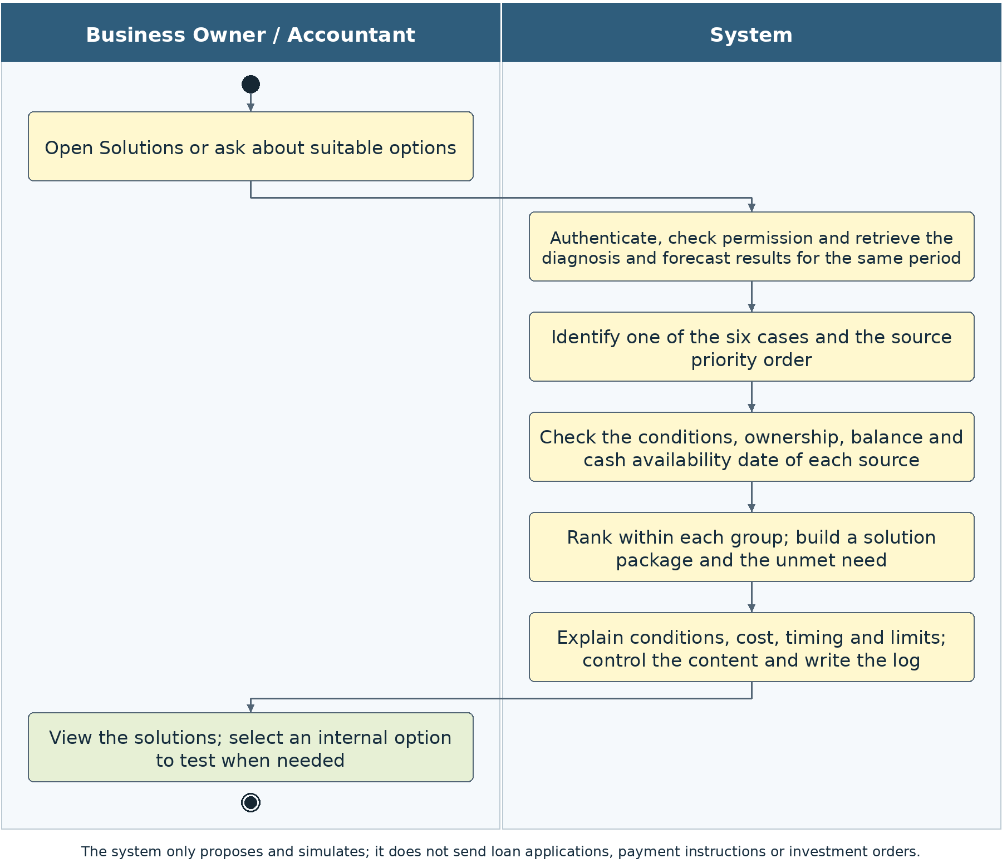
Figure 2-11: UC03 flow that opens directly and automatically prepares background results

2.9.4 View solution recommendations
Use case code | UC03.1 | Use case name | View solution recommendations
Actors | Business Owner and Accountant
Description | Receive recommendations according to the enterprise’s situation, the amount and the date needed, without choosing an algorithm.
Trigger event | Open Solutions or send a question from any screen.
Preconditions | A valid session exists; the system handles the background data conditions itself. The enterprise code and permission are checked on the server side; no technical code needs to be entered.
Main event flow  (Success)
  Step | Component | Activity and handover result
  1 | Users | Open Solutions directly.
  2 | System | Check and automatically retrieve/run UC01–UC02 with the correct data, policy and Base.
  3 | System | Assign the cell M1–M6; determine the shortfall below L and the target to restore to Z, or the reserve/investment branch.
  4 | System | Check ownership, balance, encumbrances, counterparty/product conditions and the effective date.
  5 | System | Apply the group order of the matrix; within a group, consider timeliness, conditions, time, cost and the impact on relationships.
  6 | System | Allocate without duplication; check the cash schedule after the option and later obligations; calculate the unmet portion.
  7 | System | Return a concise recommendation, the sources, conditions, limits and a button to test the internal options.
Alternative event flows
  Code | Condition | Handling and result
  A1 | Data is not ready | One consolidated notice; the user is not required to open each task individually.
  A2 | No source is eligible/in time | Return that no suitable package exists, with the amount/date still missing; do not select an excluded source to fill the gap.
  A3 | Surplus branch but SafeCash equals zero | State that the reserve is maintained; do not propose an investment that could create a shortfall.
  A4 | The financing catalogue has expired | Display that an update is needed; do not use old fees as a current offer.
Postconditions | A recommendation by cell, the correct group order, conditions, cost and the remaining gap or the reason no allocation is needed. On failure, state the reason and the part to be supplemented; do not release dependent conclusions and do not create an additional classification layer.
Related rules | The BR-03 rules in the corresponding business section; data, permission and interpretation controls in Section 3. Limit: do not edit accounting data or carry out transactions.

Table 2-92: Specification of use case UC03.1
No. | Data field | Description | Mandatory? | Validity condition | Example / display
1 | Need | Taken automatically from Base | Yes | The date/amount below L and the restoration to Z are separated | Episode requiring cash
2 | W and TH | Valid results on the same basis | Yes | M1–M6 under matrix.v2 | Automatic cell
3 | Catalogue | Products/policies in effect | By group | Expired conditions are not used | Has a source
Table 2-93: Input data of UC03.1

No. | Component | Description | Mandatory? | Format / value domain | Example / display
1 | Group order | Policy by six cells | Yes | M1: borrowing; M3: AR→AP; M5: AR→INV→AP→borrowing | Not changed automatically
2 | Sources and packages | Net amount, date, cost | If eligible | No duplication and in time | Conditional
3 | Remaining gap | By the schedule after the package | Yes | Do not report as sufficient while shortfall days remain | Amount and date
4 | Surplus branch | Maintain the reserve or conditional investment | If TH02 | SafeCash and the date of recovery | Investment is not forced
Table 2-94: Output data of UC03.1

2.9.5 Recommendation Q&A through the Chat
Use case code | UC03.2 | Use case name | Recommendation Q&A through the Chat
Actors | Business Owner and Accountant
Description | Explain why a source group is prioritised and which conditions determine suitability.
Trigger event | Ask from the Solutions screen or the general Chat.
Preconditions | Has permission; the system resolves the appropriate background result itself. The enterprise code and permission are checked on the server side; no technical code needs to be entered.
Main event flow  (Success)
  Step | Component | Activity and handover result
  1 | Users | Ask about the order of sources, cost, timing or the remaining gap.
  2 | System | Identify the cell code and the policy version in use; if the base is missing, run it automatically when the data is ready.
  3 | System | Supply the source facts, the missing conditions, the cash schedule and the rank within the group.
  4 | System | Explain the priority by cell, the ability to have cash on the right day, the conditions and the limits.
  5 | System | Check the answer; do not allow the LLM to replace the policy or to assert that a loan is obtainable.
Alternative event flows
  Code | Condition | Handling and result
  A1 | The question asks to change the group order | Explain the current policy; refer to a policy proposal according to permission if needed.
  A2 | No suitable source | State the cause and the amount/date still missing; do not invent a product to complete a package.
Postconditions | A traceable answer is provided with the option to view details or test the internal part. On failure, state the reason and the part to be supplemented; do not release dependent conclusions and do not create an additional classification layer.
Related rules | The BR-03 rules in the corresponding business section; data, permission and interpretation controls in Section 3. Limit: do not edit accounting data or carry out transactions.

Table 2-95: Specification of use case UC03.2
No. | Data field | Description | Mandatory? | Validity condition | Example / display
1 | Question | Chat on the solution result | Yes | Priorities cannot be changed by a prompt | Why does this source come first?
Table 2-96: Input data of UC03.2

No. | Component | Description | Mandatory? | Format / value domain | Example / display
1 | Explanation | Policy, conditions, timing | Yes, if passed | No new lending condition is created | Reason and limits
Table 2-97: Output data of UC03.2

2.9.6 View excluded sources and the reasons
Use case code | UC03.3 | Use case name | View excluded sources and the reasons
Actors | Business Owner and Accountant
Description | Understand why a source is prioritised or not suitable.
Trigger event | Open a source or the list of unsuitable sources.
Preconditions | A UC03 result and permission to read the source are available. The enterprise code and permission are checked on the server side; no technical code needs to be entered.
Main event flow  (Success)
  Step | Component | Activity and handover result
  1 | Users | Open the source details.
  2 | System | Display the basis of eligibility, timing, net amount, fees, obligations and evidence.
  3 | Users | A source can be excluded with a reason, or a data update can be proposed.
  4 | System | Create a selection version and rebuild the remaining gap, without changing the policy order.
Alternative event flows
  Code | Condition | Handling and result
  A1 | A wish to bypass a hard condition | Overriding ownership, duplicate prevention, permission limits or legal/product conditions is not allowed.
  A2 | A proposal to change a source or a business flag | Carry it out through the data/policy screen according to permission, storing before and after; do not edit through a Chat sentence.
Postconditions | A clear reason and a new package corresponding to the selection are available; historical results are retained. On failure, state the reason and the part to be supplemented; do not release dependent conclusions and do not create an additional classification layer.
Related rules | The BR-03 rules in the corresponding business section; data, permission and interpretation controls in Section 3. Limit: do not edit accounting data or carry out transactions.

Table 2-98: Specification of use case UC03.3
No. | Data field | Description | Mandatory? | Validity condition | Example / display
1 | Source viewed | Select an excluded source | Yes | Belongs to the result and the enterprise | AR or borrowing group
Table 2-99: Input data of UC03.3

No. | Component | Description | Mandatory? | Format / value domain | Example / display
1 | Reason for exclusion | Code and explanatory sentence | Yes | Distinguish insufficient basis from failure to meet the condition | Not in time
2 | Supplementary conditions | Information that can be supplemented | If any | No commitment that it will become eligible | Constraints need confirmation
Table 2-100: Output data of UC03.3

2.9.7 Exclude a source or update a selection with a reason
Use case code | UC03.4 | Use case name | Exclude a source or update a selection with a reason
Actors | Business Owner and Accountant
Description | Allow the enterprise to exclude a source that does not suit reality, without bypassing hard conditions or changing policy implicitly.
Trigger event | Select Do not use this source in the UC03 result.
Preconditions | A source result and permission to use it are available. The enterprise code and permission are checked on the server side; no technical code needs to be entered.
Main event flow  (Success)
  Step | Component | Activity and handover result
  1 | Users | Select the source to exclude and record a specific reason.
  2 | System | Check that the source belongs to the result, the permission and the data; a hard-excluded source cannot be converted into a valid one.
  3 | System | Rebuild the package from the remaining valid sources in the same group order and the same date needed.
  4 | System | Display the changed package, the remaining gap and the sources that must be prepared in addition.
  5 | System | Save the selection and the reason as a new version; keep the original package.
Alternative event flows
  Code | Condition | Handling and result
  A1 | The user wants to use a source that fails ownership or balance | Refuse the override; guide the user to supplement the evidence or correct the data through the proper flow.
  A2 | The remaining sources are insufficient | Keep the unmet result; do not automatically raise a limit or a collection rate.
Postconditions | A package after the selection and a clear before-and-after history are available. On failure, state the reason and the part to be supplemented; do not release dependent conclusions and do not create an additional classification layer.
Related rules | The BR-03 rules in the corresponding business section; data, permission and interpretation controls in Section 3. Limit: do not edit accounting data or carry out transactions.

Table 2-101: Specification of use case UC03.4
No. | Data field | Description | Mandatory? | Validity condition | Example / display
1 | Excluded source | Select from the list | Yes | Correct source result | Code taken automatically
2 | Reason | Text with a basis | Yes | Hard conditions are not removed | Counterparty refuses
Table 2-102: Input data of UC03.4

No. | Component | Description | Mandatory? | Format / value domain | Example / display
1 | Updated package | Rebuilt according to the selection | Yes | Keep the policy order | The gap increases
2 | Log | Selection before and after | Yes | Person, time, reason | History is not edited
Table 2-103: Output data of UC03.4

2.9.8 Configure products and solution policy
Use case code | UC03.5 | Use case name | Configure products and solution policy
Actors | The Business Owner confirms; the Accountant proposes and views.
Description | Ensure that the catalogue, fees, conditions and policy order are in effect, with a source and a confirmer.
Trigger event | Open Policy details from Solutions.
Preconditions | Has permission to view; the confirmation right belongs to the Business Owner. The enterprise code and permission are checked on the server side; no technical code needs to be entered.
Main event flow  (Success)
  Step | Component | Activity and handover result
  1 | Accountant | Propose an update to product data or actual information, with a source and an effective date.
  2 | System | Check fees/interest, terms, units, mandatory conditions and version conflicts.
  3 | Business Owner | View the change and confirm or return it; there is no need to recalculate the set of indicators manually.
  4 | System | Save the new catalogue/policy; results already released are not changed.
  5 | System | State which packages must be rerun because the policy or the product has changed.
Alternative event flows
  Code | Condition | Handling and result
  A1 | The Accountant attempts to release a change | Only the proposal is saved; it is not applied without the confirmation right.
  A2 | Change the group order of the six cells | Require a clear policy proposal; do not carry it out by adjusting the ranking score.
  A3 | A product has not been verified | Illustrative/awaiting-confirmation label; do not present it as a real offer.
Postconditions | A policy version or catalogue with a source, a confirmer and an effective date. On failure, state the reason and the part to be supplemented; do not release dependent conclusions and do not create an additional classification layer.
Related rules | The BR-03 rules in the corresponding business section; data, permission and interpretation controls in Section 3. Limit: do not edit accounting data or carry out transactions.

Table 2-104: Specification of use case UC03.5
No. | Data field | Description | Mandatory? | Validity condition | Example / display
1 | Parameter/catalogue | Proposed change with a source | Yes | Price, fees, term, effective date | Awaiting confirmation
2 | Confirmation right | Business Owner | Yes, to apply | The Accountant only proposes | New version
Table 2-105: Input data of UC03.5

No. | Component | Description | Mandatory? | Format / value domain | Example / display
1 | Solution policy | Version in effect | When approved | Priority groups are not overridden implicitly | Has a basis
2 | Expiry warning | Source is no longer suitable | If any | Old figures are not taken as the current offer | Needs updating
Table 2-106: Output data of UC03.5

2.9.9 Transfer internal options to a test
Use case code | UC03.6 | Use case name | Transfer internal options to a test
Actors | Business Owner and Accountant
Description | Reduce repeated data entry and check the impact before deliberation.
Trigger event | Select What-if Test.
Preconditions | The source belongs to O4/O3/O1; it has a subject, balance and schedule. The enterprise code and permission are checked on the server side; no technical code needs to be entered.
Main event flow  (Success)
  Step | Component | Activity and handover result
  1 | Users | Select one or more supported internal sources.
  2 | System | Pre-load the subject, amount, date and cost into UC04; keep the source code unchanged.
  3 | Users | View and adjust the assumptions; confirm the conditions needed for the test.
  4 | System | Run UC04 on a copy; the selection is not treated as an actual transaction.
Alternative event flows
  Code | Condition | Handling and result
  A1 | O2 or I0 is in the package | Explain the part that is not simulated. Do not run the whole package as if borrowing/investment were included.
  A2 | Only a supported subset is selected | Allow the subset to run with a label of partial simulation; display the sources left out.
Postconditions | A UC04 request with a clear scope, source and conditions; data already available is not re-entered. On failure, state the reason and the part to be supplemented; do not release dependent conclusions and do not create an additional classification layer.
Related rules | The BR-03 rules in the corresponding business section; data, permission and interpretation controls in Section 3. Limit: do not edit accounting data or carry out transactions.

Table 2-107: Specification of use case UC03.6
No. | Data field | Description | Mandatory? | Validity condition | Example / display
1 | Part of the option | Select O1/O3/O4 | Yes | Must belong to the simulated set | Internal source
2 | Conditions required for the test | Amount, date and cost pre-filled | Yes | The user checks before running | The base is not re-entered
Table 2-108: Input data of UC03.6

No. | Component | Description | Mandatory? | Format / value domain | Example / display
1 | UC04 request | Source and structured changes | Yes | Same base; has a scope | Internal simulation
2 | Part outside the scope | Borrowing/investment not yet tested | If any | Do not report that the whole package was tested | Labelled subset
Table 2-109: Output data of UC03.6

2.9.10 Six-cell priority policy
Cell | State | Priority order | Conditions and the result to be returned
M1 | Safe + cash shortfall | Short-term borrowing/financing first. | Propose only sources that can meet the exact date and have a repayment basis; do not assume that a W0 enterprise will be approved for a loan.
M2 | Safe + cash surplus | Consider short-term investment. | Only the portion of cash that can genuinely be allocated; prioritise protecting cash and the ability to withdraw, and do not advise on long-term investment. If SafeCash = 0, return that there is no suitable amount to allocate yet.
M3 | At risk + cash shortfall | AR → AP. | Collect receivables with a basis first, then extend payables under conditions; if there is still a shortfall, report the unmet portion and do not add a borrowing priority outside the policy.
M4 | At risk + cash surplus | Keep as a reserve. | Do not create a borrowing package or push investment; state the timing and the sources that could cause volatility.
M5 | Severe + cash shortfall | AR → INV → AP → borrowing. | Consider the three internal/commercial sources first. Only the portion not yet covered is considered for eligible borrowing sources; borrowing is not guaranteed.
M6 | Severe + cash surplus | Keep as a reserve. | Positive cash does not remove the bottleneck. State the capital tied up, the obligations, the collection risk and the level to be protected.
Table 2-110: Solution priority order by six cells

The levels safe/at risk/severe in the table are the W axis and are not forecast colours. The surplus branch of W1/W2 prioritises the reserve because the working capital problem may make the existing cash unsustainable. No additional “low/high” surplus-cash variable is to be added in place of the six-cell rule unless a definition and an approved policy exist.

2.9.11 Source groups and their interpretation
Code | Group | Usable value | Must not be inferred
O4 | Receivables — AR | The portion of invoices that can be collected earlier than the Base schedule, after discounts/costs. | Do not add all of AR; do not treat an amount not yet due as late. Do not both collect early and finance the same part of an invoice.
O3 | Inventory release — INV | The net sale proceeds of the owned goods that may be sold and have a basis for price/buyer/collection date. | Do not use book value as cash; do not sell WIP or goods tied to an order that is still needed without a basis; do not use goods owned by customers.
O1 | Payment extension — AP | A payment moved away from the time cash is needed, with the repayment date and fees. | It is not new cash receipts; the balance is not permanently increased; the enterprise’s consent is not treated as the supplier’s consent.
O2 | Short-term borrowing/financing | Net disbursement that can be received on the exact date, the remaining limit and the repayment schedule are assessed. | Do not include an undrawn loan in Cash0; do not assume that having enough assets means being granted a loan.
R0 | Hold cash as a reserve | An amount kept within available cash to protect obligations. | Do not record it as a new receipt; do not add the same cash a second time.
I0 | Conditional short-term investment | The SafeCash portion and a term that can match the date cash is needed; only an option for the enterprise to consider. | Do not open a transaction; do not promise returns or treat an amount that cannot be withdrawn as available cash.
Table 2-111: Catalogue of source groups and options

Specific forms of financing within O2 may include a revolving credit line, short-term working capital loans, invoice or inventory financing if the product catalogue has sufficient data. They are options within the same O2 group and do not change the group order of the matrix. Simulated products must carry an illustrative label.

2.9.12 Checking conditions before ranking
Code | Mandatory requirement
EL-03-01 | AR: the invoice exists, has a balance and belongs to the correct enterprise; the amount to be collected has not been used in another source; dispute and assignment status have a basis; the new collection schedule does not lie in the past.
EL-03-02 | AR: a strategic/large customer must be assessed for relationship impact; the current order terms are not changed automatically. A new or occasional customer is not automatically subjected to requirements contrary to the contract.
EL-03-03 | INV: ownership confirmed, available quantity, pledges and order constraints checked; a sale has a feasible price and collection date. If an important constraint is missing, eligibility is not confirmed.
EL-03-04 | AP: there is a payment that can be rescheduled, the supplier permits it or the negotiable assumption is clearly stated; an essential/exclusive supplier is not treated as a source that can certainly be extended.
EL-03-05 | O2: the product is in effect, suits the subject, meets the asset/document conditions, has an unused limit and a disbursement date no later than the need; the repayment plan has data.
EL-03-06 | I0: the term, ability to withdraw, fees and capital-preservation limits are appropriate; do not place a risky or long-term product in the short-term cash branch automatically.
EL-03-07 | Every source must have a net amount, timing, cost, unconfirmed conditions and an evidence source. A portion lacking conditions may be output only as a direction for consideration and is not included in firm coverage.
Table 2-112: UC03 hard conditions

2.9.13 Ranking and building a package over time
The ranking key consists of: priority_group by matrix cell; ability to meet the date needed; level of confirmation of conditions; time to execute; cost on the same amount and term; impact on relationships; a stable subject code. A source that ranks first but is not in time for the date must not be counted as having covered the shortfall. The reason for skipping or partially using a source must be output together with the result.
For M5, the system determines the portion that can be collected from AR, the net inventory sale portion and the payment that can be moved from AP, and then calculates the remaining gap on each day. Only this portion is considered for O2. The system may display the need to prepare borrowing early because of processing time, but does not push borrowing ahead of the three groups as a priority source. It must not wait until the day cash runs out to discover that the borrowing time is not sufficient.
M1 prioritises short-term borrowing because no major bottleneck has been seen, but if the conditions are not met this must be stated clearly; the M5 order is not applied automatically. M3 has only the order AR and then AP under the current policy; if there is still a shortfall, report the remaining gap and the conditions to consider next, without implicitly adding a new group. A change of policy must be confirmed by the Business Owner through a new version.
The package builder uses daily cash events. AR is the shifting of an existing receipt, net of discounts; INV is a net new receipt if no corresponding sale event exists; AP is the shifting of a payment and retention of the later payment. Borrowing is a net disbursement with a repayment obligation, not merely an added inflow. The theoretical “released cash” of UC01 is not added to the forecast cash a second time.
The need is reported by consecutive episodes and key days. It is not a hard limit that every shortfall path becomes one change of level or a maximum of two episodes if the actual schedule has several episodes. The screen prioritises one important episode for readability; the rest can be expanded. A package that covers the first episode must be checked so that it does not create a shortfall in the next episode or on the repayment date.

2.9.14 Cost and the unmet portion
Indicator | Rule
Net usable cash | Disbursement/sale proceeds/invoice collections less the cash fees actually incurred by the source itself; the maximum limit is not used in place of net cash.
Illustrative borrowing cost | Principal × annual rate × number of days / day-count basis + fees on the correct basis; a schedule for each tranche if there are several disbursements/repayments.
Early-collection discount | The nominal portion collected early × the rate; reflected in net receipts and not deducted a second time in payments.
Payables extension | The amount of the payment moved and the new payment date; fees/penalties are attached to events; the whole extended amount is not treated as new cash receipts.
Inventory sale | Net sale proceeds and the difference from book value reported separately; an accounting loss is not by itself a second cash payment.
Portion not covered below L | MAX(0, L − cash path after the package) on each day, the peak and the number of days still short.
Portion not reaching target Z | Reported separately from the shortfall below L; do not call it fully resolved if shortfall days or obligations that cannot be checked remain.
Table 2-113: Solution package formulas and indicators

2.9.15 Surplus cash, reserve and short-term investment
M4 and M6 hold cash as a reserve by default; L is not raised automatically merely because W is high, since the cash thresholds must follow the confirmed policy. The system states the reason for holding cash, the L/Z/H levels and the upcoming obligations. The amount retained remains within the original cash path and does not create an additional source or receipt event.
M2 suggests the short-term investment group when there is cash that can genuinely be allocated. Under the Miller–Orr logic, touching/exceeding H is the point at which transferring cash back to Z is considered; within the control zone, a transaction is not assumed to be needed. If there is no suitable amount, “no allocation needed yet” is a valid result. The surplus branch must not be turned into a requirement to buy a product.
For an allocation time t0 and a known recovery date τ, SafeCash = MAX(0, MIN(Cash_available_t0 − Z, MIN_{s,t from t0 to τ}(Cash_s,t − Z))). s runs across all three compatible scenarios. Restricted cash or cash tied to identified obligations does not belong to Cash_available. This formula is an initial cap; a cash-flow check of fees, term and ability to withdraw must still be run before suitability is confirmed.
If τ falls outside the forecast period, it is not concluded that the whole investment period is safe without a supplementary cash schedule. When product conditions or data to calculate SafeCash are missing, state only the direction for consideration and maintain the reserve; do not set an allocation figure on your own. The result must show clearly that cash from borrowing or advances is checked for obligations, and the whole bank balance is not treated as surplus cash.

2.9.16 Results and interpretation templates
Part | Requirement
Source and policy | source_uc01_run, source_uc02_run, wc_class, cash_state, matrix_case, matrix_version, priority_policy_version and catalogue_version.
Need or allocable portion | The date needed, the amount below the floor/target, the time needed; or SafeCash, the recovery date needed and the limits.
List of sources | Groups by order, subject, amount_net, effective date, cost, conditions, level of confirmation, reason for exclusion.
Package and limits | Amount by day, remaining gap, later obligations, coverage status; not marked as resolved if not sufficient.
Transfer to test | The O1/O3/O4 portion that is simulated; the borrowing/investment portion not yet supported by UC04 is stated clearly.
Table 2-114: UC03 outputs

Template for M5: “The enterprise has a severe bottleneck and the forecast shows a shortfall of [amount] from [date]. The system considers in turn receivables, goods that can be sold and payments that can be negotiated for deferral. After the eligible sources, [amount] remains uncovered; borrowing sources are considered for this portion only if they meet the conditions and are in time. Receipts or extensions not yet confirmed by the counterparty remain assumptions.” Every figure to be filled in is taken from the tool results.
Code | Mandatory requirement
BR-03-01 | The group order of M1/M3/M5 is mandatory; M2/M4/M6 do not create a borrowing need by themselves.
BR-03-02 | Conditions and timing are checked before coverage; a source not in time for the date is not counted as covering.
BR-03-03 | If no eligible source exists, return the limits and the remaining gap; do not create a fictitious product or condition.
BR-03-04 | The same asset/invoice is allocated only once; track the remaining portion on each day.
BR-03-05 | A recommendation does not mean that a counterparty has agreed or that the enterprise will be granted funds.
BR-03-06 | The Business Owner decides policy; the Accountant prepares information; the LLM does not reselect the group order.
BR-03-07 | Only short-term instruments are used in the investment branch; maintaining the reserve may be the valid final choice.
BR-03-08 | A package that contains functions outside UC04 must be distinguished; do not report a full-package test result when only the internal part was run.
Table 2-115: UC03 business rules

2.10 UC04 What-if testing on cash flow
UC04 checks the impact of an internal option on the UC02 cash path, based on the customers, suppliers or lots identified in UC01. The user does not need to choose a numbered technical scenario. The user selects only the subject and the assumption; the system applies the same change to Base, Conservative and Positive to compare the improvement and the remaining risk.

2.10.1 Objective and scope
UC04 simulates only three internal levers. Every test has a base, subject, change, cost and the results of all three scenarios; it does not edit ledgers or send instructions to counterparties.

2.10.2 Inputs and outputs
The inputs are two UC01–UC02 runs on the same base and the user’s assumptions; UC03 is an optional source of transfer. The outputs are the before-and-after cash, the shortfall, the cost, the days that worsen, items outside the period, the evidence and the limits.

2.10.3 Overall processing flow
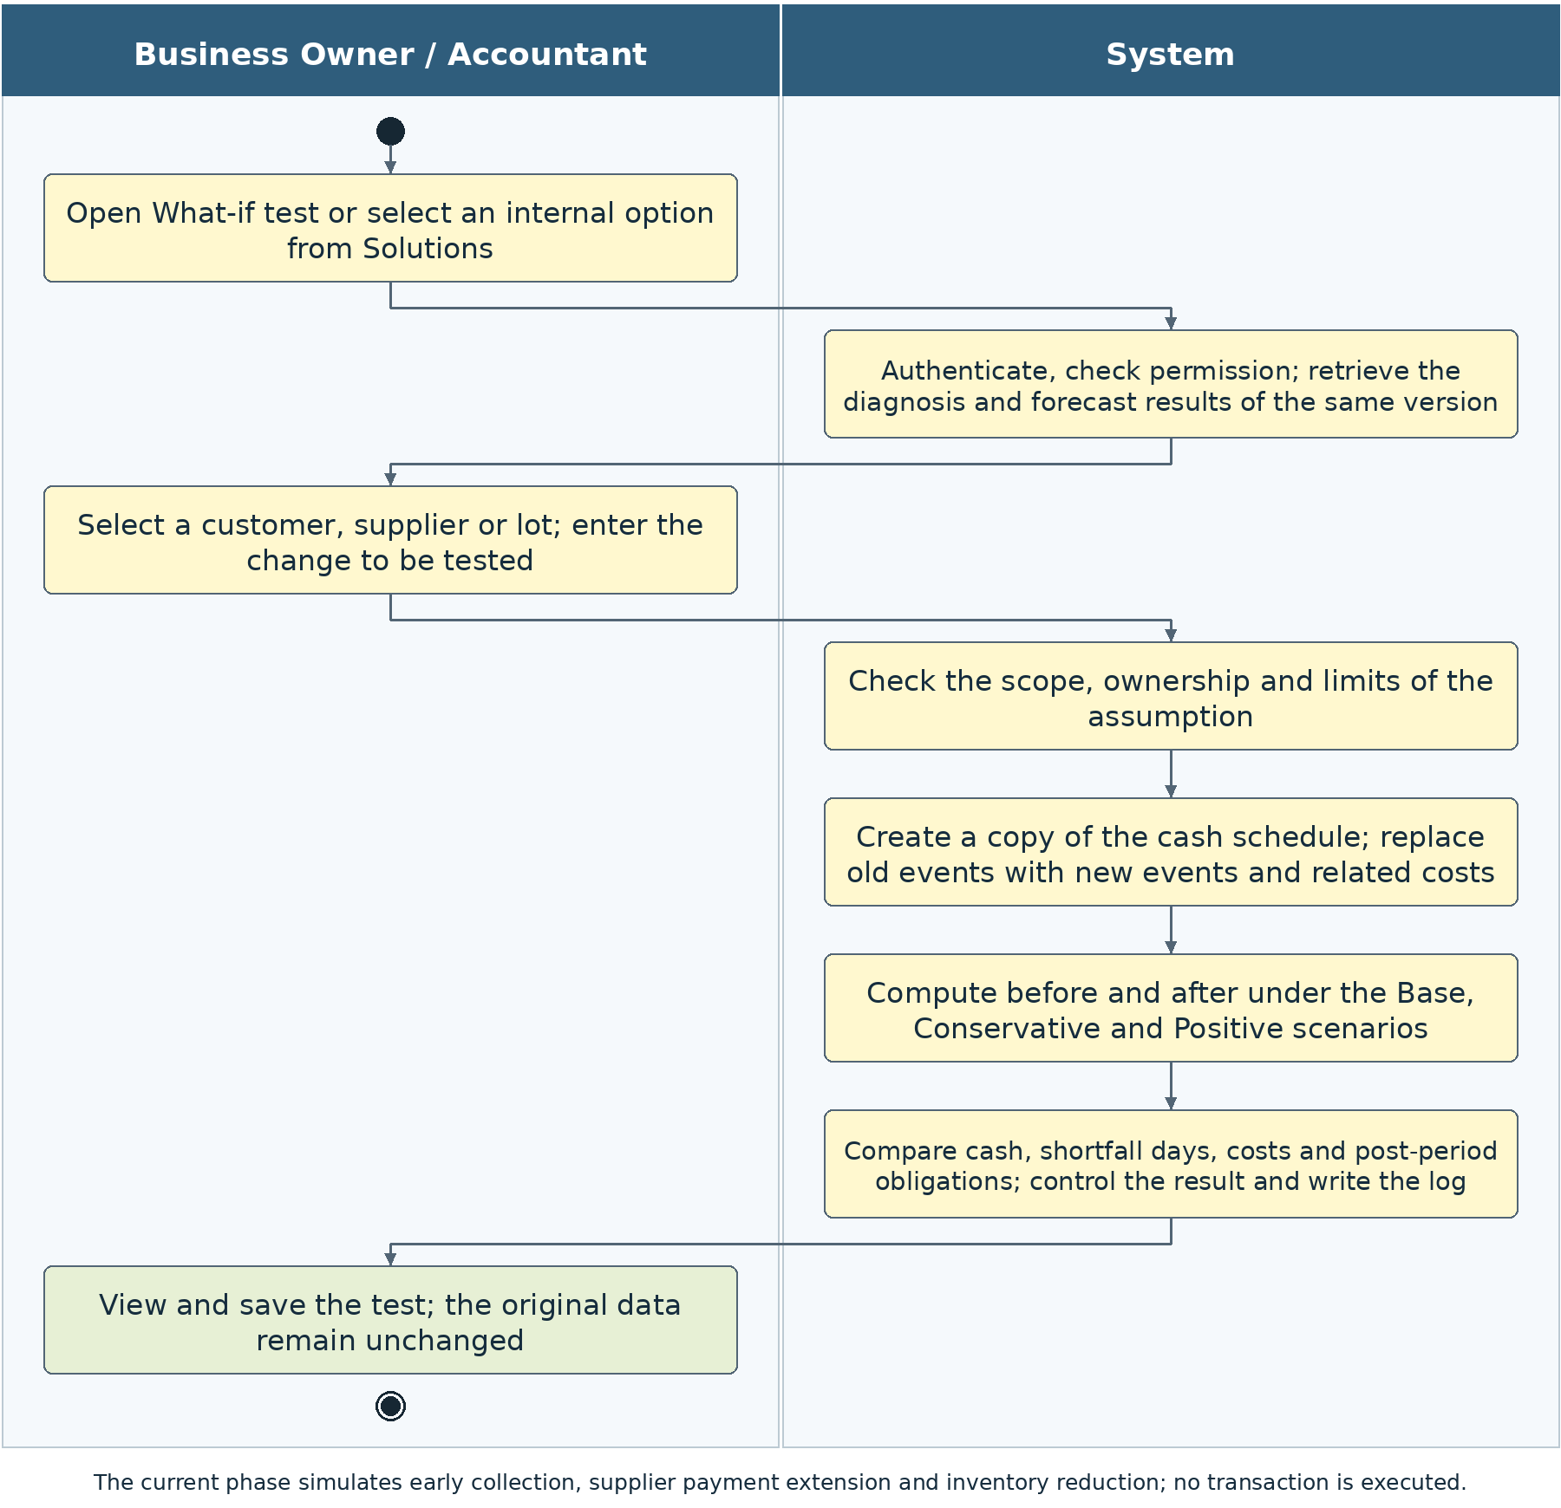
Figure 2-12: What-if testing flow with short operations and three scenarios

2.10.4 Set up and run a test
Use case code | UC04.1 | Use case name | Set up and run a test
Actors | Business Owner and Accountant
Description | Know whether the option improves the cash shortfall before considering implementation.
Trigger event | Select What-if Test from UC01/UC02/UC03 or the menu.
Preconditions | A compatible base result exists and the subject belongs to the three supported levers. The enterprise code and permission are checked on the server side; no technical code needs to be entered.
Main event flow  (Success)
  Step | Component | Activity and handover result
  1 | Users | Select a suggested subject; if coming from UC03, the system pre-fills the data.
  2 | System | Display only the relevant fields: the amount/quantity portion, the new date, the discount/fee/selling price.
  3 | Users | Adjust the assumptions and confirm the conditions necessary for the test.
  4 | System | Check permission, source, balance, constraints and duplicates; state the error at the field itself.
  5 | System | Create a copy of the events, replace exactly the selected portion; run the three scenarios with the same option.
  6 | System | Reconcile; display before and after, the cost, items outside the period and the remaining gap.
Alternative event flows
  Code | Condition | Handling and result
  A1 | A portion exceeding the balance/quantity is selected | Reject the incorrect portion; keep the other input and do not require re-entry of everything.
  A2 | The supplier has not agreed to the extension | Allow only a test of a labelled assumption; do not record it as agreed.
  A3 | A lot whose ownership or encumbrance is not confirmed | Block an eligible recommendation; if the test needs that data, request supplementary input first.
  A4 | A package that includes borrowing or investment | Do not run fully outside the scope; the user may clearly select an internal subset to test.
Postconditions | A versioned simulation result exists, the original figures are not edited and no action is executed. On failure, state the reason and the part to be supplemented; do not release dependent conclusions and do not create an additional classification layer.
Related rules | The BR-04 rules in the corresponding business section; data, permission and interpretation controls in Section 3. Limit: do not edit accounting data or carry out transactions.

Table 2-116: Specification of use case UC04.1
No. | Data field | Description | Mandatory? | Validity condition | Example / display
1 | Subject | Customer/supplier/lot from the result | Yes | Balance/availability remains | Code auto-filled
2 | Portion changed | Amount or ratio/quantity | Yes | Does not exceed the balance or reuse the same portion | The user adjusts
3 | Date and cost | New date, fee, price/discount | By lever | One valid price basis | Not generated automatically
Table 2-117: Input data of UC04.1

No. | Component | Description | Mandatory? | Format / value domain | Example / display
1 | Test | Code and valid assumptions | When passed | Same base; mode=simulation | Original figures are not edited
2 | Results of the three scenarios | Before and after and the limits | Yes | base/conservative/positive | No scenario is added
Table 2-118: Output data of UC04.1

2.10.5 View the result and adjust the test
Use case code | UC04.2 | Use case name | View the result and adjust the test
Actors | Business Owner and Accountant
Description | Understand the improvement, the part not yet resolved and the trade-offs.
Trigger event | Complete the test or open a saved result.
Preconditions | A test within the user’s permission and sufficient source information exist. The enterprise code and permission are checked on the server side; no technical code needs to be entered.
Main event flow  (Success)
  Step | Component | Activity and handover result
  1 | System | Display the changed assumptions and the Base before-and-after comparison first.
  2 | Users | Open Conservative/Positive or the detail of the moved item.
  3 | System | Indicate the days that are still short, the days that worsen, the cost, the payments due after the period and the conclusion for each scenario.
  4 | Users | Save or change the assumptions; a change creates a new test linked to the previous version.
Alternative event flows
  Code | Condition | Handling and result
  A1 | The source has a new version | Keep the historical result; to calculate the current position, run on the new base and notify that the basis differs.
  A2 | Opening cash increases but a shortfall appears on the new payment date | State that the pressure has shifted to another day; do not conclude it is resolved.
  A3 | The shortfall is only reduced but not eliminated | Conclude a partial improvement together with the remaining shortfall; do not use an absolute success label.
Postconditions | A transparent conclusion and history exist; a multi-level approval process is not required. On failure, state the reason and the part to be supplemented; do not release dependent conclusions and do not create an additional classification layer.
Related rules | The BR-04 rules in the corresponding business section; data, permission and interpretation controls in Section 3. Limit: do not edit accounting data or carry out transactions.

Table 2-119: Specification of use case UC04.2
No. | Data field | Description | Mandatory? | Validity condition | Example / display
1 | Test | Select from the generated results | Yes | Correct permission, with a source and version | The test currently open
Table 2-120: Input data of UC04.2

No. | Component | Description | Mandatory? | Format / value domain | Example / display
1 | Before and after | MinCash, gap, number of days, cost | Yes | Same L/Z/H and horizon | Base first
2 | Trade-off | Days that worsen and items after the period | Yes | The deferred obligation is not dropped | Partial improvement
3 | Conclusion | By scenario | Yes | Interest savings are not inferred from CCC | Conditional
Table 2-121: Output data of UC04.2

2.10.6 Simulation result Q&A through the Chat
Use case code | UC04.3 | Use case name | Simulation result Q&A through the Chat
Actors | Business Owner and Accountant
Description | Explain the impact and trade-offs of the test across exactly three scenarios.
Trigger event | Ask while viewing a test or opening a historical result.
Preconditions | A test result within the user’s permission and complete source facts exist. The enterprise code and permission are checked on the server side; no technical code needs to be entered.
Main event flow  (Success)
  Step | Component | Activity and handover result
  1 | Users | Ask how much the option reduces the shortfall, which days are still short or what obligations arise.
  2 | System | Tie the question to the correct sim_run_id and source; check whether it is current or historical.
  3 | System | Supply the before-and-after indicators, the cost, the days that worsen and the items outside the period.
  4 | System | Explain in plain language, separating Base from the other two scenarios.
  5 | System | Block figures or conclusions not found in the fact_registry before displaying.
Alternative event flows
  Code | Condition | Handling and result
  A1 | A question that changes an assumption | Create a new test when the parameter is confirmed; do not answer with the LLM’s spontaneous calculation.
  A2 | A question about interest savings from a lower CCC | Do not infer; explain that a debt model and prepayment conditions are needed, which are not part of the current version.
Postconditions | A correct explanation of the test is given; an assumption is not presented as a transaction that has been executed. On failure, state the reason and the part to be supplemented; do not release dependent conclusions and do not create an additional classification layer.
Related rules | The BR-04 rules in the corresponding business section; data, permission and interpretation controls in Section 3. Limit: do not edit accounting data or carry out transactions.

Table 2-122: Specification of use case UC04.3
No. | Data field | Description | Mandatory? | Validity condition | Example / display
1 | Question | Chat about the test | Yes | Parameters are not changed outside a calculation turn | Does the option eliminate the shortfall?
Table 2-123: Input data of UC04.3

No. | Component | Description | Mandatory? | Format / value domain | Example / display
1 | Interpretation | Impact, cost and limits | Yes, if passed | Correct simulation facts | No assertion that a transaction has been made
Table 2-124: Output data of UC04.3

2.10.7 Compare tests and Q&A
Use case code | UC04.4 | Use case name | Compare tests and Q&A
Actors | Business Owner and Accountant
Description | Choose an understandable option on the same comparison basis.
Trigger event | Select two tests or ask about the results.
Preconditions | The tests have the same enterprise, base, horizon, policy and scenario set. The enterprise code and permission are checked on the server side; no technical code needs to be entered.
Main event flow  (Success)
  Step | Component | Activity and handover result
  1 | Users | Select tests from the saved list.
  2 | System | Check compatibility; present a table of amounts, dates, costs and limits.
  3 | System | Explain the trade-offs from verified facts; do not calculate interest savings on your own.
  4 | System | Check the interpretation and display; decisions outside the system belong to the Business Owner.
Alternative event flows
  Code | Condition | Handling and result
  A1 | Different base or version | Do not rank directly as an equivalent comparison; recommend rerunning on the same base.
  A2 | Asked to send an instruction or sign an agreement | Explain that this is a simulation only, with no right to execute.
Postconditions | A consistent comparison exists; figures from different bases are not merged. On failure, state the reason and the part to be supplemented; do not release dependent conclusions and do not create an additional classification layer.
Related rules | The BR-04 rules in the corresponding business section; data, permission and interpretation controls in Section 3. Limit: do not edit accounting data or carry out transactions.

Table 2-125: Specification of use case UC04.4
No. | Data field | Description | Mandatory? | Validity condition | Example / display
1 | List of tests | Select two or more suitable versions | Yes | Same base, policy, scenario set | Periods are not mixed automatically
Table 2-126: Input data of UC04.4

No. | Component | Description | Mandatory? | Format / value domain | Example / display
1 | Comparison | Assumptions and indicators side by side | Yes, if compatible | Explain the important differences | Do not select solely by peak cash
2 | Compatibility error | State the different bases | If any | Request a rerun on the same base | Not ranked directly
Table 2-127: Output data of UC04.4

2.10.8 Simulate the option portion received from UC03
Use case code | UC04.5 | Use case name | Simulate the option portion received from UC03
Actors | Business Owner and Accountant
Description | Continue from a solution to a test without re-entering base information or the subject.
Trigger event | Select Test the internal portion in UC03.
Preconditions | The selection comprises O1/O3/O4 with sources and balances that have a sufficient basis. The enterprise code and permission are checked on the server side; no technical code needs to be entered.
Main event flow  (Success)
  Step | Component | Activity and handover result
  1 | System | Receive source_match_run, the option_ids and the allocated portion of the subject.
  2 | System | Reconcile the UC01–UC02 base, the policy, the time and the supported scope.
  3 | System | Pre-fill the subject, amount, date and fees; state clearly the borrowing/investment portion that is not simulated, if any.
  4 | Users | Check or adjust the assumptions, confirm what is necessary, and then run.
  5 | System | Use the same UC04.1 service; store a link from the result back to the UC03 package.
  6 | System | Return the before-and-after and the unmet portion, with a subset label if only a part is tested.
Alternative event flows
  Code | Condition | Handling and result
  A1 | O2/I0 is in the selection | Block the request for a full test; run only the subset clearly selected by the user.
  A2 | The base or balance has changed | Request a source update or view the history; do not use the new balance with the old schedule.
Postconditions | The result is consistent with a direct run using the same assumptions; do not report a full test when the scope is only a subset. On failure, state the reason and the part to be supplemented; do not release dependent conclusions and do not create an additional classification layer.
Related rules | The BR-04 rules in the corresponding business section; data, permission and interpretation controls in Section 3. Limit: do not edit accounting data or carry out transactions.

Table 2-128: Specification of use case UC04.5
No. | Data field | Description | Mandatory? | Validity condition | Example / display
1 | UC03 option | The selected parts, structured | Yes | Only O1/O3/O4 are currently supported | Received automatically
2 | Confirm assumptions | By required data field | Yes, if relevant | Does not replace counterparty consent | Has an assumption label
Table 2-129: Input data of UC04.5

No. | Component | Description | Mandatory? | Format / value domain | Example / display
1 | Transferred test | Result equals a direct run with the same parameters | Yes, when passed | Keep the UC03 link and the base | A part is not simulated
2 | Scope | Fully internal / subset | Yes | Does not include borrowing or investment | Clearly identified
Table 2-130: Output data of UC04.5

2.10.9 Draft actions and approval
After a test, the user often needs the next step in writing: a request to a customer to pay earlier, an application to a funder, a request to a supplier to extend payment terms. UC04.6–UC04.8 let Lilact AI Agent prepare that text as a draft action, store it in the Approval queue, and let the Business Owner decide. These functions belong to UC04; they are not a separate use case. They start only from a saved UC04 test result and they use the same facts, versions and permissions as the rest of UC04.
The boundary is deliberate. A draft is only a prepared text and a set of facts. When the Business Owner approves a draft, the application calls its internal function submit_action in simulation mode and writes the log; the draft becomes a simulated action. Nothing is transmitted to a customer, supplier, funder, bank or accounting system. The Business Owner remains free to use the approved text outside the application.

2.10.9.1 Purpose and action tiers
The purpose is to close the gap between a tested option and an accountable decision without giving the system any power to act on its own. The Approval queue is the single place where this happens; the same record is shown in the Chat and on the screens.
Tier | Name | What the system does | Who authorises | Effect outside the application
1 | Inform | Reads data, answers questions and explains results (UC01–UC03 and UC04.3). | Role permission only. | None.
2 | Simulate | Creates versioned analyses and tests on a copy of the cash schedule (UC04.1–UC04.5). | A user with a permitted role. | None; the source data are unchanged.
3 | Draft and simulated action | Prepares drafts in the Approval queue and, after approval, records a simulated action through submit_action in simulation mode (UC04.6–UC04.8). | The Business Owner approves; the Accountant may prepare and review. | None; nothing is sent. Only a log entry is written.
4 | Real execution (reserved) | Would send a message, file an application, instruct a payment or sign an agreement through a real channel. | Not available in this version. | Not provided. Needs a separate scope, authorisation, controls and legal review (Appendix G).

Table 2-131: Action tiers

The approval screen of the application labels the simulated action as “tier 3”; tiers 1, 2 and 4 are defined here so that the labels are consistent across the document, the interface and the log.

2.10.9.2 Action types and when a draft may be offered
Three action types are supported. Each type is tied to the lever that was tested, so that the text sent for approval is always backed by a result that the Business Owner has already seen.
Action type | Recipient | Source lever | Preconditions | Mandatory facts and attachment
payment_reminder | A customer of the enterprise. | Early collection (lever 1). | A saved test of earlier collection that includes the customer’s open invoices; the customer exists in the registry; the invoices are open at the cut-off date. | Days earlier; period phrase from the shortfall episode; attached statement of the open invoices (invoice, due date, residual amount, proposed settlement date).
financing_application | The desk of an active product in the catalogue (for example reverse factoring RF-001 or dynamic discounting DD-001). | Early collection financed through a catalogue product, with the product’s discount or fee as the cost of the lever. | The tested lever uses the product’s conditions; the invoice is open and eligible; the funds-needed date and the expected receipt date are known; the product is active. | Invoice, amount if stated, funds-needed date, repayment basis (expected receipt date), product, indicative total cost from the tested lever.
term_extension_request | A supplier of the enterprise. | Extension of payment dates (lever 2). | A saved test of extension on the payments to that supplier; the payments are unpaid at the cut-off date. The supplier’s agreement is not assumed (BR-04-04). | Payment due dates covered; number of days requested.
(none) | — | Inventory reduction (lever 3). | No draft type exists in this version; the system explains that and lists the supported types. | —

Table 2-132: Action types and their source levers

A financing_application draft states the cost as an indicative figure taken from the tested lever and does not claim that the product will be granted. It does not simulate the disbursement and repayment of the financing as a complete package (BR-04-07, Appendix G).

2.10.9.3 Life cycle and status model
The Approval queue shows four statuses. The cause of each status is carried by a reason code, so that no further status needs to be shown to the user.
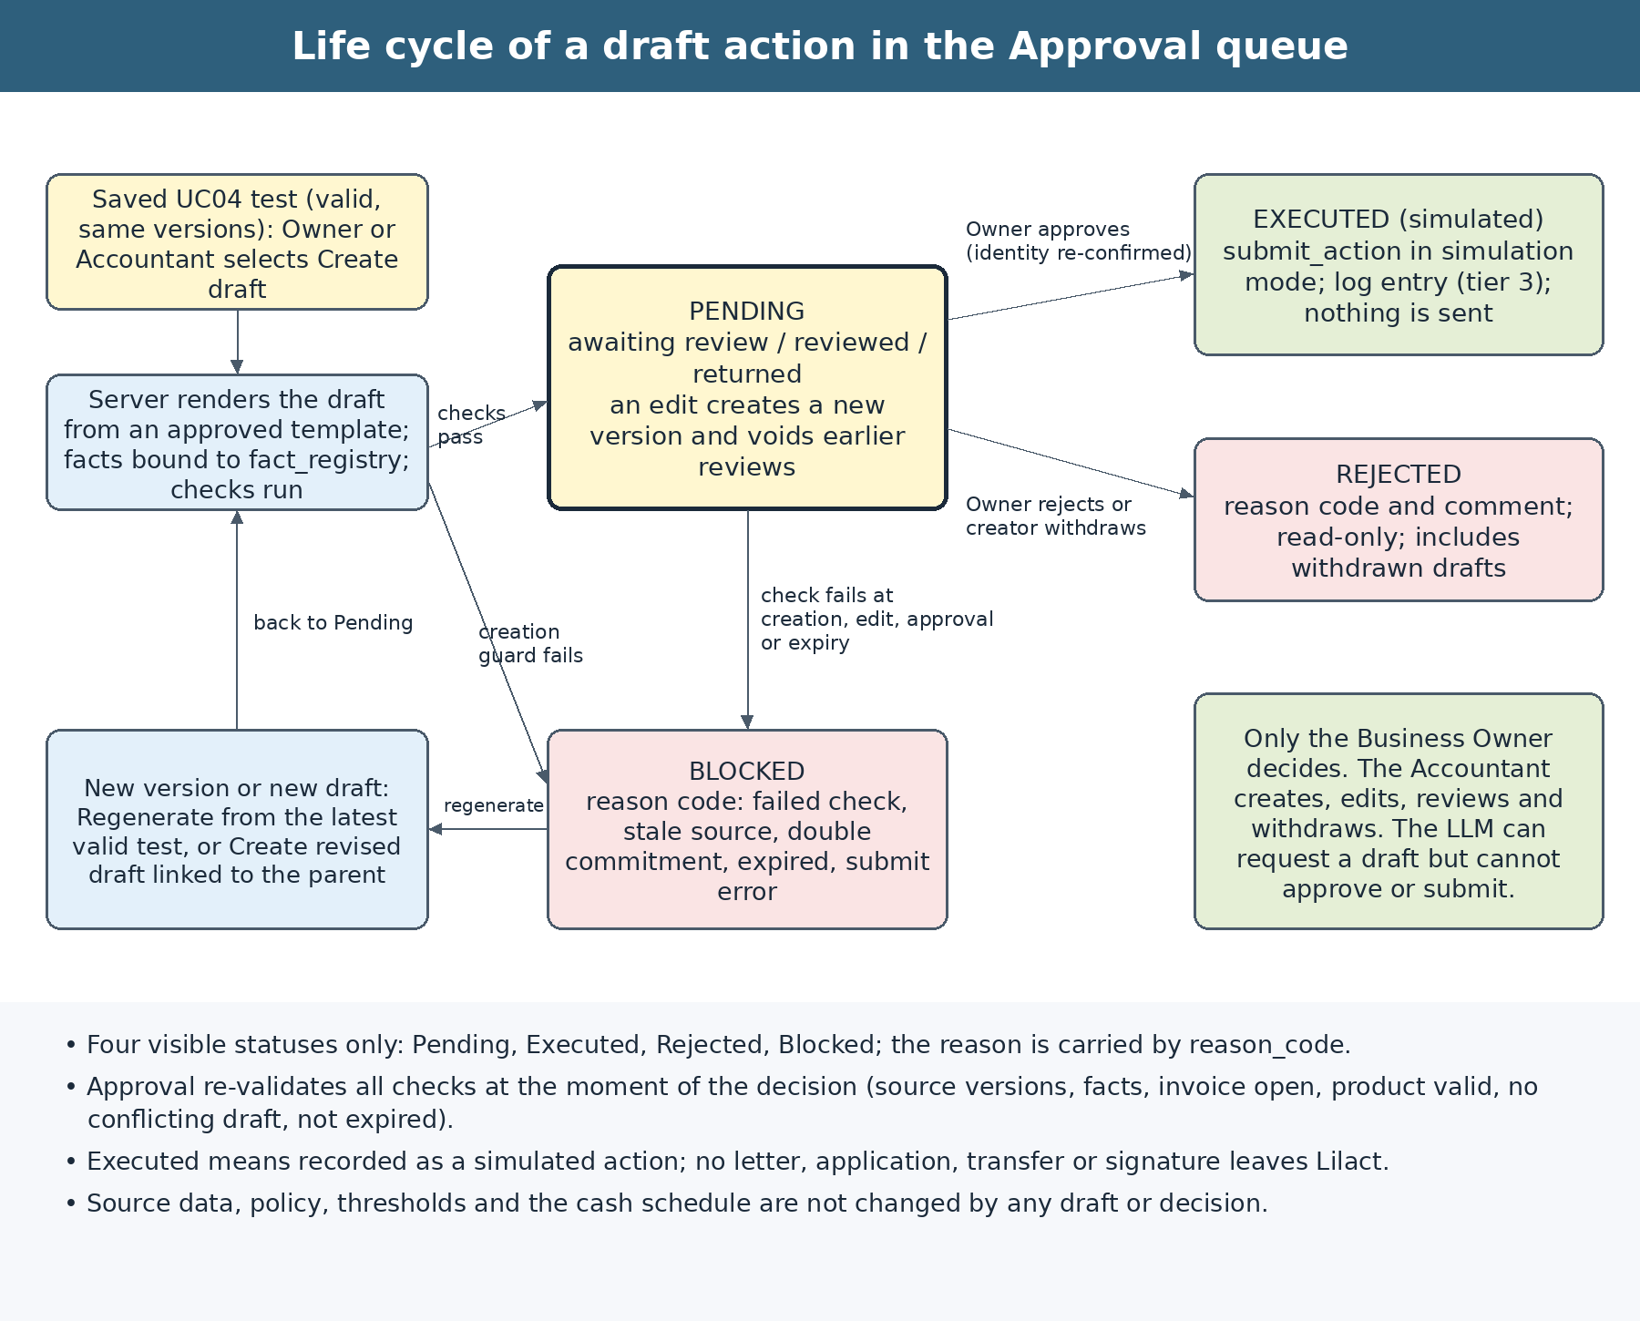
Figure 2-13: Life cycle of a draft action in the Approval queue
Status | Meaning | Reason codes | Final? | Editable?
Pending | The draft exists and waits for the Business Owner’s decision. Its review label is awaiting_review, reviewed or returned. | — | No | Yes, in the permitted fields; each edit creates a new version.
Executed | The Business Owner approved the draft and the system recorded a simulated action. Nothing was sent. | — | Yes | No; the approved text can be copied (BR-04-29).
Rejected | The Business Owner rejected the draft, or its creator withdrew it. | INCORRECT_FIGURES, WRONG_RECIPIENT, TIMING, NOT_PREFERRED, WITHDRAWN, OTHER | Yes | No; a revised draft can be created from it.
Blocked | The system stopped the draft because a check failed or the conditions changed. | CHECK_FAILED, STALE_SOURCE, DOUBLE_COMMITMENT, OBJECT_INVALID, EXPIRED, SUBMIT_FAILED | For that version | No; regenerate from the latest valid test.

Table 2-133: Draft status model

No. | Event | Actor | Guard | Resulting status | Side effects
1 | Create draft | Business Owner or Accountant (or the LLM tool on their behalf) | Checks CK-01 to CK-10 pass | Pending | Audit record; Owner notified if the creator is the Accountant.
2 | Create draft, a guard fails | System | DOUBLE_COMMITMENT, OBJECT_INVALID or CHECK_FAILED | Blocked | Audit record; reasons shown. Authorisation, stale-source and missing-data failures create no draft.
3 | Edit a permitted field | Owner or Accountant | expected_version; CK-08, CK-09 | Pending (new version) | Review label returns to awaiting_review; Owner notified.
4 | Record a review | Accountant or Owner | Role permits | Pending | Review label becomes reviewed or returned; log entry.
5 | Approve | Business Owner | CK-01 to CK-12 pass, including fresh identity confirmation | Executed | submit_action in simulation mode; action log entry (tier 3); creator notified.
6 | Approve, a check fails | System | Any of CK-02 to CK-07, CK-10 or CK-11 fails | Blocked | No action is recorded; the Owner is told what changed.
7 | Reject | Business Owner | Reason code and comment | Rejected | Creator notified; read-only.
8 | Withdraw | Creator | Draft is Pending | Rejected (WITHDRAWN) | Log entry.
9 | Source becomes stale or the draft expires | System | Version change, new data date or expires_at reached | Blocked (STALE_SOURCE or EXPIRED) | Notification to creator and Owner.
10 | Regenerate | Owner or Accountant | A valid latest test exists | Pending (new version) | The earlier version remains in the history.
11 | Retry after a technical failure | Business Owner | Reason code SUBMIT_FAILED; checks pass again | Pending | A new approval is required.
12 | Create revised draft | Owner or Accountant | Draft is Rejected or Blocked; a valid test exists | New draft, Pending | Linked by parent_draft_id.

Table 2-134: Status transitions

2.10.9.4 Roles, permissions and separation of duties
No new role is introduced. The Business Owner keeps the right to decide; the Accountant prepares and checks. Permission is checked on the server at the time of each write, not by the visibility of a button (SRS 3.2.1).
Operation | Business Owner | Accountant | LLM / system
View the Approval queue and drafts of the enterprise | Yes | Yes, within the granted scope | —
Create a draft from a saved test | Yes | Yes | The LLM may request it through create_action_draft; the server creates it.
Edit the permitted fields of a Pending draft | Yes | Yes | No
Record a review (reviewed or return with comment) | Yes | Yes | No
Withdraw a draft | Yes | Own drafts only | No
Approve a draft | Yes, after fresh identity confirmation | No | No; submit_action is not a tool
Reject a draft | Yes | No | No
Copy the approved text of an Executed draft | Yes | Yes | No
Change draft settings (expiry, mandatory review) | Yes, through a new policy version | Propose only | No
Send a draft outside the application | No such function | No such function | No such function

Table 2-135: Permissions for draft actions

When the Business Owner approves a draft that he or she created, the approval is allowed and is recorded as self_approved. When the enterprise has an Accountant and the review label is not “reviewed”, the screen shows that the draft has not been reviewed and asks for an additional confirmation. A policy setting, require_accountant_review (default off), makes the review mandatory.

2.10.9.5 UC04.6 Create a draft action
Use case code | UC04.6 | Use case name | Create a draft action
Actors | Business Owner or Accountant. The Chat acts for the user through the controlled tool create_action_draft; it has no authority of its own.
Description | From a saved UC04 test, prepare a draft of the follow-up action from an approved template and place it in the Approval queue with status Pending. Creating a draft is tier 3 preparation only.
Trigger event | The user selects Create draft on a test result or in a Chat answer, or asks Lilact in the Chat to prepare the next step for a tested lever.
Preconditions | The enterprise code and permission are checked on the server side. A saved test exists for the enterprise, is valid and has the current versions. The action type is supported for the tested lever. The recipient or product, the invoices and the dates exist in the registry. No technical code needs to be entered.
Main event flow  (Success)
  Step | Component | Activity and handover result
  1 | User | Open a saved test and select Create draft; or ask in the Chat. For the Chat, the LLM calls create_action_draft with the test, the action type and the target selected from the result.
  2 | System | Authenticate; check the role, the enterprise scope and the ownership of the test (CK-01).
  3 | System | Check that the test and its parent runs, the policy, formula, schema, catalogue and template versions are the current ones (CK-02).
  4 | System | Select the template for the action type and determine the recipient or product from the registry; they are never taken from the prompt, an LLM output or user-typed text.
  5 | System | Resolve every variable of the template from the fact_registry of the test; build the attachment, for example the statement of open invoices (CK-03, CK-04).
  6 | System | Run the remaining checks: object validity, double commitment, timing, text safety (CK-05 to CK-09).
  7 | System | Write the audit record (CK-10), store the draft with status Pending, version 1, content_hash and expires_at, and set the review label.
  8 | System | Confirm to the user: “Draft created and waiting for approval. Nothing has been sent.” with a link to the Approval queue; update the Pending counter; notify the Business Owner if the creator is the Accountant.
Alternative event flows
  Code | Condition | Handling and result
  A1 | The test is stale, blocked or has been replaced | Create nothing; state that the test must be re-run and offer to open UC04.1. Error STALE_SOURCE.
  A2 | A mandatory fact is missing (for example the invoice, the product or the funds date) | Create nothing; list the missing items once, with the location and how to supply them; status missing_data.
  A3 | The action type is not supported for the tested lever (for example inventory reduction) | Create nothing; explain and list the supported types. Error UNSUPPORTED_ACTION_TYPE.
  A4 | A guard fails: double commitment, object no longer valid, fact inconsistency | Store the draft as Blocked with the reason code and show the reasons, so that the user can regenerate or choose another option.
  A5 | The same request is repeated, or an identical live draft exists | Return the existing draft; do not create a duplicate (Idempotency-Key; DUPLICATE_DRAFT).
  A6 | The user asks the Chat to send, approve or edit directly | Refuse to send or approve; explain that only the Business Owner can approve in the Approval queue and that nothing is sent outside; offer to create a draft.
  A7 | The audit record cannot be written | Create no draft; error AUDIT_WRITE_FAILED (consistent with D25).
  A8 | The creation limit is exceeded | Create nothing; state the limit (BR-04-31).
Postconditions | Exactly one draft exists with status Pending (or a Blocked draft with its reasons); the source data, policy, cash schedule and the test result are unchanged; nothing was sent; the creation is logged. On failure, state the reason and the part to be supplemented; do not release dependent conclusions and do not create an additional classification layer.
Related rules | BR-04-09 to BR-04-16, BR-04-23, BR-04-24, BR-04-31; checks CK-01 to CK-10; Section 3 for permission, API and audit controls.

Table 2-136: Specification of use case UC04.6

No. | Data field | Description | Mandatory? | Validity condition | Example / display
1 | Source test | The saved UC04 result from which the draft is made | Yes | Belongs to the enterprise; valid; current versions | sim_run_id of the test
2 | Action type | The kind of follow-up action | Yes | One of the three supported types for the tested lever | payment_reminder
3 | Target | The customer, supplier, invoice or product chosen in the result | Yes, selected; not typed | Exists in the registry of the enterprise | Customer K1; invoice S-F01-0070
4 | Product | The catalogue product for a financing application | Only for financing_application | Active; matches the tested conditions | RF-001
5 | Lever parameters | Days earlier, days of extension, funds-needed date, expected receipt date | Filled by the system from the test | Equal to the tested values | 7 days; 23/10/2026
6 | Wording variant | An approved wording variant of the template | No | Listed for the template | payment_reminder.v1
7 | Language | Language of the draft text | No | vi or en | en
8 | Idempotency-Key | Key that prevents duplicate creation | Yes | Unique for the user, enterprise and content | UUID

Table 2-137: Input data of UC04.6

No. | Component | Description | Mandatory? | Format / value domain | Example / display
1 | Draft | The stored draft with its variables, attachment, checks and content_hash | Yes | Status Pending, or Blocked with a reason code | DRAFT-… version 1
2 | Checks | The result of each check CK-01 to CK-10 | Yes | Pass or fail with the reason | CK-06 pass
3 | Notice to the user | Confirmation that nothing was sent and where the draft is | Yes | States Pending or Blocked; no wording of an executed action | “Draft created and waiting for approval.”
4 | Counters | Pending count of the Approval queue | Yes | Equals the number of Pending drafts | Pending 1
5 | Audit reference | Link to the append-only record | Yes | Exists | audit_ref

Table 2-138: Output data of UC04.6

2.10.9.6 UC04.7 Review and edit a draft
Use case code | UC04.7 | Use case name | Review and edit a draft
Actors | Accountant and Business Owner.
Description | Open the Approval queue, inspect a draft with its evidence, change the permitted fields, record a review, or return the draft, so that the Business Owner can decide on a checked draft.
Trigger event | The user opens the Approval queue from the workspace navigation, from a notification, or from the link in the Chat.
Preconditions | The user has a valid session and a permitted role for the enterprise. The draft is Pending (to edit or review) or Blocked (to regenerate). The enterprise code and permission are checked on the server side.
Main event flow  (Success)
  Step | Component | Activity and handover result
  1 | User | Open the Approval queue; the system shows the drafts of the enterprise by tab (All, Pending, Executed, Rejected, Blocked) with counts.
  2 | User | Open a draft; the system shows the recipient, the title, the text with the locked values highlighted, the attachment, the summary of the source test (before and after, cost, three scenarios), the checks, the history and the actions that the role and the status allow.
  3 | User | Open the evidence of any highlighted figure; the system applies the permission of the run and the evidence (2.7.3).
  4 | User | Edit a permitted field: choose another approved wording variant, or add a short note; the client sends expected_version.
  5 | System | Validate the edit (CK-08, CK-09), increment the version, recompute content_hash, return the review label to awaiting_review, write the before-and-after to the audit record and notify the Business Owner.
  6 | Accountant | Record a review: “Reviewed – figures and recipient checked”, or “Return with comment” (a comment is mandatory).
  7 | System | Keep the draft Pending with a visible review label; the Business Owner sees that it is ready for decision.
Alternative event flows
  Code | Condition | Handling and result
  A1 | Another user changed the draft after it was opened | Reject the edit with VERSION_CONFLICT; reload the latest version; do not overwrite.
  A2 | The source test became stale after creation | Show a stale warning; disable approval; offer Regenerate, which creates a new version from the latest valid test.
  A3 | The user tries to change a locked value (amount, date, recipient, product, invoice) or to remove the mandatory notice | Reject with TEMPLATE_VALIDATION_FAILED and the field; to change the value, the user changes the test and regenerates.
  A4 | A note contains digits, a link, an e-mail address, a phone number or a bank-account string, or exceeds the length limit | Reject with the field and the rule; keep what has been entered.
  A5 | The Accountant tries to approve or reject | Refuse with APPROVAL_REQUIRES_OWNER; no state change; log entry.
  A6 | The draft is Executed, Rejected or Blocked | Show read-only; offer Create revised draft or Regenerate when permitted.
  A7 | The creator withdraws a Pending draft | Require a reason; set Rejected with reason code WITHDRAWN.
  A8 | The role or permission was revoked while the draft is open | Apply the new permission on the next request; the old button grants no authority (E34).
Postconditions | The draft carries a versioned history of every edit and review. Any earlier review or decision applies only to the version it was given for. No external effect has occurred. On failure, state the reason and the part to be supplemented; do not release dependent conclusions and do not create an additional classification layer.
Related rules | BR-04-12 to BR-04-19, BR-04-26 to BR-04-30; checks CK-01, CK-08, CK-09.

Table 2-139: Specification of use case UC04.7

No. | Data field | Description | Mandatory? | Validity condition | Example / display
1 | Draft | The draft being opened or edited | Yes | Belongs to the enterprise; status allows the operation | DRAFT-… version 2
2 | expected_version | Version that the user is looking at | Yes for every change | Equal to the stored version | 2
3 | Wording variant | Approved variant of the title and body | No | Listed for the template | payment_reminder.v2
4 | Note | A short additional sentence added by the user | No | Up to 300 characters; no digits, links, e-mail, phone or account strings | “Thank you for your support.”
5 | Review decision | Reviewed or return with comment | For a review | Comment mandatory for return | Reviewed
6 | Withdraw reason | The reason for withdrawing | For withdrawal | Non-empty | Option no longer needed

Table 2-140: Input data of UC04.7

No. | Component | Description | Mandatory? | Format / value domain | Example / display
1 | Draft detail | Content, attachment, source summary, checks, history | Yes | Locked values shown as such; evidence linked | Draft detail panel
2 | Review label | awaiting_review, reviewed or returned with name and time | Yes | Matches the latest version | Reviewed by the Accountant
3 | History | Versions, edits, reviews, notifications | Yes | Append-only; before-and-after | Version 1 → 2
4 | Conflict or error | Field, rule and how to correct | When it occurs | Specific, without stack traces | VERSION_CONFLICT

Table 2-141: Output data of UC04.7

2.10.9.7 UC04.8 Approve, reject or return a draft
Use case code | UC04.8 | Use case name | Approve, reject or return a draft
Actors | Business Owner only.
Description | Decide on a Pending draft. Approval re-validates the draft and then records a simulated action through submit_action in simulation mode; rejection closes the draft with a reason; return sends it back for changes without closing it.
Trigger event | The Business Owner opens a Pending draft and selects Approve, Reject or Return for changes.
Preconditions | The user is the Business Owner of the enterprise and has a valid session. The draft is Pending and its version equals the version on screen. For approval, the Business Owner has re-confirmed identity within the last five minutes. The enterprise code and permission are checked on the server side at the time of writing.
Main event flow  (Success)
  Step | Component | Activity and handover result
  1 | Business Owner | Open the draft; read the text as the recipient would see it, the attachment, the summary of the test (three scenarios, cost, remaining risk), the checks and the review label.
  2 | Business Owner | Select Approve. The system asks for identity re-confirmation and shows a confirmation: “Approval does not mean a real send. Lilact records a simulated action only.” with the type, the recipient, the key figures and the short content_hash.
  3 | Business Owner | Confirm. The client sends the approval with expected_version and an Idempotency-Key.
  4 | System | Check the role, the enterprise scope, the status, the version and the identity confirmation (CK-01, CK-12).
  5 | System | Re-validate at this moment: current versions, facts against the fact_registry, invoice or payments still open, product still active, no conflicting live draft, not expired, content_hash unchanged, mode equals simulation (CK-02 to CK-08, CK-11).
  6 | System | Write the approval to the audit record: approver, time, version, content_hash, basis versions (CK-10). If it cannot be written, stop here.
  7 | System | Call submit_action in simulation mode: render the final text, perform no external call, write the action log entry (tier 3) and return action_id and log_ref.
  8 | System | Set the status to Executed (simulated); store the decision and the log reference; notify the creator; update the counters; show “Executed (simulated) – nothing was sent”.
  9 | Business Owner | Optionally copy the approved text to use it outside the application; the copy is logged.
Alternative event flows
  Code | Condition | Handling and result
  A1 | Rejection | The Owner chooses a reason code (INCORRECT_FIGURES, WRONG_RECIPIENT, TIMING, NOT_PREFERRED or OTHER) and a comment (mandatory for OTHER); set Rejected; the draft is read-only; notify the creator; offer Create revised draft.
  A2 | Return for changes | The Owner writes a comment; the draft stays Pending with the review label returned; the Accountant or creator is notified. No new status is created.
  A3 | Re-validation fails (stale source, a value changed, invoice settled, product inactive, conflicting draft, expired) | Set Blocked with the reason code; record no action; show what changed and offer Regenerate.
  A4 | The draft was edited after the Owner opened it | Reject with VERSION_CONFLICT; show the new version for a new decision; nothing is executed.
  A5 | Identity was not re-confirmed or the confirmation failed | Reject with REAUTH_REQUIRED; the draft stays Pending; repeated failures lock the approval for the session.
  A6 | submit_action fails or times out | Set Blocked with SUBMIT_FAILED; do not mark the draft Executed; the Owner may retry, which re-validates and returns the draft to Pending for a new approval.
  A7 | The audit record cannot be written | Do not execute; the draft stays Pending; error AUDIT_WRITE_FAILED (D25).
  A8 | An Accountant, a service account or the LLM attempts the operation | Refuse with APPROVAL_REQUIRES_OWNER; no change; log entry.
  A9 | The same approval request is repeated | Return the original result using the Idempotency-Key; do not write a second action entry; if the key differs, reject with DRAFT_NOT_PENDING.
  A10 | The draft expires before the decision | Set Blocked (EXPIRED); notify the creator and the Owner.
Postconditions | The draft is Executed (simulated) with an action log entry, or Rejected, or Blocked, or still Pending with the review label returned. The source data, policy, thresholds, cash schedule and every UC01–UC04 result are unchanged. Nothing was sent outside the application. On failure, state the reason and the part to be supplemented; do not release dependent conclusions and do not create an additional classification layer.
Related rules | BR-04-17 to BR-04-22, BR-04-25 to BR-04-30; checks CK-01 to CK-12; SRS 3.2.4 for audit and idempotency.

Table 2-142: Specification of use case UC04.8

No. | Data field | Description | Mandatory? | Validity condition | Example / display
1 | Draft and expected_version | The draft and the version on screen | Yes | Pending; the version equals the stored version | DRAFT-… version 2
2 | Decision | Approve, reject or return | Yes | One of the three | Approve
3 | Identity confirmation | Fresh confirmation by the Business Owner | Yes for approval | Within the last five minutes; bound to the session | Confirmed 14:02
4 | Reason code and comment | Reason for rejection; comment for return | For reject or return | Listed code; comment mandatory for OTHER and for return | TIMING
5 | Acknowledgement of missing review | Confirmation when the draft has not been reviewed by the Accountant | When applicable | Explicit tick | Ticked
6 | Idempotency-Key | Key that prevents a repeated decision | Yes | Unique per decision | UUID

Table 2-143: Input data of UC04.8

No. | Component | Description | Mandatory? | Format / value domain | Example / display
1 | Status and reason | Executed, Rejected, Blocked or Pending with a label | Yes | Matches the decision and the checks | Executed (simulated)
2 | Action log entry | action_id, log_ref, mode, tier, content_hash, approver, versions | For Executed | Written before the status changes | ACT-… tier 3
3 | Re-validation result | Each check and what changed | Yes | Pass or fail with the reason | CK-02 pass
4 | Notices | To the creator and the Owner; counters updated | Yes | No financial figures in the notice text | Draft executed (simulated)
5 | Notice on screen | The mandatory statement that nothing was sent | Yes | Shown on every draft and in every confirmation | “Nothing is sent outside.”

Table 2-144: Output data of UC04.8

2.10.9.8 Checks before and at approval
The same checks protect creation, editing and approval. At approval they are run again, because the facts may have changed since the draft was created. A check that fails at approval never lets the draft proceed; it blocks it with a reason code.
Code | Check | When | Failure outcome | Reason code
CK-01 | Role, enterprise scope and ownership of the test, the draft and every identifier received | Always | 403 UNAUTHORIZED_SCOPE or APPROVAL_REQUIRES_OWNER; no change | —
CK-02 | Source freshness: the test and its parent runs, policy, formula, schema, catalogue and template versions are current; the data date is unchanged | Creation, edit, approval | No draft at creation; Blocked at approval | STALE_SOURCE
CK-03 | Completeness: every mandatory variable is resolved and its data_status is valid | Creation, edit | No draft; missing_data with the list | —
CK-04 | Fact consistency: every variable equals the fact_registry value; amounts, dates, days and costs reconcile with the test; funds date is not later than the expected receipt date; statement rows add up to the tested amount | Always | Blocked | CHECK_FAILED
CK-05 | Object validity: the invoice is open with a positive residual; the customer or supplier is active; the payments are unpaid; the product is active and eligible | Always | Blocked | OBJECT_INVALID
CK-06 | Double commitment: no other live draft (Pending or Executed) on the same invoice portion or payment with a conflicting type, and no identical live draft | Creation, approval | Blocked; duplicate returns the existing draft | DOUBLE_COMMITMENT
CK-07 | Timing: the needed date is not in the past and expires_at has not been reached | Creation, approval | Blocked | EXPIRED
CK-08 | Content integrity: locked values unchanged; mandatory notice present and verbatim; content_hash equals the hash shown to the approver | Edit, approval | 422 or Blocked | CHECK_FAILED
CK-09 | Text safety: names and notes are escaped; links, e-mail addresses, phone numbers, bank-account strings and control characters are removed or rejected | Creation, edit | 422 or sanitised | —
CK-10 | Audit availability: the record can be written | Always | No change; AUDIT_WRITE_FAILED | —
CK-11 | Mode: the execution mode equals simulation; no other value is accepted | Approval | 422; no execution | —
CK-12 | Identity: the Business Owner re-confirmed identity within five minutes in the same session | Approval | 401 REAUTH_REQUIRED | —

Table 2-145: Draft checks

2.10.9.9 Draft content, templates and locked values
A draft is rendered by the server from a versioned template; it is not composed by the language model. The LLM may choose the action type and the target by calling create_action_draft, and may explain the draft in the Chat, but every figure, date, name and identifier in the text is a variable bound to a fact_id of the test. This keeps the text reproducible: the same draft version always renders the same content_hash (E62).
Every template has a title, a body with variables, a sign-off formed from the enterprise code (“{firm_code} Finance Team”) and a mandatory notice: “Simulated products and indicative figures only. This is not a credit decision; lenders decide.” The notice is locked. Templates are system configuration released under change control; they are not edited by end users, and a change of template does not alter existing drafts. The catalogue of templates, the variables and the sample scripts for the simulated dataset are in Appendix H.
Part of the draft | Content | Can the user change it?
Recipient, product, invoice identifiers | Taken from the registry and the test | No (locked). To change, change the test and regenerate.
Amounts, dates, number of days, costs, statement rows | Variables bound to facts with display values | No (locked).
Title and body wording | One of the approved wording variants of the template | Yes, by choosing another approved variant.
Sign-off | “{firm_code} Finance Team” | No in this version; changed only by an enterprise setting released with a version.
Note added by the user | Up to 300 characters, no digits, links, e-mail, phone or account strings; labelled “Added by user” | Yes.
Mandatory notice | The statement that the content is simulated and not a credit decision | No (locked).

Table 2-146: Locked and editable parts of a draft

2.10.9.10 Simulated execution and the action log
submit_action is an internal function of the server. It is not offered to the language model, is not callable from the client and exists only behind the approval operation. In this version it accepts only mode = simulation.
Aspect | Specification
Input | draft_id, draft_version, content_hash, approver user_id and role, approval time, basis versions (policy, formula, schema, catalogue, template), Idempotency-Key, mode = simulation.
Behaviour | Renders the final text from the approved version; performs no network call to a customer, supplier, funder, bank or accounting system; writes one action log entry with tier 3 and result simulated; returns action_id and log_ref.
Does not do | Does not send a message, file an application, instruct a payment or sign an agreement; does not change source data, policy, thresholds, the cash schedule or any UC01–UC04 result; does not create an obligation or a commitment.
Action log fields | action_id, tier, mode, action_type, draft_id and version, content_hash, firm_id, creator, reviewer, approver and times, source runs (sim_run_id and its UC01–UC03 runs), versions, check results, result, reason_code, request_id, audit_ref.
Failure | If the log entry cannot be written, no action is recorded and the draft is not marked Executed (SUBMIT_FAILED or AUDIT_WRITE_FAILED).
Idempotency | The same approval request returns the original result; a second action entry is never written for the same draft version.
Effect on results | None. To see the effect of the follow-up action, the user runs a new test; an approved draft is not treated as a confirmed receipt, payment or financing.

Table 2-147: Contract of submit_action in simulation mode

2.10.9.11 Approval queue screen
The Approval queue is a workspace item in the navigation, next to the company data and the chat list. It opens in the right-hand panel beside the Chat and can be expanded to full screen. Its wording below is part of the requirement; the prototype wording “Ask Copilot” is replaced by “Ask Lilact”.
Element | Content | Behaviour and rules
Navigation entry | “Approval queue” under the workspace heading, with a badge showing the number of Pending drafts. | The badge equals the Pending count; it is not shown when zero.
Panel header | “Approvals” with the enterprise code and name, for example “F01 · Alpha Garment Subcontractor”; Full screen and Close controls. | Shows only the enterprise of the session; changes with the enterprise selected from the authorised list.
Heading and rule | “Approval queue – Only here does a draft become a simulated action. Nothing is sent outside.” | Always visible.
Status tabs | All, Pending, Executed, Rejected, Blocked, each with a count. | Counts equal the list; All equals the sum; the active tab is marked by text as well as style.
Empty state | “No drafts yet. Ask Lilact in the chat to test a lever, then create a draft from its answer.” | Shown when the tab has no drafts.
Draft row | Action type, recipient, title, status with reason, source test, creator and time, review label, expiry. | Newest Pending first; opens the draft detail.
Draft detail | Text with locked values highlighted, attachment, source summary, checks, history, evidence links. | Buttons follow role and status: Edit, Review, Return, Approve, Reject, Withdraw, Regenerate, Copy approved text.
Standing notice | “Approval does not mean a real send. When you press Approve, the UI only calls submit_action in simulation mode and writes the log (tier 3).” | Always visible; also repeated in the approval confirmation.
Chat integration | After a UC04 answer, chips such as “Create draft” appear only for supported action types; after creation the Chat shows a card with a link to the draft. | The Chat and the screen use the same API and the same checks.
Accessibility and labels | Status shown by text and not by colour alone; keyboard operation; simulated results labelled as simulated (UX-08). | Executed is always shown as “Executed (simulated)”, never as “Sent”.

Table 2-148: Approval queue screen

2.10.9.12 Business rules for draft actions
Code | Mandatory requirement
BR-04-09 | A draft is created only from a saved UC04 test (or a UC03 option transferred to a test). There are no free-standing drafts.
BR-04-10 | Only three action types exist: payment_reminder, financing_application and term_extension_request, each tied to the lever that was tested. Inventory reduction has no draft type in this version.
BR-04-11 | The recipient, product, invoices, amounts and dates come from the registry and the fact_registry of the test; they are never taken from the prompt, an LLM output, a file name or text typed by the user.
BR-04-12 | The text of a draft is rendered by the server from an approved template. The LLM may request a draft and explain it; it may not write, edit, approve, reject or submit a draft.
BR-04-13 | Every number, date, identifier and name in a draft is bound to a fact_id and locked. To change one, the user changes the test and regenerates the draft.
BR-04-14 | Every draft carries the mandatory notice “Simulated products and indicative figures only. This is not a credit decision; lenders decide.” It cannot be removed, shortened or reworded.
BR-04-15 | Text added by users is limited to 300 characters with no digits, links, e-mail addresses, phone numbers or bank-account strings, and is labelled as added by the user.
BR-04-16 | Only four statuses are shown: Pending, Executed, Rejected and Blocked. The cause is carried by a reason code; no fifth status is created.
BR-04-17 | Only the Business Owner may approve, reject or return a draft. The Accountant may create, edit, review and withdraw. No approval right is delegated to the LLM, a service account or any other role.
BR-04-18 | Approval requires identity re-confirmation by the Business Owner at the time of approval, and all checks are run again at that moment, not only at creation.
BR-04-19 | A decision applies only to the draft version and content_hash that the Owner viewed. Any edit creates a new version, voids earlier reviews and requires a new decision.
BR-04-20 | An approved draft is executed in simulation mode only. No message, filing, payment, ledger edit or signature leaves the application. The mode cannot be set to real by a client request, and no real mode is configured in this version.
BR-04-21 | Executed means recorded as a simulated action. The interface says “Executed (simulated)” and never “Sent”.
BR-04-22 | Approval does not change source data, policy, thresholds, the cash schedule or any UC01–UC04 result, and is not treated as a confirmed receipt, payment, extension or financing.
BR-04-23 | An invoice portion or payment cannot appear in two live drafts (Pending or Executed) of conflicting types, for example an earlier-settlement request and a financing application on the same portion, consistent with the rule of not both collecting early and financing the same part of an invoice. An identical live draft is not duplicated.
BR-04-24 | A financing_application states its cost as indicative and from the tested lever. It does not state that the product will be granted and does not simulate the full disbursement and repayment (BR-04-07).
BR-04-25 | A draft expires at the earlier of the needed date and the creation time plus draft_ttl_days (default 7 days). An expired draft becomes Blocked (EXPIRED).
BR-04-26 | When the source test becomes stale because of a new data date, policy, formula, catalogue or run, Pending drafts based on it are marked stale and cannot be approved until regenerated.
BR-04-27 | A Rejected or Blocked draft is not reopened. Regenerate creates a new version from the latest valid test, and Create revised draft creates a new draft linked by parent_draft_id.
BR-04-28 | Every creation, edit, review, decision, failed attempt and copy is written to the append-only audit log. If the record cannot be written, the change is not made (D25).
BR-04-29 | The approved text can be copied only from an Executed draft. It carries the mandatory notice and the copy is logged. Pending, Rejected and Blocked drafts cannot be copied or exported. The decision to send the text through any channel remains with the Business Owner outside the application.
BR-04-30 | Drafts are visible only to users of the same enterprise; an Accountant sees the enterprises granted to him or her. Notifications show only the type, the recipient label and the status, and no financial figures.
BR-04-31 | At most 50 Pending drafts per enterprise and 10 draft creations per user per hour (parameters). Excess requests are refused without creating drafts.
BR-04-32 | The draft is rendered in the language of the template variant; the interface language does not change locked values, and dates follow the format of the language (English “23 October 2026”, Vietnamese dd/mm/yyyy).

Table 2-149: Business rules for draft actions

2.10.10 The three levers and the transformation formulas
Lever | Event transformation | Condition
Early/late collection of AR | A = nominal portion; remove A from the old collection schedule, add A × (1 − d) on the new date; keep the remainder of the invoice. | A does not exceed the unallocated balance; d is the discount of the selected portion; the new date does not precede the time of the test.
Extension of AP | Remove the portion P from the old payment date, add P + fee on the new payment date; keep the portion not extended on the old date. | State the assumption of agreement; do not change current terms automatically; the fee has a clear basis and timing.
Inventory sale | BookSold = value of the owned portion sold; Gross = quantity sold × a supported selling price, or BookSold × recovery_rate; Net = Gross − cash selling costs. | Do not use goods owned by customers; do not exceed the available quantity; do not add an event if a plan to sell the same goods already exists.
Table 2-150: UC04 cash flow transformations

Only one valid selling-price basis is allowed: a price per unit or a recovery ratio on book value; the two are not multiplied. Selling costs may be a percentage of revenue or a fixed amount according to the declared configuration. The difference BookSold − Gross is a value gain/loss, reported separately; if the selling price is higher than book value it may be negative and is not forced into a loss.
An early-collection option always shifts from the collection schedule of each source scenario. If the collection date is committed independently of the scenario, store the method absolute_date; if collection is brought forward by a number of days, store shift_days and apply it to each source schedule. Conservative makes the effect worse only when the assumption set declares it clearly; the delay is not silently applied twice.

2.10.11 Preventing double counting and items outside the period
Each change links source_event_id, object_id, the nominal portion, the remaining portion, the old/new dates and the cost. With several changes on the same subject, the calculation engine tracks the total portion used and checks that it does not exceed the balance. An invoice collected early is not simultaneously counted as financed on the same portion. A lot that is sold is not simultaneously used on that portion to secure another source’s facility.
A new event beyond the horizon is kept in tail_events with its date, amount and type of obligation. Moving AP past the last day of the period may improve the cash path within the period, but it does not reduce the obligation. The cash path is not extended automatically on the assumption that other costs are zero; to assess a longer period, a corresponding operating schedule is required.
A reduction in the book value of inventory does not by itself create a receipt. A planned inventory sale must replace the old planned portion before a new receipt is added; if duplication cannot be determined, block the test for that portion and request mapping.

2.10.12 Comparison and conclusion
Indicator | Rule
DeltaNet_day | The net receipt/payment flow of the change on the day; includes reversal of the old schedule, the new schedule and fees with the correct sign.
CashAfter_day | CashBase_day + cumulative DeltaNet to the day, calculated separately for each scenario.
Shortfall after the test | Recalculate FloorGap and TargetGap with the same source L/Z/H; do not lower the threshold in order to change the result in a favourable direction without basis.
GapDays / NegativeDays | Number of days with Cash < L / number of days with Cash < 0, before and after; report separately.
WorseDays | The days on which CashAfter < CashBefore; state the dates and amounts, especially the payment dates that are moved.
Improvement of cash on key days | CashAfter − CashBefore on the selected day; it is not by itself a cost saving.
Cost | Discounts, extension fees, selling costs; interest savings from a lower CCC are not inferred.
Conclusion | Full improvement within the assessment scope / partial improvement / no improvement / worse; with the conditions and obligations outside the period.
Table 2-151: Before-and-after indicators

The historical W and the CCC at the cut-off date remain unchanged when future events are simulated. “Equivalent capital in DSO/DIO days” may be output if a separate formula and a reference label exist, but it does not replace a new historical CCC. Interest savings on borrowing are calculated only when the debt schedule, the interest rate, the prepayment conditions and the fees are actually simulated; the current version does not publish such a figure.
The shortfall/surplus state after the test can be calculated on Base after the change and a simulated cell can be assigned with the source W, but source_matrix_case and simulated_matrix_case must be separated; the cell of the released result is not edited. The other two scenarios always report sensitivity. An improvement under Positive is not treated as having resolved the shortfall under Base.

2.10.13 Outputs, controls and limits
Part | Fields and meaning
meta | sim_run_id, source_uc01_run, source_uc02_run, source_uc03_run if any; snapshot, policy/formula/schema versions; mode=simulation.
assumptions | Subject and event source; ratios/values; dates; price/discount/fees; level of confirmation and the conditions of the assumption.
scenario_results | Exactly three codes; before/after daily/weekly; min_cash, floor_gap, target_gap, gap_days, negative_days and worse_days.
obligations and costs | Items outside the period, items not simulated, cash costs and the difference from book value reported separately.
conclusion and evidence | Conclusion for each scenario, the missing conditions, reconciliation, fact_registry and audit_ref.
action_drafts | Optional list of draft_id created from this test, with type, status and reason code; see 2.10.9. A draft is a separate record and does not change the test.
Table 2-152: UC04 outputs

Code | Mandatory requirement
BR-04-01 | There are only three source scenarios; a test is a set of changes across all three, and no additional technical scenario system is kept.
BR-04-02 | Do not replace source data or implicit assumptions; every change creates a versioned simulation result.
BR-04-03 | Double-counting is prevented down to each portion of an invoice, each lot quantity and each event.
BR-04-04 | A simulated condition not yet confirmed by the counterparty must carry a label; it is not called a commitment.
BR-04-05 | The portion outside the period retains the obligation; do not explain it as having saved the whole deferred amount.
BR-04-06 | Do not lower the cash floor on your own, change the historical W or infer interest savings from equivalent capital.
BR-04-07 | Borrowing and investment suggested by UC03 are not yet part of the current cash flow test; do not report that their impact has been checked.
BR-04-08 | Do not send letters, edit ledgers, disburse funds or sign agreements. A draft action may be prepared and approved inside the application, but approval records only a simulated action (2.10.9); the decision to implement belongs to the Business Owner outside the application.
Table 2-153: UC04 business rules

3 Non-functional requirements

3.1 User interface
The web interface must be clear on computers and on tablets from 768 pixels. The title bar needs only the enterprise name, the data date, the update status and the user. Technical names such as snapshot, formula code and version are not made a mandatory step; they sit in the “Calculation details” section. Requirements UX-09 to UX-17 come from the usability review in Appendix J. No new screen is created merely to describe an internal check.
Screen | Main content | User operations
Data | Connected sources/files, the update date, the readiness status and the list of items to supplement. | The Accountant uploads or updates; corrects only the issues; the Business Owner confirms the parts within their authority.
Diagnosis | Three items and four indicators; the W level; notable customers, lots and suppliers with amounts and dates. | Open details, Q&A, move to Forecast or Solutions.
Forecast | Base by default; three scenario tabs; the cash path and L/Z/H; the first shortfall day, the shortfall amount and the main factors. | Switch tabs; open a day/episode; View solutions.
Solution | The conclusion and the order of sources according to the correct cell; net amounts, timing, conditions and the unmet portion. | Open the reasons; select supported sources to test.
What-if Test | Pre-filled subject; a few relevant fields; a table and a before-and-after cash path. | Adjust, run, save, compare.
Details and policy | Evidence, history, threshold sources and proposed changes; opened from the main screen and not mandatory to pass through. | The Accountant proposes; the Business Owner confirms; view the history.
Approval queue | Tabs All, Pending, Executed, Rejected and Blocked; for each draft: type, recipient, product, title, content, status and reason; the notice “Approval does not mean a real send”. | The Accountant edits and reviews; the Business Owner approves, rejects or returns; copy the approved text of an Executed draft.
Settings | The language model provider, the types of data sent and where they are processed; whether an external model is switched on; the interface language (vi or en); requests to export or delete data. | The Business Owner switches the external model on or off at any time and files export and deletion requests (3.2.7, Table 3-3).
Table 3-1: Simplified interface layout

Code | Mandatory requirement
UX-01 | The user is not required to select a matrix cell, tool or algorithm; the system routes automatically.
UX-02 | Display the conclusion first, then the amount and timing; at most one primary action for each overview result.
UX-03 | Use plain language. The competition build has an English interface; a Vietnamese interface is mandatory before a pilot (UX-16). Colour labels must be accompanied by text and must not flash; do not rely on colour alone.
UX-04 | Amounts use a consistent unit of million/billion or VND; dates in dd/mm/yyyy format; the original value can be viewed.
UX-05 | Missing data must be stated with the field, the impact and how to supplement it on the spot; do not move to a chain of error screens.
UX-06 | Keep the fields already entered when an error occurs; report progress for long tasks; avoid repeated confirmation requests.
UX-07 | There is no fourth classification state; use a supplementary-input notice separated from the business conclusion.
UX-08 | Separate current, historical and simulated results by text labels; do not use simulated figures as actual figures.
UX-09 | In default mode, the Chat answers and screens of all four tasks, UC03 and UC04 included, use plain language. Internal codes (W1, TH01, M3, L, Z, O4, EX-01, matrix.v2, priority.v2, run identifier, tool name) appear only in expert mode, which is the “Calculation details” section of Table 3-1. The tool used is named in words.
UX-10 | Every answer opens with one sentence of conclusion and ends with one next action. When UC03 cannot build a package in time, the answer says in words which source is late and by how many days, which source is excluded and why, and the nearest option that can be tested in UC04.
UX-11 | The flow Diagnosis → Forecast → Solution → What-if Test is shown as a fixed progress bar of four steps that marks the current step and the next one. Each of the four steps has its own item in the main menu; Data, Details and policy, and the Approval queue sit in a separate group.
UX-12 | Within one answer, money uses one unit (all in million or all in billion) and dates use the format dd/mm/yyyy (see UX-04).
UX-13 | A Red alert shown while the balance is still positive carries a sentence of explanation next to it, for example “Red because the balance is below the safe level; cash is not negative”.
UX-14 | When the detail panel is open, the Chat keeps a width of at least 560 pixels or the panel opens as an overlay; tables in the Chat do not break word by word.
UX-15 | A toast does not cover the main content and hides itself after 4 seconds; on a mobile device only one toast is shown at a time.
UX-16 | The competition build has an English interface. A Vietnamese interface is mandatory before a pilot with enterprises in Vietnam. The language is a parameter (vi or en) in Table 3-7.
UX-17 | Before a pilot, a usability test with at least 5 business owners or accountants who perform 4 tasks (find where capital is tied up, find the first shortfall day, find the priority solution, test one option); the target is at least 80% of the tasks completed without help.
Table 3-2: User experience requirements

3.2 Security design
Every read and write path must pass server-side access control, including evidence, exported files and historical results. There are only two business roles; connection and background-processing service accounts do not appear as users authorised to decide policy. Security must be applied uniformly to the Chat and to the screens. These principles apply to every access point: the screens, the Chat, the API and background jobs. Section 3.2.7 adds privacy by design.

3.2.1 Authentication, sessions and enterprise isolation
The server authenticates the user before every request. The enterprise code is selected from the list of enterprises authorised for the session; it is not taken directly from a prompt, an LLM output or a file name. If a URL carries firm_id, that value is only a reference to be checked against the session, not a basis for granting access. Every query, cache key, file object and piece of evidence carries the enterprise scope.
Sessions have a time limit, with sign-out and revocation controls; a change of permission must take effect on the next request. Connection keys are not stored in the browser or in Chat excerpts. A policy confirmation operation requires a valid session and a permission check at the time of writing, and does not rely on the button being displayed.
Every user signs in with a second factor, which is a passkey or a time-based one-time code; a code sent by SMS or e-mail is accepted only for recovery and is flagged. Sessions end after 20 minutes without activity and after 8 hours at most; they are rotated at sign-in and after a step-up, and they are revoked at once when a role, a user or a second factor changes. These timers are default values that the product owner may change. Automated use is limited by rate limits per account, address and enterprise and by a risk-based human or bot check, which slows an attacker down but is not a security boundary (IAM-01 to IAM-06 of the Security Design Document).
Step-up re-authentication. Before an action in the following list, the user confirms identity again with the second factor, even in a valid session. The confirmation is valid for 5 minutes, for that session only, and is recorded. The list is: confirm Cash0, policy, thresholds or strategic flags; create, change or delete a data connection; reveal masked identifiers or open transaction-level evidence beyond the default view; export results or evidence to a file; invite or remove a user, change a role or change the second factor; approve, reject or return an action draft (2.10.9); accept or reject a calibration proposal (H3, H5) or an enterprise-level threshold release (Part 4); grant or revoke vendor support access. A call without a valid confirmation returns REAUTH_REQUIRED and changes nothing (IAM-05, ACT-02).
Operation | Business Owner | Accountant
View figures and evidence belonging to the enterprise | Yes | Yes, within the granted scope
Upload files, edit mappings, reconcile | Yes | Yes
Set up read sources and refresh | Confirm the connection authority | Perform according to the assigned connection authority
Propose Cash0, L, thresholds and flags | Yes | Yes, with proposal status
Confirm Cash0, policy and strategic flags | Yes, after step-up re-authentication | No
View solutions and create tests | Yes | Yes
Change the policy priority order | Yes, through a new version | Propose only
Create, edit and review an action draft from a saved test | Yes | Yes
Approve, reject or return an action draft | Yes, after fresh identity confirmation | No; may record a review or return with a comment
Export enterprise data (JSON or CSV) | Yes, after step-up re-authentication | Yes, within the granted scope and after step-up re-authentication
Delete uploaded files with their derived data, or delete an account | Yes, for the enterprise and its users | Own account only
Invite or remove an Accountant; change a role | Yes, after step-up re-authentication | No
View the audit log | Yes, the whole enterprise | Entries on data, sources and own actions
Accept or reject calibration proposals (H3, H5) and enterprise-level threshold releases (Part 4) | Yes, after step-up re-authentication | View; supplies and confirms the reconciled data
Grant or revoke time-limited support access for the vendor | Yes, after step-up re-authentication | No
Send a payment instruction, a debt reminder or a loan signature, or send a draft outside the application | No such function | No such function
Table 3-3: Two-role permission matrix
Separation of duties. The person who confirms the data and the person who decides are different roles. When one person holds both roles in a micro enterprise, every operation records the role used, and a result whose data were edited and confirmed by the same person carries the label “duties not separated”. The label does not block the result.
Source of the role. The role is stored on the server and read from the session; it is never taken from the interface, a question, a request parameter or the LLM. The “Acting as” control shows only the roles that have been granted. Only the Business Owner invites and removes Accountant accounts. A missing role returns UNAUTHORIZED_ROLE (HTTP 403) with no figures, and the attempt is logged.
Vendor support access. The product owner (the vendor) is not a user of the enterprise. Its operators do not read enterprise data unless the Business Owner grants support access that is limited in time and scope, can be revoked at any time and is logged (IAM-08). Without such a grant an operator request returns UNAUTHORIZED_SCOPE.

3.2.2 File, source and storage safety
File sources must be checked for extension, actual content type, size, row count, compression depth and prohibited content. Macros, external links, formulas and code in uploaded files are not executed. The system extracts values into an isolated area, validates them, and only then publishes the standardised data. When exporting tables, content that could become a dangerous formula in spreadsheet software is neutralised.
APIs and accounting software use minimum read permissions, a limiter on permitted sources and a timeout. Server-side checks of connection addresses prevent arbitrary access to internal systems. Secrets are managed separately, encrypted, rotatable and revocable, and separated by enterprise and environment. Connection strings are not written to logs or explanations.
Transmission is over HTTPS; data and backups are encrypted at rest. Files have no long-lived public access path; downloads must re-check permission or use a link limited in time and scope. Backup, restoration and deletion follow a retention policy agreed with the enterprise. The default periods are in Table 3-16 (3.7.4); they are proposals for the pilot, and no statutory retention period is asserted before the scope of deployment has been determined.

3.2.3 LLM limits and output control
The LLM receives only the minimum fact package of the authorised run. Invoice notes, counterparty names and file contents are untrusted data and must not be interpreted as instructions. The LLM may call only the tools of Table 3-7, with the exact name and the permitted parameters; a tool or a parameter outside the list is rejected with INVALID_REQUEST and logged. The LLM is not allowed to fetch data of another enterprise or query the database directly, and it neither receives nor sets thresholds, Cash0, reserve levels, the enterprise code or the snapshot. System instructions are separated from source facts.
Numbers, dates, object names, ratios, units and status assertions in a draft must be reconciled against the fact_registry of the run. Release is blocked when a number or conclusion lacks a basis; one rewrite is allowed at most, after which a deterministic sentence template is used. A draft that has not been checked is not streamed to the interface, since this could expose an incorrect conclusion.
The LLM provider is a replaceable configuration; data use, retention and use for training must be checked against the deployment agreement. By default the system does not send entire original files. When the LLM fails or is disabled, the calculation engines and sentence templates must still operate.

3.2.4 Change recording, duplicate prevention and incident handling
Requests that create results use an idempotency key bound to the user, the enterprise and the normalised content. The same key with different content is rejected. Policy storage uses an expected-version check to avoid overwriting concurrent changes. The client is not permitted to supply the enterprise owner’s confirmation through an unverified boolean field.
The log is append-only and includes the actor, role, source data, tool, policy, before-and-after changes, check results and reason for blocking. Secrets and unnecessary personal data are removed from the log. If a mandatory audit record cannot be written, no new result is released; previously confirmed results may still be viewed under a historical label.
Testing is required for cross-enterprise access, cross-role access, guessing of run_id/evidence_id, prompt injection, malicious files, repeated requests, disconnected sources and leakage through errors. Error messages do not return stack traces or sensitive figures. When an incident is suspected, the relevant sessions/keys are revoked, the affected access paths are locked and evidence is preserved according to the operating procedure.

3.2.5 Approval, action drafts and the action log
The Approval queue is the only place where a draft becomes a simulated action. Four controls apply to it. First, authority: only the Business Owner may approve, reject or return a draft, after a fresh identity confirmation (re-authentication within the previous 5 minutes); no service account, LLM tool or other role holds this right, and the server checks it at every write. Second, binding: an approval is bound to the draft version and its content_hash, so a draft that has been edited after it was opened cannot be approved by mistake. Third, content integrity: the text is rendered by the server from a versioned template; every figure, date, name and identifier is a variable bound to a fact of the test; the user note is limited to 300 characters without digits, links, e-mail addresses, telephone numbers or account strings; the mandatory notice cannot be edited. Fourth, containment: submit_action runs only in simulation mode and writes an action_log entry; no message, file or payment leaves the application, and the source data, policy and cash schedule are not changed.
Every creation, edit, review, decision, failed attempt and copy is written to the append-only audit log. If the record cannot be written, the change is not made (consistent with D25). Creation and decision requests carry an idempotency key and, for edits and decisions, an expected version (consistent with D26 and D27). The test cases are D29–D42 and E41–E62.

3.2.6 Security Design Document and requirement mapping
The Security Design Document v1.2 specifies the architecture, controls, threat model, data inventory, compliance matrix, risk register and test plan that realise this section. Its Annex A lists the security requirements with a gate for each: Demo, Pilot (before real data are processed) and Production. Those requirements are part of this section. Where this section and the Security Design Document differ, the stricter requirement applies, and the difference is recorded in Table G-2 so that both documents are corrected together.
Appendix I maps each requirement family to the sections of this specification in which it applies. A requirement with the gate Demo must be met in the competition demonstration with simulated data; a requirement with the gate Pilot must be met before any real data of an enterprise are processed. The test cases D29–D47 and E41–E62 of this specification and the tests T-01 to T-28 of the Security Design Document are run together before each gate.

3.2.7 Privacy by design
Privacy is designed into the architecture and is not added afterwards. The system handles two groups of data that need protection: confidential business data (ledgers, receivables and payables, prices, cash plans) and data that can identify a person (names and e-mail addresses of users; names and tax codes of counterparties that are household businesses or individuals). The controls below apply at every access point. The Security Design Document v1.2 gives the requirements behind them (PRV, DAT and AI in Appendix I). The design refers to the Law on Personal Data Protection No. 91/2025/QH15 and Decree No. 356/2025/NĐ-CP guiding it; the applicable obligations are confirmed by counsel before real data are processed (LEG-01).
Minimisation. Only the fields of the standardised data dictionary (3.7.1, Tables 3-11 to 3-13) are collected. Personal salaries, personal account numbers and the content of contracts are not collected.
Data sent to the LLM. Only the question, the fact codes and the labels are sent. Names and tax codes of counterparties are replaced by pseudonyms (“Customer A”, “Supplier B”) before sending; the server restores the real values only when it displays the answer, after the reconciliation with the fact_registry in 3.2.3. The question is filtered for telephone numbers, e-mail addresses and account numbers. Draft actions are rendered by the server and never pass through the LLM (2.10.9). Amounts by counterparty are never sent next to a real name or tax code; they travel only as fact codes resolved on the server. Before the Pilot gate an automated test inspects every outbound LLM payload of the test set and fails if it contains a real counterparty name, a tax code, a telephone number, an e-mail address or an account number (D45).
Privacy by default. Until the enterprise agrees to an external LLM, no data leave the system and deterministic sentence templates are used (3.3). The Settings screen (Table 3-1) names the provider, the types of data sent and where they are processed, and lets the Business Owner switch the external model on or off at any time.
User rights. Users can export their data (JSON or CSV), delete uploaded files together with all derived data, and delete an account, within the permissions of Table 3-3. A deletion request is carried out within 30 days and is logged; the log records the deletion and not the deleted content.
Protection in storage and in transit. Transmission uses HTTPS (TLS 1.2 or higher) and data are encrypted at rest; encryption keys and API keys are kept outside the source code and can be revoked. Passwords are hashed with a slow algorithm (Argon2id or PBKDF2); password recovery goes only through a verified e-mail address; account lockout is enforced on the server.
Third-party libraries. Libraries that read files and other components must be at a version with no published vulnerability and are either stored with the application or loaded with a Subresource Integrity (SRI) check; the web interface sets a Content Security Policy (CSP).
Retention. Table 3-16 in 3.7.4 gives the default periods. They are proposals for the pilot, and the enterprise may set shorter ones.
Calibration data (Part 4). Survey, Delphi and pilot data are collected with written consent and used for calibration only. Enterprises are identified by a random code, and the key linking the code to the enterprise is kept separately and deleted when follow-up ends. Results are reported only for groups of at least five enterprises. A pooled model is trained only on pseudonymised features of enterprises that have consented, and the data of one enterprise are never used to train a model for another enterprise without its consent. Retention is in Table 3-16.
Before operation. A data protection impact assessment is carried out; a cross-border transfer assessment is made if the LLM is hosted abroad; a data processing agreement is signed with the LLM provider (PRV-01 to PRV-05 and TPM-01 of the Security Design Document).

3.3 Implementation constraints and architecture
The calculation engines share a standard schema for all sources. Monetary amounts use Decimal or an equivalent decimal type; calculations are not made from rounded values. Dates are exchanged in ISO 8601; business dates follow UTC+7; log timestamps follow UTC. The same source hash, parameters, formula version and policy must reproduce the numerical result.
The architecture may be deployed as a modular application to reduce operating cost: interface; controlled API; orchestrator; the UC01–UC04 modules; data and policy store; background jobs; LLM adapter. It is not required to split into multiple separate services merely to match a diagram. Source intake and validation may be processed in the background; users are not taken through technical steps. 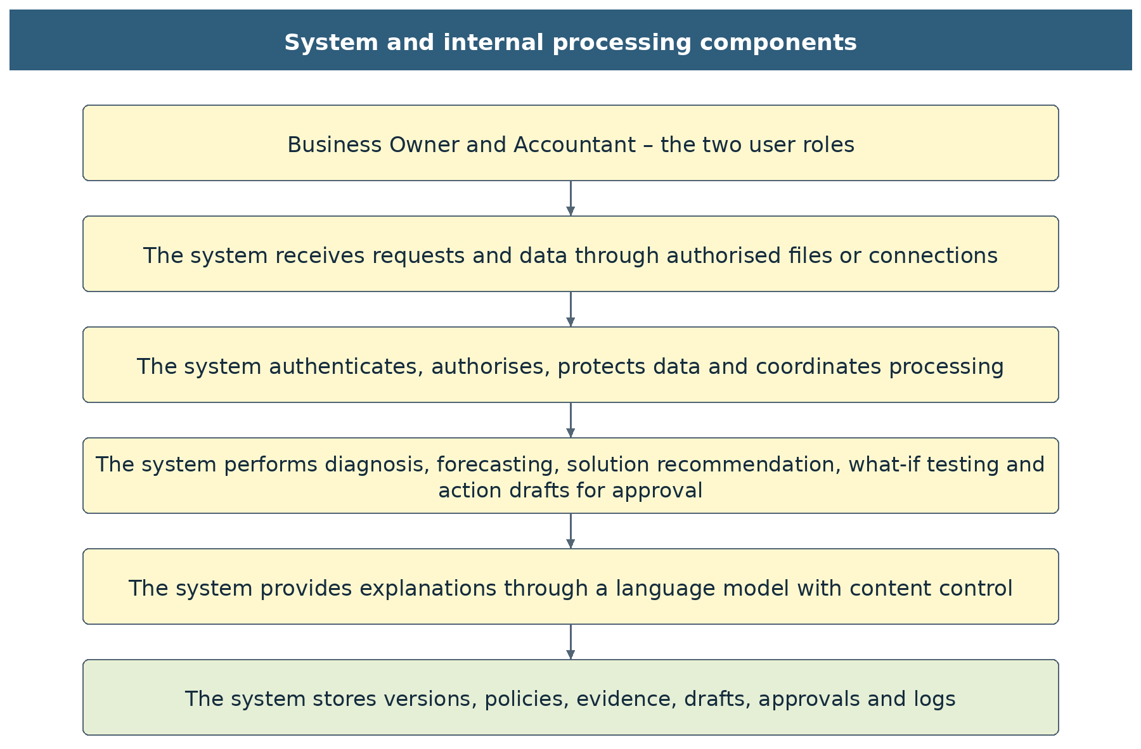

Figure 3-1: Architecture supporting two roles, six cells and three scenarios

3.4 Reliability and result status
Run status | Meaning | Interface behaviour
ok | Sufficient inputs, policy and release checks. | Display the result together with the period, the source and the forecast limits.
provisional | Declared assumptions exist, but no data mandatory for the conclusion being released is missing. | A provisional label and the assumptions are shown next to the result.
missing_data | A mandatory field or policy is missing. | Request supplementary input; do not release dependent classifications.
invalid_data | Data are contradictory or fail validation. | State the specific error; do not adjust figures automatically in order to continue.
rejected | The permission or the request is invalid. | Do not return unauthorised figures.
failed | Tool error, timeout or audit failure. | Do not create fictitious figures; allow an appropriate retry.
Table 3-4: Processing statuses separated from the business classes

These statuses are technical/quality statuses; they are not matrix cells or business groups. A classification object is output only when a valid result exists. A value that cannot be calculated carries a reason_code; it is not replaced by 0 and no additional classification value is used. A zero balance confirmed from a complete source is a valid value.
Code | Mandatory requirement
REL-01 | UC01: the counterparty total equals the balance; the aging buckets, including the portion lacking a due date, reconcile; owned rows and excluded portions reconcile; the CCC matches its unrounded components.
REL-02 | UC02: closing cash − Cash0 equals total inflows − outflows; the daily totals match the weekly totals; reconciled sources within the period/outside the period/unscheduled; no duplication between plans and invoices.
REL-03 | UC03: the total allocated portion does not exceed the source; the groups are in the correct order; days with available cash are checked; the remaining gap and later obligations are not concealed.
REL-04 | UC04: the total change matches the reversed/added events; the closing balance equals the base plus the impact; costs and amounts outside the period are not lost; history is not altered.
REL-05 | A cash discrepancy above VND 1 must block the dependent portion; for dates, the independent reconciliation indicator differs by up to 0.1 day after rounding. Passing the arithmetic reconciliation does not prove that the forecast is correct.
REL-06 | Test repeatability and environment separation; results from different snapshots or versions are not combined as the same base.
Table 3-5: Mandatory reconciliations

3.5 Performance
Function | Acceptance target | Measurement conditions
Diagnostic dashboard | No more than 3 seconds for calculation and data. | Fewer than 10,000 invoices; the machine configuration and cache are disclosed.
Three-scenario forecast | p95 no more than 3 seconds. | 10,000 events, at most 91 days, reference machine of 4 CPUs/8 GB; excluding LLM explanation generation.
Controlled Chat | p95 no more than 20 seconds; interrupted at 30 seconds with an appropriate status returned. | Retrieval, calculation, LLM and control are measured separately.
What-if Test | Response target within 3 seconds for the calculation engine at the same scale. | Three scenarios; objects already checked; measure in practice before acceptance.
Data upload and extraction | Run in the background if the interactive time is exceeded; show progress and retain status. | Size/row limits according to the tested configuration.
Concurrency | Pilot target of at least 50 user sessions. | Permission checks or audit are not bypassed in order to achieve speed.
Table 3-6: Performance targets to be measured

These indicators are test targets, not measurements already achieved. Update time depends on the source; the actual freshness must be displayed. The enterprise owner is not required to click repeatedly because a task is running; the status button and duplicate prevention must prevent the creation of multiple identical calculation runs.

3.6 Logging and operational support
Each run stores request_id, user_id/role, firm_id, cut-off date, source, source_hash, task, normalised parameters, the applicable schema/formula/policy/matrix/priority/catalogue versions, scenarios, reconciliation, audit_ref and the explanation mode. UC04 stores the parent and each change; UC03 stores the reasons for exclusion and the allocation. Secrets, the full content of documents and sensitive prompts are not placed in the default log. The action log records each simulated action with the draft identifier, version, content_hash, type, recipient reference, approver, time and tier 3; entries are never edited and are destroyed only in whole batches when the retention period of Table 3-16 ends.
Single audit trail. One logging component serves every channel: the screens, the Chat, the API and background jobs. The Chat applies the same rule, “no log, no release”: an answer that contains figures is not shown and the system returns AUDIT_WRITE_FAILED.
Events that must be logged. Running a task; an answer that was blocked, with the reason; a tool call or a parameter that was rejected; access denied (UNAUTHORIZED_SCOPE, UNAUTHORIZED_ROLE); changes to policy and master data; overwriting a source; creating, approving or rejecting a draft; exporting and deleting data; failed sign-ins and account lockouts.
Tamper evidence. Each record contains the hash of the previous record and its own hash. The hash chain is verified daily; a mismatch raises an incident code and an alert to the operator on duty of the product owner (IAM-08), who reports to the Business Owner.
What is not logged. API keys, passwords, the full text of a draft and the content of files. A draft is recorded only by its identifier and the hash of its content; counterparties are recorded by code.
Retention. The retention and destruction of the log follow Table 3-16.
Traceability runs from an explanatory sentence to fact_id, from the fact to formula_id and source_record_id, and from there to the correct file or source record within permission. A user who opens the history sees the date and a historical label; an old figure is not treated as current. Validators and policy changes must have a history so that it can be explained why the same enterprise has a different result after an update.

3.7 Tools, APIs and data contracts
LLM tool | Permitted parameters | The server determines automatically
diagnose_working_capital | Cut-off date/period, focus, language. | Enterprise, source, thresholds, permission and versions.
forecast_cash | Cut-off date, number of weeks 1–13, scenario within the three codes, language. | Cash0, L/Z/H, policy, source and assumption set.
match_liquidity_options | Scope of need or source_run_id, language. | W, TH, six cells, priority order and product conditions; source groups assigned by the LLM are not accepted.
simulate_scenario | Base code, object, nominal portion, date/shift, discount/fee/price or recovery ratio, language. | Enterprise, source, thresholds, three scenarios and the enterprise owner’s confirmation of authority.
create_action_draft | Test id, action type, target identifier (customer, supplier, invoice or product), template variant, optional user note. | Enterprise, ownership of the test, permission, template and its version, every figure, date and name (from the fact_registry), checks CK-01 to CK-10. The LLM has no tool that approves or executes; submit_action is not exposed.
Table 3-7: List of controlled tools

The match_liquidity_options tool allows UC03 to be opened directly through the Chat; this is an additional contract of version 2.2. The tools may read only authorised data and store analysis/simulation results. No tool has the authority to send an instruction to a bank or to edit a ledger. Parameters outside the schema are rejected; the LLM may not write policy.
Rules for Table 3-7. (1) The names in the table are canonical; the source code, the logs and the interface use exactly these names. (2) The permission layer checks every call in this order: the tool name is in the table; the role of the session is allowed (Table 3-3); each parameter is on the allowed list, of the right type and within its range. The enterprise code is always overwritten by the value of the session. (3) The step that records a simulated action (submit_action, tier 3 in Table 2-131) is never in the tool list of the LLM. Only the Approve button in the interface, pressed by the Business Owner, can trigger it, and in this version it runs in simulation mode only. For reference, diagnose_working_capital, forecast_cash and match_liquidity_options are tier 1, simulate_scenario is tier 2 and create_action_draft prepares a draft only. (4) A question may use at most 8 tool steps, and each tool is stopped after 30 seconds (TOOL_TIMEOUT), within the overall limit of 30 seconds of the Chat (Table 3-6).
The endpoints that run a task (POST /api/v1/tv1/diagnoses, /api/v1/tv2/forecasts, /api/v1/tv3/matches and /api/v1/tv4/simulations) do not accept thresholds, Cash0, L/Z/H or reserve levels; a request that carries them is rejected with INVALID_REQUEST. These values change only through the policy endpoints, by proposal and confirmation of the Business Owner (Table 3-8). The role of the caller is checked against Table 3-3.
Method and path | Function and control
POST /api/v1/data/imports | Securely receives a file; returns job_id; does not publish the source until it has been checked.
GET /api/v1/data/imports/{job_id} | Progress, issues and data status; checks object-level permission.
POST /api/v1/connections | Creates a read-permission API source configuration; the source type is declared explicitly.
POST /api/v1/connections/{id}/sync | Refreshes with duplicate prevention; does not force an update before every question.
GET /api/v1/data/status | Data date, freshness and issues to supplement; does not expose secrets.
POST /api/v1/tv1/diagnoses | UC01; the same calculation engine for the Chat and the screens.
GET /api/v1/tv1/diagnoses/{run_id} | Reads the result and the historical label.
POST /api/v1/tv2/forecasts | UC02; three scenario codes and the same assumption set.
GET /api/v1/tv2/forecasts/{run_id} | Reads the three cash paths and the evidence.
POST /api/v1/tv3/matches | Opens UC03 directly; the server resolves the base result itself.
GET /api/v1/tv3/matches/{run_id} | Reads the recommendation, the excluded sources and the remaining gap.
POST /api/v1/tv4/simulations | UC04; creates a test across the three scenarios.
GET /api/v1/tv4/simulations/compare | Compares on the same base; register the static route before the route with sim_run_id.
GET /api/v1/tv4/simulations/{sim_run_id} | Reads the test and the scope not simulated.
GET /api/v1/runs/{run_id}/evidence/{evidence_id} | Paginated evidence; 50 rows by default, 200 at most; checks that enterprise/run/evidence share the same permission.
POST /api/v1/policies/proposals | The Accountant or the enterprise owner creates a proposal; it has no effect yet.
POST /api/v1/policies/{proposal_id}/confirm | Only the enterprise owner confirms, using expected_version, reason and effective_date.
PUT /api/v1/master-flags | Propose/confirm flags according to the correct permission; store the source and the confirmer.
POST /api/v1/tv4/actions/drafts | UC04.6; creates a draft from a saved test; requires Idempotency-Key; returns draft_id, version, content_hash.
GET /api/v1/tv4/actions/drafts | Lists the Approval queue by status (all, pending, executed, rejected, blocked); only drafts of the caller’s enterprise.
GET /api/v1/tv4/actions/drafts/{draft_id} | Reads the draft, the checks, the history and the evidence links; checks object-level permission.
PATCH /api/v1/tv4/actions/drafts/{draft_id} | UC04.7; edits the permitted fields; requires expected_version; returns the new version and content_hash.
POST /api/v1/tv4/actions/drafts/{draft_id}/review | Records reviewed or returned with a comment; Accountant or Business Owner.
POST /api/v1/tv4/actions/drafts/{draft_id}/approve | UC04.8; Business Owner only; body carries draft_version, content_hash and the identity confirmation; re-runs CK-01 to CK-12; calls submit_action in simulation mode and writes the action log.
POST /api/v1/tv4/actions/drafts/{draft_id}/reject | Business Owner rejects with a reason code; creator may withdraw own draft (WITHDRAWN).
POST /api/v1/tv4/actions/drafts/{draft_id}/copy | Returns the approved text of an Executed draft for copying; the copy is logged; refused for any other status.
Table 3-8: Target APIs of version 2.2

POST requests that create analyses, simulations and proposals must carry an Idempotency-Key. The API accepts a run_id from the client only after verifying that it belongs to an authorised enterprise. The UI does not pass enterprise parameters as an authentication basis. No endpoint that creates a gap request is retained as a mandatory user step before UC03 is opened.
Code / HTTP | Behaviour
403 UNAUTHORIZED_SCOPE | Do not return data of the enterprise or of objects that are not authorised.
422 INVALID_REQUEST | State the field and the condition; keep the valid input on the UI. A tool or a parameter outside Table 3-7, or a threshold, Cash0 or reserve level in a run request, is rejected in the same way and logged.
422 UNSUPPORTED_SCENARIO | Reject codes other than base/conservative/positive; do not switch to Base automatically.
409 VERSION_CONFLICT / STALE_SOURCE | Do not combine versions; allow reloading or viewing the history.
200 with status=missing_data/invalid_data | Return the issues and the scope that can be calculated; an HTTP success is not treated as an achieved classification.
503 TOOL_TIMEOUT / AUDIT_WRITE_FAILED | Do not release fictitious figures or an uncontrolled draft.
403 APPROVAL_REQUIRES_OWNER / 401 REAUTH_REQUIRED | Approval by a role other than the Business Owner, or without identity confirmation in the last 5 minutes; no change to the draft; the attempt is logged.
409 DRAFT_NOT_PENDING / DUPLICATE_DRAFT | The draft was already decided, or an identical live draft exists; return the existing record, create nothing.
409 DOUBLE_COMMITMENT | The same invoice portion or payment is in another live draft; name the draft and do not create the second one.
422 TEMPLATE_VALIDATION_FAILED / UNSUPPORTED_ACTION_TYPE | A locked value, the notice or the note rules are violated, or the action type is not offered for the test; keep the valid input on the screen.
409 CHECK_FAILED / SUBMIT_FAILED | A check failed at approval or the simulated submission failed; the draft becomes Blocked with the reason code, or stays Pending if nothing was recorded.
403 UNAUTHORIZED_ROLE | The role of the session does not permit the operation (Table 3-3), for example an Accountant who tries to confirm a policy; no change; the attempt is logged. The role is read from the session and never from the interface.
Table 3-9: Error codes and handling

The common envelope comprises meta, status, issues[], data, evidence[], fact_registry and audit_ref. meta must contain schema_version, formula_version, policy_version and the source versions. issues carry code, field, row/source_ref, the impact and the guidance for supplementation. Numeric values use decimal strings or the decimal type according to the schema; ratios are specified explicitly in decimal form.
Subject | Constrained fields
classification when valid | wc_class: W0/W1/W2; cash_state: TH01/TH02; matrix_case: M1/M2/M3/M4/M5/M6; scenario: base/conservative/positive; matrix_version is mandatory.
When data are insufficient | Do not create the corresponding classification object; return status and issues. Do not use a different class code or force the result into W0/TH02.
Fact | fact_id, formula_id, raw_value, display_value, unit, as_of, scenario, evidence_ids, data_status.
Event | event_id, enterprise scope, source_record_id, object_id, type, direction, amount, date, scenario, certainty, replaces_event_id if any.
Policy | version, method, model_profile=FOB, inputs and sources, effective_date, confirmed_by, confirmed_at.
Match | priority_groups, eligible_sources, excluded_sources/reasons, package_events, remaining_gap_by_day, supported_simulation_scope.
Simulation | parent runs, changes[], results for the three scenarios, costs, tail_events, conclusion and reconciliation.
Table 3-10: Output contract constraints

3.7.1 Standardised data dictionary
The groups below are internal data contracts, not screens that the enterprise owner must fill in. The intake module maps column names from accounting software or Excel to these fields. Mandatory fields are determined by task; a missing field must not be converted automatically into a value of 0 or a business conclusion.
Subject | Field | Type / mandatory | Validation and use
Enterprise | firm_id | String; server | Identifier according to session permission; present on every record and query.
Enterprise | business_model | FOB; confirmed | Not inferred from the enterprise name or from individual delivery terms.
Enterprise | currency / timezone | VND / UTC+7 | Foreign-currency conversion, if any, must have an exchange rate, date and source; if absent, amounts are not added automatically.
Financial period | period_start / period_end | Date; mandatory for UC01 | N counts both end dates; a 365-day year is not assumed by default.
Financial period | revenue_vnd / cogs_vnd | Decimal; mandatory for indicators | Within the correct period; clear tax basis and deductions; a non-positive denominator produces no indicator.
Financial period | current_assets_vnd | Decimal; mandatory when material | Uses the same cut-off date; a proxy only when a confirmed policy exists, with a provisional label.
Dataset | snapshot_id / hash | String; auto-generated | Determines a reproducible base; not accepted from the LLM as a basis for granting access.
Dataset | as_of / source_batches | Date and list of codes | Consistent cut-off date; stores the source table and the time of successful reading.
Dataset | coverage / issues | Status structure | Separated by item, date and task; supplementation guidance is centralised.
Table 3-11: Profile, period and dataset fields

Subject | Field | Type / mandatory | Validation and use
Counterparty | party_id / party_type | String / customer or supplier | Not joined by name alone; the tax code, if available, supports reconciliation but is not disclosed unnecessarily.
Counterparty | relationship_start / invoice_months | Date / count | Computes the new/regular/occasional label on the declared historical window.
Counterparty | strategic / essential / exclusive | Yes/no/unconfirmed | Business flags confirmed by the enterprise owner; an unclear value is a field-quality issue, not an enterprise result class.
Counterparty | extension_allowed / evidence_ref | Condition and source | It is not inferred from the goods type that the supplier has agreed to an extension.
Invoice | invoice_id / party_id / order_id | Code; mandatory | invoice_id is unique within the enterprise scope and the source system.
Invoice | issue_date / due_date | Date | Missing due date: classified as an incomplete-schedule bucket; it is not assumed to be not yet overdue.
Invoice | amount / tax / currency | Decimal and code | Nominal amount, tax and accounting basis are clear; currency is uniform before aggregation.
Invoice | residual_amount_vnd | Decimal at the cut-off date | From the value after deductions less the allocated payment portion; the current balance is not used for historical dates.
Payment | payment_id / invoice_id | Source code and link | A payment allocated to several invoices must have a table of portions; the total of the portions does not exceed the source amount.
Payment | paid_date / allocated_amount | Date and Decimal | The delinquency sample is separated from the aging of open balances; only events up to the cut-off date are taken.
Adjustment | credit_note / disputed_amount | Decimal and basis | By business type; not all negative lines are forced to be treated as erroneous data.
Table 3-12: Counterparty, invoice and payment fields

Subject | Field | Type / mandatory | Validation and use
Lot / stage | lot_id / order_id / inventory_type | Code and type | Raw materials, work in progress, finished goods, merchandise or customer-owned goods.
Lot / stage | qty / available_qty / unit | Decimal and unit | Different units are not added; availability considers the portion reserved for orders and already allocated.
Lot / stage | unit_cost / book_value | Decimal | For WIP, use the confirmed accounting value; do not infer from the name or from estimated costs lacking a source.
Lot / stage | stock_start_date / date_basis | Date and measurement method | Receipt date, stage start date or a confirmed milestone; a missing milestone is not assigned the cut-off date.
Lot / stage | owner / pledge / restrictions | Flag and evidence | Customer-owned goods are excluded from INV and from sale sources; an unconfirmed pledge is not a reliably usable asset.
Lot / stage | cancelled_order / demand_evidence | Status and source | Not based merely on a name containing the word “cancelled”; confirmation is required to conclude that goods belong to a cancelled order.
Inventory sale | sale_qty / price / recovery_rate | Decimal according to the selected basis | Only one price basis is effective; there is a collection date and cash selling costs.
Cash | cash_balance / restricted_cash | Reconciled Decimal | Cash0 includes only usable cash; undrawn facilities are not added.
Historical cash | date / in / out / category | Date and Decimal | Complete coverage of the daily calendar; internal transfers are not counted twice.
Plan | plan_id / event_date / obligation | Code, date, type | Payroll, tax, electricity, transport, purchases, debt repayment and other items with a basis.
Standard event | event_id / source_record_id | Internal code / source | Unique link; an option does not cause the old source to be lost.
Standard event | direction / amount / date | Inflow or outflow; Decimal; date | Clear sign and type; sources outside the period are kept in a separate bucket.
Standard event | certainty / scenario / replaces | Level of confirmation, three codes, replacement code | No duplicate sources are created among plans, invoices and simulations.
Table 3-13: Inventory, cash and event fields

3.7.2 Record lifecycle and handling of missing information
Stage | Transition condition | Retention requirement
Intake | Authorised source and a file that has passed the safety check. | Private original file, batch_id and timestamp.
Extraction and mapping | Tables, columns, units and period identified. | Original values, standardised values and mapping rules.
Reconciliation | Balances and events match; mandatory issues resolved. | Row-level error reporting and evidence of the confirmer.
Base lock | Source and scope sufficient; the policy used for the task is in effect. | snapshot_id/hash and versions; no in-place editing.
Analysis / simulation | Permission granted and input schema valid. | run_id and parent relationship, effective parameters, checks.
Release | Arithmetic, content and audit all pass. | Facts, controlled text, status and evidence.
History | New data or policy exists. | The old version can still be read within permission with a historical label; it is not presented as current.
Action draft | Created from a saved UC04 test; edited, reviewed, then approved, rejected or blocked; the Business Owner’s approval is bound to the version and content_hash. | Each version, content_hash, decision, reason code and action_log entry; no in-place editing.
Table 3-14: Data and result lifecycle

If information is missing, the system identifies the task and the affected fields. For example, a missing due date on one invoice does not necessarily block total AR, but it blocks any assertion of the number of overdue days for that invoice. A missing Cash0 blocks the cash path; a missing threshold blocks threshold-based classification; a missing asset flag blocks only those UC03/UC04 sources that depend on the flag. The user sees the portion that has a sufficient basis and one centralised list of items to supplement, and does not pass through a chain of technical screens.

3.7.3 Inter-task handover rules
From → to | Content handed over | Mandatory checks
UC00 → all tasks | Standard source, period, quality and version. | Do not combine a portion of new data with an old portion that has not been reconciled.
UC01 → UC02 | Balances, objects, observed delay, findings and evidence. | UC02 builds its schedule independently; W does not replace the cash balance or add inflow rows automatically.
UC01 + UC02 → UC03 | W, Base TH, the six-case cell, objects and schedule. | Same enterprise, base and policy; paragraph text is not used as a data contract.
UC03 → UC04 | The selected O1/O3/O4 portion, amount, date, cost and conditions. | Separate the borrowing/investment not simulated; keep the selection with a clear scope.
UC02 → UC04 | Three original event schedules, L/Z/H and the assumption source. | Same Cash0 and horizon; a change creates a copy.
UC04 → interface | Before and after for the three scenarios, cost, days that worsen, obligations after the period. | Do not replace the historical W/CCC, do not write to the accounting system, do not create a transaction.
UC04 → Approval queue | The saved test, the action type, the target and the template variables as facts of the test. | Same enterprise, current versions and permission; the draft does not change the test; nothing is sent outside the application.
Table 3-15: Shared handover contracts

A request to open Solutions may trigger a chain of internal preparation, but only one progress status is returned to the user. If a mandatory error arises, the exact issue is returned and the current screen is retained; once the supplement is complete, the system continues from the valid state instead of requiring each task to be rerun.

3.7.4 Retention of data
Table 3-16 lists the data groups, where they are kept and the default retention. The periods are proposals for the pilot; the enterprise may set shorter ones, and no statutory period is asserted before the scope of deployment is determined (3.2.2). Export and deletion follow 3.2.7.
Data group | Examples | Where kept | Default retention | Who may delete
User accounts | Name, e-mail, role, enterprises granted | Server, encrypted at rest | Until the account is deleted | The user; the Business Owner for Accountant accounts of the enterprise
Uploaded files | Sales, purchase and inventory ledgers, cash plan | Buffer of the server, encrypted | Deleted after the snapshot is created; 30 days at most | Accountant; Business Owner
Snapshots, results and evidence | Standardised data, indicators, forecasts, solution packages, simulations, action drafts | Server, encrypted | 24 months, or the policy of the enterprise | Business Owner
Chat history | Questions, answers, run identifiers | Server, encrypted | 12 months | The user
Audit log | Request id, actor, tool, parameters, result, reason for blocking | Append-only store with a hash chain | 5 years; the actor is anonymised when the account is deleted | No one may edit; destroyed in batches on expiry
Data sent to the LLM | Filtered question, fact codes, labels, pseudonyms of counterparties | LLM provider | The system keeps no copy; the terms of the provider apply | Not applicable
Calibration data (Part 4) | Survey answers, Delphi ranges, pilot ledgers used for backtests | Server, encrypted; pseudonymised | Link key: deleted when follow-up ends, 6 months at most; pseudonymised data: until the repeat validation, 36 months at most | Product owner; an enterprise may withdraw its data at any time
Calibration log | Key, old and new value, sources, n, metrics, proposer, approver | Append-only store with a hash chain | As the audit log | No one may edit
Support access grants | Operator, scope, start and end, reason | Audit log | As the audit log | No one may edit
Web demonstration | Accounts, files and Chat with fictitious data | The browser of the user | Until the user deletes them | The user

Table 3-16: Data kept, where it is kept and default retention

3.8 Legal, copyright and usage limits
Every result must make clear that it is an analysis based on data and assumptions, not a credit decision or a commitment to receive or pay. Simulated data must carry fictitious names. Industry and product sources may be used only according to the rights granted; original data are not redistributed where the terms do not permit it.
Where a legal conclusion requires an SME classification, it must rely on records and current regulations checked at deployment; this SRS does not itself confirm status from annualised revenue. Data retention policy, data protection obligations and the scope of financial services must be reviewed against the actual deployment option. This document describes software requirements and does not assert that the system has been certified or that the targets have been measured. Personal data are processed under the Law on Personal Data Protection No. 91/2025/QH15 and Decree No. 356/2025/NĐ-CP; the role of the vendor and of the enterprise under that law, the impact assessment and any cross-border transfer are confirmed by counsel (LEG-01, PRV-01 to PRV-05).

4 Phase 2 calibration
Part 4 specifies how the parameters released in this version are made relevant to small and medium-sized FOB garment enterprises and kept up to date after go-live. It is a plan for the period after the competition demonstration; it does not change any figure, rule or test case of Parts 2 and 3. Where Part 4 proposes a value, the value is a proposal until it is approved and released as a configuration version.

4.1 Purpose, scope and principles
The thresholds of this version come from configuration fob.threshold.v3: 20 listed FOB garment enterprises, 60 enterprise-years, FiinTrade 2023–2025, with the v11 formula set (2.7.8, Table 2-25). Several other parameters are still demo_assumption or a default owner_policy (Appendix C, Table C-1). Phase 2 turns them into SME-relevant, self-calibrating parameters by combining four sources: the industry panel, a primary SME survey, structured expert judgement and each enterprise's own history. Its main release is the threshold set fob.threshold.v4 .
Calibrate the calculation, not the language model. Lilact improves by re-estimating the parameters of the deterministic engines. The LLM only explains verified results (3.2.3), so every improvement can be measured, approved and reversed.
No silent change. Only the collection delay of each customer updates without approval (rules H1 and H2 of 2.8.17.5). Thresholds, global defaults and the cash policy change only through an approved configuration version; L changes only through UC02.3.
FOB first. CMT data are not used as defaults (Table 1-4). A CMT stratum may be surveyed for comparison, but CMT thresholds need their own panel and the same steps before release.
Evidence before release. A parameter is released only when the acceptance rules of 4.4 and 4.8 are met; otherwise the earlier version stays in force and the gap is recorded in Table G-1.

4.2 Parameter inventory and approval route
Of the parameters in Table C-1, only the FOB industry thresholds and the cash-buffer percentile are verified_reference . Phase 2 gives every family a named source and an approval route. Families are listed in calibration priority order.
Priority | Parameter family (configuration keys) | Phase 1 value and source | Phase 2 source | Approval
1 | DSO and DIO thresholds: wc.dso.watch.fob, wc.dso.severe.fob, wc.dio.watch.fob, wc.dio.severe.fob | P75 / P90 of FOB 2023–2025: 58.2 / 66.3 and 86.1 / 138.0 days (verified_reference) | Three-layer design (4.3); validated on SME outcomes (4.4) | Product owner for the industry layer; Business Owner for the enterprise layer
1 | Payables and cash-pressure rule: wc.dpo.low.fob, liq.cash_buffer.thin.fob, wc.severe_forces_w2 | P10 DPO 14.9 days with a cash buffer below 8.3% of revenue (P25); severe forces W2 = 1 (owner_policy) | Survey shortfall events; validation of the W2 rule (4.4) | Product owner for defaults; Business Owner for the enterprise
1 | Materiality: wc.materiality_share | 5% of current assets (owner_policy) | Delphi range (4.7) checked against survey outcomes | Business Owner, after step-up re-authentication
2 | Invoice and lot signals: ar.invoice.overdue_rho, inv.lot.slow_days | 0.5 / 1.0; 60 / 30 days (demo_assumption) | Contract terms and production cycles from the survey; Delphi | Business Owner
2 | Size and seasonal factors: wc.factor.size, wc.factor.season | 1 / 1; Mann–Whitney p = 0.17–0.59; seasonality not calibrated | Monthly or quarterly data from the survey and pilot enterprises; tests re-run | Product owner
2 | Cash policy: L (ℓ × TTM revenue, owner floor), b, r, q_yellow, q_orange | ℓ = 4.18%; b = VND 1 million; r = 4.75%; q levels pending confirmation | Survey (actual buffers, shortfall episodes) and Delphi; σ refreshed by H5 | Business Owner through UC02.3 only; never changed automatically
3 | Collection delay: fb.shift_days, fb.recent_n, default and overdue delay | 7 days / 5 invoices (demo_assumption) | Loops 1 and 2 (4.9); ML challenger (4.10) | Automatic per customer (H1, H2); global defaults by H3 and the Business Owner
3 | Bottleneck and counterparty rules: bn.near_threshold_ratio, bn.concentration_share, cl.*, history_min_count | 0.9 / 0.5 (demo_assumption); cl.* pending confirmation | Counterfactual test on pilot data; survey distributions; Delphi | Product owner; Business Owner confirms cl.* for the enterprise
4 | Feedback-loop settings: fb.rerun_days, fb.min_matched, fb.consecutive_runs and the model_health thresholds (Table 2-88) | 7 days / 20 invoices / 2 runs; watch and severe levels of FB-1 to FB-7 | Backtests on pilot enterprises (4.4) | Product owner

Table 4-1: Parameter families, Phase 2 sources and approval

4.3 Three-layer thresholds with credibility weighting
A single industry percentile cannot reflect an enterprise's contracts or its own trend. Phase 2 evaluates each of DSO, DIO and DPO against three references and combines them with a credibility weight, so that a new client relies on the industry and an established client gradually receives thresholds of its own.
Layer | Question it answers | How it is computed | Main use
Industry (outside view) | Where does the enterprise stand among FOB garment enterprises? | P75 / P90 of the FOB panel (P10 for low DPO), with size and seasonal factors where a test supports them (2.7.8, Table 2-25) | Anchor; prevents an enterprise from benchmarking only against itself
Contract (operating norm) | Are balances drifting from what the enterprise has agreed? | DSO norm = revenue-weighted customer terms; DIO norm = purchase lead time + production cycle + shipment wait; DPO norm = purchase-weighted supplier terms | Primary operational signal
Own history (trend) | Is the enterprise getting worse than its own normal? | Rolling 12-month median and P75 of the enterprise’s own days (P25 for DPO) | Early warning of deterioration

Table 4-2: The three threshold layers
The enterprise-specific watch threshold for an indicator is:
T_firm = w × T_own + (1 − w) × T_industry, w = MIN( n / (n + k); w_max )
where T_own is the larger of the contract norm plus tolerance and the enterprise’s own P75 (for DPO, the smaller of the contract norm minus tolerance and its own P25); n is the number of months of confirmed enterprise data; k is the credibility constant (proposed 12 months, so w = 0.5 after one year); and w_max caps the enterprise weight (proposed 0.7). The severe threshold is built in the same way from P90. The approach follows Bühlmann credibility theory used in insurance pricing: the less data an enterprise has, the more weight the population receives.
Industry floor. With w_max = 0.7, at least 30% of every threshold comes from the industry, and T_firm is never set below the industry reference level (wc.dso.reference.fob, wc.dio.reference.fob), so an enterprise that has been weak for years is still flagged.
Persistence (proposal). A W2 that arises only from the enterprise layer requires the signal in two consecutive confirmed snapshots, unless the excess capital exceeds twice the materiality share. A breach of the industry P90 keeps the behaviour of wc.severe_forces_w2.
Materiality and double counting unchanged. The three layers set the threshold, not the decision. Excess capital, materiality and the prevention of double counting follow 2.7.11.3 and Table 2-27; a high DPO alone does not raise W (Table C-1).
Transparency. Expert mode shows the three components, w, n and the configuration version of each threshold; the Chat quotes them only through the fact_registry.

4.4 Validating the thresholds
A threshold is relevant only if enterprises above it run into trouble more often than enterprises below it. Validation figures of earlier samples are not carried over (2.7.8); Phase 2 measures this on the 60 FOB enterprise-years and on the SME survey.
Outcome definition for SMEs. An enterprise-year counts as distressed if, within the next 12 months, any of the following occurs: a self-reported cash shortfall that delayed payroll, tax or supplier payments; a bank loan overdue by more than 10 days; a net loss together with a fall in revenue of more than 30%. The survey (4.6) collects these events directly.
Metrics. (1) Distress rate by W level with 95% Wilson confidence intervals; the rate must rise from W0 to W1 to W2. (2) Fisher’s exact test for W1 against W2 and W0 against W2. (3) Discrimination of the continuous score (excess capital / current assets) for next-year distress: area under the ROC curve (AUC). (4) Precision and recall of W2, so that users know how many W2 alerts are false alarms. (5) Sensitivity: repeat (1)–(4) with watch thresholds at P70 and P80 and severe thresholds at P85 and P95. (6) Out-of-time check: calibrate on 2023–2024 and test on 2025, then repeat after the first pilot year.
Criterion | Accept | Action if not met
Monotonic distress rate W0 < W1 < W2 | Point estimates increase and W0 against W2 has p < 0.05 | Revisit the percentiles and factors
W1 against W2 separation | p < 0.10 | Merge W1 and W2 into one level and let materiality set the severity wording
Rule wc.severe_forces_w2 | Enterprises above P90 but below materiality are distressed at least as often as W1 enterprises | Propose wc.severe_forces_w2 = 0 for approval
AUC of the continuous score | ≥ 0.65 on the out-of-time sample | Add the contract and trend layers before release
Stability between annual releases | Change ≤ 15% unless a documented market shift explains it | Freeze the previous version and investigate
SME check | Same direction on the survey sample as on the listed panel | Keep the industry weight high (lower w_max) for SMEs

Table 4-3: Acceptance criteria for a threshold release (proposed; confirmed by the product owner)

4.5 Data sources and triangulation
No single source is enough: published SME data in Vietnam are scarce, listed enterprises are larger than SMEs, and survey answers are self-reported. Each source is used for what it measures best, and a parameter is accepted only when the sources do not contradict each other (4.8).
Source | What it provides | Main bias | Use in Phase 2
FiinTrade FOB panel, 20 listed enterprises, 2023–2025 (existing) | Audited DSO, DIO, DPO, cash buffers, distress outcomes | Larger enterprises; annual year-end balances; survivors | Industry layer; out-of-time validation
Primary SME survey (new, 4.6) | Contract terms, production cycles, balances, cash-shortfall events, seasonality | Self-report and recall; non-response | Contract layer; SME validation; evidence in the update of 4.8
Expert Delphi panel (new, 4.7) | Ranges for parameters without data: materiality, tolerances, bottleneck rules, reserve days | Judgement; anchoring | Prior distributions; plausibility check
Pilot enterprises’ ledgers (new, 5–10 FOB enterprises) | Invoice-level history, actual receipt dates, daily cash | Small sample | Own-history layer; collection-delay model; forecast backtests
Public enterprise microdata (to be confirmed) | Financial statements of SMEs | Access conditions; coverage of garment SMEs | Cross-check of SME percentiles

Table 4-4: Data sources and their use
Candidate public sources to verify in month 1: the annual Enterprise Survey microdata of Vietnam’s national statistics agency for research use, and the World Bank Enterprise Surveys rounds for Vietnam. Their availability and coverage of garment SMEs have not yet been checked.

4.6 Primary SME survey design
Target population. Vietnamese FOB garment and apparel SMEs that meet the SME criteria of Decree 80/2021/NĐ-CP. A CMT stratum may be added for comparison only (4.1).
Sampling frame and strata. Membership lists of garment industry associations and provincial SME registries, stratified by size (micro, small, medium). Target 120 completed responses with at least 30 per size class; oversample enterprises that hold their own fabric stock, which carry most of the inventory risk.
Module | Content | Feeds
A. Profile | Size, main buyers, share of export orders, months with peak output | Factors; strata
B. Contract terms and cycles | Payment terms given to the top 3 customers and received from the top 3 suppliers; purchase lead time; production cycle; shipment wait | Contract layer; inv.lot.slow_days; ar.invoice.overdue_rho
C. Working-capital balances | Receivables, inventory, payables and cash at the last two quarter-ends; optional upload of an ageing report | SME percentiles; validation
D. Cash-shortfall events (last 12 months) | Months with delayed payroll, tax or supplier payments; overdue bank loans; actions taken (early collection, supplier extension, overdraft, sale of stock) | Outcome for validation; source preferences of UC03
E. Practices and tolerance | Minimum cash the owner is comfortable with (days of essential spending); how late a payment must be before it causes concern | L floor; tolerances; Delphi anchor

Table 4-5: Questionnaire modules (about 25 minutes; online with telephone follow-up)
Data quality. Ranges instead of single numbers where respondents are unsure; consistency checks between modules B and C; a recall window of 12 months only; follow-up calls for outliers; documents (ageing report, payment terms) earn a higher weight in 4.8.
Ethics and privacy. Written consent; no personal data beyond the respondent’s role; enterprises identified by a random code; results reported only in groups of at least 5 enterprises; storage and deletion as in 3.2.7 and Table 3-16. The survey data are used for calibration only, never to train a model on an identifiable enterprise.

4.7 Expert elicitation (Delphi)
Expert judgement is used where no data exist, and it is collected in a structured way so that it is repeatable and auditable rather than a single opinion.
Panel. 10–12 experts, anonymous to each other: SME credit officers from at least two banks (4), chief accountants or CFOs of garment SMEs (3), auditors (2), corporate-finance academics (2) and an industry association representative (1).
Rounds. Round 1: for each parameter, a minimum, a most likely value and a maximum, with a short reason. Round 2: each expert sees the group median, the interquartile range (IQR) and anonymised reasons, plus the fob.threshold.v3 value, and may revise. Round 3: only for parameters without consensus; the survey result (4.6) is shown when available.
Consensus rules. A parameter reaches consensus when the IQR is at most 20% of the median and the median moves by less than 10% between rounds. For ranking questions (for example the source priority of a cell in UC03), Kendall’s W of at least 0.5 is required.
Parameter | Question asked | Configuration key
Materiality | Above what share of current assets does excess working capital become a real problem for a garment SME? | wc.materiality_share
Invoice tolerance | How far past the payment term (as a multiple of the term) is a receivable worrying, and when is it severe? | ar.invoice.overdue_rho
Slow stock | After how many days is a lot slow-moving, for materials and for finished goods? | inv.lot.slow_days
Cash floor | How many days of essential spending should a garment SME hold as a minimum? | L (owner floor, ℓ)
Concentration | Above what share of excess receivables is one customer a concentration risk? | bn.concentration_share
Seasonality | Which months carry peak inventory and receivables for FOB enterprises? | wc.factor.season

Table 4-6: Questions for the panel
Aggregation. The final range of each parameter is summarised as a PERT distribution, which becomes the prior in 4.8:
μ0 = (a + 4m + b) / 6, σ0 = (b − a) / 6
where a, m and b are the group medians of the minimum, most likely and maximum values.

4.8 Combining the sources
Each SME-level parameter is estimated by updating the expert prior with survey evidence. For a parameter with prior mean μ0 and spread σ0, and a survey estimate x̄ with standard error s/√n (bootstrap standard error for percentiles), the combined value is the precision-weighted mean:
θ = ( μ0 / σ0² + x̄ × n / s² ) / ( 1 / σ0² + n / s² )
The more survey responses and the tighter they are, the more the result moves from the experts’ view toward the data. Responses backed by documents count twice in the survey estimate. The combined value becomes the SME industry layer; the enterprise layer is then added with the credibility weight of 4.3.
Situation | Status | Action
Survey estimate inside the experts’ [a; b] range and the 90% interval of the combined value narrower than 20% of its level | verified_reference | Release in a new configuration version
Survey estimate outside the experts’ range | provisional | Show the survey result in Delphi round 3; keep the label “provisional” in the interface
Fewer than 20 responses in the stratum | Not updated | Keep the fob.threshold.v3 value; record the gap in Table G-1
Combined value differs from the listed-enterprise value by more than 30% | verified_reference with a note | Document the reason (for example SME payment terms) in calibration_log

Table 4-7: Acceptance rules for a combined value
Every released value records its sources, n, prior, posterior, interval, approver and date in calibration_log (4.11).

4.9 Self-calibrating loops
The feedback loop of 2.8.17 is the engine of Phase 2. Phase 2 groups its rules into three loops with different speeds and different approvers. We describe the result as self-calibrating, human-approved .
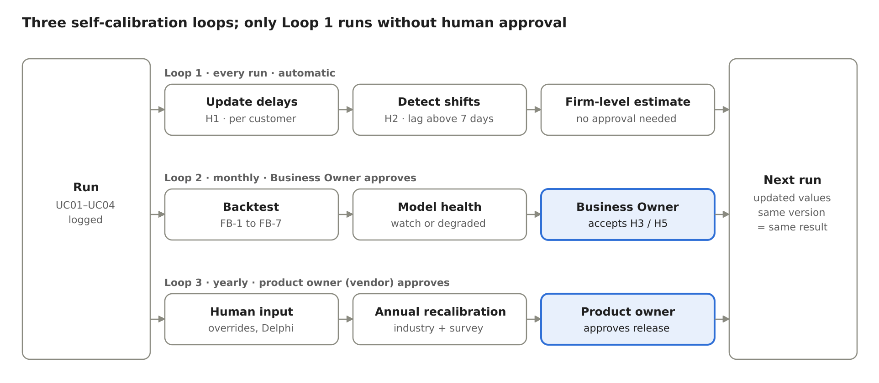
Figure 4-1: Three self-calibration loops and two approval gates
Loop | Trigger | What changes | Who approves | Evidence
1. Behavioural update | Every run on a new confirmed snapshot | Each customer’s delay estimate (H1); “delay has shifted” label and recent-sample estimate (H2) | None (enterprise-level estimates only) | Delay source and sample size shown per customer; calibration_log for H2
2. Error-driven recalibration | model_health = watch or degraded with at least fb.min_matched reconciled invoices; new daily cash data | Default and overdue delay (H3); Z and H through a cash policy proposal (H5) | Business Owner, after step-up re-authentication | model_health, FB-1 to FB-7 before and after, calibration_log
3. Structural recalibration | Yearly, or after a validation failure | FOB thresholds, factors, materiality default, bn.*, fb.* and model_health thresholds | Product owner with independent review; firm-level values by the Business Owner | Validation report (4.4), Delphi and survey reports

Table 4-8: The three loops
How to show it in the demonstration. Load a second snapshot in which one major customer pays later than forecast. The demonstration then shows that customer’s delay estimate updating (Loop 1), model_health moving to watch with a proposed new default (Loop 2), and the approved change appearing in calibration_log with a new configuration version.

4.10 Machine-learning component: champion and challenger
Machine learning is introduced only where it can beat a transparent rule on real data. The first candidate is the collection-date forecast, because it drives the 13-week cash path and produces labelled data automatically each time an invoice is paid.
Champion. The current rule: the delay of each customer estimated from its collected invoices (H1), the recent-sample estimate after a shift (H2), and the overall and default levels as fallback (2.8.17.5).
Challenger. A gradient-boosted model or a survival model predicting days late per invoice. Features: the customer’s past delays and their trend, invoice size relative to the customer’s average, days already overdue, month of year, payment terms, customer class (cl.*) and concentration share. No personal data and no free text.
Activation. The challenger is trained only when an enterprise has at least 500 reconciled invoices over at least 6 months, or when enterprises consent to a pooled model trained on pseudonymised features.
Promotion rule. The challenger replaces the champion for an enterprise only if it reduces the receipt WAPE (FB-2) and the absolute bias (FB-3) by at least 10% in two consecutive monthly backtests, without worsening the delay error (FB-4) or the misses of FB-6. Promotion needs the product owner’s approval and creates a new model version.
Rollback. If the promoted model’s model_health becomes degraded, the system returns to the champion automatically and records the event.
Explainability. Each predicted date shows its top three drivers in Expert mode; the Chat still quotes only the computed dates through the fact_registry.
What is not done. The language model is not fine-tuned on client data, and one enterprise’s data are never used to train a model for another enterprise without that enterprise’s consent.

4.11 Governance, privacy and security of calibration
No silent change. Loop 1 updates only enterprise-level behavioural estimates. Global defaults, thresholds and the cash policy change only through an approved configuration version; L changes only through UC02.3, and rule H6 blocks any calibration that would change L without confirmation.
Versioning and reproducibility. Each result records the schema, formula and configuration versions; the same snapshot with the same versions gives the same figures and ranking (3.4). A reconciliation always uses the version of the original run (FB-E6).
calibration_log. Each change records the configuration key, old and new value, data sources and n, method (Delphi, Bayesian update, backtest, ML promotion), metrics before and after, proposer, approver, step-up confirmation, date and effective version. The log is append-only and follows the retention of the audit log (Table 3-16).
Roles. The product owner (the vendor, not a user of the enterprise) approves global defaults and model promotions and has no access to enterprise data except through a time-limited support grant (3.2.1). Within each enterprise, the Business Owner approves enterprise-level thresholds, the cash policy and Loop 2 proposals after step-up re-authentication; the Accountant supplies and confirms the data they rest on (snapshots, reconciled receipts, the proposed Cash0) and cannot approve a calibration change (Table 3-3).
Privacy. Survey, Delphi and pilot data follow 3.2.7: consent, pseudonymisation, aggregated reporting, and the retention periods of Table 3-16. Calibration uses only the fields of the standardised data dictionary (3.7.1).
Independent review. Before each annual release, a person who did not run the calibration re-runs the validation metrics of 4.4 from the logged inputs.

4.12 Roadmap
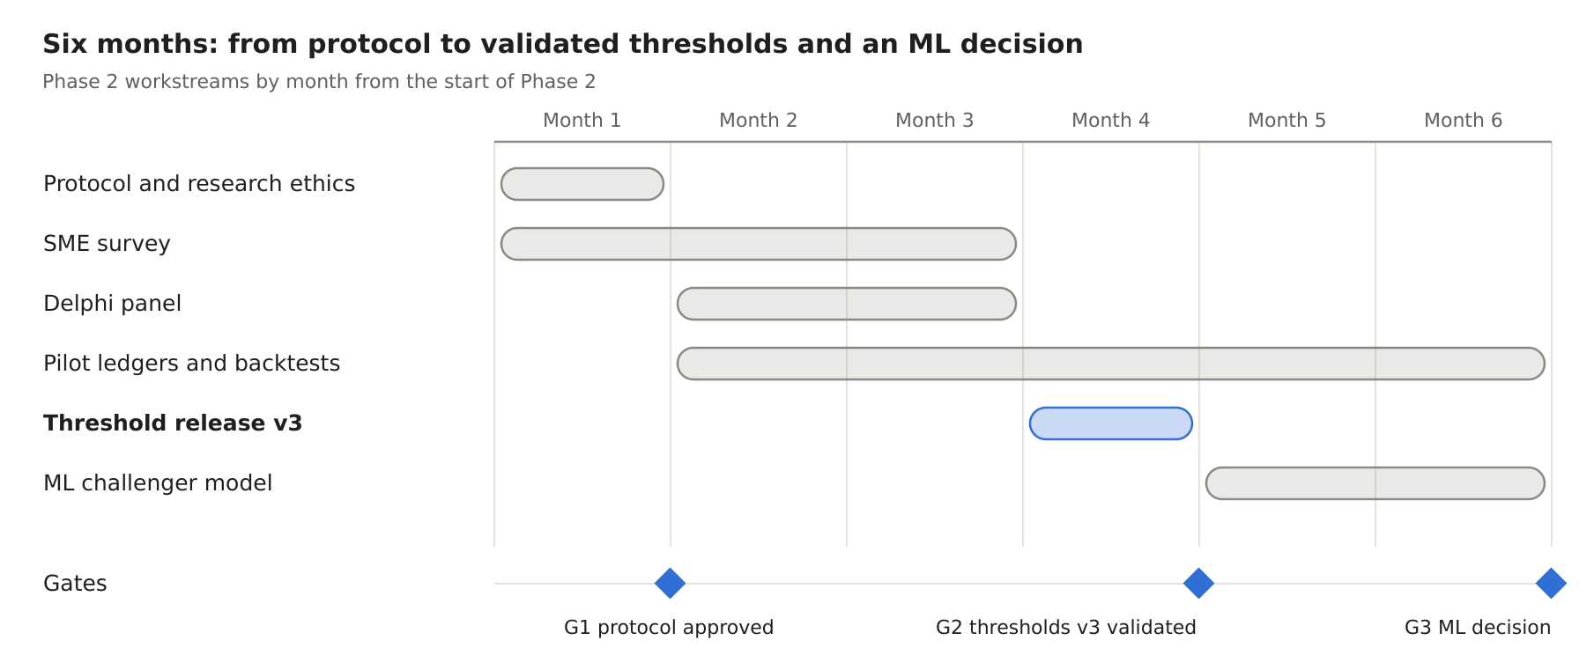
Figure 4-2: Phase 2 roadmap: six workstreams and three gates
G1 approves the protocol, questionnaire and Delphi questions; G2 releases fob.threshold.v4 only if the acceptance criteria of 4.4 are met; G3 decides whether the collection-delay challenger replaces the rule for each pilot enterprise. Pilot backtests run from month 2 so that six monthly comparisons are available by G3. All three gates fall after the Pilot security gate (3.2.6), because real enterprise data are processed.

4.13 Deliverables, KPIs and limitations
Deliverable | Content | Due
Calibration protocol | This plan, signed off; survey questionnaire; Delphi question set | Month 1
SME survey dataset and report | 120 responses, cleaned and pseudonymised; descriptive tables by stratum | Month 3
Delphi report | Final ranges, consensus statistics, reasons | Month 3
Threshold release fob.threshold.v4 | Three-layer thresholds, validation report (4.4), calibration_log | Month 4
Pilot backtest report | Forecast errors FB-1 to FB-7 on 5–10 pilot enterprises; proposals H3 and H5 | Month 6
ML challenger report | Champion against challenger results and the promotion decision | Month 6

Table 4-9: Phase 2 deliverables
KPIs for the end of Phase 2 (targets proposed for the pilot). The distress rate rises monotonically across W0, W1 and W2 on the SME sample, and the AUC of the score is at least 0.65. At least 80% of the demo_assumption parameters in Table C-1 move to verified_reference or owner_policy. On pilot enterprises, FB-2 is at or below 25% and |FB-3| at or below 10%, and FB-6 records no miss in the last two months of the pilot.
Limitations. The survey is self-reported and may over-represent better-organised enterprises; documents and pilot ledgers are used to correct for this. Twelve months of outcomes are short for distress events, so the validation is repeated after the second year. Thresholds remain calibrated for FOB garment enterprises; other industries and CMT need their own panel and the same steps.

Appendix A UC01 formula dictionary
Code | Formula / definition | Control
F01 | N = end_date − start_date + 1 | Number of calendar days; N > 0.
F02 | Rev = revenue_vnd; COGS = cogs_vnd | Within the correct period, on the same calculation basis.
F03 | AR = Σ balance of sales invoices at the cut-off date | Deductions/payments allocated on the correct date.
F04 | INV = Σ value of owned goods | Goods at the workshop are not assumed to be owned goods.
F05 | AP = Σ balance of trade purchase invoices | Borrowings, payroll and taxes are not included.
F06 | DSO = AR / Rev × N | Rev > 0; if the denominator is invalid, the indicator is not computed.
F07 | DIO = INV / COGS × N | COGS > 0.
F08 | DPO = AP / COGS × N | Same basis as DIO.
F09 | CCC = DSO + DIO − DPO | Computed from unrounded components.
F10 | TWC = AR + INV − AP | A trade balance, not Cash0.
F11 | AR_share_k = AR_k / AR | When AR=0, the share does not apply; do not divide by 0.
F12 | DSO_contribution_k = AR_k / Rev × N | The total equals DSO if the scope is the same.
F13 | DIO_contribution_j = INV_j / COGS × N | The total equals DIO; customer-owned goods are not included.
F14 | Overdue = Σ balances with due_date < as_of | The portion lacking a due date is reported separately.
F15 | DaysOverdue_i = MAX(0, as_of − due_date_i) | Applies only when a due_date exists.
F16 | OverdueWeightedDays = Σ(residual_i × overdue_days_i) / Σresidual_i | Overdue sample; balances not yet due are not implicitly included in the sample.
F17 | DelaySigned = Σ(paid_amount × (paid_date − due_date)) / Σpaid_amount | Payment sample with complete dates; disclose the lookback and the number of observations.
F18 | DelayPositive = Σ(paid_amount × MAX(0, paid_date − due_date)) / Σpaid_amount | Distinguishes historical late payment from the contractual term.
F19 | DaysHeld_j = as_of − stock_start_date_j | The date of entry into the warehouse/stage is defined; time is not measured when the source is missing.
F20 | ExcessDays = MAX(0, observed_days − threshold_days) | The threshold of the correct goods type or indicator.
F21 | E_AR_agg = MAX(0, AR − dso_watch × Rev/N) | A policy in effect exists.
F22 | E_INV_agg = MAX(0, INV − dio_watch × COGS/N) | A policy in effect exists.
F23 | E_AR = E_AR_agg; E_INV = E_INV_agg; invoice-level and lot-level signal amounts are reported separately | Detail-level amounts do not change W; no double counting.
F24 | E_AP = overdue AP with a signal | Reported as an obligation; not added to trapped cash.
F25 | money_at_risk = E_AR + E_INV | Not identical to the forecast inflow.
F26 | materiality = MAX(E_AR,E_INV,E_AP) / current_assets | Valid denominator; an unapproved proxy is not used automatically.
F27 | W according to the signal level and materiality | W0/W1/W2 only when the conditions are met.
Table A-1: Diagnostic formula dictionary

Changes to formula codes in the SRS must be mapped to the workbook codes when the formula set is updated in the next step. The F codes in this appendix are the requirement codes of version 2.2; they are not a statement that the current workbook has been synchronised.

Appendix B UC02 UC03 UC04 formulas
Code | Formula | Meaning
CF01 | x_t = historical_in_t − historical_out_t | Daily net cash flow of the estimation sample.
CF02 | x̄ = Σx_t/n; σ² = Σ(x_t − x̄)²/(n−1) | A sample with complete days and sufficient coverage.
CF03 | D = (3×b×σ²/(4×i))^(1/3) | Miller–Orr adjustment range.
CF04 | Rmin=L; Rtarget=Z=L+D; Rupper=H=L+3D | Compatible with the old names; values must be recomputed.
CF05 | Cash_t = Cash_(t−1) + In_t − Out_t | Computed separately for each scenario.
CF06 | FloorGap_t = MAX(0,L−Cash_t) | Used for the branch below the floor.
CF07 | TargetGap_t = MAX(0,Z−Cash_t) | Replenishment target; not mixed with CF06.
CF08 | AboveUpper_t = MAX(0,Cash_t−H) | The portion above H; not equal to the investable amount.
CF09 | pressure_t = CLAMP((Z−Cash_t)/(Z−L),0,1) | q_yellow/q_orange are separate early-warning policies.
CF10 | TH01 if there exists Cash_base,t < L; otherwise, if there exists Cash_base,t > H, then TH02; otherwise within the band | Two routing branches; within the band no cell is assigned and there is no balance code.
CF11 | GapDays = COUNT(Cash_t < L); NegativeDays = COUNT(Cash_t < 0) | The sum of daily gaps is not taken as the amount to borrow.
CF12 | RequiredCash0_L = MAX(0,MAX[L−CumulativeNetFlow]) | Computed including the point before the first day; the CF for Z is similar.
CF13 | WeeklyNet = Σ In_t − Σ Out_t; WeeklyMin = MIN Cash_t | A 7-day week; forecast start date = as_of+1.
MT01 | priority_groups = policy(matrix_case) | M1 O2; M3 O4→O1; M5 O4→O3→O1→O2; M2 I0; M4/M6 R0.
MT02 | RemainingFloorGap_t = MAX(0,L−CashAfterPackage_t) | By schedule; source amounts are not stacked.
MT03 | SafeCash = MAX(0,MIN(Cash_available_t0−Z, MIN_s,t(Cash_s,t−Z))) | From t0 to the recovery date τ, in all three scenarios.
U401 | AR_new = A × (1−discount) | Remove A from the old schedule and then add the net amount on the new date.
U402 | AP_new = P + fee | Remove P from the old date; keep the new payment, including after the period.
U403 | GrossSale = qty_sold × price or BookSold × recovery | Only one price basis.
U404 | NetSale = GrossSale − cash_selling_cost | The fee is deducted once.
U405 | DeltaNet_t = Σ changed_in_t − Σ changed_out_t | Includes the reversal of the source schedule.
U406 | CashAfter_t = CashBefore_t + Σ_(u≤t)DeltaNet_u | Computed for each source scenario.
U407 | WorseDays = COUNT(CashAfter_t < CashBefore_t) | Report the degree of deterioration, not only the peak improvement.
U408 | TailObligation = Σ obligations dated after forecast_end | Obligations outside the period are not dropped.
U409 | EquivalentDSODays = reference capital portion / (Rev/N) | Does not replace the historical DSO/CCC; no interest saving is inferred.
Table B-1: Cross-task formulas

Appendix C Parameters and release conditions
Group / key | Source and status | Mandatory conditions
model_profile | FOB; enterprise profile confirmed. | The default CMT configuration is not used.
dso_watch / dso_severe | fob.threshold.v3: 58.2 / 66.3 days (P75 / P90 of FOB 2023–2025). | Positive; watch < severe; a balance basis and a sample period exist.
dio_watch / dio_severe | fob.threshold.v3: 86.1 / 138.0 days (P75 / P90 of FOB 2023–2025). | Separate stage differences where necessary.
dpo_low / cash_pressure_rule | fob.threshold.v3: low DPO of 14.9 days (P10) together with a cash buffer < 8.3% of revenue (P25). | A high DPO alone is not used to raise W.
materiality_share | 5% of current assets (default owner_policy); confirmed by the enterprise owner. | 0 < value ≤ 1; source, basis and sensitivity.
inventory_age_limits | 60 days (raw materials, merchandise); 30 days (WIP, finished goods) – demo_assumption. | Type, start date of measurement, watch/severe level.
cl.* and history_min_count | Counterparty profile policy; pending confirmation. | Used consistently for behavioural labels and forecasting.
L / Cash0 | L = MAX(4.18% × TTM revenue; owner floor); F01: VND 5,564.5 million. Cash0 confirmed by the enterprise. | L ≥ 0; Cash0 excludes restricted portions. A Cash0 below L is permitted but must be flagged with a warning.
b / i / σ² | b = VND 1 million per transaction; r = 4.75% per year, i = r/365; σ from the enterprise’s daily cash flow (F01: VND 611.3 million/day), with a fallback of 0.25% of TTM revenue per day. | b>0, i>0, σ²>0; consistent daily unit.
min_history_days / coverage_min | At least 90 days within at most 3 years (cash.mo.min_daily_obs). | Not based solely on the mathematical condition n≥2.
q_yellow / q_orange | Early-warning policy; pending confirmation. | 0<q_yellow<q_orange<1; not assigned as original Miller–Orr parameters.
forecast_scenarios | base / conservative / positive. | Exactly three codes, not extended automatically.
forecast_horizon_weeks | 1–13; default 13. | 13 weeks = 91 days; the data must cover the full range.
historical_period | 01/01/2026–30/06/2026 is the designed sample period. | N=181; newly simulated data must be recomputed.
matrix_version | matrix.v2. | M1–M6 carry the new meaning; do not read them according to the old diagram.
priority_policy_version | priority.v2. | The group order is correct for the six cells; the owner confirms changes.
source / formula / schema / catalogue versions | Mandatory by task. | Do not combine different bases; expiry must be displayed.
language | vi or en. | Same fact_registry; only the language differs, not the figures.
bn.near_threshold_ratio / bn.concentration_share | demo_assumption: 0.9 / 0.5. | Used for the near-threshold flag and customer concentration (Section 2.7.11); does not change W.
fb.rerun_days / fb.min_matched / fb.consecutive_runs | demo_assumption: 7 days / 20 invoices / 2 runs. | Feedback loop in Section 2.8.17; does not alter earlier results.
fb.shift_days / fb.recent_n | demo_assumption: 7 days / 5 invoices. | Calibration of delay by customer; record calibration_log.
Table C-1: Catalogue of parameters to be managed

The values above are the fob.threshold.v3 configuration set, computed from 20 FOB garment enterprises over 2023–2025 and the v11 formula set; L, b, r and the demo_assumption parameters still require confirmation by the enterprise at operation. Development may use a separate fixture labelled for testing to verify the formulas and flows; that fixture is not used to publish enterprise thresholds. When a new set of figures is available, store one policy release and rerun all relevant test cases.

Appendix D UC01 data and security test cases
Code | Setup | Expected result
D01 | Complete file source, correct mapping | Automatically recognise and create the dataset; do not ask again for every field.
D02 | Export file from local software without an API | Use the file upload flow; do not require an integrated administration system.
D03 | One day missing in the cash history | Record the missing coverage; do not fill in 0 automatically to compute σ².
D04 | A complete day with no transactions | Zero inflow/outflow is accepted.
D05 | An invoice and a plan for the same obligation | Only one event is in effect.
D06 | Due date is missing | Separate the bucket lacking a due date; do not assign it as on time or as 0 delay.
D07 | A balance with no open invoice, complete source | AR/AP=0 is valid when the denominator is correct.
D08 | Rev=0 or COGS=0 | Do not divide by 0; do not release dependent indicators or W.
D09 | Customer-owned goods in the FOB warehouse | Excluded from INV, DIO and from sale/financing sources.
D10 | The oldest lot differs from the slowest lot of largest value | Output both objects and explain correctly.
D11 | One invoice with several partial payments | Balance and aging correct as of the date; history uses the allocated portions.
D12 | Exactly at the dso_watch boundary | Use the > operator as in the policy; do not report an excess when equal.
D13 | A signal below materiality | W1; not raised to W2 automatically.
D14 | A severe signal / reaching materiality under the policy | W2 together with the rule; do not conclude a cash shortage on its own.
D15 | No signal but the forecast is short | W0 is retained, TH01 produces M1.
D16 | A severe signal but cash is positive | W2 is retained; may be M6; the bottleneck is not erased.
D17 | FOB threshold missing | Classification is not released; no additional class is created and none is called safe.
D18 | Cash/lot with several duplicate labels | MAX or a unique set according to the rule; no double counting.
D19 | Difference between the annual-average and the period-end industry balance | Carries a label of a different basis; equivalence is not asserted by default.
D20 | The Accountant confirms the policy | 403; the proposal may be saved, the policy is not yet in effect.
D21 | A user edits firm_id or guesses evidence_id | No cross-enterprise figures, including aggregates.
D22 | A customer name containing a command for the LLM | Handled as data; the tool/permission does not change.
D23 | A file with macros / external-link formulas | Not executed; apply the file rules and report a specific error.
D24 | The LLM adds a number or changes an object name | Block, rewrite once or use a deterministic template.
D25 | The audit cannot be written | Do not release a new result.
D26 | Two concurrent policy changes | Report a version conflict; do not overwrite silently.
D27 | The same idempotency key with a different body | Reject; do not create a contradictory result.
D28 | Rerun on the same base and policy | Figures, W and the order of objects are reproduced.
D29 | An Accountant calls the approve endpoint | 403 APPROVAL_REQUIRES_OWNER; the draft stays Pending; the failed attempt is logged.
D30 | The Business Owner approves more than 5 minutes after the last identity confirmation | 401 REAUTH_REQUIRED; no approval; the Owner is asked to confirm identity again and the draft is unchanged.
D31 | The draft is edited after the Owner opened it and the old version is then approved | 409 VERSION_CONFLICT; no approval; the screen reloads the new version.
D32 | An approval request carries a content_hash that differs from the stored draft | Rejected; nothing is executed; recorded as an integrity failure.
D33 | A user guesses the draft_id of another enterprise | 403 UNAUTHORIZED_SCOPE; no draft data is returned, not even a count.
D34 | A customer name, a note or a document tells the LLM to approve or send a draft | Handled as data; the Chat can call only create_action_draft; there is no approve or send tool.
D35 | The user note contains digits, a link, an e-mail address, a telephone number or an account string | 422 TEMPLATE_VALIDATION_FAILED; the draft is not saved or the edit is not applied.
D36 | An edit tries to change a locked variable or the mandatory notice | Rejected; locked values come only from the template and the facts of the test.
D37 | The same create request is sent twice with the same idempotency key | One draft only; the second call returns the first result.
D38 | The same idempotency key is used with a different body | Rejected; no second draft and no contradictory result.
D39 | The Approve button is double-clicked, or two users approve at once | Exactly one action_log entry; the other call returns DRAFT_NOT_PENDING.
D40 | The audit record cannot be written at creation or at approval | Nothing is created or executed; AUDIT_WRITE_FAILED (consistent with D25).
D41 | The Owner approves an expired draft, or the invoice was settled after the draft was created | Blocked with reason EXPIRED or OBJECT_INVALID; no simulated action is recorded.
D42 | The text of a Pending, Rejected or Blocked draft is copied | Refused; only an Executed draft can be copied, and each copy is logged.
D43 | One person holds both roles, edits a mapping and confirms the snapshot | The result is released with the label “duties not separated”; the log records the role used for each operation.
D44 | A vendor operator without a support grant opens an enterprise result | 403 UNAUTHORIZED_SCOPE; no data are returned; the attempt is logged.
D45 | The outbound LLM payloads of the test set are inspected | No real counterparty name, tax code, telephone number, e-mail address or account number is present; amounts appear only as fact codes.
D46 | An Accountant accepts an H3 or H5 calibration proposal | 403 UNAUTHORIZED_ROLE; the configuration version does not change.
D47 | The Business Owner accepts an H3 proposal without step-up re-authentication | 401 REAUTH_REQUIRED; nothing changes; the attempt is logged.
Table D-1: Diagnostic data and security test cases

Appendix E UC02 UC03 UC04 and user experience test cases
Code | Setup | Expected result
E01 | L,b,i,σ² valid | Compute D/Z/H by an independent formula; L<Z<H.
E02 | σ entered instead of σ² | Detected through unit/schema; not used by mistake.
E03 | Only annual financial statements | The variance of daily cash is not adjusted automatically.
E04 | b=0 or i≤0 or σ²=0 | Report an invalid model condition; do not set the threshold band automatically.
E05 | Base has Cash<L on exactly one day | TH01; the shortfall day, FloorGap and TargetGap are correct.
E06 | Base has Cash=L but not below it | Within the monitoring band with a warning of touching L; no cell is assigned; cash is not treated as available for investment.
E07 | Negative Cash | Red; report the negative portion separately from the shortfall below the floor.
E08 | Base is ≥L on every day, no day ≥H | Within the monitoring band; no cell is assigned, no investment is proposed.
E09 | Conservative is short, Base is not short | The primary cell follows Base, with a sensitivity warning from Conservative.
E10 | A scenario code outside the list | Rejected; exactly three codes in the UI/API.
E11 | Payroll and tax obligations in every scenario | They do not disappear under Positive or Conservative.
E12 | Weekend inflow is positive but mid-week is short | WeeklyMin reflects the shortfall; the weekend is not used to dismiss the warning.
E13 | An inflow is moved beyond the horizon | Report it as outside the period; do not call it permanently lost or erase the balance.
E14 | q_yellow/q_orange equal or in reversed order | Reject the policy; do not assign colours automatically.
E15 | Six combinations of W and TH | M1/M2/M3/M4/M5/M6 per the table; matrix_version present.
E16 | One axis not yet released | Do not assign a cell or treat it as W0/TH02; return the missing part.
E17 | M1 and an eligible borrowing source | O2 is prioritised; the receipt/repayment dates are still checked.
E18 | M3 has AR and AP | AR before AP; borrowing is not implicitly inserted into the priority group.
E19 | M5 has all four groups | O4→O3→O1→O2; O2 covers only the remaining shortfall.
E20 | A first-group source does not arrive in time | Not counted as coverage; state the reason and the remaining gap.
E21 | M2 SafeCash=0 | Do not propose an allocation that could cause a shortfall.
E22 | M4/M6 with a large positive balance | Keep the reserve; do not change the priority to investment on its own.
E23 | The same invoice is used for early collection and financing | The total portion used does not exceed the balance; no double counting.
E24 | AP extension past the period | Keep the tail and the fee; do not call it a permanent saving.
E25 | Selling a lot that already has a collection plan | Replace the old portion and then add the new receipt; do not add twice.
E26 | Partial early collection with a discount | Remove the nominal portion from the old date; add the net amount on the new date; keep the remainder.
E27 | UC04 across three scenarios | Same option scope, assumptions applied clearly; no separate scenario set is added.
E28 | A loan is selected within a UC04 package | Do not report a full-package run; only a labelled supported subset if the user selects it.
E29 | A day after the test is worse | Report WorseDays and cost; do not display only the peak improvement.
E30 | A request to compute interest savings from a lower CCC | No figure is produced; a corresponding debt/cost model is needed.
E31 | Open Solutions before opening Diagnosis | The system prepares automatically; no need to run each screen.
E32 | Several mandatory fields missing | A single consolidated list, with location and how to fix; keep the information already entered.
E33 | Data ready | The user can go from result → solution → test in three main operations.
E34 | Role change / permission revoked while a session is open | The server applies the new permission; the old button grants no authority.
E35 | Compare two tests on different bases | Refuse an equivalent comparison or request a run on the same base.
E36 | Switch the language vi/en | Same figures, period, status and evidence.
E37 | The cash bridge does not reconcile by >VND 1 | Do not release the dependent portion.
E38 | A threshold is updated after an older result | The old result carries a historical label and the old policy_version.
E39 | Base has a day with Cash < L and a day with Cash > H | TH01 (shortfall takes priority); cash scenario CS4; no investment is proposed for the portion above H.
E40 | F01 data at 30/06/2026 | F01 data at 30/06/2026: W1 (BN1), TH01, cell M3; L 5,564.5; Z 6,856.0; H 9,438.8 (VND million).
E41 | Open the Approval queue when no draft exists | Empty state with the text “Only here does a draft become a simulated action. Nothing is sent outside.”; tabs All, Pending, Executed, Rejected, Blocked with count 0.
E42 | Create a payment_reminder for the large exporter K1 from a saved early-collection test (F01-C) | Draft Pending (awaiting_review); figures and dates equal the test; appears under All and Pending; the mandatory notice is present.
E43 | Create a financing_application with RF-001 for invoice S-F01-0070 (F01-C) | Template financing_application.v1; the recipient is the funder of RF-001; the cost equals the cost fact of the tested lever.
E44 | Create a financing_application with DD-001 (F02-D) | Template financing_application.v2; the amount, the expected receipt date and the funds-needed date are shown.
E45 | Create a term_extension_request to the paper-roll supplier P1 (F03-A) | Title states the 7-day extension; the unpaid due dates of the test are listed; the recipient is the supplier.
E46 | Create a payment_reminder in wording v2 for the garment subcontractor (F02-C) | The short template is rendered; the numbers are variables of the test; the notice is present.
E47 | Ask for a draft from an inventory-reduction test | No draft; the screen explains that this lever has no action type (UNSUPPORTED_ACTION_TYPE).
E48 | Create a draft when 50 drafts are Pending | Refused with the limit message; nothing is created; the Owner is offered the Pending tab.
E49 | Create a second draft for an invoice portion already in a live draft | Blocked: DOUBLE_COMMITMENT; the existing draft is named.
E50 | The Accountant edits the user note | A new version; content_hash changes; review label returns to awaiting_review; the Owner is notified.
E51 | The Accountant tries to change the recipient, an amount or a date | Not editable; only the permitted fields change; the attempt is logged.
E52 | The Accountant records “reviewed”; the Owner approves | Executed (simulated); the log shows the reviewer and the approver; self_approved is not set.
E53 | The Owner returns a draft with a comment | Stays Pending with review label returned; the creator is notified with the comment; no new status appears.
E54 | The Owner approves a reviewed draft within 5 minutes of identity confirmation | Executed (simulated); action_log entry at tier 3; nothing is sent; source data, policy and cash schedule are unchanged.
E55 | A source is refreshed after the draft was created, then the Owner approves | Blocked: STALE_SOURCE; no simulated action; the Owner sees what changed and can regenerate.
E56 | The Owner rejects a draft with the reason WRONG_RECIPIENT | Rejected with the reason code; the creator is notified; no action is recorded.
E57 | A draft is not decided before expires_at (the earlier of the needed date and 7 days) | Blocked: EXPIRED; the creator and the Owner are notified.
E58 | The creator withdraws a Pending draft | Rejected with WITHDRAWN; it can be used as the basis of a new draft.
E59 | Open the Executed tab and copy the approved text | The text is copied; the copy is logged; the Copy button is absent on other tabs.
E60 | Check the banner after approval | “Approval does not mean a real send” is shown; the log line states simulation mode and tier 3.
E61 | Switch the language vi/en on a draft | The labels change; the figures, dates, names and the content_hash do not.
E62 | Render the same draft version twice | The same content_hash and the same text; any difference blocks release.
E63 | Ask a UC03 question and a UC04 question in default mode | No internal code (W1, TH01, M3, L, Z, O4, EX-01, matrix.v2, priority.v2, run identifier, tool name) is shown; the same codes appear in expert mode.
E64 | UC03 cannot build a package in time | The answer says in words which source is late and by how many days, which sources are excluded and why, and the nearest option to test in UC04; it ends with one next action.
E65 | Read one answer that contains amounts, dates and a Red alert with a positive balance | One currency unit and the format dd/mm/yyyy throughout; the Red alert has its explanation next to it.
E66 | Open the screen at 1440 and 390 pixels with the detail panel open | The progress bar shows the four steps and the current one, with a menu item for each; the Chat keeps at least 560 pixels or the panel overlays; tables do not break word by word; a toast hides after 4 seconds and only one is shown at a time on mobile.
Table E-1: Cross-task and user experience test cases

The cases must be implemented with an independent fixture that has inputs and answers computed by hand or by a reference calculator. Old figures are not yet used as the benchmark for a new FOB enterprise. Acceptance requires passing all mandatory cases, no permission leakage, no error in the priority order, no additional classification group and no explanation that goes beyond the facts.

Appendix F Threshold calibration and FOB data preparation
Step | Task | Output to be stored
1 | Check the group of FOB garment enterprises; exclude those of another model, duplicates and missing periods; describe the selection criteria. | List of the sample, number of enterprises/years observed, source and representativeness limits.
2 | Standardise industry indicators, the average/period-end basis, number of days and units; select suitable percentiles/characteristics. | A reference table and a reproducible method; listed results are not called an absolute SME standard.
3 | Assess scale/seasonality with data; avoid adjusting FOB twice; check sensitivity. | UC01 item thresholds, lot age and materiality level to be confirmed.
4 | Standardise the enterprise’s daily receipts and payments, excluding internal transfers; check coverage and cash management items. | Series x_t, event scope, n, coverage, treatment of exceptions.
5 | Confirm L, b, i; compute σ², D, Z, H and assess fit to the assumptions. | Cash policy, source, observation period, conditions of effect.
6 | Finalise the early-warning boundaries and the three-scenario assumptions; run out-of-sample tests when history is available. | Yellow/orange/red configuration; report forecast error and false alarms.
7 | The enterprise owner confirms the policy version and releases it by version. | Basis of approval, effective date; history is not edited.
8 | Create one shared FOB dataset and the six-cell variants. | Every class is computed from data, not labelled and then having formulas adjusted to force the answer.
Table F-1: Threshold computation process after the SRS is agreed

The simulated dataset requires one enterprise but many relationships: major/regular customers, new customers and occasional customers; main/essential raw-material suppliers, auxiliary suppliers and service providers; raw materials, work in progress and finished goods with clear ownership. Each object needs complete dates, amounts, terms, payments and plans so that the analysis can be carried through to the end; the number of enterprises is not increased merely to produce different results.
Keep the historical period 01/01/2026–30/06/2026 and the forecast 01/07/2026–29/09/2026 if these are the periods confirmed for the new dataset. All tables must match the same cut-off date; the historical cash schedule uses calibration that is not mixed with the assumed future. The six-cell test variants are sets of scenarios of the same enterprise profile; they are not presented as six real enterprises.
Cell to be verified | Variant to be created, with a basis
M1 | No bottleneck exceeds the threshold, but the timing of inflows and outflows makes Cash<L.
M2 | No bottleneck; Cash does not fall below L; with and without SafeCash, in order to test the investment conditions as well.
M3 | One or more W1 signals and a cash path that is short.
M4 | W1 but the Base path is not yet short; Conservative may be sensitive, in order to test the reserve.
M5 | W2 together with a shortfall; internal sources meet part of it and the remainder needs borrowing to be considered.
M6 | W2 but Base is not yet short thanks to opening cash/other inflows; the bottleneck is retained.
Table F-2: Covering the six cells with variants of one enterprise

Industry datasets are not sufficient to replace the daily cash schedule; a simulated dataset used to test the software is not sufficient to prove empirical thresholds. It must be stated clearly which parts are parameters computed from observation, which are enterprise policy and which are demo assumptions. Only after the calibration step are the formula workbook and the numerical test answers updated.

Appendix G Deployment limits and change control
Content | Current version | Extension phase
Data source | Files and connections are supported specifically; the same standardisation flow. | Add accounting-software adapters when documentation and connection authority are available.
Thresholds | fob.threshold.v3 has been computed from 20 FOB garment enterprises over 2023–2025; L, b, r are pending confirmation by the enterprise at operation. | Further validation with history and out-of-sample data.
UC03 borrowing/investment | Conditional suggestions, no transactions; the schedule is checked against available information. | Integration of the actual catalogue and a permitted intake process.
UC04 borrowing/investment | Disbursement, repayment and investment assets are not yet simulated as a complete package. | Add the principal/interest/fee schedule and the investment refund, and recheck the whole period.
Action execution | No real sending of letters, money transfers or loan signing; the enterprise owner’s decision is made outside the application. Approval in the Approval queue records a simulated action only (2.10.9). | Extend only when a separate scope, authorisation and controls exist; no business role is added by default.
Self-learning | Reconcile forecast against actual and propose calibration. | Apply a new model only after validation and a versioned release. The plan, sources, approval routes and acceptance criteria are specified in Part 4.
Security requirements and gates | Section 3.2 and the Security Design Document v1.2 apply; the Demo gate is met with simulated data. | Pilot and Production gates are met before real data and general availability; legal items marked “To verify” are confirmed by counsel (LEG-01).
Action drafts and approval | Drafts of three action types are stored in the Approval queue; the Business Owner approves; submit_action runs in simulation mode only; no message, file or payment is sent. | A real channel (e-mail, bank or funder interface) only with a separate scope, authorisation, legal review and controls; no business role is added by default.
Storage and sign-in of the web demonstration | The web demonstration keeps accounts, files and Chat history in the browser without encryption, and hashes passwords with a single round of SHA-256. Use only fictitious data. | Server-side storage with encryption at rest and a slow password hash (3.2.7) before any real data are processed.
Role selection in the demonstration | The control “Acting as” lets the user choose a role; it is not access control. | The role is taken from the session and checked on the server (3.2.1, Table 3-3).
Calculation engines in the demonstration | The demonstration has its own JavaScript engine next to the standard Python engine; the two can differ. | One deterministic engine serves all data, the Chat and the screens (3.3).
Pseudonymisation and audit hash chain | Not yet in the code. | Implemented before the Pilot gate (3.2.7, 3.6).
Table G-1: Deployment boundaries

Change requirement | Where applied | Acceptance evidence
Focus on FOB garment SMEs and multiple data sources | 1.1–1.2, 2.6, 2.7, Appendix F; Figures 2-1, 2-6, 2-8 and 3-1. | D01–D09; customer-supplied goods are not assumed by default.
Only two user roles | 2.1, 3.2; all use case diagrams. | D20–D22; there is no separate approval role.
Readers are enterprises and evaluators | Audience table in 1.1; there is no column on how the content should be read. | Check of the document structure.
Automatic extraction, validation and standardisation | 2.6, UC00.1; Figure 2-6. | D01–D06, E31–E33; supplementary questions are centralised.
Six-cell matrix and no additional classification group | 2.7.8, 2.8.12, 2.9.10, 3.7; Figure 2-10. | D17, E15–E16; check the enum and matrix_version.
Miller–Orr and daily cash thresholds | 2.8.9–2.8.11, Appendices B/C/F; Figure 2-8. | E01–E08, E39; fob.threshold.v3 values carry a source and a version.
Exactly three scenarios | 2.8.8, 2.10, 3.7; Figures 2-3, 2-9, 2-12. | E09–E11, E27; there are no other scenario codes.
Solution priorities under the new policy | 2.9.10–2.9.15; Figures 2-10–2-11. | E17–E24; the group order is not overridden by a composite score.
Open Solutions directly, with few operations | 2.2, UC02.4, UC03.1, 3.1; Figures 2-6, 2-11. | E31–E33; there is no separate preparation step for the user.
Redraw all diagrams | Figures 2-1–2-13 and Figure 3-1. | Check labels, actors, matrix, scenarios and flows against SRS 2.0.
Add how the system responds in each case (version 2.3) | 2.7.11 (BN0–BN7), 2.8.16 (CS1–CS6, six cells), 2.8.17 (feedback loop). | BN-T01–BN-T14, CS-T01–CS-T10, FB-E1–FB-E7.
Populate the new FOB and Miller–Orr threshold figures (version 2.3) | 2.7.8 (Table 2-25), 2.8.9 (Table 2-69), Appendix C. | Consistent with Nguong_SMEs_FOB_2023_2025 and the v11 formula set; data as at 30/06/2026 (version 2.4); action drafts and approval in UC04 (version 2.5).
Excess cash is cash above H; within [L; H] it is monitored (version 2.3) | 1.3, 2.5.3, 2.8.12, Appendices B, E; Figures 2-9, 2-10. | E06, E08, E39.
Add the list of abbreviations of the security requirement codes (version 2.8) | 1.3 (Table 1-3), Appendix I (Table I-1). | Every prefix used in 3.2 and Appendix I appears in Table I-1.
Align the specification with the Security Design Document (version 2.7) | 1.4, 3.2.1 (second factor, sessions, step-up), 3.2.6, Table 3-3, Appendix I. | Tests T-01 to T-28 with D29–D42 and E41–E62; Table I-1 lists the gate of each requirement.
Add draft actions and approval flow for the Business Owner and the Accountant, inside UC04 (version 2.5) | 2.1, 2.10.9 (UC04.6–UC04.8), 3.1, 3.2.5, 3.6, 3.7, Appendix H; Figures 2-5, 2-13 and 3-1; BR-04-08 and BR-04-09–BR-04-32. | D29–D42, E41–E62; approval only by the Business Owner; nothing is sent.
Make the rendering rules of the sample scripts official (version 2.6) | Appendix H.4, Table H-4 (rules H-R1 to H-R4). | Samples 1–5 of Table H-3 are reproduced; the period phrase follows H-R2.
Rename the product to Lilact AI Agent (version 2.5) | Cover, 1.1, 2.10.9; interface text “Ask Lilact”. | Check the names across the document.
Add usability requirements, privacy by design, rules for the tools of the language model, a single audit trail and the usability review (version 2.9) | 1.1, 1.2, 3.1 (UX-03, UX-04, UX-09 to UX-17), 3.2, 3.2.7, 3.6, 3.7, 3.7.4, Tables 3-1, 3-3, 3-9 and 3-16; Appendices G and J. | E63–E66; Appendix J lists the findings behind each requirement.
Align security and privacy with SRS v1.10; add Phase 2 calibration (version 2.10) | 1.4 (Table 1-4), 1.5, 3.2.1 (Table 3-3), 3.2.6, 3.2.7, 3.6, 3.8, Table 3-16, Appendix D, Part 4; Figures 4-1 and 4-2 | D43–D47; Part 4 acceptance criteria (Tables 4-3 and 4-7)
Table G-2: Change requirement traceability

Conditions for moving to development and numerical acceptance: complete the FOB/Miller–Orr configuration; synchronise the formula workbook; create the shared dataset and independent answers; pass the test cases and the permission checks. The SRS fixes the design requirements first and does not itself certify that the existing datasets and software already satisfy this version.

Appendix H Action draft templates and sample scripts
This appendix lists the approved templates of the three action types, the variables that they use and the sample scripts for the simulated dataset. The samples show what the Business Owner sees in the Approval queue for the dataset of the demonstration; all figures are illustrative, all products are simulated and nothing is sent. The behaviour of drafts, approval and the action log is specified in 2.10.9.

H.1 Template catalogue
Template | Recipient type | Title | Body (outline) | Variables
payment_reminder.v1 | Customer | Request for earlier settlement of open invoices | “Dear Customer,” a request to settle the invoices in the attached statement {earlier_days} days earlier than the agreed due dates; the reason with {period_phrase}; an invitation to say whether it is possible; sign-off; mandatory notice. | earlier_days, period_phrase, statement, sender_name
payment_reminder.v2 | Customer | Request for earlier settlement of open invoices | Short form: appreciation for settlement of the invoices in the attached statement {earlier_days} days earlier than agreed, to help working capital {period_phrase}; sign-off; mandatory notice. | earlier_days, period_phrase, statement, sender_name
financing_application.v1 | Product desk | {product_kind} application – invoice {invoice_id} | “To the {desk_name},” the application for the invoice with funds needed on {funds_date} and repayment on the expected invoice receipt date; the product; the indicative total cost with the early-collection lever; sign-off; mandatory notice. | product_kind, desk_name, invoice_id, funds_date, product_id, cost_text, sender_name
financing_application.v2 | Product desk | {product_kind} application – invoice {invoice_id} | Same recipient and title; the invoice amount and the expected receipt date are stated with the funds-needed date; the indicative cost; sign-off; mandatory notice. | product_kind, desk_name, invoice_id, amount_text, expected_receipt_date, funds_date, cost_text, sender_name
term_extension_request.v1 | Supplier | Request for {extension_days}-day extension of payment terms | “Dear Supplier,” a request for an extension on the payments due on {due_dates}, with the reason of a short-term timing difference in collections and a commitment to settle on the new dates; sign-off; mandatory notice. | extension_days, due_dates, sender_name

Table H-1: Template catalogue

H.2 Variable dictionary
Variable | Meaning | Source | Format and rule
sender_name | Sign-off of the enterprise | Enterprise code | “{firm_code} Finance Team”, for example F01 Finance Team; locked.
earlier_days | Number of days earlier that was tested | Parameter of the early-collection lever | Integer followed by “days”; equals the tested value.
extension_days | Number of days of extension that was tested | Parameter of the extension lever | Integer; equals the tested value.
period_phrase | The period in which cash is short | Dates of the UC02 shortfall episode | Chosen from a closed list of approved phrases, for example “through the end of October” or “in late October”; no free phrase.
statement | Attached statement of open invoices | Events of the test for the customer | Rows: invoice, due date, residual amount, proposed settlement date; statement_hash; rows add up to the tested amount.
invoice_id | Invoice identifier | Registry | For example S-F01-0070; open at the cut-off date.
amount_text | Amount of the invoice | fact_registry display_value | For example “322.9 million VND”; no rounding by the template.
expected_receipt_date | Date the invoice is expected to be received | UC01–UC02 events | Date in the language format; not earlier than funds_date.
funds_date | Date the funds are needed | UC02 shortfall day and the tested lever | Date in the language format; not in the past when checked.
cost_text | Indicative total cost of the lever | UC04 cost fact | For example “about 3.87 million VND in total”; indicative, not a quotation.
product_id, product_kind, desk_name | Catalogue product and its desk | Product catalogue | For example RF-001, Reverse factoring, Reverse Factoring Desk; the product is active.
due_dates | Payments covered by the extension request | Events of the test for the supplier | List grouped by month and year, for example “13, 19 and 23 October 2026”; unpaid at the cut-off date.

Table H-2: Variables of the templates

H.3 Sample scripts for the simulated dataset
The dataset reference is the enterprise code and the variant code used in the simulated dataset, as given for each sample. A recipient shown with another enterprise code is a counterparty record of the drafting enterprise; no data of another enterprise are read for it.
No. | Template | To / product | Dataset | Title | Content
1 | payment_reminder.v1 | Large exporter K1 | F01-C | Request for earlier settlement of open invoices | Dear Customer,  We would be grateful if you could settle the invoices listed in the attached statement 7 days earlier than the agreed due dates. Earlier settlement would help us manage our working capital through the end of October.  Please let us know if this is possible.  Best regards,  F01 Finance Team  Simulated products and indicative figures only. This is not a credit decision; lenders decide.
2 | financing_application.v1 | Funder of RF-001 | F01-C | Reverse factoring application – invoice S-F01-0070 | To the Reverse Factoring Desk,  We would like to apply for reverse factoring on invoice S-F01-0070, with funds needed on 23 October 2026 and repayment on the expected invoice receipt date. Product: RF-001. Indicative cost: about 3.87 million VND in total with the early-collection lever.  Best regards,  F01 Finance Team  Simulated products and indicative figures only. This is not a credit decision; lenders decide.
3 | financing_application.v2 | Product DD-001 | F02-D | Dynamic discounting application – invoice S-F02-0094 | To the Dynamic Discounting Desk,  We would like to apply for dynamic discounting on invoice S-F02-0094 (322.9 million VND, expected receipt 9 November 2026), with funds needed on 23 October 2026. Indicative cost: about 3.23 million VND.  Best regards,  F02 Finance Team  Simulated products and indicative figures only. This is not a credit decision; lenders decide.
4 | term_extension_request.v1 | Paper-roll supplier P1 | F03-A | Request for 7-day extension of payment terms | Dear Supplier,  Due to a short-term timing difference in our collections, we kindly request a 7-day extension on the payments due to you on 13, 19 and 23 October 2026. We value our relationship and will settle promptly on the new dates.  Best regards,  F03 Finance Team  Simulated products and indicative figures only. This is not a credit decision; lenders decide.
5 | payment_reminder.v2 | Alpha Garment Subcontractor (F01) | F02-C | Request for earlier settlement of open invoices | Dear Customer,  We would appreciate settlement of the invoices listed in the attached statement 7 days earlier than agreed, to help our working capital in late October.  Best regards,  F02 Finance Team  Simulated products and indicative figures only. This is not a credit decision; lenders decide.

Table H-3: Sample draft scripts

H.4 Rules for rendering the samples
The five samples have the types payment_reminder (two wording variants), financing_application (two products) and term_extension_request. Each is rendered from a template; the figures, dates, identifiers and names are variables bound to facts of the test, and the notice in the last line is mandatory and locked. When the Business Owner approves a sample, the system records a simulated action; the text is not sent. Rules H-R1 to H-R4 are part of the requirement.
Rule | Requirement
H-R1 | The cost in a financing_application (cost_text) equals the cost fact of the tested lever with the product’s discount or fee, stated as indicative. The draft does not claim that the product will be granted, and the disbursement and repayment of the financing are not simulated (BR-04-07).
H-R2 | The period phrase (period_phrase) is chosen from a closed list by the shortfall episode of UC02: “through the end of {Month}” when the episode reaches the last day of that month; “in late {Month}” when the episode starts on or after the 21st day of the month and ends before its last day; “in {Month}” in every other case. When the episode crosses a month, the month of its first shortfall day is used. No free phrase is accepted.
H-R3 | Dates are written as “23 October 2026” and amounts as “322.9 million VND”; the number of days and the dates equal the tested values, and the funds-needed date is not in the past when the draft is created or approved.
H-R4 | The sign-off is “{firm_code} Finance Team” with the code of the drafting enterprise. The statement referred to in a payment_reminder is attached by the system and its rows add up to the tested amount.

Table H-4: Rules for rendering the samples

Appendix I Security requirement codes and mapping
This appendix expands the codes of the security requirements and maps the requirement families of Annex A of the Security Design Document v1.2 to the places where they apply in this specification. The text of each requirement is in that document; it is not repeated here. The gate states when the requirement must be met: Demo (competition demonstration with simulated data), Pilot (real data from a small number of customers) or Production. Section 3.2.6 states how the two documents relate. Table I-2 maps the families.
Each requirement of the Security Design Document has a code made of a prefix and a number, for example IAM-01. Table I-1 gives the meaning of every prefix and the numbers in use. The codes of Table I-1 are the only security requirement codes used in this specification.
Prefix | Meaning | Numbers in use | Subject of the requirements
IAM | Identity and Access Management | IAM-01 to IAM-08 | IAM-01 second factor; IAM-02 human or bot verification; IAM-03 rate limits and lockout; IAM-04 passkey and password rules; IAM-05 step-up re-authentication; IAM-06 sessions; IAM-07 invite-only provisioning and per-enterprise grants; IAM-08 operator access.
AUT | Authorisation and enterprise isolation | AUT-01 to AUT-04 | Deny by default, object-level checks, row-level isolation, Owner-only confirmation, service identities.
DAT | Data protection | DAT-01 to DAT-08 | Classification, detection of sensitive data, minimisation, encryption, retention and deletion, residency, test data, export controls.
PRV | Privacy and data-subject rights | PRV-01 to PRV-05 | Roles and agreements, notice and consent, data-subject requests, impact assessment, data-protection function.
LOG | Logging, monitoring and alerting | LOG-01 to LOG-06 | Security log, retention of logs, monthly activity report, real-time alerts, anomaly detection, availability of the audit path.
AI | Controls for the language model and AI use | AI-01 to AI-06 | Pseudonymisation, provider contract, prompt-injection defences, classification of the AI system, quotas, version pinning.
ACT | Action drafts and approval (UC04.6–UC04.8) | ACT-01 to ACT-11 | Owner-only decision, step-up, binding to version and hash, locked content, containment, idempotency, logging, limits, storage and copy, notification.
NET | Network security | NET-01 to NET-02 | Edge protection, egress control, segmentation.
OPS | Operations and secure development | OPS-01 to OPS-03 | Secure development life cycle, vulnerability handling, penetration test.
IR | Incident response | IR-01 to IR-02 | Response plan, 72-hour notification, contact lists and exercises.
BCP | Business continuity and recovery | BCP-01 | Recovery objectives, backups, restore tests.
TPM | Third-party management | TPM-01 | Vendor assessment, contracts, sub-processor register, exit plan.
CMP | Compliance and system classification | CMP-01 | Level of the information system under the Cybersecurity Law.
LEG | Legal review | LEG-01 | Confirmation by counsel of the items marked “To verify” before real data are processed.

Table I-1: Prefixes of security requirement codes

Requirements | Subject | Where it applies in this SRS | Gate
IAM-01 to IAM-08 | Second factor, passkey and password rules, step-up re-authentication, sessions, bot control and rate limits, invite-only provisioning, operator access | 3.2.1, 3.2.6, Table 3-3, 2.10.9.4 | Demo: IAM-06; Pilot: the others
AUT-01 to AUT-04 | Deny-by-default authorisation, enterprise isolation, Owner-only confirmation, service identities | 3.2.1, Table 3-3, Tables 3-8 and 3-9 | Demo: AUT-01, AUT-02; Pilot: the others
DAT-01 to DAT-08 | Classification, detection and masking of sensitive data, minimisation, encryption, retention and deletion, residency, export controls | 3.2.2, 3.2.7, 3.7.1, 3.7.2, 3.7.4, Tables 3-14 and 3-16 | Demo: DAT-07; Pilot: the others
PRV-01 to PRV-05 | Roles under privacy law, notice and consent, data-subject rights, impact assessment, data-protection function | 3.2.7, 3.8 | Pilot
LOG-01 to LOG-06 | Security log, monthly activity report, real-time alerts, anomaly detection, availability of the audit path | 3.2.4, 3.2.5, 3.6 | Demo: LOG-01; Pilot: the others except LOG-05; Production: LOG-05
AI-01 to AI-06 | Pseudonymisation, provider contract, prompt-injection defences, classification of the AI system, quotas, version pinning | 3.2.3, 3.2.7, 3.7 (Table 3-7), 2.10.9.9 | Demo: AI-03, AI-05; Pilot: the others
ACT-01 to ACT-11 | Draft actions and approval: Owner-only decision, step-up, binding to version and hash, locked content, containment, idempotency, logging, limits, storage and copy, notification | 2.10.9, 3.2.5, Tables 3-3, 3-7, 3-8, 3-9 | Demo: ACT-01, ACT-03 to ACT-08; Pilot: ACT-02, ACT-09 to ACT-11
NET, OPS, IR, BCP, TPM, CMP, LEG | Network, secure development and testing, incident response, continuity, vendors, system classification, legal review | 3.3, 3.4, 3.8 | Demo: NET-01; Pilot: the others; Production: CMP-01

Table I-2: Mapping of security requirements to this specification

Appendix J Usability review of the interface
Scope of the review. The web demonstration on the branch feature/frontend-demo (commit 0b9bbb1, 20/10/2026), with the sample data F01, a demonstration account, default mode and expert mode, on screens of 1440 and 390 pixels. The reviewer completed all four steps with the questions “Where is my working capital stuck?”, “Will I run short of cash in the next 13 weeks?”, “What are my solutions for this shortfall?” and “What if K1 pays half of its invoices 7 days early?”, and ran the automated tests of the project (129 of 129 passed).
Conclusion. The layout is clear, and the Diagnosis and Forecast steps are easy to use. The Solution and What-if Test steps are not yet acceptable: even in default mode their answers still use technical codes that a business owner does not understand. The four-step flow is guided by suggested questions but shows no progress bar. Three actions come first: plain language for UC03 and UC04 in default mode (UX-09); one currency unit and one date format in each answer (UX-12); and a progress bar for the four steps (UX-11).
Criterion | Rating | Evidence | Recommendation | Requirement
Layout and identity | Pass | One Chat flow with a detail panel on the right, light and dark modes; no JavaScript error; 129 of 129 automated tests passed. | Keep as it is. | -
Guidance through the four steps | Partly met | A suggested question under each answer leads to the next step. The left menu has only Solutions, What-if and Company data; Diagnosis and Forecast open only from the Dashboard button or the Chat; there is no progress bar; the menu differs from the layout in 3.1. | Add a progress bar and a menu item for each of the four steps. | UX-11
Language of UC01 and UC02 | Pass | Answers of 4 to 5 numbered parts in plain words, with limits stated and “not a credit decision”. | Fix singular and plural forms (“There are 1 periods”, “There are 1 gap”). | UX-09
Language of UC03 and UC04 | Not met | In default mode the answers still show “W1 and TH01 on Base give cell M3 (matrix.v2, priority.v2)”, “below L”, “target Z”, “O4”, “EX-01”, “WorseDays 39” and SIM codes; a business owner finds them hard to understand. | Apply the default-mode rules of UC01 and UC02 to UC03 and UC04; add matching automated tests. | UX-09
Actionability | Partly met | UC03 answers “There is no timely package” without saying in words what to do next. | End every answer with one next action. | UX-10
Consistency of units and dates | Not met | One answer shows both 1.99B and 1,993.9M; dates appear as “21 Jun 2026” while 3.1 requires dd/mm/yyyy. | One unit in one answer; one date format, as in this specification. | UX-12, UX-04
Explanation of alerts | Partly met | A Red alert appears while the lowest balance is still positive (4.64 billion); the explanation sits at the end of the paragraph. | Put the explanation right next to the alert level. | UX-13
Density with the detail panel open | Partly met | The Chat keeps about 400 pixels; tables in the Chat break word by word. | Keep a minimum width or use an overlay. | UX-14
Mobile device (390 pixels) | Pass | No horizontal scrolling; the menu opens; a toast sometimes covers a table. | Limit toasts. | UX-15
Transparency of tools | Pass | Each answer names the tool that was used and its status. | In default mode, say it in words (“Done: working capital diagnosis”). | UX-09
Interface language | Pass (competition build) | English only; the tool table has a language parameter vi / en. | Add Vietnamese before a pilot. | UX-16, UX-03
Assignment of roles in the interface | Not met | The button “Acting as owner / accountant” lets the user choose a role. | Take the role from the session, as in 3.2.1 and Table 3-3. | 3.2.1, Table 3-3

Table J-1: Results of the usability review by criterion

The review is a record of one build at one date. Its findings are turned into the requirements UX-09 to UX-17 (3.1) and the test cases E63–E66 (Appendix E). The usability test with at least five users (UX-17) is still to be run before a pilot.

