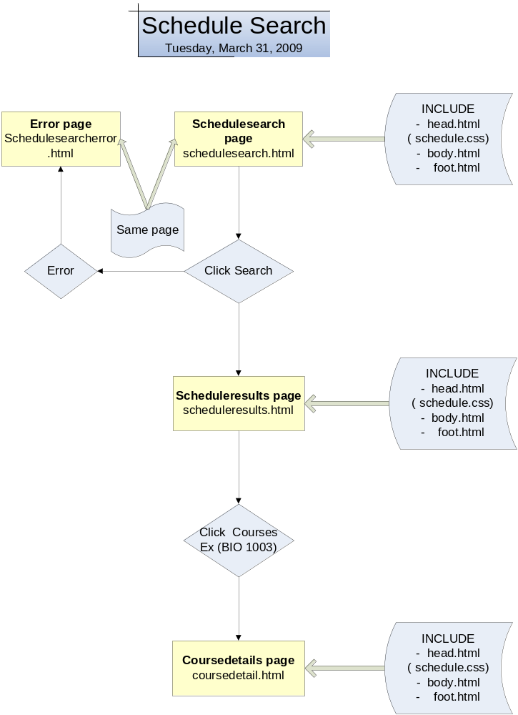

Admin Interface:
Login.html → update.html → display.html→logout.html

