Azure-Based Interruptible Workload Management
with Checkpointing and Recovery
Project Documentation — Prototype Design, Implementation, Live Demonstration & Applications

1. Abstract
This project presents a prototype for interruptible workload management using Microsoft Azure. Cloud providers offer low-cost, interruptible compute capacity (such as Azure Spot Virtual Machines) that can be reclaimed by the platform with little notice whenever that capacity is needed elsewhere. Workloads that use this capacity must be resilient to sudden interruption, or all of their progress is lost and has to be recomputed.
The system demonstrates how a long-running workload can periodically save its state as checkpoints to Azure Blob Storage, respond to an interruption event, and resume execution automatically from the most recently saved checkpoint rather than restarting from zero. The prototype uses an Azure-hosted Flask application to simulate an interruptible worker, with a live web dashboard that lets a user start the workload, trigger a simulated eviction, and watch the system recover in real time.

2. Objectives
- Develop a working prototype for an interruptible cloud workload.
- Implement periodic checkpointing of workload progress.
- Store checkpoints reliably using Azure Blob Storage.
- Simulate a worker interruption / eviction event on demand.
- Recover the workload automatically from the latest saved checkpoint.
- Demonstrate continuation of processing without restarting from zero.
- Provide a simple, visual dashboard so the recovery behaviour can be observed live.

3. Technologies Used
- Microsoft Azure — Cloud platform hosting the entire solution.
- Azure App Service — Hosts and runs the Flask application.
- Azure Blob Storage — Durable storage for checkpoint data.
- Flask — Python web framework used for the application and dashboard.
- Python — Core application development language.
- Azure CLI — Used for resource provisioning and deployment.
- Gunicorn — Production-grade Python WSGI application server.
- HTML / CSS / JavaScript — Front-end dashboard for live progress, checkpoint and status updates.

4. Azure Resources
- App Service: spotprototype-flask-2026
- Storage Account: spotprototype2026abc
- Blob Container: checkpoints
- Region: India South Central

5. Live Prototype
Application URL:
https://spotprototype-flask-2026-a0a6dke3e8c6a5az.indiasouthcentral-01.azurewebsites.net
Open the URL in a browser to access the deployed workload dashboard. The dashboard exposes controls to start the workload, simulate a 30-second eviction warning, start a new worker to resume from the last checkpoint, and reset the demo.

6. System Architecture
User → Azure App Service / Flask Application → Interruptible Workload → Azure Blob Storage (Checkpoint) → Simulated Interruption → New Worker / Resume → Workload Completion
At a component level, the Controller (Flask app) drives a Worker process that periodically reports progress and writes a checkpoint. On eviction, the Worker VM/process is stopped; a new Worker reads the last checkpoint from Blob Storage and continues the job to completion.
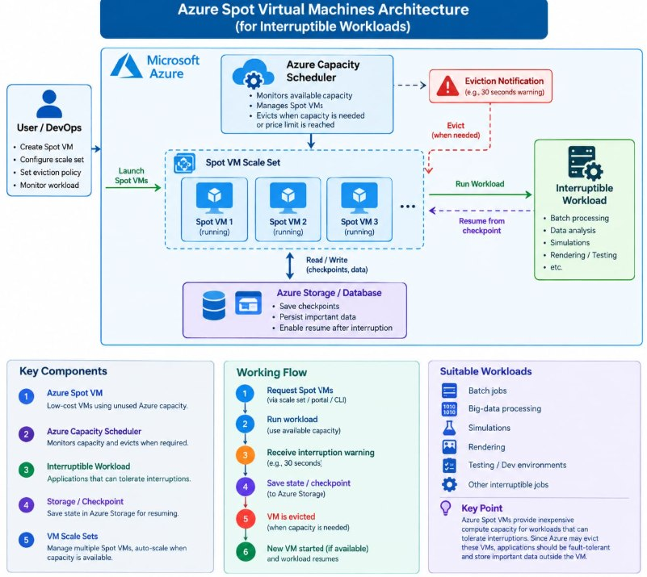
Fig. A — Azure Spot Virtual Machines architecture for interruptible workloads: the Capacity Scheduler launches/evicts Spot VMs, workers checkpoint state to Azure Storage, and a new VM resumes from the last checkpoint.
As shown above, User/DevOps provisions Spot VMs through a scale set; the Azure Capacity Scheduler monitors available capacity and issues an eviction notification (e.g., a 30-second warning) when the VM must be reclaimed. Before eviction, the running worker persists its state/checkpoint to Azure Storage. When capacity is available again, a new VM is started and resumes the workload from that checkpoint — the exact behaviour this prototype simulates end-to-end.

7. Checkpointing and Recovery
The workload periodically records its progress at fixed intervals (e.g., every 500 units of work). The checkpoint value is written to the checkpoints container in Azure Blob Storage. If the worker is interrupted — either through a real Spot eviction or the simulated eviction in this prototype — a new worker instance loads the latest checkpoint on startup and continues processing from that saved state instead of starting over, ensuring no completed work is wasted.

8. Demonstration Workflow
- Open the deployed application using the live URL above.
- Click "Start Workload" to begin processing (progress moves from 0 toward 10,000).
- Allow progress and checkpoint information to be generated and observe the progress bar update.
- Click "Simulate Eviction (30s)" to demonstrate an interruption event, as a real Azure Spot VM eviction notice would trigger.
- Click "Start New Worker / Resume" to bring up a new worker.
- Verify that processing continues from the last saved checkpoint rather than from zero.
- Observe the status change to "COMPLETED" once progress reaches 10,000 / 10,000.

9. Working Prototype — Screenshots
The following screenshots were captured directly from the live, deployed application and show the dashboard progressing through a full run: workload in progress, a simulated eviction warning, and successful completion after recovery.
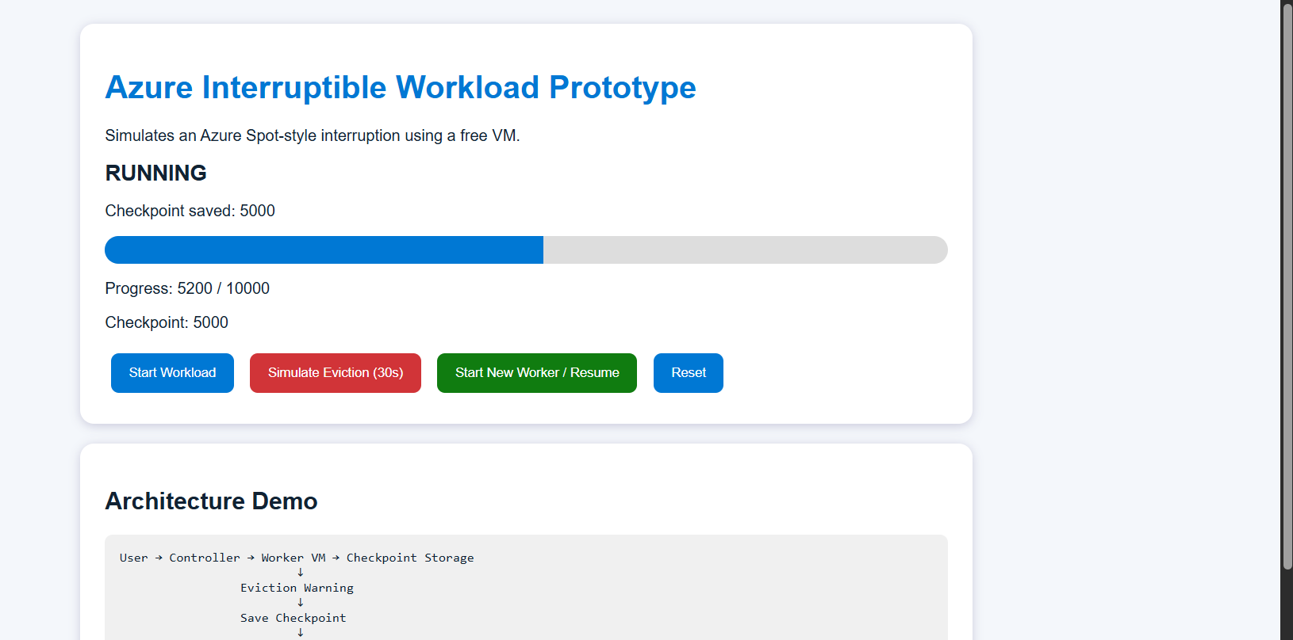
Fig. 1 — Dashboard while the workload is RUNNING, showing live progress (5,200 / 10,000) and the last saved checkpoint (5,000).
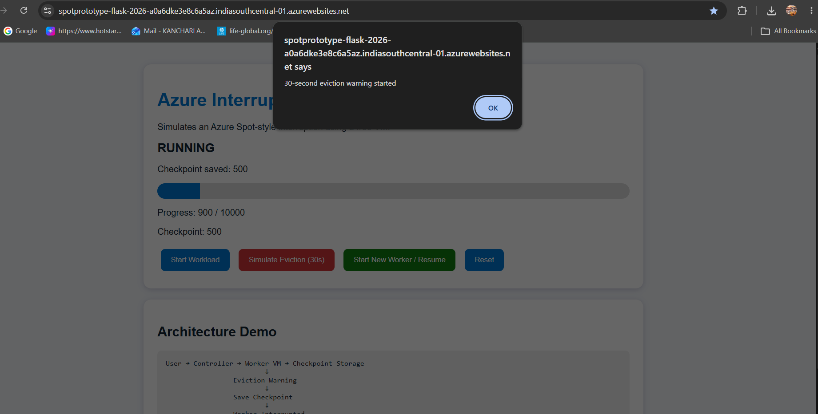
Fig. 2 — Simulated eviction triggered from the deployed Azure URL; a 30-second eviction warning starts and the last checkpoint (500) is preserved.
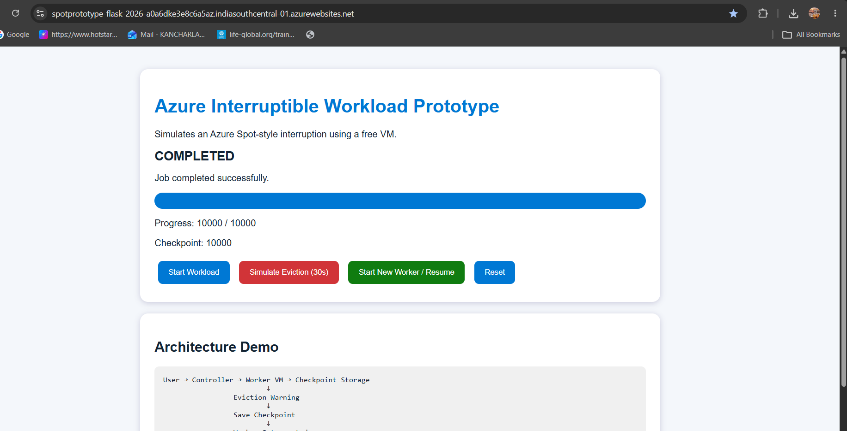
Fig. 3 — After the new worker resumes from the checkpoint, the workload reaches COMPLETED status at 10,000 / 10,000.

10. Testing Results
Beyond the web dashboard, the checkpoint-and-resume logic was verified directly on Azure using Azure Cloud Shell, confirming that the worker script correctly persists and reloads its checkpoint independent of the front-end.
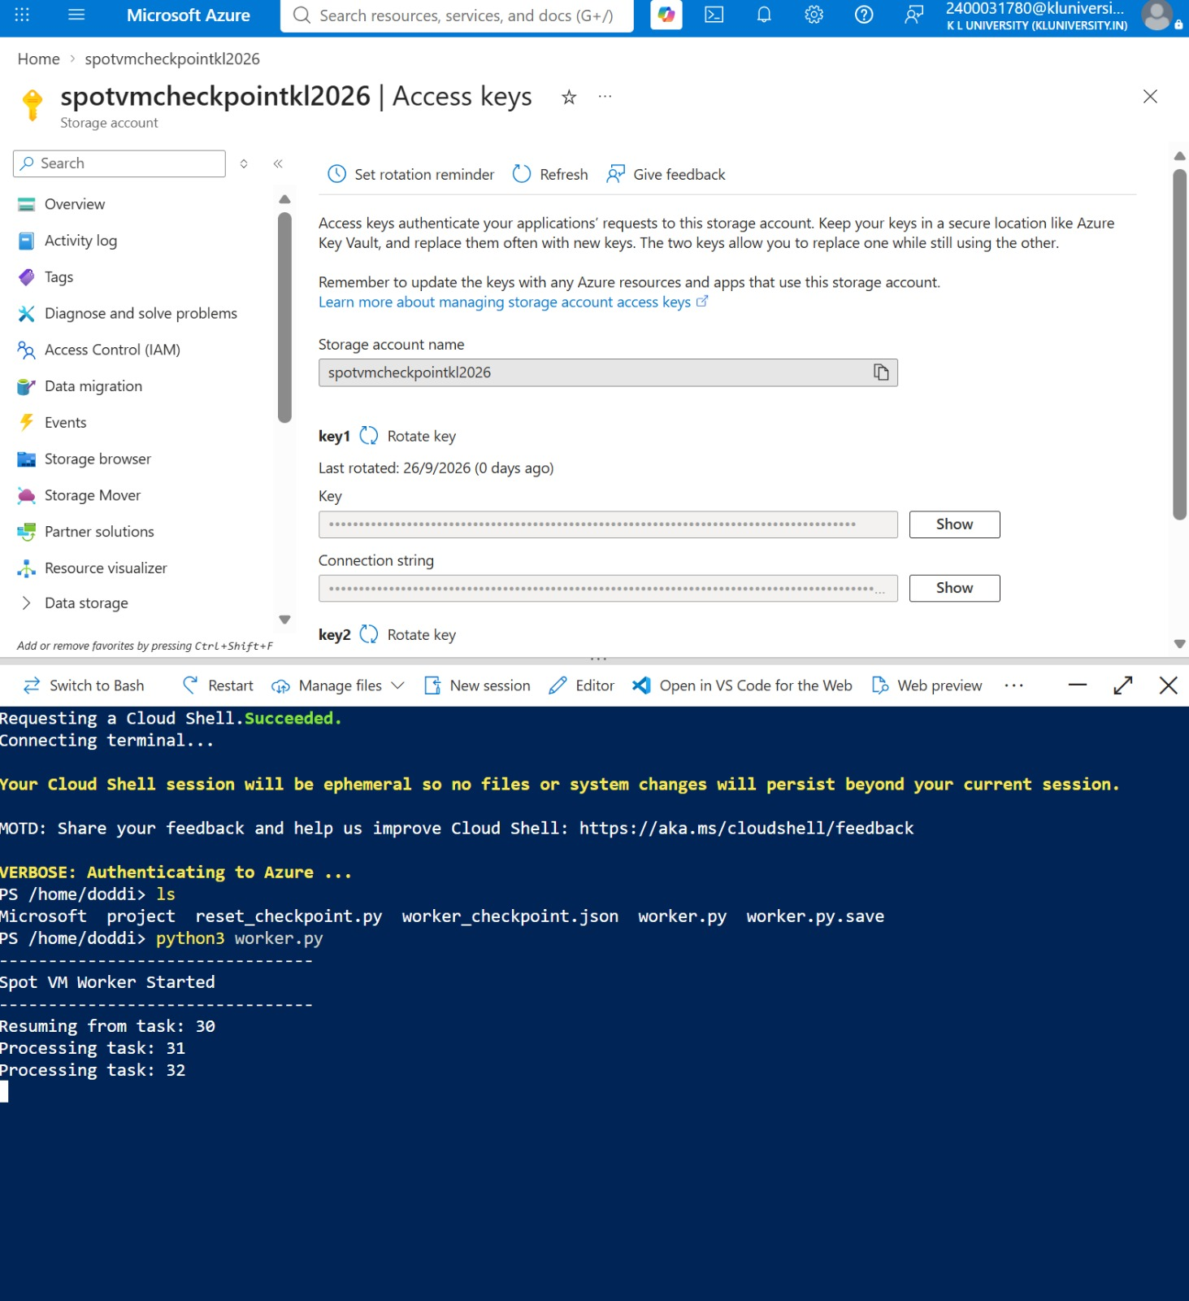
Fig. 4 — Azure Storage Account (spotvmcheckpointkl2026) access-keys blade alongside Cloud Shell running worker.py, which resumes from task 30 and continues processing (tasks 31, 32, ...).
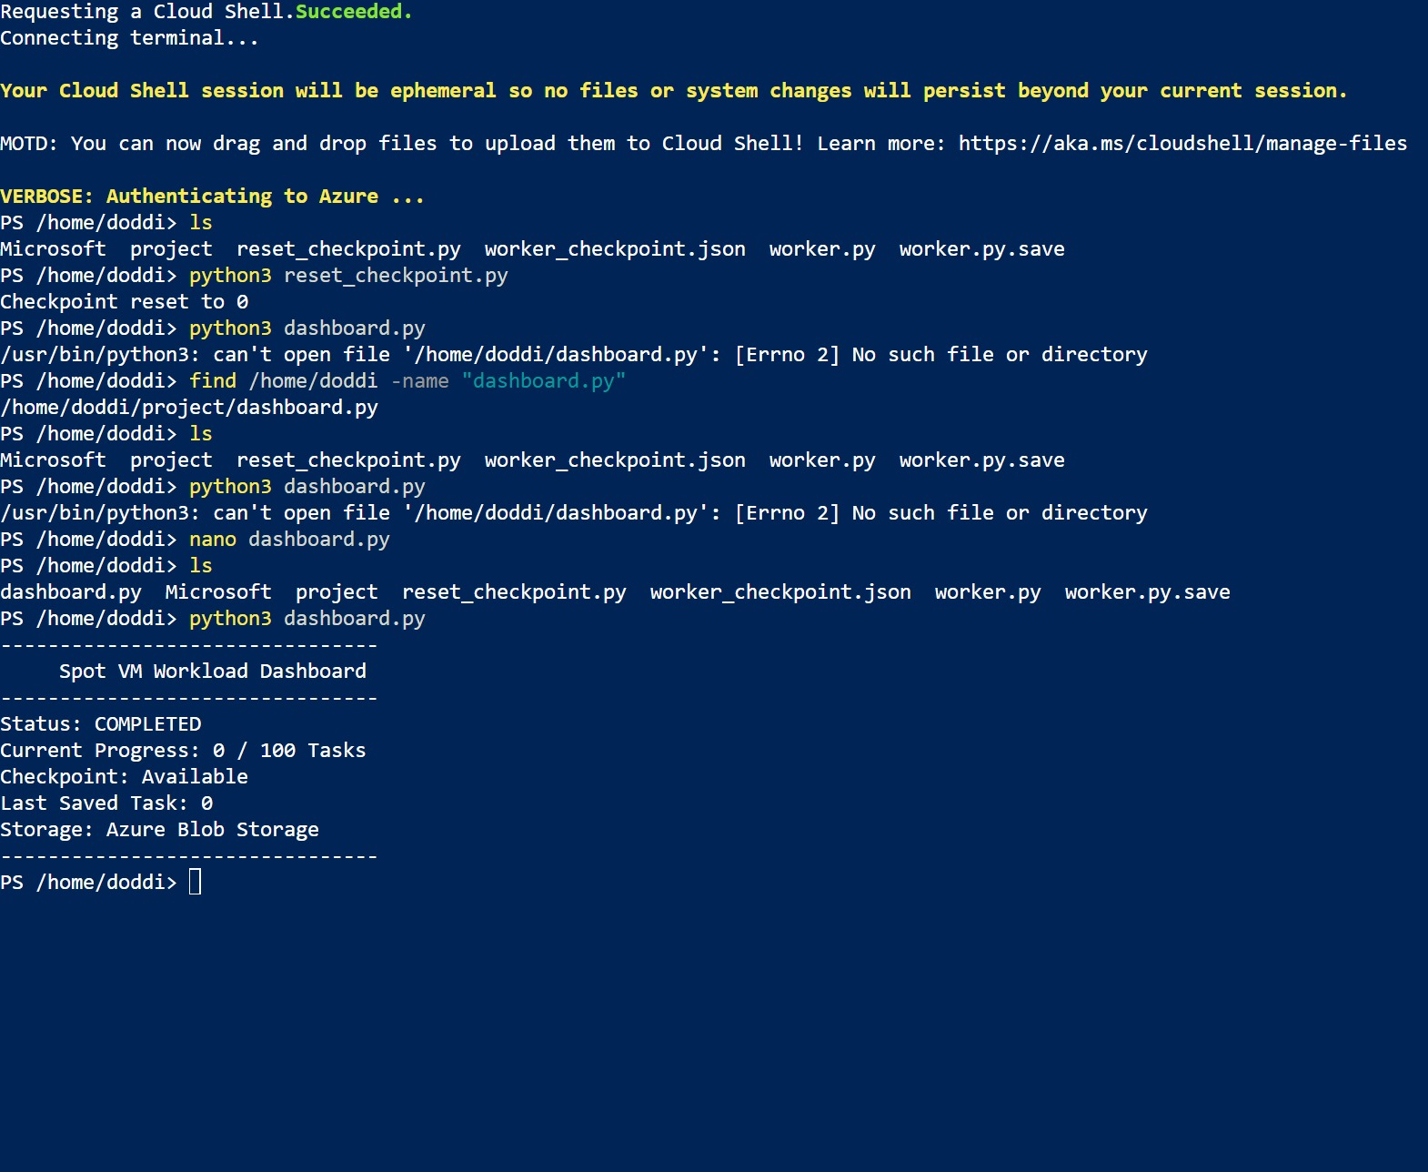
Fig. 5 — Cloud Shell test run: the checkpoint is reset to 0 via reset_checkpoint.py, then dashboard.py reports Status: COMPLETED, confirming the dashboard correctly reads checkpoint state from Azure Blob Storage.
Together these tests confirm two things independently of the live URL demo: (1) the worker process can be interrupted and correctly resumes from whatever checkpoint value is stored in Azure, and (2) the dashboard accurately reflects the checkpoint and status data persisted in Azure Blob Storage.

11. Real-World Applications — Where This Is Used
The checkpoint-and-resume pattern demonstrated in this prototype is exactly the mechanism that makes low-cost, interruptible cloud compute usable in production. It is widely used wherever an organisation wants the cost savings of preemptible/spot capacity without losing progress when that capacity is reclaimed:

Big Data & Batch Processing
Large ETL and batch analytics jobs (e.g., Apache Spark or Hadoop jobs processing terabytes of data) run on clusters of Azure Spot VMs. Individual worker nodes can be checkpointed so that if a node is evicted mid-job, only that node's partition of work needs to be redone, not the entire job.

Machine Learning Model Training
Deep learning training jobs, which can run for many hours or days, are commonly run on Spot GPU VMs to cut compute costs by 60–90%. Frameworks like PyTorch and TensorFlow periodically save model weights and optimiser state as checkpoints, so training can resume from the last saved epoch instead of restarting from scratch after an eviction.

Rendering & Media Encoding
Visual-effects and animation studios render individual frames on large fleets of low-priority VMs. Each rendered frame or batch acts as a checkpoint, so an interrupted render farm node simply picks up remaining frames rather than re-rendering completed ones.

Genomics & Scientific Computing
Long-running simulations and genomic sequence-analysis pipelines checkpoint intermediate results, allowing research workloads to run economically on interruptible capacity across days without losing partial results.

CI/CD and Test Automation
Build and test farms use Spot/low-priority VM Scale Sets for cost efficiency; checkpointing test progress or splitting suites into resumable stages avoids re-running an entire pipeline after a node is reclaimed.

Batch Video/Audio Transcoding & Financial Risk Simulations
Media transcoding pipelines and Monte Carlo-style financial risk or actuarial simulations both benefit from the same pattern — periodic checkpointing lets each job resume cleanly on interruptible infrastructure, keeping cloud costs low while guaranteeing eventual completion.
In each of these domains, this project's core idea — periodic checkpoint → Blob/durable storage → detect interruption → resume from latest checkpoint — is the standard design pattern that lets organisations use Azure Spot VMs (or AWS Spot Instances / GCP Preemptible VMs) safely in production.

12. Important Note
This is a prototype/simulation. The interruption is simulated at the application level; the current App Service deployment is not an actual Azure Spot VM eviction. The prototype demonstrates the checkpointing and recovery concept in a controlled, repeatable way that is easy to observe and evaluate.

13. Advantages
- Demonstrates recovery from workload interruption end-to-end.
- Reduces recomputation by preserving completed progress via checkpoints.
- Uses persistent Azure Blob Storage, so checkpoints survive process/VM restarts.
- Provides a simple, live web dashboard for demonstration and evaluation.
- Directly maps to a real, cost-saving production pattern (Spot VM workloads).
- Can be extended to real interruptible infrastructure with minimal redesign.

14. Limitations
- The eviction event is simulated rather than produced by an actual Azure Spot VM.
- The workload is an artificial demonstration workload (a progress counter), not production data processing.
- The prototype is intended for learning and demonstration rather than production use.
- Production deployments would require stronger security, monitoring, authentication, and concurrency handling.

15. Conclusion
The project demonstrates how checkpointing and persistent cloud storage can be used to recover an interruptible workload. By saving progress to Azure Blob Storage and restoring the latest checkpoint after an interruption, the workload can continue without repeating all previously completed work. This mirrors the same pattern that production systems rely on to run cost-effectively on interruptible cloud infrastructure across big data, machine learning, rendering, and scientific computing workloads.

