

|  |
| --- |
| ROOM-HOUSE.COM |
| USER’S MANUAL |
| Authorization “GURU” |

|  |
| --- |
| v1.22(C) Room-House.com 2023 |

Contents

1 Basic info 5

1.1 Summary 5

1.1.1 Log in to Admin’s interface 6

1.1.2 Guru’s window 6

1.1.3 Logging out 8

1.2 Security 8

2 Users 8

2.1 Adding authorized users 8

2.2 Changing user’s name 9

2.3 User’s login and password 9

2.4 Deleting a user 9

3 Entering the Room9

3.1 Selection “open”9

3.2 Selection “locked” 10

3.3 Using “captcha”10

3.4 Authorization11

4 Guest mode 11

5 Parameters 13

5.1 Number of free chairs 13

6Chat in Admin’s interface13

7Room menu 15

7.1 Main menu 15

7.1.1 Front (or main) camera 15

7.1.2 Back (or second) camera 16

7.1.3 Mute/unmute all sound 16

7.1.4 Text chat 17

7.1.5 Video control/Signal18

7.1.6 AUDIO-ONLY mode19

7.1.7 Exit19

7.2 Room controls 20

7.2.1 Sound 20

7.2.2 Annotations 21

7.2.3 Playing MP4 files 21

7.2.4 Share Screen 22

7.2.5 Cinema Mode 22

7.2.6 Dropping users 23

7.2.7 Sound signals 24

8 Known issues25

8.1 Broken connection 25

8.2 Expired cookies 27

8.3 Bad cookies 28

9 F.A.Q.30

# Basic info

**Room-House** is a decentralized autonomous media platform, independent of global providers and allowing for high-end quality video and audio with no preset restrictions on number of users, connections or total time. The web application **Room-House** source codes are available on the Github and licensed with Apache License v2.0 and GPLv3.

## Summary

Being a **Guru** – you’re the master of your **Room**. You can add, edit and delete authorized users of your Room, you can lock and open the door, you can change the mode of Room access, and you set some parameters. For doing this you needthe **Admin’s interface –** it’s on the same address as the Room, but on a different port. So, if the Room’s URL is **https://iron.room-house.com** – its Admin’s interface is on **https://iron.room-house.com:8453** [**https://**](https://milan.room-house.com:8453/)**https://iron.room-house.comhttps://iron.room-house.com https://iron.room-house.com**– that is adding “:8453” to the Room’s URL.

### Log in to Admin’s interface

Open URL: https//[room_name].room-house.com:8453

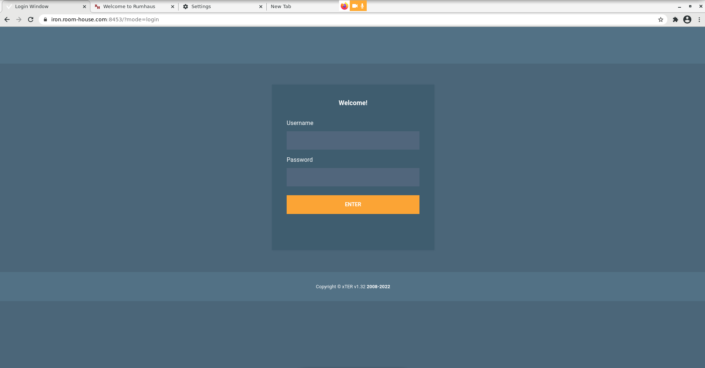Into Username field, type in the number you received as your login, and into Password field – 6-digit code you received as your password.

### Guru’s window

After logging in as a guru, you will see the following window.

Find there key elements of the interface that are supposed to b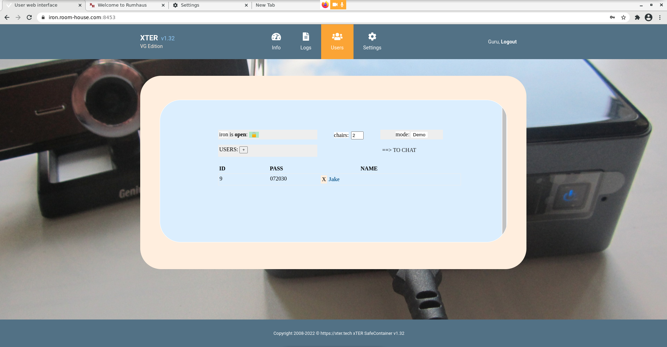e used by a guru to change settings of the Room:

A. “*Add user*” button and a table with a list of existing users – if there are none yet, click “**+**” and make sure a new user has been created.

B. *Door mode* selector “**open**”/”**locked**” in the top left corner of the window with a “lock” icon.

C. Input field for the *number of free chairs* in the Room, after the word “**chairs**”.

D. *Access mode* selector, with the default mode “**Normal**”.

E. Skip to the chat in this interface - click “**TO CHAT**” on the right.

### Logging out

Click on the words “**Guru, Logout**” on the right in the top menu panel.

## Security

Working with the Admin’s interface is about following some basic security rules: do not leave the guru window open when you’re leaving; always “**Logout**” before leaving the room – just closing window is **not enough**! Do not tell your guru’s password to anyone. If your computer can be accessed by other people, do not save your login and password in your browser’s memory.

# Users

There are two types of users other than gurus: **authorized users** and **guests**. The former are always participants in the Room, while the latter can be both participants or just «viewers». Gurus create authorized users in the Admin’s interface.

## Adding authorized users

Click the “**+**” and make sure a new user has been added to the list.

## Changing user’s name

A new user is always created with a random 4-digit name. To change it, click on this code and type in a normal name like “John” or “Peter”, then click the key “Enter”.

## Login and password

When a new user is created, its login (number) and a 6-digit random password are created automatically. This pair can not be changed. In case a user’s password was compromised, the guru must **delete** this user and re-create it with a new pair of login/random password. Then the guru will pass the new login/password to the user for whom they were made.

## Deleting a user

To remove an authorized user, click the “**X**” on the left of the name and confirm.

# Entering the Room

Gurus can lock the Room’s door, and then only they and this Room’s authorized users will be able to enter it. Guest cannot enter the room when the door is “**locked**”.

## Selection “open”

Guru’s having selected the door mode “**open**” by click on the “lock” icon, and the access mode set to “**Normal**”, the door of the Room will look like this:

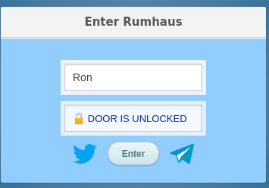

## Selection “locked”

Guru’s having selected the door mode “**locked**”, and the access mode set to “**Normal**”, the door of the Room will look like this:

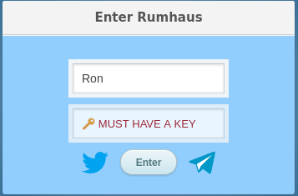

## Using “captcha”

After hitting “Enter”, we are obliged to deal with “captcha” (see picture in the next page): in the field ”..code?” type the 4-digit code that you see in the picture above it, and then click the right button. “Captcha” is a tool to protect the Room against bots. **Room-House** uses its own simple “captcha”, one which you save your time with. And it can be even omitted, if the guru selects the g**uest mode** (see Paragraph 4) – which is the quickest way to enter the Room for guests.

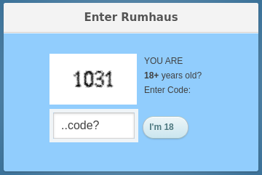

## Authorization

To log in the Room, **right after** the 4 digits of the captcha, no spaces, enter your login and password **together**. For example, with the captcha “**1031**” (as in the picture above), the login “**34**” and the password “**456789**” - you have to type in “**103134456789**” - only numbers, captcha+login+password.

# Guest mode

Guest mode works only when the door is “**open**”. Make sure the left selector is set to this position. Then click on the right selector and change from “**Normal**” to “**Demo**”. Go to the Room in **another browser -** not in the onewhere you’re already authorized as guru. The start page will now look different (see below): this is the guest mode. No captcha required, just click on this screen to enter the Room:

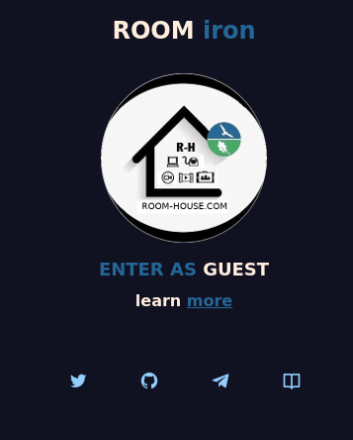

You may ask – if there is no captcha now, then where to type in the login and password? Obviously, the guru must set the access mode to “**Normal**”, then log in as the guru, and also let in other authorized users with their logins and passwords, – and *only* after that change the access mode to “**Demo**”, for guests. The authorization process will store the name cookie in the browser for 10 days, - and you don’t have to authenticate in this browser again until this cookie expires.

# Parameters

## Number of free chairs

Guru will set an important room parameter – the number of free “chairs”, which is the number of guests who can switch on their cameras and become participants when there are no gurus/authorized users in this Room. The total number of active cameras in a Room is in fact limited by the capacity of browsers to support all concurrent videos. Usually when this number gets big enough, all browsers become slow. This is why we recommend to set this number maximum as “6”. Set it as “0” if you want that no guests could activate their cameras when there are no gurus present in the Room.

# Chat in Admin’s interface

Gurus can chat with other authorized users in a protected chat inside the Admin’s interface – find “TO CHAT” in the main guru’s window and click on this link:

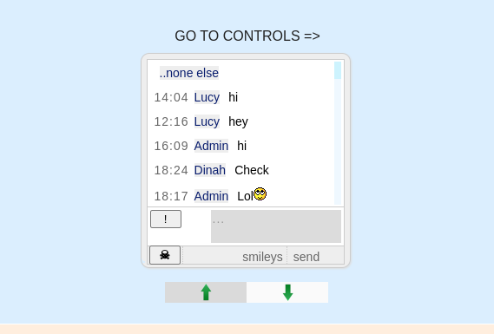Gurus can delete their last chat input with the “**!**” button, and the other button (“scull”) will empty the whole chat. All authorized users in this Room can also enter the Admin’s interface with their login and password, see Paragraph 1.1.1 – “Log in to the Admin’s interface”, – but they can not be anywhere except this chat, while gurus can return from the chat to their main window clicking on the link above: “GO TO CONTROLS”.

Two buttons for deletion of the texts from the chat are only there for gurus – there are no such buttons for other users. Two green arrows in the bottom of the page are for scrolling the chat.

# Room menu

## Main menu

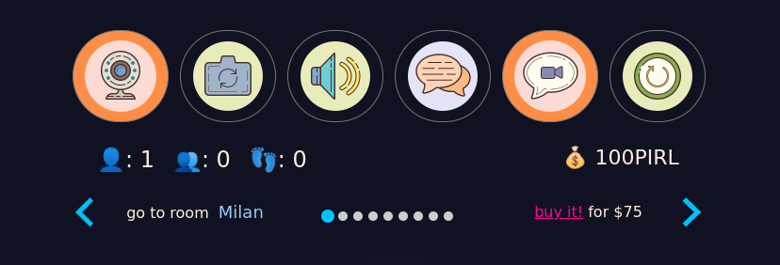

### Main (front) camera

The first button of the menu (see picture) switches on/off **video** from the main (or the only), or front camera, that the browser has found on your device: desktop, notebook, tablet or phone. Being an authorized user and not a guest, one can always switch one’s camera on/off. While guests can only switch their cameras on if there are free chairs left, (see Paragraph 5), or upon having been activated by gurus, see p. 7.1.5.

Perhaps you know that your browser can switch your cameras, or microphones, only after receiving your permission to do so. So don’t worry if clicking on this menu button you receive requests from your browser to authorize switching your cameras or microphones on. Besides, many systems have special settings with permissions for web cameras, then if whatever you tried to switch on your camera in the Room was fruitless – try locate your system’s camera permissions in Settings, may be the problem lies there. For example, it’s often the case with Android. Set your permissions for web camera and microphone to “On” in Settings, and then you can switch them on and off in the Room.

### Back camera

The second button in the main menu switches on/off the device’s second (or back) camera. Both camera buttons are aware of each other, so you can switch view from one camera to the other with a single click.

### Mute/unmute all sound

The third button in the main menucontrols **all** sound in the Room. Which means you either allow all sound or disallow it. However you should remember that individual settings for each sound source in the Room have more priority than this button. So if you have disallowed all sound *with this button*, then switched on a video’s sound (or your microphone), this latter setting will overrun the former one. Or, having permitted **all** sounds, then mute one by one all videos except one – the result will be the same.

### **Text chat**

The fourth button of the main menu from the left shows and hides a small window that appears on top of the screen and holds a text chat and its small menu:

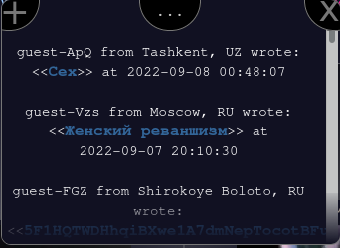

The left button “+” opens a small input window. Type in your message and hit “Enter”. The right button “X” closes the chat window. Between them there is a **content switch** and indicator of the number of *viewers* in the Room – these are guests with inactive cameras. Click on it to see who is in the “audience” now.

When someone adds a message to the chat, everyone else present in the Room will hear a signal and see the 4th button slowly glowing green. Everyone can write in this chat, including guests and viewers.

### **Video control/ “signals”**

Button 5 from the left, the one before the last, appears in either of two variants - a) video control, b) a yellow “bell” for signals. In the first case, this button does the following:

1. switches on video from the main camera or switches off video from any active camera and sets it audio-only, or

2. starts and stops playing an MP4 file, or

3. starts and stops “screen share”.

In the other case, that is with a guest and no free chairs left in the Room, this guest instead of the “video control” will see a ”yellow bell”**,** to call it means the guest is asking to be activated as a participant, which is like bringing another free chair specially for this guest, an action quite possible – just wait for it. In most cases, the request will be heard and satisfied, a guru activating this guest with a click on the bright line “waiting” that shows up in the same small window as the chat. The reverse process (which looks like pushing the guest from the chair) is even more simple – a guru clicks on this guest’s name, sending him back to the “audience” as a viewer.

### **«AUDIO-ONLY» mode**

In this mode, the participant’s camera is active, but sends no video, only its microphone can work. Everyone else in the Room will see this participant’s square as dark and empty, with the name in the bottom; and if the microphone is also switched off, in the right bottom corner of the square there will be «X». Switching off video from your camera, you send it to the «audio-only» mode. Will the others in the Room be able to hear you or not depends on whether you microphone is on or off. Almost all web cameras come with a microphone, which is controlled separately from video, that is, video on/off, microphone on/off.

### **Exit**

The last button in the main menu allows one to leave the Room. Clicking on it, a guest or a participant returns to the outside of the Room seeing the door or “click to enter” screen – depending on the Room’s access mode and the “name“ cookie. NB: Ctrl+R actually does the same thing as the “Exit” button, so it’s up to you to choose.

## **Room controls**

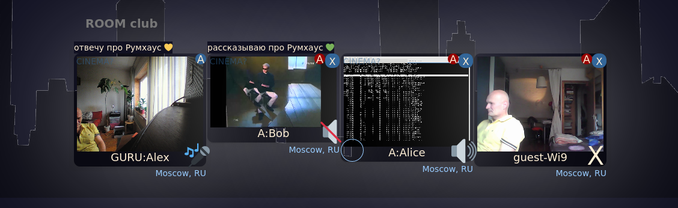

### **Sound**

Everyone in the Room: gurus, authorized users, guests, including “viewers” - can control the sound from each of the sources. Basically, they can mute and unmute each source; this is done by clicking on the icon in the right bottom corner of each square, on the right of the name (see picture above). Depending on whose camera it is and what is its current setting, this icon can be one of the following four: “speaker”, “crossed-out speaker”, “microphone” and “X” - meaning, a) this video’s sound is “on”, b) it’s “off”, c) your microphone is “on”, d) the microphone (yours or that of another participant) is “off”. Clicking on the icon toggles the sound mode, except when “X” means, the microphone of another participant is “off” (as shown in this picture), a situation you can not change but speaking or writing to the person directly.

In most browsers (except on Apple devices) clicking on the sound icon opens the volume control in the left corner of the square, by moving which one can increase or decrease the volume of sound from this particular source.

### **Annotations**

All users can write short comments to videos, both their own and those of other users except gurus. Click on the letter «A» inside the blue (own) or red (others) circle in the top right corner of the square. These comments or “annotations” are not saved and are shown above the square only while its video state has not changed.

### **Playing MP4 files**

**This function is available only for gurus and authorized users and works in «Firefox» on desktops and notebooks.** To start, click on the words «ROOM [room’s name]» - they are above your empty square. Upon receiving your click, the words color changes to blue and the «Select File» button appears on the right. Select an MP4 file and click on the button «video control» - which is the fifth one in the main menu. You will see that the selected file started playing in your square - *silently*. You may choose to make it silent **for everyone:** mute its sound with a small button inside the video – not the sound button-indicator we were describing earlier! — but a small “speaker” **inside** your video, in its bottom panel which is only visible when pointing the mouse cursor on the video. You can control that your **local** sound from the played MP4 video is heard or muted with the “speaker” icon on the right bottom corner of the box. To stop playing the file, click the «video control» button - its color changes back from orange to transparent. You may also pause playing the MP4 file with a small button in the panel inside the video (as described earlier).

### **Share Screen**

**This function is available only for gurus and authorized users and works on desktops and notebooks.** Click on the words «ROOM [room’s name]» **twice** (double click) — their color changes to light green. Then click the «video control» button in the main menu – a small window will appear, suggesting you should choose the window (or the whole desktop?), that you’d like to share. Confirm your selection, and you should see the selected window (or desktop) appear small in your square — make sure the screen sharing was started by clicking on it. By default, the microphone from your main camera becomes active, so you may comment on what is going on in the screen you’re sharing, and everyone in the Room will hear you. To stop the Share Screen, click again on the«video control» button – its color will change back from orange to transparent.

### **Cinema Mode**

A guru can send any of the videos played in the Room into «Cinema» mode, by clicking on this word, which is shown in dark blue capital letters in the top left corner of the square. After the click, the letters change to yellow color. When the «Cinema» mode is on, to watch the video full screen one has to bind a SkyPirl account in the Room. Read more on such binding here: https://room-house.com/sp_help/index.html <https://room-house.com/sp_help/index.html>If the video is not in «Cinema» mode, to watch it full screen just click on it (except iPhone, or other Apple devices). The mode «Cinema», other than going full screen, also switches off temporarily all other videos, letting a better quality for the sole remaining video by economizing the Room’s traffic.

### **Dropping users**

Reducing the number of concurrent videos in the Room improves the quality of the remaining videos. To switch off a video, click on «X» in the top right corner of any user’s square. After a confirmation, this video (or just the empty dark square) will disappear from the Room. Anyone can drop (= switch off) anyone in the Room – but **only** in their own browser. Except gurus, - because when a guru drops a user, this user will disappear from **all** other browsers in the Room. This is the big difference. Guru can also drop a viewer by clicking «X» on the right of the guest’s name in the list, which is shown inside the chat window by clicking on the content switch (see p.7.1.4), or by clicking on the viewers icon in the stats bar below the main menu.

### **Sound signals**

Each event such as a new participant joining the Room, is heard by everyone else as a short “ding”. A new viewer — four loud steps. The yellow bell signal — a dry cracking sound. A new message in the chat — a melodic «wow».

# Known Issues

## **Broken connection**

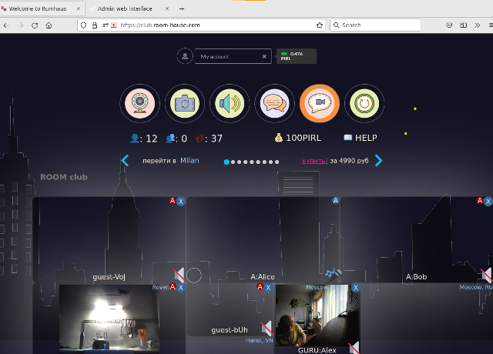

**Case A**

See the picture above— something strange is happening: а) videos in two rows(?!) б)the number of participants in the stats bar (12?!) is too big 3) many empty squares. It is all about your browser losing connection to the Room (may be you were dropped by a guru, see p. 7.2.6)), but the Room is probably all right. Click on «Exit» in the menu and re-enter, and it’s all right again.

**Case B**

When you enter the Room you see — three “zeros” for numbers of participants, guests and traces, and no videos – the Room is empty. The problem is with the Room. Wait a minute and re-enter, and if nothing has changed — contact your admin, that is one who told you the guru’s login and password for the Room.

**Case C**

You see only the dark blue empty screen and in light blue «RE-CONNECTING..» - it means your browser has just lost the connection and is trying to automatically re-enter the Room. Statistically, success is 50% and time required is about half minute. If you don’t want to wait, just Reload (Ctrl+R), and enter again as in Case A.

## **Expired cookie**

Sometimes, the guru’s window starts to look like this:

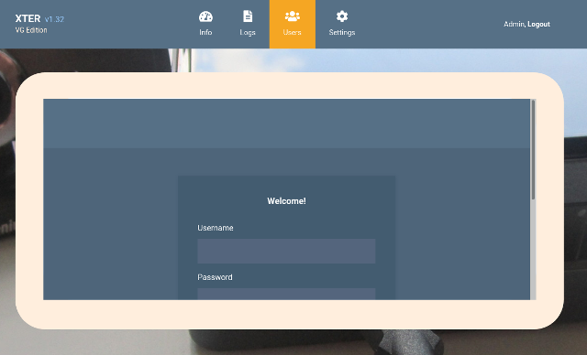

Why? The authorization cookie has expired. All by itself, or you may have erased it, see how to erase cookies in the next paragraph. What to do? First, leave the Admin’s interface clicking on «Guru, Logout». Second, enter it again. This way, you have got a new authorization cookie. But all you see again is the gray square inside the frame. It’s there because you must do the third thing now: erase the stale cache of the browser, but leave the new authorization cookie you have just received – find “Clear History” in the browser Settings (see picture below, it’s Firefox, but it looks the same in other browsers):

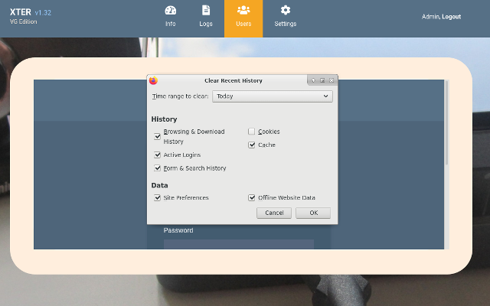

Then, Ctrl-R - and you will see the guru’s window.

## **Bad cookies**

Sometimes cookies become “bad” because they contain old and unusable data. What to do? You have to erase old cookies and receive new cookies. Erasing cookies may be done in one of the ways:

A. **Clear History –** find this option in your browser’s Settings and erase **only cookies** – not the whole of the history! Be careful, this option erases **all** cookies— those from **Room-House**, and those from other sites. Is this what you really want to do? If no, use other ways, see below.

B. **Manage cookies** — Chrome/Firefox/Opera have this option in their Settings, though it may be not so easy to find it. But it works — you may delete not all cookies as above, but only those from **Room-House**.

C. When you have switched to “**Normal**” access mode, or have the “name” cookie set, click on the link «help» on the right half of the door, and find the link «Clear Cookies» near the bottom of the popup, click it and confirm: you delete only Room-House cookies, but not all of them – the “name” cookie stays intact; if you need to erase it, use A or B.

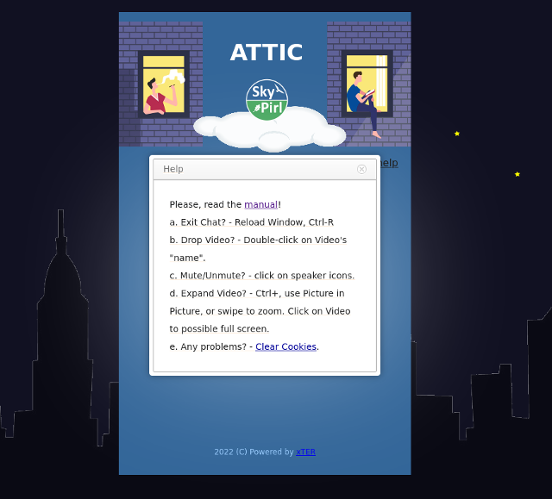

# F.A.Q.

**1. Why not all areas of the Admin’s interface are accessible by gurus?**

**Room-House** has multilevel administration, and a guru is only a “second-level” admin, while all options of the Admin’s interface are available for the “first-level” admins, those who create new gurus and tell them their logins and passwords. For example, admins can reload the Room, block users on the IP, check Room logs, create new gurus, - all this is done in the same Admin’s interface that is used by gurus.

**2. Is it possible to become a “first-level” admin?**

Well, yes. Try to set up your own **Room-House**, for a good start, read this howto: https://github.com/kl3eo/room-house/blob/main/xTER_VB_install.txt

**3. What is xTER and why «Room-House is powered by xTER»?**

**Room-House** lives inside xTER, thats’ a short answer. xTER is our own protected container system for **Room-House**, called **SafeContainer**, that we use to safely store and deploy our own software and technologies. xTER is very convenient for everyone, because it contains all the work that we have done and others don’t have to do, like configuration of the software, while all that is left to do for others is load this container in VirtualBox.

**4. Why VirtualBox? Is it possible to use other virtuals for setting up a Room-House node?**

**VirtualBox** from Oracle’s site works on Windows,MacOS and on other OS, this is why **Room-House** can be set up on a usual desktop machine with 4GB RAM and static IP. Other virtual schemes would not probably suit xTER because its network boot is of rather specific design.

**5. Is it possible to set up Room-House on bare metal?**

Well, yes, and an old laptop from your attic would do, even with no HDD or screen, — xTER only needs a working Ethernet port, a boot from USB flash and 4GB of RAM.