

Capstone Project Report
Report 4 – Software Design Document

– Hanoi, August 2019 –

Table of Contents
I. Record of Changes 3
II. Software Design Document 4
1. System Design 4
1.1 System Architecture 4
1.2 Package Diagram 4
2. Database Design 4
3. Detailed Design 5
3.1 Authentication & Account 5
3.2 Customer & Pet Management 6

I. Record of Changes
Date | A*  M, D | In charge | Change Description
03/06/2026 | A | Team PCMS | Initial Software Design Document: system architecture, service package structure, database design (schema-per-service) and detailed design of core features.
*A - Added M - Modified D - Deleted

II. Software Design Document

1. System Design
The Pet Care Management System (PCMS) is a cloud-native, Spring Cloud microservices application for a veterinary clinic and its in-clinic pet store. Each business capability is an independently deployable Spring Boot 4 service (Java 25, virtual threads) that owns its own PostgreSQL schema and communicates synchronously over HTTP (through the API Gateway and Eureka service discovery) and asynchronously over RabbitMQ for domain events. This section describes the runtime architecture, the external systems PCMS depends on, and the internal package organisation shared by every service.

1.1 System Architecture
A single API Gateway is the only public entry point; it validates JWTs, applies Redis rate-limiting and Resilience4j circuit breakers, aggregates the per-service OpenAPI specifications, and load-balances calls to downstream services resolved through the Eureka discovery server. Centralised configuration is served by the Config Server, and operational visibility is provided by Spring Boot Admin together with the Prometheus / Grafana / Tempo observability stack. The diagram below shows the sub-systems, the external systems and the connections among them.
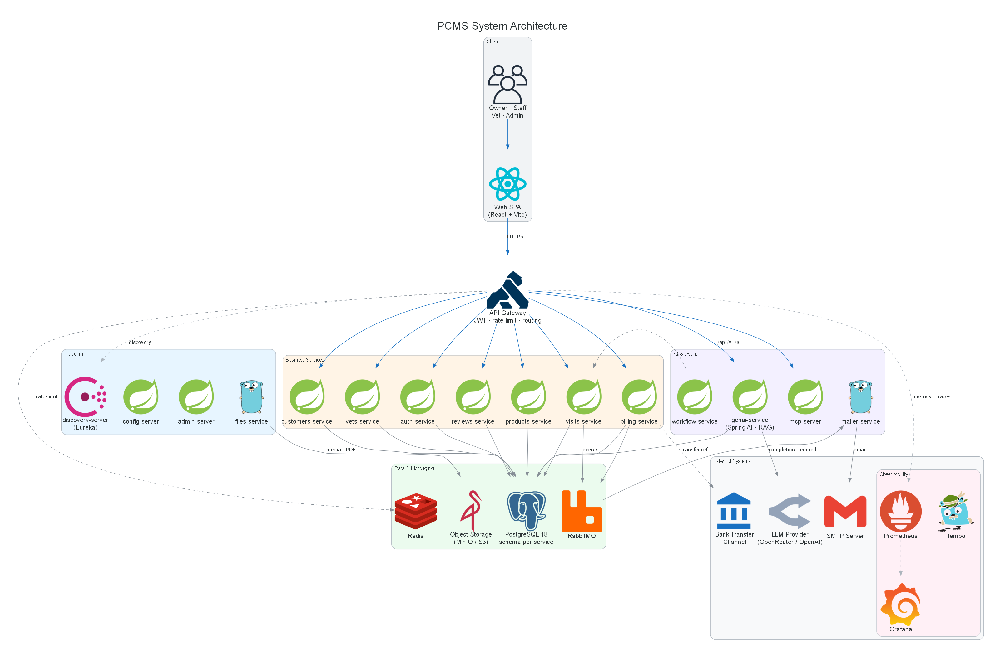
Figure 1-1: PCMS System Architecture (container view)
Platform / infrastructure services
• api-gateway – Single public entry point: JWT validation, Redis rate-limiting, Resilience4j circuit breakers and per-route bulkheads, OpenAPI aggregation and routing via lb://.
• discovery-server – Netflix Eureka service registry for client-side load balancing.
• config-server – Spring Cloud Config; serves env-split configuration from config-repo/ to all services.
• admin-server – Spring Boot Admin; auto-discovers Spring services through Eureka for health, metrics and loggers.
• files-service (Go) – Media and document service: stores pet photos, vet media and invoice PDFs in object storage and returns signed URLs.
Business services (each owns a PostgreSQL schema)
• auth-service – Registration, email verification, login, JWT issuing/rotation and JWKS; roles USER / STAFF / VET / ADMIN / INVENTORY_MANAGER.
• customers-service – Owners and pets, including pet medical profile and photos.
• vets-service – Vets, specialties, ratings, work schedule, badges, education and photos.
• visits-service – Visit lifecycle, availability slots, prescriptions and saga-based completion notifications.
• reviews-service – Polymorphic reviews (vet / product / visit) with helpful voting and staff moderation.
• products-service – Pet-product and medicine catalogue, categories, stock levels and pricing; lines are added to clinic invoices by reception.
• billing-service – Clinical invoices with in-store product lines, PDF export, and cash / bank-transfer payment recording.
AI and asynchronous services
• genai-service – Spring AI chat with Retrieval-Augmented Generation (RAG) over a pgvector store; persists chat memory and per-model LLM configuration.
• mcp-server – Model Context Protocol server (OAuth 2.1) exposing PCMS tools and resources to LLM agents.
• workflow-service – BPMN orchestrator for long-running visit workflows, driving visits-service through callbacks.
• mailer-service (Go) – Go notifier consuming domain events from RabbitMQ, sending e-mail via SMTP and publishing generic ACK / failure envelopes for the saga.
Shared libraries and frontend
• shared/ modules – Spring Boot auto-configuration libraries reused by every service: common-web, common-jpa, common-security, common-clients, common-events, common-testing (see §1.2).
• apps/web – React 19 + Vite SPA consuming the gateway through a typed, contract-generated API client (orval).
External systems
• PostgreSQL 18 – Single instance, schema-per-service; Liquibase owns each schema.
• RabbitMQ 4 – Topic exchange for asynchronous domain events with per-consumer dead-letter queues.
• Redis 8 – Gateway rate-limiting and caching.
• Object Storage (MinIO / S3) – Pet photos, vet media and invoice PDFs, fronted by files-service.
• SMTP Server (Mailpit in dev) – Outbound transactional e-mail used by mailer-service.
• LLM Provider (OpenAI-compatible) – Chat completion and embedding API consumed by genai-service.
• Bank Transfer Channel – Out-of-band bank transfer; reception records the transfer reference against the invoice.
• Observability stack – Prometheus, Grafana, Tempo / Zipkin (OTLP) for metrics and distributed tracing.

1.2 Package Diagram
Every business service follows the same mandatory, layered-by-feature package structure under com.mss301.petclinic.<service>. Controllers depend on service interfaces; implementations are isolated in service/impl; persistence is in repository/model; request/response DTOs are Java records with static from() / toEntity() mappers (no mapper layer, no Lombok). Cross-cutting concerns are never duplicated per service — they live in the shared/ auto-configuration modules.
[ Figure 1-2: Service package structure and shared modules — diagram to be added ]
Package Descriptions
No | Package | Description
01 | config | Service-specific @Configuration / @ConfigurationProperties beans (security, clients, property activators).
02 | controller | @RestController endpoints under /api/v1/**; return ResponseEntity / Page / DTO records.
03 | service | Service interfaces — the contract controllers depend on.
04 | service.impl | @Service @Transactional implementations holding the business logic.
05 | repository | Spring Data JpaRepository interfaces (and Specifications for dynamic queries).
06 | model | JPA entities (plain classes) extending AbstractAuditingEntity; enums implementing IdentifiedEnum.
07 | dto.req | Request records with Jakarta validation and a toEntity() instance method.
08 | dto.res | Response records with a static from(Entity) factory.
09 | exception | Domain-specific subclasses only (e.g. OwnerNotFoundException extends ResourceNotFoundException).
10 | client | Service-to-service @HttpExchange interfaces + tolerant-reader DTOs + bean factory (consumer side).
11 | events / saga | Concrete DomainEvent records and saga entities/handlers for asynchronous choreography.
12 | shared:common-web | ExceptionTranslator (RFC 9457 ProblemDetail), ResourceNotFoundException, BadRequestAlertException, OpenAPI customizer.
13 | shared:common-jpa | AbstractAuditingEntity, SystemAuditorAware, IdentifiedEnum / OrderedEnum utilities.
14 | shared:common-security | JWT resource-server config, PetClinicJwtProperties, filter-chain defaults (defense-in-depth).
15 | shared:common-clients | RestClient.Builder beans (@Primary + @LoadBalanced) and JwtForwardInterceptor for downstream calls.
16 | shared:common-events | EventPublisher, EventQueues, EventsProperties and saga ACK / failure envelopes over RabbitMQ.
17 | shared:common-testing | Shared Testcontainers / test-slice support reused across service test suites.

2. Database Design
PCMS is Postgres-first. A single PostgreSQL 18 instance hosts one schema per service (auth, customers, vets, visits, reviews, products, billing, files, genai). Liquibase owns each schema (hibernate ddl-auto=validate); changeset 001 creates the schema and subsequent changesets evolve it forward-only. Every business table whose entity extends AbstractAuditingEntity carries four audit columns — created_by, created_date, last_modified_by, last_modified_date — filled automatically by Spring Data JPA auditing. There is no cross-schema foreign key: services reference each other by id only, preserving loose coupling.
[ Figure 2-1: Entity-Relationship overview (per-service schemas) — diagram to be added ]
Table Descriptions
No | Table | Description
01 | auth.users | Application accounts: username, email, BCrypt password, roles_csv, enabled flag, optional vet_id / customer_id links.
Primary keys:
id (UUID)
Foreign keys:
none (cross-service refs by id only)
02 | auth.refresh_tokens | Rotating refresh tokens (token hash, expiry, owning user, revoked flag).
Primary keys:
id (UUID)
Foreign keys:
none (cross-service refs by id only)
03 | auth.email_verifications | Email-verification and password-reset tokens (token, type VERIFY/RESET, expiry, used).
Primary keys:
id (UUID)
Foreign keys:
user_id -> auth.users(id)
04 | customers.owners | Pet owners: name, address, city, telephone; optimistic version.
Primary keys:
id (UUID)
Foreign keys:
none (cross-service refs by id only)
05 | customers.pets | Pets of an owner: name, birth date, weight, profile fields, version.
Primary keys:
id (UUID)
Foreign keys:
owner_id -> customers.owners(id); pet_type_id -> customers.pet_types(id)
06 | customers.pet_types | Reference catalogue of pet species/types.
Primary keys:
id (UUID)
Foreign keys:
none (cross-service refs by id only)
07 | vets.vets | Veterinarian profile: name, email (unique), phone, resume.
Primary keys:
id (UUID)
Foreign keys:
none (cross-service refs by id only)
08 | vets.specialties | Reference list of veterinary specialties.
Primary keys:
id (UUID)
Foreign keys:
none (cross-service refs by id only)
09 | vets.vet_specialties | Many-to-many join of vets and specialties.
Primary keys:
vet_id, specialty_id
Foreign keys:
vet_id -> vets.vets(id); specialty_id -> vets.specialties(id)
10 | vets.educations | Education history entries for a vet.
Primary keys:
id (UUID)
Foreign keys:
vet_id -> vets.vets(id)
11 | vets.vet_work_schedule | Weekly work slots (workday + work hour) per vet.
Primary keys:
vet_id, workday, work_hour
Foreign keys:
vet_id -> vets.vets(id)
12 | vets.ratings | Customer ratings for a vet (one per customer per vet).
Primary keys:
id (UUID)
Foreign keys:
vet_id -> vets.vets(id)
13 | vets.badges | Achievement badges awarded to a vet.
Primary keys:
id (UUID)
Foreign keys:
vet_id -> vets.vets(id)
14 | vets.vet_photos / vet_album_photos | Profile photo and album media references for a vet.
Primary keys:
id (UUID)
Foreign keys:
vet_id -> vets.vets(id)
15 | visits.visits | Appointments and visit records: pet_id, vet_id, customer_user_id, scheduled_at, status, reason, diagnosis, treatment, fee; version.
Primary keys:
id (UUID)
Foreign keys:
logical refs: pet_id, vet_id, customer_user_id
16 | visits.prescriptions | Prescription issued at visit completion (header): visit_id, issued_by, notes.
Primary keys:
id (UUID)
Foreign keys:
visit_id -> visits.visits(id)
17 | visits.prescription_items | Prescribed medicine lines: medicine_id, dosage, duration_days, instructions.
Primary keys:
id (UUID)
Foreign keys:
prescription_id -> visits.prescriptions(id); medicine_id -> products.products(id)
18 | visits.notification_sagas | Choreography-saga state per completed visit (event_id unique, status PENDING/COMPLETED/COMPENSATED).
Primary keys:
id (UUID)
Foreign keys:
none (cross-service refs by id only)
19 | reviews.reviews | Polymorphic reviews (target_type VET/PRODUCT/VISIT, target_id): rating, title, body, status, helpful counters.
Primary keys:
id (UUID)
Foreign keys:
none (cross-service refs by id only)
20 | reviews.review_votes | Helpful / not-helpful votes on a review (one per customer per review).
Primary keys:
id (UUID)
Foreign keys:
review_id -> reviews.reviews(id)
21 | products.product_categories | Catalogue categories (kind PRODUCT / MEDICINE).
Primary keys:
id (UUID)
Foreign keys:
none (cross-service refs by id only)
22 | products.products | Pet products and medicines: sku, name, type, price, listing_status, stock_quantity, description; medicine metadata (dosage_form, requires_prescription).
Primary keys:
id (UUID)
Foreign keys:
category_id -> products.product_categories(id)
23 | products.stock_movements | Stock adjustments/audit (delta, reason, resulting quantity).
Primary keys:
id (UUID)
Foreign keys:
product_id -> products.products(id)
24 | billing.bills | Clinical invoice header: visit_id, owner_id, status (DRAFT/SENT/REVIEWED/PAID/CANCELLED/REFUNDED), subtotal, tax, total, payment_method (CASH/BANK_TRANSFER), payment_reference, paid_at.
Primary keys:
id (UUID)
Foreign keys:
logical refs: visit_id, owner_id
25 | billing.bill_line_items | Invoice lines: line_type (SERVICE/MEDICINE/PRODUCT), product_id (nullable), description, quantity, unit_price, line_total.
Primary keys:
id (UUID)
Foreign keys:
bill_id -> billing.bills(id); product_id -> products.products(id)
26 | billing.payments | Payment records against an invoice (method, amount, reference, recorded_at).
Primary keys:
id (UUID)
Foreign keys:
bill_id -> billing.bills(id)
27 | files.stored_files | Object-storage metadata: owner_type, owner_ref, bucket, object_key, content_type, size_bytes, url.
Primary keys:
id (UUID)
Foreign keys:
none (cross-service refs by id only)
28 | genai.ai_llm_config | Per-model LLM configuration (provider, model name, parameters, active flag).
Primary keys:
id (UUID)
Foreign keys:
none (cross-service refs by id only)
29 | genai.spring_ai_chat_memory | Spring AI conversation memory (conversation id, message type, content, timestamp).
Primary keys:
composite (conversation + ordinal)
Foreign keys:
none (cross-service refs by id only)
30 | genai.vector_store | pgvector embedding store for RAG (content + 1536-dim embedding + metadata).
Primary keys:
id (UUID)
Foreign keys:
none (cross-service refs by id only)

3. Detailed Design
This section details the design of each feature group from the SRS. Because every service shares the same layering (controller → service interface → service.impl → repository → entity), the class structure is described once for Authentication (§3.1) and referenced by the others; only the feature-specific collaborators and sequence diagrams are repeated.

3.1 Authentication & Account
Owner: auth-service. Registration with email verification, login, JWT access-token issuance, refresh-token rotation, logout, password reset and the JWKS endpoint used by every other service to validate tokens independently (defense-in-depth). Roles: USER / STAFF / VET / ADMIN / INVENTORY_MANAGER.

3.1.1 Class Diagram
[ Figure: Authentication & Account class diagram — diagram to be added ]
Class Specifications
No | Class | Responsibility
01 | AuthController | Endpoints: register, verify-email, login, refresh, me, logout, reset-password.
02 | AuthService / AuthServiceImpl | Credential verification, token issuance, refresh-token rotation, verification/reset tokens; @Transactional.
03 | JwtTokenProvider | Builds RSA-signed JWTs from AuthProperties (access / refresh TTLs).
04 | JwksController | Publishes the public RSA key set at /.well-known/jwks.json.
05 | User / RefreshToken / EmailVerification | JPA entities for accounts, rotating tokens and verification/reset tokens.
06 | common-security (shared) | Resource-server JWT validation reused by all downstream services.

3.1.2 Login
Client posts credentials → gateway routes to auth-service → AuthService verifies the BCrypt password → JwtTokenProvider issues an access token and a persisted refresh token → tokens returned.
[ Figure: Login sequence diagram — diagram to be added ]

3.1.3 Register & Verify Email
Client registers → account created (disabled) + verification token persisted → mailer-service e-mails the link → user confirms → account enabled.
[ Figure: Register & Verify Email sequence diagram — diagram to be added ]

3.1.4 Token Refresh
Client presents a valid refresh token → AuthService validates and rotates it (old revoked, new pair issued); a revoked token is rejected.
[ Figure: Token Refresh sequence diagram — diagram to be added ]

3.2 Customer & Pet Management
Owner: customers-service. Owners self-manage their pets and medical profile (UC03); reception maintains owner and pet records for phone or walk-in support (UC04). Class layering as in §3.1.1.

3.2.1 Class Diagram
[ Figure: Customer & Pet Management class diagram — diagram to be added ]
Class Specifications
No | Class | Responsibility
01 | OwnerController / PetController / PetTypeController | CRUD endpoints for owners, pets and pet types (paged, filtered).
02 | OwnerService / PetService (+ impl) | Business rules, optimistic locking, pet medical profile.
03 | Owner / Pet / PetType | JPA entities; Pet references Owner and PetType.
04 | files-service (client) | Stores and returns pet-photo URLs.

3.2.2 Manage Pets (Owner)
Owner creates/updates a pet with profile and photo → PetService validates and persists → photo stored via files-service.
[ Figure: Manage Pets (Owner) sequence diagram — diagram to be added ]

3.2.3 Maintain Owner & Pet (Staff)
Receptionist looks up or creates owner + pet records on behalf of a walk-in/phone customer.
[ Figure: Maintain Owner & Pet (Staff) sequence diagram — diagram to be added ]

3.3 Vet Discovery & Scheduling
Owner: vets-service. Owners and reception browse/search vets and view profiles (UC05/UC06); vets maintain their own profile, working hours and unavailable slots (UC07); availability is queried before booking (UC08).

3.3.1 Class Diagram
[ Figure: Vet Discovery & Scheduling class diagram — diagram to be added ]
Class Specifications
No | Class | Responsibility
01 | VetController / SpecialtyController / VetMeController | Browse/search vets, view profile, self-service vet profile.
02 | WorkScheduleController | Manage weekly work slots and availability.
03 | RatingController / BadgeController / EducationController / VetAlbumController | Vet ratings, badges, education and media.
04 | Vet / WorkScheduleSlot / Rating / Badge / Education | JPA entities for the vet aggregate.

3.3.2 Browse & Search Vets
Client searches by specialty / rating / availability → VetService runs a Specification query → paged results returned.
[ Figure: Browse & Search Vets sequence diagram — diagram to be added ]

3.3.3 Manage Schedule
Vet edits working hours / blocks slots → WorkScheduleService updates vet_work_schedule.
[ Figure: Manage Schedule sequence diagram — diagram to be added ]

3.3.4 Check Availability
Client picks a vet + date → service computes free slots from the schedule minus booked visits.
[ Figure: Check Availability sequence diagram — diagram to be added ]

3.4 Book & Manage Visit
Owner: visits-service. Owners and reception book a visit with pet, vet and time slot (UC09) and cancel/reschedule (UC13). visits-service validates the chosen slot against vets-service via an HTTP-Interface client (tolerant reader).

3.4.1 Class Diagram
[ Figure: Book & Manage Visit class diagram — diagram to be added ]
Class Specifications
No | Class | Responsibility
01 | VisitController | Search, book, update, cancel/reschedule visits (paged).
02 | VisitService / VisitServiceImpl | Booking rules (slot availability), status transitions; @Transactional.
03 | VetClient (client/) | @HttpExchange interface to vets-service for slot validation.
04 | Visit / VisitStatus | Appointment entity and lifecycle enum (OrderedEnum).

3.4.2 Book Visit
Client requests a slot → VisitService checks vet availability via VetClient → visit persisted as SCHEDULED → confirmation returned.
[ Figure: Book Visit sequence diagram — diagram to be added ]

3.4.3 Cancel / Reschedule
Owner/reception changes a scheduled visit → VisitService validates the transition and frees/reassigns the slot.
[ Figure: Cancel / Reschedule sequence diagram — diagram to be added ]

3.5 Visit Lifecycle & Prescription
Owner: visits-service (with workflow-service and mailer-service). Vets track and run visits (UC10/UC11), record diagnosis and treatment, and issue prescriptions (UC12). Visit completion publishes a domain event and runs a choreography saga for the completion notification.

3.5.1 Class Diagram
[ Figure: Visit Lifecycle & Prescription class diagram — diagram to be added ]
Class Specifications
No | Class | Responsibility
01 | VisitService / VisitServiceImpl | IN_PROGRESS → COMPLETED transitions; writes diagnosis/treatment; publishes VisitCompletedEvent and the saga row in one transaction.
02 | Prescription / PrescriptionItem | Prescription header and medicine lines linked to the visit.
03 | NotificationSaga / NotificationSagaHandler | Saga state + @RabbitListener that marks COMPLETED/COMPENSATED and triggers compensation.
04 | EventPublisher (shared) / VisitWorkflowController | Publishes events; bridges BPMN workflow callbacks into the lifecycle.

3.5.2 Start / Complete Examination
Vet starts the visit (IN_PROGRESS) → records diagnosis + treatment → completes (COMPLETED) → VisitCompletedEvent + saga row written.
[ Figure: Start / Complete Examination sequence diagram — diagram to be added ]

3.5.3 Issue Prescription
Vet adds prescribed medicines, dosage, duration and instructions → PrescriptionService persists the header + items.
[ Figure: Issue Prescription sequence diagram — diagram to be added ]

3.5.4 Completion Notification (saga)
mailer-service e-mails the owner and replies NotificationAck / NotificationFailed → the saga marks the row COMPLETED, or COMPENSATED and publishes a manual-follow-up event. markCompleted()/markCompensated() are idempotent for broker redelivery.
[ Figure: Completion Notification (saga) sequence diagram — diagram to be added ]

3.6 Reviews & Ratings
Owner: reviews-service. Customers write polymorphic reviews for a vet, product or visit, vote reviews helpful/not-helpful, and staff moderate (approve/hide) submitted reviews.

3.6.1 Class Diagram
[ Figure: Reviews & Ratings class diagram — diagram to be added ]
Class Specifications
No | Class | Responsibility
01 | ReviewController | Create/list reviews for a target; cast helpful votes.
02 | ReviewModerationController | Staff approve / reject / hide reviews.
03 | ReviewService (+ impl) | Validation, one-vote-per-customer, helpful counters, moderation status.
04 | Review / ReviewVote / TargetType / ReviewStatus | JPA entities and enums for the review aggregate.

3.6.2 Write a Review
Customer submits rating + text for a target → ReviewService validates eligibility and persists as PENDING.
[ Figure: Write a Review sequence diagram — diagram to be added ]

3.6.3 Vote & Moderate
Customers vote helpful (deduped); staff approve/hide → status and counters updated.
[ Figure: Vote & Moderate sequence diagram — diagram to be added ]

3.7 Clinical Billing & Invoicing
Owner: billing-service (with products-service and mailer-service). Implements the clinic POS flow: the vet creates an examination charge list (UC14) and sends a clinical invoice to reception (UC15/UC16); reception reviews/adjusts it (UC17), adds store products the owner buys (UC18), collects cash or bank-transfer payment (UC19), e-mails the receipt (UC20) and manages bills (UC21/UC22). There is no online payment gateway.

3.7.1 Class Diagram
[ Figure: Clinical Billing & Invoicing class diagram — diagram to be added ]
Class Specifications
No | Class | Responsibility
01 | BillController | Create/review/adjust invoices, add product lines, record payment, list billing history.
02 | BillingService / BillingServiceImpl | Totalling, status machine (DRAFT→SENT→REVIEWED→PAID), payment recording; @Transactional.
03 | Bill / BillLineItem / Payment | Invoice header, lines (SERVICE/MEDICINE/PRODUCT) and payment records.
04 | ProductClient (client/) | Fetches product price/stock and decrements stock when products are added to an invoice.
05 | EventPublisher (shared) | Publishes InvoicePaidEvent so mailer-service sends the receipt e-mail.

3.7.2 Create Charge List → Clinical Invoice
Vet lists performed services + prescribed medicines → a DRAFT bill is created and SENT to reception.
[ Figure: Create Charge List → Clinical Invoice sequence diagram — diagram to be added ]

3.7.3 Add Store Products
Reception adds pet products/medicines via ProductClient → lines appended, stock decremented, totals recomputed.
[ Figure: Add Store Products sequence diagram — diagram to be added ]

3.7.4 Collect Payment & Send Receipt
Reception records cash or bank-transfer reference → bill marked PAID → InvoicePaidEvent → mailer-service e-mails the PDF receipt.
[ Figure: Collect Payment & Send Receipt sequence diagram — diagram to be added ]

3.8 Catalogue & Inventory
Owner: products-service. Inventory managers and admins maintain pet products, medicines, categories and listing status (UC23/UC24) and adjust stock and pricing (UC25). The catalogue is the source of truth for prices and stock used by billing.

3.8.1 Class Diagram
[ Figure: Catalogue & Inventory class diagram — diagram to be added ]
Class Specifications
No | Class | Responsibility
01 | ProductController | CRUD products/medicines, categories, listing status, price (paged, filtered).
02 | ProductService / ProductServiceImpl | Catalogue rules, low-stock tracking, stock movements; @Transactional.
03 | Product / ProductCategory / StockMovement | Catalogue entities; medicine metadata on Product (requires_prescription, dosage_form).
04 | ProductPriceController (consumed by billing) | Read API for price/stock used by billing-service ProductClient.

3.8.2 Manage Products & Medicines
Inventory manager creates/updates a product or medicine with category, price and listing status.
[ Figure: Manage Products & Medicines sequence diagram — diagram to be added ]

3.8.3 Adjust Stock & Pricing
Inventory manager changes quantity/price → StockMovement recorded; low-stock flagged.
[ Figure: Adjust Stock & Pricing sequence diagram — diagram to be added ]

3.9 AI Care Assistant
Owner: genai-service. Answers user questions about pets, vets and visits using Retrieval-Augmented Generation (UC27): relevant context is retrieved from the pgvector store and supplied to the LLM provider with the prompt and persisted chat memory.

3.9.1 Class Diagram
[ Figure: AI Care Assistant class diagram — diagram to be added ]
Class Specifications
No | Class | Responsibility
01 | ChatController | Endpoint /api/v1/ai/** to send a prompt and stream/return the answer.
02 | ChatService | Builds the RAG prompt, calls the LLM client, persists chat memory.
03 | VectorStore (pgvector) | Similarity search over embedded domain documents.
04 | LLM client (Spring AI) | OpenAI-compatible sync/async client for completion + embeddings.

3.9.2 Ask the Assistant (RAG)
User asks a question → ChatService embeds it and retrieves top-k context → prompt + context + memory sent to the LLM → answer returned and appended to chat memory.
[ Figure: Ask the Assistant (RAG) sequence diagram — diagram to be added ]

3.10 Administration
Owners: auth-service and genai-service. Admins create/disable accounts and assign roles (UC26 Manage Users & Roles) and configure the AI provider/model, including bring-your-own-key (UC28 Configure LLM).

3.10.1 Class Diagram
[ Figure: Administration class diagram — diagram to be added ]
Class Specifications
No | Class | Responsibility
01 | UsersController | Admin CRUD of accounts and role assignment.
02 | AdminLlmController | Manage the active LLM provider/model and parameters (BYOK).
03 | AiLlmConfig | Persisted per-model configuration row.
04 | common-security (shared) | @PreAuthorize / filter-chain enforcement of the ADMIN role.

3.10.2 Manage Users & Roles
Admin creates/disables an account and assigns roles → UsersService updates auth.users.
[ Figure: Manage Users & Roles sequence diagram — diagram to be added ]

3.10.3 Configure LLM (BYOK)
Admin sets provider/model/key → AdminLlmController validates and activates the ai_llm_config row used by ChatService.
[ Figure: Configure LLM (BYOK) sequence diagram — diagram to be added ]

4. Deployment & Observability
For the course demo, PCMS is deployed to Google Cloud (GKE) using the free-trial credit. The deployment follows a pragmatic-pro split: stateless services run on Google Kubernetes Engine, while stateful backends and the observability stack run on dedicated Compute Engine VMs in the same VPC. This isolates the application, data and monitoring tiers so a failure in one does not cascade, and keeps databases off vanilla Kubernetes (avoiding StatefulSet/operator complexity). The manifests live under k8s/ in the repo.

4.1 Deployment Architecture (GKE)
The API Gateway is the only public entry point, exposed through a Google Cloud HTTP(S) Load Balancer (GKE Ingress); the React SPA is served from Cloud Storage + Cloud CDN. Service images are built into Artifact Registry and pulled by the cluster. Pods reach the off-cluster VMs through selector-less Kubernetes Services that map stable DNS names (postgres, rabbitmq, redis, minio, camunda, otel-collector) to the VMs' internal IPs.
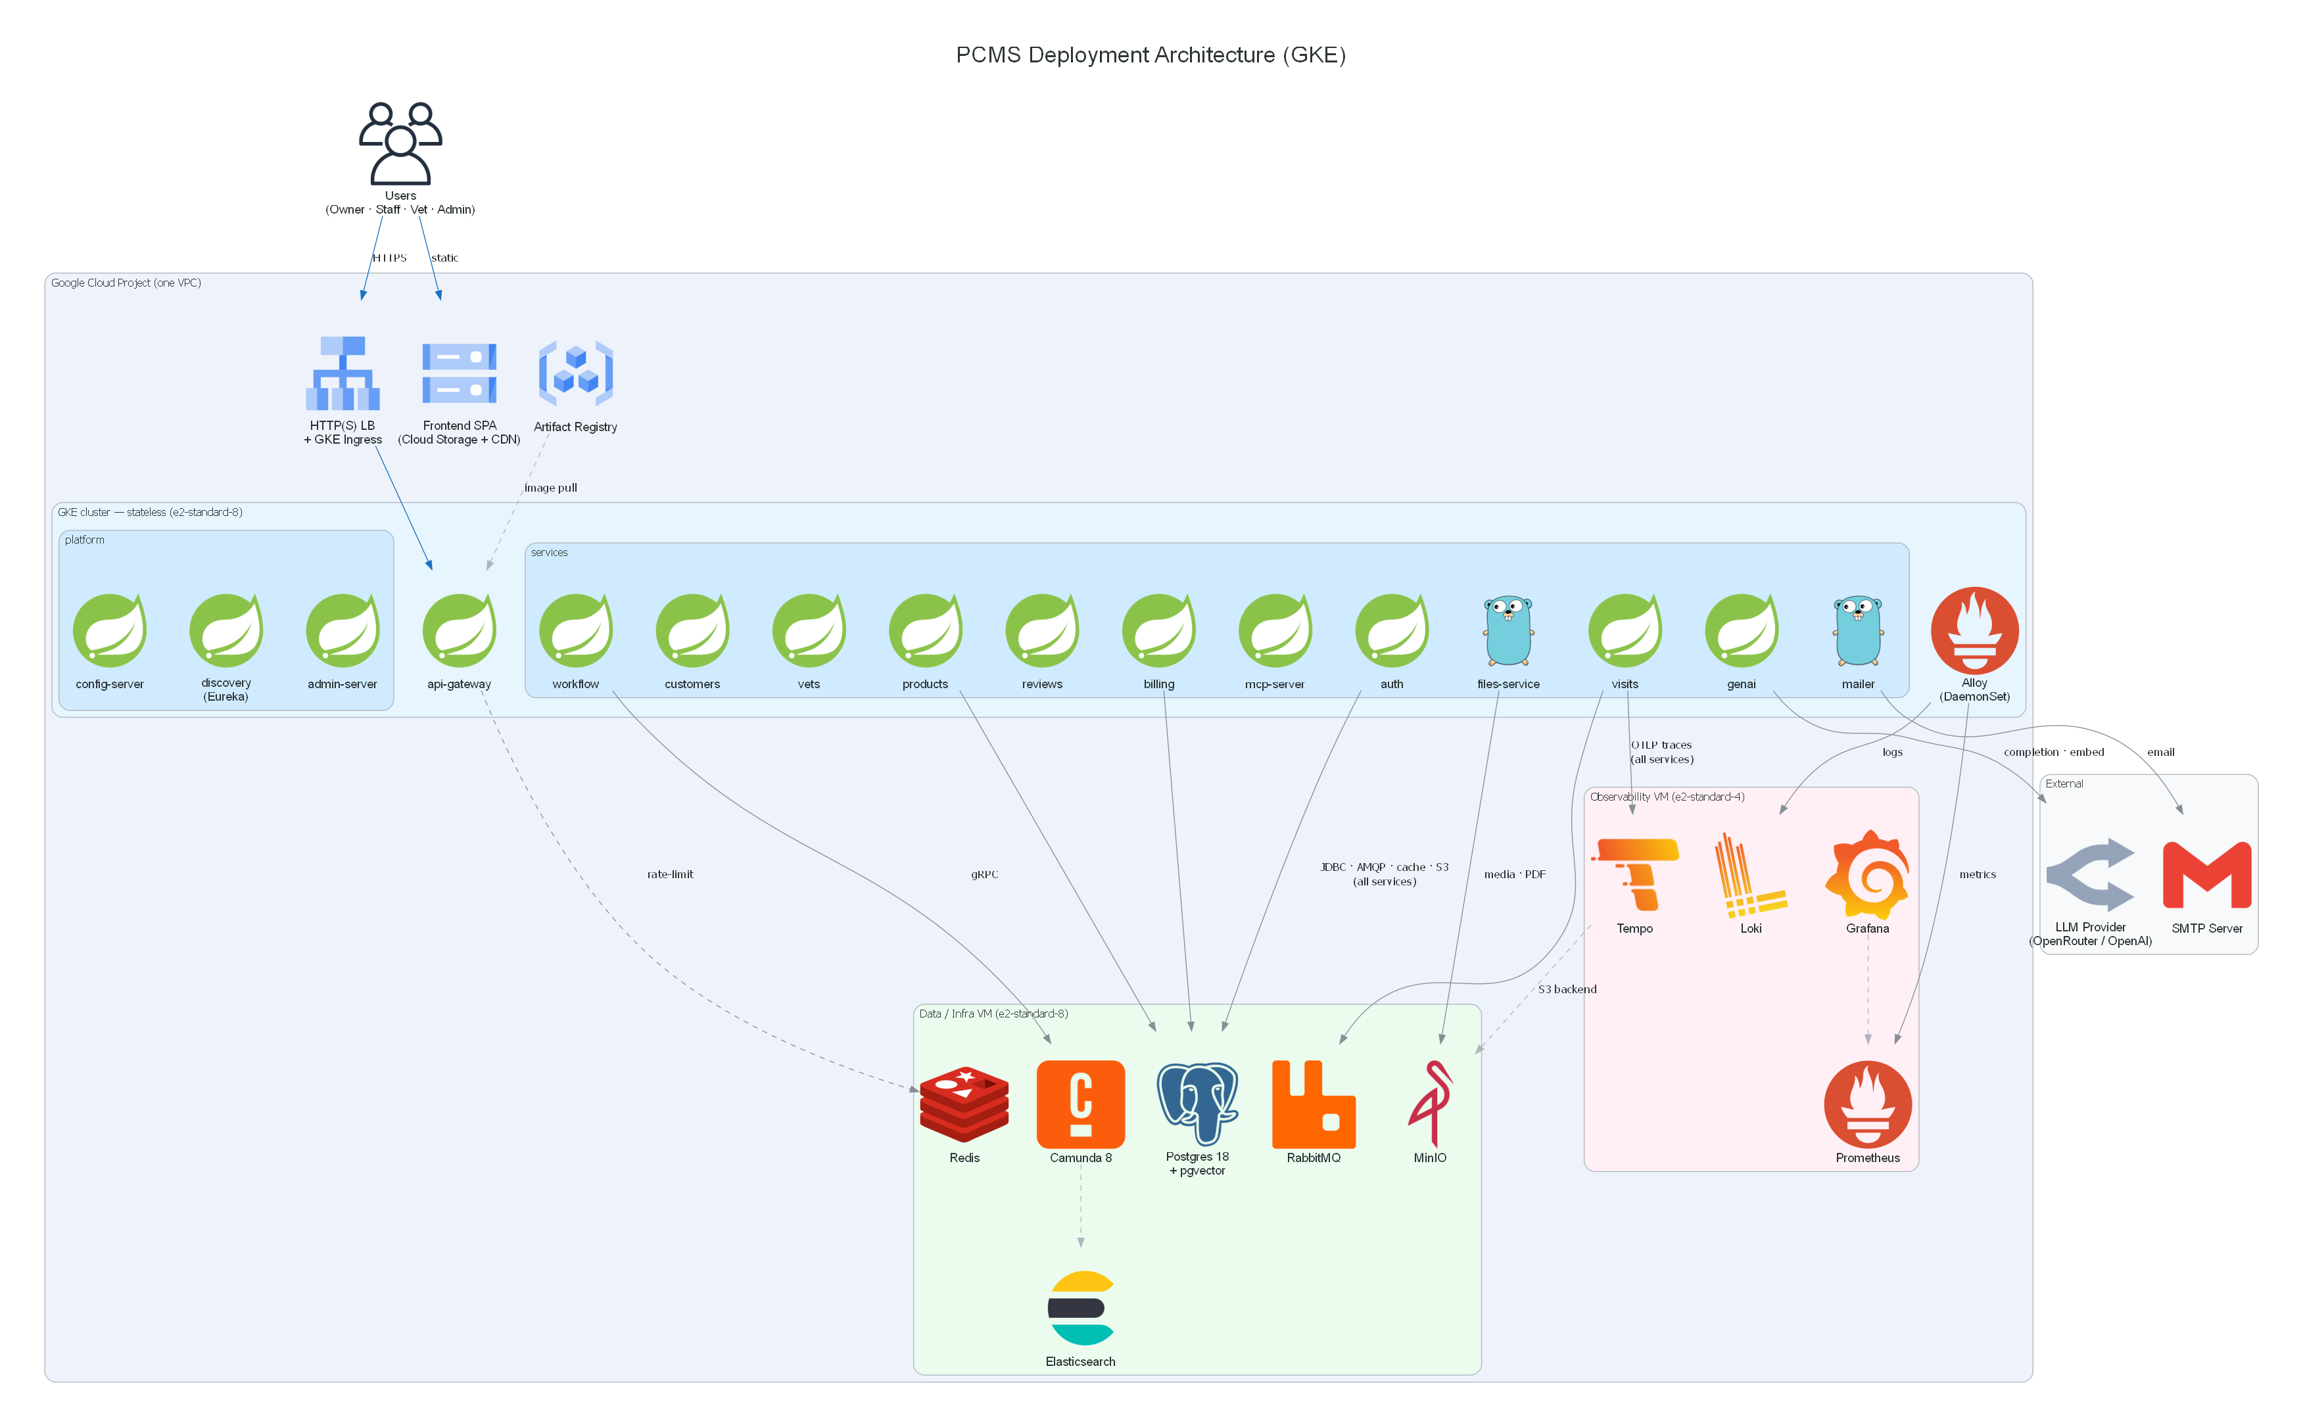
Figure 4-1: PCMS GKE Deployment Architecture
• GKE cluster (e2-standard-8) – stateless tier: api-gateway, the platform services (config-server, discovery/Eureka, admin-server) and the business/AI services, plus the in-cluster Alloy DaemonSet.
• Data / Infra VM (e2-standard-8) – Postgres 18 + pgvector, RabbitMQ, Redis, MinIO, and Camunda 8 + Elasticsearch — all stateful backends via docker-compose.
• Observability VM (e2-standard-4) – self-hosted Grafana LGTM, isolated from the cluster it monitors.
• Cloud Storage + CDN – hosts the React SPA (static).
• Artifact Registry – stores the per-service container images.

4.2 Component Placement
Placement is driven by statefulness and blast-radius isolation:
Component | Placement | Rationale
13 Spring + Go services (incl. workflow-service) | GKE | Stateless, horizontally scalable — the natural fit for Kubernetes.
Alloy agent | GKE (DaemonSet) | Collects metrics + logs at source, ships to the Obs VM.
Frontend SPA | Cloud Storage + CDN | Static assets; no pod needed.
Postgres+pgvector, RabbitMQ, Redis, MinIO | Data VM | Stateful — avoid DB-on-Kubernetes operator complexity; stable disk/IO, easy backup.
Camunda 8 + Elasticsearch | Data VM | Heavy JVM + ES; isolated so it cannot starve the app pods.
LGTM (Grafana, Prometheus, Loki, Tempo, Alloy gateway) | Observability VM | Monitoring must live outside the cluster it watches (SRE isolation).

4.3 Observability
Observability uses a self-hosted Grafana LGTM stack on the dedicated VM. The application is instrumented vendor-neutrally — Micrometer Prometheus metrics, OTLP traces and structured logs — so the services run unchanged whether telemetry goes to self-hosted LGTM (GKE demo) or the docker-compose LGTM used in local dev. Configs and dashboards live under k8s/infra-vm/observability/.
Telemetry data flow:
• Metrics – the in-cluster Alloy DaemonSet scrapes each pod's /actuator/prometheus and remote-writes to Prometheus on the Obs VM (services are not scraped directly across the network).
• Logs – Alloy tails pod logs and pushes to Loki, labelled by application / namespace / pod.
• Traces – services send OTLP directly to the Alloy gateway on the Obs VM, which batches and forwards to Tempo.
• Grafana – single pane over Prometheus + Loki + Tempo, with log-to-trace correlation (click a log's traceId to open the trace).
Provisioned dashboards: JVM (Micrometer), Spring Boot statistics, PostgreSQL, Redis and a PetClinic logs dashboard.
Storage note: Loki chunks and Tempo trace blocks can use the Data-VM MinIO as their S3 backend, so a single MinIO serves both application media and observability storage.

4.4 Cloud Platform Notes (free-trial)
• Quota – the free trial does not allow quota increases; upgrade to a paid billing account early (the $300 credit still applies) to raise the vCPU quota before sizing the cluster.
• LLM – the credit cannot be spent on partner GenAI model-as-a-service, so genai-service keeps an external OpenRouter / OpenAI provider.
• Lifecycle – the environment is brought up for the demo week and torn down afterwards (kubectl delete -k, docker compose down, delete cluster + VMs).

