Pet Care Management System
Software Requirement Specification
Project Code: MSS301-SP2026-PCMS
Document Code: SRS-PCMS – v1.0
Architecture: Spring Boot 4 · Spring Cloud · Microservices
— Hanoi, May 2026 —

Table of Contents

I. Record of Changes
Date | A*/M/D | In charge | Change Description
2026-03-10 | A | Project Team | Initial draft — product overview, actors, context diagram.
2026-04-02 | A | Project Team | Full use-case catalogue, functional overview, ERDs.
2026-04-25 | M | Project Team | Feature details with screen mock-ups (clinical + shop + billing).
2026-05-20 | M | Project Team | Non-functional requirements, business rules, message catalogue.
2026-05-29 | M | Project Team | Finalise v1.0 for MSS301 submission.
*A – Added | M – Modified | D – Deleted

II. Software Requirement Specification

1. Product Overview
Pet Care Management System (PCMS) is a cloud-native platform for a veterinary clinic and its in-clinic pet store. Pet owners register and manage their pets, discover and rate veterinarians, check availability and book visits, receive prescriptions, and view their invoices and receipts — and can ask a built-in AI assistant for help. Clinic staff, veterinarians, inventory managers and administrators operate the clinic, the catalogue and the platform.
The system is built as a Spring Boot 4 / Spring Cloud microservices monorepo (Java 25, virtual threads, Spring AI). This document specifies the complete functional and non-functional requirements of the system.
The context diagram identifies the external actors and third-party systems and the information exchanged with each.
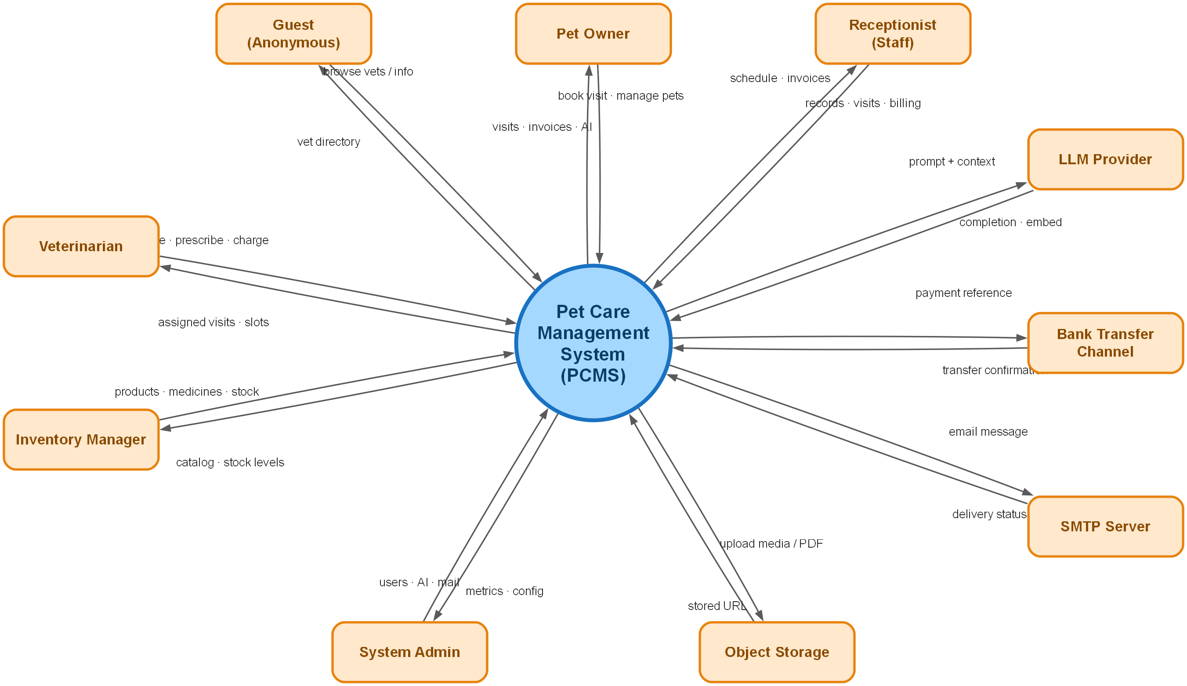
Figure 1-1: PCMS System Context
External entities:
- Guest — anonymous visitor who can browse the public catalogue and vet directory.
- Pet Owner — registered customer who self-serves clinical and shopping features.
- Receptionist (Staff) — front desk: owner/pet records, visits, billing, review moderation.
- Veterinarian — runs visits, manages own schedule/profile, issues prescriptions.
- Inventory Manager — maintains pet products, medicines, stock and pricing.
- System Admin — manages users, AI provider, emails and observability.
- LLM Provider / Bank Transfer Channel / SMTP / Object Storage — external services for AI, bank-transfer reference, email and media.
Internally PCMS is decomposed into focused services behind an API gateway, supported by platform services and shared infrastructure.
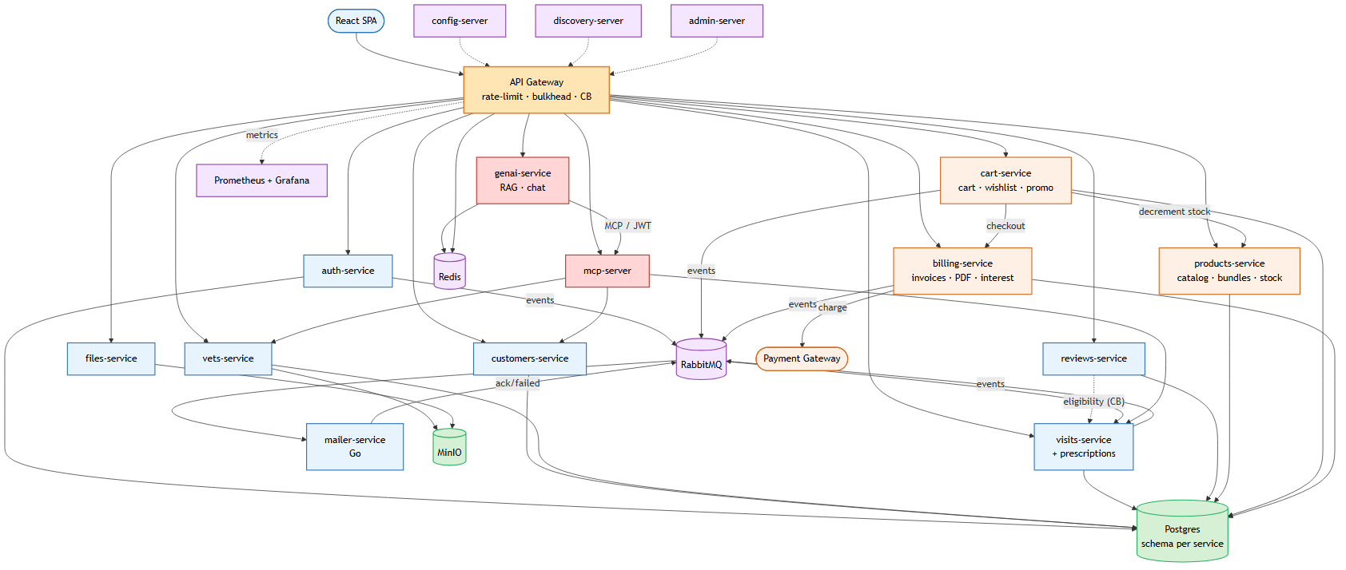
Figure 1-2: PCMS High-Level Architecture
Services and responsibilities:
- api-gateway — single entry point; JWT validation, Redis rate-limiting, Resilience4j circuit breakers & per-route bulkheads.
- auth-service — registration, email verification, login, JWT issuing/rotation, JWKS; roles USER / STAFF / VET / ADMIN / INVENTORY_MANAGER.
- customers-service — owners and pets; vets-service — vets, specialties, ratings, schedule, badges, education, photos.
- visits-service — visit lifecycle, availability slots, prescriptions, and saga-based notifications.
- reviews-service — polymorphic reviews (vet / product / visit) with voting and moderation.
- products-service — pet-product & medicine catalogue, stock and pricing (back-office; managed by inventory and added to clinic invoices by reception).
- billing-service — clinical invoices with in-store product lines, PDF export, and cash / bank-transfer payment recording.
- genai-service — Spring AI chat with RAG; mcp-server — MCP/OAuth 2.1 tools; mailer-service (Go) — async email + saga replies.
- config-server, discovery-server, admin-server, files-service — platform, registry, monitoring and media services.

2. User Requirements

2.1 Actors
An actor is a person, role or external system that interacts with PCMS.
# | Actor | Description
1 | Guest | Unauthenticated visitor who can register as a pet owner or log in to an existing account.
2 | Pet Owner (USER) | Registered customer who manages own pets, books visits by selecting pet, veterinarian, time slot and reason, and views visit history, prescriptions and invoices.
3 | Receptionist (STAFF) | Front-desk employee who sees all appointments, reschedules/cancels visits with reasons, receives clinical invoices, adds in-store products, collects cash or bank-transfer payments and sends receipts.
4 | Veterinarian (VET) | Clinical user who sees assigned appointments, performs examinations, updates visit results, records services and prices, and issues prescriptions.
5 | Inventory Manager (INV) | Catalogue and stock operator who manages pet products, medicines, quantities, prices and availability.
6 | System Admin (ADMIN) | Platform operator who manages accounts, roles and system configuration.
7 | Email / SMTP Service | External service used for account verification, appointment notifications, invoices and receipts.
8 | Bank Transfer Channel | External transfer channel used when the receptionist records a bank-transfer payment reference; cash payment is recorded internally.

2.2 Use Cases

2.2.1 Use Case Diagrams
Two diagrams group the updated main use cases: appointment and clinical flow, and billing, payment and inventory.
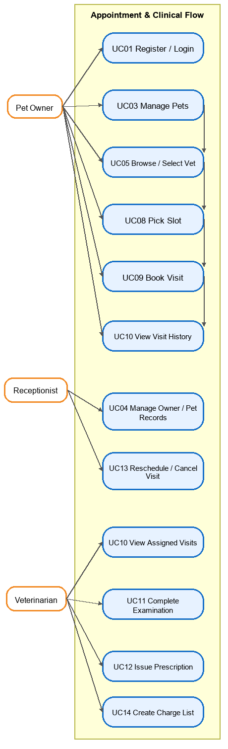
Figure 2-1: Use Cases - Appointment & Clinical Flow
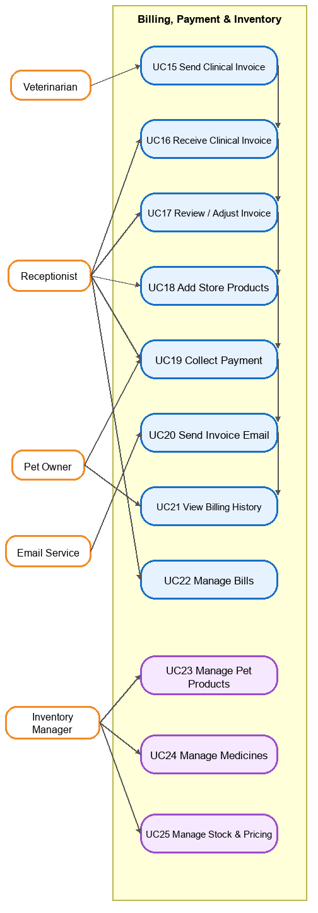
Figure 2-2: Use Cases - Billing, Payment & Inventory

2.2.2 Use Case Descriptions
Each use case is named verb-object and describes the updated core clinic workflow from owner registration through visit booking, examination, invoice finalisation, payment, email receipt and inventory control.
ID | Group function | Use Case | Actors | Description
UC01 | Identity | Register / Login | Guest, All roles | Create an account or authenticate; issue access + refresh JWTs with role claims.
UC02 | Identity | Verify Email / Reset Password | Pet Owner, Staff, Vet, INV, ADMIN | Verify a new account by email and recover forgotten passwords.
UC03 | Pet Management | Manage Pets | Pet Owner | CRUD own pets, pet photos and basic medical profile before booking a visit.
UC04 | Customer Support | Manage Owners & Pets | Receptionist | Maintain owner and pet records for phone or walk-in support.
UC05 | Vet Discovery | Browse & Select Vets | Pet Owner, Receptionist | Search veterinarians by specialty, rating or availability before booking.
UC06 | Vet Discovery | View Vet Profile | Pet Owner, Receptionist | View veterinarian details, specialties and available clinical information.
UC07 | Vet Scheduling | Manage Vet Profile & Schedule | Veterinarian | Maintain own profile, working hours and unavailable slots.
UC08 | Scheduling | Check Availability / Pick Slot | Pet Owner, Receptionist | View available appointment slots for a selected veterinarian and date.
UC09 | Visit Booking | Book a Visit | Pet Owner, Receptionist | Create a scheduled visit with pet, veterinarian, time slot and owner-provided description/reason.
UC10 | Visit Lifecycle | Track Appointment / Visit History | Pet Owner, Veterinarian, Receptionist | Owners see their visits; veterinarians see assigned visits; receptionists see the clinic schedule.
UC11 | Clinical | Start / Complete Examination | Veterinarian | Move the visit through examination, then record diagnosis, treatment notes, performed services and clinical fees.
UC12 | Clinical | Issue Prescription | Veterinarian | Add prescribed medicines, dosage, duration and instructions to the completed visit.
UC13 | Scheduling | Cancel / Reschedule Visit | Pet Owner, Receptionist | Cancel or move a scheduled visit; receptionist may update on behalf of owner with a delay/change reason.
UC14 | Clinical Billing | Create Examination Charge List | Veterinarian | List the services just performed, prescribed medicines and prices for the visit.
UC15 | Clinical Billing | Send Clinical Invoice to Receptionist | Veterinarian, System | Forward the examination charge list and prescription-linked charges to reception for final billing.
UC16 | Billing | Receive Clinical Invoice | Receptionist | Receive the doctor-created invoice draft for the completed appointment.
UC17 | Billing | Review / Adjust Invoice | Receptionist | Verify clinical line items, correct allowed billing details and prepare the invoice for payment.
UC18 | Billing | Add Store Products to Invoice | Receptionist | Add pet products or medicines that the owner buys directly at the clinic store.
UC19 | Payment | Collect Payment | Receptionist | Request payment from the owner, record cash or bank transfer and mark the invoice paid.
UC20 | Communications | Send Invoice Email | Receptionist, Email / SMTP Service | Send the final paid invoice/receipt to the owner by email.
UC21 | Billing | View Invoices / Visit Billing History | Pet Owner, Receptionist | Display invoices inside the owner appointment history and staff billing screens.
UC22 | Billing | Manage Bills | Receptionist, ADMIN | Filter bills, update payment status, cancel/refund when authorised and audit billing changes.
UC23 | Inventory | Manage Pet Products | Inventory Manager, ADMIN | CRUD pet products, categories, prices, listing status and store availability.
UC24 | Inventory | Manage Medicines | Inventory Manager, ADMIN | CRUD medicines, dosage metadata, prices and prescription availability.
UC25 | Inventory | Manage Stock & Pricing | Inventory Manager, ADMIN | Adjust quantities, track low stock, update product/medicine prices and reconcile sold items.
UC26 | Administration | Manage Users & Roles | ADMIN | Create/disable accounts and assign roles for clinic operations.

3. Software Features

3.1 Functional Overview
Screen flow, screen descriptions, role-based authorisation, non-screen functions and the entity model.

3.1.1 Screens Flow
The web application navigates between the screens below (rectangles = full screens, dashed ovals = pop-ups). The Home Dashboard is the post-login hub; admin/clinical screens are gated by role.
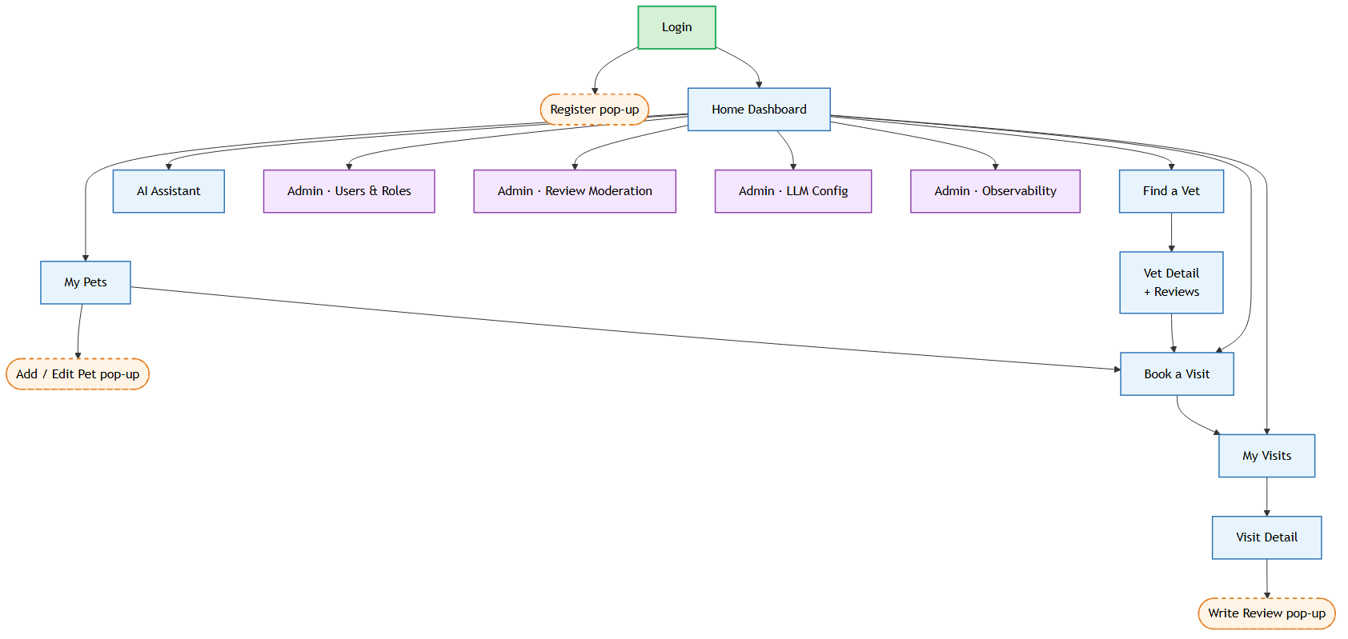
Figure 3-1: PCMS Screen Flow (core journeys)

3.1.2 Screen Descriptions
# | Feature | Screen | Description
1 | Identity | Login / Register | Email + password; register creates a USER + Owner; email verification.
2 | Identity | Home Dashboard | Role-aware hub; menu filtered by JWT roles.
3 | Discovery | Find a Vet / Vet Detail | Searchable grid + vet profile, ratings and reviews.
4 | Pet Mgmt | My Pets / Pet form | Owner’s pets; add/edit pop-up.
5 | Booking | Book a Visit | Pet + vet + slot picker with availability.
6 | Visit Lifecycle | My Visits / Visit Detail | KPI summary + role-scoped table; full record on detail.
7 | Clinical | Complete Visit & Prescribe | Vet records diagnosis/treatment/fee and prescriptions.
8 | Feedback | Write Review (pop-up) | Star rating + text for a completed interaction.
9 | Billing | Invoices / Invoice Detail | Bill list with status; detail + PDF + pay.
10 | AI | AI Assistant | Streamed chat with tool-call indicators.
11 | Admin | Users & Roles | Manage accounts and role assignment.
12 | Admin | Review Moderation | Approve/hide/delete queued reviews.
13 | Admin | Manage Products / Inventory / Promotions | Catalogue, stock and pricing management.
14 | Admin | LLM Config / Observability / Emails | BYOK LLM, dashboards, email templates.

3.1.3 Screen Authorization
“X” = the role may open the screen and perform its primary action. Guests may only browse the public catalogue and vet directory. Empty cells are hidden in the menu and refused at the API layer (Spring Security @PreAuthorize + declarative YAML RBAC).
# | Screen | USER | STAFF | VET | ADMIN | INV
1 | Login / Register / Dashboard | X | X | X | X | X
2 | Find a Vet / Vet Detail | X | X
3 | My Pets / Book a Visit | X
4 | My Visits (own / assigned / all) | X | X | X | X
5 | Complete Visit & Prescribe |  | X | X
6 | Write Review | X
7 | Review Moderation |  | X |  | X
8 | Invoices (own) | X
9 | Manage Bills (all) |  | X |  | X
10 | AI Assistant | X
11 | Manage Products / Inventory / Promotions |  |  |  | X | X
12 | Users & Roles / LLM / Observability / Emails |  |  |  | X

3.1.4 Non-Screen Functions
System-internal behaviours (async listeners, scheduled jobs, machine APIs) without a UI.
# | Feature | System Function | Description
1 | Visit Booking | Notification Saga | Publish visit events; consume ack/failed; compensate on failure.
2 | Notification | Mailer Consumer (Go) | Consume events, send email, reply ack/failed; idempotent by eventId.
3 | Checkout | Bill Creation | Completing a visit or adding store products creates an invoice in billing-service.
4 | Checkout | Stock Reservation | products-service decrements stock when products are added to a clinic invoice.
5 | Marketing | Invoice Totalling | Sum clinical fees and store-product lines into the final invoice total.
6 | Billing | Interest & Overdue Job | Scheduled job flags overdue bills and accrues interest (unless exempt).
7 | Clinical | Prescription PDF | Render a prescription PDF for the owner.
8 | AI | RAG + MCP Tools | Embed knowledge into pgvector; expose user-scoped MCP tools over OAuth 2.1.
9 | Identity | JWT Refresh & JWKS | Rotating refresh tokens; /.well-known/jwks.json.
10 | Observability | Metrics & Tracing | Micrometer → Prometheus/Grafana; W3C trace context → Zipkin.

3.1.5 Entity Relationship Diagram
Each service owns its Postgres schema (Database-per-Service); cross-service references are logical. Two ERDs are shown: the clinical core and the commerce & billing domain.
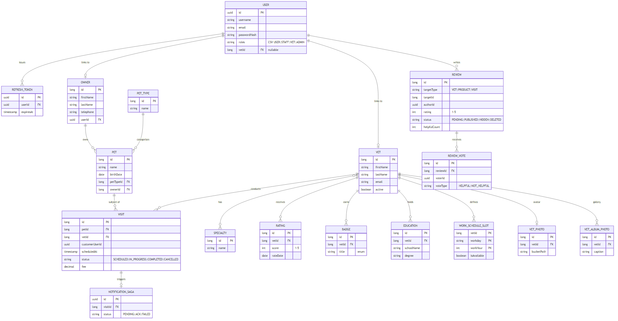
Figure 3-2: ERD — Clinical Core
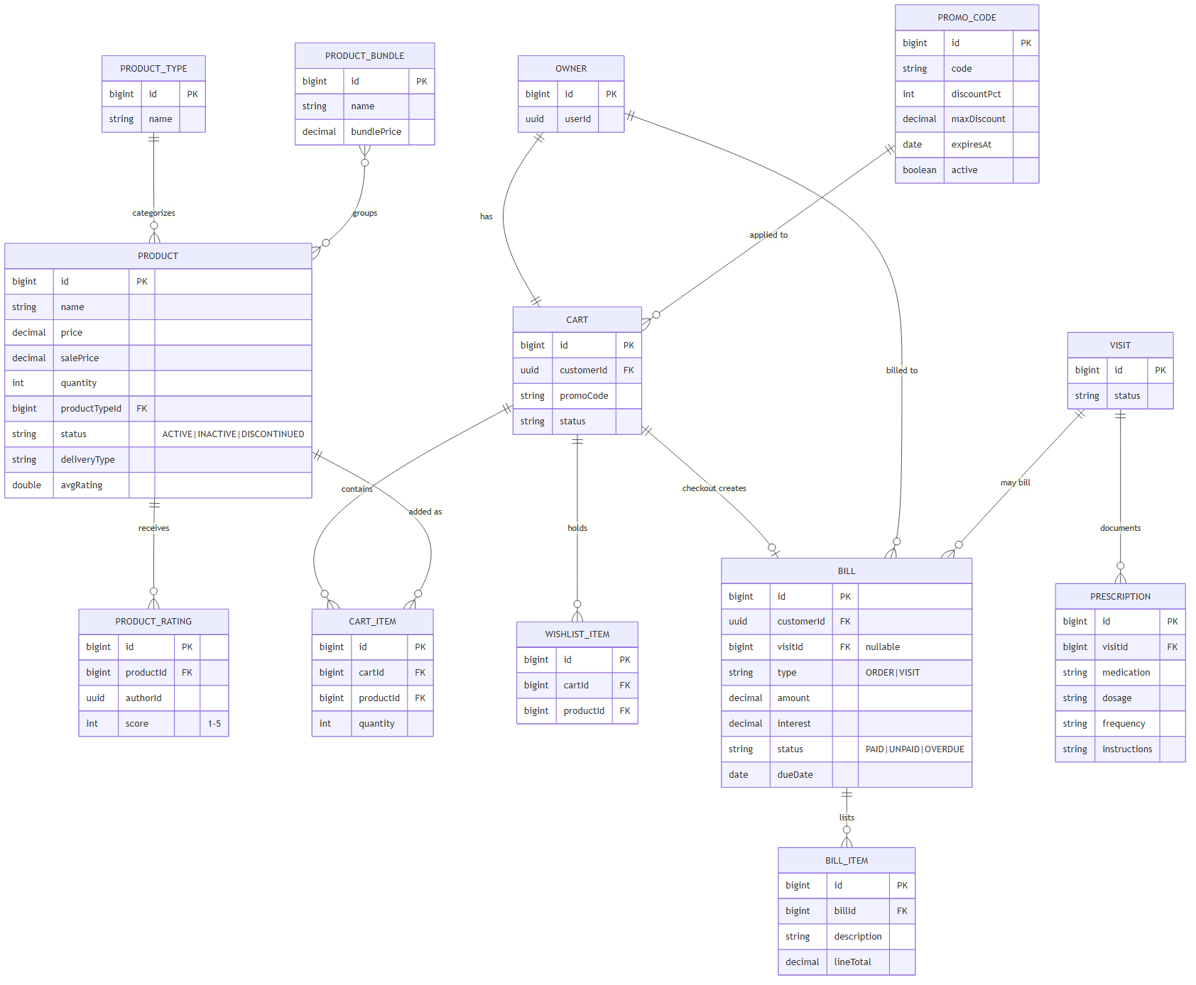
Figure 3-3: ERD — Commerce, Billing & Prescriptions

3.1.6 Entity Details
Visit
# | Attribute | PK | Type | Mandatory | Description
1 | id | x | bigint | Yes | Identity.
2 | petId / vetId |  | bigint | Yes | Logical FKs to pet & vet.
3 | customerUserId |  | uuid | Yes | Owning user (row-level access).
4 | scheduledAt |  | timestamptz | Yes | Appointment time (BR-01/02).
5 | status |  | varchar(20) | Yes | SCHEDULED|IN_PROGRESS|COMPLETED|CANCELLED.
6 | diagnosis / treatment / fee |  | text / numeric | No | Recorded on completion.
Product
# | Attribute | PK | Type | Mandatory | Description
1 | id | x | bigint | Yes | Identity.
2 | name / description |  | varchar / text | Yes | Catalogue display.
3 | price / salePrice |  | numeric(10,2) | Yes | List price.
4 | quantity |  | int | Yes | On-hand stock (BR-21).
5 | productTypeId |  | bigint | Yes | FK to product type.
6 | status / deliveryType |  | enum | Yes | ACTIVE|INACTIVE|DISCONTINUED; delivery options.
Bill (Invoice)
# | Attribute | PK | Type | Mandatory | Description
1 | id | x | bigint | Yes | Identity / invoice number.
2 | customerId |  | uuid | Yes | Billed customer.
3 | visitId |  | bigint | No | Set for visit bills.
4 | type |  | varchar(10) | Yes | ORDER | VISIT.
5 | amount / interest |  | numeric(10,2) | Yes | Principal + accrued interest.
6 | status / dueDate |  | enum / date | Yes | PAID|UNPAID|OVERDUE (BR-22).
Prescription
# | Attribute | PK | Type | Mandatory | Description
1 | id | x | bigint | Yes | Identity.
2 | visitId |  | bigint | Yes | Owning completed visit.
3 | medication / dosage / frequency |  | varchar | Yes | Prescribed item lines.
4 | instructions |  | text | No | Owner guidance.

3.2 Authentication & Account

3.2.1 UC01 — Login
3.2.1.1 Screen Mock-up
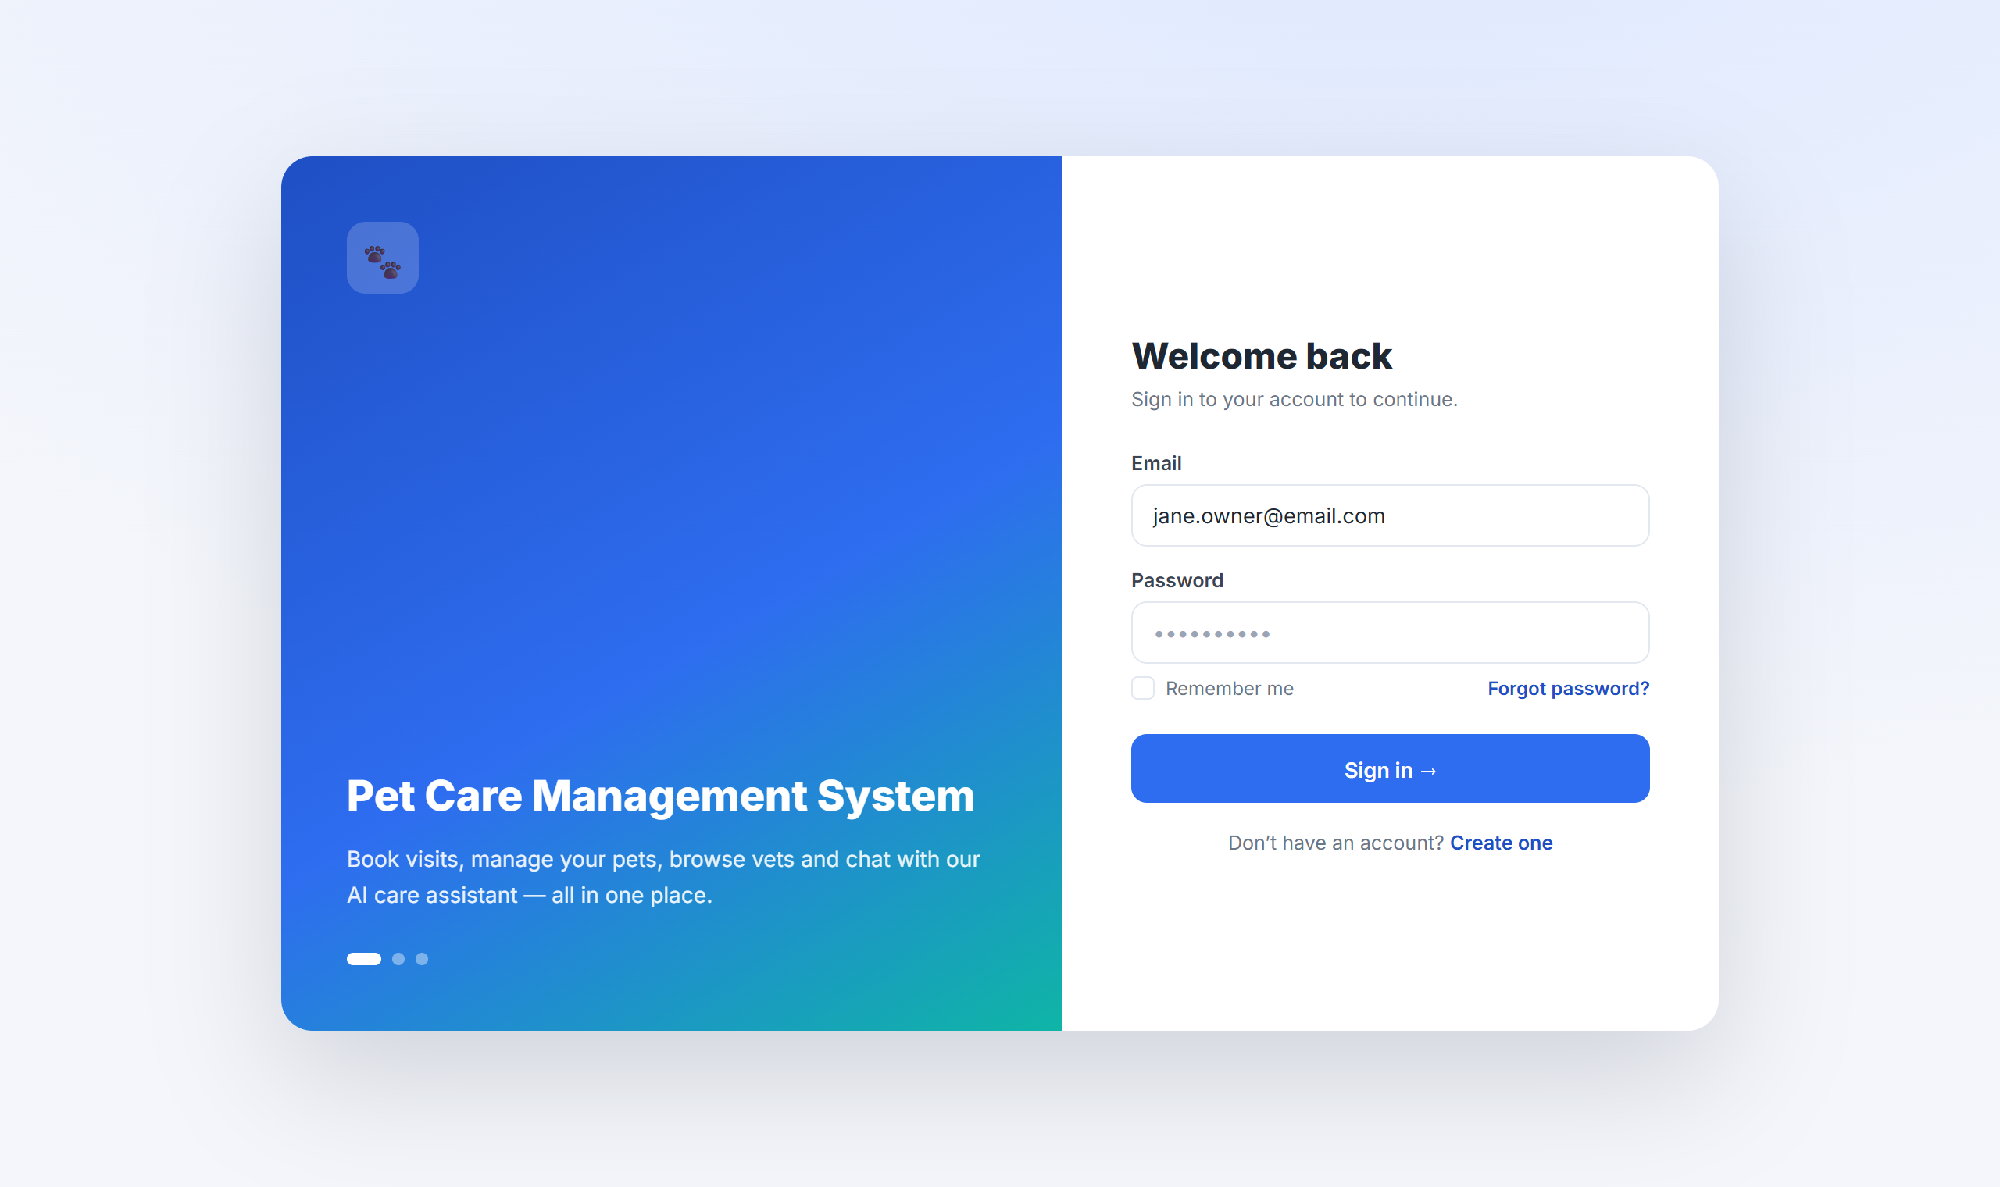
Figure 3-4: Login Screen
Table 3-1: Screen Definition
# | Field Name | Type | Mandatory | Max Length | Description
1 | Email | Text | Yes | 254 | RFC 5321 email; inline validation.
2 | Password | Password | Yes | 128 | Masked; BR-09.
3 | Remember me | Checkbox |  |  | Persists session cookie.
4 | Sign in / Register | Button / Link |  |  | Submit credentials / open Register.
3.2.1.2 Use Case Description
Use Case ID |  | UC01 | Use Case Name |  | Login
Author |  | Project Team | Version | 1.0 | Date | 2026-04-25
Actor |  | USER, STAFF, VET, ADMIN, INV
Description |  | A registered user signs in so the system recognises them and applies their role-based permissions.
Precondition |  | PRE-01: The user has a registered, email-verified account.  PRE-02: The system is available.
Trigger |  | TRG-01: User opens the application.
Post-Condition |  | POS-01: The user is authenticated and signed in.  POS-02: The user is taken to the role-appropriate dashboard.
Main Flow
Step | Actor | Action
1 | User | Opens the application.
2 | PCMS | Displays the Login screen with Email, Password, Sign in and Register.
3 | User | Enters email and password and clicks Sign in.
4 | PCMS | Validates the credentials, signs the user in and shows the role-appropriate dashboard.
Alternative flows
AT1 | At step 4, the credentials are invalid.
Sub step | Actor | Action
4.1 | PCMS | Shows an error message (MSG09) and lets the user try again.
4.2 | PCMS | After 5 failed attempts within 15 minutes, locks the account for 30 minutes (MSG10).
Business Rules
# | Rule Description
BR-08 | Passwords stored as bcrypt (cost 12); never logged.
BR-09 | Password ≥ 8 chars with ≥1 digit and ≥1 letter.
BR-10 | Access token 15 min; refresh 7 days, single-use rotation.
BR-26 | Email must be verified (UC02) before first login.

3.3 Browse Vets & Book a Visit

3.3.1 UC05 — Browse & Search Vets
3.3.1.1 Screen Mock-up
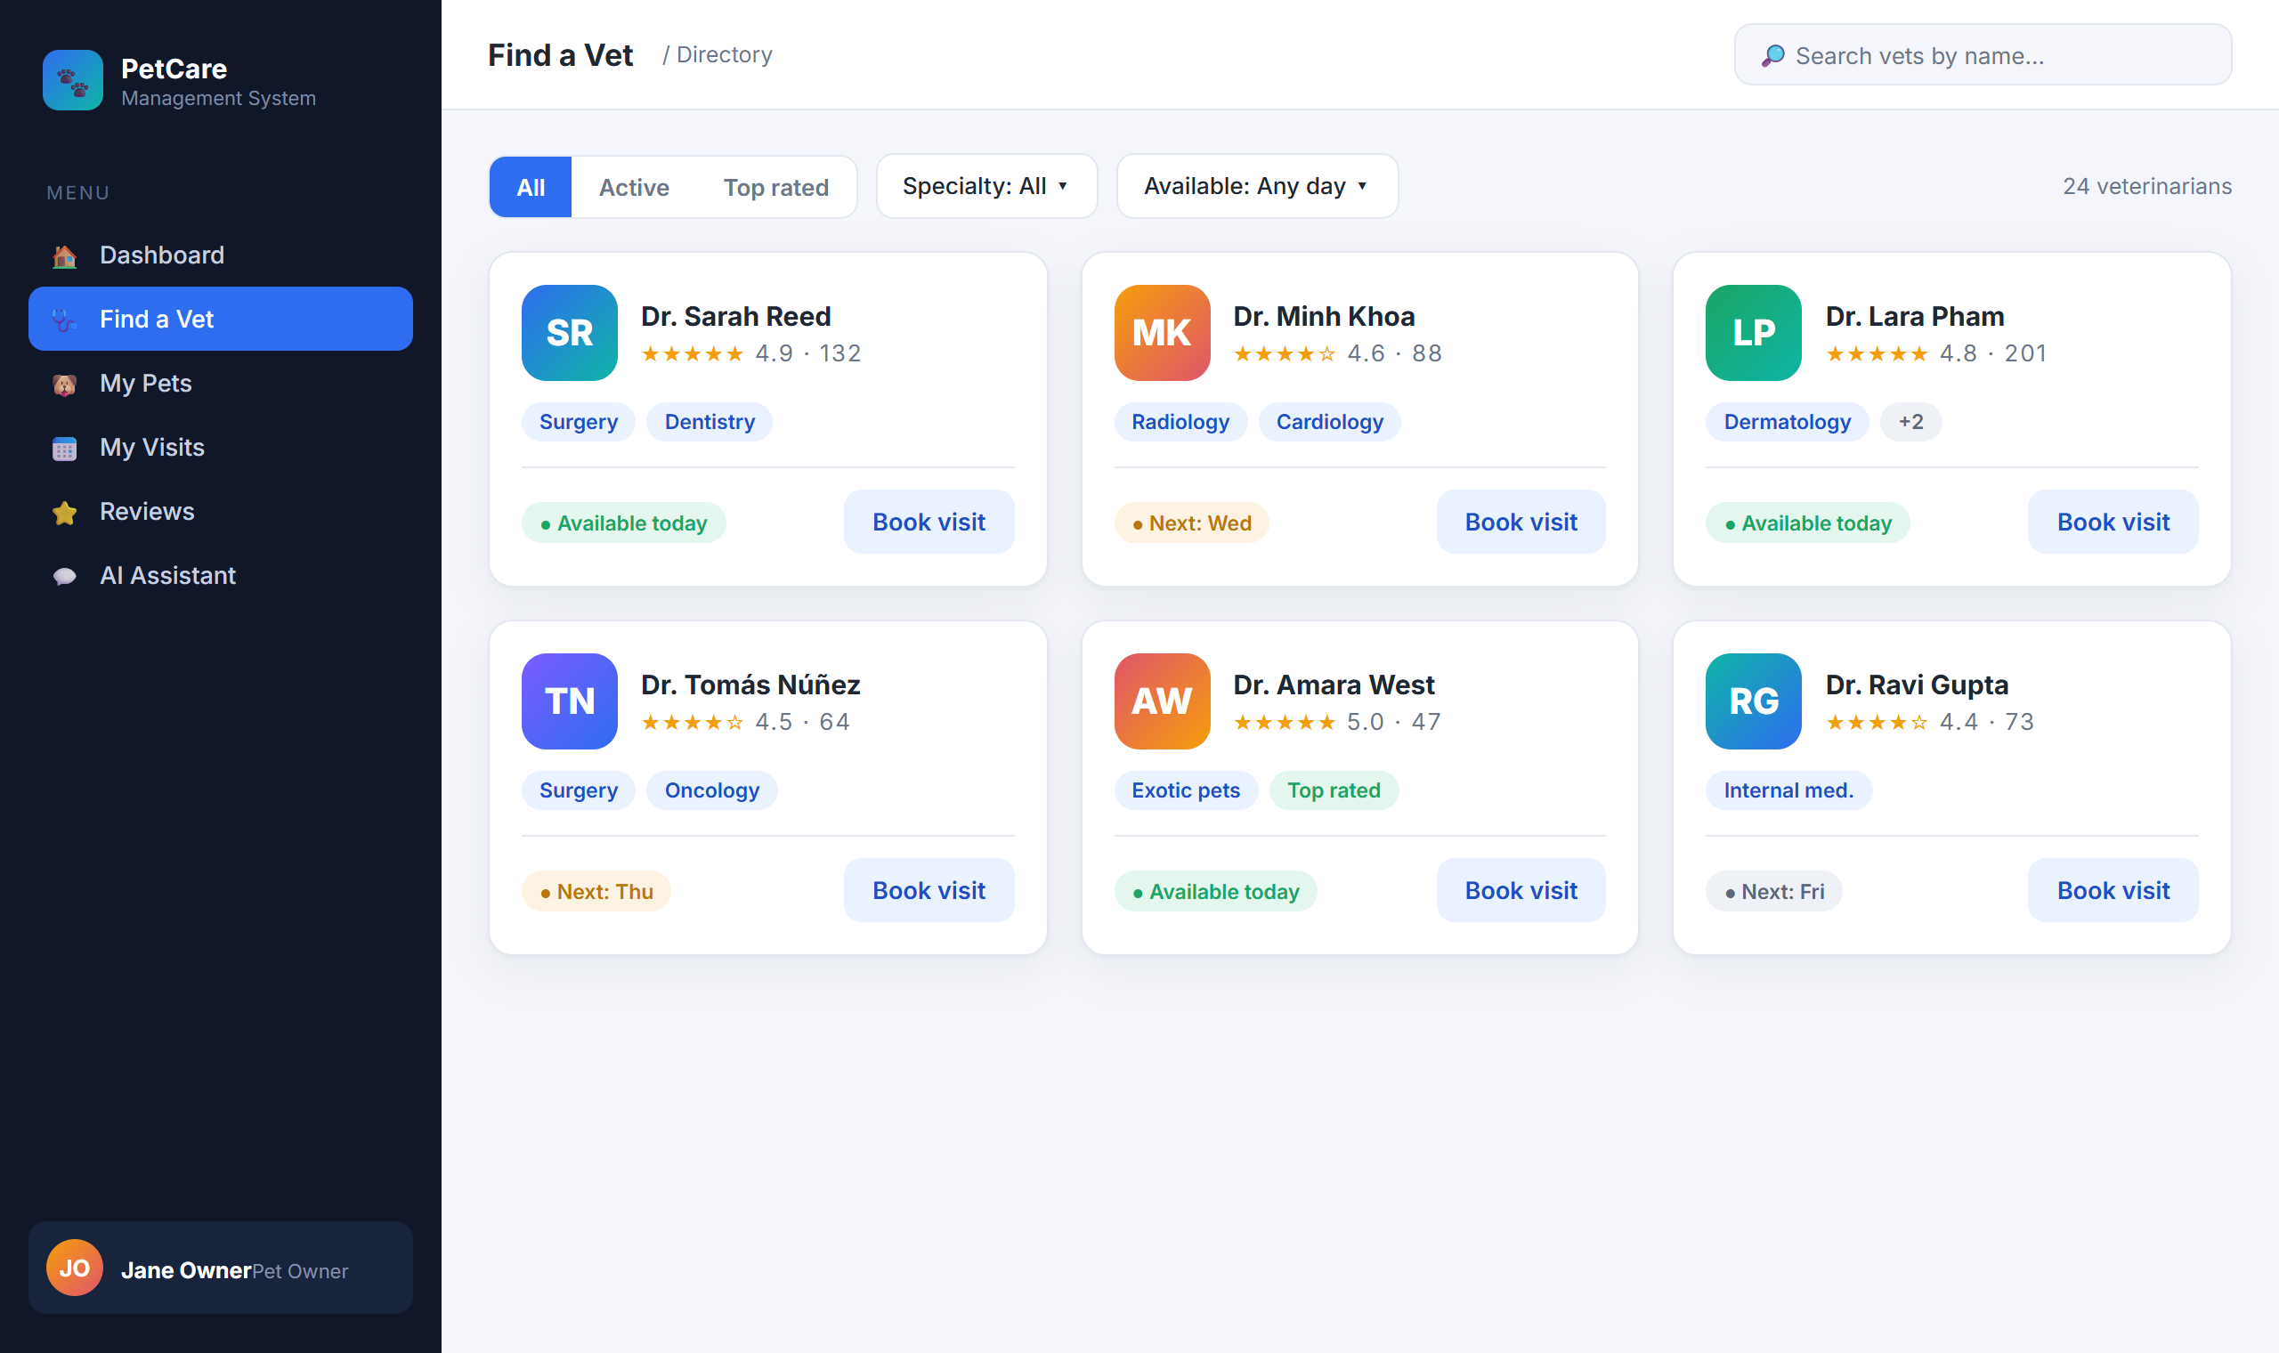
Figure 3-5: Find a Vet (Directory)
Guests and owners search and filter the vet directory and open a vet to view profile, ratings and reviews before booking. Implemented by vets-service (GET /api/v1/vets, /top-rated, /{id}).

3.3.2 UC09 — Book a Visit
3.3.2.1 Screen Mock-up
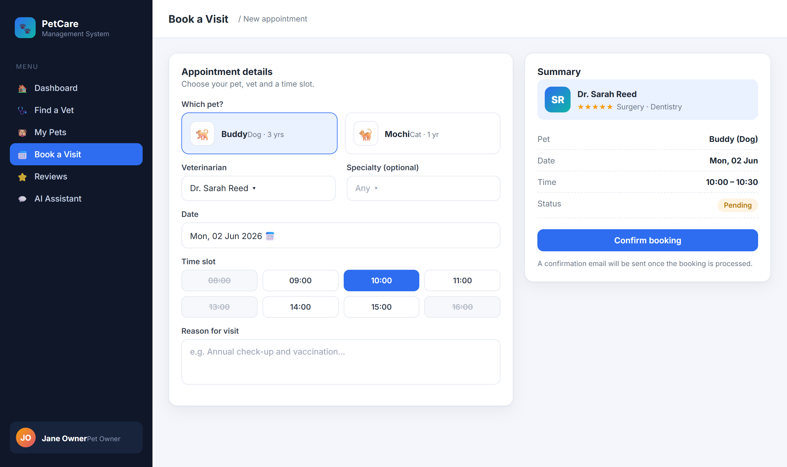
Figure 3-6: Book a Visit
Table 3-2: Screen Definition
# | Field Name | Type | Mandatory | Max Length | Description
1 | Pet | Selector | Yes | – | Owner’s pets only.
2 | Veterinarian / Specialty | Dropdown | Yes | – | Specialty narrows vet list.
3 | Date / Time slot | Picker / grid | Yes | – | Free slots only (BR-06).
4 | Reason | Textarea |  | 500 | Symptom description.
5 | Confirm booking | Button |  |  | POST /api/v1/visits.
3.3.2.2 Use Case Description
Use Case ID |  | UC09 | Use Case Name |  | Book a Visit
Author |  | Project Team | Version | 1.0 | Date | 2026-04-25
Actor |  | USER
Description |  | A pet owner books an appointment for a pet with a chosen vet; the system records a scheduled visit and sends a confirmation email.
Precondition |  | PRE-01: The user is signed in (UC01).  PRE-02: The user has at least one pet (UC03).  PRE-03: The chosen vet is active and has a free slot (UC08).
Trigger |  | TRG-01: User chooses Book a Visit.
Post-Condition |  | POS-01: The visit is recorded with status Scheduled.  POS-02: A booking confirmation email is sent to the owner.
Main Flow
Step | Actor | Action
1 | User | Selects a pet, a vet, a date and a free time slot, enters a reason and clicks Confirm booking.
2 | PCMS | Validates the slot and business hours and records the visit as Scheduled.
3 | PCMS | Sends a booking confirmation email to the owner and shows a success message (MSG04).
4 | PCMS | Lists the new visit under My Visits with status Scheduled.
Alternative flows
AT1 | At step 3, the confirmation email cannot be delivered.
Sub step | Actor | Action
3.1 | PCMS | Flags the visit for manual follow-up and notifies the front desk so staff can confirm with the owner.

AT2 | At step 2, the chosen slot is no longer available.
Sub step | Actor | Action
2.1 | PCMS | Shows MSG12 and asks the user to pick another slot.
Business Rules
# | Rule Description
BR-01 | Bookings Mon–Sat, 08:00–18:00 (Asia/Ho_Chi_Minh).
BR-02 | Minimum 30-minute lead time.
BR-06 | At most one visit per vet per 30-minute slot.
BR-07 | Confirmation converges within 60 seconds.

3.4 Visit Lifecycle & Prescriptions

3.4.1 UC10/UC11 — Track & Complete Visit
3.4.1.1 Screen Mock-up
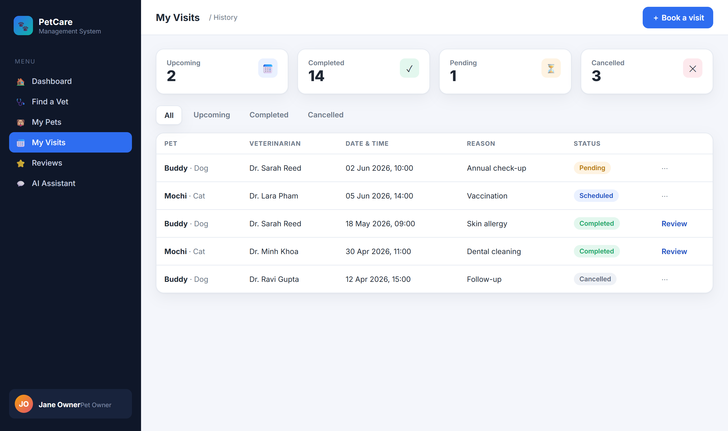
Figure 3-7: My Visits (history & status)
Owners see their own visits; vets see assigned visits; staff/admin see all. A vet starts a visit (IN_PROGRESS) and completes it with diagnosis, treatment and fee (visits-service PATCH /start, /complete).

3.4.2 UC12 — Issue Prescription
3.4.2.1 Screen Mock-up
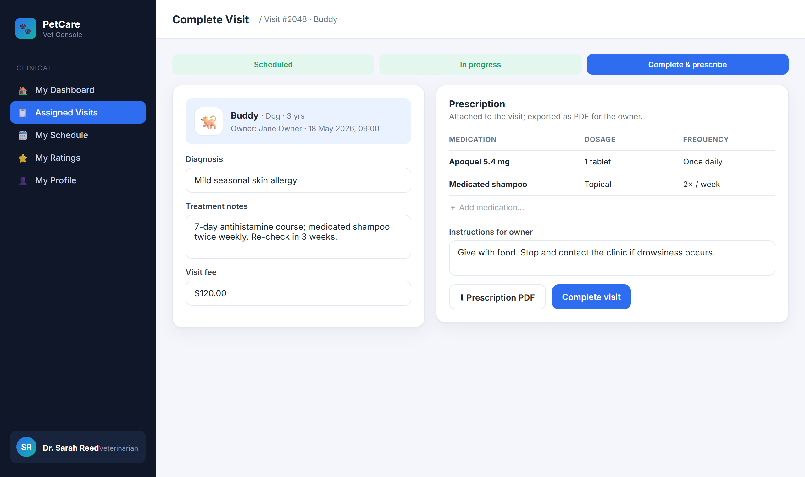
Figure 3-8: Complete Visit & Prescribe
3.4.2.2 Use Case Description
Use Case ID |  | UC12 | Use Case Name |  | Issue Prescription
Author |  | Project Team | Version | 1.0 | Date | 2026-04-25
Actor |  | VET
Description |  | When completing a visit, a vet records the prescribed medications so the owner receives a prescription.
Precondition |  | PRE-01: The vet is assigned to the visit.  PRE-02: The visit is in progress.
Trigger |  | TRG-01: Vet opens Complete Visit & Prescribe.
Post-Condition |  | POS-01: The prescription is saved against the visit and the visit is marked Completed.  POS-02: A prescription PDF is available to the owner.
Main Flow
Step | Actor | Action
1 | Vet | Records diagnosis, treatment and fee.
2 | Vet | Adds medication lines (name, dosage, frequency) and owner instructions.
3 | Vet | Clicks Complete visit.
4 | PCMS | Saves the prescription, marks the visit Completed and generates a prescription PDF.
5 | PCMS | Emails the owner a visit summary with the prescription and shows MSG21.
Alternative flows
AT1 | At step 3, the visit has not been started.
Sub step | Actor | Action
3.1 | PCMS | Prevents completion until the visit is in progress (BR-16).
Business Rules
# | Rule Description
BR-16 | A visit may not move backwards (e.g. COMPLETED → SCHEDULED).
BR-25 | A prescription belongs to a completed visit and is exported as PDF.

3.5 Reviews & Ratings

3.5.1 UC14 — Write a Review
3.5.1.1 Screen Mock-up
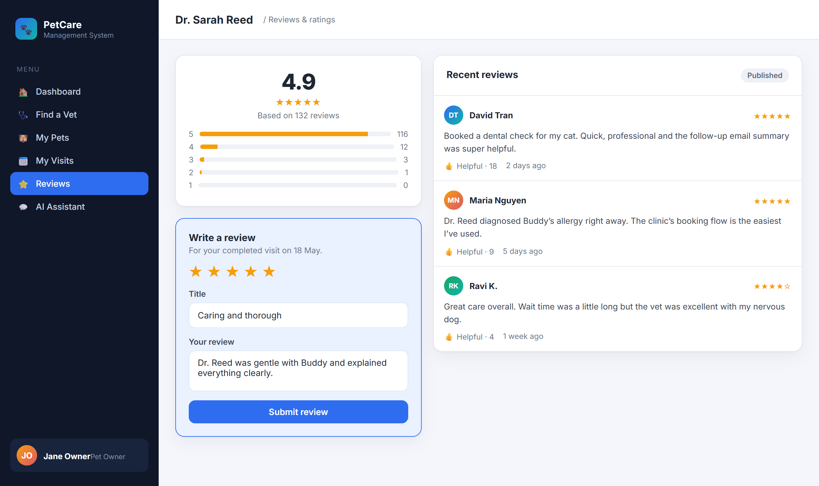
Figure 3-9: Vet Detail — Ratings & Write Review
Table 3-3: Screen Definition
# | Field Name | Type | Mandatory | Max Length | Description
1 | Star rating | Star picker | Yes | – | 1–5 stars.
2 | Title / Review | Text / Textarea | Yes | 120 / 2000 | Headline + feedback.
3 | Submit / Helpful | Button |  |  | Create review / vote helpful.
3.5.1.2 Use Case Description
Use Case ID |  | UC14 | Use Case Name |  | Write a Review
Author |  | Project Team | Version | 1.0 | Date | 2026-04-25
Actor |  | USER
Description |  | After a completed visit (or a purchased product), the owner leaves a star rating and review, which is moderated before it appears publicly.
Precondition |  | PRE-01: The user is signed in.  PRE-02: The user has a completed interaction with the target.
Trigger |  | TRG-01: User chooses Write a Review.
Post-Condition |  | POS-01: The review is saved as Pending moderation and is visible to its author.  POS-02: Once approved, the review is published.
Main Flow
Step | Actor | Action
1 | User | Selects a star rating, writes a title and review, and clicks Submit.
2 | PCMS | Confirms the user is eligible and saves the review as Pending moderation (MSG03).
3 | Staff / Admin | Reviews the moderation queue and approves the review (UC15).
4 | PCMS | Publishes the review so others can read and vote on it.
Alternative flows
AT1 | At step 2, the user has no completed interaction with the target.
Sub step | Actor | Action
2.1 | PCMS | Declines the review with an eligibility message and does not save it.
Business Rules
# | Rule Description
BR-12 | Reviews require a prior COMPLETED interaction.
BR-17 | Author may edit within 7 days; delete is soft.
BR-18 | New reviews are PENDING_MODERATION until approved.

3.7 Billing & Invoices

3.7.1 UC21 — View Invoices
3.7.1.1 Screen Mock-up
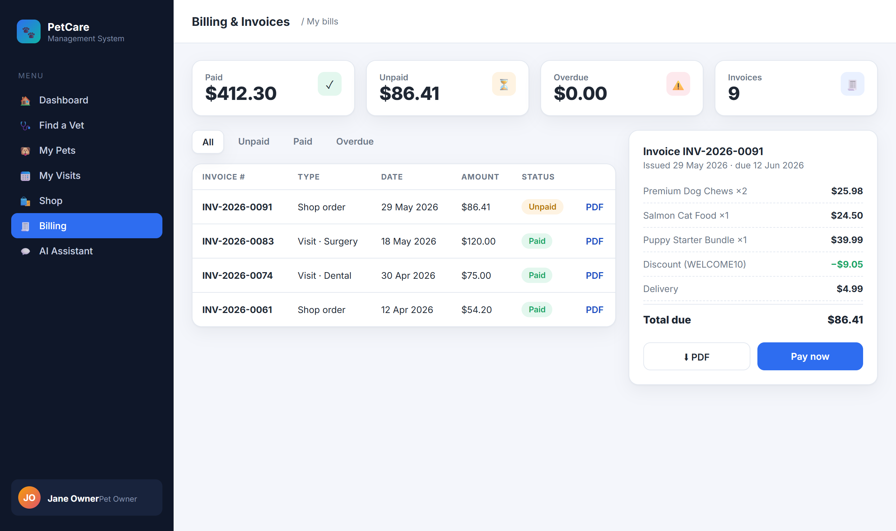
Figure 3-12: Billing & Invoices
Table 3-5: Screen Definition
# | Field Name | Type | Mandatory | Max Length | Description
1 | Status filter | Tabs |  | – | All / Unpaid / Paid / Overdue.
2 | Invoice row | List |  | – | Number, type, date, amount, status.
3 | PDF / Pay now | Button |  |  | Download invoice / pay an unpaid bill.
3.7.1.2 Use Case Description
Use Case ID |  | UC21 | Use Case Name |  | View Invoices / Download PDF
Author |  | Project Team | Version | 1.0 | Date | 2026-04-25
Actor |  | USER, STAFF
Description |  | A customer views their invoices (shop orders and visit bills) with status, opens an invoice and downloads a PDF; staff and admins manage all bills (UC22).
Precondition |  | PRE-01: The user is signed in.  PRE-02: At least one invoice exists.
Trigger |  | TRG-01: User opens Billing.
Post-Condition |  | POS-01: The selected invoice is shown and its PDF can be downloaded.
Main Flow
Step | Actor | Action
1 | User | Opens Billing and filters by status.
2 | PCMS | Displays the user’s own invoices with number, type, date, amount and status.
3 | User | Opens an invoice and clicks PDF.
4 | PCMS | Generates and downloads the invoice PDF.
Alternative flows
AT1 | At step 2, an invoice is overdue.
Sub step | Actor | Action
2.1 | PCMS | Shows the accrued interest unless an admin has exempted it (BR-22).
Business Rules
# | Rule Description
BR-22 | A bill is UNPAID on creation, OVERDUE past due date; interest accrues unless ADMIN exempts it.
BR-12 | A user may only view their own bills (row-level security).

3.8 Catalog & Inventory Administration

3.8.1 UC23/UC24/UC25 — Manage Products, Inventory & Promotions
3.8.1.1 Screen Mock-up
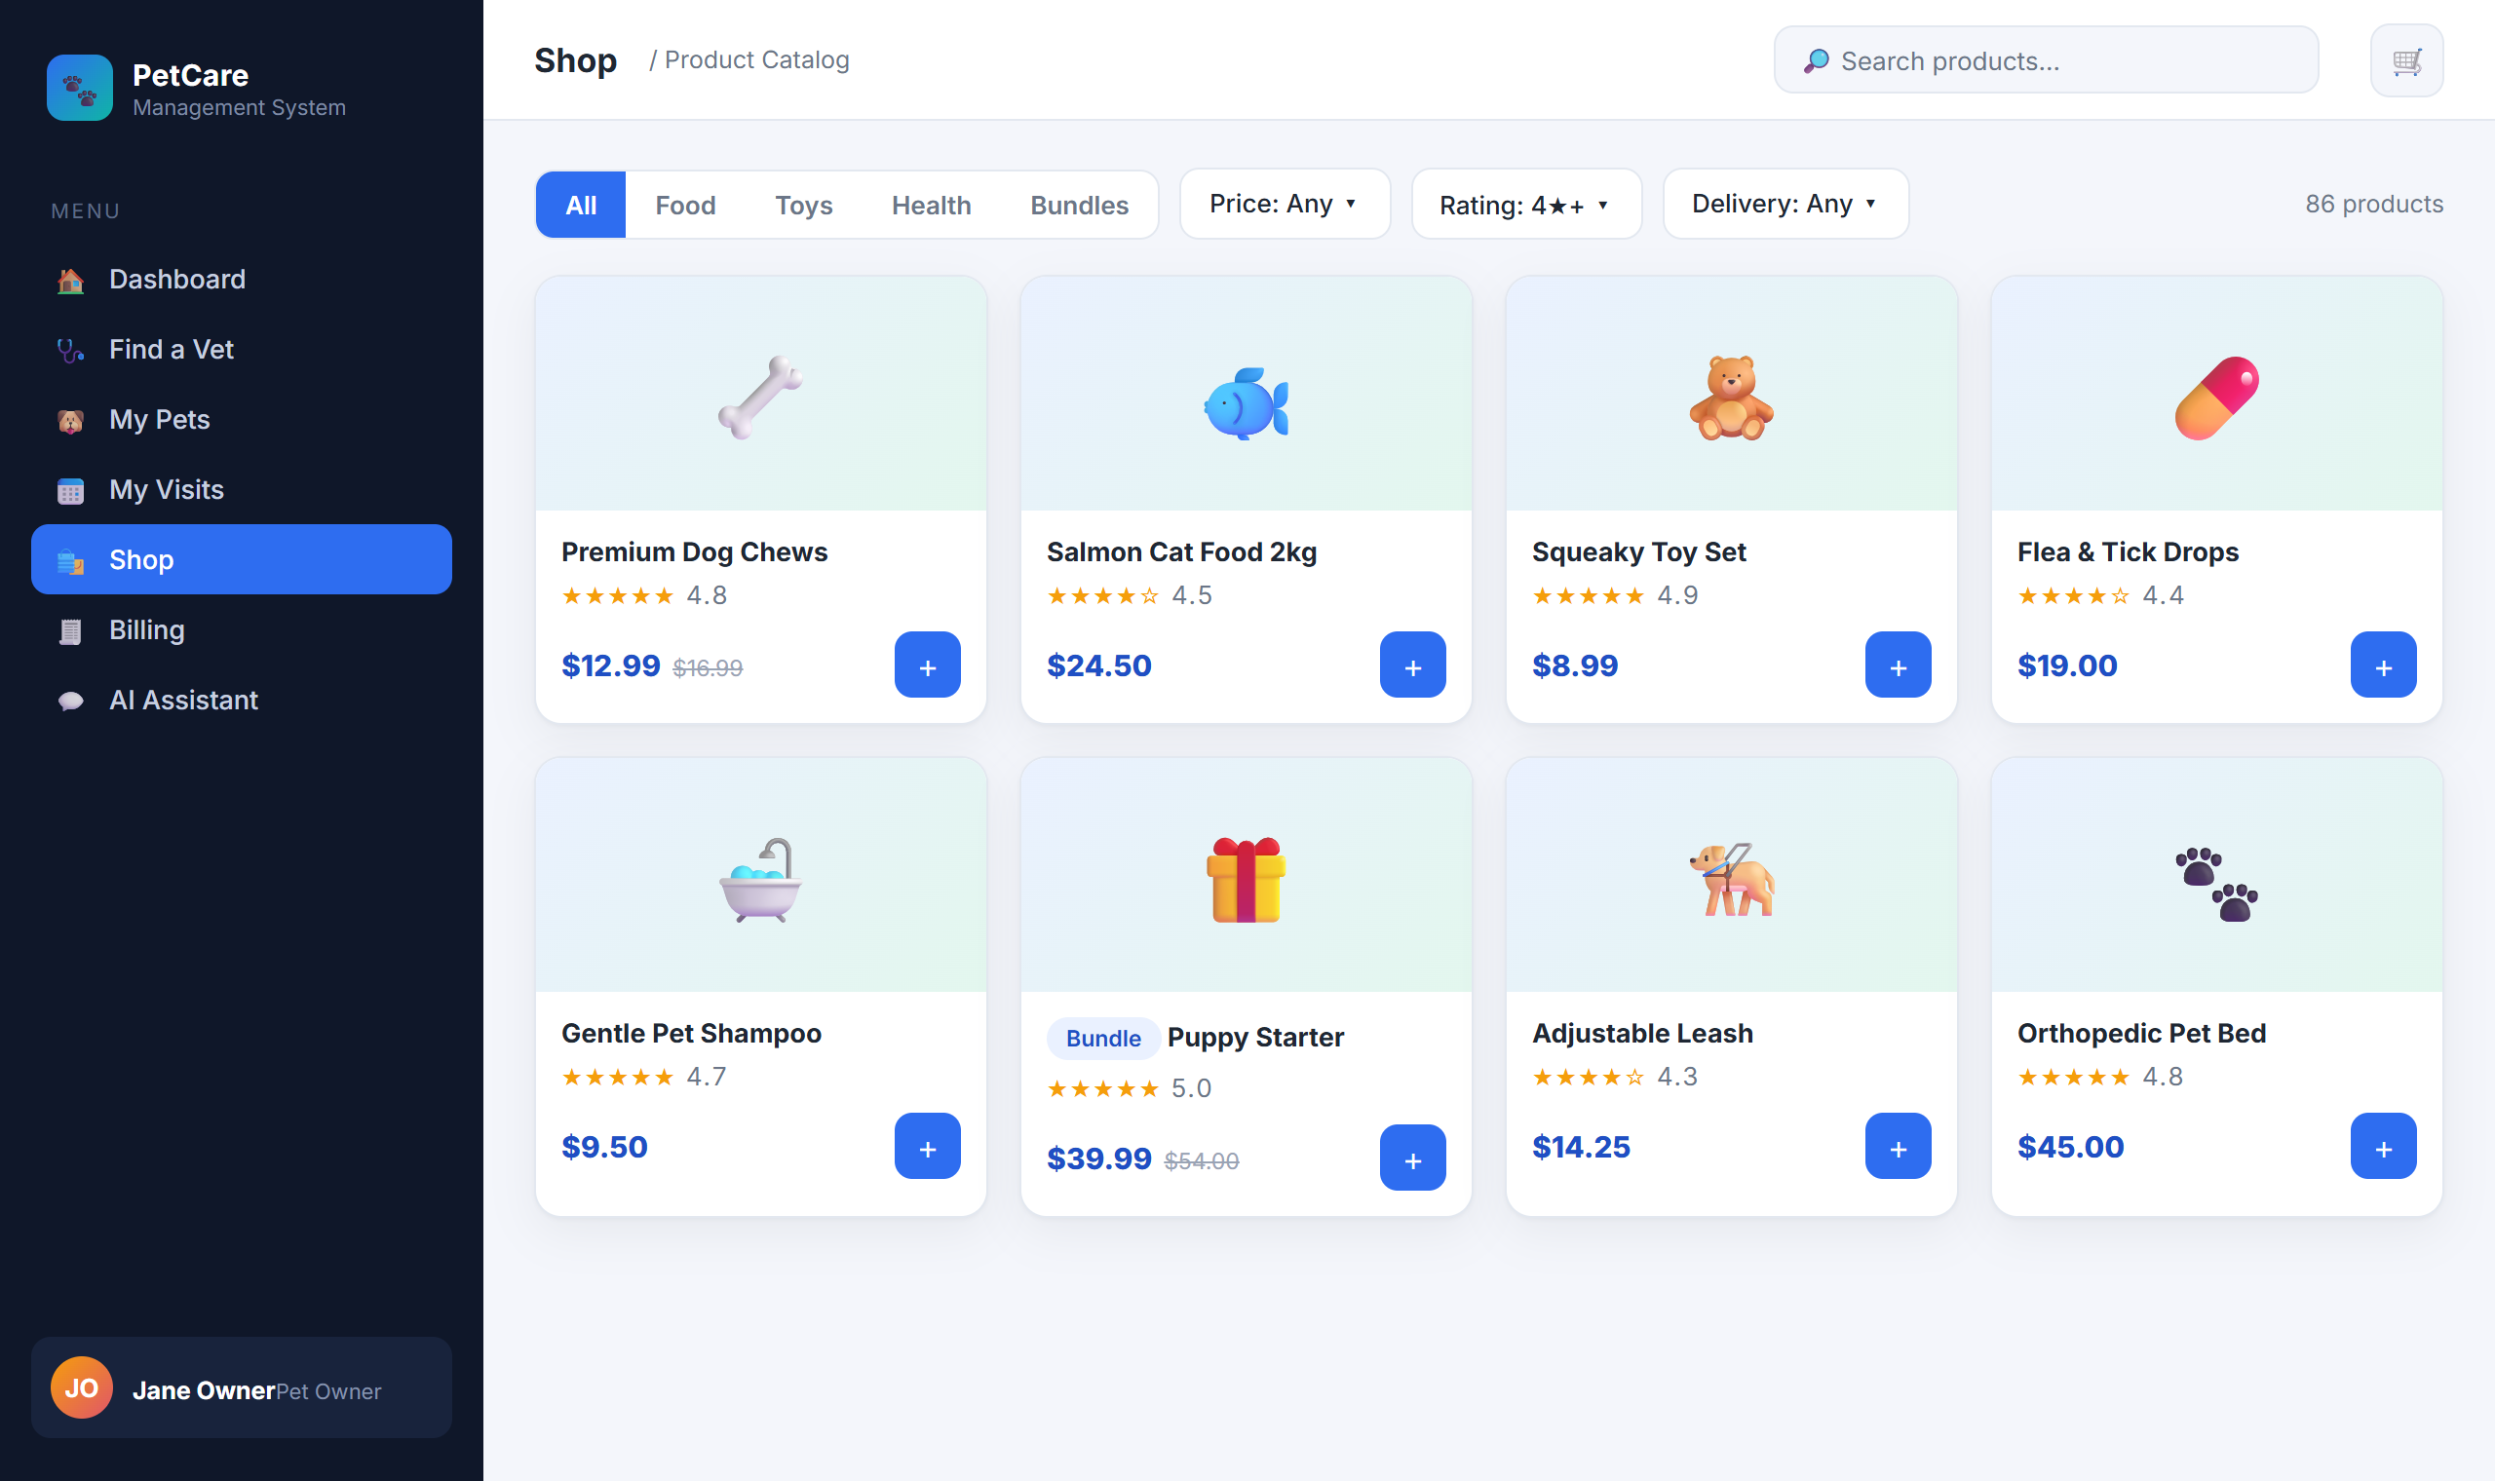
Figure 3-13: Catalogue management (admin view of the product grid)
Inventory managers and admins create and maintain pet products, medicines, types and bundles, and adjust stock levels and listing status. Implemented by products-service.
3.8.1.2 Use Case Description
Use Case ID |  | UC23 | Use Case Name |  | Manage Products & Bundles
Author |  | Project Team | Version | 1.0 | Date | 2026-04-25
Actor |  | INVENTORY_MANAGER, ADMIN
Description |  | An inventory manager or admin creates, updates and retires products, types and bundles, including price, stock and listing status.
Precondition |  | PRE-01: The user has the Inventory Manager or Admin role.
Trigger |  | TRG-01: Operator opens Manage Products.
Post-Condition |  | POS-01: The catalogue reflects the change; listing status governs visibility to shoppers.
Main Flow
Step | Actor | Action
1 | Operator | Creates or edits a product (name, price, type, stock, delivery, status).
2 | PCMS | Validates and saves the product; its listing status controls whether shoppers can see it.
3 | Operator | Groups products into a bundle with a bundle price.
4 | PCMS | Saves the bundle and updates the catalogue.
Alternative flows
AT1 | At step 1, a user without permission attempts the action.
Sub step | Actor | Action
1.1 | PCMS | Denies access and keeps the menu hidden (BR-24).
Business Rules
# | Rule Description
BR-24 | Only INVENTORY_MANAGER or ADMIN may create/modify products, medicines, stock or pricing.
BR-21 | Stock cannot go negative; out-of-stock products are not purchasable.

3.9 AI Care Assistant

3.9.1 UC26 — Chat with AI Assistant
3.9.1.1 Screen Mock-up
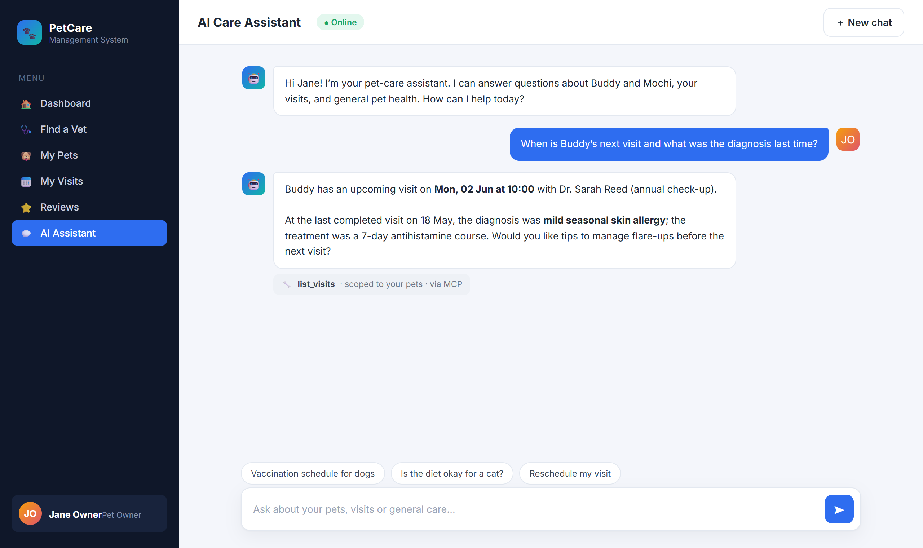
Figure 3-14: AI Care Assistant
Table 3-6: Screen Definition
# | Field Name | Type | Mandatory | Max Length | Description
1 | Message input | Textarea | Yes | 4000 | Enter sends; Shift+Enter newline.
2 | Send / New chat | Button |  |  | Stream reply / reset session.
3 | Conversation pane | Display |  |  | User / assistant / tool-call bubbles.
3.9.1.2 Use Case Description
Use Case ID |  | UC26 | Use Case Name |  | Chat with AI Assistant
Author |  | Project Team | Version | 1.0 | Date | 2026-04-25
Actor |  | USER
Description |  | A pet owner asks questions in natural language and the assistant replies using clinic knowledge and the owner’s own data, streaming the answer.
Precondition |  | PRE-01: The user is signed in.  PRE-02: A working AI provider is configured (UC28).
Trigger |  | TRG-01: User sends a message.
Post-Condition |  | POS-01: The conversation keeps the question and answer.  POS-02: The answer is shown without error.
Main Flow
Step | Actor | Action
1 | User | Types a question and sends it.
2 | PCMS | Interprets the question, looks up only the user’s own data when needed, and streams a grounded answer.
3 | PCMS | Shows the answer in the conversation, indicating any data it looked up.
Alternative flows
AT1 | At step 2, the AI provider is unavailable.
Sub step | Actor | Action
2.1 | PCMS | Shows MSG13; chat resumes once an admin restores the provider.

AT2 | At step 2, too many AI requests are in progress.
Sub step | Actor | Action
2.2 | PCMS | Shows MSG14 and asks the user to retry shortly.
Business Rules
# | Rule Description
BR-13 | The AI assistant may only access the requesting user’s own data.
BR-14 | Chat memory window is the last 10 messages.
BR-15 | Prompts/completions logged at DEBUG only; never persisted in plain text in production.

3.10 Administration

3.10.1 UC28 — Configure LLM (BYOK)
3.10.1.1 Screen Mock-up
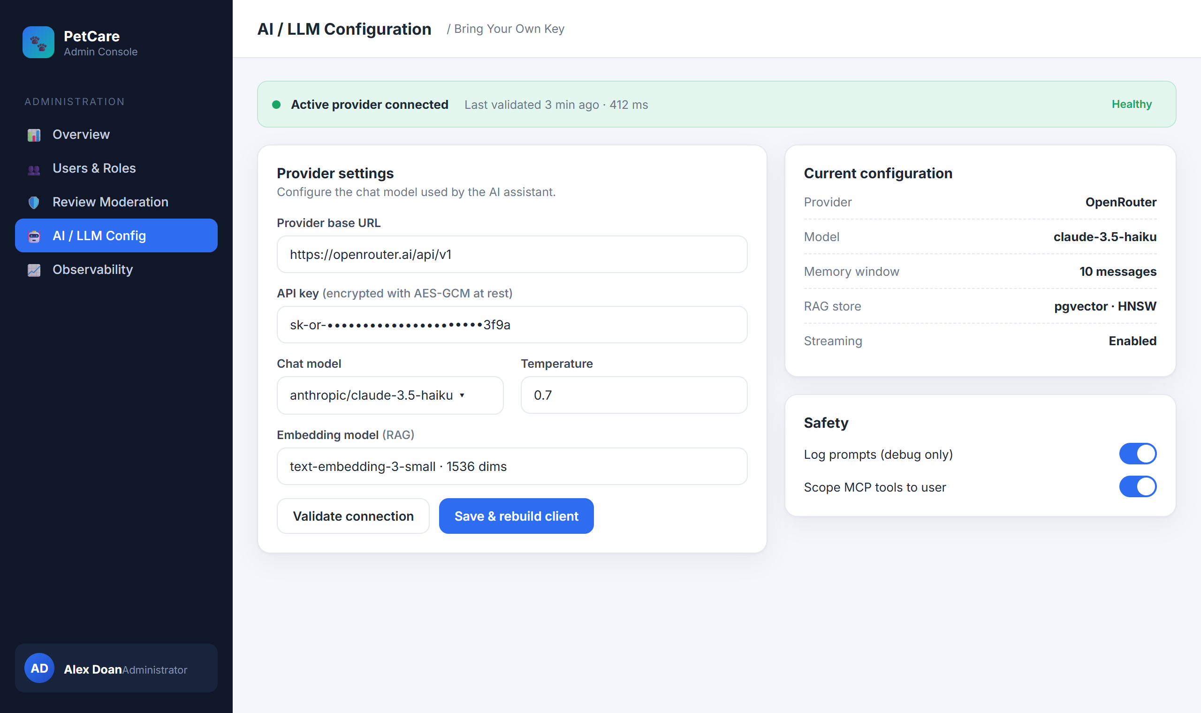
Figure 3-15: Admin — LLM Configuration
Table 3-7: Screen Definition
# | Field Name | Type | Mandatory | Max Length | Description
1 | Provider base URL | Text | Yes | 255 | OpenAI-compatible endpoint.
2 | API key | Password | Yes | 255 | AES-GCM encrypted; masked on read.
3 | Chat model / Temperature | Dropdown / Number | Yes | – | Model id; 0.0–2.0.
4 | Validate / Save | Button |  |  | Test without saving / persist & rebuild client.
3.10.1.2 Use Case Description
Use Case ID |  | UC28 | Use Case Name |  | Configure LLM (BYOK)
Author |  | Project Team | Version | 1.0 | Date | 2026-04-25
Actor |  | ADMIN
Description |  | An admin sets the AI provider, key and model so the assistant can work; the key is stored securely and applied without a restart.
Precondition |  | PRE-01: The user has the Admin role.  PRE-02: The system is available.
Trigger |  | TRG-01: Admin opens LLM Config.
Post-Condition |  | POS-01: The configuration is saved securely.  POS-02: The assistant immediately uses the new provider.
Main Flow
Step | Actor | Action
1 | Admin | Enters the provider URL, API key, model and temperature.
2 | Admin | Clicks Validate connection.
3 | PCMS | Tests the configuration and reports whether it works and how fast.
4 | Admin | Clicks Save & rebuild client.
5 | PCMS | Stores the configuration securely and applies it immediately (MSG07).
Alternative flows
AT1 | At step 3, the provider rejects the key.
Sub step | Actor | Action
3.1 | PCMS | Reports a validation error and saves nothing.
Business Rules
# | Rule Description
BR-11 | Only ADMIN may view or change the LLM configuration.
BR-19 | API keys are AES-GCM encrypted at rest and masked on read.
Administrators also manage users & roles (UC27), observability dashboards (UC29) and email templates/history (UC30) from the admin console.

4. Non-Functional Requirements

4.1 External Interfaces
Interface | Protocol | Direction | Description
LLM Provider | HTTPS + OAuth 2.1 | Outbound | Chat completions and embeddings.
Bank Transfer Channel | Manual reference / bank portal | Out/In | Record bank-transfer payment reference for clinic invoices; cash is recorded internally.
SMTP relay | SMTPS (465) | Outbound | Transactional email.
Web SPA | HTTPS + JSON / SSE | Inbound | React front-end.
Object storage | S3 API (presigned) | Out/In | Photos, prescription & invoice PDFs.
Prometheus / Zipkin | HTTP | In/Out | Metrics scrape & distributed tracing.

4.2 Quality Attributes

4.2.1 Usability
- A new user can register, add a pet and book a visit in under 3 minutes (P50).
- Inline validation on every form; server errors as toast + field highlights.
- Keyboard navigable; Lighthouse accessibility ≥ 90.

4.2.2 Reliability
- Availability ≥ 99.5% during business hours (Mon–Sat, 08:00–18:00 ICT).
- MTBF ≥ 30 days for gateway & identity; MTTR ≤ 15 min per single-service outage.
- Notification saga converges within 60 s for 99% of bookings — no silent loss.
- Invoice finalisation is atomic: stock decrement and invoice update either all succeed or roll back.

4.2.3 Performance
- REST P95 ≤ 300 ms (reads) / ≤ 500 ms (writes) at 50 RPS at the gateway.
- Catalogue listing P95 ≤ 400 ms with filters over 10k products.
- AI chat time-to-first-token ≤ 1.5 s; full ~200-token reply ≤ 8 s.

4.2.4 Security
- HTTPS everywhere; plain HTTP redirected.
- JWT (RSA), short-lived access + rotating refresh; JWKS validation.
- Least-privilege RBAC: declarative YAML + method-level @PreAuthorize ownership checks.
- Secrets (LLM & payment keys) AES-GCM encrypted; PCI-sensitive data never stored — payment delegated to the gateway.

4.2.5 Maintainability & Observability
- All services expose /actuator/health, /metrics, /prometheus; JSON logs with trace IDs.
- Spotless + Checkstyle gates and mandatory PR review in CI.

5. Requirement Appendix

5.1 Business Rules
# | Rule Description
BR-01 | Bookings Mon–Sat, 08:00–18:00 (Asia/Ho_Chi_Minh).
BR-02 | Booking lead time ≥ 30 minutes.
BR-03 | Pet name + birth date unique per owner.
BR-04 | Pet birth date not in the future; age derived.
BR-05 | Telephone digits only, length 8–15.
BR-06 | At most one visit per vet per 30-minute slot.
BR-07 | Booking confirmation converges within 60 seconds.
BR-08 | Passwords bcrypt (cost 12); never logged.
BR-09 | Password ≥ 8 chars with ≥1 digit and ≥1 letter.
BR-10 | Access token 15 min; refresh 7 days, single-use rotation.
BR-11 | Only ADMIN may configure or rotate the LLM provider.
BR-12 | A user may only see/act on their own owner/pet/visit/bill/review records.
BR-13 | The AI assistant may only access the requesting user’s own data.
BR-14 | Chat memory window is the last 10 messages.
BR-15 | Prompts/completions logged at DEBUG only; never persisted in plain text in production.
BR-16 | A visit may not transition backwards.
BR-17 | A review may be edited by its author within 7 days; deletion is soft.
BR-18 | New reviews are PENDING_MODERATION until approved.
BR-19 | API keys are AES-GCM encrypted at rest and masked on read.
BR-20 | Promo: % discount capped at maxDiscount; not combinable; respects expiry & usage limit.
BR-21 | Checkout reserves stock; stock cannot go negative; out-of-stock blocks purchase.
BR-22 | Bill UNPAID on creation, OVERDUE past due date; interest accrues unless ADMIN exempts.
BR-23 | Order total = Σ(unit × qty) − discount + delivery; money stored in minor units.
BR-24 | Only INVENTORY_MANAGER or ADMIN may manage products, medicines, stock and pricing.
BR-25 | A prescription belongs to a completed visit and is exported as PDF.
BR-26 | Email must be verified before first login.

5.2 Common Requirements
- All timestamps stored as UTC; rendered in Asia/Ho_Chi_Minh.
- Money stored in minor units (integer); no floating-point currency.
- Identifiers in URLs are opaque (UUID v4 or numeric id).
- All error responses follow RFC 9457 ProblemDetail.
- CORS restricted to configured front-end origins; no wild-card in production.
- Privileged actions (role change, LLM/key rotation, visit completion, review moderation, bill exemption, stock change) are audit-logged with actor, target and timestamp.

5.3 Application Messages List
# | Code | Type | Context | Content
1 | MSG01 | Inline | No search result | No matching results.
2 | MSG02 | Inline (red) | Required field empty | The {field} field is required.
3 | MSG03 | Toast | Review submitted | Your review has been submitted for moderation.
4 | MSG04 | Toast | Visit booked | Your visit has been booked. Confirmation will arrive by email.
5 | MSG05 | Toast | Visit confirmed | Booking confirmed for {pet} with Dr. {vet}.
6 | MSG06 | Toast | Visit completed | Visit marked as completed.
7 | MSG07 | Toast | LLM saved | LLM configuration saved and applied.
8 | MSG08 | Inline (red) | Value exceeds max length | Maximum length is {max} characters.
9 | MSG09 | Inline (red) | Invalid credentials | Email or password is incorrect.
10 | MSG10 | Modal | Account locked | Too many failed attempts. Try again in 30 minutes.
11 | MSG11 | Inline (red) | Outside business hours | Bookings are available Mon–Sat, 08:00–18:00.
12 | MSG12 | Toast (error) | Slot taken | This time slot is no longer available.
13 | MSG13 | Toast (error) | AI unavailable | AI service is temporarily unavailable. Please try again.
14 | MSG14 | Toast (warn) | AI rate limit | Too many AI requests in flight — please retry shortly.
15 | MSG16 | Toast | Invoice updated | The invoice has been updated.
16 | MSG17 | Inline (red) | Payment failed | The payment could not be recorded. Please try again.
17 | MSG18 | Toast (error) | Out of stock | Sorry, {product} is out of stock.
18 | MSG19 | Toast | Checkout success | Order placed. Invoice {invoice} created.
19 | MSG20 | Toast | Payment success | Payment received. Thank you!
20 | MSG21 | Toast | Prescription saved | Prescription saved and PDF generated.
21 | MSG-INT | Modal | Internal error | An internal error occurred. Please contact the administrator.

5.4 Other Requirements
- Personal data handling complies with applicable Vietnamese personal-data protection guidance.
- Payment processing is delegated to a PCI-DSS compliant gateway; no card data is stored by PCMS.
- Container images are scanned in CI; HIGH/CRITICAL vulnerabilities block the merge.
- Disaster recovery: nightly base backups + continuous WAL archiving; RPO ≤ 1 h, RTO ≤ 4 h.

