

SOFTWARE SPECIFICATION
PET CARE MANAGEMENT SYSTEM

Group 6 - SE1943-JV
Group Member | Phan Hồng Đạt - HE180379
 | Nhữ Đình Nhật - HE182328
 | Phạm Nhật Anh - HE181399
 | Nhữ Xuân Việt - HE182409
 | Nguyễn Đức Anh - HE182203
Supervisor | Nguyễn Văn Sang

–Hanoi, Jun 2026–

Record of Changes

Version | Date | A* M D | In charge | Change Description
V1.0 | 16/1 | A | Phan Hồng Đạt
V1.0 | 29/1 | A | Phạm Nhật Anh
V1.0 | 29/1 | A | Nhữ Xuân Việt
V1.0 | 30/1 | A | Nhữ Đình Nhật
V1.0 | 30/1 | A | Nguyễn Đức Anh
V1.0 | 30/1 | A | Phan Hồng Đạt
V1.0 | 30/1 | A | Phạm Nhật Anh
V1.0 | 30/1 | M | Nhữ Xuân Việt
V1.0 | 30/1 | M | Nhữ Đình Nhật

II. Software Requirement Specification

1. Overview

1.1 Context
Pet Care Management System (PCMS) is a cloud-native platform for a veterinary clinic and its in-clinic pet store. Pet owners register and manage their pets, discover and rate veterinarians, check availability and book visits, receive prescriptions, and view their invoices and receipts — and can ask a built-in AI assistant for help. Clinic staff, veterinarians, inventory managers and administrators operate the clinic, the catalogue and the platform.
The system is built as a Spring Boot 4 / Spring Cloud microservices. This document specifies the complete functional and non-functional requirements of the system.
The context diagram identifies the external actors and third-party systems and the information exchanged with each.
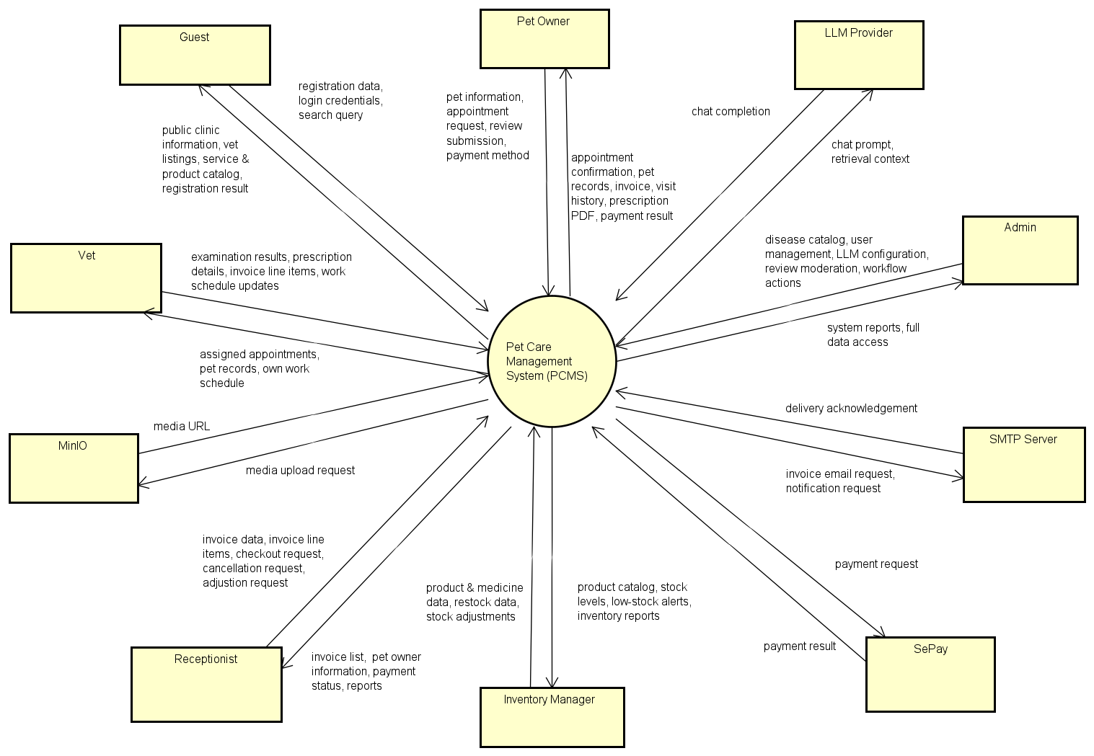
Figure 1-1: PCMS System Context
External entities

- Guest — anonymous visitor who can browse the public catalogue and vet directory, run searches, and register/log in.
- Pet Owner — registered customer who self-serves clinical, pet records, appointment booking, invoices, visit history, prescriptions, reviews and payment.
- Receptionist (Staff) — front desk: owner/pet records, visit handling, billing (create invoice, add line items, checkout, cancellation), and review moderation.
- Veterinarian — runs visits, manages own schedule and profile, records examination results, and issues prescriptions and invoice line items.
- Inventory Manager — maintains pet products, medicines, stock levels and pricing (restock and stock adjustments), and monitors low-stock alerts.
- System Admin — manages users, disease catalogue, AI/LLM provider configuration, emails and system observability/reports.

External systems
- LLM Provider — external AI service (OpenAI via Spring AI); receives chat prompt and retrieval context, returns chat completion for the assistant.
- Bank Transfer Channel — out-of-band bank transfer flow; PCMS records the transfer reference and receipt status, but stores no bank credentials.
- SMTP Server (Email Service) — external mail relay; receives invoice email and notification requests, returns delivery acknowledgement.
- files-service (Go) + MinIO — stores pet photos, vet media and prescription PDFs; returns signed URLs while domain services keep only metadata/object-key references. Invoice receipts are e-mail content generated by mailer-service in v1.

1.2 Business Process Management

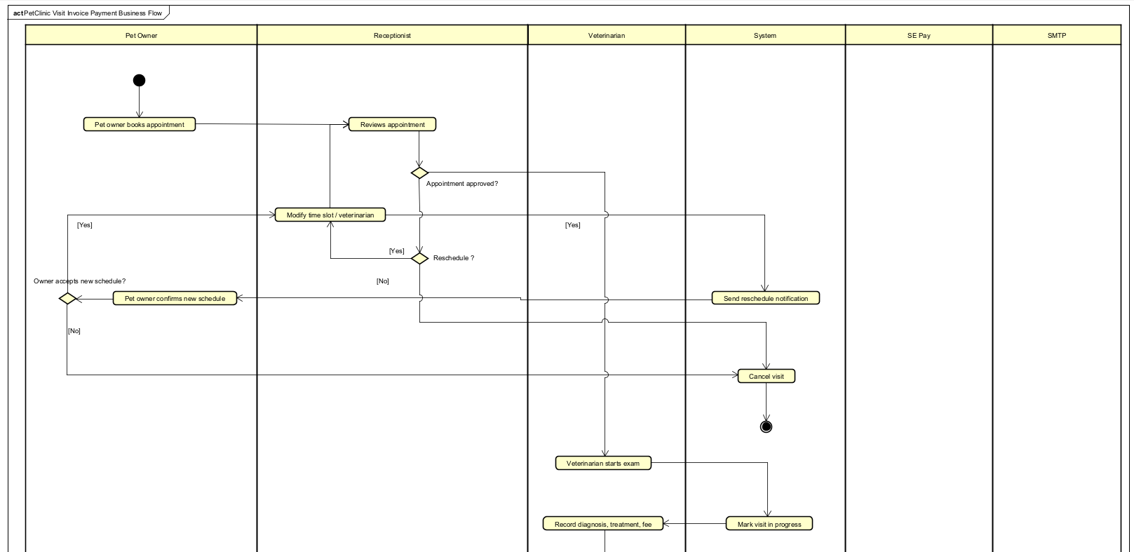
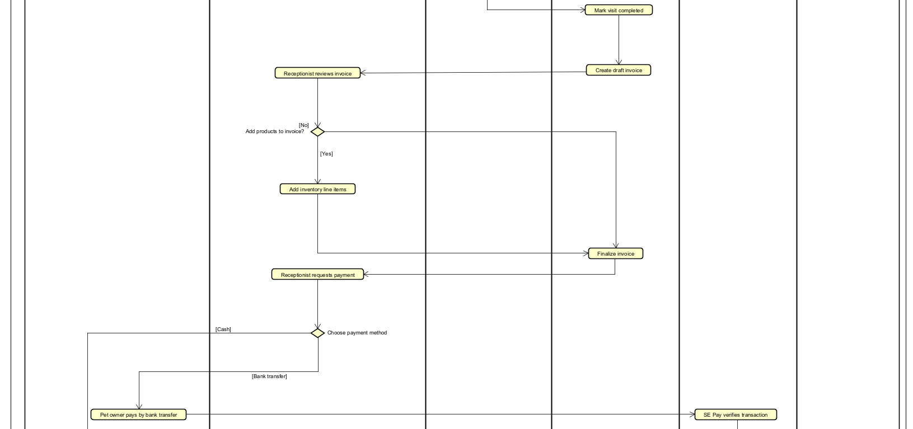
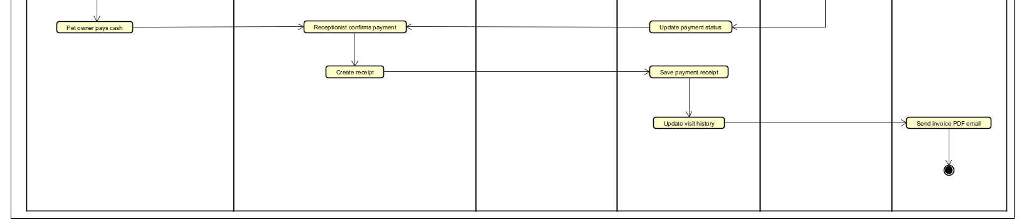
Description
The Pet Visit Management Workflow supports the complete lifecycle of a veterinary visit, including appointment scheduling, examination, prescription, invoice creation, payment recording, review eligibility and customer notification.
The workflow begins when a pet owner books an appointment. The receptionist reviews the appointment request and may approve, modify, or cancel the appointment. If a schedule modification is required, the pet owner may either accept or reject the proposed schedule. Rejected appointments are cancelled and the workflow terminates.
Once approved, the veterinarian performs the examination and records diagnosis, treatment information and consultation fees. Visit completion starts a choreography saga: billing-service appends the visit fee to the customer invoice, and mailer-service sends the completion notification.
The receptionist completes checkout at the clinic by recording cash, card, or bank-transfer settlement. Bank transfers require a transfer reference. After payment confirmation, billing-service marks the invoice PAID and emits InvoicePaidEvent so mailer-service can send the receipt e-mail.
Actors
- Pet Owner
- Receptionist
- Veterinarian
- System
- Bank Transfer Channel
- SMTP Service
Preconditions
- A registered pet owner exists in the system.
- A valid appointment request has been submitted.
Postconditions
- The visit is completed or cancelled.
- The invoice is finalized.
- Payment is successfully processed and recorded.
- A receipt e-mail is queued/sent by mailer-service and the paid invoice state is stored.
- Visit history is updated.
- The receipt is delivered to the pet owner via e-mail when an address is available.
Business Rules
- A receptionist may approve, modify, or cancel an appointment.
- A modified appointment requires customer confirmation.
- A rejected schedule modification results in appointment cancellation.
- Additional inventory items may be added before invoice finalization.
- Cash/card/transfer settlement is recorded by Receptionist; bank transfers require a reference and may be verified manually or by a future bank API.
- A receipt e-mail is sent only after successful checkout; no invoice PDF is generated in v1.

2. User Requirements

2.1 Actors
An actor is a person, role or external system that interacts with PCMS.
# | Actor | Description
1 | Guest | Unauthenticated visitor who can register as a pet owner or log in to an existing account.
2 | Pet Owner | Registered customer who manages own pets, books visits by selecting pet, veterinarian, time slot and reason, and views visit history, prescriptions and invoices.
3 | Receptionist | Front-desk employee who sees all appointments, reschedules/cancels visits with reasons, receives clinical invoices, adds in-store products, collects cash or bank-transfer payments and sends receipts.
4 | Veterinarian (Vet) | Clinical user who sees assigned appointments, performs examinations, updates visit results, records services and prices, and issues prescriptions.
5 | Inventory Manager | Catalogue and stock operator who manages pet products, medicines, quantities, prices and availability.
6 | System Admin | Platform operator who manages accounts, roles and system configuration.
7 | SMTP Service | External service used for welcome e-mails, appointment notifications, invoices and receipt e-mails.
8 | Bank Transfer Channel | External transfer channel used when the receptionist records a bank-transfer payment reference; cash payment is recorded internally.

2.2 Use Cases

2.2.1 Use Case Diagrams

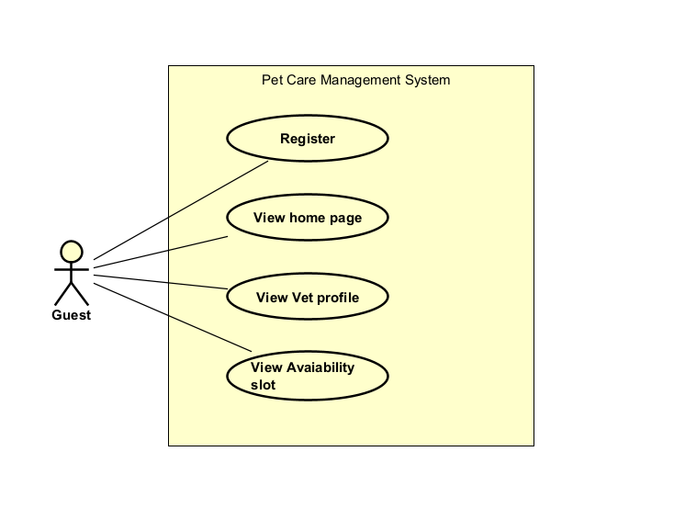
Figure 2-1: Use Cases Diagram of Guest in PCMS
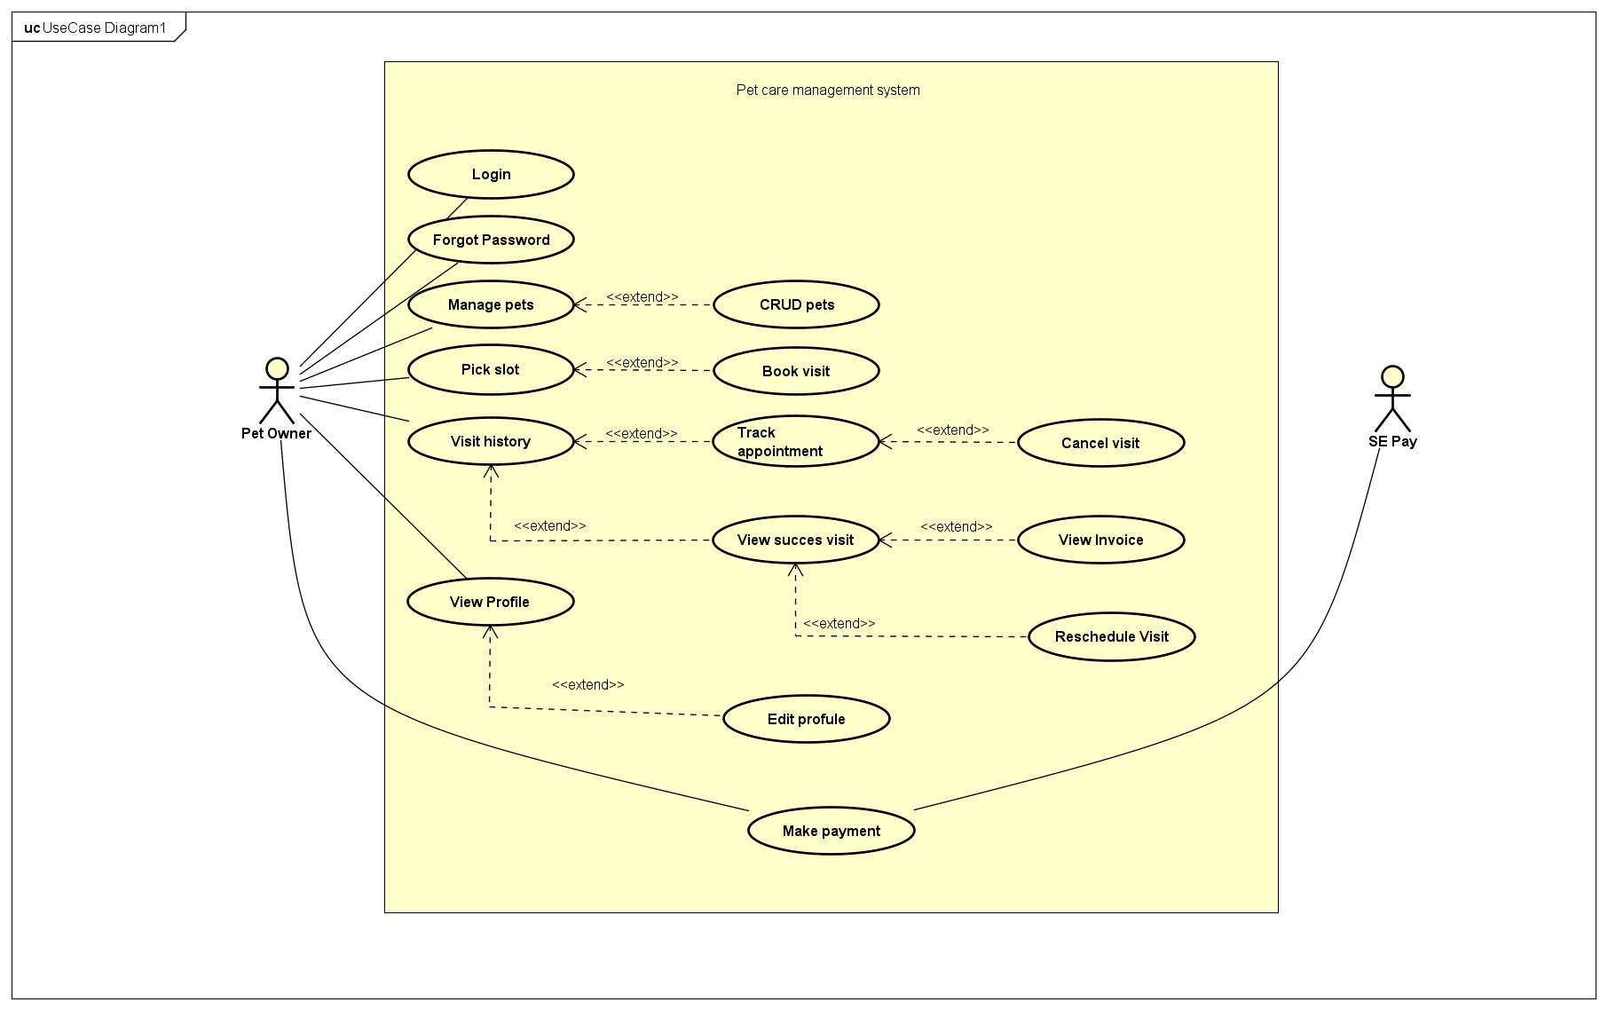
Figure 2-2: Use Cases Diagram of Pet Owner in PCMS
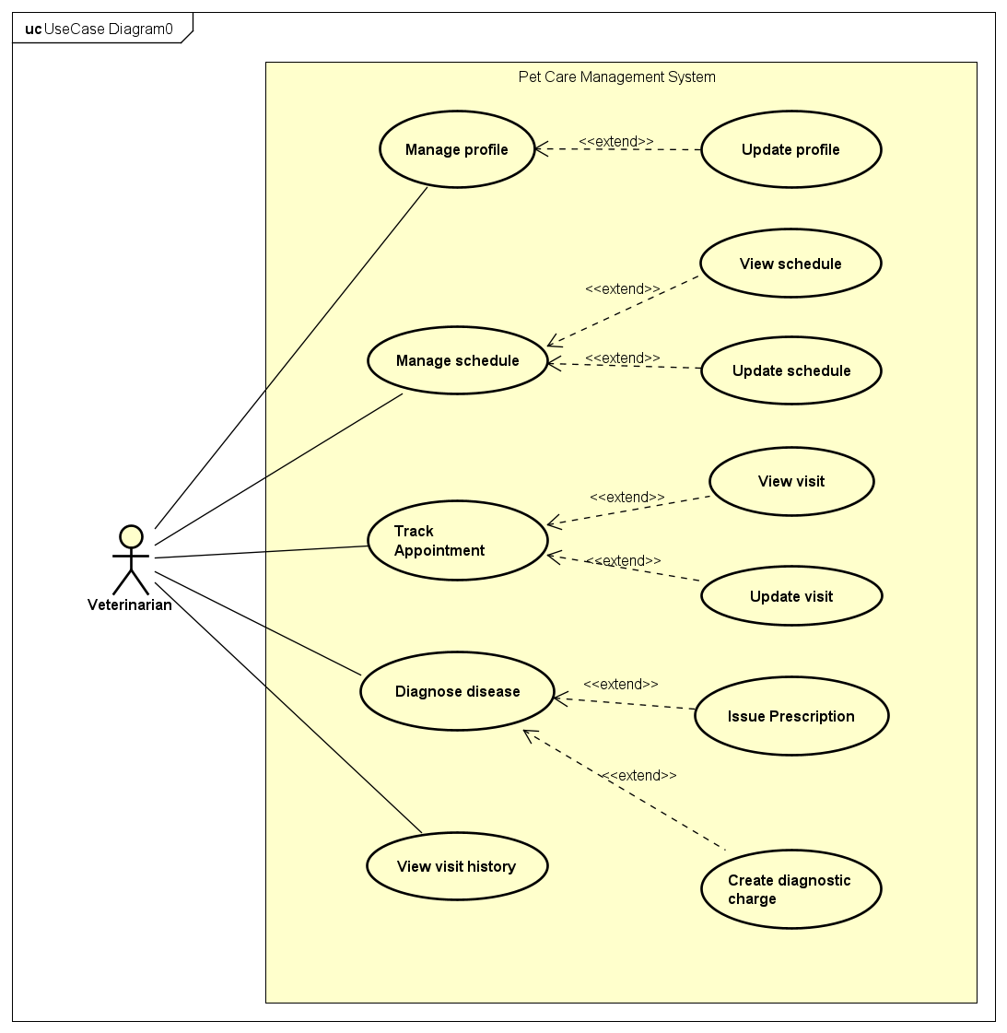
Figure 2-3: Use Cases Diagram of Vet in PCMS
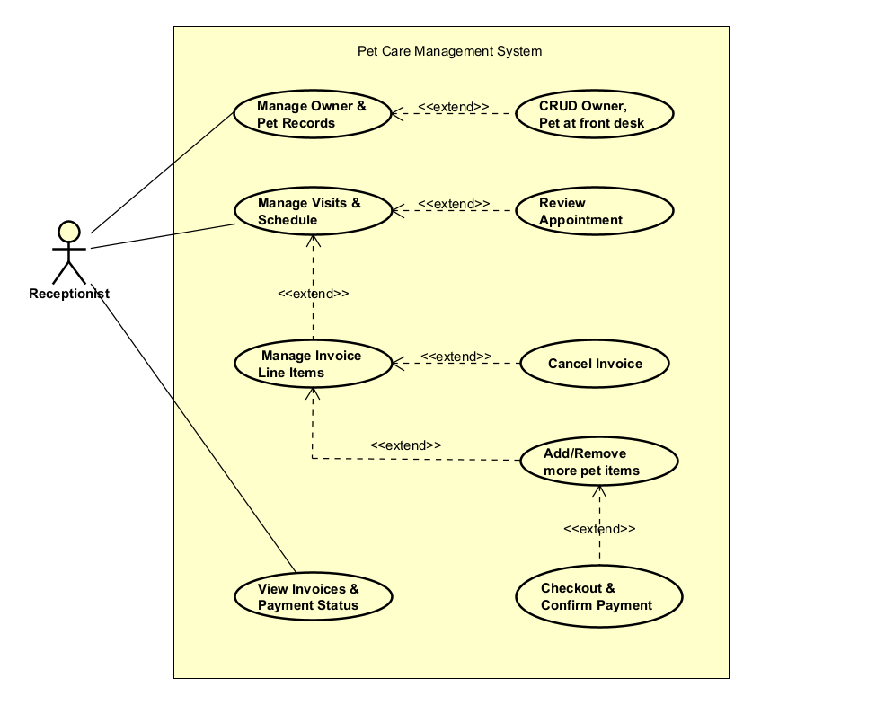

Figure 2-4: Use Cases Diagram of Receptionist in PCMS
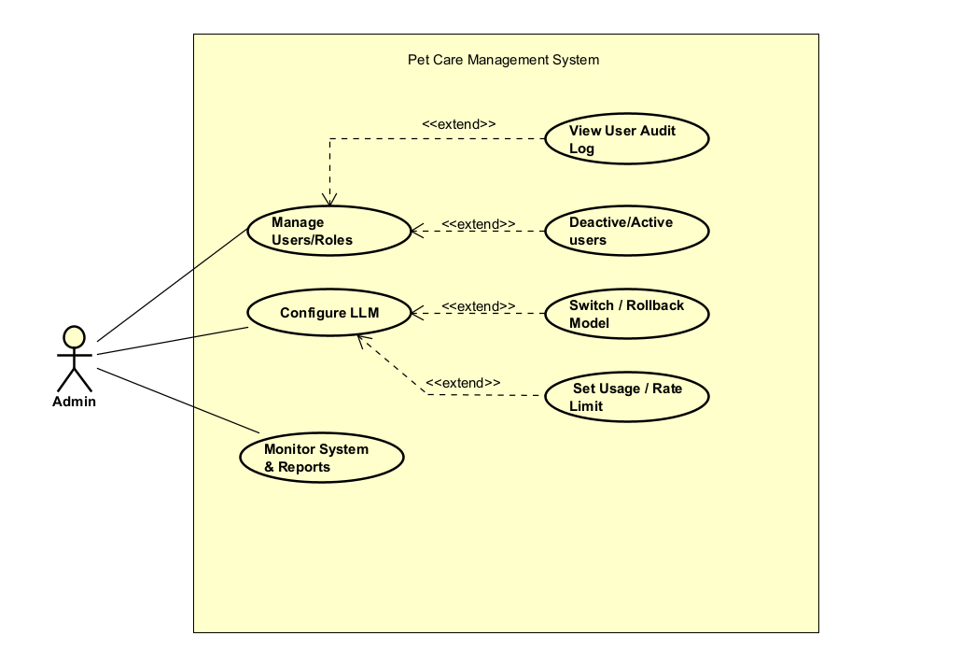
Figure 2-5: Use Cases Diagram of Admin in PCMS
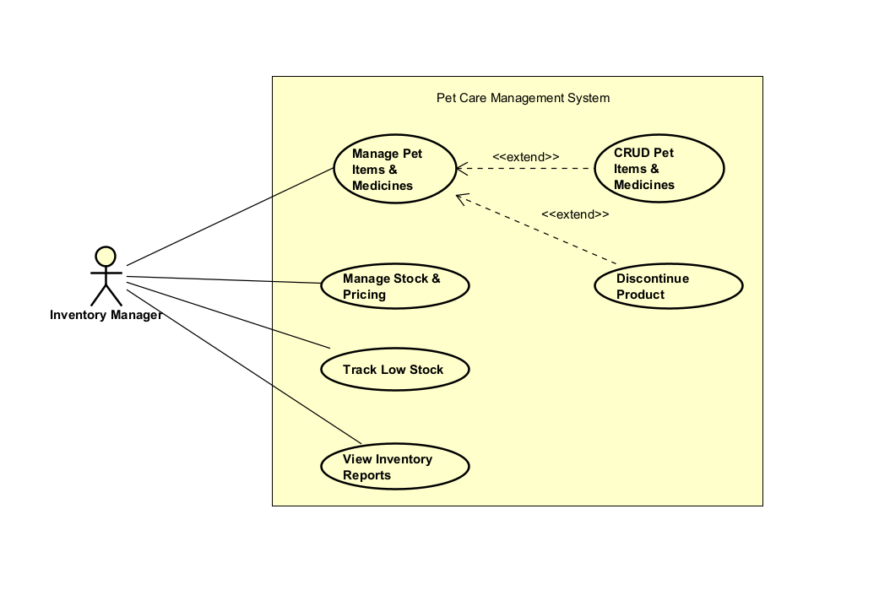

Figure 2-6: Use Cases Diagram of Inventory Manager in PCMS

2.2.2 Use Case Descriptions
Each use case is named verb-object and describes the updated core clinic workflow from owner registration through visit booking, examination, invoice finalisation, payment, email receipt and inventory control.
ID | Group function | Use Case | Actors | Description
UC01 | Identity | Register | Guest | Create a new account with default USER role; user logs in separately; user.registered event queues a welcome email.
UC02 | Identity | Login | Pet Owner, Receptionist, Vet, Inventory Manager, Admin | Authenticate with credentials and obtain JWTs carrying role claims.
UC03 | Identity | Change Password | Pet Owner, Receptionist, Vet, Inventory Manager, Admin | Authenticated user changes their own password from the profile/security screen.
UC04 | Public | View Home Page | Guest | Browse the public landing page, clinic info and service/product catalogue.
UC05 | Public | View Vet Profile | Guest, Pet Owner | View the veterinarian directory and individual vet profiles.
UC06 | Public | View Availability Slot | Guest | View open appointment slots before deciding to register or book.
UC07 | Pet Management | Manage Pets | Pet Owner | Maintain own pets, photos and basic medical profile before a visit.
UC08 | Pet Management | CRUD Pets | Pet Owner | Create, read, update and delete individual pet records. (Extends UC07)
UC09 | Profile | View Profile | Pet Owner | View own account and contact profile.
UC10 | Profile | Edit Profile | Pet Owner | Update contact details and account info. (Extends UC09)
UC11 | Scheduling | Pick Slot | Pet Owner, Receptionist | View available slots for a selected veterinarian and date.
UC12 | Visit Booking | Book a Visit | Pet Owner, Receptionist | Create a scheduled visit with pet, vet, time slot and reason. (Extends UC11)
UC13 | Visit Lifecycle | Track Appointment / Visit History | Pet Owner, Veterinarian, Receptionist | Owners see their visits; vets see assigned visits; receptionists see the clinic schedule.
UC14 | Scheduling | Cancel Visit | Pet Owner, Receptionist | Cancel a scheduled visit. (Extends UC13)
UC15 | Scheduling | Reschedule Visit | Pet Owner, Receptionist | Move a visit to a new slot. (Extends UC16)
UC16 | Visit Lifecycle | View Successful Visit | Pet Owner | View the result of a completed visit: diagnosis, services and prescription.
UC17 | Billing | View Invoice | Pet Owner | Open the invoice attached to a completed visit. (Extends UC16)
UC18 | Payment | Make Payment | Pet Owner, Receptionist, Bank Transfer Channel | Pet owner views invoice and bank-transfer instructions; receptionist records cash/card/transfer checkout and receipt.
UC19 | Customer Support | Manage Owner & Pet Records | Receptionist | Maintain owner and pet records for phone or walk-in support.
UC20 | Customer Support | CRUD Owner & Pet at Front Desk | Receptionist | Create and update owner and pet records at the desk. (Extends UC19)
UC21 | Scheduling | Manage Visits & Schedule | Receptionist | View and manage the clinic appointment schedule.
UC22 | Scheduling | Review Appointment | Receptionist | Confirm or adjust an appointment on behalf of the owner. (Extends UC21)
UC23 | Billing | Manage Invoice Line Items | Receptionist | Maintain billed lines (services, medicines, products) accumulating the total.
UC24 | Billing | Add / Remove Pet Items | Receptionist | Add or remove store products/medicines bought at the clinic. (Extends UC23)
UC25 | Payment | Checkout & Confirm Payment | Receptionist | Close the invoice, request payment and record cash/bank-transfer settlement. (Extends UC24)
UC26 | Billing | Cancel Invoice | Receptionist | Void an unpaid or erroneous invoice. (Extends UC23)
UC27 | Billing | View Invoices & Payment Status | Pet Owner, Receptionist | Display invoices and paid/pending status in owner history and staff screens.
UC28 | Vet Scheduling | Manage Vet Profile & Schedule | Veterinarian | Maintain own profile, working hours and unavailable slots.
UC29 | Clinical | Start / Complete Examination | Veterinarian | Run the exam, then record diagnosis, treatment notes, performed services and fees.
UC30 | Clinical | Issue Prescription | Veterinarian | Add prescribed medicines, dosage, duration and instructions to the visit.
UC31 | Clinical Billing | Generate Diagnostic Costs | Veterinarian | List performed services and prescribed medicines with prices as the invoice draft.
UC32 | Inventory | Manage Pet Items & Medicines | Inventory Manager | Maintain the catalogue of pet products and medicines (name, type, price, availability).
UC33 | Inventory | CRUD Pet Items & Medicines | Inventory Manager | Create, read, update and delete catalogue entries. (Extends UC32)
UC34 | Inventory | Discontinue Product | Inventory Manager | Mark a product inactive instead of deleting it, keeping invoice history. (Extends UC32)
UC35 | Inventory | Manage Stock & Pricing | Inventory Manager | Adjust quantities, restock, update prices and reconcile sold items.
UC36 | Inventory | Track Low Stock | Inventory Manager | Monitor stock levels and view low-stock / out-of-stock alerts.
UC37 | Inventory | View Inventory Reports | Inventory Manager | View stock-movement, valuation and restock-history reports.
UC38 | Administration | Manage Users & Roles | Admin | Create accounts and assign roles for clinic operations.
UC39 | Administration | View User Audit Log | Admin | Review a user login and role-change history. (Extends UC38)
UC40 | Administration | Deactivate / Activate Users | Admin | Disable or re-enable an account without deleting it. (Extends UC38)
UC41 | AI | Configure LLM | Admin | Set the AI/LLM provider, model and credentials for the chatbot.
UC42 | AI | Switch / Rollback Model | Admin | Revert to a previous provider/model configuration. (Extends UC41)
UC43 | AI | Set Usage / Rate Limit | Admin | Cap tokens or requests per period for the chatbot. (Extends UC41)
UC44 | Observability | Monitor System & Reports | Admin | View system health, metrics and operational reports.
UC45 | Communications | Send Invoice Email | SMTP Service | Send the final paid invoice/receipt to the owner by email.
UC46 | Reviews | Write a Review | Pet Owner | Submit a rating/review after an eligible completed visit or purchase.
UC47 | Reviews | Vote & Moderate Review | Pet Owner, Receptionist, Admin | Vote helpful/unhelpful and approve/reject reviews before public display.
UC48 | AI | Chat with AI Assistant | Pet Owner | Ask care questions; assistant answers from clinic knowledge and the owner’s permitted data.
UC49 | Files & Media | Upload / Download Media & Documents | Pet Owner, Vet, Receptionist, Admin | Upload photos/PDFs through files-service and retrieve signed URLs for authorized viewers.

3. Software Features

3.1 Functional Overview

3.1.1 Screens Flow
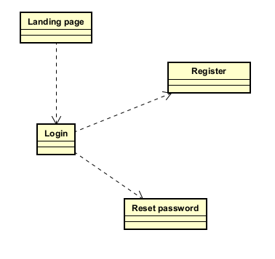

Figure 3-1: PCMS Screen Flow of Guest
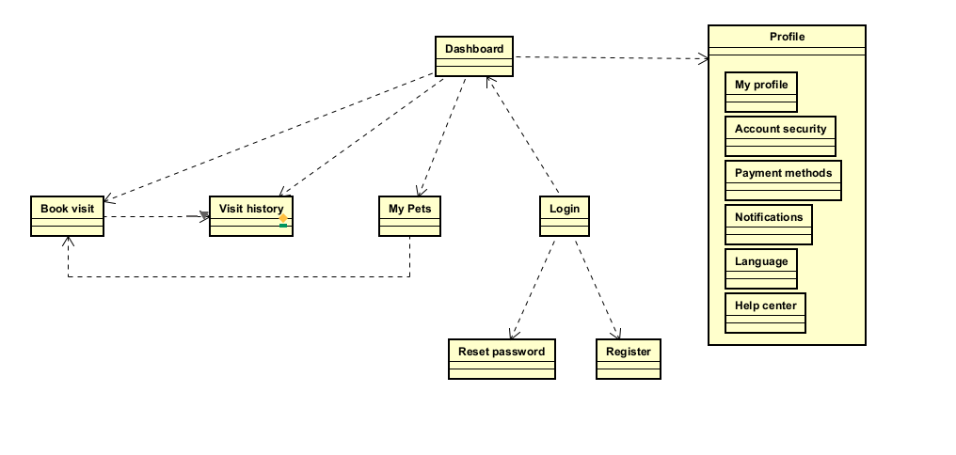
Figure 3-2: PCMS Screen Flow of Pet Owner
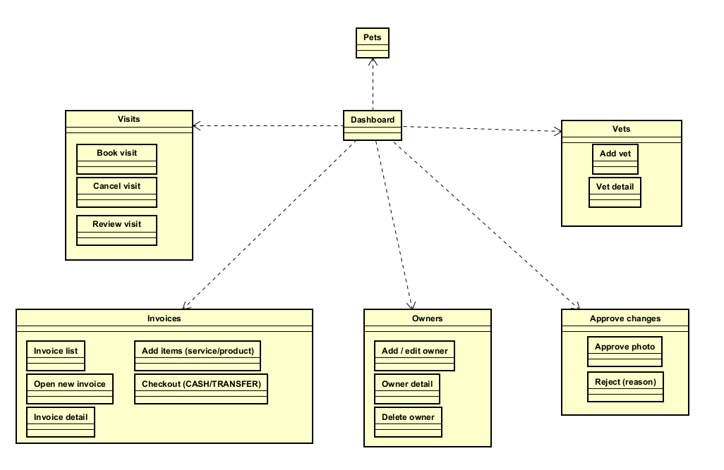
Figure 3-3: PCMS Screen Flow of Receptionist
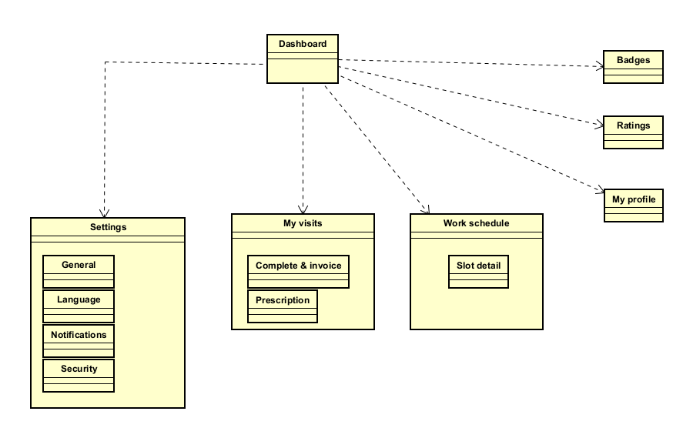
Figure 3-4: PCMS Screen Flow of Vet

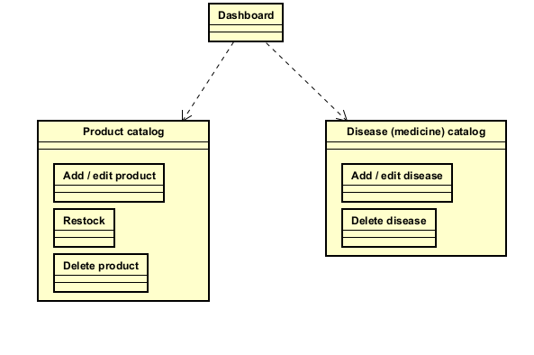
Figure 3-5: PCMS Screen Flow of Inventory Manager

3.1.2 Screen Descriptions
# | Actor | Screen | Description
1 | Guest | Landing page | Public homepage: clinic intro, services, pricing and doctors; entry points to Store, Login and (after login) the role home.
2 | Guest | Store | Public pet-shop catalogue (food, toys, accessories) with search, categories and a cart counter; browsing only — no online checkout.
3 | Guest | Login | Username + password sign-in; on success routes to the role home (Owner → /customer, Vet → /vet, Staff/Admin → /admin).
4 | Guest | Register | Self sign-up that creates a USER (pet-owner) account; links back to Login.
5 | Pet Owner | Dashboard | Post-login hub: upcoming and recent visits, pet count and a quick “Book a visit” shortcut.
6 | Pet Owner | Book visit | One-page wizard: pick pet → pick vet → pick date & time slot (live availability) → reason; a sticky summary confirms the booking.
7 | Pet Owner | Visit history | KPI metrics and a filterable visit list; opens Visit detail and the Reschedule, Cancel and Rate-vet pop-ups.
8 | Pet Owner | My Pets | Manage the owner’s pets (add / edit / delete pop-ups); each pet can jump straight to Book visit.
9 | Pet Owner | Profile | Account area with sub-pages: My profile, Account security, Payment methods, Notifications, Language and Help center.
10 | Vet | Dashboard | Vet portal overview.
11 | Vet | My visits | Visits assigned to the vet; “Complete & invoice” records diagnosis/services/fee and raises the invoice, “Prescription” issues the prescription.
12 | Vet | Work schedule | Weekly / today / summary duty-roster heat-map; the Slot detail pop-up lists the visits booked in a slot.
13 | Vet | My profile | The vet’s own profile and avatar (avatar changes go to Receptionist approval).
14 | Vet | Ratings | Ratings and reviews received from owners.
15 | Vet | Badges | Achievement badges earned.
16 | Vet | Settings | General, Language, Notifications and Security sub-pages.
17 | Receptionist | Dashboard | Front-desk overview.
18 | Receptionist | Visits | All clinic visits; the receptionist can Book a visit or Cancel a visit on behalf of owners.
19 | Receptionist | Owners | Manage owner accounts: Add/edit owner, Owner detail (which also manages that owner’s pets) and Delete owner.
20 | Receptionist | Pets | Read-only list of all pets (pets are edited from Owners → Owner detail).
21 | Receptionist | Vets | Vet directory with Add vet and Vet detail.
22 | Receptionist | Invoices (POS) | Counter billing: Invoice list (Open/Paid/Cancelled) → Open new invoice / Invoice detail → Add items (disease treatment + retail products + misc fees) → Checkout (CASH / CARD / TRANSFER).
23 | Receptionist | Approve changes | Moderate vet avatar-change requests: Approve photo or Reject with a reason.
24 | Admin | Dashboard | System overview.
25 | Admin | User management | Manage users & roles: User list & roles, Activate / deactivate users and User audit log.
26 | Admin | AI config | Configure the LLM provider (BYOK); Switch / rollback model and set Usage / rate limit.
27 | Inventory Manager | Dashboard | Inventory overview.
28 | Inventory Manager | Product catalog | Pet products / merchandise with stock: Add/edit product, Restock and Delete.
29 | Inventory Manager | Disease (medicine) catalog | Diseases & medicine items with default cost: Add/edit and Delete.

3.1.3 Screen Authorization
“X” = the role may open the screen and perform its primary action; an empty cell means the screen is hidden in the menu and refused at the API layer (gateway JWT check + each service’s Spring Security, defence in depth). Role mapping: Guest = unauthenticated visitor, USER = Pet Owner, VET = Veterinarian, STAFF = Receptionist, ADMIN = Administrator, INV = Inventory Manager. ADMIN additionally has super-access and may open any screen.
# | Screen | Guest | USER | VET | STAFF | ADMIN | INV
1 | Public site — Landing page, Store | X | X | X | X | X | X
2 | Login / Register | X
3 | Pet Owner — Dashboard |  | X
4 | Pet Owner — Book visit |  | X
5 | Pet Owner — Visit history |  | X
6 | Pet Owner — My Pets |  | X
7 | Pet Owner — Profile |  | X
8 | Vet — Dashboard / Work schedule / Ratings / Badges / Settings |  |  | X | X
9 | Vet — My visits · Complete & invoice · Prescription |  |  | X | X
10 | Receptionist — Dashboard |  |  |  | X | X
11 | Receptionist — Visits (book / cancel) |  |  |  | X | X
12 | Receptionist — Owners / Pets |  |  |  | X | X
13 | Receptionist — Vets |  |  |  | X | X
14 | Receptionist — Invoices (POS) / Checkout |  |  |  | X | X
15 | Receptionist — Approve changes |  |  |  | X | X
16 | Admin — User management |  |  |  |  | X
17 | Admin — AI config |  |  |  |  | X
18 | Inventory — Product catalog |  |  |  |  | X | X
19 | Inventory — Disease (medicine) catalog |  |  |  |  | X | X

3.1.4 Non-Screen Functions
System-internal behaviours (async listeners, scheduled jobs, machine APIs) without a UI.
# | Area | System Function | Description
1 | Discovery | Service registry (Eureka) | discovery-server registers every service; clients resolve peers through a @LoadBalanced RestClient instead of hard-coded hosts.
2 | Configuration | Central config (Config Server) | config-server serves env-split YAML from config-repo/; each service imports it at boot (optional, so it still starts if the server is down).
3 | Gateway | Request routing & API aggregation | Spring Cloud Gateway forwards /api/** to services over lb://, and merges every service’s OpenAPI into one Swagger UI.
4 | Security | JWT validation (defence in depth) | auth-service signs RSA JWTs; the gateway and every service validate them independently via JWKS, and the bearer token is forwarded on downstream calls.
5 | Security | Refresh-token rotation | auth-service issues short-lived access tokens, rotates refresh tokens and revokes them on logout.
6 | Security | Rate limiting | a custom gateway filter throttles request rate (Gateway WebMVC has no built-in limiter).
7 | Messaging | Domain-event publishing | services publish events to a RabbitMQ topic exchange; each consumer has its own durable queue and a dead-letter queue.
8 | Visit lifecycle | Notification saga (choreography) | on visit completion, visits-service writes a saga row (PENDING) and publishes the event in one transaction; an ack marks it COMPLETED, a failure marks it COMPENSATED and raises a manual-follow-up event.
9 | Notification | Mailer consumer (Go) | mailer-service consumes events, sends the e-mail (SMTP/Mailpit) and replies ack/failed — cross-language, idempotent by eventId.
10 | Messaging | Idempotent consumption | consumers de-duplicate by eventId inside the same transaction as the side effect, so broker redelivery is safe.
11 | Billing | Invoice creation | completing a visit (“Complete & invoice”) raises an invoice in billing-service from the recorded services and fees.
12 | Billing | Invoice totalling | billing sums disease-treatment lines, retail-product lines and misc fees into the final invoice total.
13 | Inventory | Stock decrement on checkout | products-service reduces stock for tracked products when the invoice is paid.
14 | Billing | Invoice delivery & history | on payment the invoice is e-mailed to the owner and stored in their visit history.
15 | Data | JPA auditing | every persisted entity is auto-stamped with created / last-modified by + timestamp (AbstractAuditingEntity + SystemAuditorAware).
16 | Data | Schema migration | Liquibase applies each service’s schema-per-service changelog at startup (Hibernate ddl-auto = validate).
17 | Resilience | Circuit breaking | Resilience4j circuit breakers wrap cross-service HTTP calls to fail fast and recover.
18 | AI | Chatbot & knowledge retrieval | the genai service streams answers from the configured LLM (BYOK key stored AES-GCM-encrypted, hot-swappable) grounded on a retrieval-augmented knowledge base.
19 | Observability | Metrics & tracing | Micrometer exports metrics to Prometheus/Grafana and W3C trace context to Tempo/Zipkin (OTLP); Spring Boot Admin monitors instances.
20 | Files & Media | Signed URL and metadata lifecycle | files-service validates file type/size, stores binaries in MinIO/S3, returns signed URLs, and publishes metadata references to owning services.

3.1.5 Entity Relationship Diagram
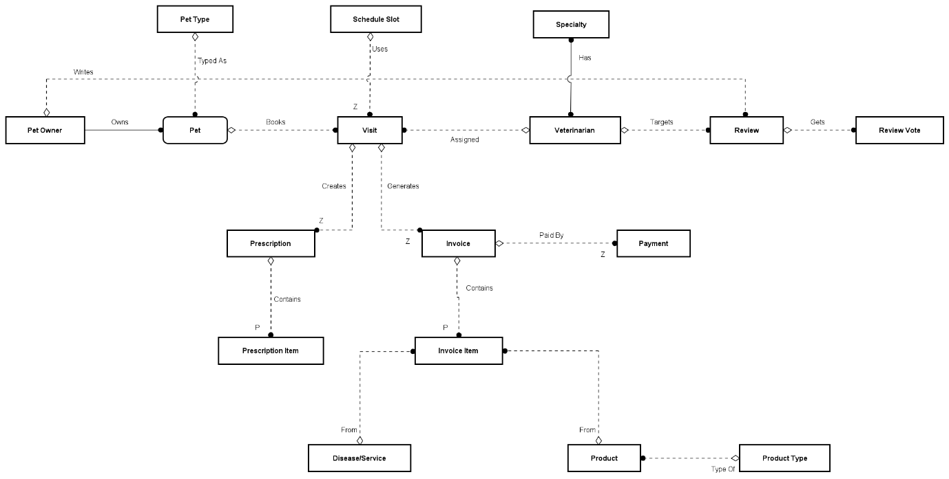
Figure 3-6: ERD — Pet Care Management System

3.1.6 Entity Details
The PCMS ERD is a conceptual business model of the clinic workflow. It identifies the main entities and their relationships for pet ownership, visit booking, clinical examination, prescriptions, invoices, payments, reviews, and inventory. The diagram is intentionally not a database design: entities do not list fields, primary keys, foreign keys, or table columns.

# | Entity | Description
1 | Pet Owner | Represents a registered customer who owns pets, manages pet records, books visits, views visit history, receives prescriptions and invoices, makes payments, and writes reviews.
2 | Pet | Represents an animal cared for by the clinic. A pet belongs to a pet owner, has a pet type, and is the subject of visits, prescriptions, and clinical history.
3 | Pet Type | Classifies pets by species or type so the clinic can organize pet profiles and apply appropriate care context.
4 | Schedule Slot | Represents an available appointment time used when a pet owner or receptionist books or reschedules a visit with a veterinarian.
5 | Visit | Represents an appointment and clinical encounter for a pet. A visit connects the pet, veterinarian, and schedule slot, and can produce prescriptions, invoice lines, and visit results.
6 | Veterinarian | Represents a clinical user who manages profile and schedule, receives assigned visits, records examination results, issues prescriptions, and is reviewed by pet owners.
7 | Specialty | Represents a veterinarian expertise area. A veterinarian can have multiple specialties, and one specialty can apply to many veterinarians.
8 | Review | Represents feedback written by a pet owner about a veterinarian or clinic experience. Reviews can be moderated and can receive votes.
9 | Review Vote | Represents a user reaction or vote on a review, used to record review usefulness or engagement.
10 | Prescription | Represents clinical medication or treatment instructions issued during an in-progress or completed visit.
11 | Prescription Item | Represents one prescribed medicine or instruction line inside a prescription, such as dosage, duration, and usage guidance.
12 | Invoice | Represents a billing document generated from a visit. It groups billable services, medicines, products, and payment status for the owner and staff.
13 | Payment | Represents settlement of an invoice, including cash or bank-transfer payment confirmation and receipt status.
14 | Invoice Item | Represents one billable line in an invoice. The line can come from a clinical service/disease item, prescribed medicine, or store product.
15 | Disease/Service | Represents clinical diagnoses, treatments, or service catalogue items that can appear in visit results and invoice lines.
16 | Product | Represents a pet-shop item or medicine managed by inventory and optionally added to an invoice during checkout.
17 | Product Type | Classifies products or medicines into catalogue categories for browsing, inventory management, and reporting.

3.2 Authentication & Account

3.2.1 UC02 — Login
3.2.1.1 Screen Mock-up
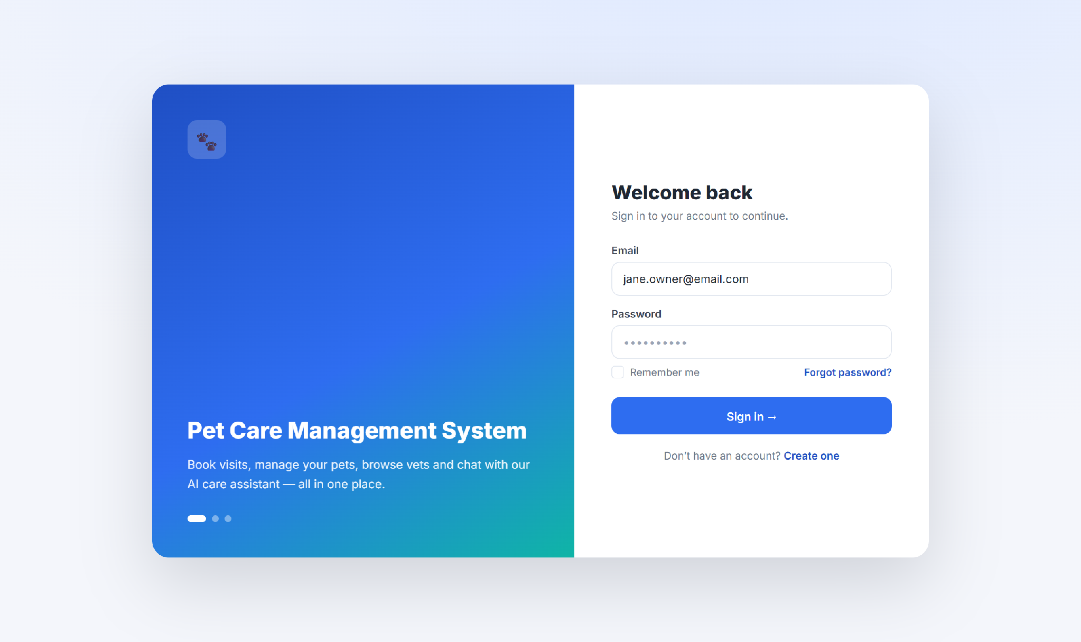
Figure 3-4: Login Screen
Table 3-1: Screen Definition
# | Field Name | Type | Mandatory | Max Length | Description
1 | Email | Text | Yes | 254 | RFC 5321 email; inline validation.
2 | Password | Password | Yes | 128 | Masked; BR-09.
3 | Remember me | Checkbox |  |  | Persists session cookie.
4 | Sign in / Register | Button / Link |  |  | Submit credentials / open Register.
3.2.1.2 Use Case Description
Use Case ID |  | UC02 | Use Case Name |  | Login
Author |  | Project Team | Version | 1.0 | Date | 2026-04-25
Actor |  | USER, STAFF, VET, ADMIN, INV
Description |  | A registered user signs in so the system recognises them and applies their role-based permissions.
Precondition |  | PRE-01: The user has a registered, email-verified account.  PRE-02: The system is available.
Trigger |  | TRG-01: User opens the application.
Post-Condition |  | POS-01: The user is authenticated and signed in.  POS-02: The user is taken to the role-appropriate dashboard.
Main Flow
Step | Actor | Action
1 | User | Opens the application.
2 | PCMS | Displays the Login screen with Email, Password, Sign in and Register.
3 | User | Enters email and password and clicks Sign in.
4 | PCMS | Validates the credentials, signs the user in and shows the role-appropriate dashboard.
Alternative flows
AT1 | At step 4, the credentials are invalid.
Sub step | Actor | Action
4.1 | PCMS | Shows an error message (MSG09) and lets the user try again.
4.2 | PCMS | After 5 failed attempts within 15 minutes, locks the account for 30 minutes (MSG10).
Business Rules
# | Rule Description
BR-08 | Passwords stored as bcrypt (cost 12); never logged.
BR-09 | Password ≥ 8 chars with ≥1 digit and ≥1 letter.
BR-10 | Access token 15 min; refresh 7 days, single-use rotation.
BR-26 | Email must be verified (UC02) before first login.

3.3 Browse Vets & Book a Visit

3.3.1 UC05 — Browse & Search Vets
3.3.1.1 Screen Mock-up
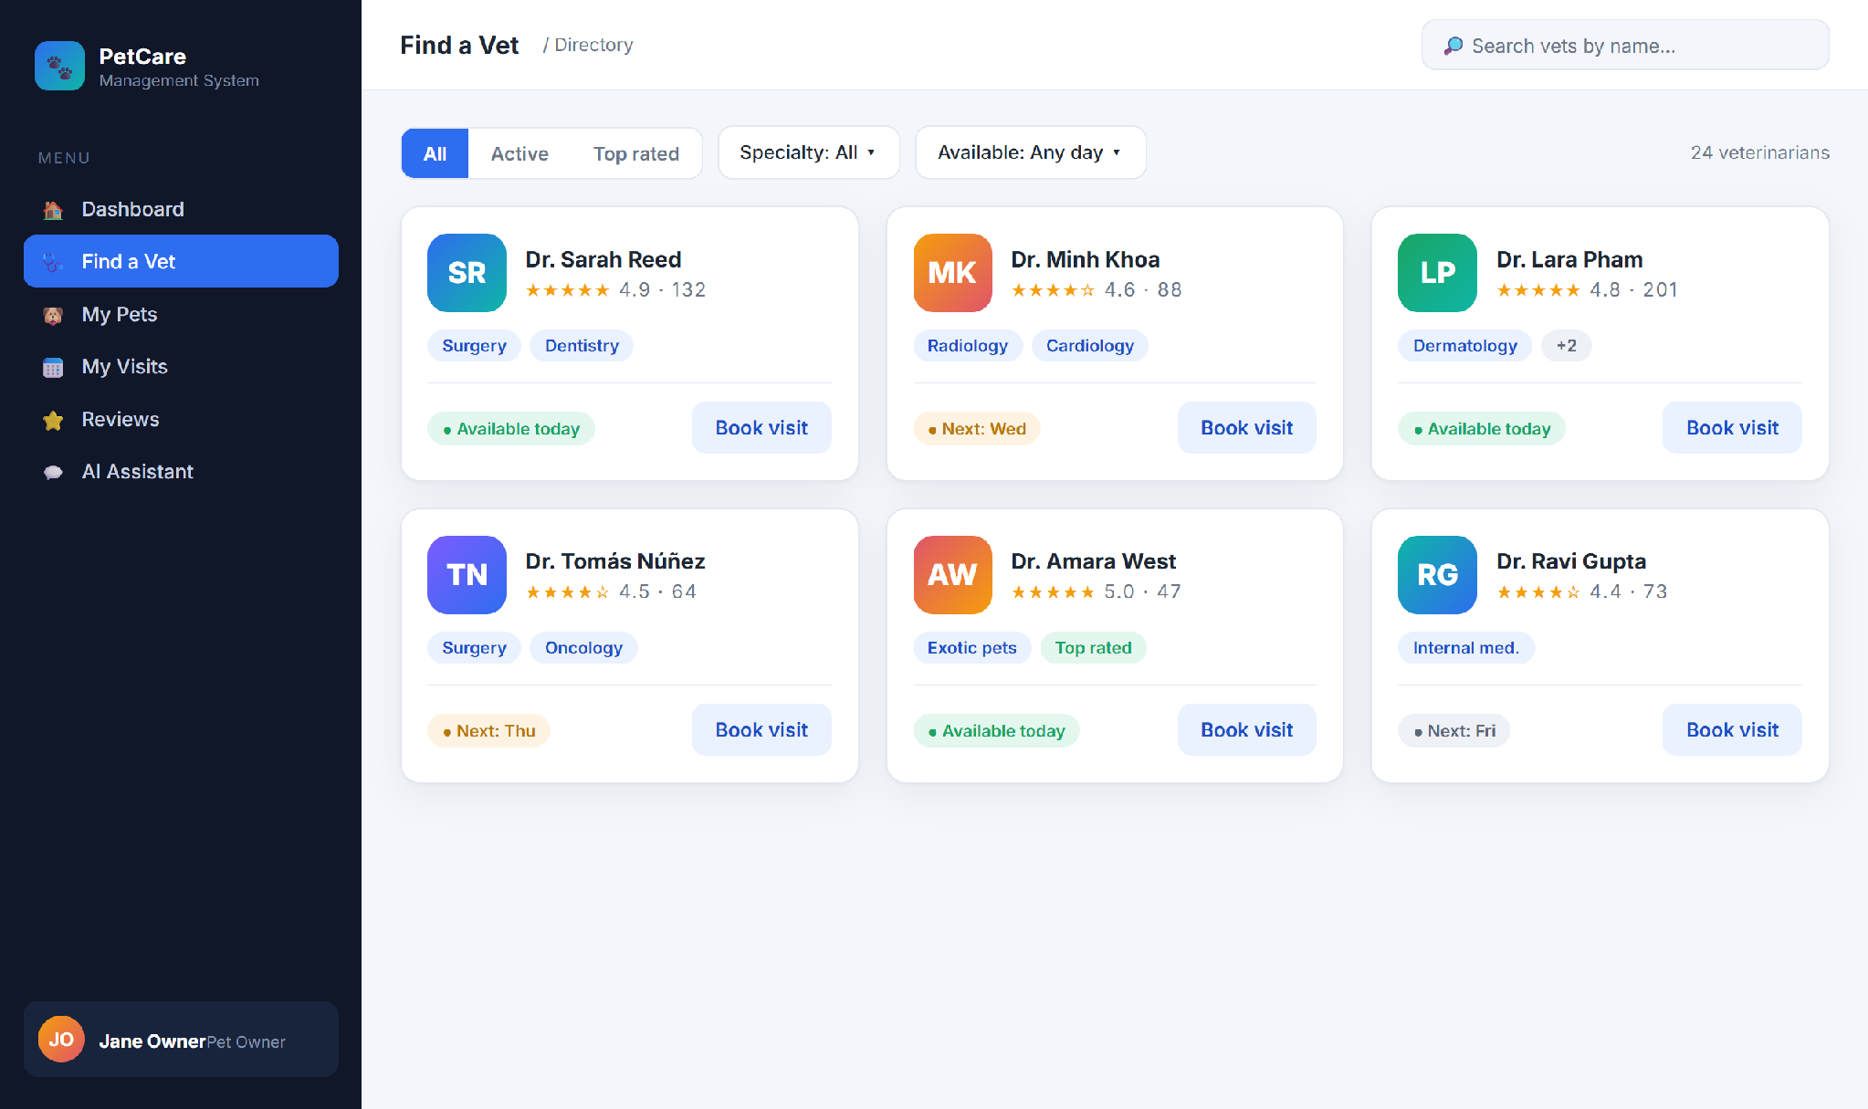
Figure 3-5: Find a Vet (Directory)
Guests and owners search and filter the vet directory and open a vet to view profile, ratings and reviews before booking. Implemented by vets-service (GET /api/v1/vets, /top-rated, /{id}).

3.3.2 UC12 — Book a Visit
3.3.2.1 Screen Mock-up
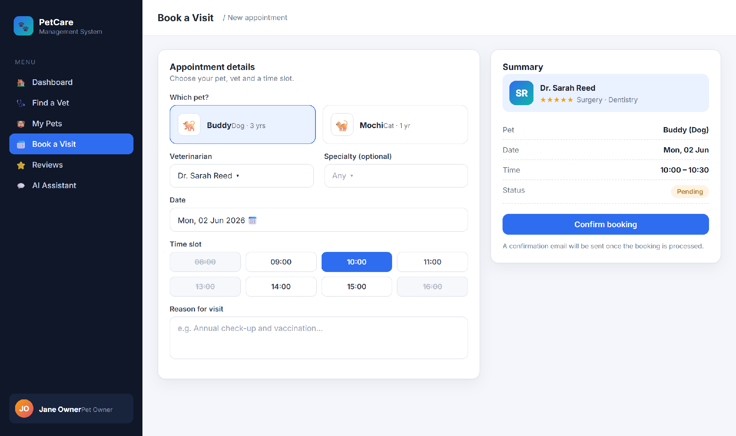
Figure 3-6: Book a Visit
Table 3-2: Screen Definition
# | Field Name | Type | Mandatory | Max Length | Description
1 | Pet | Selector | Yes | – | Owner’s pets only.
2 | Veterinarian / Specialty | Dropdown | Yes | – | Specialty narrows vet list.
3 | Date / Time slot | Picker / grid | Yes | – | Free slots only (BR-06).
4 | Reason | Textarea |  | 500 | Symptom description.
5 | Confirm booking | Button |  |  | POST /api/v1/visits.
3.3.2.2 Use Case Description
Use Case ID |  | UC12 | Use Case Name |  | Book a Visit
Author |  | Project Team | Version | 1.0 | Date | 2026-04-25
Actor |  | USER
Description |  | A pet owner books an appointment for a pet with a chosen vet; the system records a scheduled visit and sends a confirmation email.
Precondition |  | PRE-01: The user is signed in (UC01).  PRE-02: The user has at least one pet (UC07).  PRE-03: The chosen vet is active and has a free slot (UC06).
Trigger |  | TRG-01: User chooses Book a Visit.
Post-Condition |  | POS-01: The visit is recorded with status Scheduled.  POS-02: A booking confirmation email is sent to the owner.
Main Flow
Step | Actor | Action
1 | User | Selects a pet, a vet, a date and a free time slot, enters a reason and clicks Confirm booking.
2 | PCMS | Validates the slot and business hours and records the visit as Scheduled.
3 | PCMS | Sends a booking confirmation email to the owner and shows a success message (MSG04).
4 | PCMS | Lists the new visit under My Visits with status Scheduled.
Alternative flows
AT1 | At step 3, the confirmation email cannot be delivered.
Sub step | Actor | Action
3.1 | PCMS | Flags the visit for manual follow-up and notifies the front desk so staff can confirm with the owner.

AT2 | At step 2, the chosen slot is no longer available.
Sub step | Actor | Action
2.1 | PCMS | Shows MSG12 and asks the user to pick another slot.
Business Rules
# | Rule Description
BR-01 | Bookings Mon–Sat, 08:00–18:00 (Asia/Ho_Chi_Minh).
BR-02 | Minimum 30-minute lead time.
BR-06 | At most one visit per vet per 30-minute slot.
BR-07 | Confirmation converges within 60 seconds.

3.4 Visit Lifecycle & Prescriptions

3.4.1 UC13/UC29 — Track & Complete Visit
3.4.1.1 Screen Mock-up
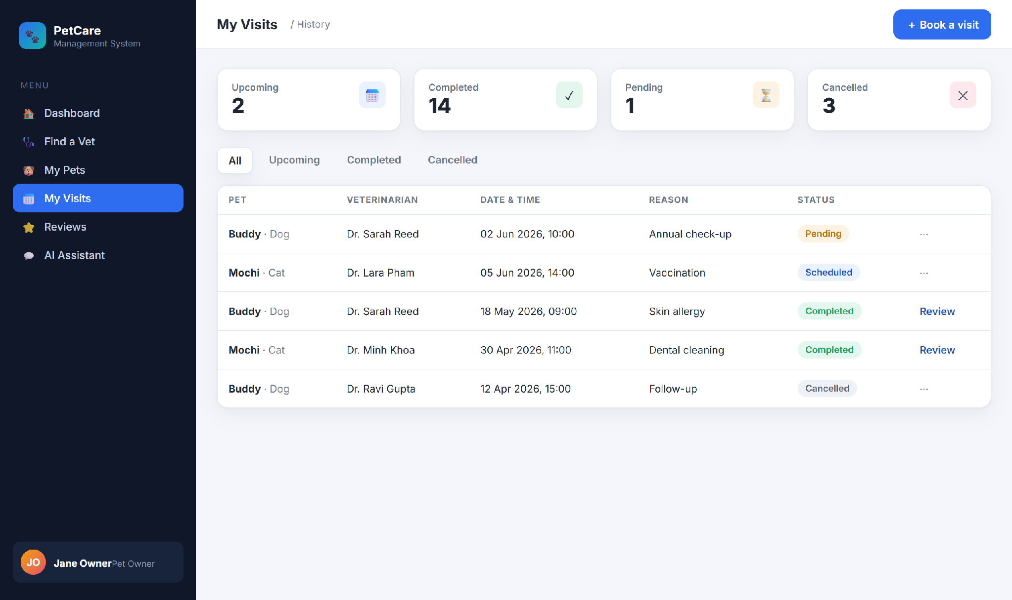
Figure 3-7: My Visits (history & status)
Owners see their own visits; vets see assigned visits; staff/admin see all. A vet starts a visit (IN_PROGRESS) and completes it with diagnosis, treatment and fee. Completion writes VisitCompletedEvent plus VisitCompletionSaga state; billing and notification participants reply ACK/FAILED.

3.4.2 UC30 — Issue Prescription
3.4.2.1 Screen Mock-up
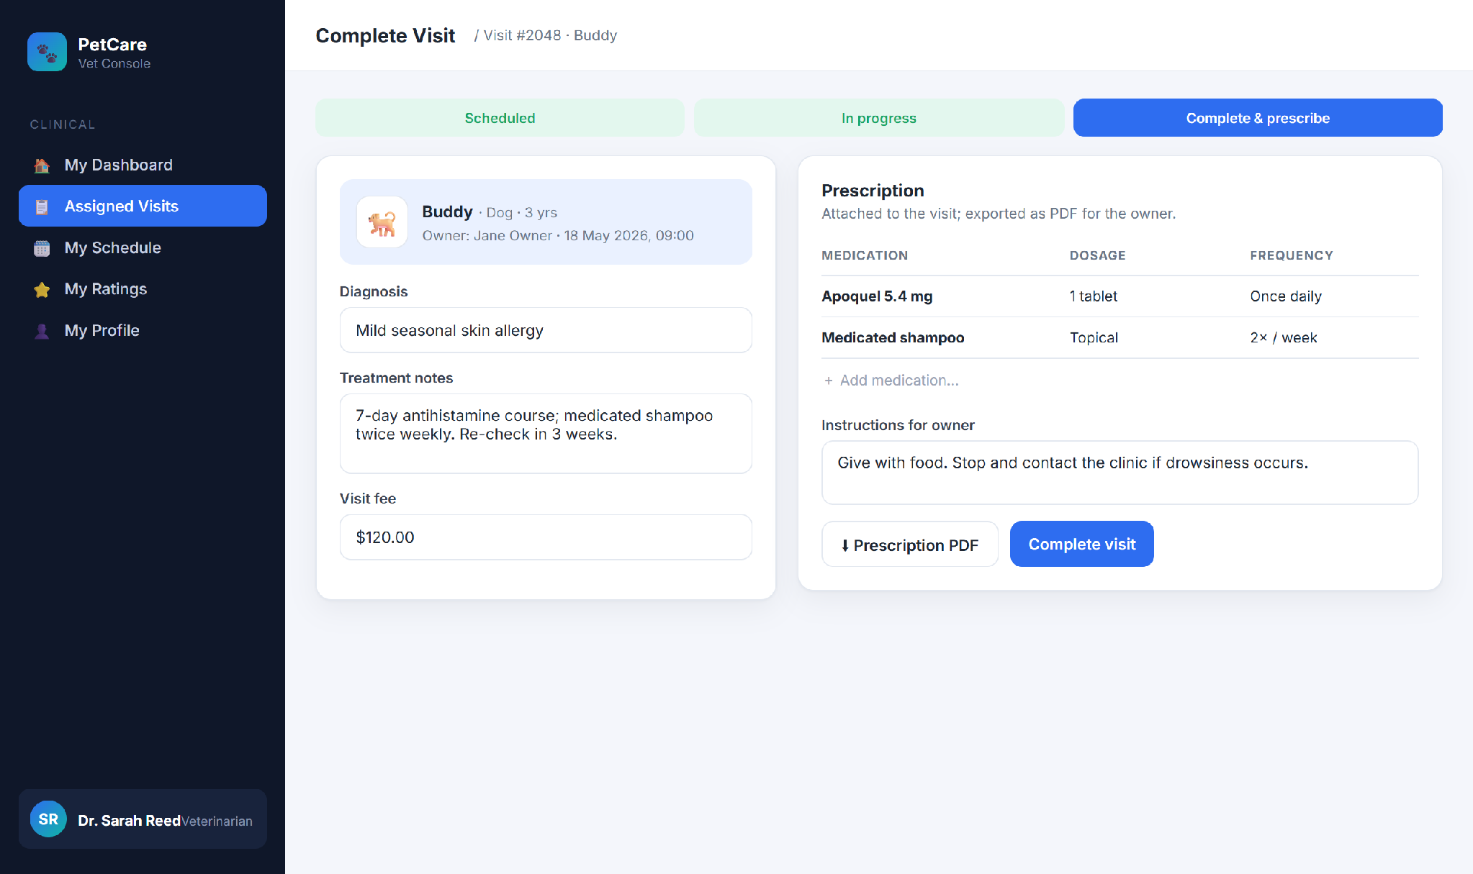
Figure 3-8: Complete Visit & Prescribe
3.4.2.2 Use Case Description
Use Case ID |  | UC30 | Use Case Name |  | Issue Prescription
Author |  | Project Team | Version | 1.0 | Date | 2026-04-25
Actor |  | VET
Description |  | When completing a visit, a vet records the prescribed medications so the owner receives a prescription.
Precondition |  | PRE-01: The vet is assigned to the visit. PRE-02: The visit is IN_PROGRESS or COMPLETED.
Trigger |  | TRG-01: Vet opens Complete Visit & Prescribe.
Post-Condition |  | POS-01: The prescription is saved against the visit. POS-02: A prescription PDF is available to the owner. POS-03: Catalog medication lines start a billing saga.
Main Flow
Step | Actor | Action
1 | Vet | Records diagnosis, treatment and fee.
2 | Vet | Adds medication lines (name, dosage, frequency) and owner instructions.
3 | Vet | Clicks Complete visit.
4 | PCMS | Saves the prescription, generates a prescription PDF through files-service, and consumes catalog medicine stock when applicable.
5 | PCMS | Publishes PrescriptionIssuedEvent; billing-service appends medication charges and replies prescription.billing ACK/FAILED.
Alternative flows
AT1 | At step 3, the visit has not been started.
Sub step | Actor | Action
3.1 | PCMS | Prevents completion until the visit is in progress (BR-16).
Business Rules
# | Rule Description
BR-16 | A visit may not move backwards (e.g. COMPLETED → SCHEDULED).
BR-25 | A prescription belongs to an IN_PROGRESS or COMPLETED clinical visit and is exported as PDF.

3.5 Reviews & Ratings

3.5.1 UC46 — Write a Review
3.5.1.1 Screen Mock-up
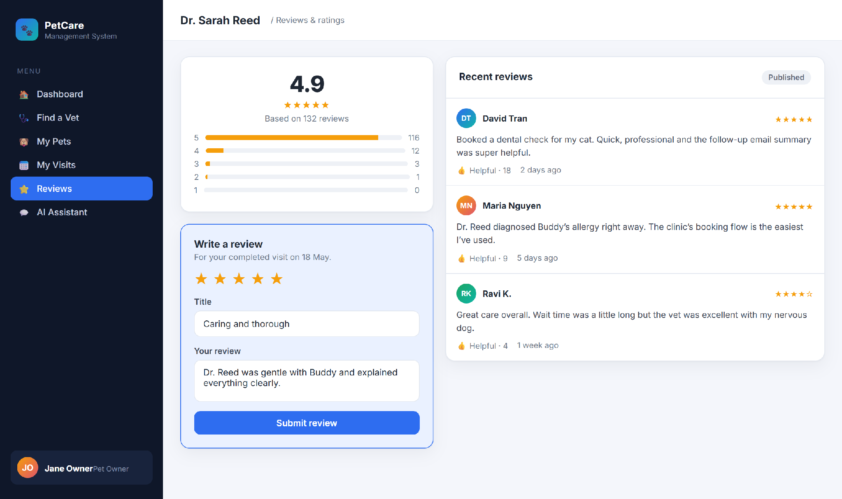
Figure 3-9: Vet Detail — Ratings & Write Review
Table 3-3: Screen Definition
# | Field Name | Type | Mandatory | Max Length | Description
1 | Star rating | Star picker | Yes | – | 1–5 stars.
2 | Title / Review | Text / Textarea | Yes | 120 / 2000 | Headline + feedback.
3 | Submit / Helpful | Button |  |  | Create review / vote helpful.
3.5.1.2 Use Case Description
Use Case ID |  | UC46 | Use Case Name |  | Write a Review
Author |  | Project Team | Version | 1.0 | Date | 2026-04-25
Actor |  | USER
Description |  | After a completed visit (or a purchased product), the owner leaves a star rating and review, which is moderated before it appears publicly.
Precondition |  | PRE-01: The user is signed in.  PRE-02: The user has a completed interaction with the target.
Trigger |  | TRG-01: User chooses Write a Review.
Post-Condition |  | POS-01: The review is saved as Pending moderation and is visible to its author.  POS-02: Once approved, the review is published.
Main Flow
Step | Actor | Action
1 | User | Selects a star rating, writes a title and review, and clicks Submit.
2 | PCMS | Confirms the user is eligible and saves the review as Pending moderation (MSG03).
3 | Staff / Admin | Reviews the moderation queue and approves the review (UC47).
4 | PCMS | Publishes the review so others can read and vote on it.
Alternative flows
AT1 | At step 2, the user has no completed interaction with the target.
Sub step | Actor | Action
2.1 | PCMS | Declines the review with an eligibility message and does not save it.
Business Rules
# | Rule Description
BR-12 | Reviews require a prior COMPLETED interaction.
BR-17 | Author may edit within 7 days; delete is soft.
BR-18 | New reviews are PENDING_MODERATION until approved.

3.7 Billing & Invoices

3.7.1 UC27 — View Invoices
3.7.1.1 Screen Mock-up
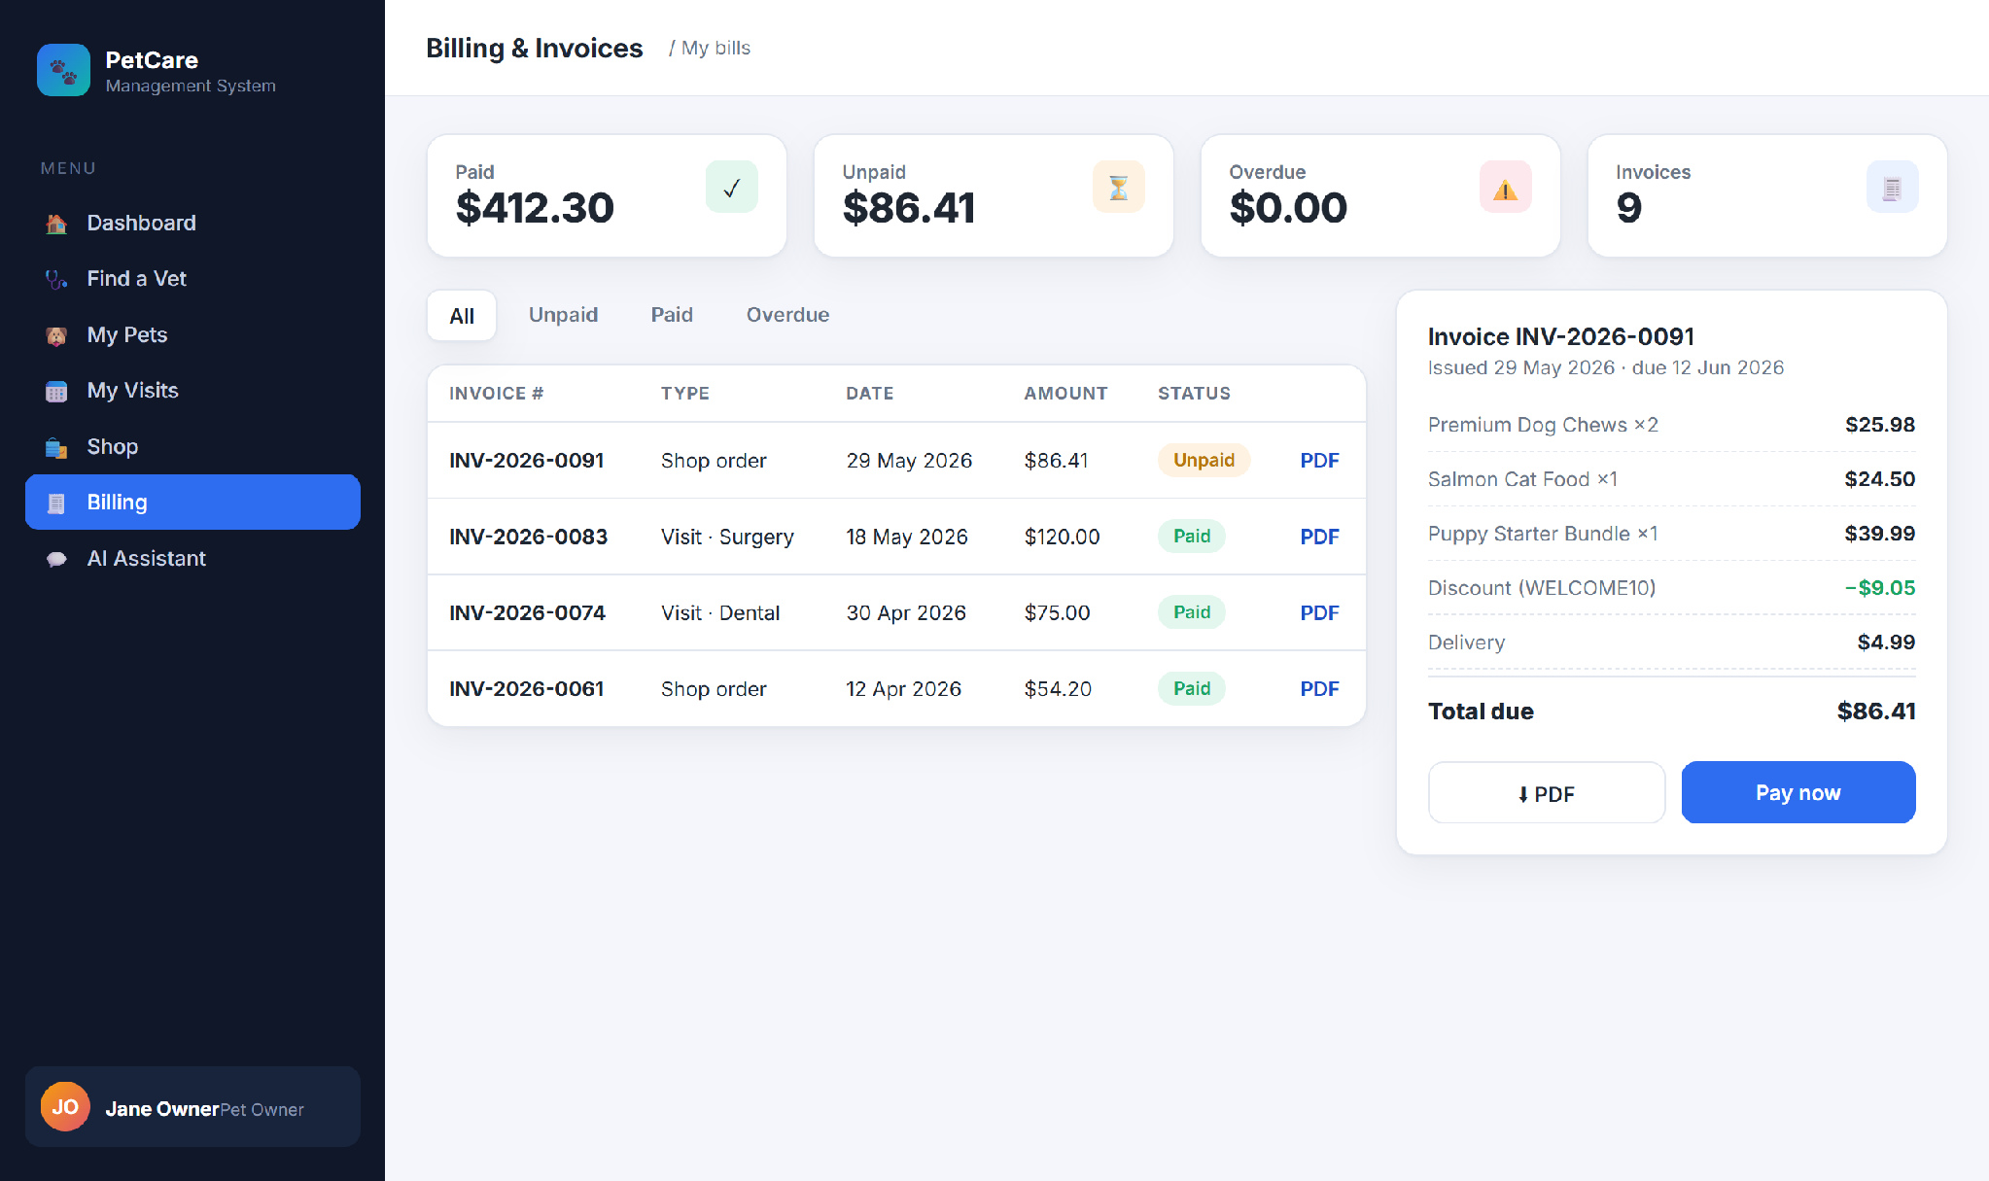
Figure 3-12: Billing & Invoices
Table 3-5: Screen Definition
# | Field Name | Type | Mandatory | Max Length | Description
1 | Status filter | Tabs |  | – | All / Open / Paid / Cancelled.
2 | Invoice row | List |  | – | Number, type, date, amount, status.
3 | Detail / Checkout | Button |  |  | Open invoice detail / staff checkout an open invoice; receipt is sent by e-mail after payment.
3.7.1.2 Use Case Description
Use Case ID |  | UC27 | Use Case Name |  | View Invoices / Receipt Status
Author |  | Project Team | Version | 1.0 | Date | 2026-04-25
Actor |  | USER, STAFF
Description |  | A customer views their invoices with status and line items; staff/admin manage all invoices and checkout at the clinic. Invoice PDF download is not part of v1.
Precondition |  | PRE-01: The user is signed in.  PRE-02: At least one invoice exists.
Trigger |  | TRG-01: User opens Billing.
Post-Condition |  | POS-01: The selected invoice is shown with status, payment method/reference and line items.
Main Flow
Step | Actor | Action
1 | User | Opens Billing and filters by status.
2 | PCMS | Displays the user’s own invoices with number, type, date, amount and status.
3 | User | Opens an invoice detail view.
4 | PCMS | Displays line items, totals, status, payment method and transfer reference when present.
Alternative flows
AT1 | At step 2, an invoice is not open.
Sub step | Actor | Action
2.1 | PCMS | Shows the latest invoice state and disables checkout when the invoice is already PAID or CANCELLED (BR-22).
Business Rules
# | Rule Description
BR-22 | Invoice OPEN on creation; checkout transitions to PAID; cancellation transitions to CANCELLED.
BR-12 | A user may only view their own invoices and receipts (row-level authorization).

3.8 Catalog & Inventory Administration

3.8.1 UC32/UC35 — Manage Products, Medicines & Stock
3.8.1.1 Screen Mock-up
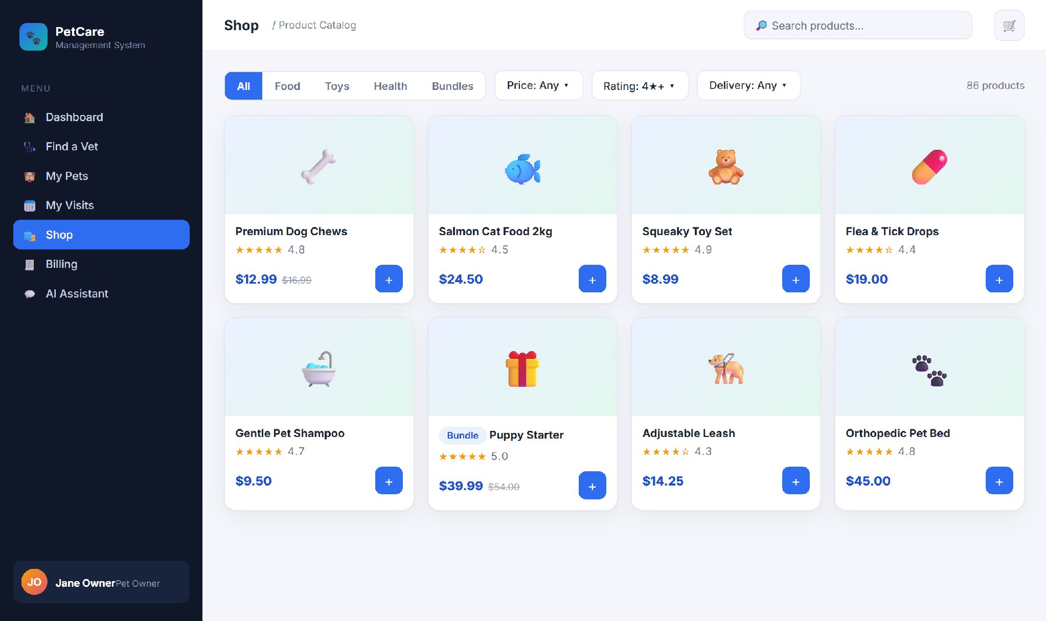
Figure 3-13: Catalogue management (admin view of the product grid)
Inventory managers and admins create and maintain pet products, medicines, types and bundles, and adjust stock levels and listing status. Implemented by products-service.
3.8.1.2 Use Case Description
Use Case ID |  | UC32 | Use Case Name |  | Manage Products, Medicines & Stock
Author |  | Project Team | Version | 1.0 | Date | 2026-04-25
Actor |  | INVENTORY_MANAGER, ADMIN
Description |  | An inventory manager or admin creates, updates and retires products, medicines, categories and stock, including price, stock and listing status.
Precondition |  | PRE-01: The user has the Inventory Manager or Admin role.
Trigger |  | TRG-01: Operator opens Manage Products.
Post-Condition |  | POS-01: The catalogue reflects the change; listing status governs visibility to shoppers.
Main Flow
Step | Actor | Action
1 | Operator | Creates or edits a product (name, price, type, stock, delivery, status).
2 | PCMS | Validates and saves the product; its listing status controls whether shoppers can see it.
3 | Operator | Adjusts stock, price, active status, and low-stock threshold.
4 | PCMS | Saves the catalogue and stock changes.
Alternative flows
AT1 | At step 1, a user without permission attempts the action.
Sub step | Actor | Action
1.1 | PCMS | Denies access and keeps the menu hidden (BR-24).
Business Rules
# | Rule Description
BR-24 | Only INVENTORY_MANAGER or ADMIN may create/modify products, medicines, stock or pricing.
BR-21 | Stock cannot go negative; out-of-stock products are not purchasable.

3.9 AI Care Assistant

3.9.1 UC48 — Chat with AI Assistant
3.9.1.1 Screen Mock-up
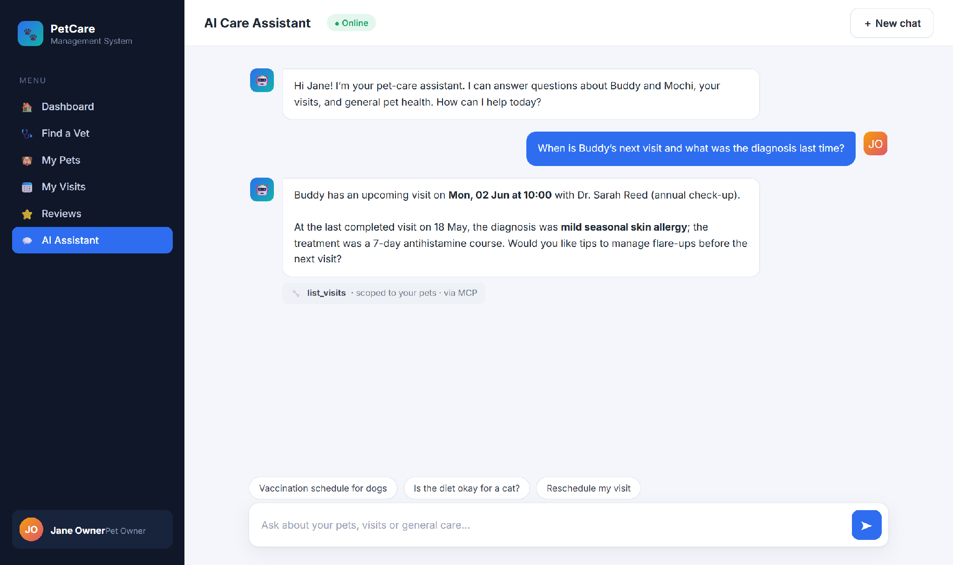
Figure 3-14: AI Care Assistant
Table 3-6: Screen Definition
# | Field Name | Type | Mandatory | Max Length | Description
1 | Message input | Textarea | Yes | 4000 | Enter sends; Shift+Enter newline.
2 | Send / New chat | Button |  |  | Stream reply / reset session.
3 | Conversation pane | Display |  |  | User / assistant / tool-call bubbles.
3.9.1.2 Use Case Description
Use Case ID |  | UC48 | Use Case Name |  | Chat with AI Assistant
Author |  | Project Team | Version | 1.0 | Date | 2026-04-25
Actor |  | USER
Description |  | A pet owner asks questions in natural language and the assistant replies using clinic knowledge and the owner’s own data, streaming the answer.
Precondition |  | PRE-01: The user is signed in.  PRE-02: A working AI provider is configured (UC41).
Trigger |  | TRG-01: User sends a message.
Post-Condition |  | POS-01: The conversation keeps the question and answer.  POS-02: The answer is shown without error.
Main Flow
Step | Actor | Action
1 | User | Types a question and sends it.
2 | PCMS | Interprets the question, looks up only the user’s own data when needed, and streams a grounded answer.
3 | PCMS | Shows the answer in the conversation, indicating any data it looked up.
Alternative flows
AT1 | At step 2, the AI provider is unavailable.
Sub step | Actor | Action
2.1 | PCMS | Shows MSG13; chat resumes once an admin restores the provider.

AT2 | At step 2, too many AI requests are in progress.
Sub step | Actor | Action
2.2 | PCMS | Shows MSG14 and asks the user to retry shortly.
Business Rules
# | Rule Description
BR-13 | The AI assistant may only access the requesting user’s own data.
BR-14 | Chat memory window is the last 10 messages.
BR-15 | Prompts/completions logged at DEBUG only; never persisted in plain text in production.

3.10 Administration

3.10.1 UC41 — Configure LLM (BYOK)
3.10.1.1 Screen Mock-up
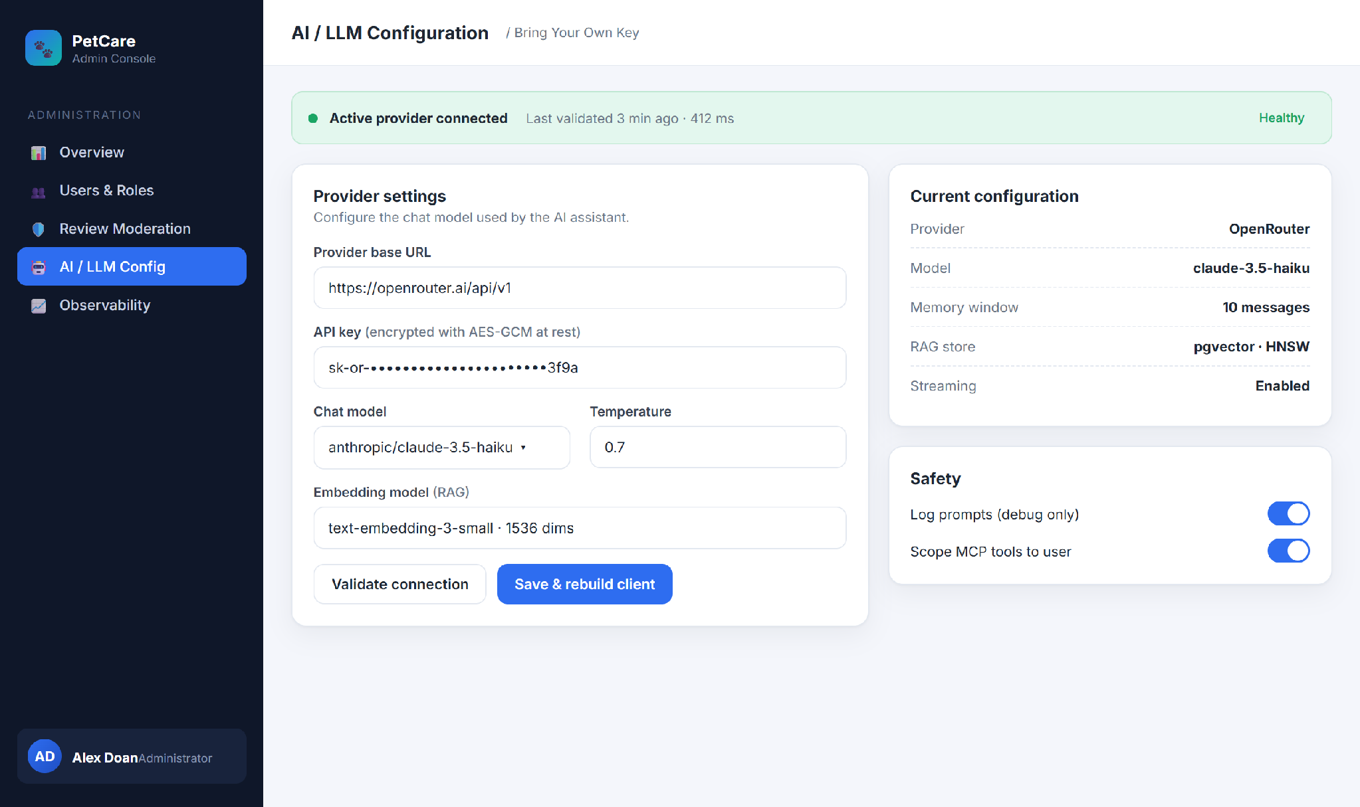
Figure 3-15: Admin — LLM Configuration
Table 3-7: Screen Definition
# | Field Name | Type | Mandatory | Max Length | Description
1 | Provider base URL | Text | Yes | 255 | OpenAI-compatible endpoint.
2 | API key | Password | Yes | 255 | AES-GCM encrypted; masked on read.
3 | Chat model / Temperature | Dropdown / Number | Yes | – | Model id; 0.0–2.0.
4 | Validate / Save | Button |  |  | Test without saving / persist & rebuild client.
3.10.1.2 Use Case Description
Use Case ID |  | UC41 | Use Case Name |  | Configure LLM (BYOK)
Author |  | Project Team | Version | 1.0 | Date | 2026-04-25
Actor |  | ADMIN
Description |  | An admin sets the AI provider, key and model so the assistant can work; the key is stored securely and applied without a restart.
Precondition |  | PRE-01: The user has the Admin role.  PRE-02: The system is available.
Trigger |  | TRG-01: Admin opens LLM Config.
Post-Condition |  | POS-01: The configuration is saved securely.  POS-02: The assistant immediately uses the new provider.
Main Flow
Step | Actor | Action
1 | Admin | Enters the provider URL, API key, model and temperature.
2 | Admin | Clicks Validate connection.
3 | PCMS | Tests the configuration and reports whether it works and how fast.
4 | Admin | Clicks Save & rebuild client.
5 | PCMS | Stores the configuration securely and applies it immediately (MSG07).
Alternative flows
AT1 | At step 3, the provider rejects the key.
Sub step | Actor | Action
3.1 | PCMS | Reports a validation error and saves nothing.
Business Rules
# | Rule Description
BR-11 | Only ADMIN may view or change the LLM configuration.
BR-19 | API keys are AES-GCM encrypted at rest and masked on read.
Administrators also manage users & roles (UC38), observability dashboards (UC44) and email templates/history (UC45) from the admin console.

4. Non-Functional Requirements

4.1 External Interfaces
Interface | Protocol | Direction | Description
LLM Provider | HTTPS + OAuth 2.1 | Outbound | Chat completions and embeddings.
Bank Transfer Channel | Manual reference / bank portal | Out/In | Record bank-transfer payment reference for clinic invoices; cash is recorded internally.
SMTP relay | SMTPS (465) | Outbound | Transactional email.
Web SPA | HTTPS + JSON / SSE | Inbound | React front-end.
Object storage | S3 API (presigned) | Out/In | Pet/vet photos and prescription PDFs via files-service; invoice receipts are e-mail content in v1.
Prometheus / Zipkin | HTTP | In/Out | Metrics scrape & distributed tracing.

4.2 Quality Attributes

4.2.1 Usability
- A new user can register, add a pet and book a visit in under 3 minutes (P50).
- Inline validation on every form; server errors as toast + field highlights.
- Keyboard navigable; Lighthouse accessibility ≥ 90.

4.2.2 Reliability
- Availability ≥ 99.5% during business hours (Mon–Sat, 08:00–18:00 ICT).
- MTBF ≥ 30 days for gateway & identity; MTTR ≤ 15 min per single-service outage.
- Visit-completion saga (billing + notification) and prescription-billing saga converge within 60 s for 99% of events; failed steps create manual follow-up events instead of silently losing work.
- Invoice checkout is transactional for invoice state; product stock is validated and consumed through products-service, with manual reconciliation required if a downstream stock call fails after physical handover.

4.2.3 Performance
- REST P95 ≤ 300 ms (reads) / ≤ 500 ms (writes) at 50 RPS at the gateway.
- Catalogue listing P95 ≤ 400 ms with filters over 10k products.
- AI chat time-to-first-token ≤ 1.5 s; full ~200-token reply ≤ 8 s.

4.2.4 Security
- HTTPS everywhere; plain HTTP redirected.
- JWT (RSA), short-lived access + rotating refresh; JWKS validation.
- Least-privilege RBAC: declarative YAML + method-level @PreAuthorize ownership checks.
- Secrets such as LLM API keys are AES-GCM encrypted; PCMS stores only payment method and receipt/reference, never card PAN/CVV or bank credentials.

4.2.5 Maintainability & Observability
- All services expose /actuator/health, /metrics, /prometheus; JSON logs with trace IDs.
- Spotless + Checkstyle gates and mandatory PR review in CI.

5. Requirement Appendix

5.1 Business Rules
# | Rule Description
BR-01 | Bookings Mon-Sat, 08:00-20:00 (Asia/Ho_Chi_Minh), aligned to whole-hour slots.
BR-02 | Booking lead time ≥ 30 minutes.
BR-03 | Pet name + birth date unique per owner.
BR-04 | Pet birth date not in the future; age derived.
BR-05 | Telephone digits only, length 8–15.
BR-06 | At most two active visits per vet per hourly slot.
BR-07 | Booking confirmation converges within 60 seconds.
BR-08 | Passwords bcrypt (cost 12); never logged.
BR-09 | Password ≥ 8 chars with ≥1 digit and ≥1 letter.
BR-10 | Access token 15 min; refresh 7 days, single-use rotation.
BR-11 | Only ADMIN may configure or rotate the LLM provider.
BR-12 | A user may only see/act on their own owner/pet/visit/bill/review records.
BR-13 | The AI assistant may only access the requesting user’s own data.
BR-14 | Chat memory window is the last 10 messages.
BR-15 | Prompts/completions logged at DEBUG only; never persisted in plain text in production.
BR-16 | A visit may not transition backwards.
BR-17 | A review may be edited by its author within 7 days; deletion is soft.
BR-18 | New reviews are PENDING_MODERATION until approved.
BR-19 | API keys are AES-GCM encrypted at rest and masked on read.
BR-20 | Promo: % discount capped at maxDiscount; not combinable; respects expiry & usage limit.
BR-21 | Stock cannot go negative; out-of-stock products are not selectable. Catalog stock changes are validated before prescription/invoice use and reconciled manually if downstream update fails after checkout.
BR-22 | Invoice OPEN on creation; checkout transitions to PAID; cancellation transitions to CANCELLED. Paid and cancelled invoices are immutable.
BR-23 | Invoice total = Σ(unit price × quantity); no delivery fee in clinic checkout; money values must not use floating-point arithmetic.
BR-24 | Only INVENTORY_MANAGER or ADMIN may manage products, medicines, stock and pricing.
BR-25 | A prescription belongs to an IN_PROGRESS or COMPLETED visit and is exported as PDF.
BR-26 | Registration creates an enabled USER account and emits user.registered for welcome e-mail; e-mail verification is a future extension, not required before first login in v1.
BR-27 | Reviews require a prior completed visit or purchase; new reviews are moderated before public display.
BR-28 | Files are accepted only for configured content types and size limits; binaries live in files-service/object storage while domain services store references.
BR-29 | Paid or cancelled invoices are immutable; product stock changes occur on prescription issue or checkout, depending on the source type.

5.2 Common Requirements
- All timestamps stored as UTC; rendered in Asia/Ho_Chi_Minh.
- Money is stored as fixed-scale decimal values; no binary floating-point currency arithmetic.
- Identifiers in URLs are opaque (UUID v4 or numeric id).
- All error responses follow RFC 9457 ProblemDetail.
- CORS restricted to configured front-end origins; no wild-card in production.
- Privileged actions (role change, LLM/key rotation, visit completion, review moderation, invoice cancellation, stock change) are audit-logged with actor, target and timestamp.

5.3 Application Messages List
# | Code | Type | Context | Content
1 | MSG01 | Inline | No search result | No matching results.
2 | MSG02 | Inline (red) | Required field empty | The {field} field is required.
3 | MSG03 | Toast | Review submitted | Your review has been submitted for moderation.
4 | MSG04 | Toast | Visit booked | Your visit has been booked. Confirmation will arrive by email.
5 | MSG05 | Toast | Visit confirmed | Booking confirmed for {pet} with Dr. {vet}.
6 | MSG06 | Toast | Visit completed | Visit marked as completed.
7 | MSG07 | Toast | LLM saved | LLM configuration saved and applied.
8 | MSG08 | Inline (red) | Value exceeds max length | Maximum length is {max} characters.
9 | MSG09 | Inline (red) | Invalid credentials | Email or password is incorrect.
10 | MSG10 | Modal | Account locked | Too many failed attempts. Try again in 30 minutes.
11 | MSG11 | Inline (red) | Outside business hours | Bookings are available Mon–Sat, 08:00–18:00.
12 | MSG12 | Toast (error) | Slot taken | This time slot is no longer available.
13 | MSG13 | Toast (error) | AI unavailable | AI service is temporarily unavailable. Please try again.
14 | MSG14 | Toast (warn) | AI rate limit | Too many AI requests in flight — please retry shortly.
15 | MSG16 | Toast | Invoice updated | The invoice has been updated.
16 | MSG17 | Inline (red) | Payment recording failed | The payment could not be recorded. Check the method/reference and try again.
17 | MSG18 | Toast (error) | Out of stock | Sorry, {product} is out of stock.
18 | MSG19 | Toast | Checkout success | Order placed. Invoice {invoice} created.
19 | MSG20 | Toast | Payment success | Payment received. Thank you!
20 | MSG21 | Toast | Prescription saved | Prescription saved and PDF generated.
21 | MSG-INT | Modal | Internal error | An internal error occurred. Please contact the administrator.

5.4 Other Requirements
- Personal data handling complies with applicable Vietnamese personal-data protection guidance.
- PCMS records only payment method and receipt/reference; no card PAN/CVV or bank credentials are stored. Future payment-gateway integrations must remain PCI-DSS compliant.
- Container images are scanned in CI; HIGH/CRITICAL vulnerabilities block the merge.
- Disaster recovery: nightly base backups + continuous WAL archiving; RPO ≤ 1 h, RTO ≤ 4 h.

