Store Activity Dashboard — Section Breakdown
Section 1 — KPI Summary Cards

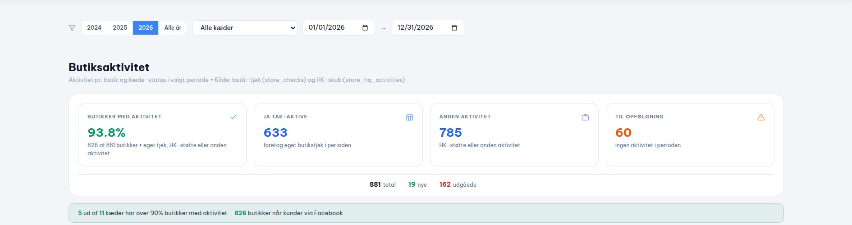
How it works:
- Displays a top-level snapshot for the selected date range and chain filter.
- Butikker med aktivitet — the overall activity rate: (stores with any activity ÷ total registered) × 100.
- JA TAK-AKTIVE — count of stores that performed their own self-check in the period.
- ANDEN AKTIVITET — count of stores that received an HQ content push (regardless of self-check).
- TIL OPFØLGNING — registered stores with zero activity of any kind in the period.
- Footer strip shows total registered stores, newly added stores, and closed/exited stores.
Columns / Cards:
Butikker med aktivitet | Overall % of registered stores that had at least one action (self-check or HQ push) in the period.
JA TAK-AKTIVE | Raw count of stores that actively did their own store check — the most direct sign of platform engagement.
ANDEN AKTIVITET | Raw count of stores touched by an HQ push — includes stores that did not self-check.
TIL OPFØLGNING | Stores that are open and registered but had absolutely no activity — the follow-up target list.
Total / Nye / Udgåede | Footer strip: total registered base, new stores onboarded this period, and stores that exited the registry.
Questions:
1) Should TIL OPFØLGNING include stores that have an HQ push but no self-check, or only stores with zero activity of any kind?

2) If a brand-new store does its first self-check in this period, should it count in the main active total or only in the 'new stores' strip?

Section 2 — Chain Breakdown Table

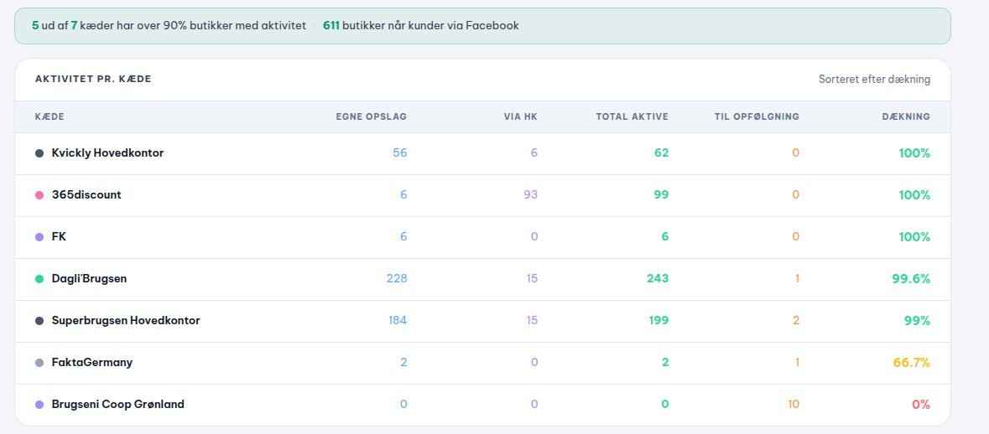
How it works:
- Breaks the global KPIs down by chain, one row per chain.
- Sorted descending by Dækning (coverage %) so the best-performing chains appear first.
- TOTAL AKTIVE is a set union of self-check stores and HQ-pushed stores — stores present in both are counted only once.
- TIL OPFØLGNING per chain = registered stores in that chain with zero self-check and zero HQ push.
- Dækning = (total_with_activity ÷ total_registered for that chain) × 100.
Columns:
KÆDE | Chain name — each row represents one corporate chain.
EGNE OPSLAG | Number of stores in this chain that did their own self-check in the period.
VIA HK | Number of stores in this chain that received an HQ content push in the period.
TOTAL AKTIVE | Unique stores with any activity (EGNE OPSLAG ∪ VIA HK, deduplicated).
TIL OPFØLGNING | Stores in this chain that are registered but had zero activity — need follow-up.
DÆKNING | Coverage %: what share of this chain's registered stores had at least one action.

Section 3 — Inactive Store Detail List

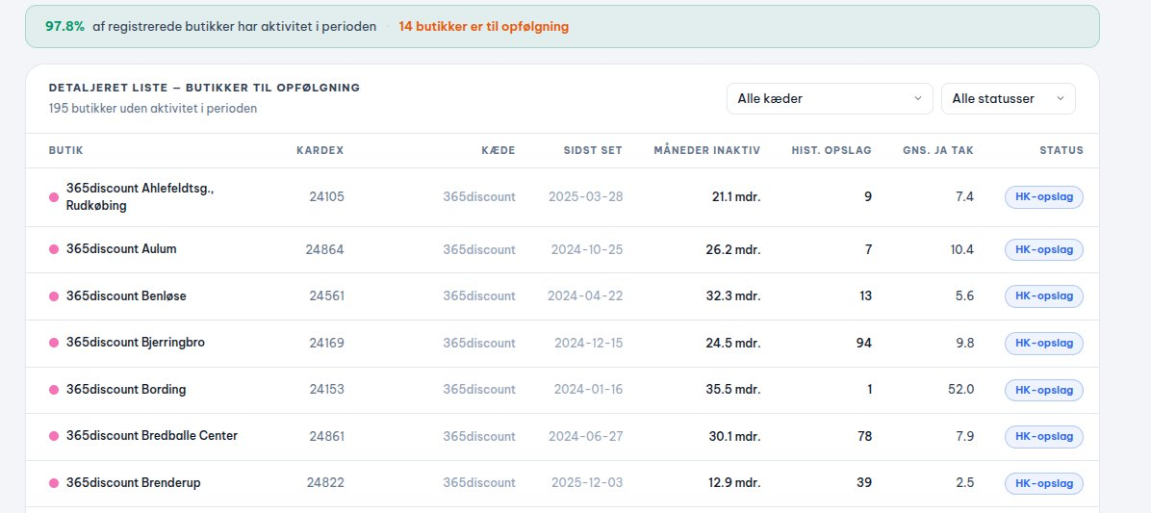
How it works:
- Shows ONLY stores that are inactive in the selected period — stores with a self-check history before the window but silent within it.
- Active stores (any self-check in the period) are completely absent from this list.
- Each store gets a status badge based on two flags — is_registered and has_hk:
- HK-opslag: registered + received HQ push, but no self-check. Still being reached by HQ.
- Pause: registered + zero activity of any kind. Highest priority for sales outreach.
- Lukket: not in the registered JSON at all — treated as decommissioned/closed.
Columns:
BUTIK | Store name
KARDEX | Unique store ID from the MySQL database.
KÆDE | The chain this store belongs to.
SIDST SET | Date of the store's last self-check — shows how long it has been silent.
MÅNEDER INAKTIV | Months since the last self-check, calculated as days_inactive ÷ 30.44.
HIST. OPSLAG | Total number of offers this store has historically posted — indicates its past engagement value.
GNS. JA TAK | Average Ja Tak rate from historical data — shows how well this store's offers performed with customers.
STATUS | Badge showing HK-opslag (HQ supported), Pause (fully inactive), or Lukket (closed/unregistered).
Questions:
1) Inactivity is currently tied to the selected date range — a store silent for just one week appears here. Should a fixed threshold (e.g. 3 or 6 months) be used instead?

2) For the Pause status, should we check inactivity only within the date range or look at all-time activity? The HIST. OPSLAG column hints that past value matters.

3) A Lukket store flagged purely because it is missing from the current store api— if it still received an HQ push in the period, should it stay Lukket or be reclassified?

