WORLD SCIENCE, ENVIRONMENT AND ENGINEERING COMPETITION 2026
FULL PAPER
DEVELOPMENT OF AN EXPLAINABLE AND UNCERTAINTY-AWARE AI SYSTEM FOR CERVICAL CELL ABNORMALITY SCREENING AND HPV-RELATED MORPHOLOGY RISK ASSESSMENT FROM THINPREP-STYLE IMAGES
INSERT
INSTITUTION LOGO
COMPILED BY
AUTHOR 1: ______________________________
AUTHOR 2: ______________________________
AUTHOR 3: ______________________________
AUTHOR 4: ______________________________
AUTHOR 5: ______________________________
AUTHOR 6: ______________________________
INSTITUTION | ______________________________
CATEGORY | TECHNOLOGY
YEAR | 2026

TABLE OF CONTENTS
This table follows the final Word/PDF pagination of the polished submission version.
Abstract | 3
Chapter 1 - Introduction | 4
Chapter 2 - Literature Review | 5
Chapter 3 - Research Method | 6
Chapter 4 - Results and Discussion | 8
Chapter 5 - Conclusion | 11
References | 12
Submission format English; A4; Arial 12 pt; single spacing; justified; margins 4/3/3/3 cm; PDF and Microsoft Word.

ABSTRACT
Cervical cancer is largely preventable when screening, interpretation, communication, and follow-up operate as a continuous pathway. This study developed CerviCo-Pilot, an explainable and uncertainty-aware research prototype for clinician-in-the-loop cervical cytology screening support. The system combines a Bethesda-style five-class output (NILM, LSIL, HSIL, SCC, and a KOIL placeholder), a binary normal/abnormal safety-triage view, Grad-CAM visual review support, Monte Carlo Dropout uncertainty, and a report lock that requires clinician sign-off before patient-facing communication. An EfficientNet-B0 model was trained and evaluated using 917 real images from the public Herlev cervical cytology dataset; segmentation masks were excluded from performance evidence. On the held-out test set (n=137), five-class accuracy was 0.6934, macro F1 was 0.5545, macro AUROC was 0.7311, and quadratic weighted kappa was 0.687. The binary safety-triage view achieved sensitivity 1.000, specificity 0.7222, AUROC 0.964, AUPRC 0.9856, and a confusion matrix of TP=101, TN=26, FP=10, and FN=0. Five-fold cross-validation produced binary sensitivity of 0.9867 +/- 0.0086 and AUROC of 0.9435 +/- 0.0448. Post-hoc temperature scaling improved held-out calibration metrics without materially changing discrimination. The prototype demonstrates a complete review workflow rather than an autonomous diagnostic device. Its present evidence is limited to the Herlev domain; it does not replace molecular HPV testing, and Thai ThinPrep validation, paired HPV endpoints, reader studies, and prospective evaluation remain necessary before clinical use.
Keywords: cervical cytology, explainable artificial intelligence, uncertainty-aware triage, Grad-CAM, clinician-in-the-loop, ThinPrep
Evidence boundary The present evidence is limited to the public Herlev domain. HPV output means morphology-related risk communication and does not replace molecular HPV testing.

CHAPTER 1
INTRODUCTION
1.1 Research Background
Cervical cancer remains an important public-health problem, yet it can be prevented or treated early when vaccination, screening, diagnosis, and follow-up are connected [1,2]. Cytology-based screening, including Pap and liquid-based preparations such as ThinPrep, examines cellular morphology, while HPV molecular testing detects viral material; the two modalities must not be described as interchangeable [3,4].
The practical gap is not limited to image classification. Screening programs also depend on timely review, understandable communication, and reliable referral. In settings with limited cytology expertise, a compact offline decision-support tool may help prioritize abnormal images, expose the image regions that influenced a prediction, and return uncertain cases to human review.
1.2 Problem Statement
Many image classifiers provide only a label and confidence score. Such output is insufficient for a safety-sensitive workflow because confidence may be miscalibrated, explanations may be over-trusted, and patient-facing communication may be released without appropriate review. A useful prototype should combine grading, triage, explainability, uncertainty, and explicit clinician control.
1.3 Research Objectives
- Develop a Bethesda-style five-class cervical cytology screening-support model.
- Add a high-sensitivity binary safety-triage view without replacing the five-class output.
- Provide Grad-CAM review support and uncertainty-aware abstention.
- Demonstrate clinician sign-off, report locking, and offline operation.
- Define a validation pathway for Thai ThinPrep images and paired HPV endpoints.
1.4 Significance
The project contributes an integrated medical-AI workflow rather than an isolated classifier. It emphasizes reviewability, conservative communication, reproducible metrics, and explicit boundaries between current evidence and future clinical validation.

CHAPTER 2
LITERATURE REVIEW
2.1 Cervical Cytology and the Bethesda Framework
The Bethesda System standardizes cervical cytology terminology and distinguishes negative findings from low-grade, high-grade, and malignant squamous abnormalities [4]. Preserving multiple classes supports clinical communication, whereas a secondary binary view is useful for screening-safety analysis.
2.2 Image Classification and Explainability
The Herlev benchmark contains 917 single-cell cervical cytology images [5]. EfficientNet provides an efficient scaling strategy for image models [6], making EfficientNet-B0 suitable for an offline prototype. Grad-CAM localizes regions associated with a class score [7], but it remains a review aid rather than causal proof.
2.3 Uncertainty, Calibration, and Governance
Monte Carlo Dropout provides an approximate uncertainty signal [8], while temperature scaling can improve probability calibration without changing class ordering [9]. Medical-AI guidance emphasizes representative data, human-AI interaction, lifecycle monitoring, and transparent reporting [10-12]. Dataset shift remains a major risk when moving from a public benchmark to a different population, preparation method, microscope, or camera [13].
Table 1. Design principles derived from the literature.
Principle | System implementation | Boundary
Structured cytology | Five-class Bethesda-style suggestion | Not a final cytology report
Screening safety | Binary normal/abnormal triage | Not the sole product output
Explainability | Grad-CAM heatmap | Review aid, not causal proof
Uncertainty | MC Dropout and abstention | Requires external validation
Governance | Clinician sign-off and report lock | Demo workflow only

CHAPTER 3
RESEARCH METHOD
3.1 Study Design and Dataset
This retrospective model-development and prototype-integration study used 917 real images from the public Herlev cervical cytology dataset [5]. Segmentation-mask files and synthetic-heavy historical experiments were excluded from public performance evidence. The held-out test set contained 137 images.
Table 2. Dataset and model card summary.
Item | Specification
Dataset | Herlev public cervical cytology dataset
Images | 917 real images; masks excluded
Architecture | EfficientNet-B0 with ImageNet transfer learning
Five-class output | NILM, LSIL, HSIL, SCC, KOIL placeholder
Binary triage | NILM=normal; remaining classes=abnormal
Evidence status | Phase 1 Herlev-only research prototype

3.2 End-to-End Workflow
The workflow accepts a cytology image, returns five-class probabilities and a binary triage interpretation, generates a Grad-CAM overlay, estimates uncertainty, and routes the result to clinician confirmation, correction, or rejection. A patient-facing report remains locked when the case is uncertain or unsigned.
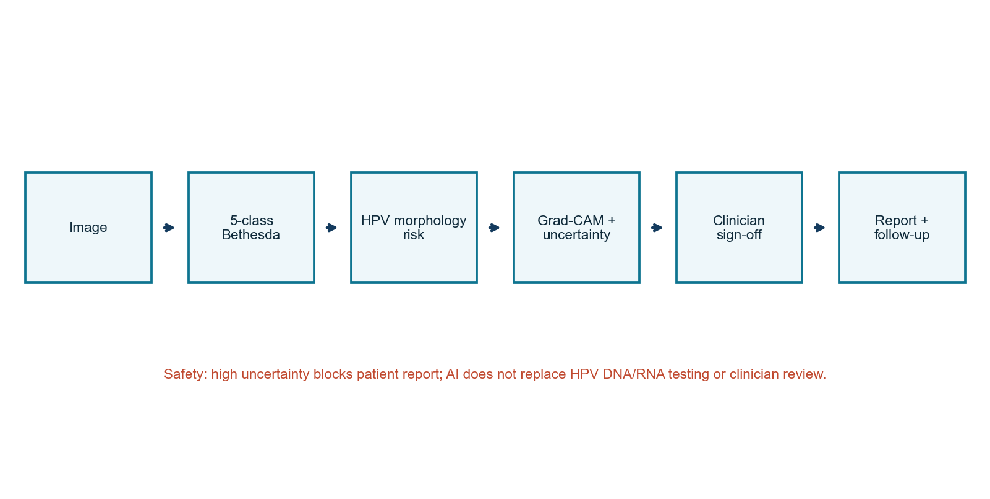
Figure 1. CerviCo-Pilot clinician-in-the-loop workflow.

CHAPTER 3
RESEARCH METHOD (CONTINUED)
3.3 Model Development and Evaluation
Images were resized for EfficientNet-B0 input and processed through the canonical project pipeline. Transfer learning, class-aware training, focal-loss experiments, oversampling, and test-time augmentation were used to address limited data and class imbalance. Only metrics reproduced from models/best_cervical.pt are used in this paper.
Table 3. Reproducible evaluation specification.
Component | Specification | Purpose
Held-out evaluation | n=137; TTA enabled | Primary test evidence
Bootstrap | 2,000 percentile resamples | Confidence intervals
Cross-validation | Five folds; mean +/- SD | Split robustness
Binary threshold | 0.50 | Normal/abnormal triage
Calibration | Temperature=0.794103 | Post-hoc probability scaling
Explainability | Grad-CAM | Visual review support
Uncertainty | MC Dropout | Abstention signal

3.4 Metrics and Safety Policy
Five-class evaluation included accuracy, macro F1, macro AUROC, per-class recall, and quadratic weighted kappa. Binary triage included sensitivity, specificity, AUROC, AUPRC, MCC, and confusion counts. Calibration used ECE and Brier score. High uncertainty triggers abstention language and blocks patient-report release.
3.5 Prototype System
The React/FastAPI prototype supports sample review, image upload, Grad-CAM display, confirm/edit/reject actions, report preview, evidence download, and an audit demonstration. It is intended for supervised research demonstration and does not satisfy regulated clinical deployment requirements.
Do-not-use boundary No autonomous diagnosis, molecular HPV status, unsupervised patient release, or Thai-domain performance claim.

CHAPTER 4
RESULTS AND DISCUSSION
4.1 Primary Quantitative Results
Table 4. Held-out and cross-validation results.
Measure | Result | Interpretation
Five-class accuracy | 0.6934 | Moderate detailed grading
Macro F1 / macro AUROC | 0.5545 / 0.7311 | Class-specific limitations
Quadratic weighted kappa | 0.687 | Severity agreement
Binary sensitivity / specificity | 1.000 / 0.7222 | FN=0; some over-referral
Binary AUROC / AUPRC | 0.964 / 0.9856 | Strong Herlev triage
Five-fold sensitivity | 0.9867 +/- 0.0086 | High across folds
Five-fold AUROC | 0.9435 +/- 0.0448 | Within-domain robustness

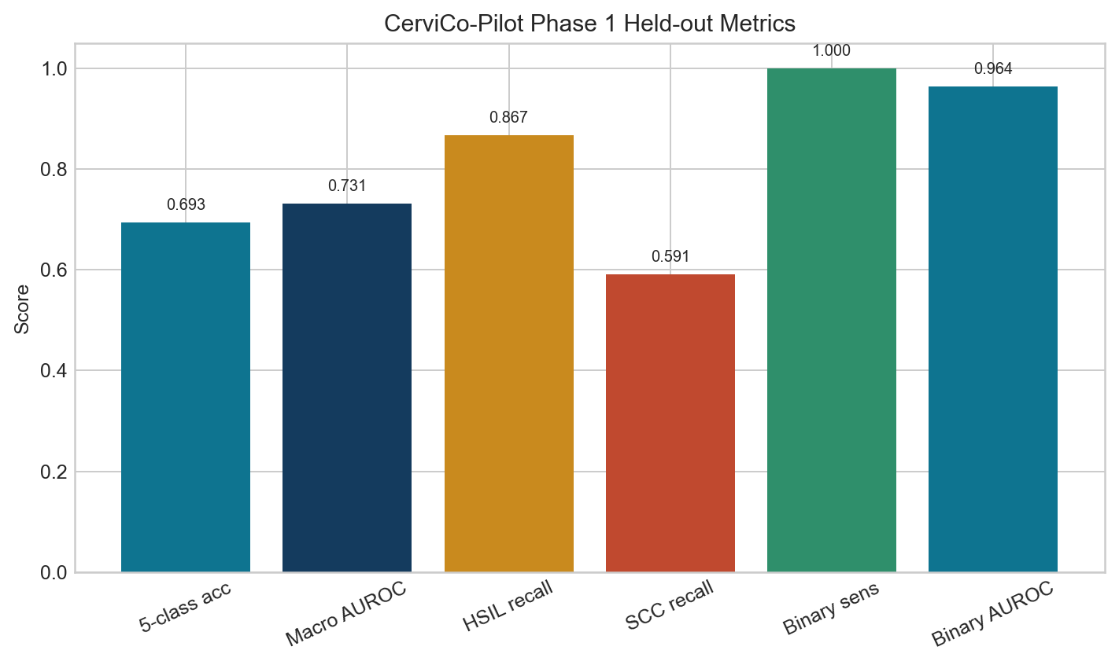 | 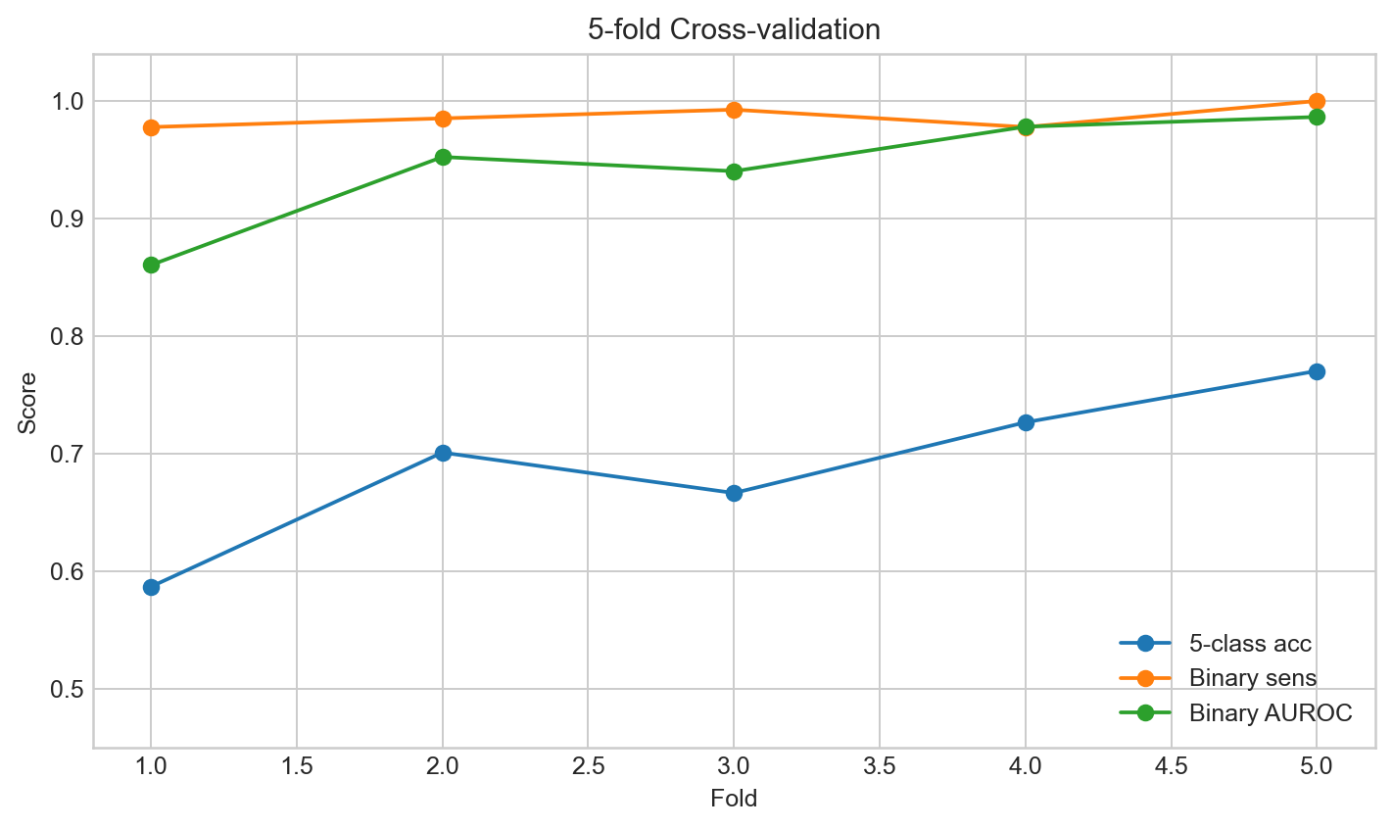
Figure 2. Held-out headline metrics. | Figure 3. Five-fold cross-validation.

The two output layers served different purposes. Five-class grading preserved cytology detail but remained moderate, while binary triage achieved high sensitivity. The binary result should therefore be interpreted as a safety view rather than a replacement for the five-class objective.

CHAPTER 4
RESULTS AND DISCUSSION (CONTINUED)
4.2 Class-Specific Error Analysis
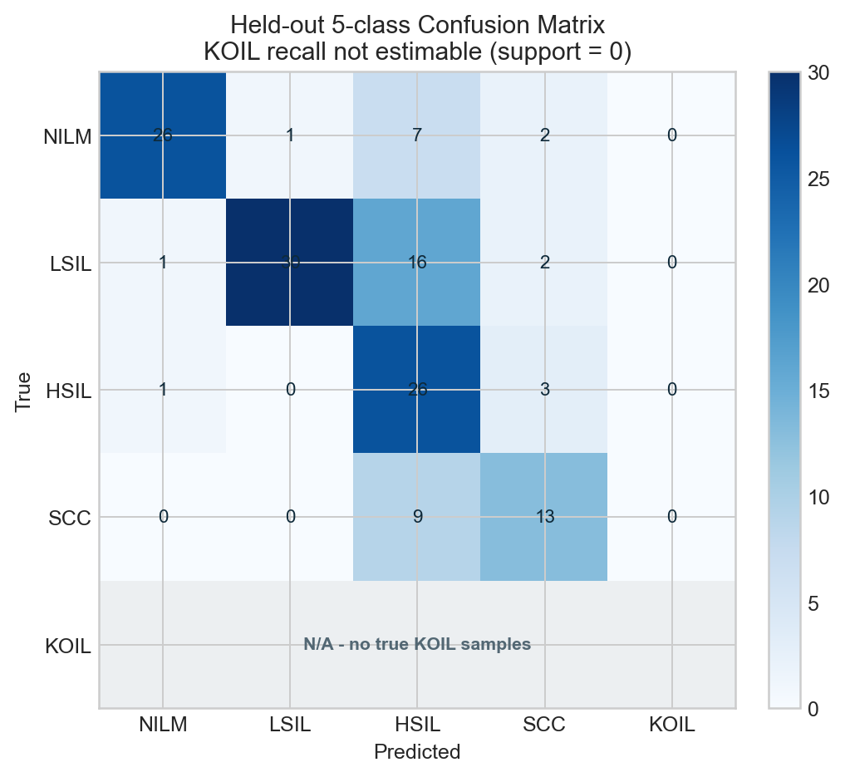
Figure 4. Five-class output-space confusion matrix on the held-out test set; KOIL recall is not estimable because support is zero.
Table 5. Held-out per-class recall and limitations.
Class | Support | Recall | Interpretation
NILM | 36 | 0.7222 | False positives reduce specificity
LSIL | 49 | 0.6122 | Overlap with higher-grade morphology
HSIL | 30 | 0.8667 | Strongest high-grade recall
SCC | 22 | 0.5909 | Requires improvement
KOIL | 0 | N/A | Not estimable; no true KOIL support

The absence of true KOIL examples is an evidence gap, not a successful negative result. KOIL is retained only as a future target and interface placeholder. SCC recall also remains insufficient for autonomous grading.

CHAPTER 4
RESULTS AND DISCUSSION (CONTINUED)
4.3 Calibration, Explainability, and System Interpretation
Table 6. Held-out calibration before and after temperature scaling.
Measure | Before | After
Multiclass ECE | 0.066853 | 0.038670
Binary ECE | 0.090679 | 0.073787
Binary Brier score | 0.071015 | 0.066994
Binary AUROC | 0.963971 | 0.963421

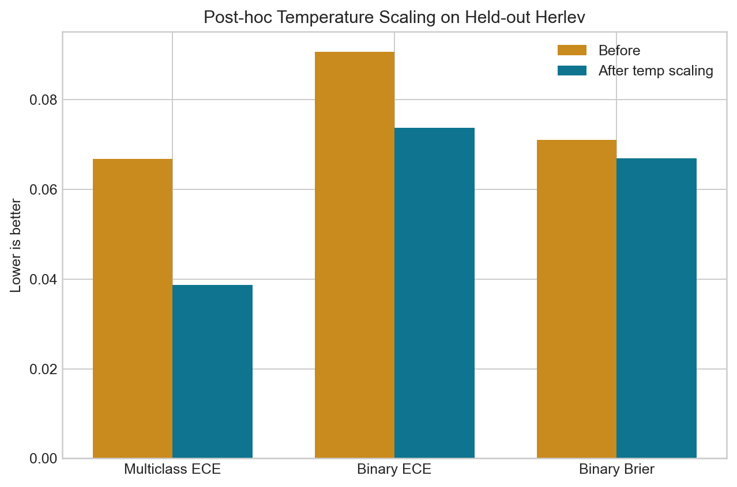 | 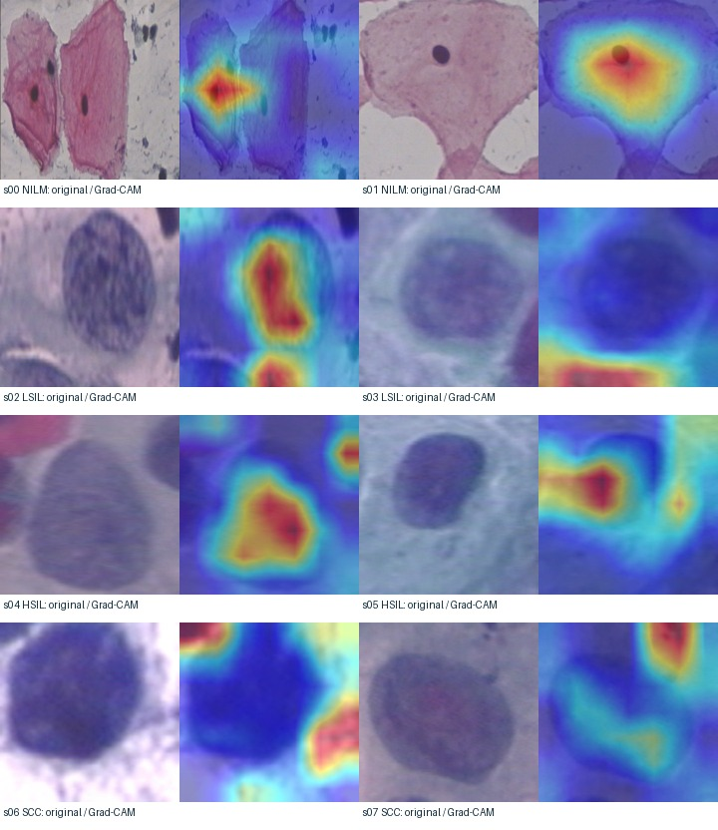
Figure 5. Calibration comparison. | Figure 6. Cytology and Grad-CAM examples.

Temperature scaling improved held-out ECE and Brier score while leaving discrimination nearly unchanged, consistent with post-hoc calibration [9]. However, calibration remains domain-dependent and cannot be extended to Thai ThinPrep images without external evidence.
The prototype's contribution is the integration of evaluation and review workflow: Grad-CAM can be challenged, uncertainty can trigger abstention, and patient communication is gated by clinician action. This aligns with human-AI interaction and transparent-reporting principles [10-12]. Dataset shift remains the principal translation risk [13].
Required next evidence Thai ThinPrep external validation, paired HPV endpoints, pathologist error review, an unaided-versus-AI-assisted reader study, and a prospective workflow pilot.

CHAPTER 5
CONCLUSION
5.1 Conclusion
CerviCo-Pilot demonstrates an end-to-end, explainable, and uncertainty-aware cervical cytology screening-support prototype. On real Herlev images, binary triage achieved held-out sensitivity of 1.000 and AUROC of 0.964, while five-class grading achieved accuracy of 0.6934 and macro AUROC of 0.7311. These results support continued research but do not justify autonomous diagnosis or deployment.
The main contribution is the system design: detailed cytology output is preserved, a binary view emphasizes screening safety, Grad-CAM supports visual review, uncertainty enables abstention, and clinician sign-off controls patient-facing communication. The system can operate locally and presents its limitations alongside its predictions.
5.2 Limitations
- Evidence is restricted to a small public single-cell dataset.
- No Thai ThinPrep/LBC external validation or paired molecular HPV endpoint is available.
- KOIL has no true support, and SCC recall remains limited.
- Grad-CAM, uncertainty, and report wording have not been evaluated in a clinical reader study.
- The web audit and report export remain research-demo components.
5.3 Future Work
The next phase will collect de-identified Thai ThinPrep/LBC images under ethics and data-governance approval, lock an external test set, add paired HPV labels, perform pathologist-reviewed error analysis, and conduct a reader study. A prospective pilot should measure review time, notification time, follow-up completion, and automation bias.
5.4 Research Integrity Statement
All performance values were copied from canonical project evaluation files for the shipped EfficientNet-B0 checkpoint. External sources support background and methods only; they do not create CerviCo-Pilot performance evidence.

REFERENCES
[1] World Health Organization, Cervical cancer, WHO Fact Sheet, 2026. Available: https://www.who.int/news-room/fact-sheets/detail/cervical-cancer.
[2] World Health Organization, Global Strategy to Accelerate the Elimination of Cervical Cancer as a Public Health Problem, WHO, 2020.
[3] Centers for Disease Control and Prevention, Screening for Cervical Cancer, CDC, 2025. Available: https://www.cdc.gov/cervical-cancer/screening/.
[4] R. Nayar and D. C. Wilbur, Eds., The Bethesda System for Reporting Cervical Cytology, 3rd ed., Springer, 2015.
[5] J. Jantzen, J. Norup, G. Dounias, and B. Bjerregaard, Pap-smear benchmark data for pattern classification, NiSIS 2005, 2005.
[6] M. Tan and Q. V. Le, EfficientNet: Rethinking model scaling for convolutional neural networks, Proc. ICML, 2019, pp. 6105-6114.
[7] R. R. Selvaraju et al., Grad-CAM: Visual explanations from deep networks via gradient-based localization, Proc. ICCV, 2017, pp. 618-626.
[8] Y. Gal and Z. Ghahramani, Dropout as a Bayesian approximation: Representing model uncertainty in deep learning, Proc. ICML, 2016, pp. 1050-1059.
[9] C. Guo, G. Pleiss, Y. Sun, and K. Q. Weinberger, On calibration of modern neural networks, Proc. ICML, 2017, pp. 1321-1330.
[10] U.S. FDA, Health Canada, and MHRA, Good Machine Learning Practice for Medical Device Development: Guiding Principles, 2021.
[11] X. Liu et al., Reporting guidelines for clinical trial reports for interventions involving artificial intelligence: the CONSORT-AI extension, Nature Medicine, vol. 26, pp. 1364-1374, 2020.
[12] B. Vasey et al., Reporting guideline for the early-stage clinical evaluation of decision support systems driven by artificial intelligence: DECIDE-AI, Nature Medicine, vol. 28, pp. 924-933, 2022.
[13] S. G. Finlayson et al., The clinician and dataset shift in artificial intelligence, New England Journal of Medicine, vol. 385, pp. 283-286, 2021.

