WORLD SCIENCE, ENVIRONMENT AND ENGINEERING COMPETITION 2026
FULL PAPER
DEVELOPMENT OF AN EXPLAINABLE AND UNCERTAINTY-AWARE AI SYSTEM FOR CERVICAL CELL ABNORMALITY SCREENING AND HPV-RELATED MORPHOLOGY RISK ASSESSMENT FROM THINPREP-STYLE IMAGES
INSERT
INSTITUTION LOGO
COMPILED BY
AUTHOR 1: ______________________________
AUTHOR 2: ______________________________
AUTHOR 3: ______________________________
AUTHOR 4: ______________________________
AUTHOR 5: ______________________________
AUTHOR 6: ______________________________
INSTITUTION | ______________________________
CATEGORY | TECHNOLOGY
YEAR | 2026

TABLE OF CONTENTS
This table follows the final Word/PDF pagination of the polished submission version.
Abstract | 3
Chapter 1 - Introduction | 4
Chapter 2 - Literature Review | 5
Chapter 3 - Research Method | 6
Chapter 4 - Results and Discussion | 8
Chapter 5 - Conclusion | 11
References | 12
Submission format English; A4; Arial 12 pt; single spacing; justified; margins 4/3/3/3 cm; PDF and Microsoft Word.

ABSTRACT
Cervical cancer is largely preventable when screening, interpretation, communication, and follow-up operate as a continuous pathway. This study developed CerviCo-Pilot, an explainable and uncertainty-aware research prototype for clinician-in-the-loop cervical cytology screening support. The system separates a four-class cytology-grade output (NILM, LSIL, HSIL, and SCC) from an independent koilocytosis-morphology endpoint, and adds a binary normal/abnormal safety-triage view, Grad-CAM visual review support, Monte Carlo Dropout uncertainty, and a report lock that requires clinician sign-off before patient-facing communication. An EfficientNet-B0 grade model was trained and evaluated using 917 real images from the public Herlev cervical cytology dataset; segmentation masks were excluded from performance evidence. On the held-out test set (n=137), the legacy five-output evaluation had accuracy 0.6934, macro F1 0.5545, macro AUROC was 0.7311, and quadratic weighted kappa was 0.687. The binary safety-triage view achieved sensitivity 1.000, specificity 0.7222, AUROC 0.964, AUPRC 0.9856, and a confusion matrix of TP=101, TN=26, FP=10, and FN=0. Five-fold cross-validation produced binary sensitivity of 0.9867 +/- 0.0086 and AUROC of 0.9435 +/- 0.0448. Post-hoc temperature scaling improved held-out calibration metrics without materially changing discrimination. For the separate KOIL endpoint, EfficientNet-B0 was trained on all 4,049 official SIPaKMeD cropped cells using source-cluster-disjoint splits. On the locked test set (641 cells; 133 KOIL-positive), sensitivity was 0.9624, specificity 0.9764, AUROC 0.9912, AUPRC 0.9810, and ECE 0.0134; cluster-bootstrap 95% confidence intervals were 0.9167-0.9921 for sensitivity and 0.9583-0.9916 for specificity. The prototype demonstrates a complete review workflow rather than an autonomous diagnostic device. Herlev and SIPaKMeD are public conventional cytology domains; the system does not replace molecular HPV testing, and Thai ThinPrep validation, paired HPV endpoints, reader studies, and prospective evaluation remain necessary before clinical use.
Keywords: cervical cytology, explainable artificial intelligence, uncertainty-aware triage, Grad-CAM, clinician-in-the-loop, ThinPrep, koilocytosis
Evidence boundary Grade and triage evidence comes from Herlev; KOIL morphology evidence comes from SIPaKMeD conventional Pap-smear crops. Neither is Thai ThinPrep validation or molecular HPV testing.

CHAPTER 1
INTRODUCTION
1.1 Research Background
Cervical cancer remains an important public-health problem, yet it can be prevented or treated early when vaccination, screening, diagnosis, and follow-up are connected [1,2]. Cytology-based screening, including Pap and liquid-based preparations such as ThinPrep, examines cellular morphology, while HPV molecular testing detects viral material; the two modalities must not be described as interchangeable [3,4].
The practical gap is not limited to image classification. Screening programs also depend on timely review, understandable communication, and reliable referral. In settings with limited cytology expertise, a compact offline decision-support tool may help prioritize abnormal images, expose the image regions that influenced a prediction, and return uncertain cases to human review.
1.2 Problem Statement
Many image classifiers provide only a label and confidence score. Such output is insufficient for a safety-sensitive workflow because confidence may be miscalibrated, explanations may be over-trusted, and patient-facing communication may be released without appropriate review. A useful prototype should combine grading, triage, explainability, uncertainty, and explicit clinician control.
1.3 Research Objectives
- Develop a four-class Bethesda-style cervical cytology grading model.
- Develop a separate koilocytosis-morphology endpoint without treating KOIL as a Bethesda grade.
- Add a high-sensitivity binary safety-triage view without replacing the grade output.
- Provide Grad-CAM review support and uncertainty-aware abstention.
- Demonstrate clinician sign-off, report locking, and offline operation.
- Define a validation pathway for Thai ThinPrep images and paired HPV endpoints.
1.4 Significance
The project contributes an integrated medical-AI workflow rather than an isolated classifier. It emphasizes reviewability, conservative communication, reproducible metrics, and explicit boundaries between current evidence and future clinical validation.

CHAPTER 2
LITERATURE REVIEW
2.1 Cervical Cytology and the Bethesda Framework
The Bethesda System standardizes cervical cytology terminology and distinguishes negative findings from low-grade, high-grade, and malignant squamous abnormalities [4]. Preserving multiple classes supports clinical communication, whereas a secondary binary view is useful for screening-safety analysis.
2.2 Image Classification and Explainability
The Herlev benchmark contains 917 single-cell cervical cytology images [5]. SIPaKMeD provides 4,049 cropped cells from 966 source cluster images across five morphology classes, including 825 koilocytotic cells [14]. EfficientNet provides an efficient scaling strategy for offline image models [6]. Grad-CAM localizes regions associated with a class score [7], but it remains a review aid rather than causal proof.
2.3 Uncertainty, Calibration, and Governance
Monte Carlo Dropout provides an approximate uncertainty signal [8], while temperature scaling can improve probability calibration without changing class ordering [9]. Medical-AI guidance emphasizes representative data, human-AI interaction, lifecycle monitoring, and transparent reporting [10-12]. Dataset shift remains a major risk when moving from a public benchmark to a different population, preparation method, microscope, or camera [13].
Table 1. Design principles derived from the literature.
Principle | System implementation | Boundary
Structured cytology | Four-class Bethesda-style grade | Not a final cytology report
KOIL morphology | Independent one-vs-rest endpoint | Not HPV DNA/RNA status
Screening safety | Binary normal/abnormal triage | Not the sole product output
Explainability | Grad-CAM heatmap | Review aid, not causal proof
Uncertainty | MC Dropout and abstention | Requires external validation
Governance | Clinician sign-off and report lock | Demo workflow only

CHAPTER 3
RESEARCH METHOD
3.1 Study Design and Dataset
This retrospective model-development and prototype-integration study used two public datasets. Grade and binary-triage evidence used 917 real Herlev images [5], with segmentation masks and synthetic experiments excluded. The independent KOIL endpoint used all 4,049 official SIPaKMeD cropped cells from 966 source clusters [14].
Table 2. Dataset and model card summary.
Item | Specification
Grade/triage dataset | Herlev: 917 real images; masks excluded
KOIL dataset | SIPaKMeD: 4,049 cells from 966 source clusters
Architecture | EfficientNet-B0 with ImageNet transfer learning
Grade output | NILM, LSIL, HSIL, SCC
KOIL output | Independent koilocytosis morphology probability
Evidence status | Internal public-dataset validation; no Thai ThinPrep evidence

3.2 End-to-End Workflow
The workflow accepts a cytology image, returns four grade probabilities, binary triage, and an independent KOIL morphology assessment. Grade and KOIL use class-specific Grad-CAM review. Uncertainty and image-quality gates route unsafe cases to clinician confirmation, correction, or rejection; patient-facing output remains locked until all gates pass.
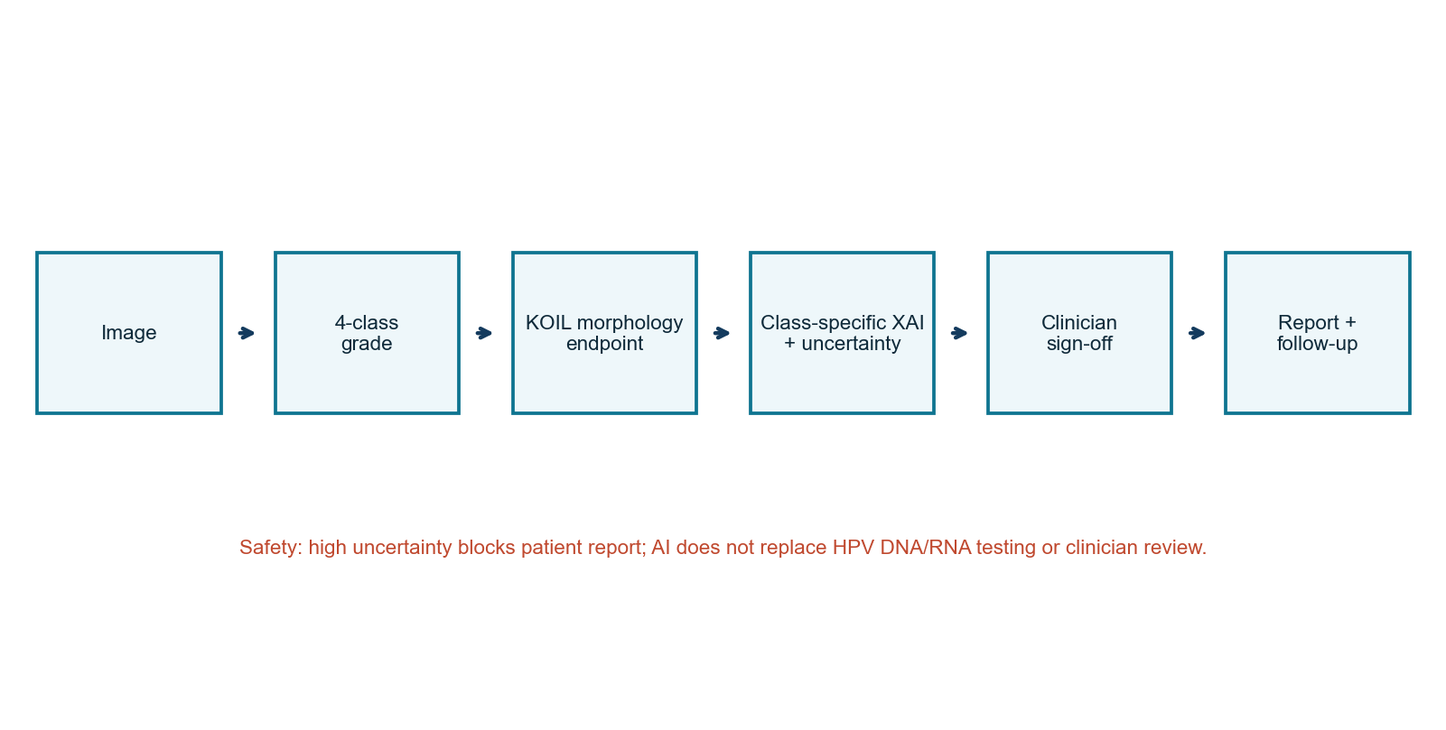
Figure 1. CerviCo-Pilot clinician-in-the-loop workflow.

CHAPTER 3
RESEARCH METHOD (CONTINUED)
3.3 Model Development and Evaluation
Images were resized for EfficientNet-B0 input and processed through canonical pipelines. Herlev grade/triage metrics were reproduced from models/best_cervical.pt. For SIPaKMeD, source clusters were split before training (676/145/145 clusters for train/validation/test), preventing cropped cells from the same cluster crossing splits. Model selection, temperature scaling, and a sensitivity-constrained KOIL threshold were fixed on validation data before one-time test evaluation.
Table 3. Reproducible evaluation specification.
Component | Specification | Purpose
Held-out evaluation | n=137; TTA enabled | Primary test evidence
KOIL locked test | 641 cells; 145 clusters | Independent endpoint evidence
Bootstrap | 2,000 percentile resamples | Confidence intervals
Cross-validation | Five folds; mean +/- SD | Split robustness
Binary threshold | 0.50 | Normal/abnormal triage
Calibration | Temperature=0.794103 | Post-hoc probability scaling
KOIL calibration | Temperature=0.838126 | Validation-fit; test locked
Explainability | Grad-CAM | Visual review support
Uncertainty | MC Dropout | Abstention signal

3.4 Metrics and Safety Policy
Legacy grade evaluation included accuracy, macro F1, macro AUROC, per-class recall, and quadratic weighted kappa. Binary triage and KOIL one-vs-rest evaluation included sensitivity, specificity, AUROC, AUPRC, precision, F1, and confusion counts. KOIL confidence intervals used 2,000 source-cluster bootstrap resamples. Calibration used ECE and Brier score. High uncertainty triggers abstention and blocks patient-report release.
3.5 Prototype System
The React/FastAPI prototype supports sample review, image upload, separate grade and KOIL probabilities, class-specific Grad-CAM, confirm/edit/reject actions, report export, and an audit demonstration. It is intended for supervised research demonstration and does not satisfy regulated clinical deployment requirements.
Do-not-use boundary No autonomous diagnosis, molecular HPV status, unsupervised patient release, or Thai-domain performance claim.

CHAPTER 4
RESULTS AND DISCUSSION
4.1 Primary Quantitative Results
Table 4. Held-out and cross-validation results.
Measure | Result | Interpretation
Legacy five-output accuracy | 0.6934 | KOIL unsupported in Herlev
Legacy macro F1 / AUROC | 0.5545 / 0.7311 | Includes unsupported KOIL output
Quadratic weighted kappa | 0.687 | Severity agreement
Binary sensitivity / specificity | 1.000 / 0.7222 | FN=0; some over-referral
Binary AUROC / AUPRC | 0.964 / 0.9856 | Strong Herlev triage
Five-fold sensitivity | 0.9867 +/- 0.0086 | High across folds
Five-fold AUROC | 0.9435 +/- 0.0448 | Within-domain robustness

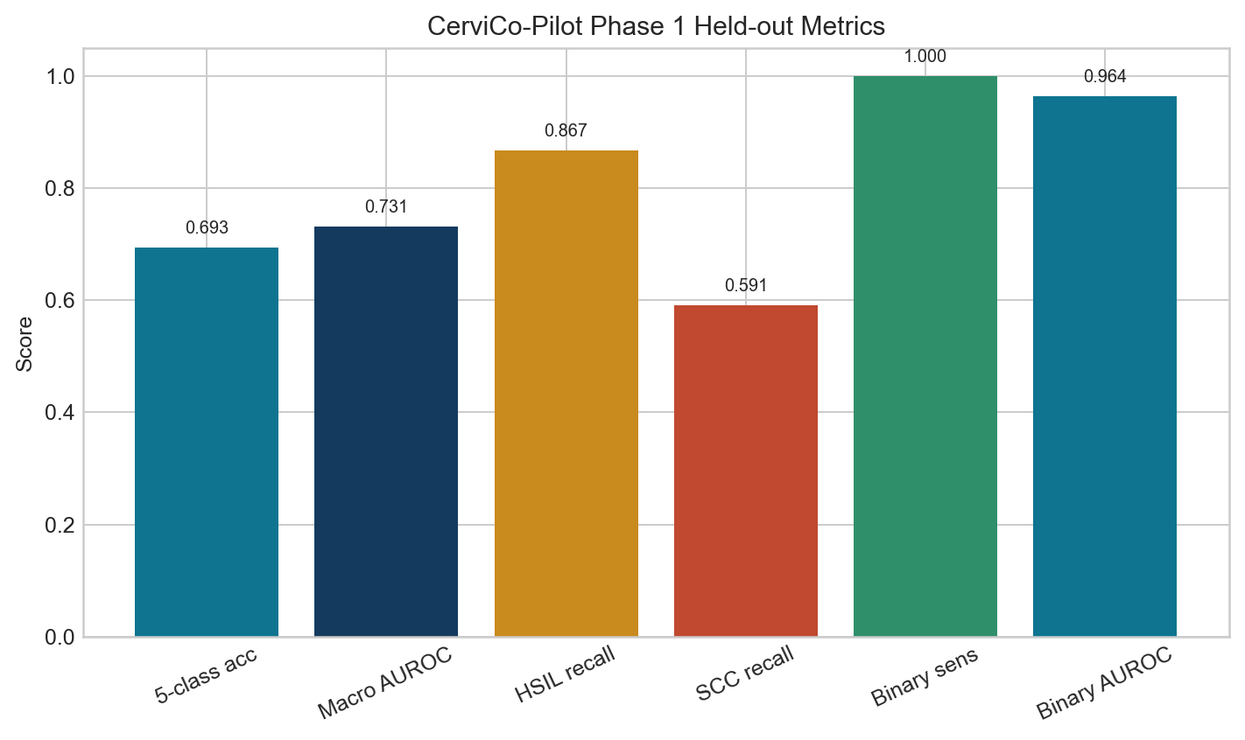 | 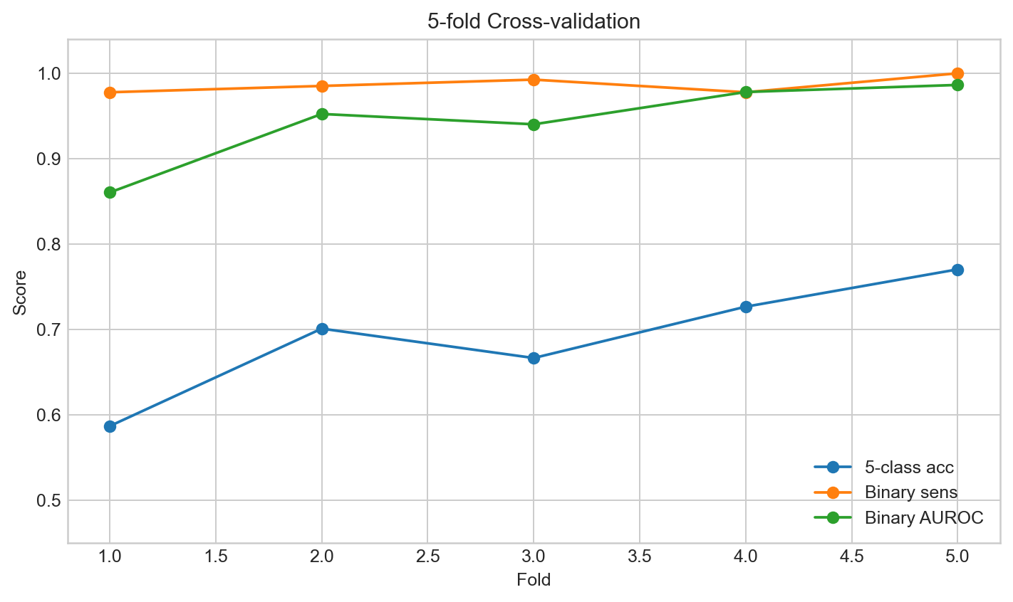
Figure 2. Held-out headline metrics. | Figure 3. Five-fold cross-validation.

The historical checkpoint used a five-output head, but Herlev contained no true KOIL support; the deployed interface therefore exposes only four grade classes and obtains KOIL morphology from the separate SIPaKMeD model. Binary triage achieved high sensitivity and remains a safety view rather than a replacement for detailed grade review.

CHAPTER 4
RESULTS AND DISCUSSION (CONTINUED)
4.2 Grade Error Analysis
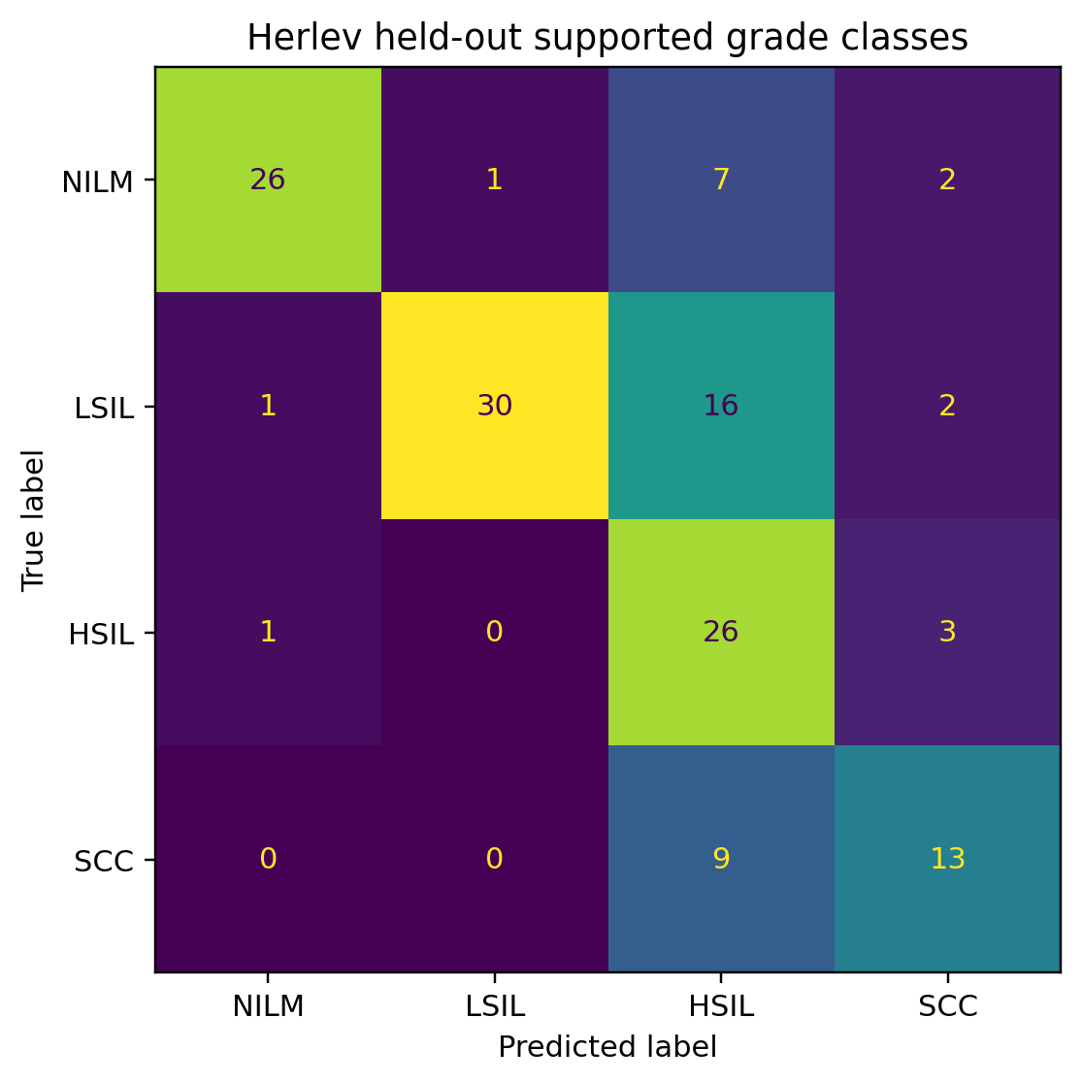
Figure 4. Herlev confusion matrix for the four supported grade classes.
Table 5. Herlev held-out per-class recall.
Class | Support | Recall | Interpretation
NILM | 36 | 0.7222 | False positives reduce specificity
LSIL | 49 | 0.6122 | Overlap with higher-grade morphology
HSIL | 30 | 0.8667 | Strongest high-grade recall
SCC | 22 | 0.5909 | Requires improvement

4.3 Independent KOIL Morphology Endpoint
Table 6. Locked SIPaKMeD KOIL one-vs-rest test results.
Measure | Result | Cluster-bootstrap 95% CI
Support | 133 positive / 508 negative | 145 source clusters
Sensitivity / specificity | 0.9624 / 0.9764 | 0.9167-0.9921 / 0.9583-0.9916
Precision / F1 | 0.9143 / 0.9377 | 0.8291-0.9702 / 0.8811-0.9706
AUROC / AUPRC | 0.9912 / 0.9810 | 0.9786-0.9984 / 0.9506-0.9951

At the validation-locked threshold of 0.3367, the model produced 128 TP, 496 TN, 12 FP, and 5 FN cells. False positives were limited to dyskeratotic (n=9) and metaplastic (n=3) morphology; each false negative came from a different source cluster. These errors require expert review and do not represent HPV test errors.

CHAPTER 4
RESULTS AND DISCUSSION (CONTINUED)
4.4 Calibration, Explainability, and System Interpretation
Table 7. Held-out calibration evidence.
Endpoint / measure | Before | After
Multiclass ECE | 0.066853 | 0.038670
Binary ECE | 0.090679 | 0.073787
Binary Brier score | 0.071015 | 0.066994
KOIL ECE | Not reported | 0.013385
KOIL Brier score | Not reported | 0.019025

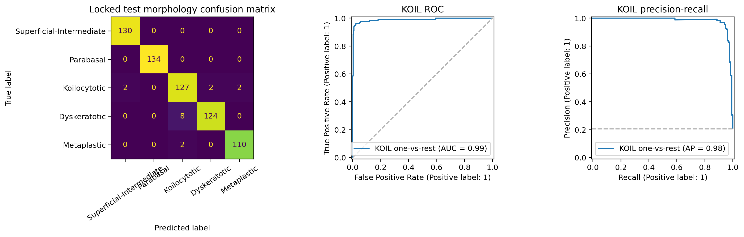
Figure 5. SIPaKMeD morphology confusion matrix and locked-test KOIL ROC/precision-recall curves.
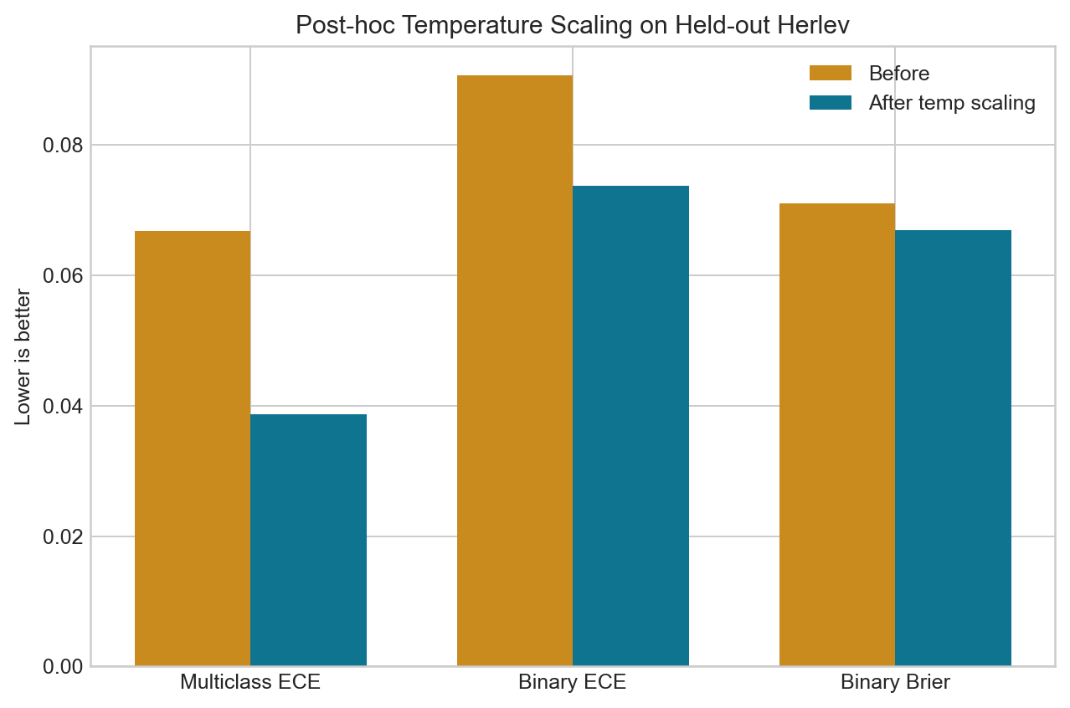 | 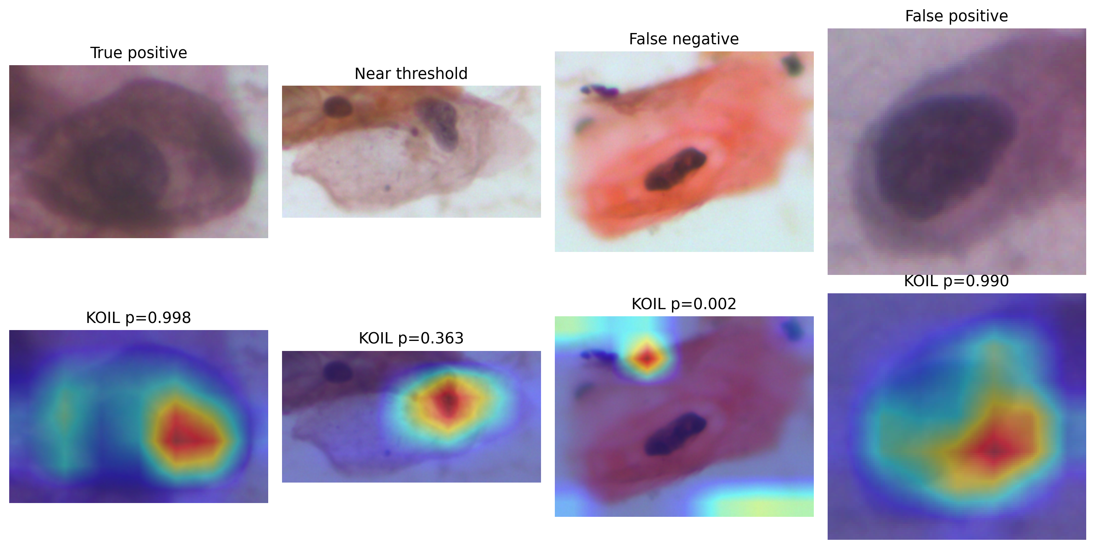
Figure 6. Herlev calibration. | Figure 7. KOIL-specific Grad-CAM audit cases.

Temperature scaling improved calibration without changing class ordering [9]. KOIL Grad-CAM was generated for the independent endpoint and is presented as attention evidence, not segmentation or causal proof. Calibration and attribution remain domain-dependent and cannot be extended to Thai ThinPrep images without external evidence.
The prototype integrates evaluation and review: explanations can be challenged, uncertainty can trigger abstention, and patient communication is gated by clinician action [10-12]. Dataset shift remains the principal translation risk [13].
Required next evidence Thai ThinPrep external validation, paired HPV endpoints, pathologist error review, an unaided-versus-AI-assisted reader study, and a prospective workflow pilot.

CHAPTER 5
CONCLUSION
5.1 Conclusion
CerviCo-Pilot demonstrates an end-to-end, explainable, and uncertainty-aware cervical cytology screening-support prototype. On Herlev, binary triage achieved held-out sensitivity 1.000 and AUROC 0.964, while the legacy five-output grade evaluation achieved accuracy 0.6934. On the separate locked SIPaKMeD test set, KOIL morphology sensitivity was 0.9624 and AUROC 0.9912. These within-dataset results support continued research but do not justify autonomous diagnosis or deployment.
The main contribution is the system design: detailed cytology output is preserved, a binary view emphasizes screening safety, Grad-CAM supports visual review, uncertainty enables abstention, and clinician sign-off controls patient-facing communication. The system can operate locally and presents its limitations alongside its predictions.
5.2 Limitations
- Evidence is restricted to two public single-cell conventional cytology datasets.
- No Thai ThinPrep/LBC external validation or paired molecular HPV endpoint is available.
- KOIL morphology is internally validated on SIPaKMeD only; SCC grade recall remains limited.
- Grad-CAM, uncertainty, and report wording have not been evaluated in a clinical reader study.
- The web audit and report export remain research-demo components.
5.3 Future Work
The next phase will collect de-identified Thai ThinPrep/LBC images under ethics and data-governance approval, lock an external test set, add paired HPV labels, perform pathologist-reviewed error analysis, and conduct a reader study. A prospective pilot should measure review time, notification time, follow-up completion, and automation bias.
5.4 Research Integrity Statement
All performance values were copied from canonical evaluation files for the shipped Herlev grade/triage and SIPaKMeD KOIL checkpoints. External sources support background and methods only; they do not create CerviCo-Pilot performance evidence.

REFERENCES
[1] World Health Organization, Cervical cancer, WHO Fact Sheet, 2026. Available: https://www.who.int/news-room/fact-sheets/detail/cervical-cancer.
[2] World Health Organization, Global Strategy to Accelerate the Elimination of Cervical Cancer as a Public Health Problem, WHO, 2020.
[3] Centers for Disease Control and Prevention, Screening for Cervical Cancer, CDC, 2025. Available: https://www.cdc.gov/cervical-cancer/screening/.
[4] R. Nayar and D. C. Wilbur, Eds., The Bethesda System for Reporting Cervical Cytology, 3rd ed., Springer, 2015.
[5] J. Jantzen, J. Norup, G. Dounias, and B. Bjerregaard, Pap-smear benchmark data for pattern classification, NiSIS 2005, 2005.
[6] M. Tan and Q. V. Le, EfficientNet: Rethinking model scaling for convolutional neural networks, Proc. ICML, 2019, pp. 6105-6114.
[7] R. R. Selvaraju et al., Grad-CAM: Visual explanations from deep networks via gradient-based localization, Proc. ICCV, 2017, pp. 618-626.
[8] Y. Gal and Z. Ghahramani, Dropout as a Bayesian approximation: Representing model uncertainty in deep learning, Proc. ICML, 2016, pp. 1050-1059.
[9] C. Guo, G. Pleiss, Y. Sun, and K. Q. Weinberger, On calibration of modern neural networks, Proc. ICML, 2017, pp. 1321-1330.
[10] U.S. FDA, Health Canada, and MHRA, Good Machine Learning Practice for Medical Device Development: Guiding Principles, 2021.
[11] X. Liu et al., Reporting guidelines for clinical trial reports for interventions involving artificial intelligence: the CONSORT-AI extension, Nature Medicine, vol. 26, pp. 1364-1374, 2020.
[12] B. Vasey et al., Reporting guideline for the early-stage clinical evaluation of decision support systems driven by artificial intelligence: DECIDE-AI, Nature Medicine, vol. 28, pp. 924-933, 2022.
[13] S. G. Finlayson et al., The clinician and dataset shift in artificial intelligence, New England Journal of Medicine, vol. 385, pp. 283-286, 2021.
[14] M. E. Plissiti et al., SIPaKMeD: A new dataset for feature and image based classification of normal and pathological cervical cells in Pap smear images, Proc. IEEE ICIP, 2018, pp. 3144-3148.

