Lab 01: Behavior simulation with Vivado

Objectives
After completing this lab, you will be able to:
- Create a Vivado project sourcing HDL model(s) and targeting the Zynq Ultrascale+ devices located on the ZCU106 boards.
- Use the provided Xilinx Design Constraint (XDC) file to constrain the pin locations.
- Simulate the design using the Vivado simulator.

Steps
Create a Vivado Project
Launch Vivado and create an empty project targeting Zynq UltraScale+ ZCU106 Evaluation Platform, selecting Verilog as a target language. Use the provided lab1.v, and lab1_zcu106.xdc (for ZCU106) files.
1. Open Vivado by selecting Start > Xilinx Design Tools > Vivado 2021.2.
2. Click Create New Project to start the wizard. You will see Create A New Vivado Project dialog box. Click Next.
3. Click the Browse button of the Project location field of the New Project form, browse to your desired location.
4. Enter lab1 in the Project name field. Make sure that the Create Project Subdirectory box is checked. Click Next.
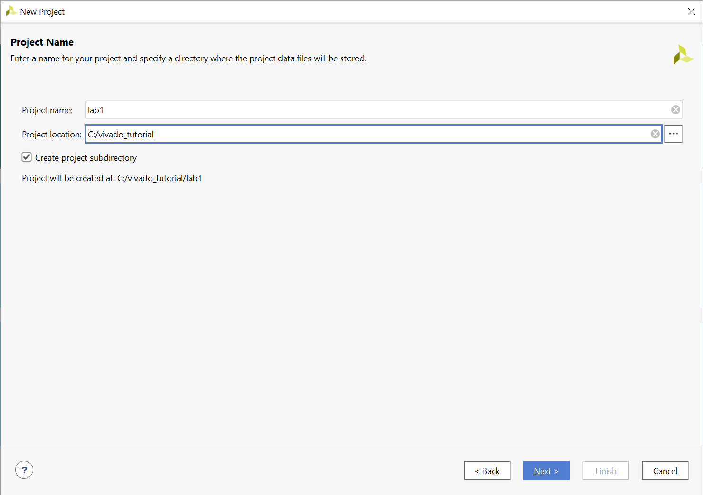
Figure 1 Project Name and Location entry
5. Select RTL Project option ONLY in the Project Type form, and click Next.
6. Using the drop-down buttons, select Verilog as the Target Language and Simulator Language in the Add Sources form.
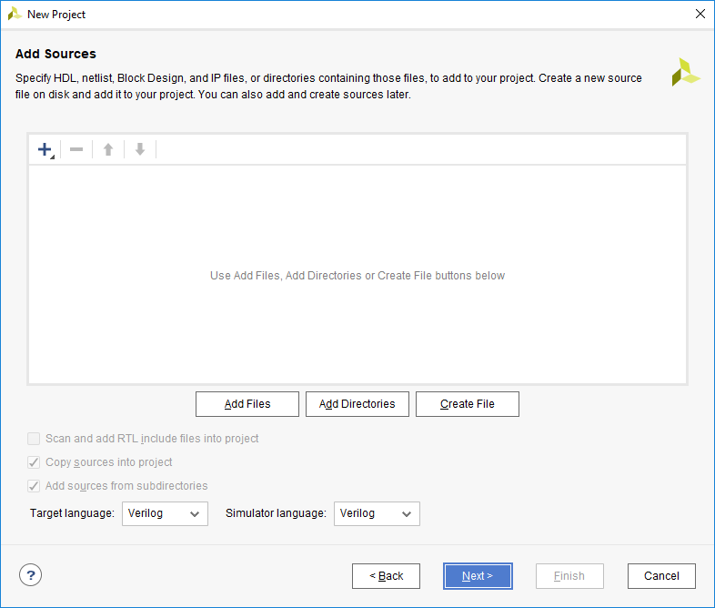
Figure 2 Selecting Target and Simulator language
7. Click on the Blue Plus button, then click Add Files… and browse to the source directory, select lab1.v, and click OK.
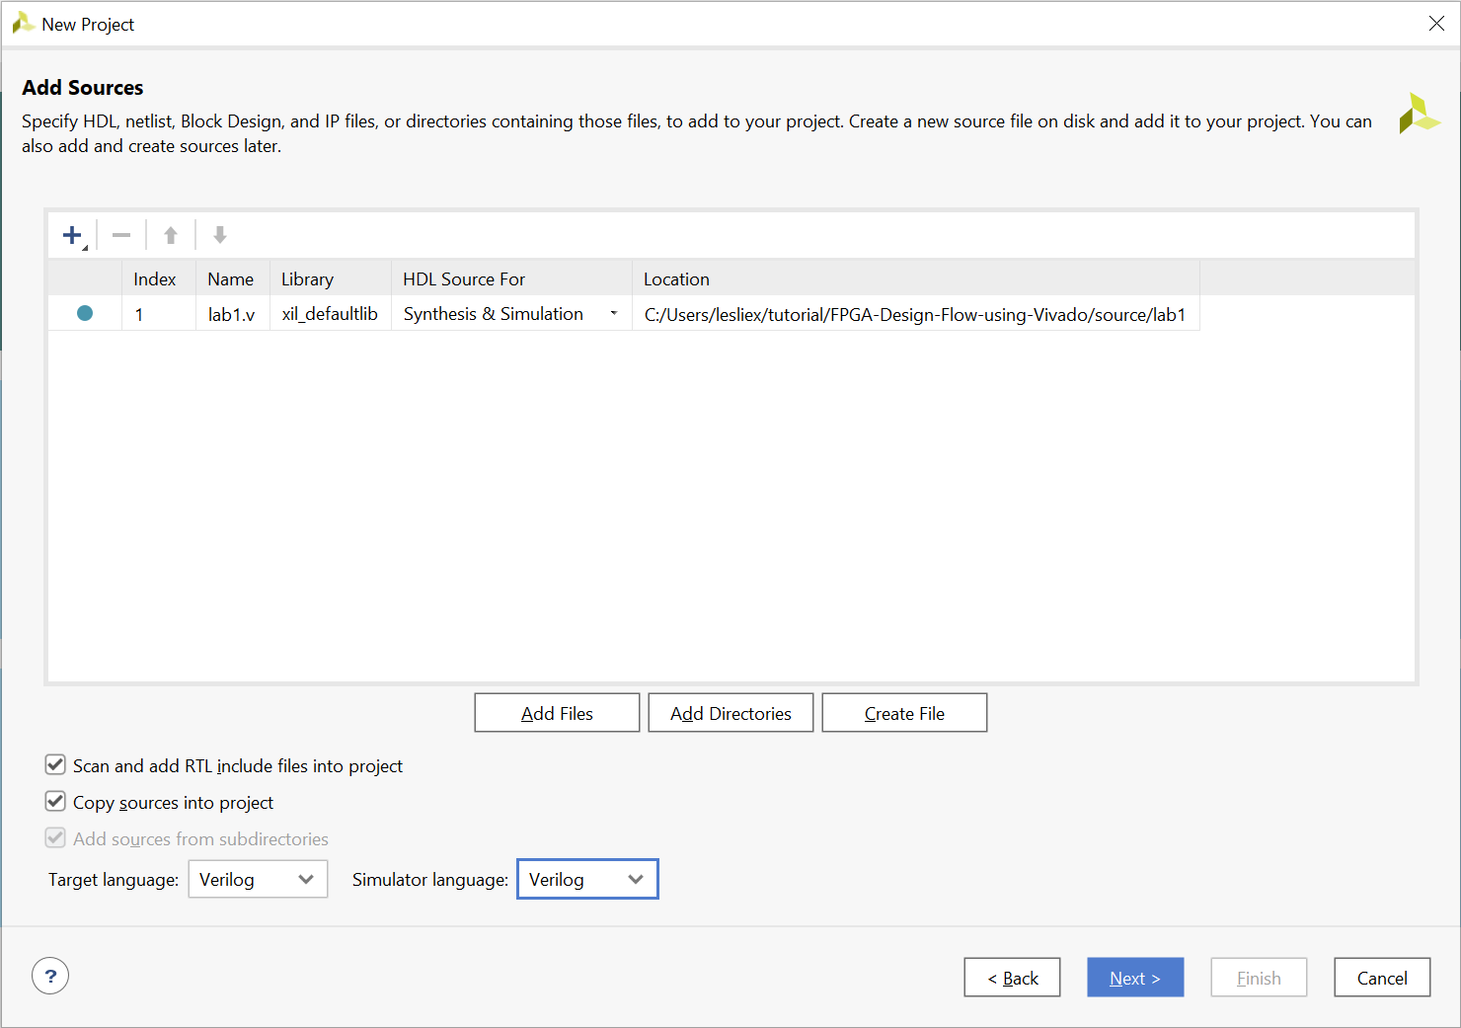
Figure 3 Adding source files
If it is not already checked, check Copy sources into project
8. Click Next to get to the Add Constraints form.
9. Click on the Blue Plus button, then click Add Files… and browse to the source directory, select lab1_zcu106.xdc and click OK (if necessary), and then click Next.
The Xilinx Design Constraints file assigns the physical IO locations on FPGA to the switches and LEDs located on the board. This information can be obtained either through the board’s schematic or the board’s user guide.
10. In the Boards tab and then select Zynq UltraScale+ ZCU106 Evaluation Platform
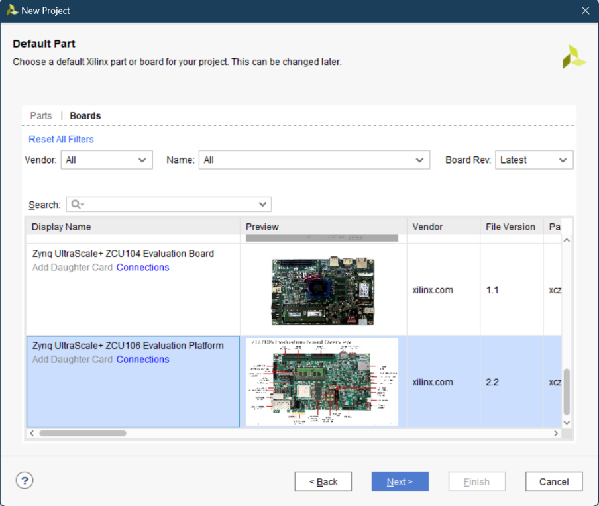
Figure 4 Boards Selection for the ZCU 106
Notice that ZCU106 Board may not be listed as they are not in the tools database. If not listed then you can download the board files for the desired boards from the respective board vendor webpage.
11. Click Next.
12. Click Finish to create the Vivado project.
Open the lab1.v source and analyze the content.
1. In the Sources pane, double-click the lab1.v entry to open the file in text mode.
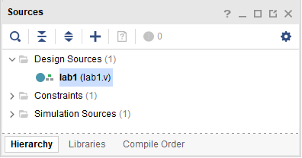
Figure 5 Opening the source file
2. Notice in the Verilog code that the first line defines the timescale directive for the simulator.
3. Line 27 defines the beginning (marked with keyword module) and Line 37 defines the end of the module (marked with keyword endmodule).
4. Line 28-29 defines the input and output ports whereas lines 32-35 defines the actual functionality.
Open the lab1 zcu106.xdc source and analyze the content.
1. In the Sources pane, expand the Constraints folder and double-click the lab1_zcu106.xdc entry to open the file in text mode.
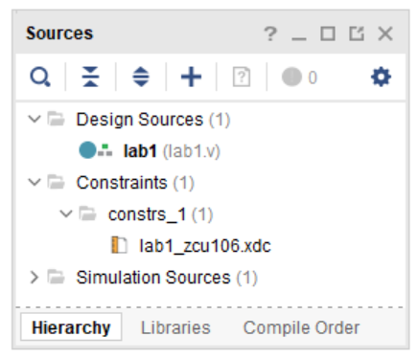
Figure 6 Opening the Constraint file
2. Lines 1-8 define the pin locations for the input buttons and lines 9-16 define pin locations for output LEDs.
Perform RTL analysis on the source file.
Expand the Open Elaborated Design entry under the RTL Analysis tasks of the Flow Navigator pane and click on Schematic.
The model (design) will be elaborated and a logic view of the design is displayed.
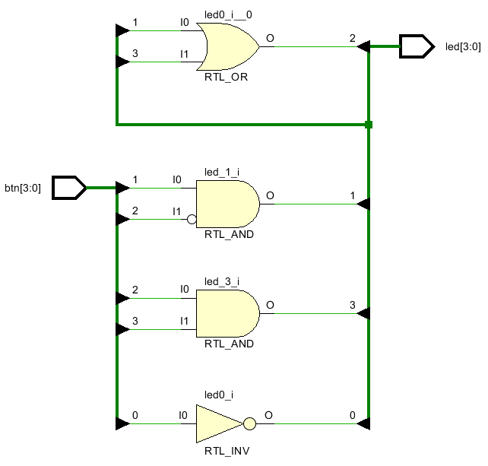
Figure 7 A Logic View of the Design
Simulate the Design using the Vivado Simulator
Add the lab1_tb.v testbench file.
1. Click Add Sources under the Project Manager tasks of the Flow Navigator pane.
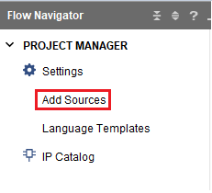
Figure 8 Add sources
2. Select the Add or Create Simulation Sources option and click Next.
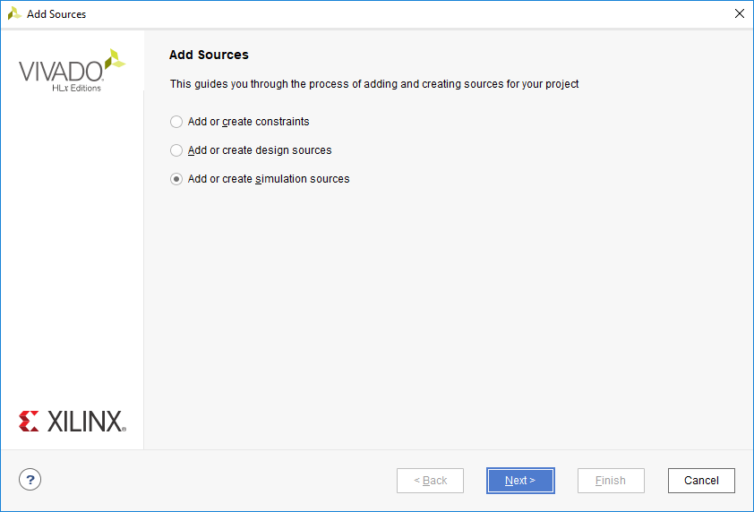
Figure 9 Selecting Simulation Sources option
3. In the Add Sources Files form, click the Blue Plus button and then then Add Files….
4. Browse to the lab1 folder and select lab1_tb.v and click OK.
5. Click Finish.
6. Select the Sources tab and expand the Simulation Sources group.
The lab1_tb.v file is added under the Simulation Sources group, and lab1.v is automatically placed in its hierarchy as a dut (device under test) instance.
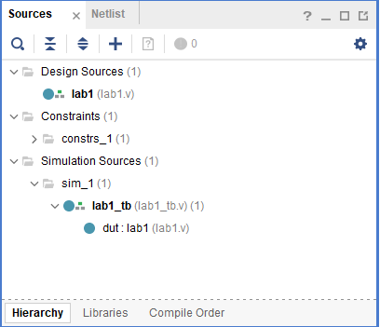
Figure 10 Simulation Sources Hierarchy
7. Using the Windows Explorer, verify that the sim_1 directory is created at the same level as constrs_1 and sources_1 directories under the lab1.srcs directory, and that a copy of lab1_tb.v is placed under lab1.srcs > sim_1 > imports > lab1.

8. Double-click on the lab1_tb in the Sources pane to view its contents. 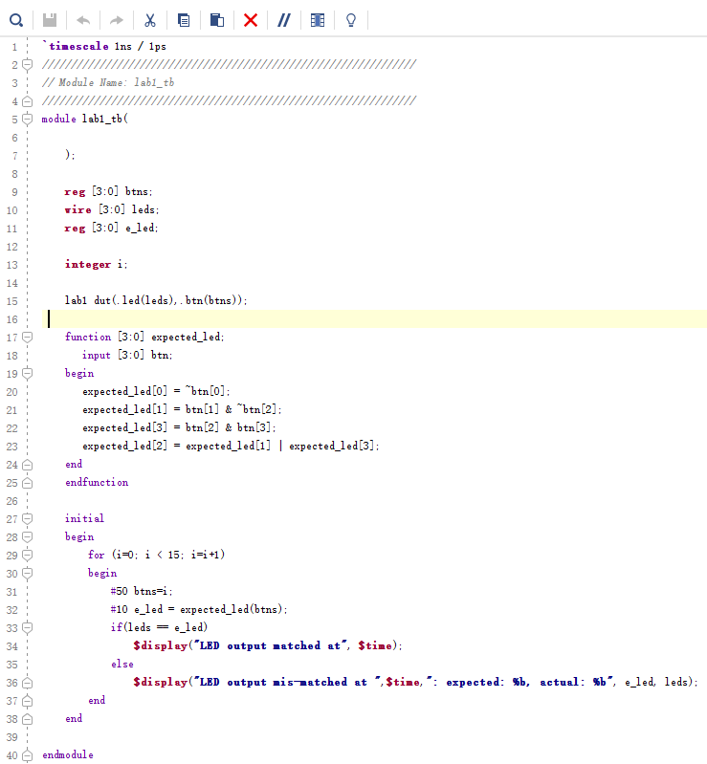
Figure 11 The self-checking test bench
The test bench defines the simulation step size and the resolution in line 1. The test bench module definition begins on line 5. Line 15 instantiates the DUT (device/module under test). Lines 17 through 25 define the same module functionality for the expected value computation. Lines 27 through 38 define the stimuli generation, and compare the expected output with what the DUT provides. Line 40 ends the test bench. The $display task will print the message in the simulator console window when the simulation is run.
Simulate the design for 200 ns using the Vivado simulator
1. Click Settings under the Project Manager tasks of the Flow Navigator pane.
A Settings form will appear showing the Simulation properties form.
2. Select the Simulation tab, and set the Simulation Run Time value to 200 ns and click OK.
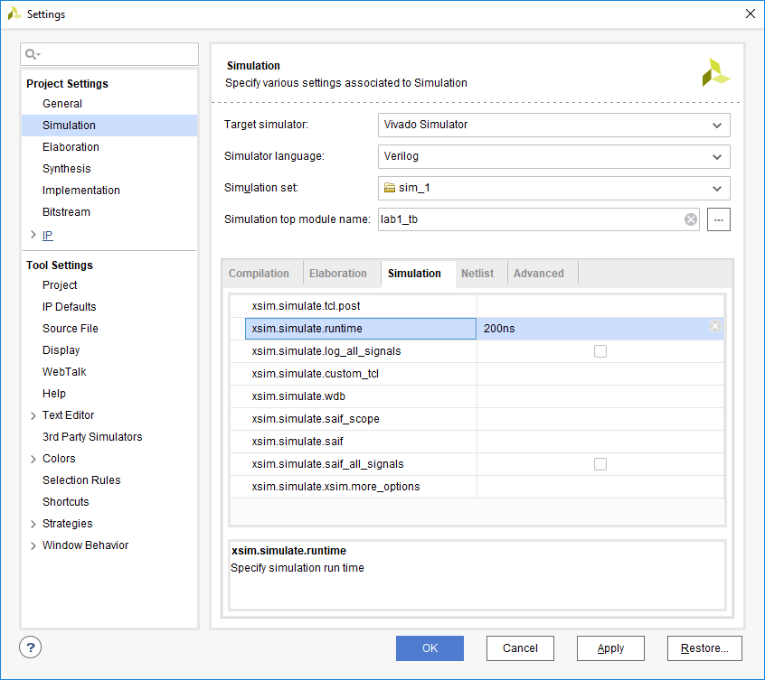
Figure 12 Setting simulation run time
3. Click on Simulation > Run Simulation > Run Behavioral Simulation under the Project Manager tasks of the Flow Navigator pane.
The testbench and source files will be compiled and the Vivado simulator will be run (assuming no errors). You will see a simulator output like the one shown below.
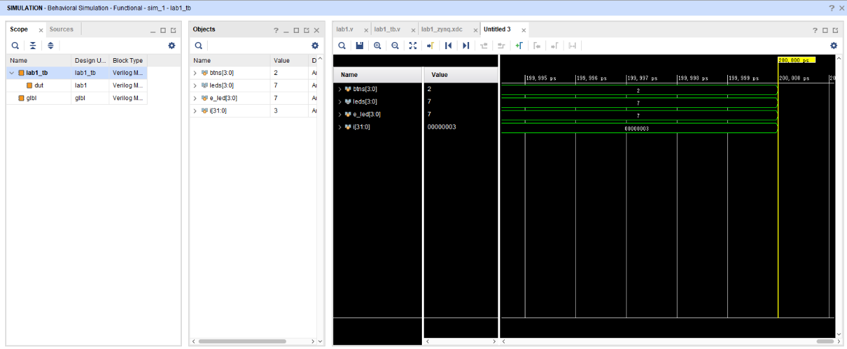
Figure 13 Simulator Output
You will see four main views: (i) Scopes, where the testbench hierarchy as well as glbl instances are displayed, (ii) Objects, where top-level signals are displayed, (iii) the waveform window, and (iv) Tcl Console where the simulation activities are displayed. Notice that since the testbench used is self-checking, the results are displayed as the simulation is run.
You will see several buttons next to the waveform window which can be used for the specific purpose as listed in the table below.
Figure 14 Various buttons available to view the waveform
4. Click on the Zoom Fit button () to see the entire waveform.
Notice that the output changes when the input changes.
Change display format if desired.
Select i[31:0] in the waveform window, right-click, select Radix, and then select Unsigned Decimal to view the for-loop index in an unsigned integer form. Similarly, change the radix of btn[3:0] to Hexadecimal. Leave the leds[3:0] and e_led[3:0] radix to binary as we want to see each output bit.
Add more signals to monitor the lower-level signals and continue to run the simulation for 500 ns.
1. Expand the lab1_tb instance, if necessary, in the Scopes window and select the dut instance.
The btn[3:0] and led[3:0] signals will be displayed in the Objects window.
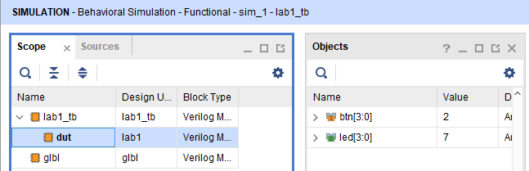
Figure 15 Selecting Lower-Level Signals
2. Select btn[3:0] and led[3:0] and drag them into the waveform window to monitor those lower-level signals.
3. On the simulator tool buttons ribbon bar , type 500 over in the simulation run time field, click on the drop-down button of the units field and select ns since we want to run for 500 ns (total of 700 ns), and click on the () button. The simulation will run for an additional 500 ns.
4. Click on the Zoom Fit button and observe the output.
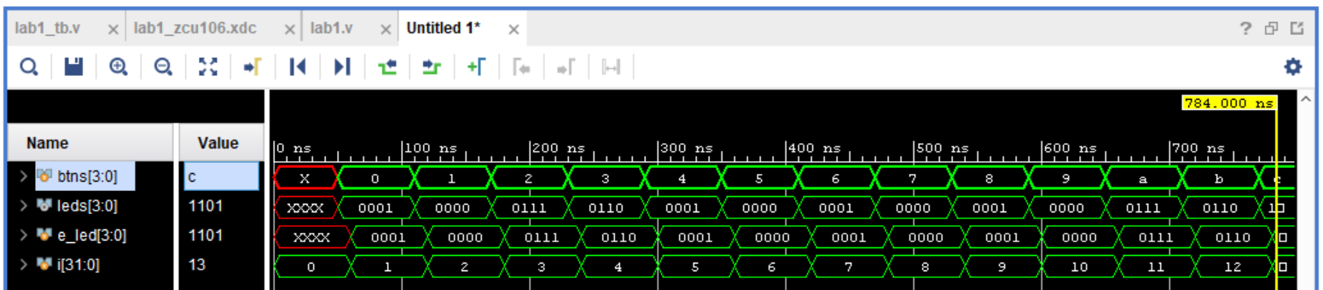
Figure 16 Running simulation for additional 500 ns
Observe the Tcl Console window and see the output is being displayed as the testbench uses the $display task.
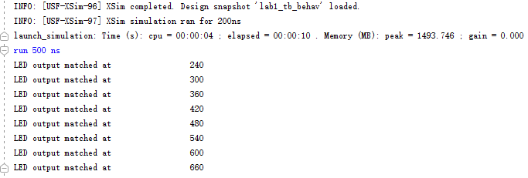
Figure 17 Tcl console output after running the simulation for additional 500 ns
5. Close the simulator by selecting File > Close Simulation.
6. Click OK and then click Discard to close it without saving the waveform.

Exercises
Make the following changes to the design and testbench files and run the simulation again:
1. Change the design so that it accepts 8 buttons as inputs and 8 leds as outputs. The new 4 outputs should be directly connected to the 4 new inputs.
2. Study the ZCU 106 User Guide to find out which FPGAs pins we should assign to the new 4 inputs and 4 outputs.
3. Change the testbench accordingly to accommodate for the new changes in the design. Run the simulation and make sure it can pass.
4. (Optional)
Design a Multiply-and-Accumulator (MAC) module. The inputs to the MAC module are 2 signed, 8-bit integer and the outputs are signed, 19-bit integer. The output is available when the MAC module received 4 pairs of inputs. The output is the sum of the products of the 4 pairs of inputs. For example, given the 2 following matrix
$$\left[\begin{matrix}5 & 7 \\ 7 & 8\end{matrix}\right] \left[\begin{matrix}3 & 2 \\ 1 & 4\end{matrix}\right]$$
The output is given as the following
$$m= \sum_{k=0}^{n}{A_{i}B_{i}}=5×3+7×2+6×1+8×4=67$$

The inputs and outputs of the MAC is given as follows
 | Signal Name | In/Out | Bus width | Descriptuion
1 | clk | In | 1 | Clock signal
2 | rst_n | In | 1 | Reset signa, active low signal
3 | ai_in | In | 8 | Input signal for A
4 | bi_in | In | 8 | Input signal for B
5 | valid_in | In | 1 | Valid signal for input  If valid_in=1, the input is valid  If valid_in=0, the input is invalid
6 | valid_out | Out | 1 | Valid signal for the output  If valid_out=1, we have received 4 inputs, and the output is available  If valid_out = 0, the output is not available
7 | mac_out | Out | 19 | The output signal

a) Crete the design in Verilog
b) Write the testbench and simulate the design in Vivado
Hint: A sample block design and hardware architecture for the MAC module is given as the followings:
