Lab 04: Build a complete Embedded System with Vivado

Objectives
After completing this lab, you will be able to:
- Create an embedded system desin using Vivado and Vitis
- Configure the Processing System (PS).
- Add Xilinx Standard IP in the Programmable Logic (PL) section

Steps
Create a Vivado Project
Launch Vivado and create an empy project targeting the ZCU106 board, selecting Verilog as a target language
1. Open Vivado by selecting Start > All Programs > Xilinx Design Tools > Vivado 2021.2 >Vivado 2021.2
2. Click Create Project to start the wizard. You will see the Create A New Vivado Project wizard page. Click Next.
3. Click the Browse button of the Project Location field of the New Project form, browse to the desired folder, and click Select.
4. Enter lab4 in the Project Name field. Make sure that the Create Project Subdirectory box is checked. Click Next.
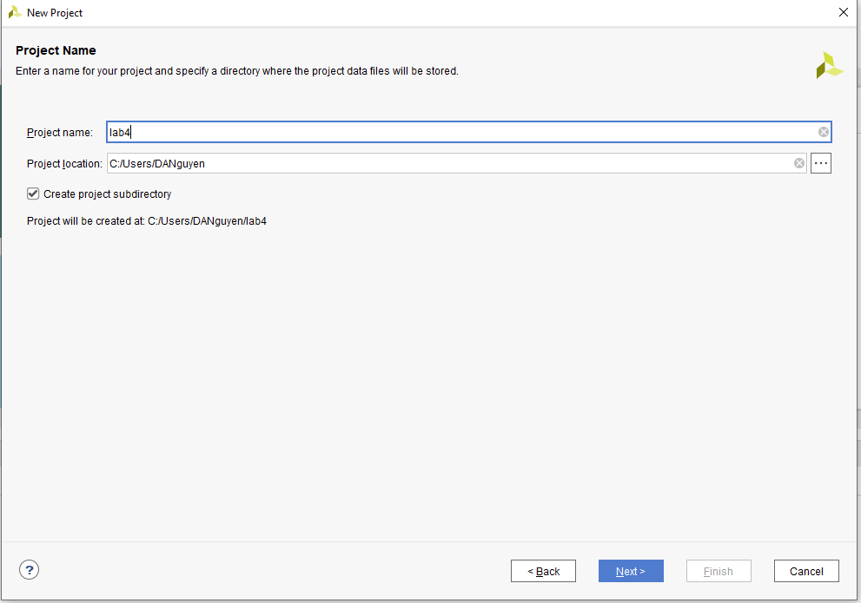
5. Select the RTL Project option in the Project Type form, and click Next.
6. Select Verilog as the Target Language and Simulation Language in the Add Sources form, and click Next.
7. Click Next to skip adding constraints.
8. In the Default Part form, click Boards filter.
9. In the Boards tab and then select Zynq UltraScale+ ZCU106 Evaluation Platform, and click Next.
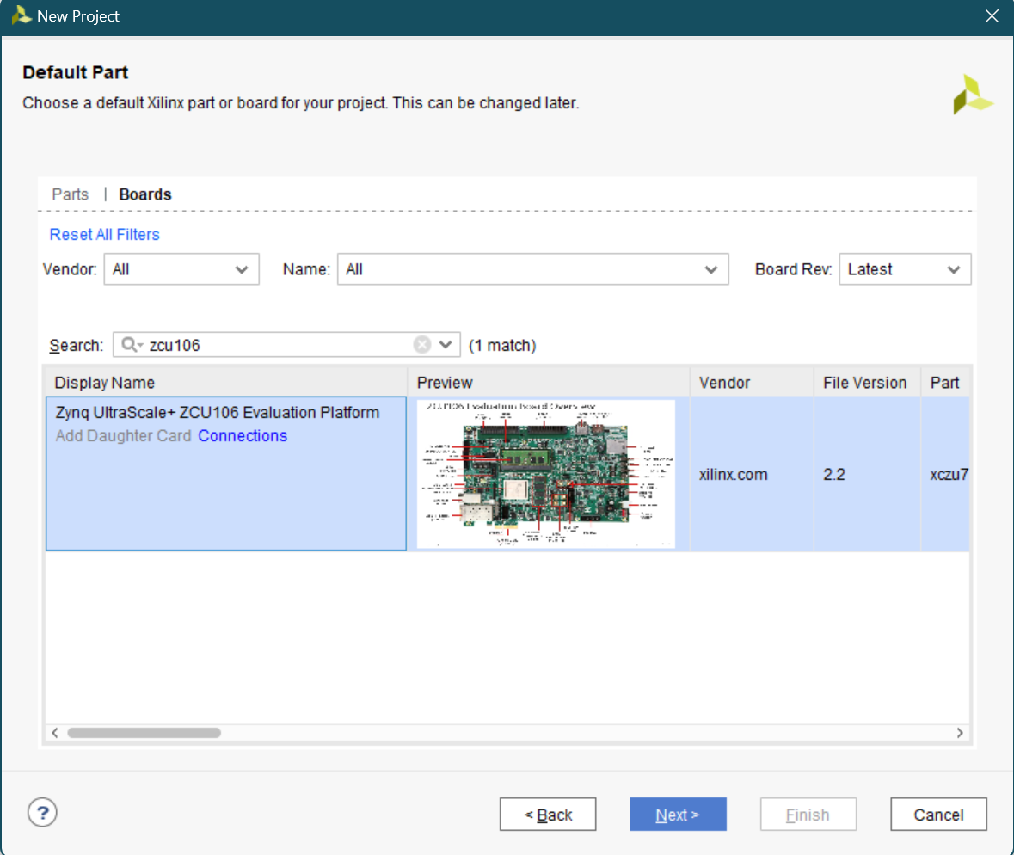
10. Click Finish to create an empty Vivado project.
Creating the Hardware System using IP Integrator
1. Create a block design in the Vivado project using IP Integrator to generate the quad core Arm® Cortex™-A53 processing system (PS) and a dual core Arm Cortex-R5F real-time processor based hardware system.
2. In the Flow Navigator, click Create Block Design under IP Integrator.
3. Name the block system and click OK.
4. Click on the button.
5. Once the IP Catalog is open, type zynq into the Search bar, and double click on the Zynq UltraScale+ MPSoC entry to add it to the design.

6. Click on Run Block Automation and click OK to automatically configure the board presets.
7. Double click on the Zynq block to open the Customization window for the Zynq UltraScale+ MPSoC.
A block diagram of the PS UltraScale+ should now be open, showing various configurable blocks of the Processing System.
8. At this stage, designer can click on various configurable blocks (highlighted in green) and change the system configuration.
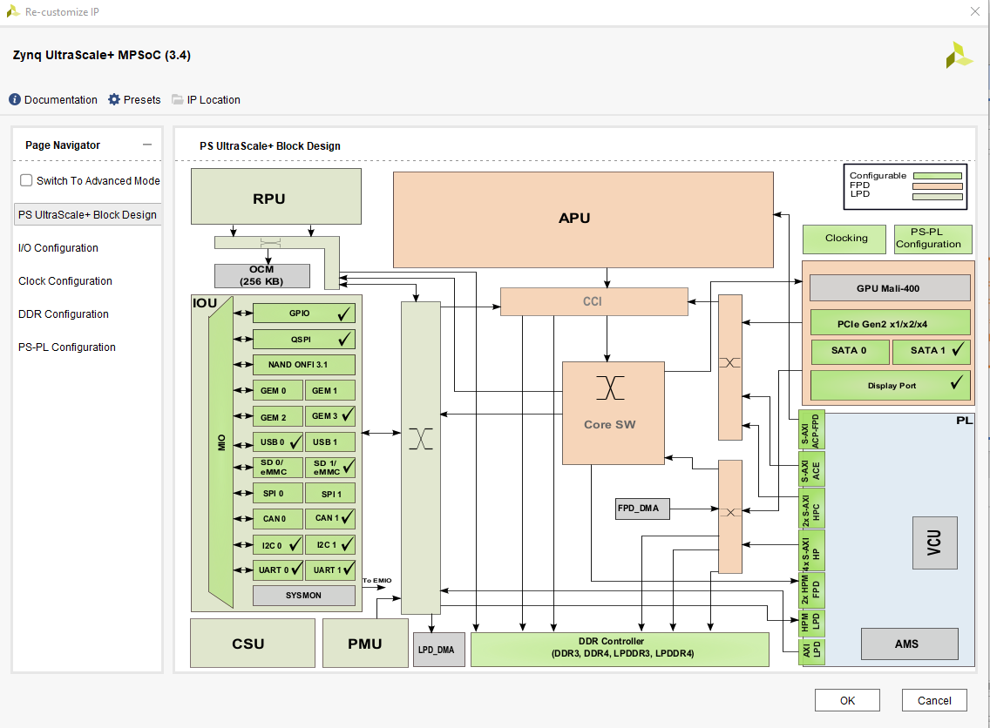
Configure the I/O Peripherals block to have UART support.
1. Click on the I/O Configuration panel to open its configuration form.
2. Expand the I/O Peripherals (and GPIO).
3. Deselect CAN and GPIO peripherals except UART.
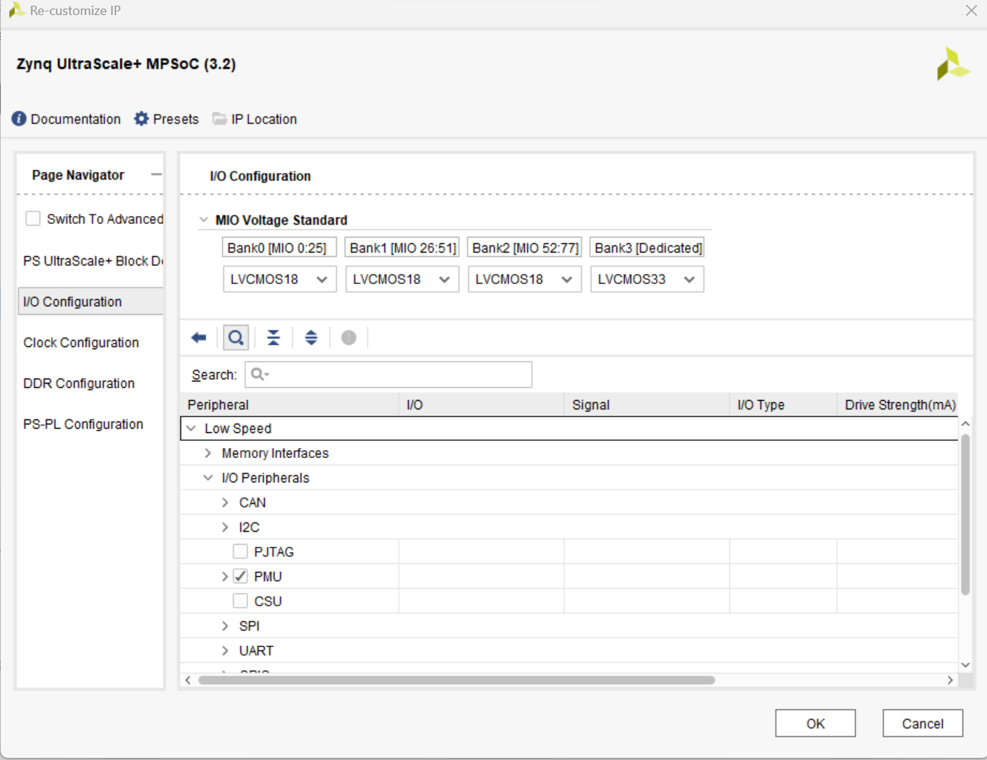
4. Select PS-PL Configuration > PS-PL interfaces > Master interface, disable AXI HPM0 FPD and AXI HPM1 FPD, then enable the AXI HPM0 LPD option.
5. Click OK.
The configuration form will close and the block diagram will be updated as shown below.
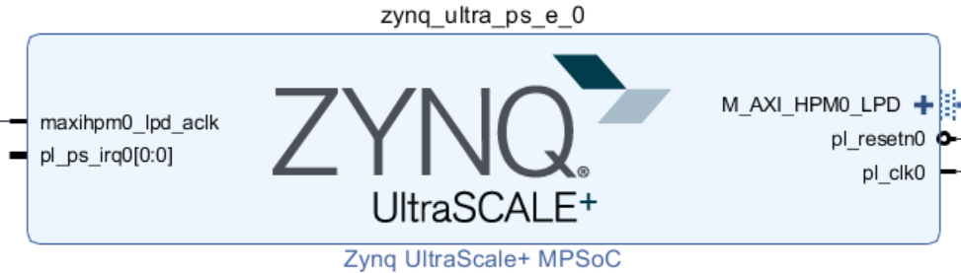
Add one instance of GPIO, name it buttons, and configure for the board. Connect the block to the Zynq.
1. Click the button and search for AXI GPIO in the catalog.
2. Double-click the AXI GPIO to add an instance of the core to the design.
3. Click on the AXI GPIO block to select it, and in the Block properties tab, change the name to buttons.
4. Double click on the AXI GPIO block to open the customization window. Under Board Interface, for GPIO, click on Custom to view the drop-down menu options, and select push buttons 5bits for the ZCU106 board.

As the board was selected during the project creation, and a board support package is available for these boards, Vivado has knowledge of available resources on the board.
5. Click the IP Configuration tab. Notice the GPIO Width is set to 5 and is greyed out. If a board support package was not available, the width of the IP could be configured here.
6. Click OK to finish configuring the GPIO and to close the Re-Customize IP window.
7. Click on Run Connection Automation, and select buttons (which will include GPIO and S_AXI)
Click on GPIO and S_AXI to check the default connections for these interfaces.
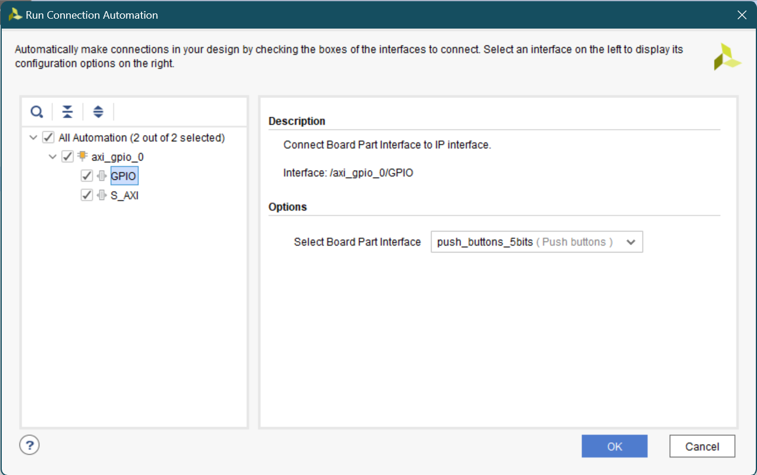
8. Click OK to automatically connect the S_AXI interface to the Zynq GP0 port (through the AXI interconnect block), and the GPIO port to an external interface.
Notice that after block automation has been run, two additional blocks that are required to connect the blocks, Processor System Reset, and AXI Interconnect have automatically been added to the design.
9. Add another instance of GPIO, name the instance leds, configure it and connect it to the Zynq.
10. Add another instance of the GPIO peripheral.
11. Change the name of the block to leds.
12. Double click on the leds block, and select leds 8bits for the GPIO interface and click OK.
13. Click on Run Connection Automation
14. Click leds, and check the connections for GPIO and S_AXI as before
15. Click OK to automatically connect the interfaces as before.

Notice that the AXI Interconnect block has the second master AXI (M01_AXI) port added and connected to the S_AXI of the leds.
16. Add another instance of the GPIO peripheral.
17. Change the name of the block to switches.
18. Double click on the switches block, and select dip switches 8bits for the GPIO interface and click OK.
19. Click on Run Connection Automation
20. Click switches, and check the connections for GPIO and S_AXI as before
21. Click OK to automatically connect the interfaces as before.
Notice that the AXI Interconnect block has the third master AXI (M02_AXI) port added and connected to the S_AXI of the leds.
At this stage the design should look like as shown below.
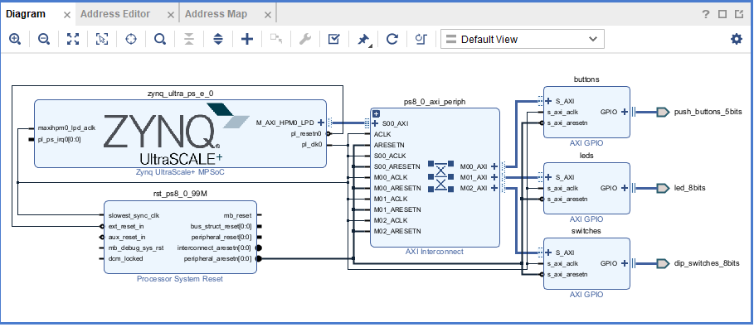
22. Select the Address Editor tab and see that the addresses are assigned to the three GPIO instances. They should look like as follows.
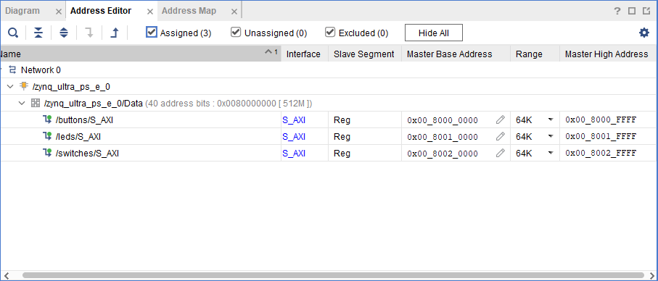
23. Select the Diagram tab, and click on the alt tag (Validate Design) button to make sure that there are no errors.
Ignore warnings.
24. Select File > Save Block Design to save the design.
25. Since all IO pins are board-aware no additional user constraints are need.
Generate the Bitstream.
1. In Vivado, select the Sources tab, expand the Design Sources, right-click the lab4.bd and select Create HDL Wrapper…
2. Click OK when prompted to allow Vivado to automatically manage this file.
The wrapper file, lab4_wrapper.v, is generated and added to the hierarchy. The wrapper file will be displayed in the Auxiliary pane.
3. Click on the Generate Bitstream in the Flow Navigator pane to synthesize and implement the design, and generate the bitstream. Click Save and Yes if prompted. Click OK to launch the runs.
4. When the bitstream generation is complete, click Cancel.
Export the Hardware.
1. Export the hardware configuration by clicking File > Export > Export Hardware… Tick the box to include the bitstream and click OK.
2. Check the location where the XSA file will be saved.
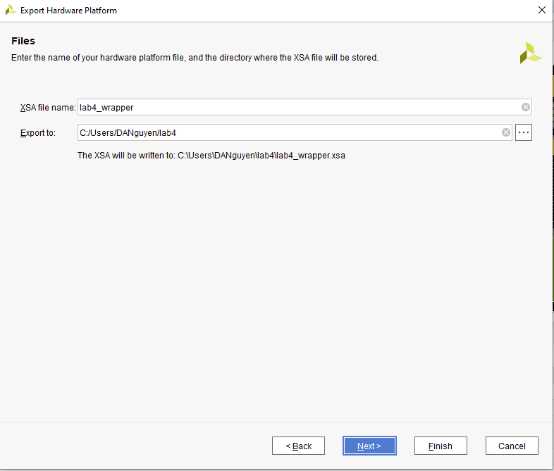
3. Click Finish.

Exercises
1. Try to make a new hardware platform. This time include the IP you have made in lab 2. You may make some modifications to the IP, such that the output LEDs can be connected to the outside world and this will be connected to the LEDs of the board.
2. (Optional) Make a new hardware platform including the MAC IP you have developed in lab 2.

