# Lab 05: Use Vitis to build software application for the embedded platform

# Objectives

After completing this lab, you will be able to:

- Create a Hardware Platform using Vitis IDE

- Running software applications for the embedded platform

# Steps

**Create a Hardware Platform using Vitis IDE**

1. Open Vitis by selecting **Start > All Programs > Xilinx Design Tools > Xilinx Vitis 2021.2**

2. Select the workspace and continue

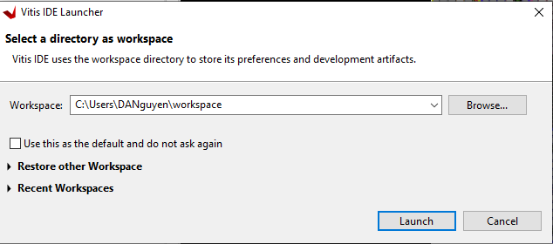

3. In the Vitis IDE, go to **File>New>Platform Project**

4. Enter the Hardware Platform name and click **Next**

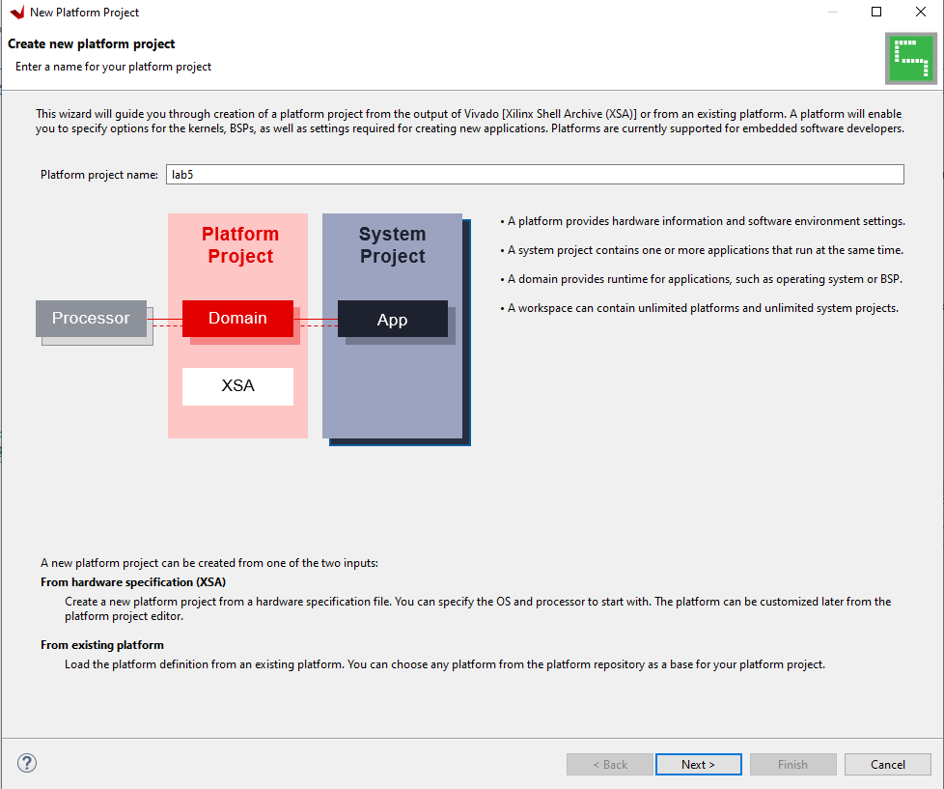

5. Browse the .xsa file which is generated from Vivado

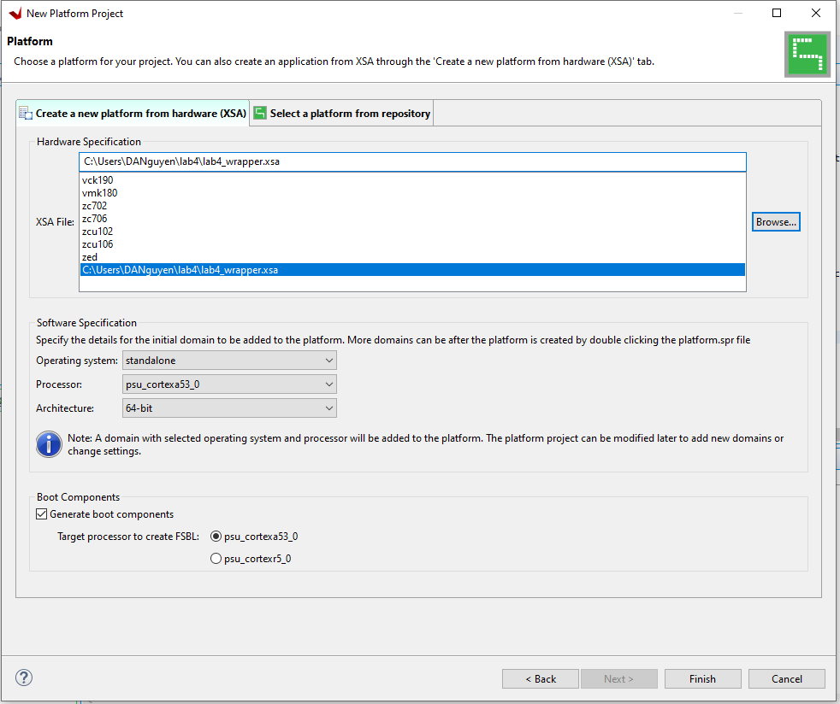

6. Click **Finish**

7. In a few minutes, the Vitis IDE generates the platform. The files that are generated are displayed in the explorer window as shown in the following figure.

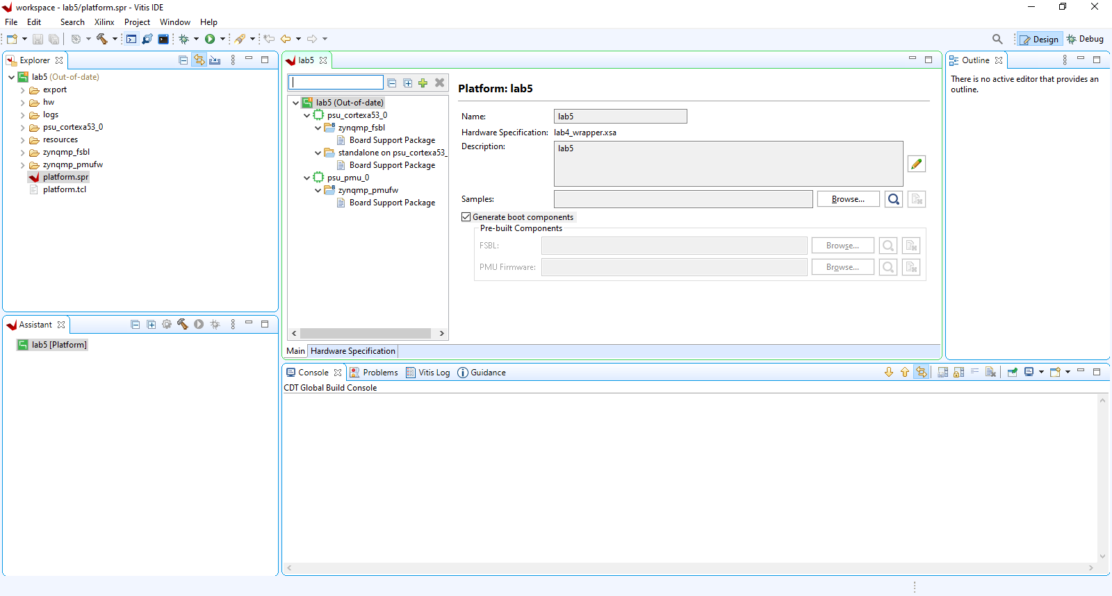

The hardware platform is ready. You can create applications using this platform and test on ZCU106 hardware.

**Running the “Hello World” Application from ARM Cortex-A53**

In this example, you will learn how to manage the board settings, make cable connections, connect to the board through your PC, and run a simple hello world software application from Arm Cortex A53 in JTAG mode using System Debugger in the Vitis IDE.

1. Connect the power cable to the board.

2. Connect a USB Micro cable between the host machine and the USB JTAG connector on the ZCU106 board.

3. Connect a USB micro cable to the UART connector on the ZCU106 board, this is used for the USB to serial transfer.

4. Ensure that the SW6 switch is set to JTAG boot mode (ON ON ON ON).

5. Power on the ZCU106 board using the power switch.

6. Open a serial communication utility in the Vitis IDE by select **Window > Show View > Other > Terminal** to open it.

7. Click the **Connect** button to set the serial configuration and connect it.

8. Verify the port details in the device manager. The following figure shows the standard configuration for the Zynq Ultrascale+ MPSoC Processing System.

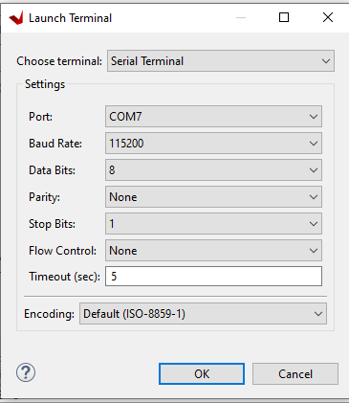

9. Select **File > New > Application Project**

The new Project wizard opens.

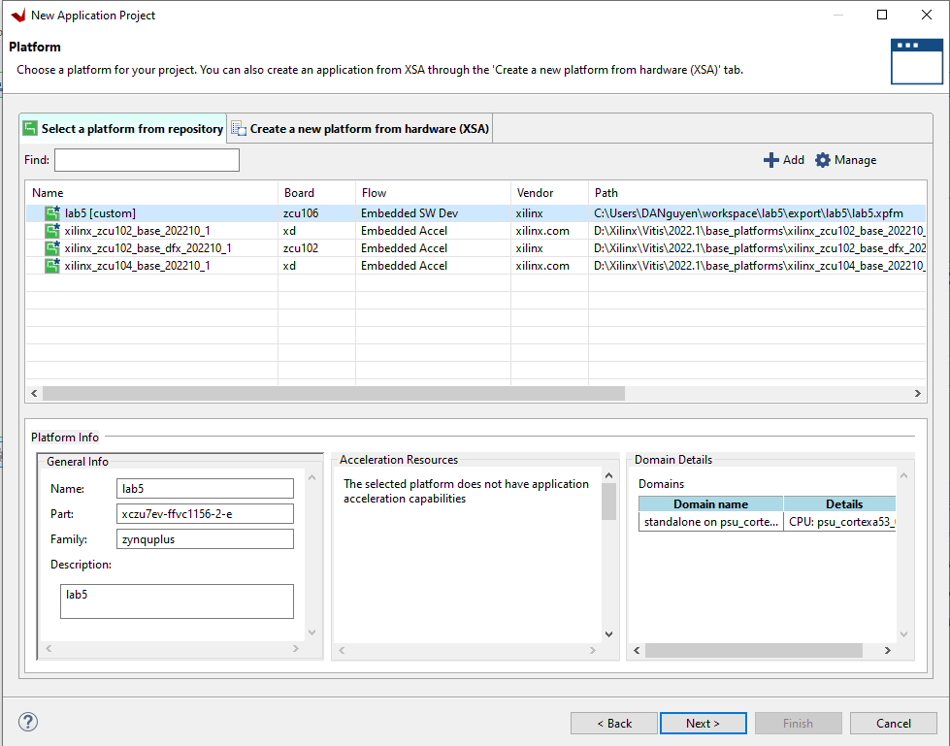

10. Click **Next.** Enter the Application Project Name

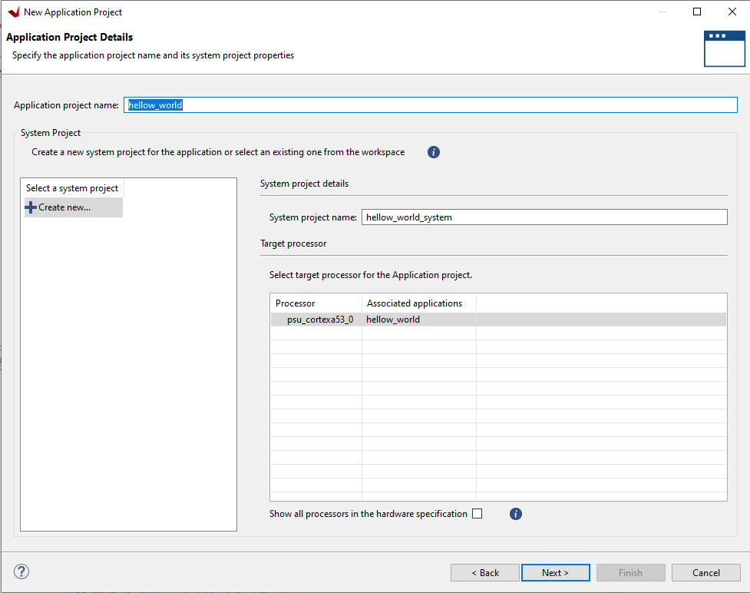

11. Click **Next.** Select the Hello World templates for the application templates.

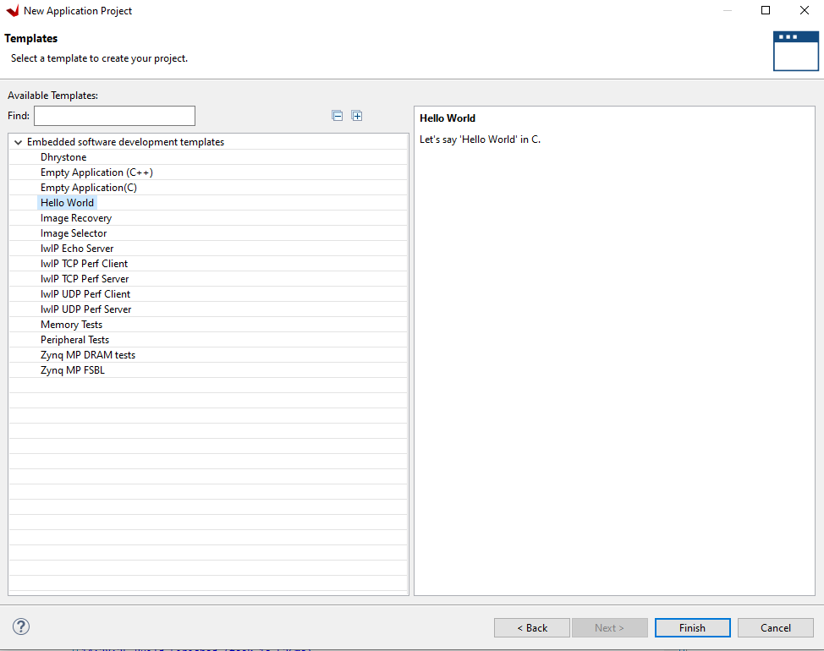

12. Click **Finish.**

13. Right click on the hello_world application project and select build option to build the application

14. Right click on the hello_world application project and select Run As > Run Configurations

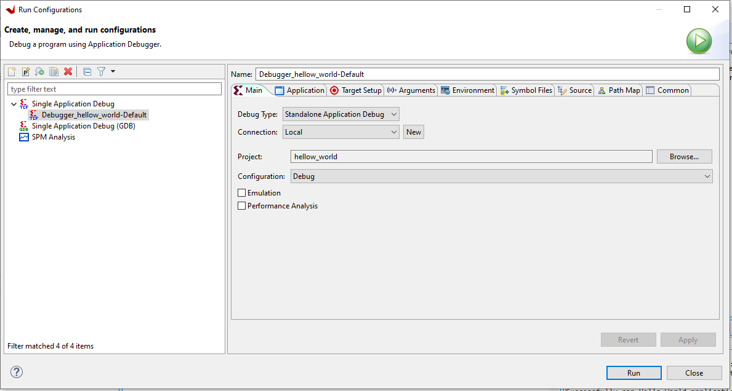

15. Click **Run**

**“Hello World”** appears on the serial communication utility in Terminal 1, as shown in the following figure.

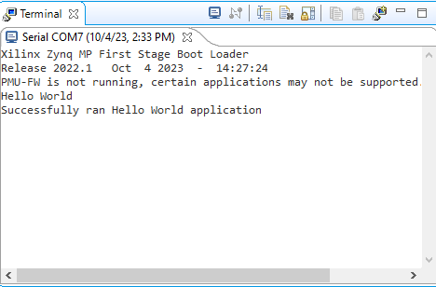

**Running an application to control the LEDs with buttons from ARM Cortex-A53**

1. Repeat the same steps from the previous section, starting from step 9 to create a new application project. Use the **Empty Application (C++)** template.

2. Right click on {Project Name/Import Sources… under the Explorer Panel to import lab5.c source file.

3. Build and run the program. You should see the following in the terminal

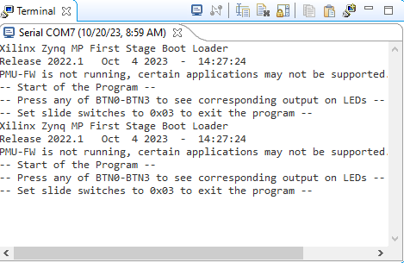

4. Press the button BTN0-BTN3 to see corresponding output on LEDs, set the switch to 0x03 to exit the program.

**Exercises**

1. Create a new hardware platform, including the modified hardware system you made in lab 04. Write an application to interact with your custom IP

2. (Optional) Write an application to interact with your MAC module.