Export the slide to PDF (if possible). Printing from PowerPoint will create a large margin (as of 2024.12).

Open the PDF file of slides and press Ctrl+P to print (shortcut can be varied between programs)



Adobe PDF printing will look like the image below. Choose Multiple and 1 by 2 to print two slides per page. Choose Print on both sides and Flip on long edge.

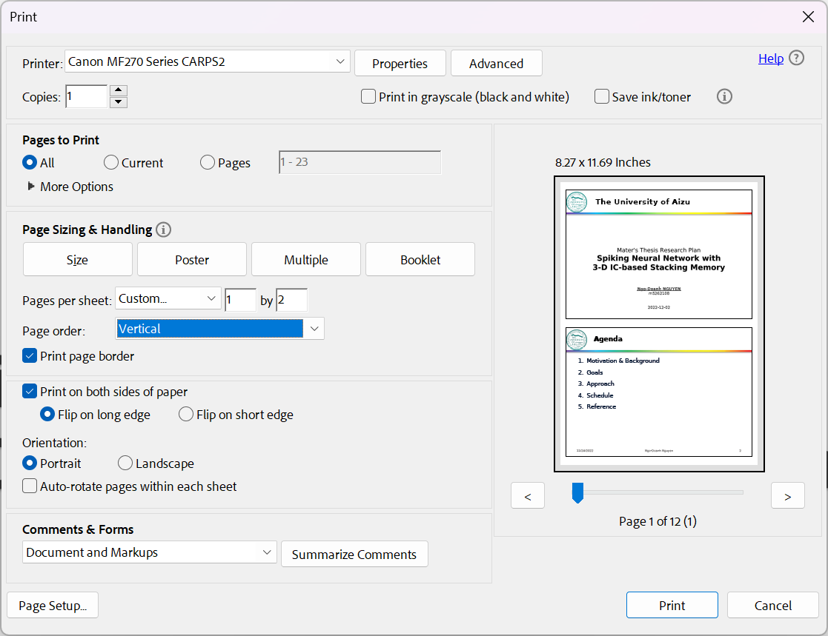

The result in B&W should look like this:

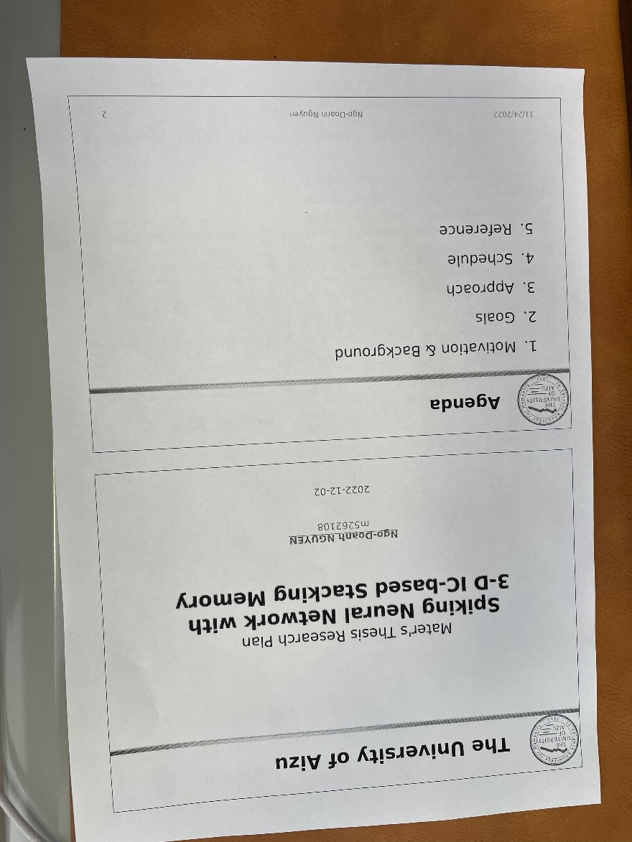s

